Vastu/Nashik/03/2023833/30490/46262
22/24-455-RPV
Date: 03.02.2024

To,
The Branch Manager,
Punjab National Bank

Canada Corner Branch
Shop No.2,3,4 Prestige Point, Opp. Vasant Market, Canada Corner
Nashik – 422 005, State – Maharashtra, Country – India.

Sub: Vetting of Extra Amenities

Sir,

With reference to above subject, we have evaluated the Extra Amenities for Residential Flat No. 204, Second Floor, A-Wing" Murali Heights Apartment ", Survey No.984/1/C/2, Plot No.11+12+13, Opposite IDBI Bank ATM, Prabhat Colony , Ashoka Marg, Khode Mala Road, Village – Nashik , Taluka & District - Nashik, PIN Code – 422 009, State – Maharashtra, Country – India belongs to Shri.Siddhant Umesh Panchbhai & Shri.Umesh Dnyaneshwar Panchbhai

We have verified the rates quoted as per current market rates. Details of work and Extra Amenities considered as per copy of Agreement for Extra Amenities Agreement Between Shri.Siddhant Umesh Panchbhai & Shri.Umesh Dnyaneshwar Panchbhai (First Party) and M/s.Kailashben Sanjaybhai Bhoraniya. (Second Party) received on dated 29.01.2024. The Extra Amenities amount is Rs.3,40,000/- ( Rupees Three Lakh Forty Thousand Only. )

The said Cost Vetting Certificate is valid upto next 6 months Only.

Thanking you

Sincerely yours

Sharadkumar B. Chalikwar
Govt. Reg. Valuer
Chartered Engineer (India)
Reg. No. (N) CCIT/1-14/52/2008-09
PNB Empanelment No. ZO:SAMD:1138
Encl: Vetting Report.

Agreement for Extra Amenities
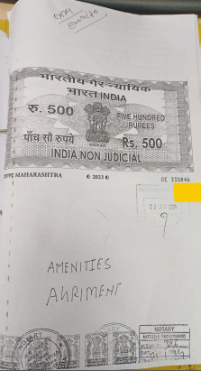
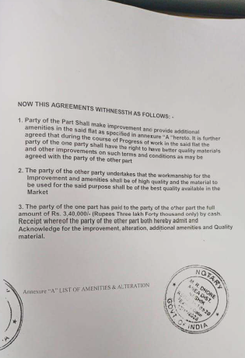

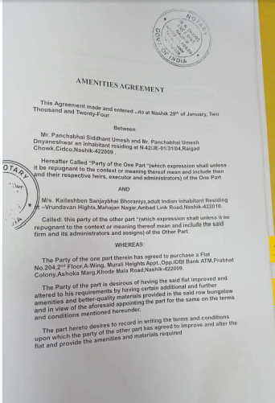
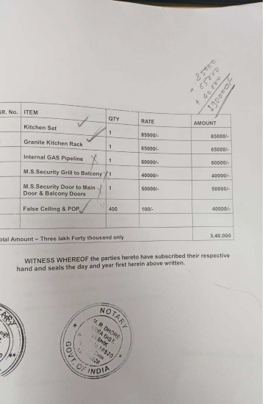

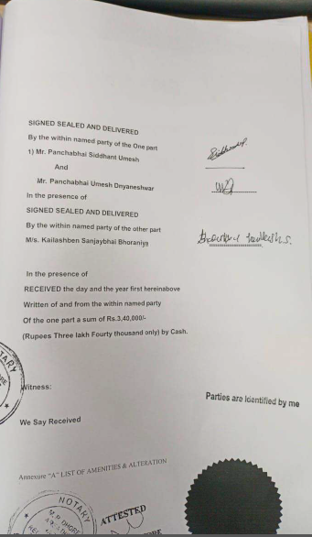

The Extra Amenities amount is Rs.3,40,000/- ( Rupees Three Lakh Forty Thousand Only. )

