Name of Owner: M/s. Lucid Colloids Limited
Details of the property under consideration:
Industrial Land & Building bearing Plot No. 757-1/1, GIDC – Jhagadia, District-Bharuch, PIN Code-393 110 State-Gujarat, Country-India.
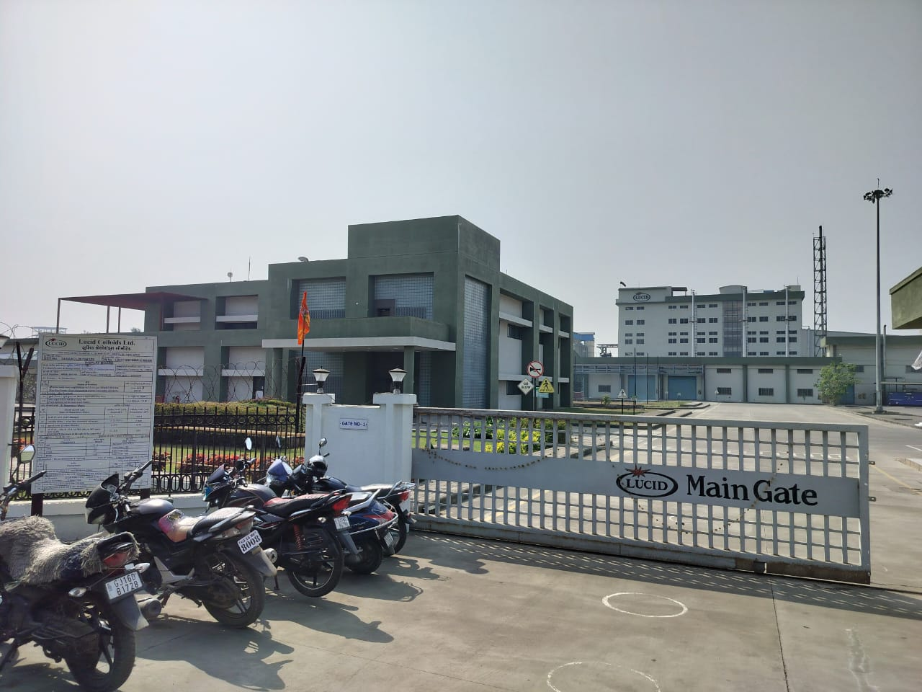

Report Prepared For
STATE BANK OF INDIA
SME Ghatkopar Branch
Hotel Roa Building, LBS Marg, Ghatkopar (West), Mumbai - 400 086,
State – Maharashtra, Country – India.
Index

Contents Page No.

1. VALUATION OPINION REPORT 3
2. VALUATION REPORT (IN RESPECT OF LAND AND BUILDING) 4
3. GOVERNMENT VALUE 17
4. TOTAL ABSTRACT OF THE ENTIRE PROPERTY 18
5. ACTUAL SITE PHOTOGRAPHS 20
6. ROUTE MAP OF THE PROPERTY 24
7. LAND CIRCLE RATE 25
8. PRICE INDICATORS 26
9. JUSTIFICATION FOR PRICE /RATE 27
10. DECLARATION-CUM-UNDERTAKING 29
11. ASSUMPTIONS, DISCLAIMERS, LIMITATIONS & QUALIFICATIONS 32
12. ASSUMPTIONS, CAVEATS, LIMITATION AND DISCLAIMERS 34
13. MODEL CODE OF CONDUCT FOR VALUERS 36
14. DEFINITION OF VALUE FOR THIS SPECIFIC PURPOSE 39

Vastu/Mumbai/03/2024/6725/2304360
05/15-62-APU
Date: 01.03.2024

VALUATION OPINION REPORT
This is to certify that the property bearing Industrial Land & Building bearing Plot No. 757-1/1, GIDC – Jhagadia, District-Bharuch, PIN Code-393 110 State-Gujarat, Country-India belongs
M/s. Lucid Colloids Limited
Boundaries of the property.
North | : | Road
South | : | Road
East | : | Open Plot
West | : | Open Plot
Considering various parameters recorded, existing economic scenario, and the information that is available with reference to the development of neighbourhood and method selected for valuation, we are of the opinion that, the property premises can be assessed and Fair Market Value for this particular purpose at
Particulars | Fair Market Value (`) | Realizable Value (`) | Distress Sale Value (`) | Insurable Value  (`)
Land and Building | 1,48,02,93,244 | 1,33,22,63,920 | 1,18,42,34,595 | 1,02,71,43,838

The valuation of the property is based on the documents produced by the concern. Legal aspects have not been taken into considerations while preparing this valuation report.

Hence certified.
Manoj B Chalikwar
Registered Valuer
Chartered Engineer (India)
Reg. No. IBBI/RV/07/2018/10366
SBI Empanelment No. – SME/TCC/2021-22/86/3.
No. – SME/TCC/2021-22/86/3

Vastukala Consultants (I) Pvt. Ltd.
B1-001, U/B Floor, Boomerang, Chandivali Farm Road, Powai, Andheri (East), Mumbai – 400 072

To,
Manager
State Bank of India
SME Ghatkopar Branch
Hotel Roa Building, LBS Marg,
Ghatkopar (West), Mumbai - 400 086,
State – Maharashtra, Country – India.

VALUATION REPORT (IN RESPECT OF LAND AND BUILDING)
I | General
1. | Purpose for which the valuation is made |  |  |  | : | As per the request from State Bank of India, SME- SME Ghatkopar Branch to assess Fair market value of the property for banking purpose.
2. | a) | Date of inspection |  |  | : | 16.02.2024.
 | b) | Date on which the valuation is made |  |  | : | 01.03.2024
3. | List of documents produced for perusal
- Copy of Deed of Rectification between M/s. Lucid Colloids Limited (The Lessee) And GIDC, Ankleshwar (The Lessor).
- Copy of Deed of Assignment dated 02.07.2022 made between M/s. Lucid Colloids Limited (The Assignor) And M/s. DCM Shriram Limited (The Assignee). For Plot No. 757-1/2 admeasuring 43,000 Sq. M.
- Copy of Amendment and Partial Release Deed of dated 08.06.2022 between M/s. Lucid Colloids Limited (Company / Mortgagor) And IDBI Trusteeship Services Limited (Security Agent / Mortgagee)
- Copy of Handing over possession of Plot No. 757-1 to M/s. Lucid Colloids Limited issued by GIDC Ankleshwar.
- Copy of Possession Receipt Vide No. GIDC/DEE-Jhagadia/512 of dated 24.10.2011 of Plot No. 757/1 admeasuring 1,25,886.58 Sq. M. issued by GIDC Jagadia.
- Copy of Deed of Rectification of Plot No. 757/1 vide No. GIDC/RM/ANK/1035 of dated 25.03.2012 GIDC, Ankleshwar.
- Copy of Application to Transfer of Industrial Plot No. 757-1/2 admeasuring area 43,000.00 Sq. M. along with water & drainage connections (if any) in favor of M/s. DCM Shriram Limited Vide No. GIDC/RM/ANK/TRF/PTO/JHA2/181 of dated 28.06.2022. issued by GIDC Ankleshwar.
- Copy of Office Order vide No. GIDC/RM/ANK/SD/FSO/JHA2/8 of dated 08.02.2022 for sub-division of Industrial Plot No. 757-1 into Proposed Plot No. 757-1/1 admeasuring 82,886.58 Sq. M. and Plot No. 757-1/2 admeasuring 43,000.00 Sq. M. issued by GIDC Ankleshwar.
- Copy of Approved Plan Vide Lette No. GIDC/ANK/XEN/PB-II/1524 of dated 23.10.2020 issued by Executive Engineer, GLDC Ankleshwar.
- Copy of Offer cum Allotment of Plot No. 757/1 to M/s. Lucid Colloids Limited. vide Letter No. GIDC/RM/ANK/5679 of dated 25.07.2011 issued by GIDC, Ankleshwar.
- Copy of Approved plan vide No. GIDC/XEN/ANK/PB-II/548 of dated 16.04.2017 issued by Executive Engineer GIDC, Ankleshwar
- Copy of Letter of Approval of plan vide No. GIDC/XEN/ANK/PB/JHG-241/A/548 of dated 16.03.2017 for Plot No. 757/1 issued by GIDC, Ankleshwar.
- Copy of Self Certification of Building completion Certificate from M/s. Lucid Colloids Limited to the Executive Engineer GIDC Ankleshwar.
- Copy of Building completion Self Certification vide Application No. BC2019ab9fc4 of dated 19.08.2019 issued by GIDC, Ankleshwar to Allottee M/s. Lucid Colloids Limited to the Executive Engineer GIDC Ankleshwar.
- Letter of Plinth level Certification vide Application No. PL20199e5846 of dated 19.08.2019 issued by GIDC, Ankleshwar to Allottee M/s. Lucid Colloids Limited to the Executive Engineer GIDC Ankleshwar.
- Letter of Plinth level Self Certification from M/s. Lucid Colloids Limited to the Executive Engineer GIDC Ankleshwar.
- Copy of Factory License Registration No. 1445/20219/2019 License No. 38906 of dated 01.05.2019. Valid till 31.12.2023. issued by Director of Industrial Safety & Health Gujarat.
- Copy of Provisional Consent Order (CCA) vide Consent No. AWH-104148 valid till 15.08.2024, Application No. Cto:CCA-Fresh No. 162468 dated 18.08.2019 granted on 23.09.2019, PCB id – 42823 issued by Gujarat Pollution Control Board, Ghandhinagar.
- Copy of Consolidated Consent and Authorization (CC & A) CCA No. AWH – 104148, Vide Ni. GPCB/ANK/CCA-1559/ID-42823/528412 of dated 29.11.2019 issued by Gujarat Pollution Control Board, Ghandhinagar.
- Copy of Central License Vide License No. 10019021004769 of dated 16.06.2022 valid upto 22.10.2024 issued by Food Safety & Standards Authority of India.
- Copy of Certificate of Registration vide No. IND.20.3650/FS/U/3 of dated 28.10.2021 issued by Bureau Veritas Certification.
4. | Name of the owner(s) and his / their address (es) with Phone no. (details of share of each owner in case of joint ownership) |  |  |  | : | M/s. Lucid Colloids Limited  Address: Industrial Land & Building bearing Plot No. 757-1/1, GIDC – Jhagadia, District-Bharuch, PIN Code-393 110 State-Gujarat, Country-India  Contact Person –  - Mr. Anil Rai - +91 63098 14848  Private Limited Ownership
5. | Brief description of the property (Including Leasehold / freehold etc.) |  |  |  | :
Industrial Land & Building bearing Plot No. 757-1/1, GIDC – Jhagadia, District-Bharuch, PIN Code-393 110 State-Gujarat, Country-India.

The property is in planned & Industrial developing area. The immovable property comprises of Industrial land and structures thereof. The property is situated at Plot No. 757-1/1, GIDC – Jhagadia, District-Bharuch, PIN Code-393 110 State-Gujarat, Country-India. It is located at about 24 Kms. travelling distance from Bharuch Railway Station.

Surface transport to the property is by Bus, auto-rickshaws & Private Vehicles. The property is in developing area having average civic and infrastructure facilities are nearby available.
Land Area:-
As per the copy of Lease deed, GIDC originally leased the Land at Plot No. 757-1 admeasuring 1,25,886.58 Sq. M to Lucid Colloids Limited for the period of 99 years. Subsequently as per the copy of letter vide No: GIDC/RM/ANK/SD/PSO/JHA2/9 dated. 11/01/2022, the Plot No. 757-1 is subdivided in 757-1/1 & 757-1/2 admeasure 82,886.58 Sq. M & 43,000.00 Sq. M respectively details for the same is as under:-
S. No. | Plot No. | Area (Sq. M)
1 | 757-1/1 | 82,886.58
2 | 757-1/2 | 43,000.00
 | Total | 1,25,886.58

As per Copy of Deed of Assignment dated 02.07.2022 made between M/s. Lucid Colloids Limited (The Assignor) and M/s. DCM Shriram Limited (The Assignee), Company has assigned the Plot No. 757-1/2 admeasuring 43,000.00 Sq. M.

Therefore, the Plot under Valuation is Plot No. 757-1/1 admeasuring 82,886.58 Sq. M. and land area is 82,886.58 Sq. M. is considered for Valuation.

Details of Construction –
As per the Copy of Approved Plan Vide Lette No. GIDC/ANK/XEN/PB-II/1524 of dated 23.10.2020 issued by Executive Engineer, GLDC Ankleshwar. Building Constructed is as under:-
S. No. | Description | Net BUA Ground Floor (Sq. M) | Net BUA First Floor (Sq. M) | Net BUA Second Floor (Sq. M) | Net BUA Third Floor (Sq. M) | Net BUA Mezz Floor (Sq. M) | Net BUA Terrace (Sq. M) | Total BUA (Sq. M)
1 | Security Cabin | 225.28 |  |  |  |  |  | 225.28
2 | Weigh Bridge & Cabin | 90.64 |  |  |  |  |  | 90.64
3 | Switch Yard & Panel Room | 71.61 |  |  |  |  |  | 71.61
4 | Admin | 1,228.22 | 876.56 |  |  |  | 89.47 | 2,194.25
5 | Water Block | 185.70 |  |  |  |  |  | 185.70
6 | Workers Amenity Block | 488.52 | 488.52 | 405.76 |  |  | 28.93 | 1,411.73
7 | Main Plant | 12,320.42 | 4,433.83 | 3,571.70 | 3,571.70 | 382.99 | 122.41 | 24,403.05
8 | R.M. Ware House | 2,129.94 |  |  |  |  |  | 2,129.94
9 | D.G. Sub Station | 956.12 | 524.26 |  |  |  |  | 1,480.39
10 | Utility Area | 717.78 |  |  |  |  |  | 717.78
11 | Maintenance Workshop | 1,313.37 |  |  |  |  |  | 1,313.37
12 | HSD Tank | 68.00 |  |  |  |  |  | 68.00
13 | General (IPA) Tank | 71.99 |  |  |  |  |  | 71.99
14 | W Block | 1,587.62 | 489.64 | 444.58 |  |  | 24.23 | 2,546.07
15 | Scrap Yard | 256.00 |  |  |  |  |  | 256.00
16 | ETP Offices & MCC Room | 100.49 |  |  |  |  |  | 100.49
17 | Sewage Treatment Plant | 188.15 |  |  |  |  |  | 188.15
18 | Effluent Treatment Plant | 655.86 |  |  |  |  |  | 655.86
19 | Car Parking Shed | 844.80 |  |  |  |  |  | 844.80
20 | Cooling Tower | 99.93 | 71.69 |  |  |  |  | 171.62
 | Total | 23,600.44 | 6,884.50 | 4,422.04 | 3,571.70 | 382.99 | 265.04 | 39,126.72

Parking Shed : Steel column and G.I Sheet roof structure. The height of the structure is 8ft (approximately).

Security Cabin : RCC framed with vitrified flooring and conduit electrical fitting. Security cabin has OHC, Visitor room & Time room. The height of the said structure is 12.7 ft. (approximately)

Weigh Bridge : RCC framed with PCC flooring and concealed electrical fitting and M.S steel Flush door with Aluminium framed glass sliding window. The height of the said structure is 8.8 ft. (approximately).

Control room of Substation :RCC framed with PCC flooring and conduit electrical fitting and Rolling shutter with an Aluminium framed glass sliding window. The height of the said structure is 12.11 ft. (approximately).

Canteen Building : Structure is Ground + 2 upper floors. RCC framed with Vitrified tiles flooring and conduit electrical fitting. Ground floor consist of Canteen, Gents locker room & Ladies changing room. First Floor consist of Guest rooms with a common gathering room. Second Floor consist of Worker room and area open to the sky.
Utility : RCC framed with PCC flooring and conduit electrical fitting and M.S Steel with an Aluminium framed glass sliding window. Utility building consist of workshops, air compressor rooms, etc. The height of the said structure is 19 ft. (approximately).

Engineering Office :Composite (RCC + Steel) with PCC flooring and conduit electrical fitting. There is M.S Steel with an Aluminium framed glass sliding window & G.I sheet roof. Engineering Office building consists of engineering room, store, Pilot plant & Chemical room. The height of the said structure is 29 ft. (approximately).

Panel Control Room :Structure is Ground+1 upper floor. RCC framed with PCC flooring and conduit electrical fitting and M.S Steel & Rolling Shutter with an Aluminium framed glass sliding window. The building consists of Seller room & Panel control room. The height of the said structure is 12 ft. (approximately) on each floor.

Raw Material Godown :Composite Structure (RCC + Steel) with PCC flooring and conduit electrical fitting. There is a Rolling Shutter with an Aluminium framed glass sliding window.

Pump Room : Structure is Basement +Ground. RCC framed with PCC flooring and conduit electrical fitting and M.S Sheet flush door and the lighting is through the fixed glass window & ventilation is through the door.

Admin Building : Structure is Ground + 1 Upper Floor. RCC framed with Vitrified flooring and concealed electrical fitting. Ground floor consists of various cabins such as the Lab area, H.R room, Quality control lab, Reception, etc. First Floor is dedicated to the Administration function.

Finished Goods Godown : Composite structure (RCC + Steel) with PCC flooring and conduct electrical fitting. Finished

Note: - For the purpose of Valuation, we have considered area as per plan Approved by Executive Engineer, GLDC Ankleshwar.
6. | Location of property |  |  |  | :
 | a) | Plot No. / Survey No. |  |  | : | Plot No. 757-1/1, GIDC – Jhagadia, District-Bharuch, PIN Code-393 110 State-Gujarat, Country-India
 | b) | Door No. |  |  | : | -
 | c) | C.T.S. No. / Village |  |  | : | Dadheda & Talodara
 | d) | Ward / Taluka |  |  | : | -
 | e) | Mandal / District |  |  | : | Bharuch
7. | Postal address of the property |  |  |  | : | Industrial Land & Building bearing Plot No. 757-1/1, GIDC – Jhagadia, District-Bharuch, PIN Code-393 110, State-Gujarat, Country-India
8. | City / Town |  |  |  | : | GIDC – Jhagadia, District Bharuch.
 | Residential area |  |  |  | : | No
 | Commercial area |  |  |  | : | No
 | Industrial area |  |  |  | : | Yes
9. | Classification of the area |  |  |  | :
 | i) High / Middle / Poor |  |  |  | : | Middle Class
 | ii) Urban / Semi Urban / Rural |  |  |  | : | Semi Urban
10. | Coming under Corporation limit / Village Panchayat / Municipality |  |  |  | : | -
11. | Whether covered under any State / Central Govt. enactments (e.g., Urban Land Ceiling Act) or notified under agency area/ scheduled area / cantonment area |  |  |  | : | No
12. | In Case it is Agricultural land, any conversion to house site plots is contemplated |  |  |  | : | N.A.
13. | Boundaries of the property
 | Particulars |  | North | South |  |  | East | West
 | As per document |  | 20 M. Wide Road | Utility Corridor |  |  | Plot No. 757 | Utility Corridor
 | As per Site |  | Road | Road |  |  | Open Plot | Open Plot
14.1 | Dimensions of the site |  |  |  | : | N.A., as the plots are internally amalgamated and irregular in shape.
 |  |  |  |  |  | A  As per the Deed |  | B  Actuals
 | North |  |  |  | : | 20 M. Wide Road |  | Road
 | South |  |  |  | : | Utility Corridor |  | Road
 | East |  |  |  | : | Plot No. 757 |  | Open Plot
 | West |  |  |  | : | Utility Corridor |  | Open Plot
14.2 | Latitude, Longitude & Co-ordinates of property |  |  |  | : | 21°38'25.6"N 73°08'28.1"E
14. | Extent of the site |  |  |  | : | Plot area =. 82,886.58 Sq. M.  (Area as per Deed)  Structure area = As per Brief Description
15. | Extent of the site considered for Valuation (least of 14A& 14B) |  |  |  | :
16 | Whether occupied by the owner / tenant? If occupied by tenant since how long? Rent received per month. |  |  |  | : | Owner Occupied
II | CHARACTERSTICS OF THE SITE
 | Classification of locality |  |  |  | : | Industrial
 | Development of surrounding areas |  |  |  | : | Fully Developed
 | Possibility of frequent flooding/ sub-merging |  |  |  | : | No
 | Feasibility to the Civic amenities like School, Hospital, Bus Stop, Market etc. |  |  |  | : | All available near by
 | Level of land with topographical conditions |  |  |  | : | Leveled
 | Shape of land |  |  |  | : | Irregular Shape
 | Type of use to which it can be put |  |  |  | : | For industrial purpose
 | Any usage restriction |  |  |  | : | No
 | Is plot in town planning approved layout? |  |  |  | : | Yes
 | Corner plot or intermittent plot? |  |  |  | : | Corner Plot
 | Road facilities |  |  |  | : | Yes
 | Type of road available at present |  |  |  | : | RCC Road
 | Width of road – is it below 20 ft. or more than 20 ft. |  |  |  | : | More than 20 ft
 | Is it a Land – Locked land? |  |  |  | : | No
 | Water potentiality |  |  |  | : | Yes
 | Underground sewerage system |  |  |  | : | Yes
 | Is Power supply is available in the site |  |  |  | : | Yes
 | Advantages of the site |  |  |  | : | No
 | Special remarks, if any like threat of acquisition of land for publics service purposes, road widening or applicability of CRZ provisions etc. (Distance from sea-cost / tidal level must be incorporated) |  |  |  | : | No
Part – A (Valuation of land)
1 | Size of plot |  |  |  | : | Plot area =. 82,886.58 Sq. M.  (Area as per Deed)
 | North & South |  |  |  | : | -
 | East & West |  |  |  | : | -
2 | Total extent of the plot |  |  |  | : | Plot area =. 82,886.58 Sq. M.  (Area as per Deed)
3 | Prevailing market rate (Along with details / reference of at least two latest deals / transactions with respect to adjacent properties in the areas) |  |  |  | : | ₹ 3,500/- to ₹7,500/- per Sq. M.  Details of online listings are attached with the report.
4 | Land circle Rates from IGR Portal (an evidence thereof to be enclosed) |  |  |  | : | ₹ 1,910/- per Sq. M.
 | In case of variation of 20% or more in the valuation proposed by the valuer and the Guideline value provided in the State Govt. notification or Income Tax Gazette justification on variation has to be given. |  |  |  | : | It is a foregone conclusion that market value is always more than RR prices. As the RR rates are fixed by respective state governments for computing stamp duty / regn. Fees. Thus, the rates differ from place to place and location. Amenities per se as evident from the fact that even RR rates decided by Govt. differ.
5 | Assessed / adopted rate of valuation |  |  |  | : | ₹ 5,500/- per Sq. M.
6 | Estimated value of land |  |  |  | : | ₹ 45,58,76,190.00/-
Part – B (Valuation of Building)
1 | Technical details of the building |  |  |  | :
 | - Type of Building (Residential / Commercial / Industrial) |  |  |  | : | Industrial
 | - Type of construction (Load bearing / RCC / Steel Framed) |  |  |  | : | As per Brief Description
 | - Year of construction |  |  |  | : | As per Brief Description
 | - Number of floors and height of each floor including basement, if any. |  |  |  | : | Brief Description
 | - Plinth area floor-wise |  |  |  | : | As per Brief Description
 | - Condition of the building |  |  |  | : | Good Condition
 | - Exterior – Excellent, Good, Normal, Poor |  |  |  | : | Good
 | - Interior – Excellent, Good, Normal, Poor |  |  |  | : | Good
 | - Date of issue and validity of layout of approved map |  |  |  | : | Copy of Approved Plan Vide Lette No. GIDC/ANK/XEN/PB-II/1524 of dated 23.10.2020 issued by Executive Engineer, GLDC Ankleshwar.
 | - Approved map / plan issuing authority |  |  |  | :
 | - Whether genuineness or authenticity of approved map / plan is verified |  |  |  | : | Yes
 | - Any other comments by our empanelled valuers on authentic of approved plan |  |  |  | : | No

Specifications of construction (floor-wise) in respect of
Sr. | Description
 | Foundation | : | R.C.C. Foundation
 | Basement | : | Basement in Pump Room
 | Superstructure | : | As per Brief Description
 | Joinery / Doors & Windows (Please furnish details about size of frames, shutters, glazing, fitting etc. and specify the species of timber | : | Brief Description
 | RCC Works | :
 | Plastering | : | Cement plaster
 | Flooring, Skirting, dado | : | Vitrified PCC, Ceramic flooring on floor
 | Special finish as marble, granite, wooden paneling, grills etc. | : | No
 | Roofing including weatherproof course | : | As per structure Table
 | Drainage | : | Connected to Sewage
2. | Compound Wall | : | Provided
 | Height | : | 8 Ft
 | Length | : | Along the plot
 | Type of construction | : | Brick Work
3. | Electrical installation | : | Good Quality
 | Type of wiring | : | -
 | Class of fittings (superior / ordinary / poor) | : | Superior
 | Number of light points | : | Provided as per requirement
 | Fan points | : | Provided as per requirement
 | Spare plug points | : | Provided as per requirement
 | Any other item | : | -
4. | Plumbing installation
 | - No. of water closets and their type | : | Provided as per requirement
 | - No. of wash basins | : | Provided as per requirement
 | - No. of urinals | : | Provided as per requirement
 | - No. of bathtubs | : | Provided as per requirement
 | - Water meters, taps etc. | : | Provided as per requirement
 | - Any other fixtures | : | Provided as per requirement

Structure
S. No. | Description | Year of Const. | Total BUA (Sq. M) | Total Life of Structure | Full Rate | Final Depreciated Rate to be considered | Final Depreciated Value to be considered | Insurable Value / Full Value
1 | Security Cabin | 2019 | 225.28 | 40 | 22,500 | 22,500 | 50,68,800 | 50,68,800
2 | Weigh Bridge & Cabin | 2017 | 90.64 | 40 | 22,500 | 18,956 | 17,18,195 | 20,39,400
3 | Switch Yard & Panel Room | 2019 | 71.61 | 40 | 20,000 | 20,000 | 14,32,200 | 14,32,200
4 | Admin | 2019 | 2,194.25 | 40 | 22,500 | 22,500 | 4,93,70,625 | 4,93,70,625
5 | Water Block | 2019 | 185.70 | 40 | 22,500 | 22,500 | 41,78,250 | 41,78,250
6 | Workers Amenity Block | 2019 | 1,411.73 | 40 | 22,500 | 22,500 | 3,17,63,925 | 3,17,63,925
7 | Main Plant | 2020 | 24,403.05 | 40 | 22,500 | 22,500 | 54,90,68,625 | 54,90,68,625
8 | R.M. Ware House | 2019 | 2,129.94 | 40 | 22,500 | 22,500 | 4,79,23,650 | 4,79,23,650
9 | D.G. Sub Station | 2019 | 1,480.39 | 40 | 22,500 | 22,500 | 3,33,08,685 | 3,33,08,685
10 | Utility Area | 2019 | 717.78 | 40 | 22,500 | 22,500 | 1,61,50,050 | 1,61,50,050
11 | Maintenance Workshop | 2019 | 1,313.37 | 40 | 22,500 | 22,500 | 2,95,50,825 | 2,95,50,825
12 | HSD Tank | 2019 | 68.00 | 40 | 20,000 | 20,000 | 13,60,000 | 13,60,000
13 | General (IPA) Tank | 2019 | 71.99 | 40 | 20,000 | 20,000 | 14,39,800 | 14,39,800
14 | W Block | 2019 | 2,546.07 | 40 | 18,500 | 18,500 | 4,71,02,295 | 4,71,02,295
15 | Scrap Yard | 2018 | 256.00 | 40 | 15,000 | 12,975 | 33,21,600 | 38,40,000
16 | ETP Offices & MCC Room | 2018 | 100.49 | 40 | 20,000 | 17,300 | 17,38,477 | 20,09,800
17 | Sewage Treatment Plant | 2018 | 188.15 | 40 | 20,000 | 17,300 | 32,54,995 | 37,63,000
18 | Effluent Treatment Plant | 2019 | 655.86 | 40 | 20,000 | 20,000 | 1,31,17,200 | 1,31,17,200
19 | Car Parking Shed | 2016 | 844.80 | 40 | 5,000 | 4,100 | 34,63,680 | 42,24,000
20 | Cooling Tower | 2018 | 171.62 | 40 | 15,000 | 12,975 | 22,26,770 | 25,74,300
21 | Road, Drain (RCC Drain & Hume Pipe Culvert), Silo Foundation, Chimney Foundation, Yard Pipe Rack, Miscellaneous Work, Fire Line Earthwork, Land Scaping, Truck Parking / Loading & Unloading Area and Land Development | 2018 | 59,286.14 |  | 3,000 | 3,000 | 17,78,58,408 | 17,78,58,408
 |  |  |  |  |  | Total | 1,02,44,17,054 | 1,02,71,43,838

Part – C (Extra Items) |  | : | Amount in Rs.
 | Portico | : | Included in the Cost of Construction
 | Ornamental front door | :
 | Sit out / Verandah with steel grills | :
 | Overhead water tank | :
 | Extra steel / collapsible gates | :
 | Total
Part – D (Amenities) |  | : | Amount in Rs.
 | Wardrobes | : | Included in the Cost of Construction
 | Glazed tiles | :
 | Extra sinks and bathtub | :
 | Marble / ceramic tiles flooring | :
 | Interior decorations | :
 | Architectural elevation works
 | Paneling works
 | Aluminum works
 | Aluminum handrails
 | False ceiling
 | Total
Part – E (Miscellaneous) |  | : | Amount in Rs.
 | Separate toilet room | : | Included in the Cost of Construction
 | Separate lumber room | :
 | Separate water tank / sump | :
 | Trees, gardening | :
 | Total
Part – F (Services) |  | :
 | Water supply arrangements | : | Included in the Cost of Construction
 | Drainage arrangements | :
 | Compound wall | :
 | C.B. deposits, fittings etc. | :
 | Pavement
 | Total

GOVERNMENT VALUE
Particulars | Village | Area (Sq. M.) | Rate (₹ Per Sq. M) | Value (₹)
Land | Jhagadia-GIDC | 82,886.58 | 1,910/- | 15,83,13,368/-
Structure |  | As per valuation table |  | 102,44,17,054/-
Total |  |  |  | 1,18,27,30,422 /-

TOTAL ABSTRACT OF THE ENTIRE PROPERTY
Part - A | Leasehold Land |  | ₹ 45,58,76,190.00/-
Part - B | Buildings-Approved |  | ₹ 1,02,44,17,054.00/-
 | Land Development |  | -
Part – C | Compound Wall |  | -
Part – D | Amenities |  | -
Part - E | Pavement |  | -
Part - F | Services |  | -
 | Fair Market Value |  | ₹ 1,48,02,93,244.00
 | Realizable Value |  | ₹ 1,33,22,63,919.60
 | Distress Sale Value |  | ₹ 1,18,42,34,595.20
 | Insurable Value |  | ₹ 1,02,71,43,838.00
Remarks | For the purpose of valuation, we have considered land area as per 8. Copy of Office Order vide No. GIDC/RM/ANK/SD/FSO/JHA2/8 of dated 08.02.2022 for sub-division of Industrial Plot No. 757-1 into Proposed Plot No. 757-1/1 admeasuring 82,886.58 Sq. M. and Plot No. 757-1/2 admeasuring 43,000.00 Sq. M. issued by GIDC Ankleshwar and we have considered Structure area as per Copy of Approved Plan Vide Lette No. GIDC/ANK/XEN/PB-II/1524 of dated 23.10.2020 issued by Executive Engineer, GLDC Ankleshwar.

- The cost approach is a Real Property Valuation method which considers the value of a property as the cost of the land plus the replacement cost of the building (construction costs) minus the physical and functional depreciation.
- This approach is most commonly used for real estate properties that are not easily sold like schools, hospitals, government buildings and above type of property.
- Land cost can be estimated using the Sales Comparison Approach by studying recent sales of land close to the subject property, and these sales should be comparable in size and location with subject property.
- There are different ways to estimate replacement costs, the most common being finding out the cost to build a square foot of comparable properties multiplied by the total square footage of the building. The cost approach is commonly used for Residential Bungalow, Industrial Building and properties mentioned above.
- As the property is an industrial land and building thereof, we have adopted Cost approach / Land and Building Method for the purpose of valuation. The Price for similar type of property in the nearby vicinity is in the range of ₹3,500/- to ₹ 7,500/- per Sq. M. for land Considering the rate with attached report, current market conditions, demand and supply position, Land size, location, sustained demand for industrial building / Plot, all round development of commercial and industrial application in the locality etc. We estimate ₹5,500 per Sq. M. for Land with appropriate cost of construction for valuation.

The saleability of the property is: Normal
Likely rental values in future in: N.A.
Any likely income it may generate: N.A.

Manoj B Chalikwar
Registered Valuer
Chartered Engineer (India)
Reg. No. IBBI/RV/07/2018/10366
SBI Empanelment No. – SME/TCC/2021-22/86/3
Place: Mumbai
Date: 01.03.2024

ACTUAL SITE PHOTOGRAPHS
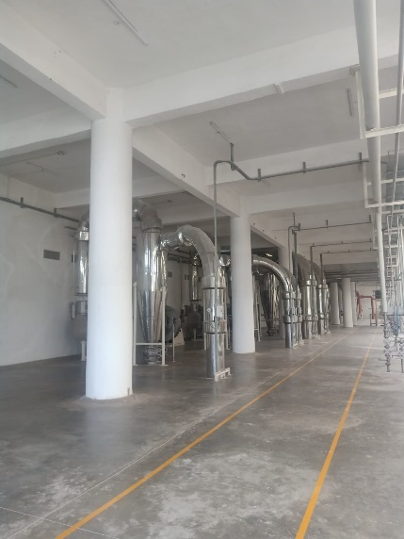
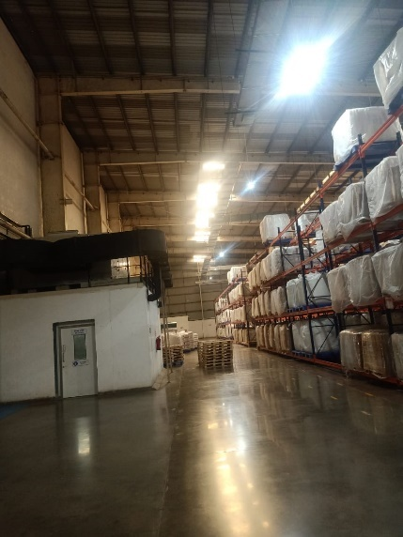
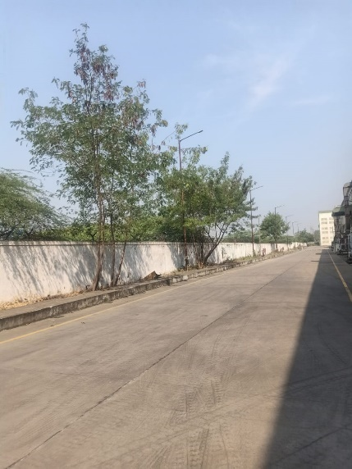

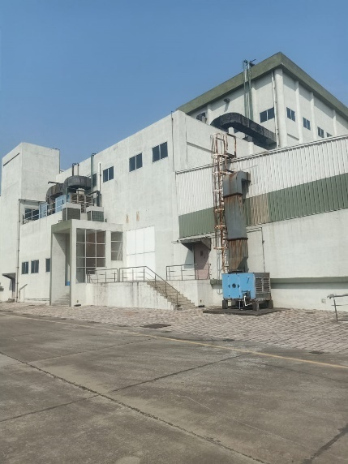
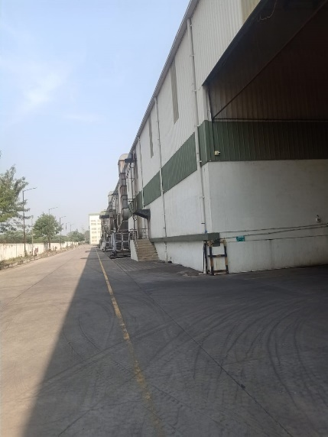
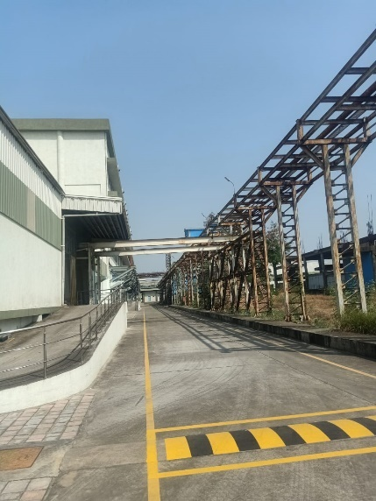

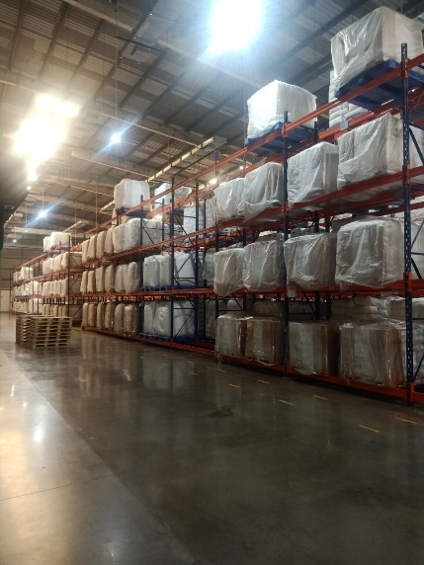
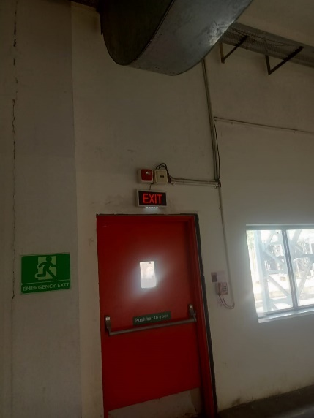
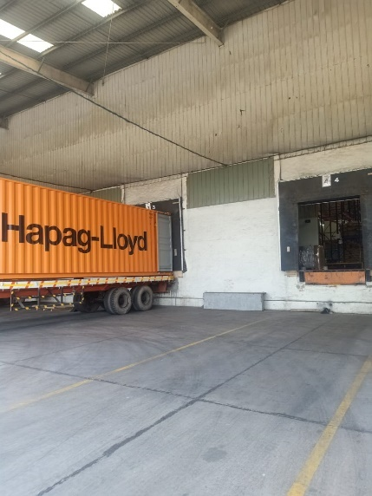

ACTUAL SITE PHOTOGRAPHS
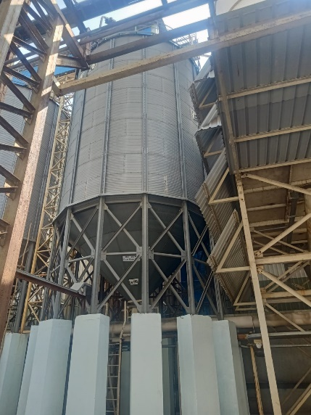
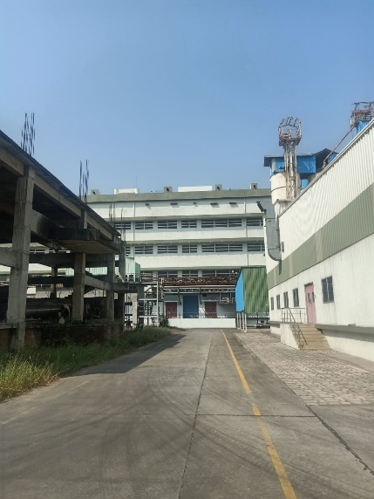
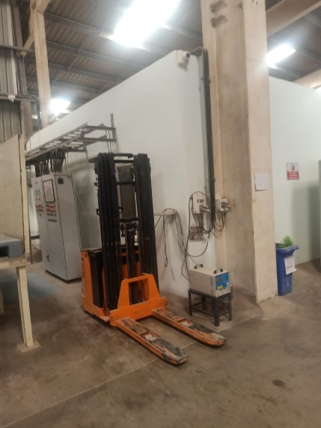

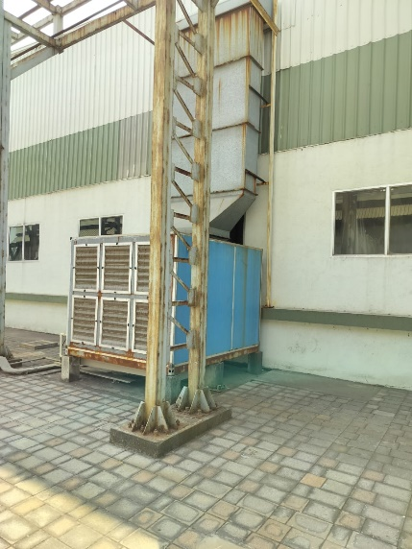
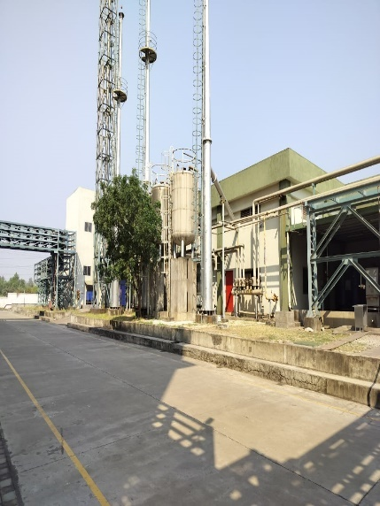
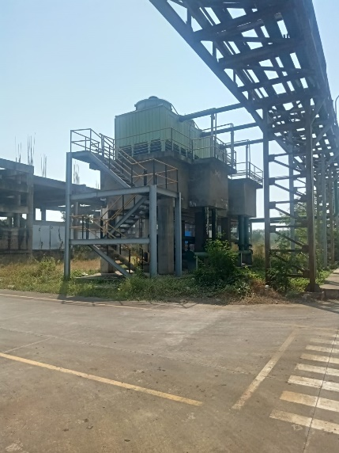

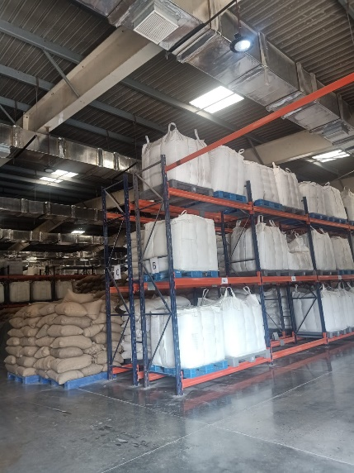
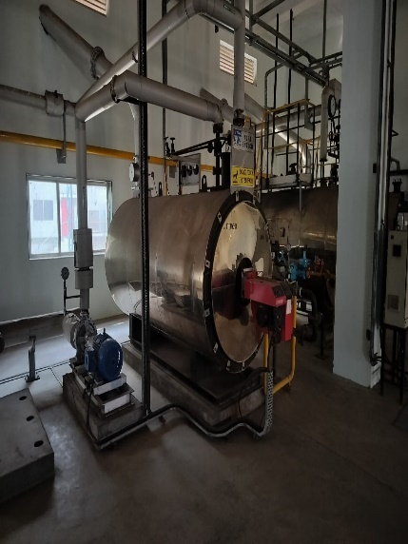
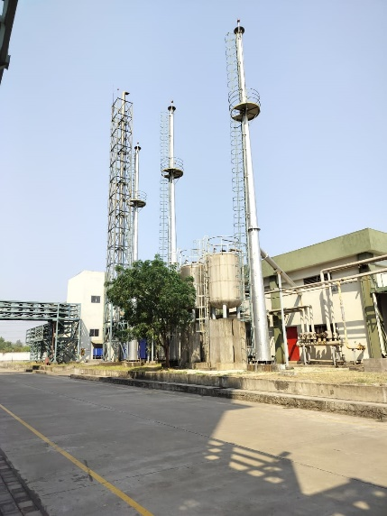

ACTUAL SITE PHOTOGRAPHS
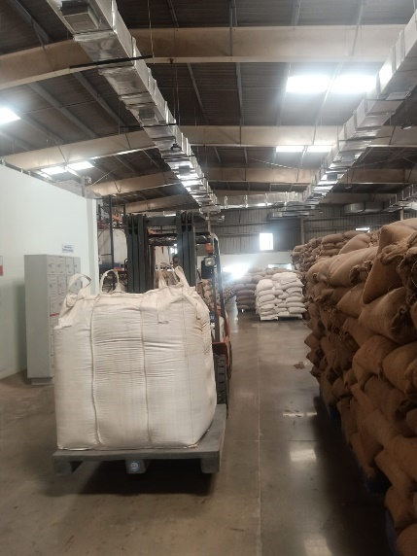
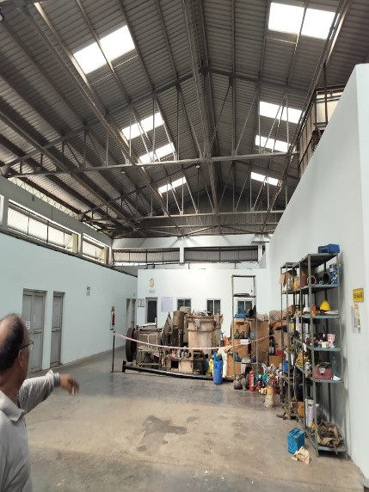
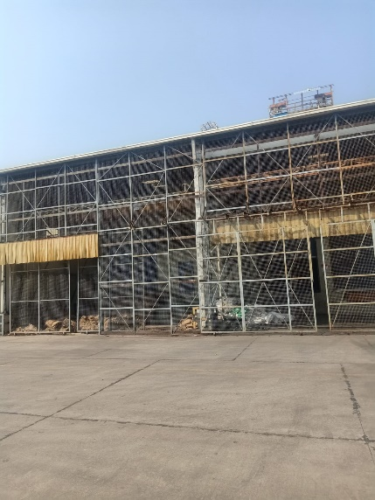

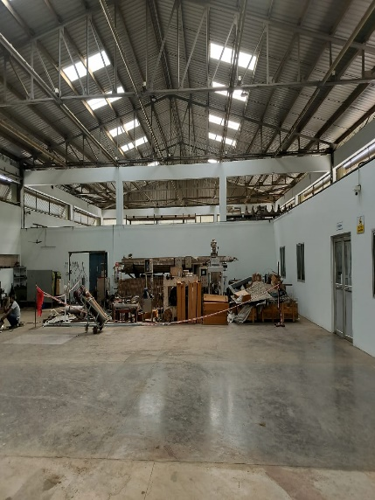
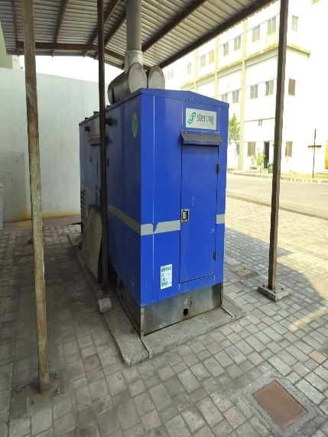
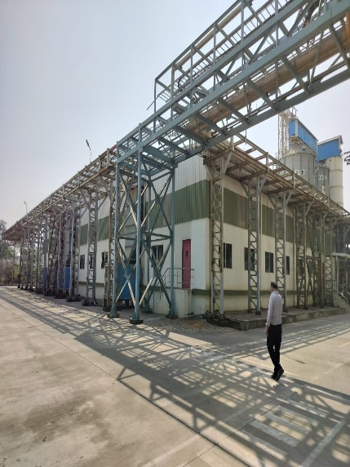

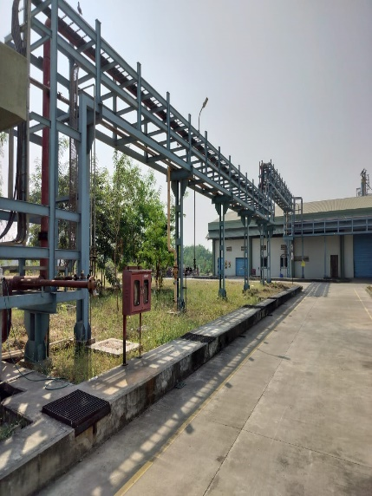
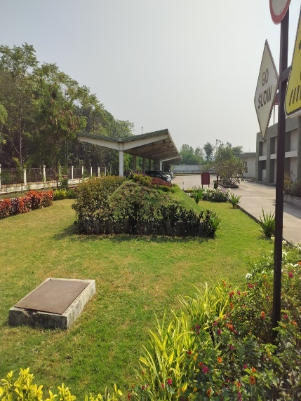
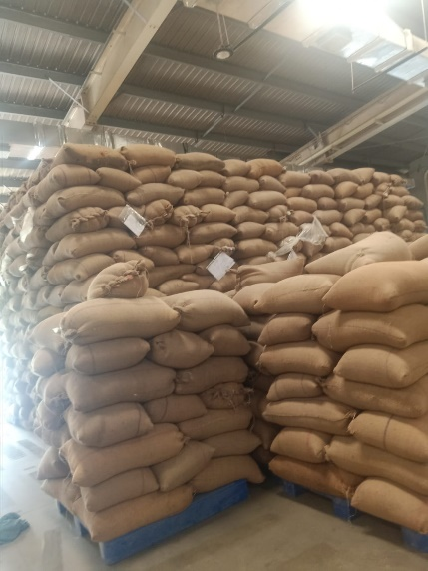

ACTUAL SITE PHOTOGRAPHS
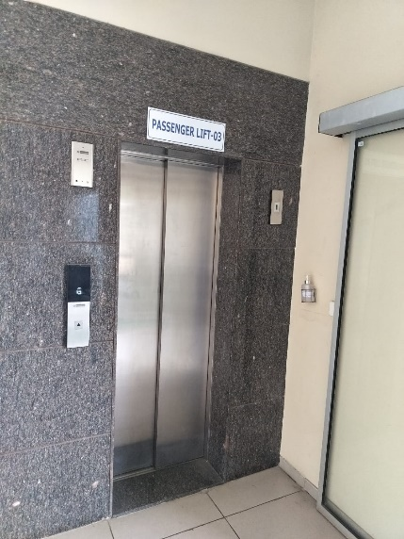
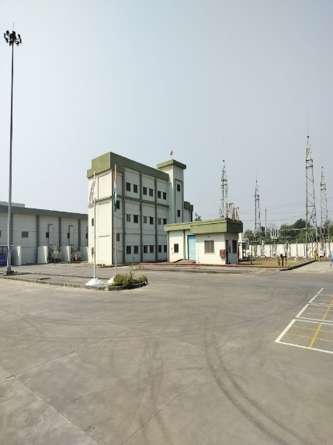
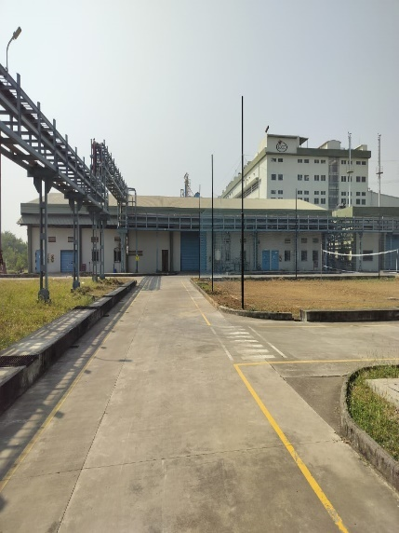

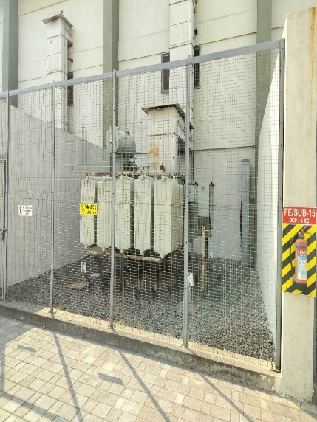
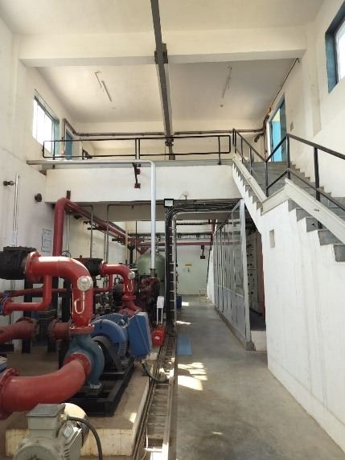
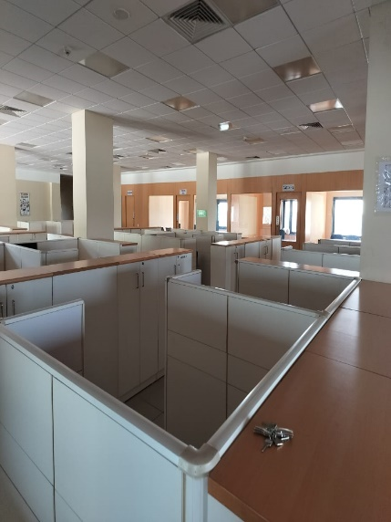

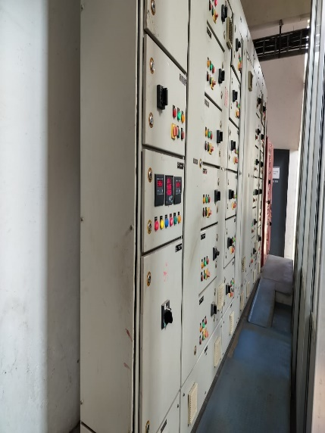
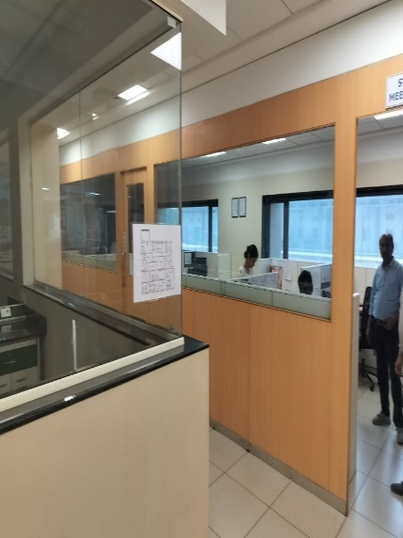
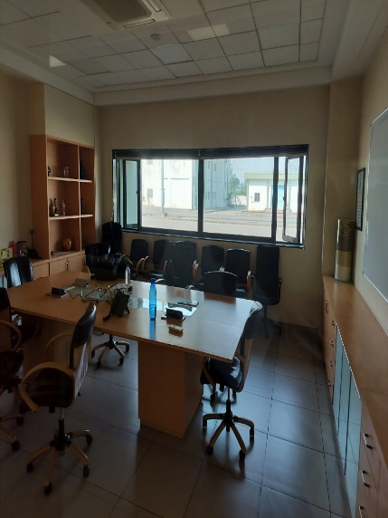

ACTUAL SITE PHOTOGRAPHS
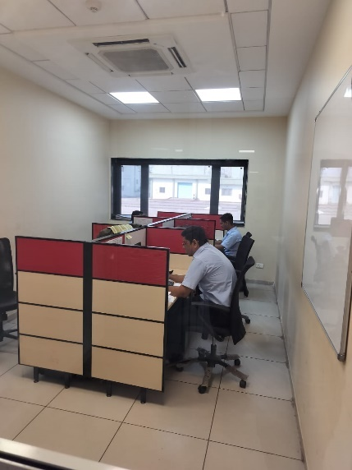
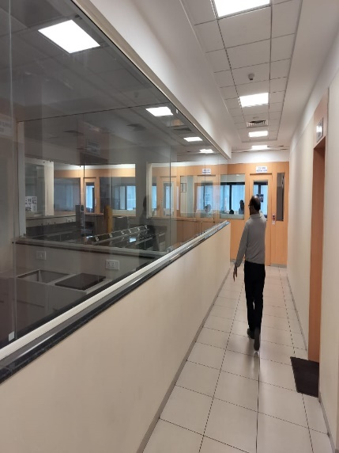
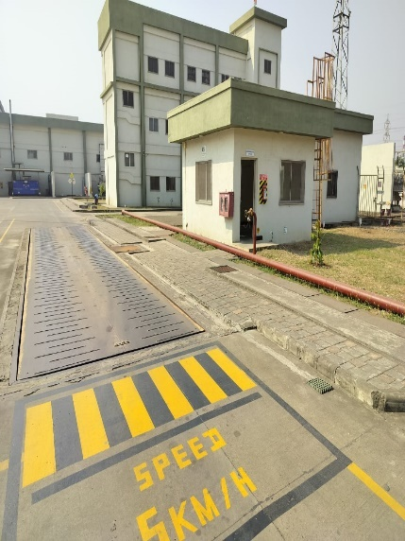

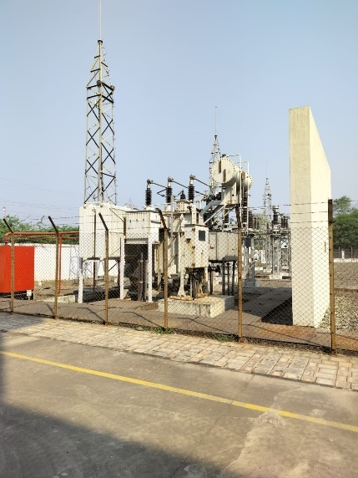
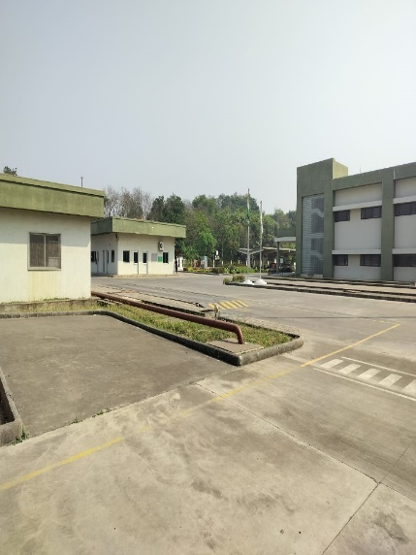
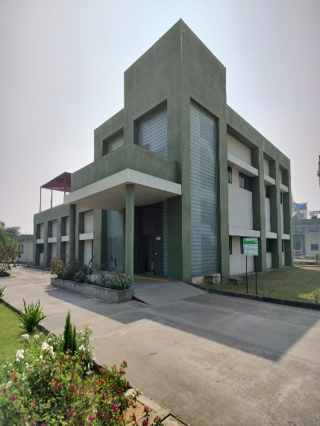

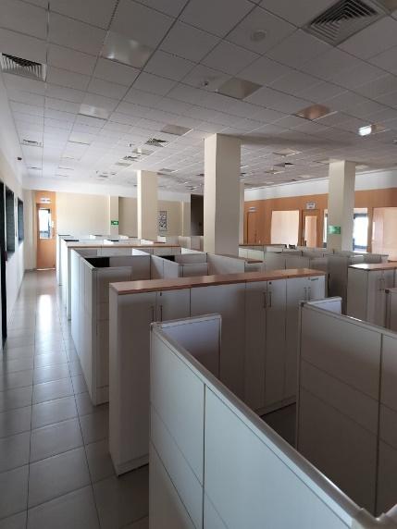
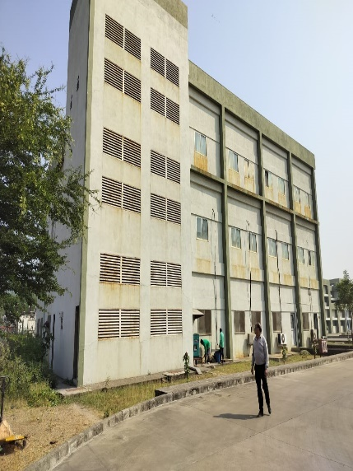
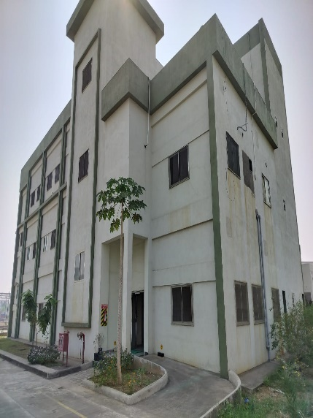

ACTUAL SITE PHOTOGRAPHS

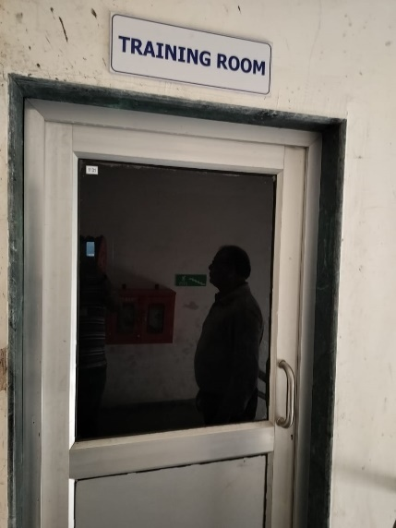
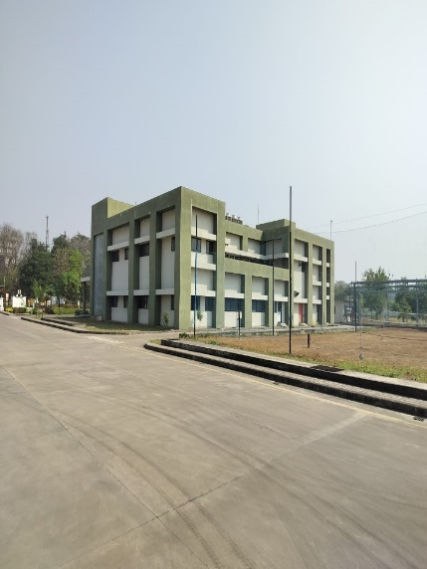
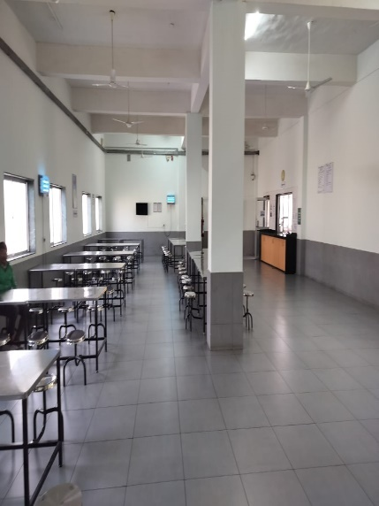

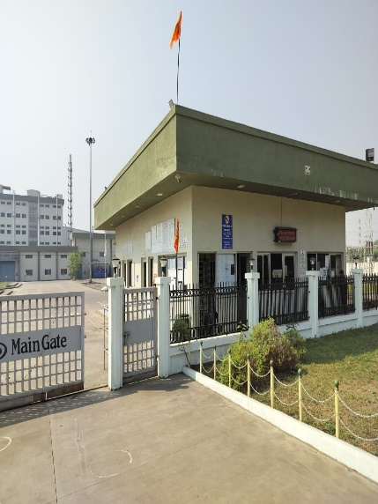
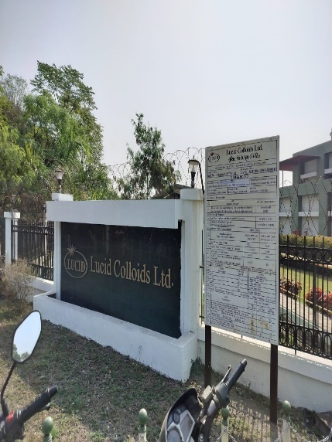
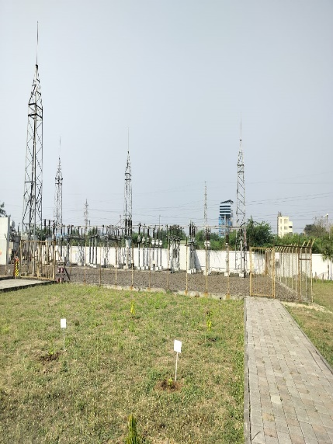

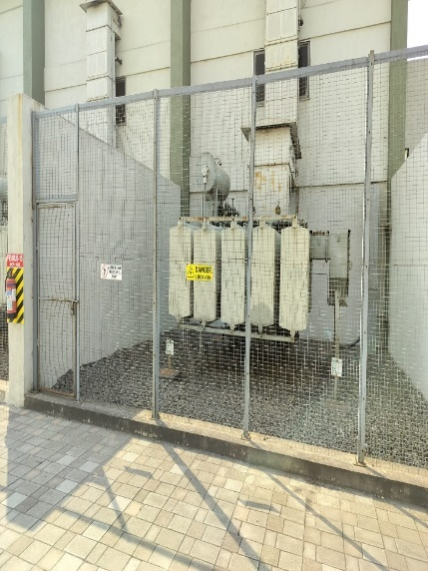

ACTUAL SITE PHOTOGRAPHS
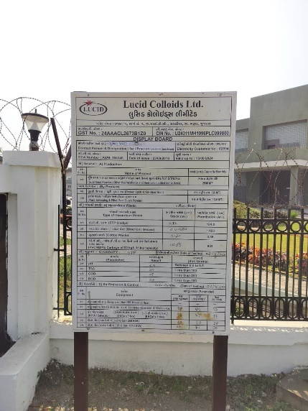
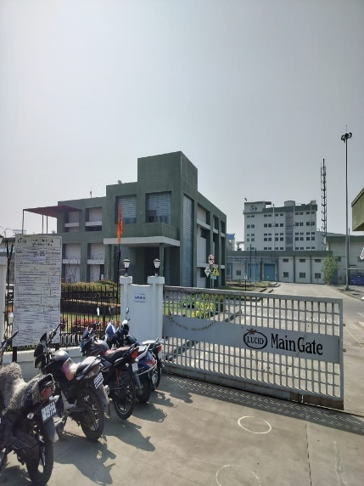

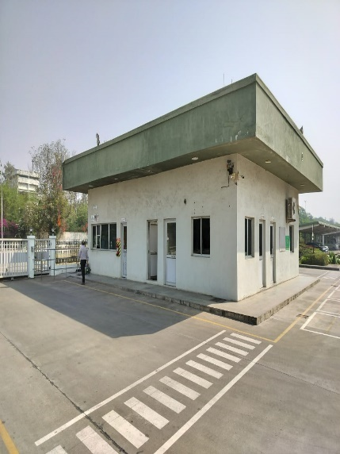
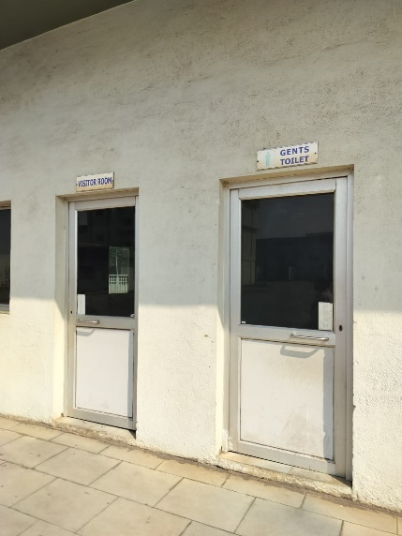

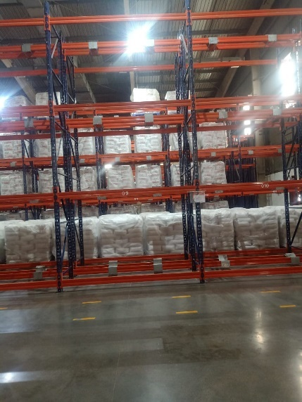
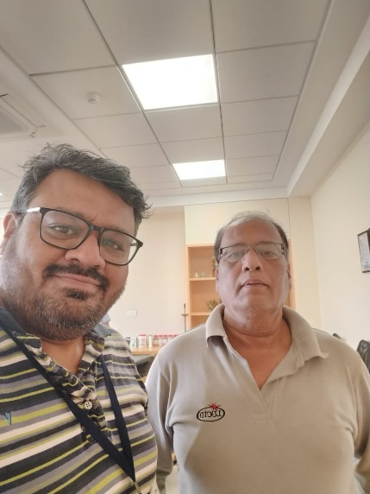
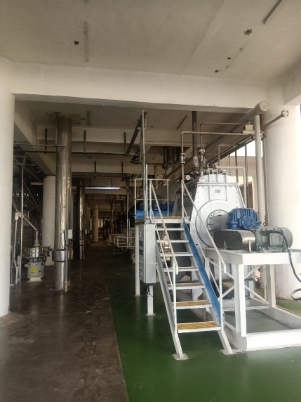

ROUTE MAP OF THE PROPERTY
Site u/r

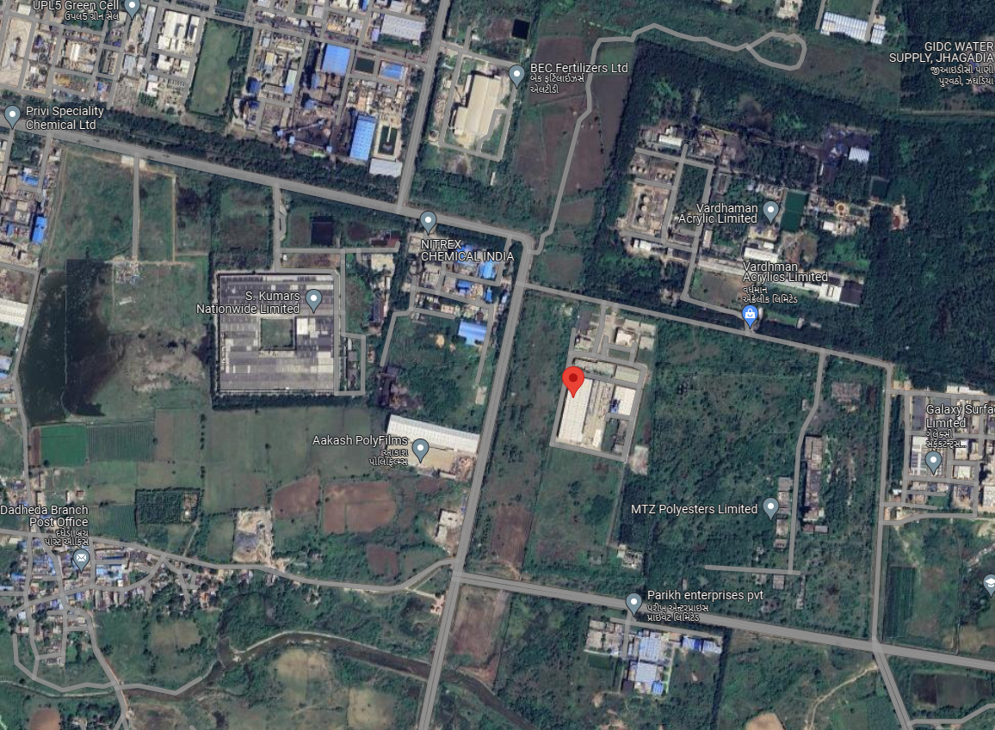
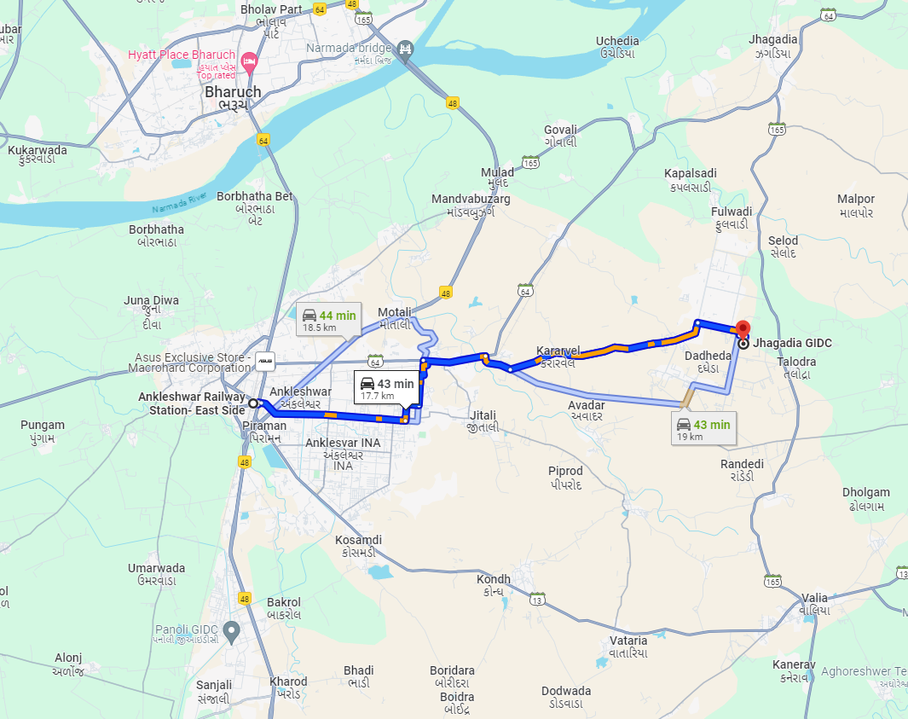
Longitude Latitude: 21°38'25.6"N 73°08'28.1"E
Note: The Blue line shows the route to site from nearest railway station (Ankleshwar –17.7 Km.)

LAND CIRCLE RATE
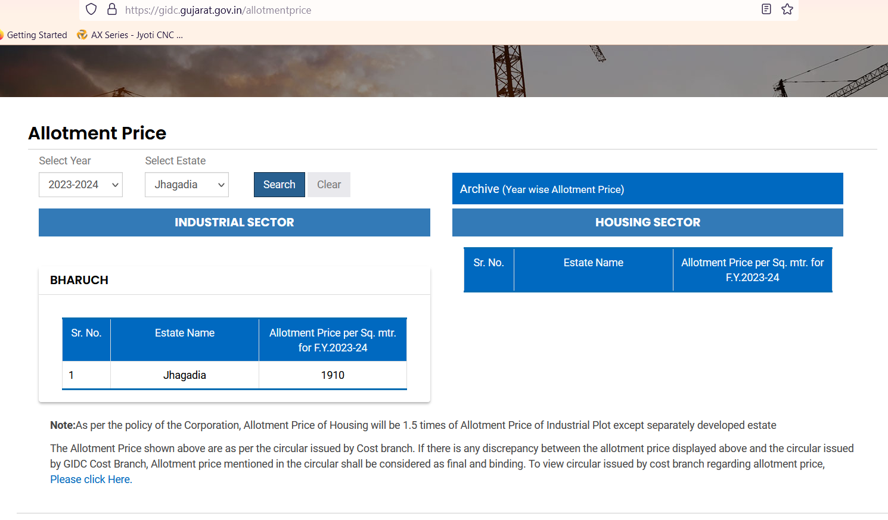

PRICE INDICATORS
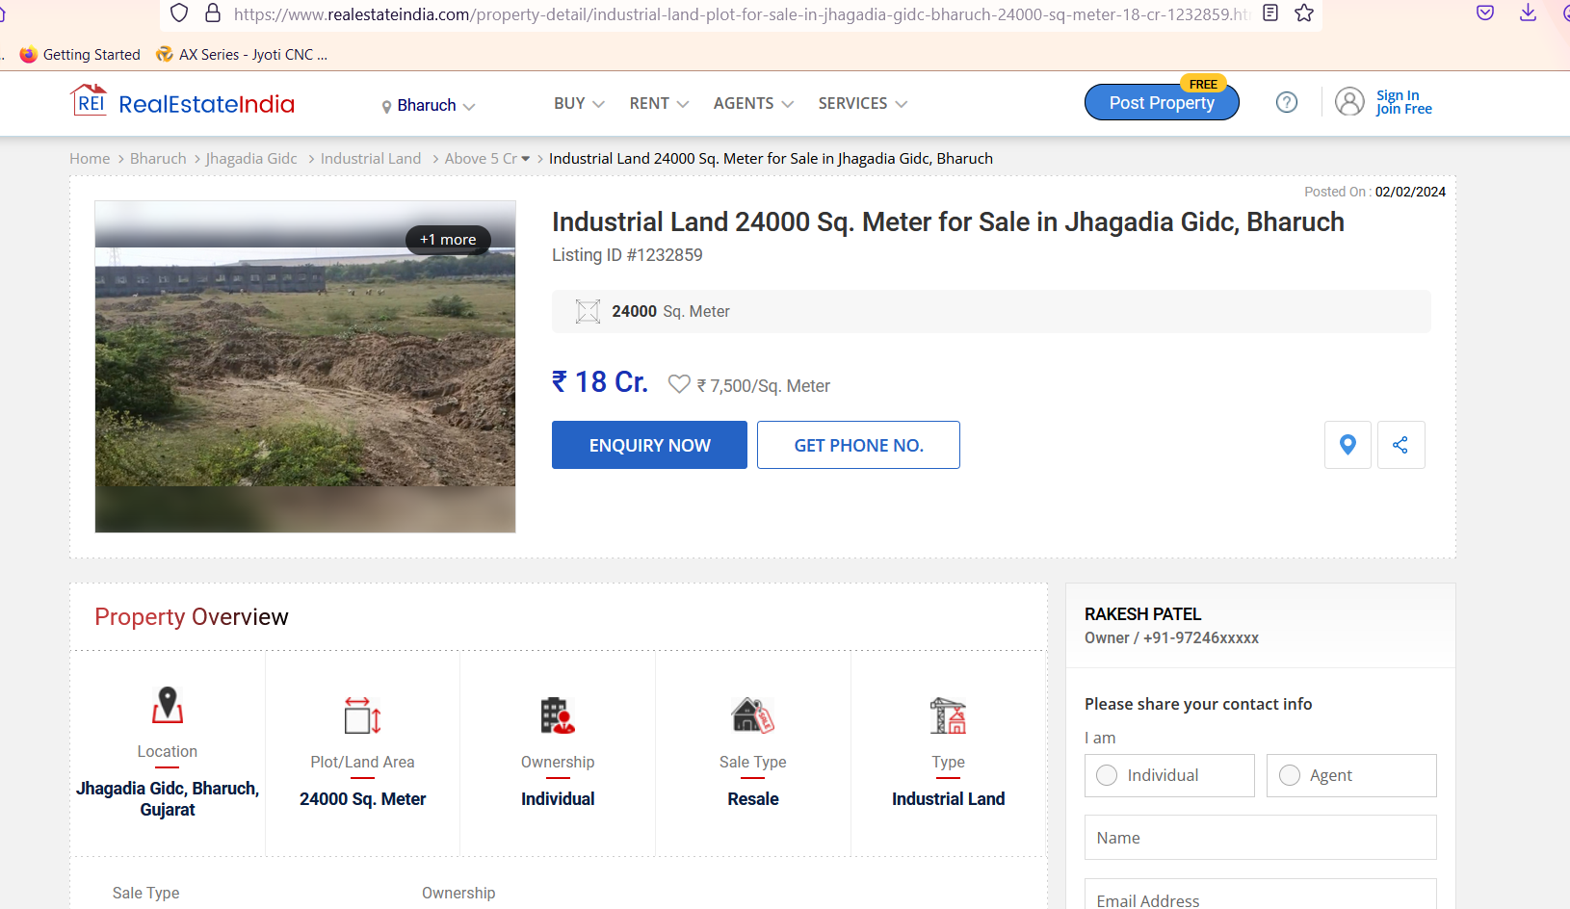

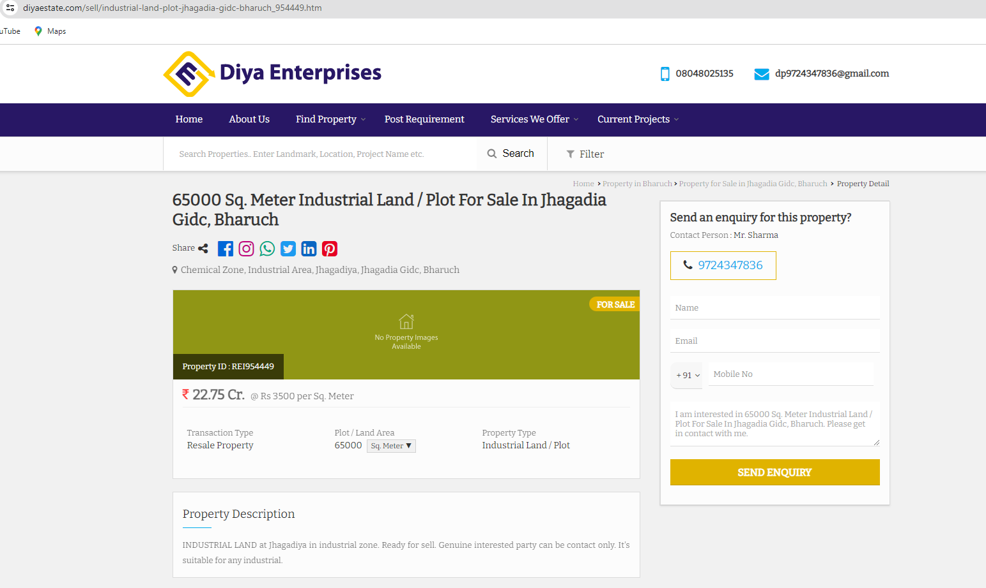

JUSTIFICATION FOR PRICE /RATE

The Market Value of the property is based on facts of markets discovered by us during our enquiries, however the government rate value in this case is less than the market value arrived by us. We are of the opinion that the value arrive by us will prove to be correct if an Auction of the subject property is carried out. As far as Market Value in Index II / Property Documents is concerned, it is not possible to comment on same, may be government rates are fixed by sampling during same point of time in part and whereas, Market values change every month.

In most of the cases the actual deal amount or Transaction value is not reflected in Index II / Property Documents because of various Market practices. As Valuer, we always try to give a value which is correct reflection of actual transaction value irrespective of any factors in market.
We Hope this will satisfy your requirements.

As a result of my appraisal and analysis, it is my considered opinion that the Fair Market Value for this particulars above property in the prevailing condition with aforesaid specification is ₹ 1,48,02,93,244.00/- (Rupees One Hundred Forty Eight Crore Two Lakh Ninety Three Thousand Three Hundred Forty Four Only). The Realizable Value of the above property is ₹ 1,33,22,63,920.00/- (Rupees One Hundred Thirty Three Crore Twenty Two Lakh Sixty Three Thousand Nine Hundred Twenty Only) and The Distress Sale Value ₹ 1,18,42,34,595.00/- (Rupees One Hundred Eighteen Crore Forty Two Lakh Thirty Four Thousand Five Hundred Ninety Five Only). The. Insurable Value (Reinstatement Value of the structure) ₹ 1,02,71,43,838.00/- (Rupees One Hundred Two Crore Seventy One Lakh Forty Three Thousand Eight Hundred Thirty Eight Only).

Place: Mumbai
Date: 01.03.2024

Manoj B Chalikwar
Registered Valuer
Chartered Engineer (India)
Reg. No. IBBI/RV/07/2018/10366
SBI Empanelment No. – SME/TCC/2021-22/86/3

The undersigned has inspected the property detailed in the Valuation Report dated _______________________ on ____________________. We are satisfied that the fair and reasonable market value of the property is `_________________________ (Rupees ______________________________________________________________________________________________only).

Date
Signature
(Name & Designation of the Inspecting Official/s)
Countersigned
(BRANCH MANAGER)
Enclosures
 | Declaration-cum-undertaking from the valuer (Annexure- IV) | Attached
 | Model code of conduct for valuer - (Annexure - V) | Attached
(Annexure-IV)

DECLARATION-CUM-UNDERTAKING

I, Manoj Chalikwar son of Shri. Baburao Chalikwar do hereby solemnly affirm and state that:

- I am a citizen of India.
- I will not undertake valuation of any assets in which I have a direct or indirect interest or become so interested at any time during a period of three years prior to my appointment as valuer or three years after the valuation of assets was conducted by me.
- The information furnished in my valuation report dated 01.03.2024 is true and correct to the best of my knowledge and belief and I have made an impartial and true valuation of the property.
- I/ my authorized representative has personally inspected the property on 16.02.2024. The work is not sub - contracted to any other valuer and carried out by myself.
- Valuation report is submitted in the format as prescribed by the bank.
- I have not been depanelled / delisted by any other bank and in case any such depanelment by other banks during my empanelment with you, I will inform you within 3 days of such depanelment.
- I have not been removed / dismissed from service / employment earlier.
- I have not been convicted of any offence and sentenced to a term of imprisonment
- I have not been found guilty of misconduct in my professional capacity.
- I have not been declared to be unsound mind
- I am not an undischarged bankrupt or has not applied to be adjudicated as a bankrupt.
- I am not an undischarged insolvent.
- I have not been levied a penalty under section 271J of Income-tax Act, 1961 (43 of 1961) and time limit for filing appeal before Commissioner of Income-tax (Appeals) or Income-tax Appellate Tribunal, as the case may has expired, or such penalty has been confirmed by Income-tax Appellate Tribunal, and five years have not elapsed after levy of such penalty
- I have not been convicted of an offence connected with any proceeding under the Income Tax Act 1961, Wealth Tax Act 1957 or Gift Tax Act 1958 and
- My PAN Card number as applicable is AEAPC0117Q
- I undertake to keep you informed of any events or happenings which would make me ineligible for empanelment as a valuer.
- I have not concealed or suppressed any material information, facts and records and I have made a complete and full disclosu
- I have read the Handbook on Policy, Standards and procedure for Real Estate Valuation, 2011 of the IBA and this report is in conformity to the "Standards" enshrined for valuation in the Part - B of the above handbook to the best of my ability.
- I have read the International Valuation Standards (IVS) and the report submitted to the Bank for the respective asset class is in conformity to the "Standards" as enshrined for valuation in the IVS in "General Standards" and "Asset Standards" as applicable. The valuation report is submitted in the prescribed format of the bank.
- I abide by the Model Code of Conduct for empanelment of valuer in the Bank. (Annexure V - A signed copy of same to be taken and kept along with this declaration)
- I am registered under Section 34 AB of the Wealth Tax Act, 1957.
- I am valuer registered with Insolvency & Bankruptcy Board of India (IBBI)
- My CIBIL Score and credit worthiness is as per Bank's guidelines.
- I am Chairman & Managing Director of the company, who is competent to sign this valuation report.
- I will undertake the valuation work on receipt of Letter of Engagement generated from the system (i.e., LLMS / LOS) only.
- Further, I hereby provide the following information.
S. No. | Particulars | Valuer comment
1 | Background information of the asset being valued; | The land along with structure of Plot No. 757-1/1, was leasehold land for the period of 99 years.
2 | Purpose of valuation and appointing authority | As per the request from State Bank of India, SME Ghatkopar Branch to assess Fair Market Value of the property for banking purpose.
3 | Identity of the Valuer and any other experts involved in the valuation; | Manoj B. Chalikwar – Regd. Valuer  Umang Patel – Regd. Valuer  Avinash Pandey –Engineer  Harshad Panchal- Site Engineer
4 | Disclosure of Valuer interest or conflict, if any; | We have no interest, either direct or indirect, in the property valued. Further to state that we do not have relation or any connection with property owner / applicant directly or indirectly. Further to state that we are an independent Valuer and in no way related to property owner / applicant.
5 | Date of appointment, valuation date and date of report; | Date of Appointment – 15.02.2024  Valuation Date – 01.03.2024  Date of Report – 01.03.2024
6 | Inspections and/or investigations undertaken; | Physical Inspection done on date 16.02.2024
7 | Nature and sources of the information used or relied upon; | - Market Survey at the time of site visit  - Ready Reckoner rates / Circle rates  - Online search for Registered Transactions  - Online Price Indicators on real estate portals  - Enquiries with Real estate consultants  - Existing data of Valuation assignments carried out by us
8 | Procedures adopted in carrying out the valuation and valuation standards followed; | Cost Approach (For building construction)  Comparative Sales Method (For Land component)
9 | Restrictions on use of the report, if any; | This valuation is for the use of the party to whom it is addressed and for no other purpose. No responsibility is accepted to any third party who may use or rely on the whole or any part of this valuation. The valuer has no pecuniary interest that would conflict with the proper valuation of the property.
10 | Major factors that were taken into account during the valuation. | Current market conditions, demand and supply position, industrial land size, location, sustained demand for industrial land, all round development of commercial and industrial application in the locality etc.
11 | Caveats, limitations, and disclaimers to the extent they explain or elucidate the limitations faced by valuer, which shall not be for the purpose of limiting his responsibility for the valuation report. | Attached

Date: 01.03.2024
Place: Mumbai

Manoj B Chalikwar
Registered Valuer
Chartered Engineer (India)
Reg. No. IBBI/RV/07/2018/10366
SBI Empanelment No. – SME/TCC/2021-22/86/3

ASSUMPTIONS, DISCLAIMERS, LIMITATIONS & QUALIFICATIONS

Value Subject to Change
The subject appraisal exercise is based on prevailing market dynamics as on 01st March 2024 and does not take into account any unforeseeable developments which could impact the same in the future.
Our Investigations
We are not engaged to carry out all possible investigations in relation to the subject property. Where in our report we identify certain limitations to our investigations, this is to enable the reliant party to instruct further investigations where considered appropriate or where we recommend as necessary prior to reliance. Vastukala Consultants India Pvt. Ltd. (VCIPL) is not liable for any loss occasioned by a decision not to conduct further investigations
Assumptions
Assumptions are a necessary part of undertaking valuations. VCIPL adopts assumptions for the purpose of providing valuation advise because some matters are not capable of accurate calculations or fall outside the scope of our expertise, or out instructions. The reliant party accepts that the valuation contains certain specific assumptions and acknowledge and accept the risk of that if any of the assumptions adopted in the valuation are incorrect, then this may have an effect on the valuation.
Information Supplied by Others
The appraisal is based on the information provided by the client. The same has been assumed to be correct and has been used for appraisal exercise. Where it is stated in the report that another party has supplied information to VCIPL, this information is believed to be reliable but VCIPL can accept no responsibility if this should prove not to be so.
Future Matters
To the extent that the valuation includes any statement as to a future matter, that statement is provided as an estimate and/or opinion based on the information known to VCIPL at the date of this document. VCIPL does not warrant that such statements are accurate or correct.
Map and Plans
Any sketch, plan or map in this report is included to assist the reader while visualizing the property and assume no responsibility in connection with such matters.
Site Details
Based on inputs received from Client's representative and site visit conducted, we understand that the subject property is currently a contiguous and non-agricultural land parcel admeasuring 82,886.58 Sq. M. and structures thereof. The property is owned by M/s. Lucid Colloids Limited. At present, the property is Owner Occupied. Further, VCIPL has assumed that the subject property is free from any encroachment and is available as on the date of the appraisal.

Property Title
Based on our discussion with the Client, we understand that the property is owned by M/s. Lucid Colloids Limited. For the purpose of this appraisal exercise, we have assumed that the subject property has a clear title and is free from any encumbrances, disputes and claims. VCIPL has made no further enquiries with the relevant local authorities in this regard and does not certify the property as having a clear and marketable title. Further, no legal advice regarding the title and ownership of the subject property has been obtained for the purpose of this appraisal exercise. It has been assumed that the title deeds are clear and marketable.
Environmental Conditions
We have assumed that the subject property is not contaminated and is not adversely affected by any existing or proposed environmental law and any processes which are carried out on the property are regulated by environmental legislation and are properly licensed by the appropriate authorities.
Town Planning
The permissible land use, zoning, achievable FSI, area statement adopted for purpose of this valuation is based on the information provided by the Client's representative and the same has been adopted for this valuation purpose. VCIPL has assumed the same to be correct and permissible. VCIPL has not validated the same from any authority.
Area
Based on the documents, we understand that the subject property is contiguous and non-agricultural land parcel admeasuring 82,886.58 Sq. M. and structure thereof.
Condition & Repair
In the absence of any information to the contrary, we have assumed that there are no abnormal ground conditions, nor archaeological remains present which might adversely affect the current or future occupation, development or value of the property. The property is free from rat, infestation, structural or latent defect. No currently known deleterious or hazardous materials or suspect techniques will be used in the construction of or subsequent alteration or additions to the property and comments made in the property details do not purport to express an opinion about, or advise upon, the condition of uninspected parts and should not be taken as making an implied representation or statement about such parts
Valuation Methodology
For the purpose of this valuation exercise, the valuation methodology used is Direct Comparison Approach Method and proposed Highest and Best Use model is used for analysing development potential.
The Direct Comparison Approach involves a comparison of the property being valued to similar properties that have actually been sold in arms - length transactions or are offered for sale. This approach demonstrates what buyers have historically been willing to pay (and sellers willing to accept) for similar properties in an open and competitive market and is particularly useful in estimating the value of the land and properties that are typically traded on a unit basis.
In case of inadequate recent transaction activity in the subject micro-market, the appraiser would collate details of older transactions. Subsequently, the appraiser would analyse rental / capital value trends in the subject micro-market in order to calculate the percentage increase / decrease in values since the date of the identified transactions. This percentage would then be adopted to project the current value of the same.
Where reliance has been placed upon external sources of information in applying the valuation methodologies, unless otherwise specifically instructed by Client and/or stated in the valuation, VCIPL has not independently verified that information and VCIPL does not advise nor accept it as reliable. The person or entity to whom the report is addressed acknowledges and accepts the risk that if any of the unverified information in the valuation is incorrect, then this may have an effect on the valuation.
Not a Structural Survey
We state that this is a valuation report and not a structural survey
Other
All measurements, areas and ages quoted in our report are approximate
Legal
We have not made any allowances with respect to any existing or proposed local legislation relating to taxation on realization of the sale value of the subject property. VCIPL is not required to give testimony or to appear in court by reason of this appraisal report, with reference to the property in question, unless arrangement has been made thereof. Further, no legal advice on any aspects has been obtained for the purpose of this appraisal exercise
Property specific assumptions
Based on inputs received from the client and site visit conducted, we understand that the subject property is currently vacant and Bank Possession, contiguous and non-agricultural land parcel admeasuring 82,886.58 Sq. M. and structure thereof.

ASSUMPTIONS, CAVEATS, LIMITATION AND DISCLAIMERS
- We assume no responsibility for matters of legal nature affecting the property appraised or the title thereto, nor do we render our opinion as to the title, which is assumed to be good and marketable.
- The property is valued as though under responsible ownership.
- It is assumed that the property is free of liens and encumbrances.
- It is assumed that there are no hidden or unapparent conditions of the subsoil or structure that would render it more or less valuable. No responsibility is assumed for such conditions or for engineering that might be required to discover such factors.
- There is no direct/ indirect interest in the property valued.
- The rates for valuation of the property are in accordance with the Govt. approved rates and prevailing market rates

(Annexure - V)

MODEL CODE OF CONDUCT FOR VALUERS

Integrity and Fairness
- A valuer shall, in the conduct of his/its business, follow high standards of integrity and fairness in all his/its dealings with his/its clients and other valuers.
- A valuer shall maintain integrity by being honest, straightforward, and forthright in all professional relationships.
- A valuer shall endeavour to ensure that he/it provides true and adequate information and shall not misrepresent any facts or situations.
- A valuer shall refrain from being involved in any action that would bring disrepute to the profession.
- A valuer shall keep public interest foremost while delivering his services.
Professional Competence and Due Care
- A valuer shall render at all times high standards of service, exercise due diligence, ensure proper care and exercise independent professional judgment.
- A valuer shall carry out professional services in accordance with the relevant technical and professional standards that may be specified from time to time.
- A valuer shall continuously maintain professional knowledge and skill to provide competent professional service based on up-to-date developments in practice, prevailing regulations / guidelines and techniques.
- In the preparation of a valuation report, the valuer shall not disclaim liability for his/its expertise or deny his/its duty of care, except to the extent that the assumptions are based on statements of fact provided by the company or its auditors or consultants or information available in public domain and not generated by the valuer.
- A valuer shall not carry out any instruction of the client insofar as they are incompatible with the requirements of integrity, objectivity and independence.
- A valuer shall clearly state to his client the services that he would be competent to provide and the services for which he would be relying on other valuers or professionals or for which the client can have a separate arrangement with other valuers.
Independence and Disclosure of Interest
- A valuer shall act with objectivity in his/its professional dealings by ensuring that his/its decisions are made without the presence of any bias, conflict of interest, coercion, or undue influence of any party, whether directly connected to the valuation assignment or not.
- A valuer shall not take up an assignment if he/it or any of his/its relatives or associates is not independent in terms of association to the company.
- A valuer shall maintain complete independence in his/its professional relationships and shall conduct the valuation independent of external influences.
- A valuer shall wherever necessary disclose to the clients, possible sources of conflicts of duties and interests, while providing unbiased services.
- A valuer shall not deal in securities of any subject company after any time when he/it first becomes aware of the possibility of his / its association with the valuation, and in accordance with the Securities and Exchange Board of India (Prohibition of Insider Trading)Regulations,2015 or till the time the valuation report becomes public, whichever is earlier.
- A valuer shall not indulge in "mandate snatching" or offering "convenience valuations" in order to cater to a company or client's needs.
- As an independent valuer, the valuer shall not charge success fee.
- In any fairness opinion or independent expert opinion submitted by a valuer, if there has been a prior engagement in an unconnected transaction, the valuer shall declare the association with the company during the last five years.
Confidentiality
- A valuer shall not use or divulge to other clients or any other party any confidential information about the subject company, which has come to his / its knowledge without proper and specific authority or unless there is a legal or professional right or duty to disclose.
Information Management
- A valuer shall ensure that he/ it maintains written contemporaneous records for any decision taken, the reasons for taking the decision, and the information and evidence in support of such decision. This shall be maintained so as to sufficiently enable a reasonable person to take a view on the appropriateness of his /its decisions and actions.
- A valuer shall appear, co-operate and be available for inspections and investigations carried out by the authority, any person authorised by the authority, the registered valuers organisation with which he/it is registered or any other statutory regulatory body.
- A valuer shall provide all information and records as may be required by the authority, the Tribunal, Appellate Tribunal, the registered valuers organisation with which he/it is registered, or any other statutory regulatory body.
- A valuer while respecting the confidentiality of information acquired during the course of performing professional services, shall maintain proper working papers for a period of three years or such longer period as required in its contract for a specific valuation, for production before a regulatory authority or for a peer review. In the event of a pending case before the Tribunal or Appellate Tribunal, the record shall be maintained till the disposal of the case.
Gifts and hospitality:
- A valuer or his / its relative shall not accept gifts or hospitality which undermines or affects his independence as a valuer.
- Explanation: For the purposes of this code the term 'relative' shall have the same meaning as defined in clause (77) of Section 2 of the Companies Act, 2013 (18 of 2013).
- A valuer shall not offer gifts or hospitality or a financial or any other advantage to a public servant or any other person with a view to obtain or retain work for himself / itself, or to obtain or retain an advantage in the conduct of profession for himself / itself.
Remuneration and Costs.
- A valuer shall provide services for remuneration which is charged in a transparent manner, is a reasonable reflection of the work necessarily and properly undertaken, and is not inconsistent with the applicable rules.
- A valuer shall not accept any fees or charges other than those which are disclosed in a written contract with the person to whom he would be rendering service.
Occupation, employability and restrictions.
- A valuer shall refrain from accepting too many assignments, if he/it is unlikely to be able to devote adequate time to each of his/ its assignments.
- A valuer shall not conduct business which in the opinion of the authority or the registered valuer organisation discredits the profession.
Miscellaneous
- A valuer shall refrain from undertaking to review the work of another valuer of the same client except under written orders from the bank or housing finance institutions and with knowledge of the concerned valuer.
- A valuer shall follow this code as amended or revised from time to time.

DEFINITION OF VALUE FOR THIS SPECIFIC PURPOSE

This exercise is to assess Fair Market Value of the property under reference as on 01st March 2024.
The term Fair Market Value is defined as
“The most probable price, as of a specified date, in cash, terms equivalent to cash, or in other precisely revealed terms for which the specified property rights would sell after reasonable exposure in a competitive market under all conditions requisite to a fair sale, with the buyer and seller each acting prudently knowledgeably and for self-interest assuming that neither is under undue duress”.
Fundamental assumptions and conditions presumed in this definition are:
1. Buyer and seller are motivated by self-interest.
2. Buyer and seller are well informed and are acting prudently.
3. The property is exposed for a reasonable time on the open market.
4. Payment is made in cash or equivalent or in specified financing terms.
DECLARATION OF PROFESSIONAL FEES CHARGED

We hereby declare that, our professional fees are not contingent upon the valuation findings. However, if the statute AND/OR clients demands that, the fees should be charged on the percentage of assessed value then, with the full knowledge of the AND/OR end user, it is being charged accordingly.

VALUATION OF THE PROPERTY PREMISES

Considering various parameters recorded, existing economic scenario, and the information that is available with reference to the development of neighbourhood and method selected for valuation, we are of the opinion that, the property premises can be assessed and Fair Market Value for this particular purpose at
Particulars | Fair Market Value (`) | Realizable Value (`) | Distress Sale Value (`) | Insurable Value  (`)
Land and Building | 1,48,02,93,244 | 1,33,22,63,920 | 1,18,42,34,595 | 1,02,71,43,838

Manoj B Chalikwar
Registered Valuer
Chartered Engineer (India)
Reg. No. IBBI/RV/07/2018/10366
SBI Empanelment No. – SME/TCC/2021-22/86/3

