Vastu/Nashik/02/2024/006724/2304806
03/2-28-RPBS
Date: 03.02.2024

To, `
The Branch Manager,
Bank of Baroda
Regional Office Nashik Road Branch
BSNL Building, Datta Mandir Road, Nashik Road,
Nashik -422 101, State - Maharashtra, Country - India.

Sub: Vetting of Extra Amenities

Sir,

With reference to above subject, we have evaluated the Extra Amenities for Residential Flat No.7, Seventh Floor, "Mansion", Survey No.233/D/91+92, Plot No.91 & 92, Near Kala Nagar Garden, Kala Nagar, Village – Mhasrul, Taluka- Nashik, District - Nashik, PIN Code – 422 004, State – Maharashtra, Country – India belongs to Sunita Kautik Patil Alias Sau. Sunita Ravindra Patil & Shri. Ravindra Yadavrao Patil

We have verified the rates quoted as per current market rates. Details of work and Extra Amenities considered as per copy of Agreement for Extra Amenities Agreement Between Sau. Sunita Kautik Patil & Shri. Ravindra Yadavrao Patil (First Party) and Shri.Rishikesh Jivan Badgujar. (Second Party) received on dated 02.02.2024. The Extra Amenities amount is Rs.15,00,000/- (Rupees Fifteen Lakh Only)

The said Cost Vetting Certificate is valid upto next 6 months Only.

Thanking you

Sincerely yours

Manoj B. Chalikwar
Registered Valuer
Chartered Engineer (India)
Reg. No. CAT-I-F-1763
Reg. No. IBBI/RV/07/2018/10366
BOB Empanelment No.: ZO:MZ:ADV:46:941
Encl: Valuation report.

Agreement for Extra Amenities
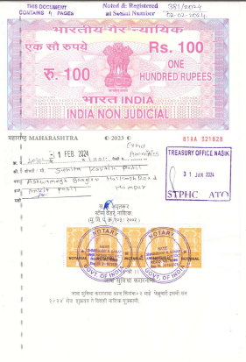


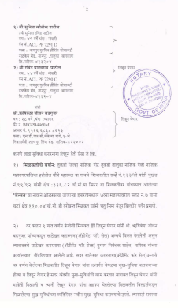
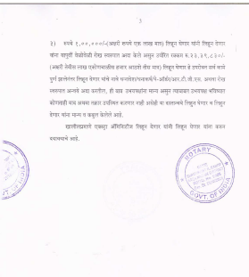

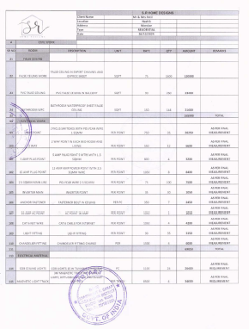
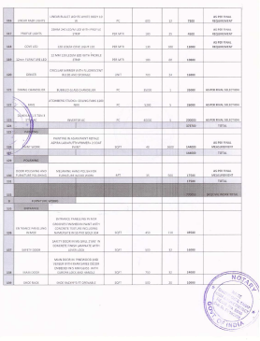

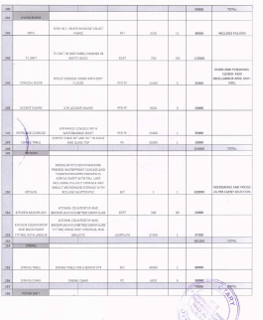
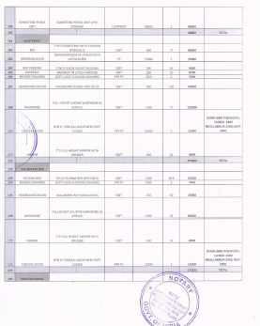

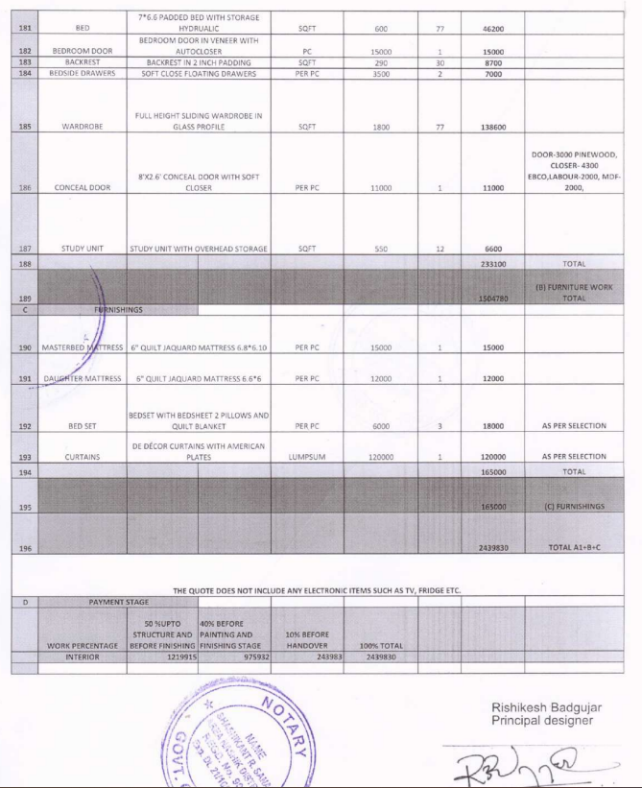

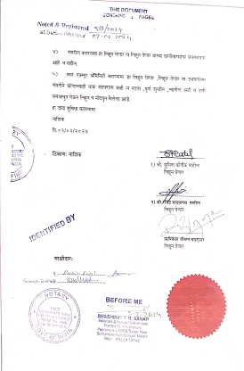

The Extra Amenities amount is Rs.15,00,000/- (Rupees Fifteen Lakh Only)

