Vastu/Nashik/02/2024/006694/2304796
02/4-18-RPBS
Date: 02.02.2024

To, `
The Branch Manager,
Bank of Baroda
Regional Office Nashik Road Branch
BSNL Building, Datta Mandir Road, Nashik Road,
Nashik -422 101, State - Maharashtra, Country - India.

Sub: Vetting of Home Renovation Agreement

Sir,

With reference to above subject, we have evaluated the Home Renovation for Residential Flat No.7, First Floor, "Khatod Park Co. Op. Hsg. Society Ltd. Nashik", Survey No.91/1/4, Plot No.3, Near Tupe Motor Driving School, Madhuban Colony , Makhmalabad Road , Village – Nashik, Taluka & District - Nashik, PIN Code – 422 003, State – Maharashtra, Country – India belongs to Shri. Balkrushna Subhash Ranmale

We have verified the rates quoted as per current market rates. Details of work and Home Renovation considered as per copy of Agreement for Home Renovation issued by Shri. Balkrushna Subhash Ranmale. (First Party) and Shri. Durgesh Dattatray Bhadange. (Second Party) received on dated 25.01.2024. The Home Renovation amount is Rs.5,30,000/- (Rupees Five Lakh Thirty Thousand Only)

The said Cost Vetting Certificate is valid upto next 6 months Only.

Thanking you

Sincerely yours

Manoj B. Chalikwar
Registered Valuer
Chartered Engineer (India)
Reg. No. CAT-I-F-1763
Reg. No. IBBI/RV/07/2018/10366
BOB Empanelment No.: ZO:MZ:ADV:46:941
Encl: Valuation report.

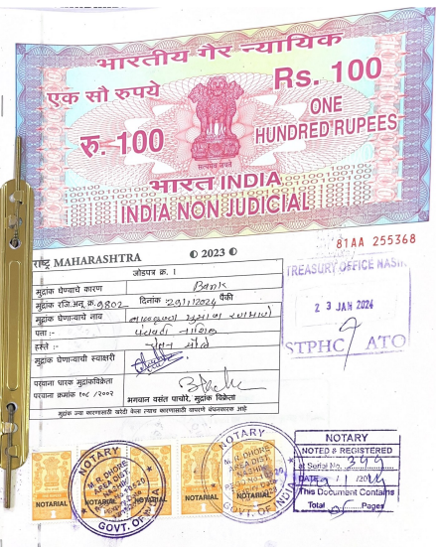
Home Renovation Agreement
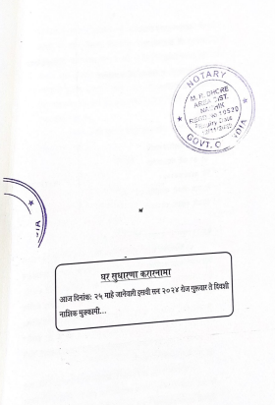

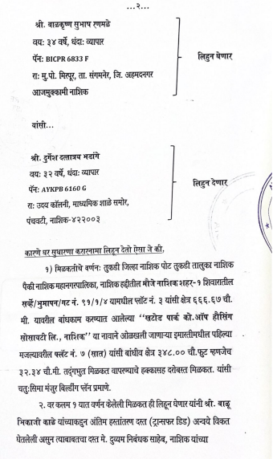

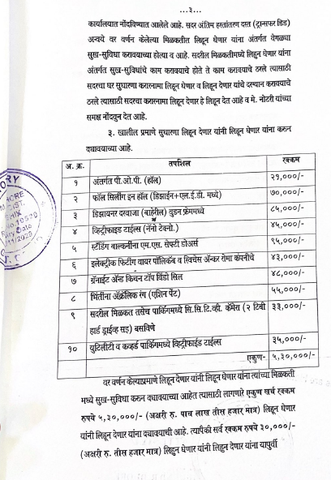
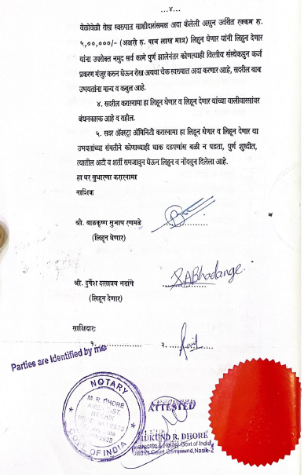

The Extra Amenities amount is Rs. 5,30,000/- (Rupees Five Lakh Thirty Thousand Only)

