# Valuation Report of the Immovable Property

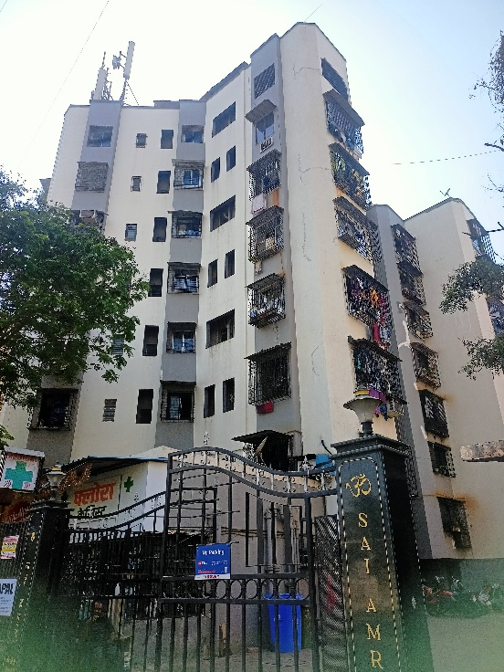

**Details of the property under consideration:**

Name of Owner: **Mr. Nirav Himatlal Shah**

Residential Flat No. 706, 7th Floor, A Wing, **“Sai Amrut Co-op. Hsg. Soc. Ltd.”,** Jaywant Sawant Road,

Dahisar (West), Mumbai – 400068, State – Maharashtra, Country – India.

# Latitude Longitude - 19°14’25.6”N 72°51’29.7”E

**Valuation Done for:**

**The Zoroastrian Co-operative Bank Ltd.**

**Borivali (West) Branch**

Shop No. 8/10, Dattani Trade Centre, Chandvkar Road, Borivali (West), Mumbai - 400 092,

State – Maharashtra, Country – India.

Vastu/Mumbai/02/2024/6013/2304388

06/22-90-SKVS

Date: 03.02.2024

**VALUATION OPINION REPORT**

This is to certify that the property bearing Residential Flat No. 706, 7th Floor, A Wing, **“Sai Amrut Co-op. Hsg. Soc. Ltd.”,** Jaywant Sawant Road, Dahisar (West), Mumbai – 400068, State – Maharashtra, Country – India belongs to **Mr. Nirav Himatlal Shah.**

|  |  |
| --- | --- |
| Boundaries of the property. | |
| North | Building No. 1B |
| South | Internal Road & Rustomjee International School |
| East | Jaywant Sawant Road |
| West | Happy Home CHSL |

Considering various parameters recorded, existing economic scenario, and the information that is available with reference to the development of neighbourhood and method selected for valuation, we are of the opinion that, the property premises can be assessed and **Fair Market Value** for this particular purpose at **` 1,08,65,000.00 (Rupees One Crore Eight Lakh Sixty Five Thousand Only).**

The valuation of the property is based on the documents produced by the concern. Legal aspects have not been taken into considerations while preparing this report.

Hence certified

**Manoj B. Chalikwar**

Registered Valuer

Chartered Engineer (India)

Reg. No. CAT-I-F-1763

TZCBL Emp. No. Ref: ZCBL/CO/AUD/19-20/100

Encl.: Valuation report

**VALUATION REPORT IN RESPECT OF IMMOVABLE PROPERTY**

|  |  |  |  |  |  |  |  |  |  |
| --- | --- | --- | --- | --- | --- | --- | --- | --- | --- |
| 1 | Date of Inspection | : | 02.02.2024 | | | | | | |
| 2 | Purpose of valuation | : | As per request from The Zoroastrian Co-operative Bank Ltd, Borivali (West) Branch, Fair Market Value of the property under reference for Bank Loan Purpose | | | | | | |
| 3 | Name and address of the Valuer | : | **Manoj B. Chalikwar**  **Vastukala Consultants (I) Pvt. Ltd.**  B1-001, U/B Floor, Boomerang, Chandivali Farm Road, Powai, Andheri (East), Mumbai – 400 072. | | | | | | |
| 4 | **List of Documents Handed Over to The Valuer by The Bank**   1. Copy of Gift Deed dated 08.03.2018 between Mr. Himatlal Manilal Shah (the Donor) AND Mr. Nirav Himatlal Shah (the Donee). 2. Copy of Agreement for Sale dated 28.09.1999 between Shri. Shakti Natvarlal Darji & Smt. Ina Shakti Darji (the Vendors) AND Mr. Himatlal Manilal Shah (the Purchaser). | | | | | | | | |
| 5 | Details of enquiries made/ visited to government Office for arriving fair market value. | : | Market analysis and as per sub-registrar value. | | | | | | |
| 6 | Factors for determining its market value. | : | Location, development of surrounding area, type of construction, construction specifications, age of building, condition of the premises & building, facilities provided and its prevailing market rate. | | | | | | |
| 7 | ANY CRITICAL ASPECTS ASSOCIATED WITH PROPERTY | : | No | | | | | | |
| 8 | Present/Expected Income from the property | : | ` 23,000.00 Expected rental income per month | | | | | | |
|  | **Property Details** | : |  | | | | | | |
| 9 | Name(s) of the Owner and Postal address of the property under consideration. | : | **Mr. Nirav Himatlal Shah** | | | | | | |
|  |  | : | **Address:** Residential Flat No. 706, 7th Floor, A Wing, **“Sai Amrut Co-op. Hsg. Soc. Ltd.”,** Jaywant Sawant Road, Dahisar (West), Mumbai – 400068, State – Maharashtra, Country – India.  **Contact Person:**  Mrs. Priya Nirav Shah (Owner’s Wife)  Contact No. 9833185272 | | | | | | |
| 10 | If the property is under joint ownership/ co-ownership share of each such owner/ are the share is undivided. | : | Sole Ownership | | | | | | |
| 11 | Brief description of the property. | : | The Residential Flat is situated on 7th Floor. The composition of residential flat consists of 1 Bedroom + Living Room + Kitchen + 2 Toilets (**i.e. 2 BHK Flat)**. The property is at 1.2 Km. walkable distance from nearest railway station Borivali. | | | | | | |
| 12 | Location of the property (C.T.S. No., Survey No., Hissa No., Plot No., etc.). | : | C.T.S. No. 925 & 926 of Village – Dahisar | | | | | | |
| 13 | **Boundaries** | : | **As per Site** | | | | **As per Documents** | | |
|  | North | : | Building No. 1B | | | | Details not available | | |
|  | South | : | Internal Road & Rustomjee International School | | | | Details not available | | |
|  | East | : | Jaywant Sawant Road | | | | Details not available | | |
|  | West | : | Happy Home CHSL | | | | Details not available | | |
| 14 | Matching of Boundaries | : | N.A. | | | | | | |
| 15 | Route map | : | Enclosed | | | | | | |
| 16 | Any specific identification marks | : | Near Rustomjee International School | | | | | | |
| 17 | Whether covered under Corporation/ Panchayat/ Municipality. | : | Municipal Corporation of Greater Mumbai | | | | | | |
| 18 | Whether covered under any land ceiling of State/ Central Government. | : | No | | | | | | |
| 19 | Is the land freehold/ leasehold? | : | Freehold | | | | | | |
| 20 | Are there any restrictive covenants in regard to use of Land? If so, attach a copy of the covenant. | : | As per Agreement | | | | | | |
| 21 | Type of the property | : | Residential | | | | | | |
| 22 | Year of acquisition/ purchase. | : | 28.09.1999 | | | | | | |
| 23 | Purchase value as per document | : | ` 6,40,000.00 | | | | | | |
| 24 | Whether the property is occupied by owner or tenant. If occupied by tenant since how long he is staying and the amount of rent being paid. | : | Owner Occupied | | | | | | |
| 25 | Classification of the site | : |  | | | | | | |
|  | 1. Population group | : | Urban | | | | | | |
|  | 1. High/ Middle/ Poor class | : | Middle Class | | | | | | |
|  | 1. Residential/ Non-Residential | : | Residential | | | | | | |
|  | 1. Development of surrounding area | : | Developed Area | | | | | | |
|  | 1. Possibility of any threat to the property (Floods, calamities etc.). | : | No | | | | | | |
| 26 | Proximity of civic amenities (like school, hospital, bus stop, market etc.). | : | All Available near by | | | | | | |
| 27 | Level of the land (Plain, rock etc.) | : | Plain | | | | | | |
| 28 | Terrain of the Land. | : | Levelled | | | | | | |
| 29 | Shape of the land (Square/ rectangle etc.). | : | Rectangular | | | | | | |
| 30 | Type of use to which it can be put (for construction of house, factory etc.). | : | Residential purpose | | | | | | |
| 31 | Whether the plot is under town planning approved layout? | : | Information not Available | | | | | | |
| 32 | Whether the building is intermittent or corner? | : | Intermittent | | | | | | |
| 33 | Whether any road facility is available? | : | Yes | | | | | | |
| 34 | Type of road available (B.T/Cement Road etc.). | : | B.T. Road | | | | | | |
| 35 | Front Width of the Road? | : | 06.00 M. Wide Road | | | | | | |
| 36 | Source of water & water potentiality. | : | Municipal Water supply | | | | | | |
| 37 | Type of Sewerage System. | : | Connected to Municipal Sewerage System | | | | | | |
| 38 | Availability of power supply. | : | Yes | | | | | | |
| 39 | Advantages of the site. | : | Located in developed area | | | | | | |
| 40 | Disadvantages of the site. | : | No | | | | | | |
| 41 | Give instances of sales of immovable property in the locality on a separate sheet, indicating the name & address of the property, registration No. sale price and area of land sold. | : | As per Sub-Registrar of Assurance records | | | | | | |
|  | **Valuation of the property:** | | | | | | | | |
| 42 | Total area of the Residential Flat | : | Carpet Area in Sq. Ft. = 451.00  (Area as per actual site measurement)  **Carpet Area in Sq. Ft. = 410.00**  **(Area as per Gift Deed)**  Built Up Area in Sq. Ft. = 492.00  (Carpet + 20%) | | | | | | |
| 43 | Prevailing market rate. | : | ` 26,500.00 per Sq. Ft. Rate on Built Up Area | | | | | | |
| 44 | Floor Rise Rate per Sq. Ft. | : | ` 0.00 | | | | | | |
| 45 | PLC Rate per Sq. Ft. | : | ` 0.00 | | | | | | |
| 46 | Total Rate per Sq. Ft. | : | ` 26,500.00 per Sq. Ft. Rate on Built Up Area | | | | | | |
| 47 | Guideline rate obtained from the Stamp Duty Ready Reckoner. | : | ` 1,34,978.00 per Sq. M. i.e.  ` 12,540.00 per Sq. Ft. | | | | | | |
| 47a | Guideline rate (after deprecation) | : | ` 1,15,221.00 per Sq. M. i.e.  ` 10,704.00 per Sq. Ft. | | | | | | |
| 48 | Government Value | : | **` 52,66,368.00** | | | | | | |
|  |  |  | **Area in**  **Sq. Ft.** | | **Rate** | | | **Value** | |
|  | Built up area | : | 492.00 | | ` 10,704.00 | | | ` 52,66,368.00 | |
| 49 | Value of the property |  |  | | | | | | |
|  |  |  | **Area in Sq. Ft.** | | | **Rate** | | | **Value** |
|  | Carpet Area | : | 410.00 | | | ` 26,500.00 | | | **` 1,08,65,000.00** |
|  | Total Value of the Property |  |  | | | | | | **` 1,08,65,000.00** |
| 50 | The realizable value of the property | : | **` 97,78,500.00** | | | | | | |
| 51 | Distress value of the property | : | **` 86,92,000.00** | | | | | | |
| 52 | Insurable value of the property | : | **` 13,28,400.00** | | | | | | |
|  | **Technical details of the building:** | | | | | | | | |
| 53 | Type of building (Residential / Commercial / Industrial). | : | | Residential | | | | | |
| 54 | Year of construction. | : | | 1999 (Approx.) | | | | | |
| 55 | Future life of the property. | : | | 35 years Subject to proper, preventive periodic maintenance & structural repairs. | | | | | |
| 56 | No. of floors and height of each floor including basement. | : | | Stilt + 7 Upper Floors. 6 Flats on 7th Floors.  The building having 2 Lifts. | | | | | |
|  | **Type of construction** | | | | | | | | |
| 57 | (Load bearing/ R.C.C./ Steel framed) | : | | R.C.C. Framed Structure | | | | | |
|  | **Condition of the building.** | | | | | | | | |
| 58 | External (excellent/ good/ normal/ poor) | : | | Good | | | | | |
| 59 | Internal (excellent/ good/ normal/ poor). | : | | Good | | | | | |
| 60 | Whether the Residential Flat is constructed strictly according to the sanctioned plan, details of variations noticed if any and effect of the same on the valuation | : | | Copy of approved building plan were not provided and not verified. | | | | | |
|  | **Remarks:** | | | | | | | | |
| 61 | **Specifications of Construction:** | | | | | | | | |
| **sr.** | **Description** | : | | **7th Floor** | | | | | |
| a | Foundation | : | | R.C.C. Foundation | | | | | |
| b | Basement | : | | No | | | | | |
| c | Superstructure | : | | R.C.C. frame work with 9-inch-thick B. B. Masonry for external walls 6-inch thick B.B. Masonry for internal walls | | | | | |
| d | Joinery/Doors/Windows | : | | Teak Wood door framed with flush door; Powder coated aluminium sliding windows | | | | | |
| e | RCC Work | : | | R.C.C. Framed Structure | | | | | |
| f | Plastering | : | | Cement Plastering | | | | | |
| g | Flooring, Skirting | : | | All rooms are finished with Italian Marble flooring. Toilets are finished with ceramic tiles flooring & full height glazed tiles dado. | | | | | |
| h | Pantry Platform | : | | Marble kitchen platform | | | | | |
| i | Whether any proof course is provided? | : | | Yes | | | | | |
| j | Drainage | : | | Connected to Municipal Sewerage System | | | | | |
| k | Compound Wall (Height, length and type of construction) | : | | 5'6" High, R.C.C. columns with B. B. Masonry wall | | | | | |
| l | Electric Installation (Type of wire, Class of construction) | : | | Concealed Electrification | | | | | |
| m | Plumbing Installation (No. of closets and wash basins etc.) | : | | Concealed Plumbing | | | | | |
| n | Bore Well | : | | Not found | | | | | |
| o | Wardrobes, if any | : | | No | | | | | |
| p | Development of open area | : | | Cemented road in open spaces, etc. | | | | | |
|  | **Valuation of proposed construction/ additions/ renovation if any:** | | | | | | | | |
| 62 | **SUMMARY OF VALUATION:** | : | |  | | | | | |
|  | Part I Land | : | | ` 0.00 | | | | | |
|  | Part II Building | : | | **` 1,08,65,000.00** | | | | | |
|  | Part III Other amenities/ Miscellaneous | : | | ` 0.00 | | | | | |
|  | Part IV Proposed construction | : | | ` 0.00 | | | | | |
|  | **TOTAL.** | : | | **` 1,08,65,000.00** | | | | | |
|  | **Calculation:** | | | | | | | | |
| **1** | **Construction** | : | |  | | | | | |
| 1.01 | Built Up Area of Residential Flat | : | | 492.00 Sq. Ft. | | | | | |
| 1.02 | Rate per Sq. Ft. | : | | ` 2,700.00 | | | | | |
| 1.03 | Cost of Construction = (1.01x1.02) | : | | **` 13,28,400.00** | | | | | |
| **2** | **Value of property** | : | |  | | | | | |
| 2.01 | Carpet Area of Residential Flat | : | | 410.00 Sq. Ft. | | | | | |
| 2.02 | Rate per Sq. Ft. | : | | ` 26,500.00 | | | | | |
| 2.03 | Floor Rise Rate per Sq. Ft. | : | | ` 0.00 | | | | | |
| 2.04 | PLC Rate per Sq. Ft. | : | | ` 0.00 | | | | | |
| 2.05 | Total Rate per Sq. Ft. | : | | ` 26,500.00 | | | | | |
| 2.06 | Value of Residential Flat = (2.01x2.05) | : | | **` 1,08,65,000.00** | | | | | |
| **3** | **The value of the property.** | : | | **` 1,08,65,000.00** | | | | | |

I certify that,

I/ my authorized representative, has inspected the subject property on 03.02.2024. Mr. Arun Mishra (Staff) has shown the property.

The rates for valuation of the property are in accordance with the Govt. approved rates and prevailing market rates.

There is no direct/ indirect interest in the property valued.

The fair value of the property as on 03.02.2024 is **` 1,08,65,000.00 (Rupees One Crore Eight Lakh Sixty Five Thousand Only).**

**Actual site photographs**

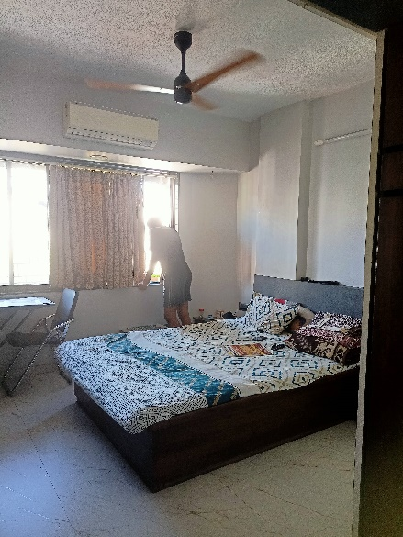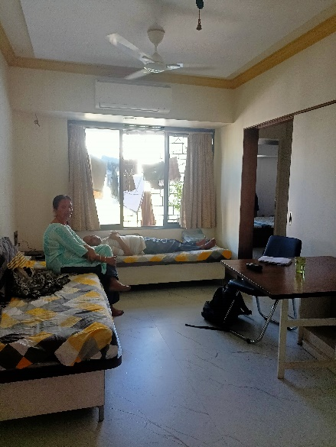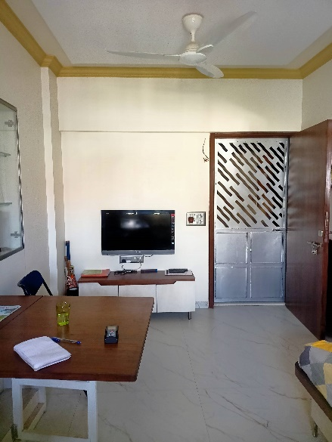

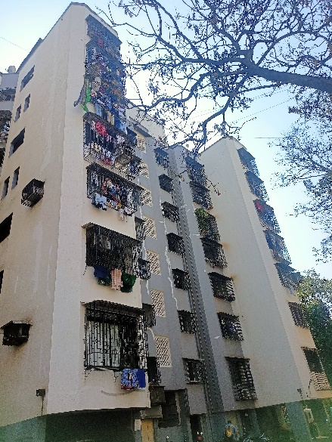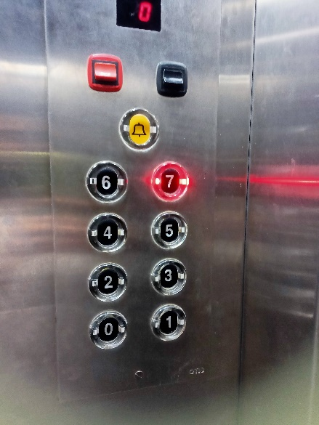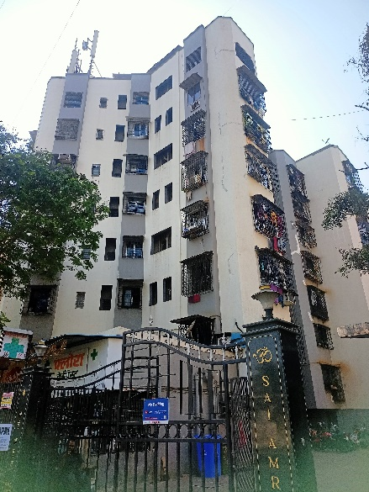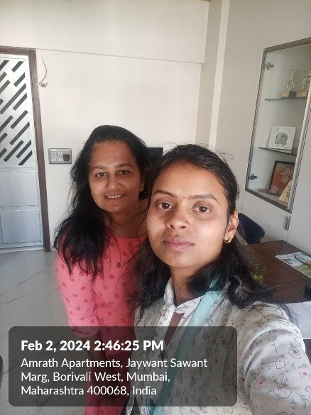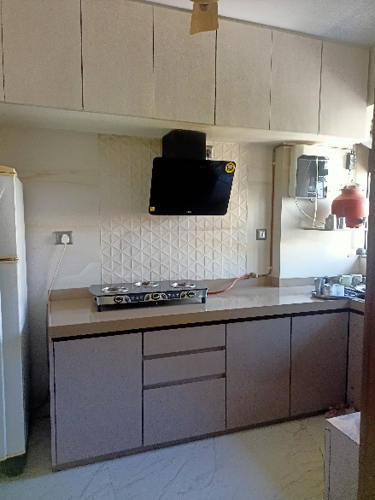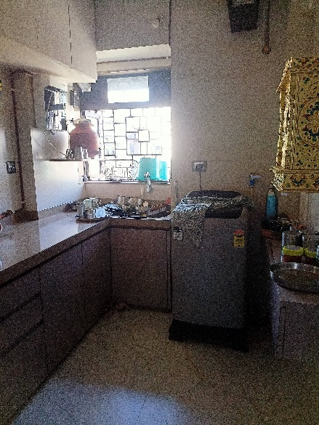**Route Map of the property**

**Site u/r**

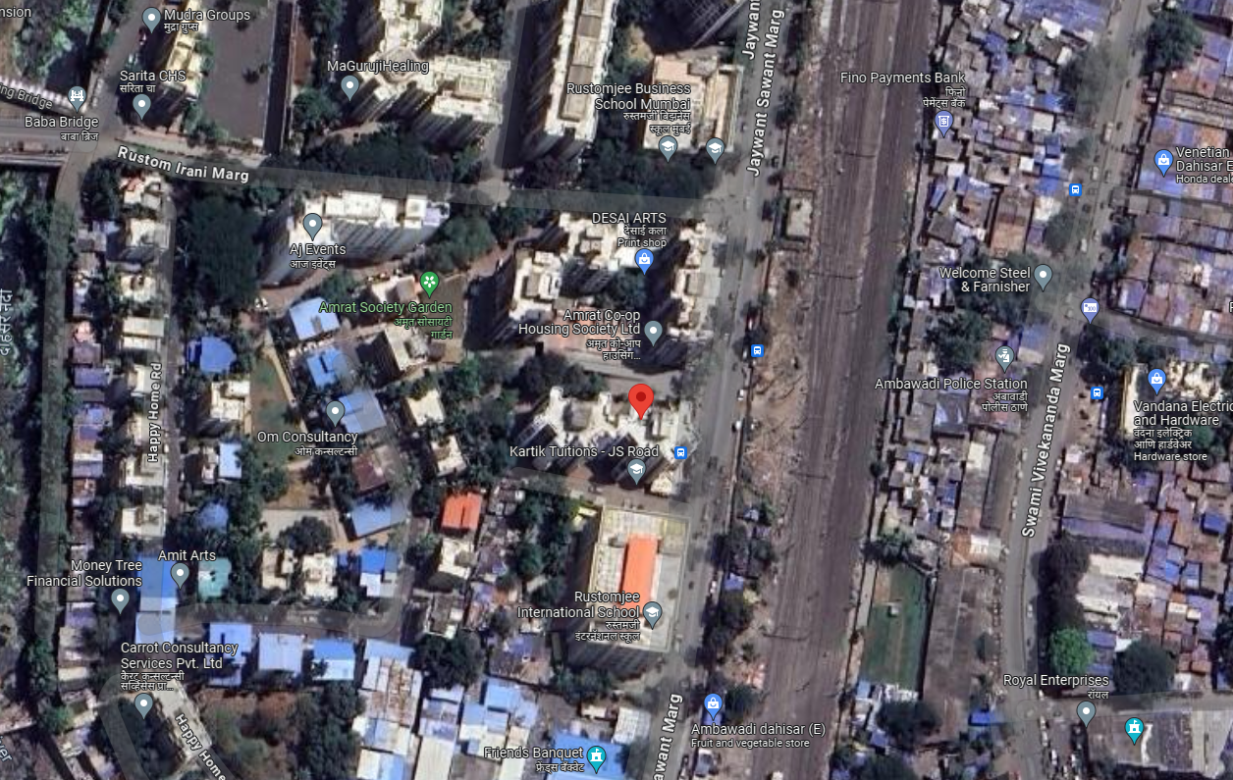

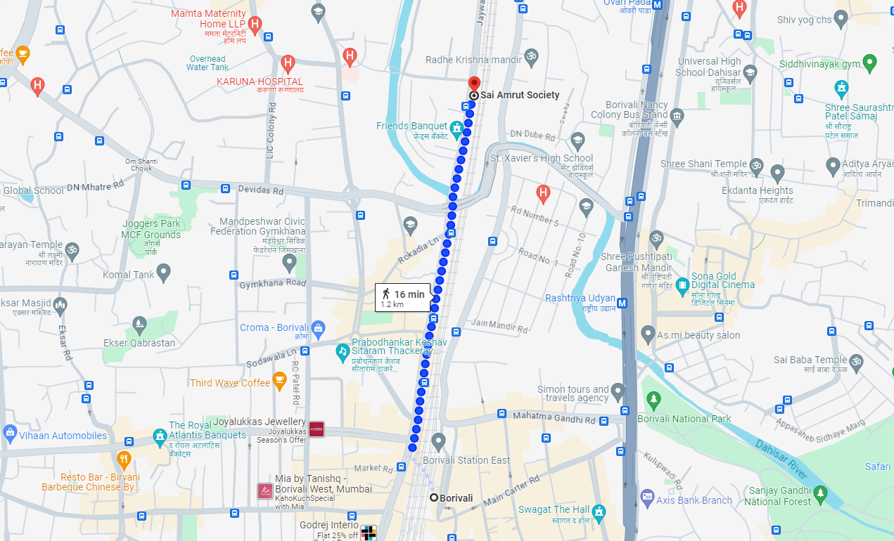

# Latitude Longitude - 19°14’25.6”N 72°51’29.7”E

**Note**: The Blue line shows the route to site from nearest railway station (Borivali – 1.2 Km.)

**Ready Reckoner Rate**

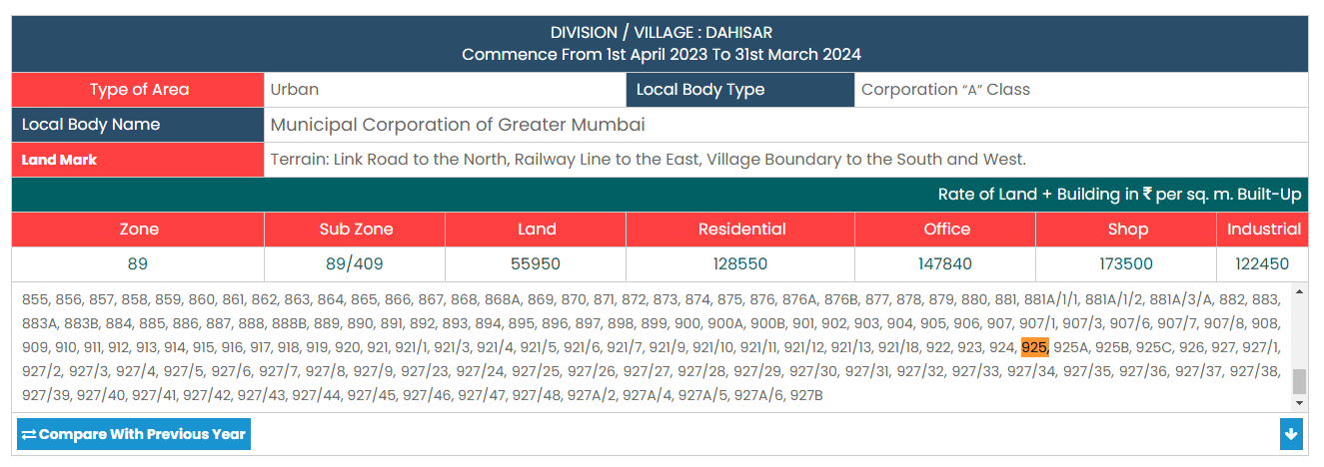

|  |  |  |  |  |
| --- | --- | --- | --- | --- |
| Stamp Duty Ready Reckoner Market Value Rate for **Flat** | 1,28,550.00 |  |  |  |
| Increase by 5% on Flat Located on 7th Floor | 6,428.00 |  |  |  |
| **Stamp Duty Ready Reckoner Market Value Rate (After Increase) (A)** | **1,34,978.00** | **Sq. Mtr.** | **12,540.00** | **Sq. Ft.** |
| Stamp Duty Ready Reckoner Market Value Rate for **Land (B)** | 55,950.00 |  |  |  |
| The difference between land rate and building rate (A – B = C) | 79,028.00 |  |  |  |
| Depreciation Percentage as per table (D) [100% - 25%]  (Age of the Building – 25 Years) | 75% |  |  |  |
| **Rate to be adopted after considering depreciation [B + (C x D)]** | **1,15,221.00** | **Sq. Mtr.** | **10,704.00** | **Sq. Ft.** |

**Multi-Storied building with Lift**

For residential premises / commercial unit / office on above floor in multistoried building, the rate mentioned in the ready reckoner will be increased as under:

|  |  |  |
| --- | --- | --- |
|  | **Location of Flat / Commercial Unit in the building** | **Rate** |
| a) | On Ground to 4 Floors | No increase for all floors from ground to 4 floors |
| b) | 5 Floors to 10 Floors | Increase by 5% on units located between 5 to 10 floors |
| c) | 11 Floors to 20 Floors | Increase by 10% on units located between 11 to 20 floors |
| d) | 21 Floors to 30 Floors | Increase by 15% on units located between 21 to 30 floors |
| e) | 31 Floors and above | Increase by 20% on units located on 31 and above floors |

**Table – D: Depreciation Percentage Table**

|  |  |  |
| --- | --- | --- |
| **Completed Age of Building in Years** | **Value in percent after depreciation** | |
|  | **R.C.C. Structure / other Pukka Structure** | **Cessed Building, Half or Semi – Pukka Structure & Kaccha Structure.** |
| 0 to 2 Years | 100% | 100% |
| Above 2 & up to 5 Years | 95% | 95% |
| Above 5 Years | After initial 5 year for every year 1% depreciation is to be considered. However maximum deduction available as per this shall be 70% of Market Value rate | After initial 5 year for every year 1.5% depreciation is to be considered. However maximum deduction available as per this shall be 85% of Market Value rate |

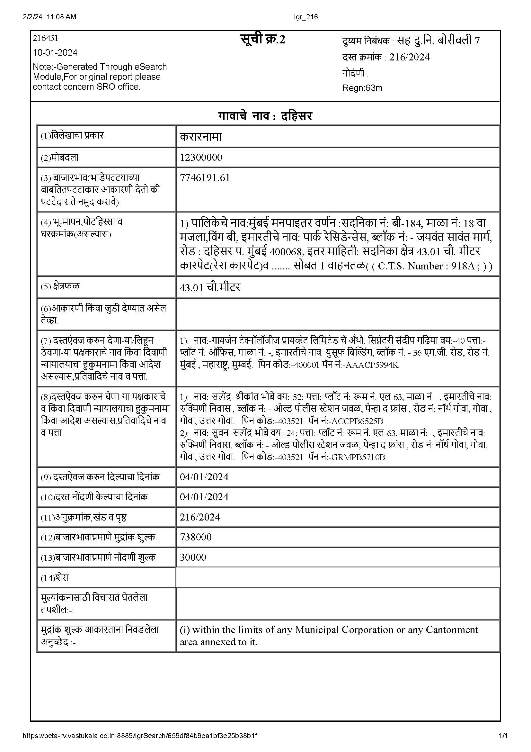**Sale Instance**

**Sale Instance**

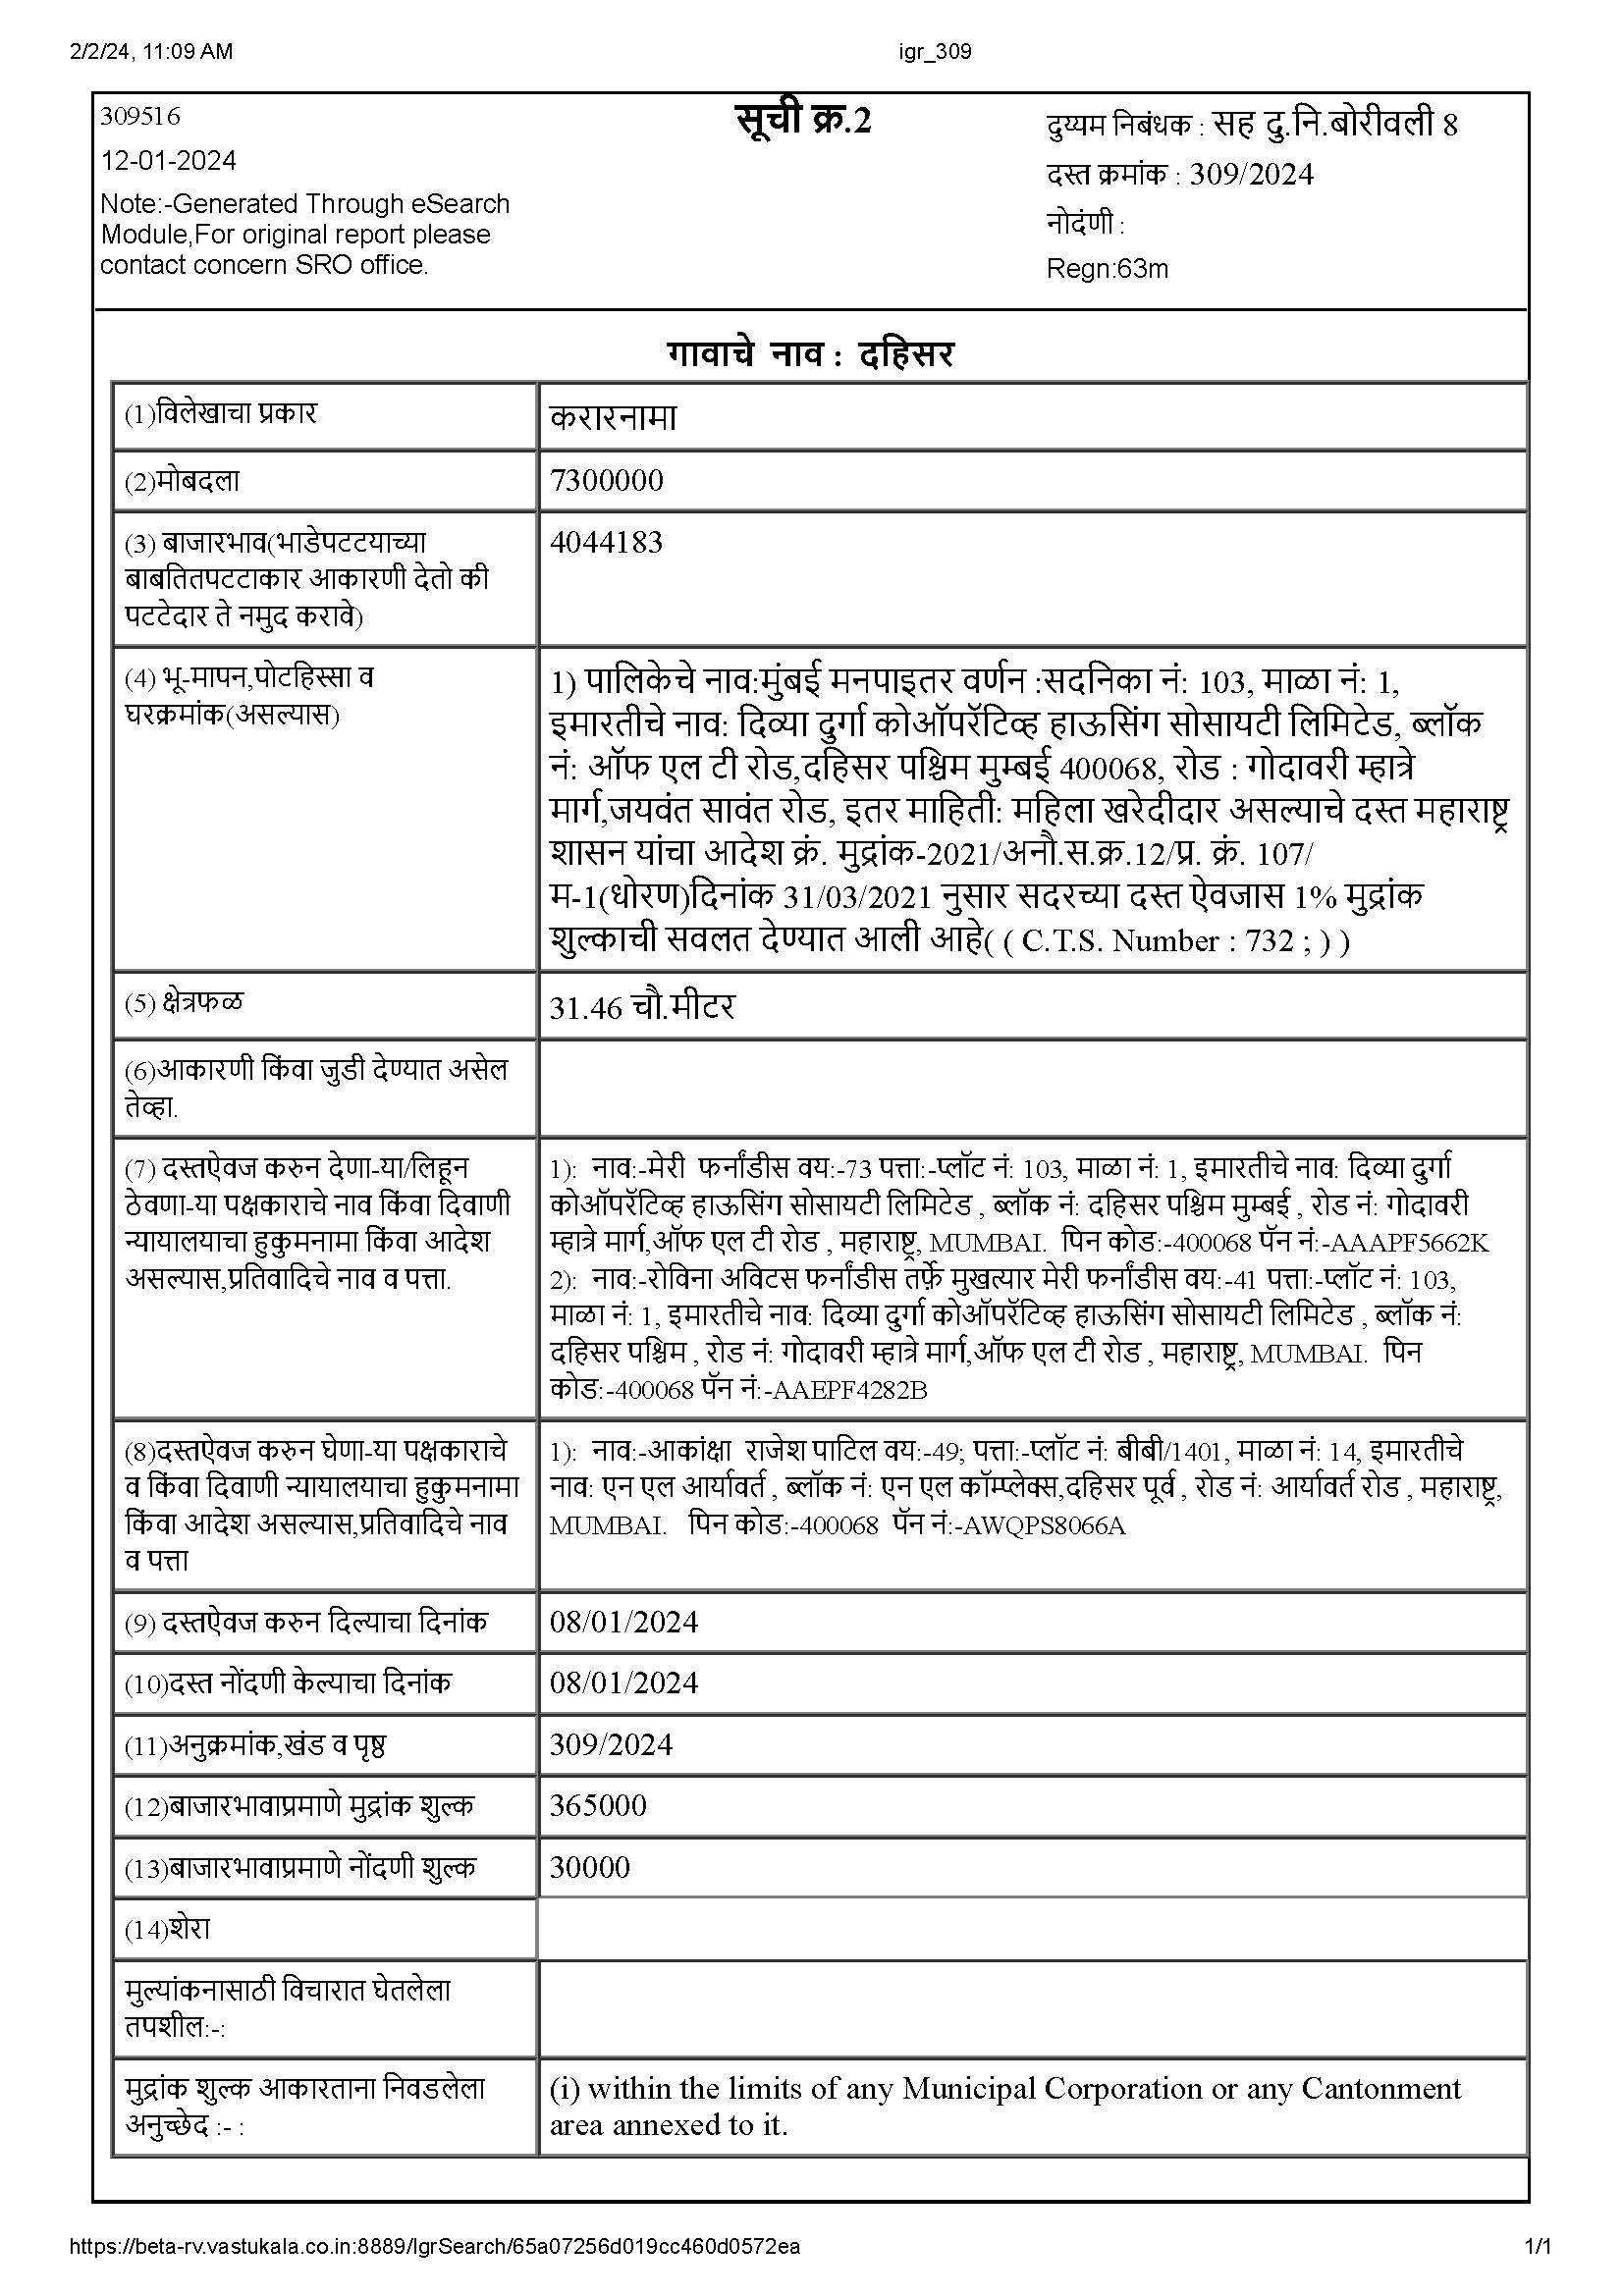

**Price Indicator**

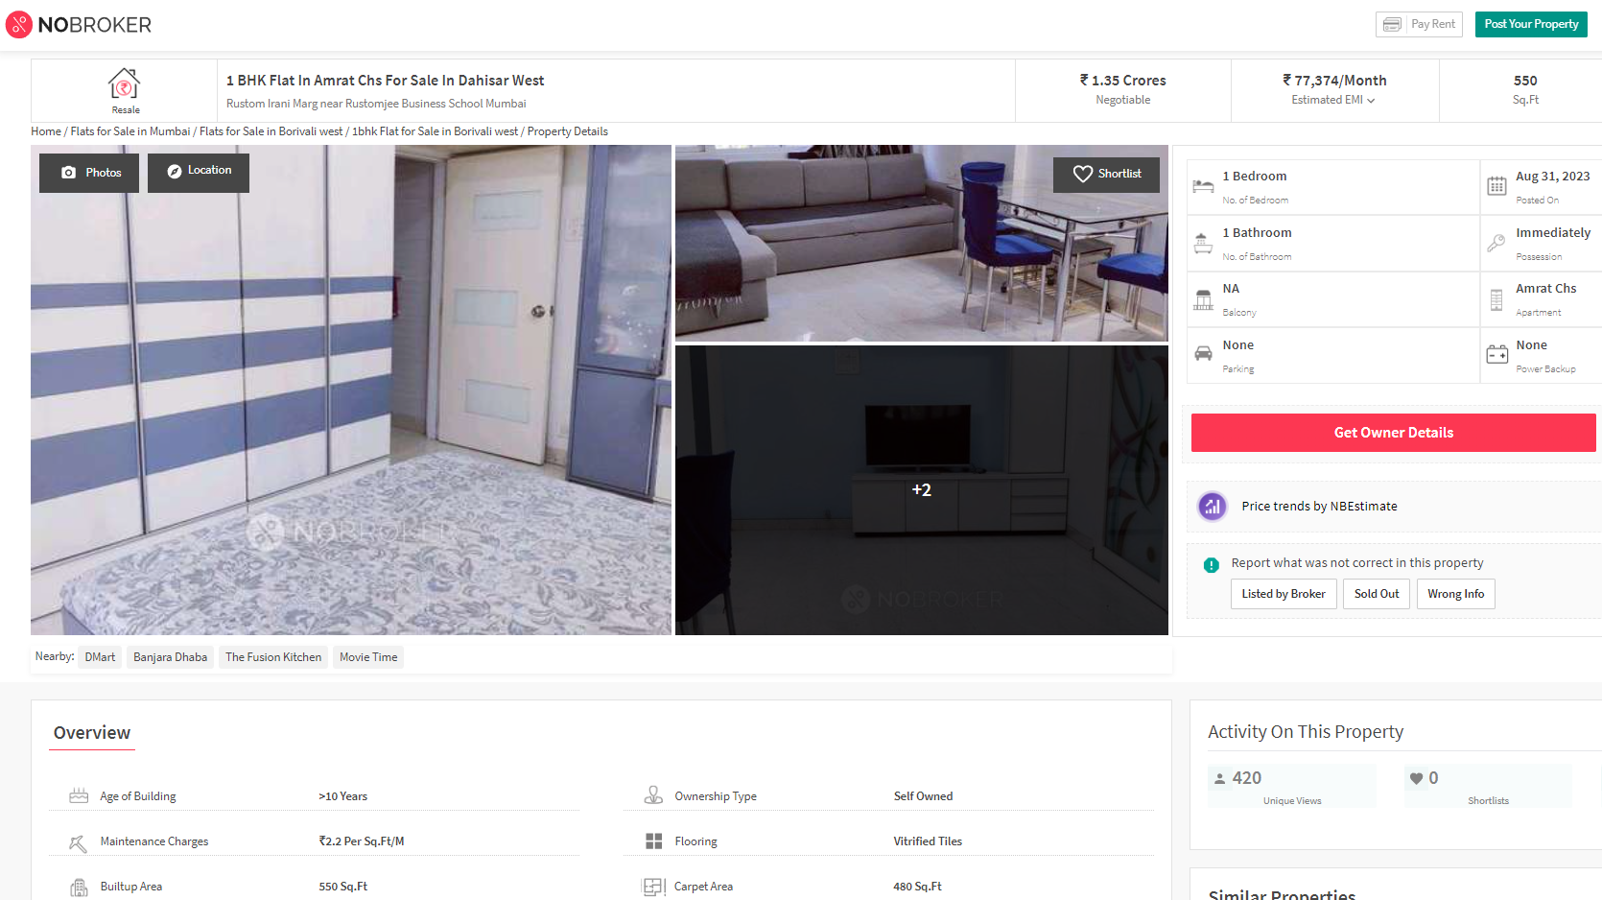

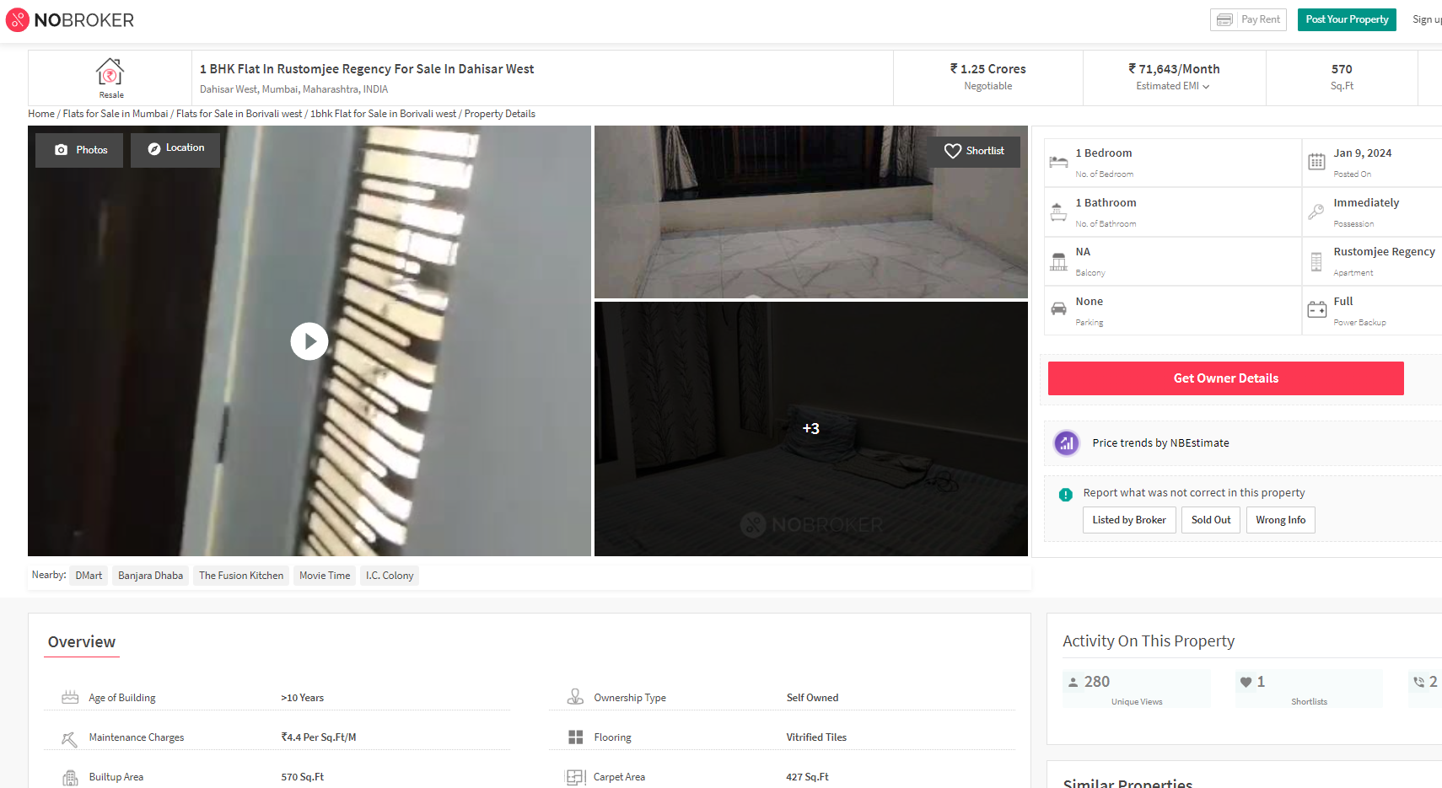

**DEFINITION OF VALUE FOR THIS SPECIFIC PURPOSE**

This exercise is to assess **Fair Market Value** of the property under reference for **Fair Market Value** purpose as on dated **03rd February 2024.**

The term **Fair Market Value** is defined as

*"The most probable price, as of a specified date, in cash, terms equivalent to cash, or in other precisely revealed terms for which the specified property rights would sell after reasonable exposure in a competitive market under all conditions requisite to a fair sale, with the buyer and seller each acting prudently knowledgeably and for self-interest assuming that neither is under undue duress"*

Fundamental assumptions and conditions presumed in this definition are:

1. Buyer and seller are motivated by self-interest.
2. Buyer and seller are well informed and are acting prudently.
3. The property is exposed for a reasonable time on the open market.
4. Payment is made in cash or equivalent or in specified financing terms.

**ASSUMPTIONS, CAVEATS, LIMITATION AND DISCLAIMERS**

1. We assume no responsibility for matters of legal nature affecting the property appraised or the title thereto, nor do we render our opinion as to the title, which is assumed to be good and marketable.
2. The property is valued as though under responsible ownership.
3. It is assumed that there are no hidden or unapparent conditions of the subsoil or structure that would render it more or less valuable. No responsibility is assumed for such conditions or for engineering that might be required to discover such factors.
4. There is no direct/ indirect interest in the property valued.
5. The rates for valuation of the property are in accordance with the Govt. approved rates and prevailing market rates.

**DECLARATION OF PROFESSIONAL FEES CHARGED**

We hereby declare that, our professional fees are not contingent upon the valuation findings. However, if the statute AND/OR clients demands that, the fees should be charged on the percentage of assessed value then, with the full knowledge of the AND/OR end user, it is being charged accordingly.

**VALUATION OF THE PROPERTY PREMISES**

Considering various parameters recorded herein above, existing economic scenario, and the information that is available with reference to the development of neighbourhood and method selected for valuation, we are of the opinion that, the property premises can be assessed and valued for this particular purpose at **` 1,08,65,000.00 (Rupees One Crore Eight Lakh Sixty Five Thousand Only).**

**Manoj B. Chalikwar**

Registered Valuer

Chartered Engineer (India)

Reg. No. CAT-I-F-1763

TZCBL Emp. No. Ref: ZCBL/CO/AUD/19-20/100