Valuation Report of the Immovable Property
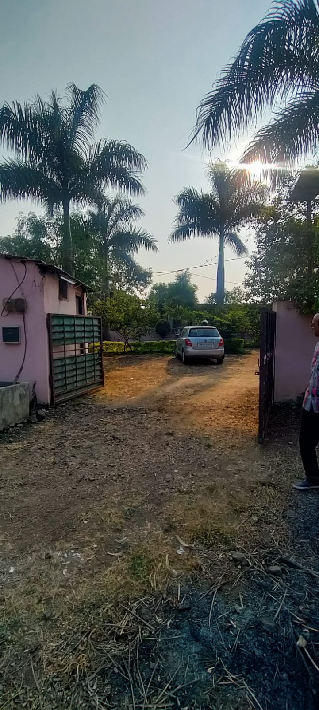

Details of the property under consideration:

Name of Owner: Shri. K Venkateshwara Rao S/o. Shri. Kesmveer Prakash Rao.

Residential Plot No. 70 “Siddhartha Nagar”, Ujjain – Dewas Road, Tehsil &
District Dewas, PIN – 455 001, State – Madhya Pradesh, Country – India.

Latitude Longitude - 22°58’59.4”N 76°01’55.1”E

Valuation Done for:

Bank of Maharashtra
Bhicholi Mardana Branch
142, Solanki Market, Bhicholi Mardana, Indore, PIN – 452016,
State – Madhya Pradesh, Country – India

Vastu/Indore/01/2024/002203/2301307
24/22-408-BSA
Date: 29.01.2024

VALUATION OPINION REPORT

The Residential property bearing Residential Plot No. 70 “Siddhartha Nagar”, Ujjain - Dewas Road, Tehsil & District Dewas, PIN – 455 001, State – Madhya Pradesh, Country - India belongs to Shri. K Venkateshwara Rao S/o. Shri. Kesmveer Prakash Rao.

Boundaries of the property:
Boundaries | : | As per Actual at Site
North | : | Road
South | : | Other Property
East | : | Plot No. 71
West | : | Plot No. 69

Considering various parameters recorded, existing economic scenario, and the information that is available with reference to the development of neighborhood and method selected for valuation, we are of the opinion that, the property premises can be assessed and valued for banking purpose at ` 37,80,000/- (Rupees Thirty Seven Lakh Eighty Thousand Only).

The valuation of the property is based on the documents produced by the concern. Legal aspects have not been taken into considerations while preparing this valuation report.

Hence certified

Manoj B. Chalikwar
Registered Valuer
Chartered Engineer (India)
Reg. No. CAT-I-F-1763
BOM Emp. No. AX40/Empanelment: Valuer/VCPL/2021-22

VALUATION REPORT IN RESPECT OF IMMOVABLE PROPERTY

1. | Date of Inspection | : | 26.11.2023
2. | Purpose of valuation | : | As per request from Bank of Maharashtra, Bhicholi Mardana Branch to assess Fair Market Value of the property under reference for Banking purpose.
3. | Name and address of the Valuer. | : | Manoj B. Chalikwar  Vastukala Consultants (I) Pvt. Ltd.  106, 1st Floor, Gold Star Tower, Opp. Treasure Island Mall, M.G. Road, Indore – 452 001
4. | Copy Of Documents Handed Over to The Valuer by The Bank |  | - Gift Deed, E-Registration No. MP108942024A1078767 dated 18.01.2024, between Shri. Kesmveer Prakash Rao S/o K.V. Prakash Rao (the Donet) AND Shri. K Venkateshwara Rao S/o. Shri. Kesmveer Prakash Rao (the Doner).  - Sale Deed, No. 08/6645 dated 06.10.2008, between Grah Nirman Sahkari Sanstha Maryadit (the Seller) AND Shri. Subahs Rao S/o Shri. Prakash Rao (the Purchaser).
5. | Details of enquiries made/ visited to govt. Offices for arriving fair market value. | : | Market analysis and as per sub-registrar value.
6. | Factors for determining its market value. | : | Location, development of surrounding area, facilities provided and its prevailing market rate.
7. | Any Critical Aspects Associated with Property | : | No
8. | Present/Expected Income from the property | : | N.A., as the property is under consideration is open plot
 | Property Details: | :
9. | Name(s) of the Owner and Postal address of the property under consideration. | : | Shri. K Venkateshwara Rao S/o. Shri. Kesmveer Prakash Rao.
 |  | : | Residential Plot No. 70 “Siddhartha Nagar”, Ujjain - Dewas Road, Tehsil & District Dewas, PIN – 455 001, State – Madhya Pradesh, Country – India.  Contact Person:  Mr. Subhash Rao  Contact No.: +91 9425048406
10. | If the property is under joint ownership/ co-ownership share of each such owner/ are the share is undivided. | : | Sole Ownership
11. | Brief description of the property:  The immovable property comprising of freehold residential land. The property is located in a developed area having basic infrastructure, well connected by road and train. It is located at 4.4 KM. travelling distance from Dewas Junction Railway station.  Land:  As per Sale Deed, the land area 175.65 Sq. M. i.e. 1,890.00 Sq. Ft., which is considered for valuation.  Property Has been Partly Demarcated on the Site Identify of the Property Eng. Somesh Nahar
12. | Location of the property. (C.T.S. No., Survey No., Hissa No., Plot No., etc.). | : | Residential Plot No. 70
13 | Boundaries of the property |  | As per Actual |  | As Per Gift Deed
 | North | : | Road |  | Road
 | South | : | Other Property |  | Other Property
 | East | : | Plot No. 71 |  | Plot No. 71
 | West | : | Plot No. 69 |  | Plot No. 69
14. | Route map | : | Enclosed
15. | Any specific identification marks | : | Near Hanuman Mandir
16. | Whether covered under Corporation/ Panchayat/ Municipality. | : | Nagar Palika Nigam Dewas
17. | Whether covered under any land ceiling of State/ Central Government. | : | No
18. | Is the land freehold/ leasehold? | : | Freehold
19. | Are there any restrictive covenants in regard to use of Land? If so attach a copy of the covenant. | : | As per Sale Deed
20. | Type of the property- Whether | :
 | Residential | : | Yes
 | Industrial | : | No
 | Commercial | : | No
 | Institutional | : | No
 | Government | : | No
 | Non – Government | : | No
 | Other (Specify) | : | N.A.
21. | In case of Agricultural land
 | Any conversion to House site is obtained | : | N.A.
 | Whether the land is dry or wet. | : | N.A.
 | Availability of irrigation facilities | : | N.A.
 | Type of crops grown | : | N.A.
 | Annual yield or income. | : | N.A.
22. | Year of acquisition/ purchase. | : | Gift Deed, E-Registration No. MP108942024A1078767 dated 18.01.2024
23. | Whether the property is occupied by owner or tenant. If occupied by tenant since how long he is staying, and the amount of rent being paid. | : | Land and structure under owner’s possession
24. | Classification of the site. | :
 | a. Population group. | : | Urban
 | b. High/ Middle/ Poor class | : | Middle class
 | c. Residential/ nonresidential. | : | Residential
 | d. Development of surrounding area. | : | Developed
 | e. Possibility of any threat to the property. (Floods, calamities etc.). | : | No
25. | Proximity of civic amenities.  (Like school, hospital, bus stop, market etc.). | : | All available nearby
26. | Level of the land (Plain, rock etc.) | : | Plain
27. | Terrain of the Land. | : | Leveled
28. | Shape of the land (Square/ rectangle etc.). | : | Rectangular
29. | Type of use to which it can be put (for construction of house, factory etc.). | : | Residential Purpose
30. | Any usage restrictions on the property. | : | Residential
31. | Whether the plot is under town planning approved layout? | : | Yes
32. | Whether the building is intermittent or corner? | : | Intermittent
33. | Whether any road facility is available? | : | Yes
34. | Type of road available (B.T. / Cement Road etc.). | : | B.T. Road
35. | Front Width of the Road? | : | More than 20 ft.
36. | Source of water & water potentiality. | : | Good
37. | Type of Sewerage System. | : | Connected to Municipal Sewerage System
38. | Availability of power supply. | : | Yes
39. | Advantages of the site. | : | Located in developed residential area
40. | Disadvantages of the site. | : | No
41. | Give instances of sales of immovable property in the locality on a separate sheet, indicating the name & address of the property, registration No. sale price and area of land sold. | : | As per Sub-Registrar of Assurance records
 | Valuation of the property:
42. | 1) Dimensions of the plot | : | -
43. | 2) Total area of the plot | : | 1,890.00 Sq. Ft.  (As per Sale Deed)
44. | 3) Prevailing Market Rate/Price trend of the Property in the locality/city from property search sites viz magickbricks.com, 99acres.com, makaan.com etc. if available | : | ` 1,500/- to ` 2,500/- per Sq. Ft. for Residential Land  Details of online listings are attached with the report.
45. | 4) Government Rate obtained from the online government records of Land | : | ` 5,000/- per Sq. M.  i.e. ` 465/- per Sq. Ft.
46. | Building |  | N.A., as only land area has been considered for valuation
47. | - Government Value
 | Particulars | : | Area in Sq. Ft. | Rate in ` |  | Value in `
 | Land | : | 1,890.00 | 465/- |  | 8,78,850/-
 | Structure |  | N.A. as only land area has been considered for valuation |  |  | -
 | Total |  |  |  |  | 8,78,850/-
 | 5) Assessed/ adopted rate of valuation. |  | ` 2,000.00 per Sq. Ft. for Residential Land
48. | - Fair Market Value
 | Particulars | : | Area in Sq. Ft. | Rate in ` |  | Value in `
 | A) Land |  | 1,890.00 | 2,000/- |  | 37,80,000/-
 | B) Building |  | N.A. as only land area has been considered for valuation |  |  | -
 | 6) Total Value (A + B) |  |  |  |  | 37,80,000/-
 | a. technical details of the Plot:
49. | 8 | : | Residential
50. | Year of construction. | : | N.A. as only land area has been considered for valuation
51. | Future life of the property. | : | N.A. as only land area has been considered for valuation
52. | No. of floors and height of each floor including basement. | : | N.A. as only land area has been considered for valuation
53. | Plinth area of each floor | : | N.A. as only land area has been considered for valuation
54. | Type of construction.  (Load bearing/ R.C.C. / Steel framed). |  | N.A. as only land area has been considered for valuation
 | Condition of the building. | :
55. | External (excellent/ good/ normal/ poor). | : | N.A. as only land area has been considered for valuation
56. | Internal (excellent/ good/ normal/ poor). | : | N.A. as only land area has been considered for valuation
 | Remarks: | :
57. | b. Specifications of Construction:
 | Foundation. | : | N.A. as only land area has been considered for valuation
 | Basement. | : | N.A. as only land area has been considered for valuation
 | Superstructure. | : | N.A. as only land area has been considered for valuation
 | Joinery/ Doors & Windows. | : | N.A. as only land area has been considered for valuation
 | RCC work. | : | N.A. as only land area has been considered for valuation
 | Plastering. | : | N.A. as only land area has been considered for valuation
 | Flooring, Skirting. | : | N.A. as only land area has been considered for valuation
 | Kitchen Pantry Platform | : | N.A. as only land area has been considered for valuation
 | Whether any weather proof course is provided. | : | N.A. as only land area has been considered for valuation
 | Drainage. | : | N.A. as only land area has been considered for valuation
 | Compound wall (Height, length and type of construction). | : | N.A. as only land area has been considered for valuation
 | Electric installation (Type of wire, Class of fittings) | : | N.A. as only land area has been considered for valuation
 | Plumbing installation (No. of water closets & wash basins etc.) | : | N.A. as only land area has been considered for valuation
 | Bore well. | : | No
 | Wardrobes, if any. | : | N.A. as only land area has been considered for valuation
 | Development of open area | : | Yes

1,

 | Summary of Valuation
 | Total Value of the Property | ` 37,80,000/-
 | Realizable Value | ` 34,02,000/-
 | Forced/ Distress Sale value. | ` 30,24,000/-
 | Insurable value of the property | N.A. as only land area has been considered for valuation
e) | Remarks:

Justification for price /rate
The Market Value of the property is based on facts of markets discovered by us during our enquiries, however the government rate value in this case is less than the market value arrived by us. We are of the opinion that the value arrive by us will prove to be correct if an Auction of the subject property is carried out. As far as Market Value in Index II is concerned, it is not possible to comment on same, may be government rates are fixed by sampling during same point of time in part and whereas, Market values change every month.
In most of the cases the actual deal amount or Transaction value is not reflected in Index II because of various Market practices. As Valuer, we always try to give a value which is correct reflection of actual transaction value irrespective of any factors in market.

Actual site photographs
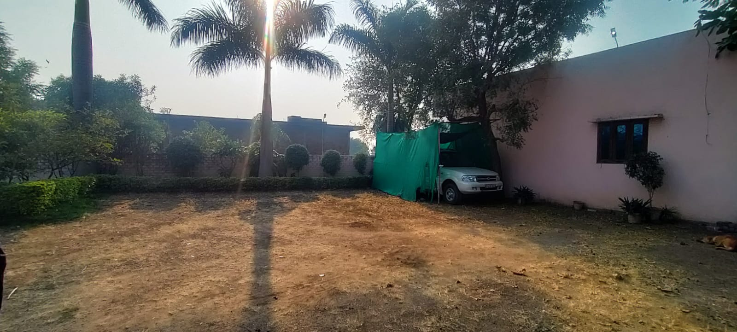
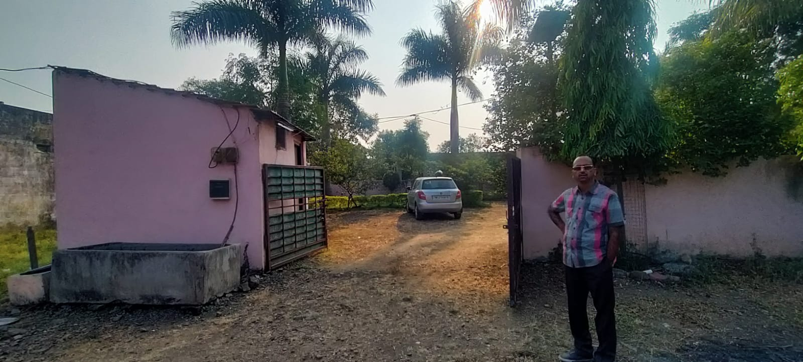


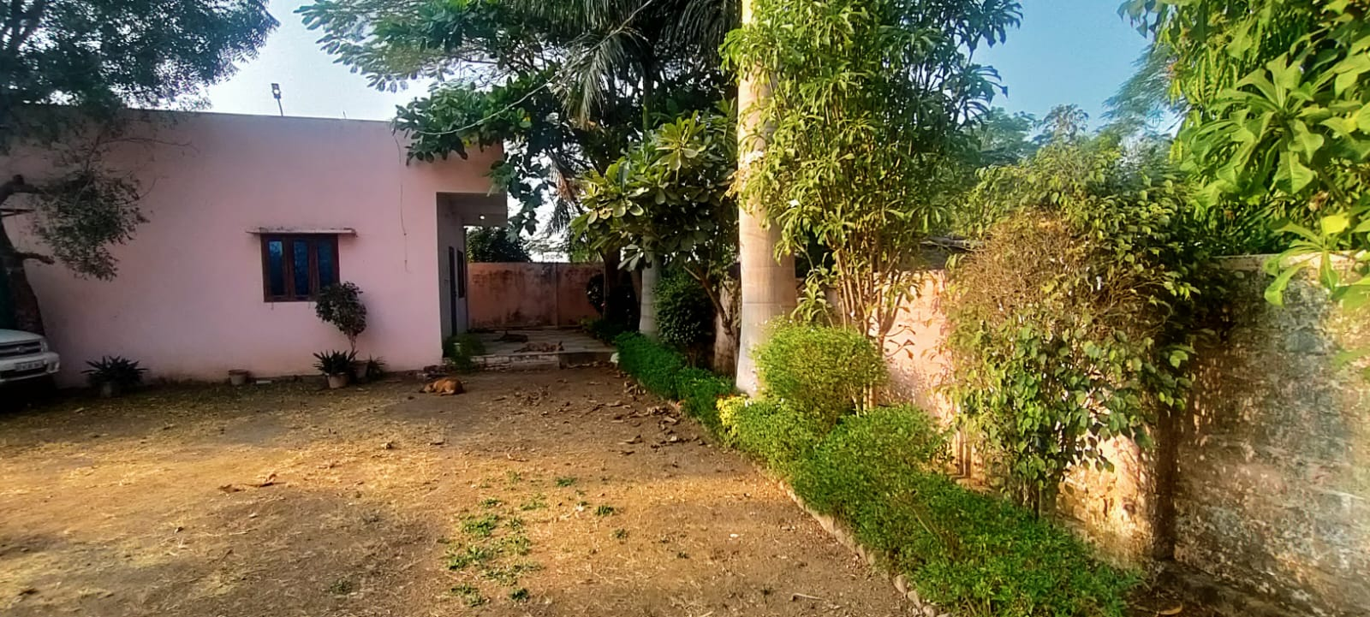
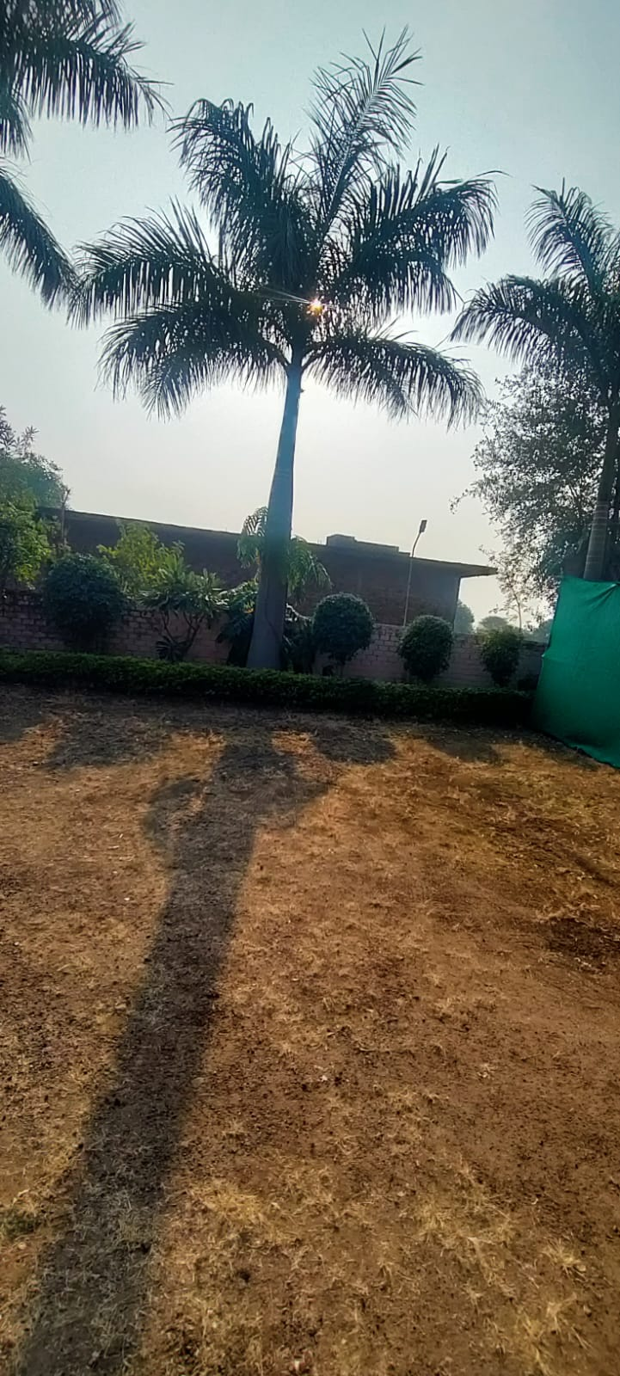
Route Map of the property
Site u/r

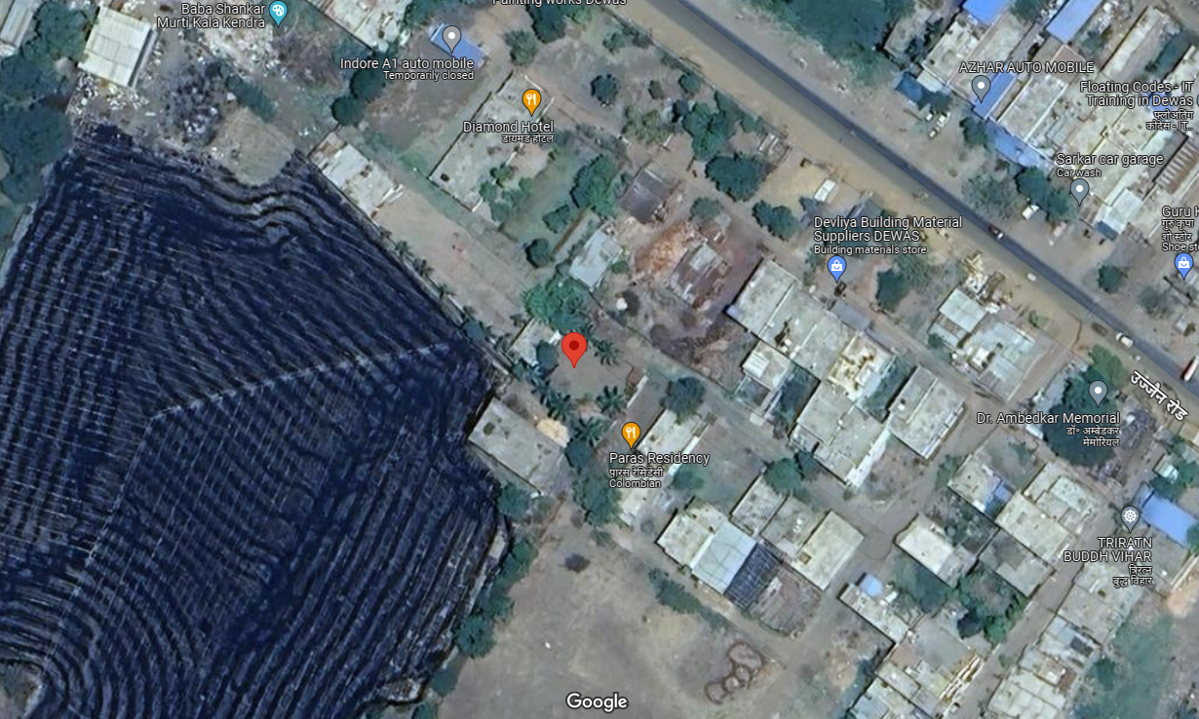

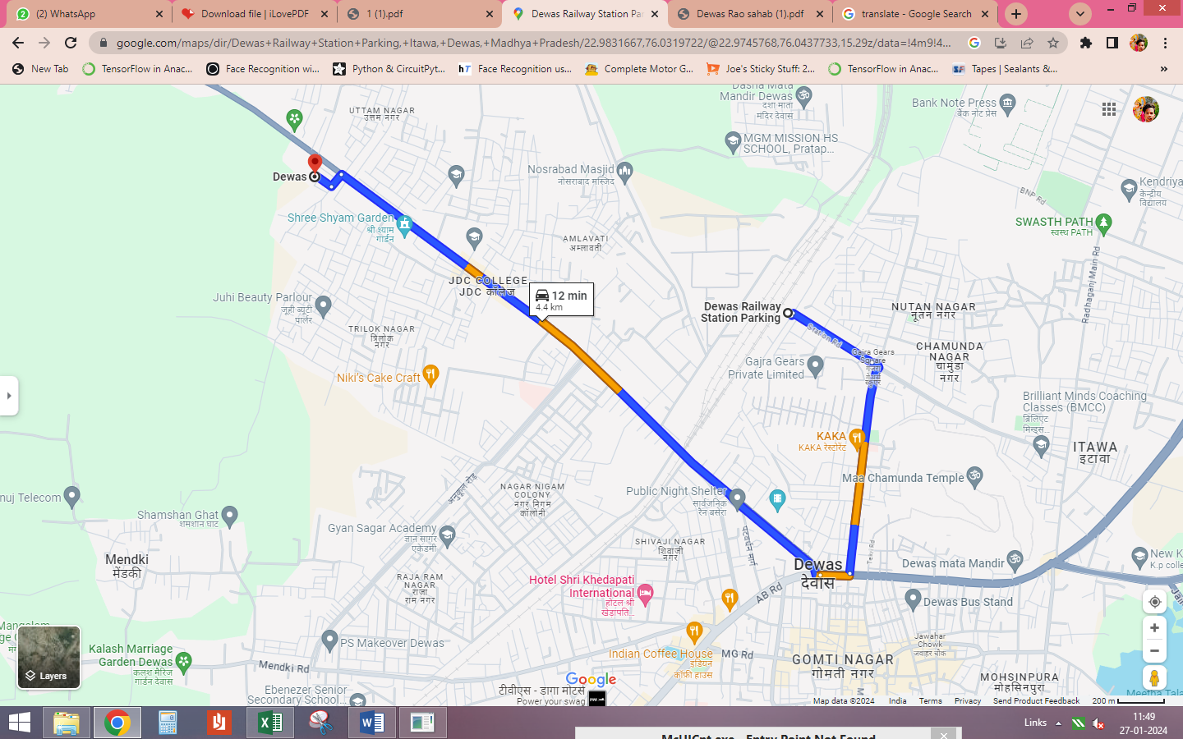

Latitude Longitude - 22°58’59.4”N 76°01’55.1”E
Note: The Blue line shows the route to site from nearest railway station (Dewas Junction – 4.4 KM.)

Government Guideline Rate
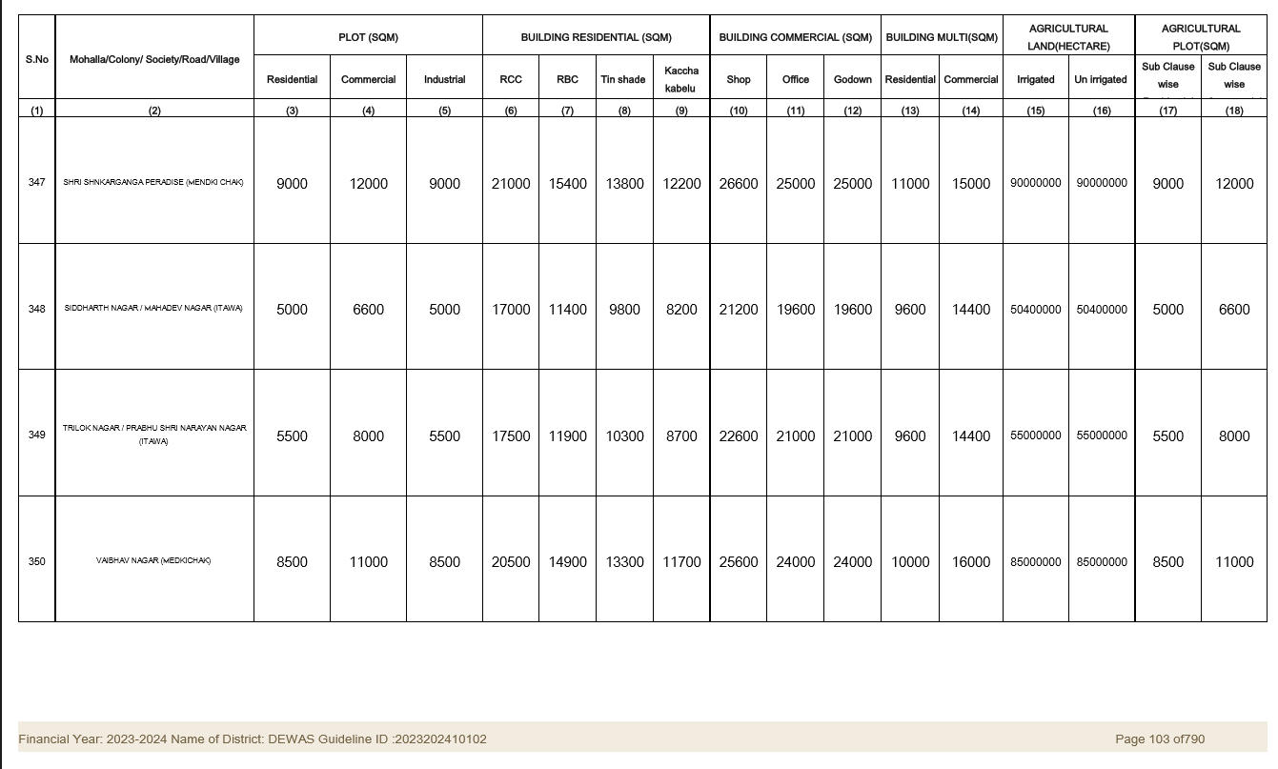

Price Indicators
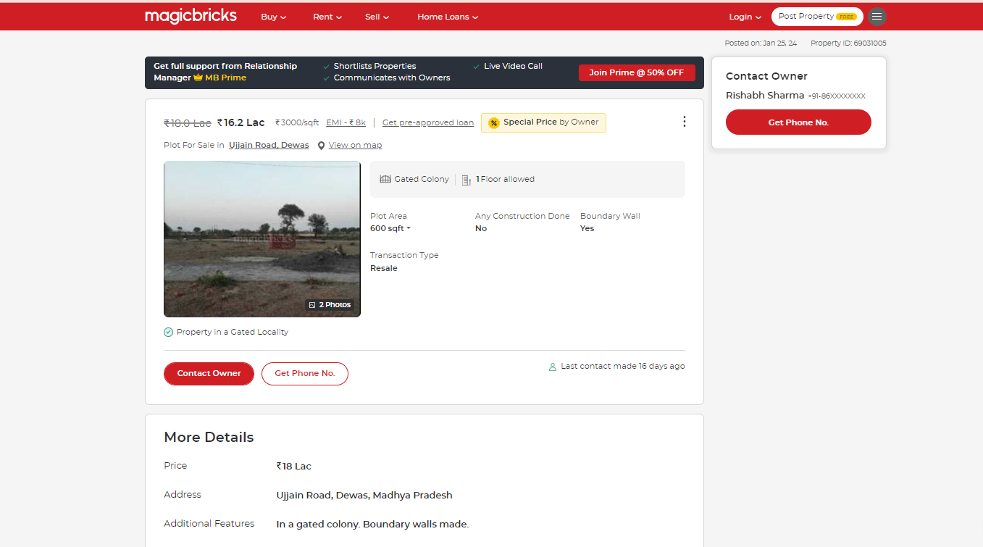

DEFINITION OF VALUE FOR THIS SPECIFIC PURPOSE

This exercise is to assess Fair Market Value of the property under reference for purpose as on 29th January 2024.

The term Fair Market Value is defined as

"The most probable price, as of a specified date, in cash, terms equivalent to cash, or in other precisely revealed terms for which the specified property rights would sell after reasonable exposure in a competitive market under all conditions requisite to a fair sale, with the buyer and seller each acting prudently knowledgeably and for self-interest assuming that neither is under undue duress"

Fundamental assumptions and conditions presumed in this definition are:

- Buyer and seller are motivated by self-interest.

- Buyer and seller are well informed and are acting prudently.

- The property is exposed for a reasonable time on the open market.

- Payment is made in cash or equivalent or in specified financing terms.

ASSUMPTIONS, CAVEATS, LIMITATION AND DISCLAIMERS
- We assume no responsibility for matters of legal nature affecting the property appraised or the title thereto, nor do we render our opinion as to the title, which is assumed to be good and marketable.
- The property is valued as though under responsible ownership.
- It is assumed that there are no hidden or unapparent conditions of the subsoil or structure that would render it more or less valuable. No responsibility is assumed for such conditions or for engineering that might be required to discover such factors.
- There is no direct/ indirect interest in the property valued.
- The rates for valuation of the property are in accordance with the Govt. approved rates and prevailing market rates.

Manoj B. Chalikwar
Registered Valuer
Chartered Engineer (India)
Reg. No. CAT-I-F-1763
BOM Emp. No. AX40/Empanelment: Valuer/VCPL/2021-22

