Vastu/Nashik/01/2024/006660/2304756 31/9-458 -RPBS Date: 31.01.2024

**Structural Stability Report**

Commercial Existing Building **"Hotel Kubera"** Plot No. 2, City Survey No. 6707, Final Plot No. 190, T. P. S. No. 2, Near Trimbak Naka Road, Old Agra Road, Shivaji Udyan, Village - Nashik, Taluka & Dist - Nashik, Pin Code – 422 002, State - Maharashtra, Country - India belongs to **Mr. Deelip Murlidhar Rahane.**

This is to certify that on visual inspection, it appears that the structure of **"Hotel Kubera"** is in normal condition and the future life can be reasonably takes under normal condition and with proper periodic repairs & maintenance is about 40 years.

**General Information**:

|  |  |  |
| --- | --- | --- |
| **A.** | **Introduction** | |
| 1 | Name of Building | **"Hotel Kubera"** |
| 2 | Property Address | Commercial Existing Building **"Hotel Kubera"** Plot No. 2, City Survey No. 6707, Final Plot No. 190, T. P. S. No. 2, Near Trimbak Naka Road, Old Agra Road, Shivaji Udyan, Village - Nashik, Taluka & Dist - Nashik, Pin Code – 422 002, State - Maharashtra, Country – India. |
| 3 | Type of Building | Commercial |
| 4 | No. of Floors | Basement + Ground + 1st + 2nd Floor / Terrace Floor |
| 5 | Whether stilt / podium / open parking provided | Open Car Parking |
| 6 | Type of Construction | R.C.C. Framed Structure |
| 7 | Type of Foundation | R.C.C. Footing |
| 8 | Thickness of the External Walls | 6’ thick brick walls both sides plastered |
| 9 | Type of Compound | Brick Masonry Walls |
| 10 | Year of Construction | 1990 (As per Full Occupancy Certificate) |
| 11 | Present age of building | 33 years |
| 12 | Residual age of the building | 27 years Subject to proper, preventive periodic maintenance & structural repairs. |
| 13 | No. of Flats | - |
| 14 | Methodology adopted | As per visual site inspection |

|  |  |  |
| --- | --- | --- |
| **B.** | **External Observation of the Building** | |
| 1 | Plaster | Good |
| 2 | Chajjas | Good |
| 3 | Plumbing | Good |
| 4 | Cracks on the external walls | Not Found |
| 5 | Filling cracks on the external walls | Not Found |
| 6 | Cracks on columns & beams | Not Found |
| 7 | Vegetation | Not Found |
| 8 | Leakages of water in the drainage pipes or water pipes | Not Found |
| 9 | Dampness external in the wall due to leakages | Not Found |
| 10 | Any other observation about the condition of external side of the building | The external condition of the structure is in Average condition |
| **C** | **Internal Observation of the common areas of the building and captioned premises** | |
| 1 | Beams (Cracks & Leakages) | Not found |
| 2 | Columns (Cracks & Leakages) | Not found |
| 3 | Ceiling (Cracks & Leakages) | Not found |
| 4 | Leakages inside the property | Not Found |
| 5 | Painting inside the property | External Wall Plaster and Painting Condition is Good. |
| 6 | Maintenance of staircase & cracks | Good |

|  |  |  |
| --- | --- | --- |
| **D** | **Common Observation** | |
| 1 | Structural Audit of the Building Under Bye – Laws No. 77 of the Model Bye Laws (Co-Operative Societies Act / Rules) | As per bye Laws No. 77 of Co-Op. Societies bye Laws under the Act the society shall conduct a Structural Audit of the building of the society as follows |
| 2 | Remark | - |

|  |  |
| --- | --- |
| **E** | **Conclusion** |
| The captioned Bungalow is having Ground + 1s floor which are constructed in year 1990 (As per Full Occupancy Certificate). Estimated future life under present circumstances is about 27 years’ subject to proper, preventive periodic maintenance & structural repairs.  The inspection dated 29.01.2024 reveals no structural damage or deterioration to the building. The building as well as the property is maintained in normal condition & will stand future life subject to proper, preventive periodic maintenance & Average structural repairs.  Our Observations about the structure are given above.  The above assessment is based on visual inspection only. | |

**Sharadkumar B. Chalikwar**

Govt. Reg. Valuer

Chartered Engineer (India)

Reg. No. (N) CCIT/1-14/52/2008-09

Encl: Valuation report.

**Actual Site Photographs**

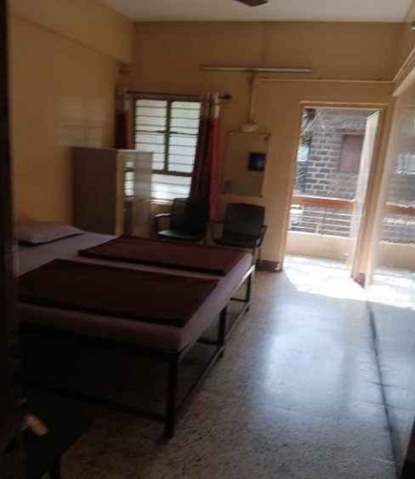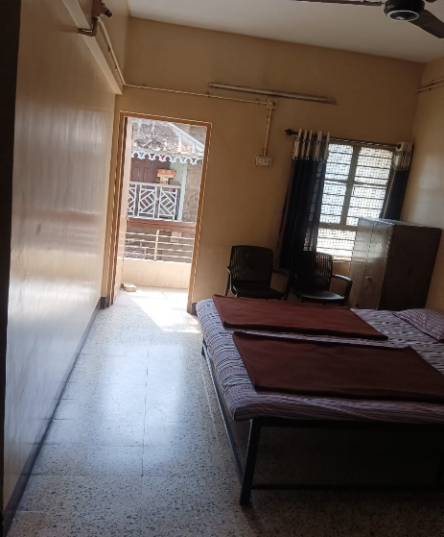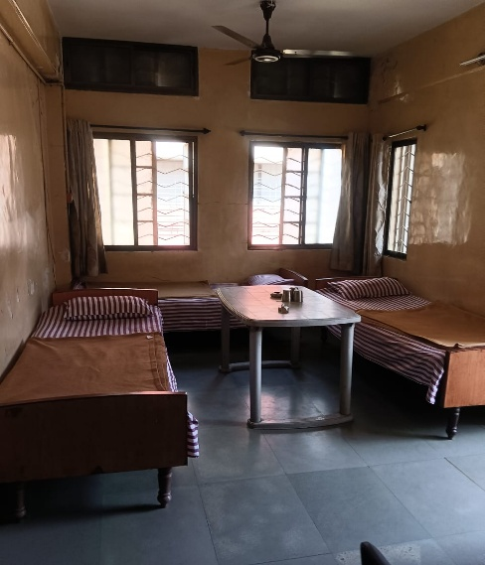

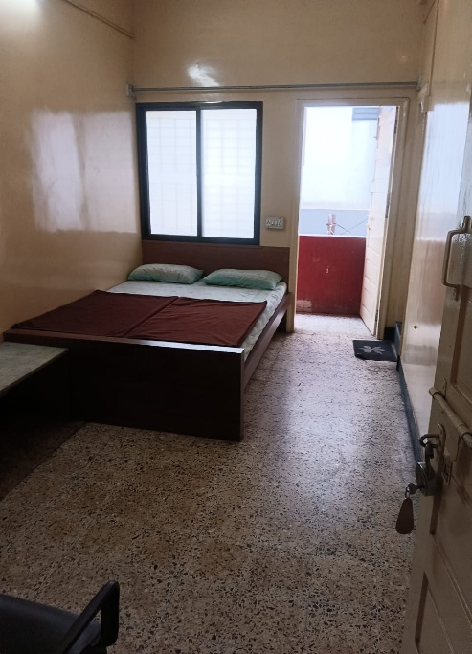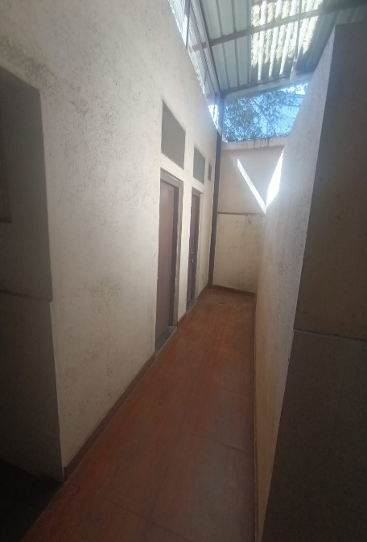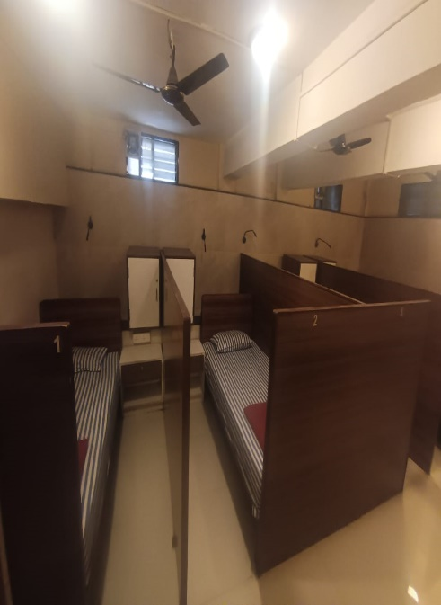

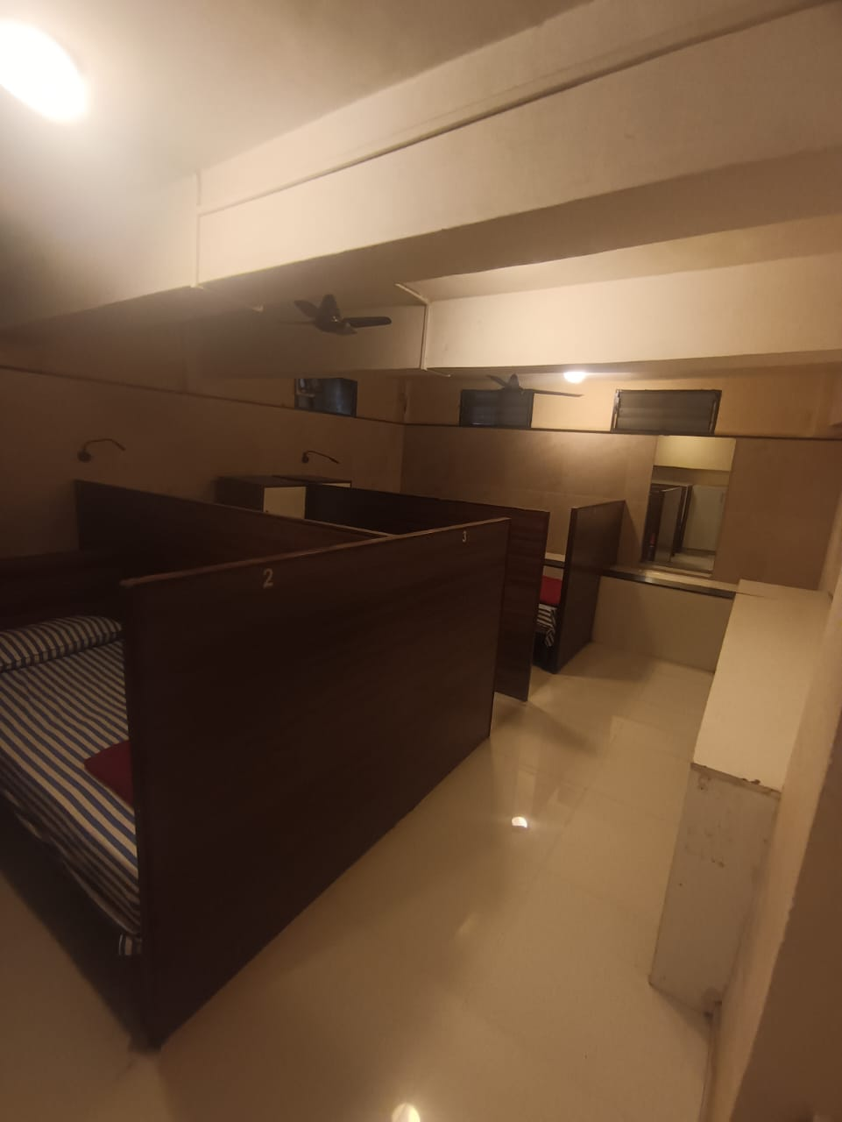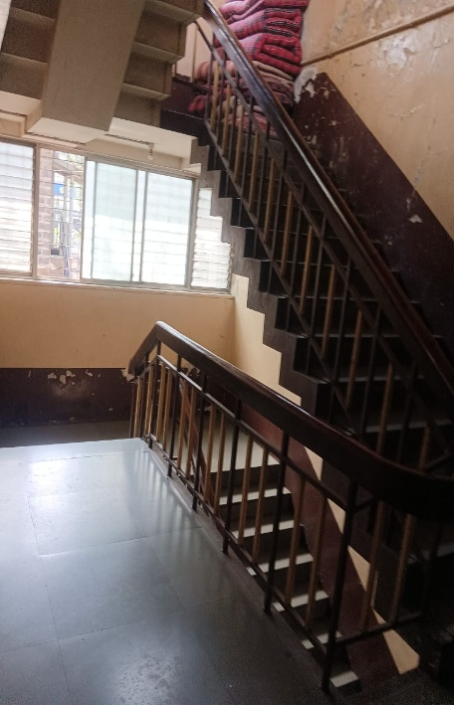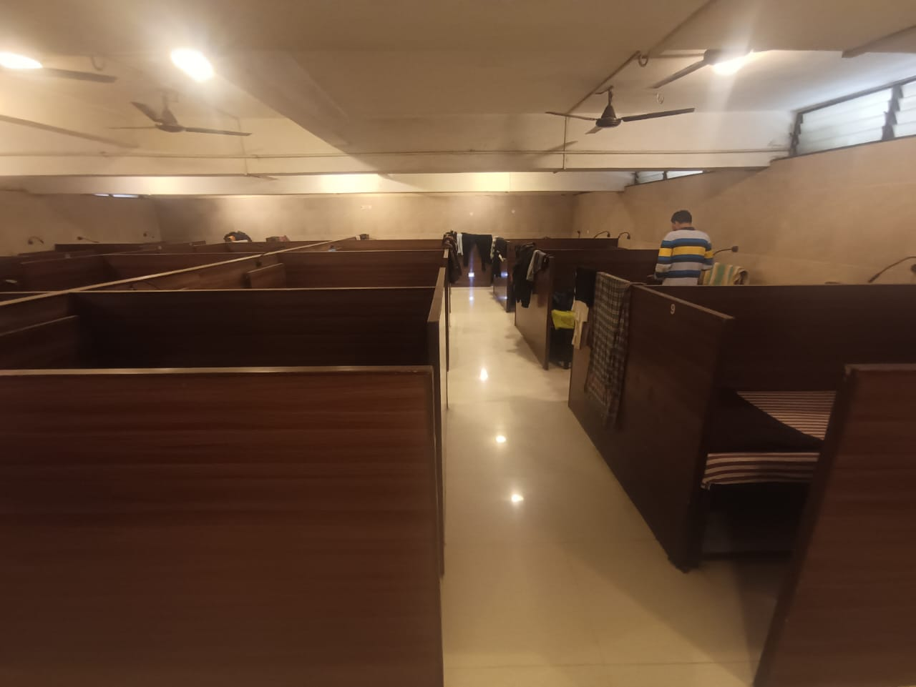

**Actual Site Photographs**

