**NAME OF OWNER: M/S. RACON MARINE PVT. LTD.**

**&**

**BUILDER: - M/S. ESSFOUR ENGINEERING PVT. LTD.**

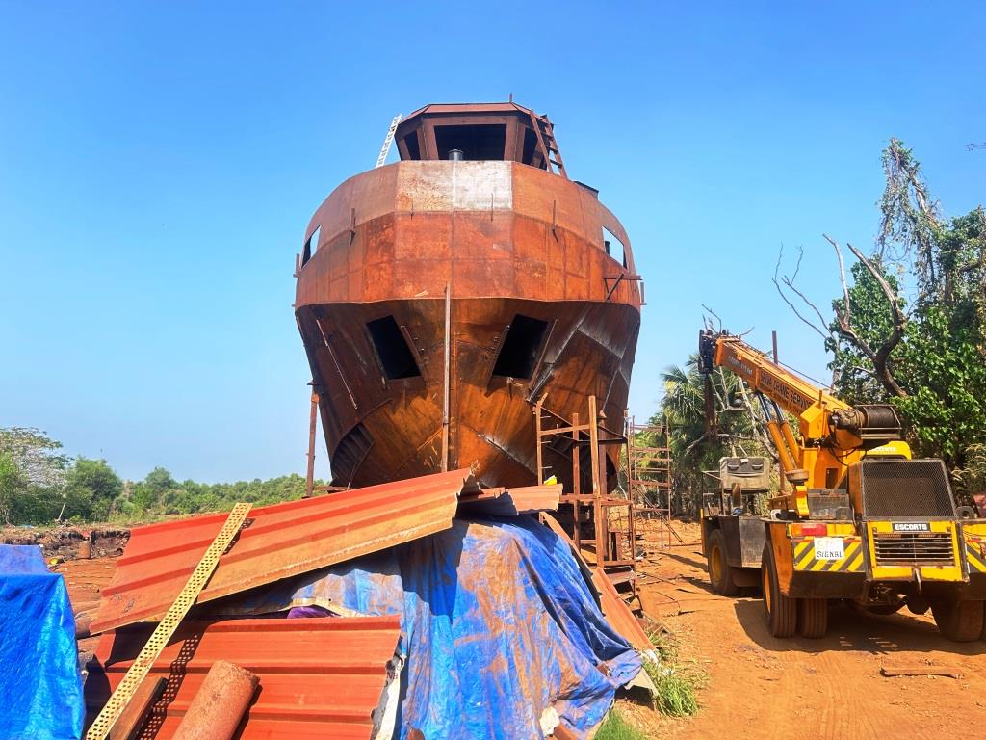

**Report Prepared For**

**State Bank of India**

**SME Chembur (Diamond Garden) Branch**

**Unit No. 11, Ground Floor, Corporate Park, Sion -Trombay Road, Chembur,**

**Mumbai – 400 071, State – Maharashtra, Country – India.**

**INDEX**

|  |  |  |
| --- | --- | --- |
| CHAPTER | NAME | PAGE NO. |
| 1 | **PREAMBLE** | **03** |
| 2 | **ASSIGNMENT OVERVIEW** | **04** |
| 3 | **ABOUT COMPANY & THE TUG** | **06** |
| 4 | **PROJECT EXECUTION** | **26** |
| 5 | **PHOTOGRAPHS** | **27** |
| 6 | **NOTES, LIMITATIONS, DISCLAIMERS & CAVEATS** | **34** |
| 7 | **SUMMARY** | **36** |
| 8 | **OPINION** | **37** |

Vastu/Thane/01/2024/6644/2304747

30/21-449-APU

Date: 23.12.2023

1. **PREAMBLE**

**State Bank of India**, SME Chembur (Diamond Garden) Branch Unit No. 11, Building No. 11, Ground Floor, Corporate Park, Sion-Trombay Road, Chembur, Mumbai- 400 071 has appointed **M/s Vastukala Consultants (I) Pvt. Ltd. (VCIPL)** as Lender’s Independent for inspection and monitoring the construction of 1 No. of MS Class Tug (Hull No. 119) of Rs. 926.88 Lakhs by **M/s Racon Marine Pvt. Ltd.,** (hereinafter referred to as either “RMPL or “the borrower” or “the company”) on behalf of lenders. **M/s Racon Marine Pvt. Ltd.**  is the borrower and the project is financed by State Bank of India as per the table mentioned below: -

**(Rs in Cr)**

| S. No | Particular | Proposed |
| --- | --- | --- |
| 1 | Term Loan from State Bank of India, SME Chembur (Diamond Garden) Branch | 6.00 |
|  | **Total** | **6.00** |

Pursuant to instructions from Relationship Manager of **State Bank of India**, SME Chembur (Diamond Garden) Branch Unit No. 11, Building No. 11, Ground Floor, Corporate Park, Sion-Trombay Road, Chembur, Mumbai- 400 071, as appointment of Lender’s Independent Engineer, our Engineer visited 1st time on 21.12.2023 at the Construction site of 1 No. of MS Class Tug Boat to be carried out by Essfour Engineering Pvt. Ltd. **(“Builder”)** located at Cortalim, Quelossim, Cortalim-Racaim-Loutulim-Borim Road, PIN Code-403 710, State- Goa, County-India with a view to ascertain and certify the quantity and amount of work progressively undertaken by the borrower.

1. **ASSIGNMENT OVERVIEW**

#### 2.1 NATURE OF ASSIGNMENT

To review the status of the 1 No. of MS Class Tug Boat to be carried out by Essfour Engineering Pvt. Ltd. **(“Builder”)** located at Cortalim, Quelossim, Cortalim-Racaim-Loutulim-Borim Road, PIN Code-403 710, State- Goa, County-India on behalf of **State Bank of India**, SME Chembur (Diamond Garden) Branch Unit No. 11, Building No. 11, Ground Floor, Corporate Park, Sion-Trombay Road, Chembur, Mumbai- 400 071 (Lender’s).

#### 2.2 SCOPE OF WORK: -

#### The scope of work is as per work order provided by the company is under: -

* Executive Summary, Brief Profile/ Basic information of the applicant Company.
* Periodic Progress Monitoring Report.
* Financial Progress.
* Project Cost, Means of Finance details and Expenses.
* Bank related details.
* Physical Progress.
* Site Visit.
* Present Physical Status of the Project.
* Status of Plant & Machinery and Miscellaneous Fixed Assets.
* Details of Plant & Machinery Installed.
* Statutory Approvals for the Projects

#### 2.3 DATE OF VISIT: -

* VCIPL’s Engineer has visited the project site 1st time on 21.12.2023.

#### 2.4 DOCUMENTS PROVIDED FOR VALUATION: -

The following documents were perused during the said assignment:

* Letter of Arrangement (Sanction Letter) made between M/s. Racon Marine Pvt. Ltd. and State Bank of India dated 28.12.2023.
* Shipbuilding Contract dated 27.01.2023 made between M/s. Essfour Engineering Pvt. Ltd. (Builder) and M/s. Racon Marine Pvt. Ltd. (“Owner”) for the construction of 1 No. of MS Class Tug (Hull No. 119).
* Letter for Cost towards additional & Alteration of Yard 119 issued by M/s. Essfour Engineering Pvt. Ltd. (Builder) dated 10.09.2023.
* Status of Approvals.
* Certificate for Approval/Allotment of Name, Official Number and Signal Letters issued by Ministry of Shipping dated 23.05.2023.
* Letter for the confirmation of receipt of payment from RMPL towards construction 15 Ton Bollard Pull Tug MS Class IX (Y-119) issued by M/s. Essfour Engineering Pvt. Ltd. (Builder) dated 15.12.2023.
* Letter for allotment of IMO Number issued by IHS Maritime & Trade dated 24.05.2023.
* Technical Specification.
* GA Drawing and Typical Midship Section Drawing.
* Tonnage Calculation report dated 19.06.2023.

#### 2.5 METHODOLOGY ADOPTED

* LIE visit to the project site 1st time on 21.12.2023.
* Perusal of documents and information provided by the Company.
* Physical verification of the project site with the following executives of the Company: -
* Mr. Amit Kumar, Director of M/s. Essfour Engineering Pvt. Ltd. (Builder).
* Explanations and information given by the following executives of the Company,
* Mr. Amit Kumar, Director of M/s. Essfour Engineering Pvt. Ltd. (Builder).
* Examinations of documents provided by the Company.
* Selective photographs of the project site are enclosed.
* Finalization of LIE Report.

1. **ABOUT COMPANY & THE TUG**

#### 3.1. ABOUT COMPANY: -

**M/s. Racon Marine Pvt. Ltd. (“RMPL” or ‘Company”)** is a Private Limited Company incorporated on 27th October 2020. It is classified as non-govt. company and is registered at Registrar of Companies, Mumbai. RMPL's Corporate Identification Number is (CIN) U63030MH2020PTC348824 and its registration number is 348824. Its registered address is Flat 301, Trishul Symphony Plot 214 - 217, Sector 19, Kharghar Navi Mumbai-410 210.

RMPL is proposes to purchase a 1 No. of MS Class Tug (Hull No. 119) to be manufactured by Essfour Engineering Pvt. Ltd. The Shipbuilding Contract dated 27.01.2023 made between   
M/s. Essfour Engineering Pvt. Ltd. (Builder) and M/s. Racon Marine Pvt. Ltd. (“Owner”) for the construction of 1 No. of MS Class Tug (Hull No. 119).

**3.2) ABOUT TUG**

The proposed type of Vessel is Tug, which has Bollard pull capacity of 15 Ton. It can tow upto 250 Ft (70 mtr) Class dumb barges in fair weather. The core business is to support Seismic Survey activities for the East and West Coast of India. The vessel will be certified for operating up to EEZ of India (200 NM). Can deploy this vessel to support seismic activities, in addition to towing purposes. Also utilise this tug in Harbour and port operations. The Technical Specification is as under:-

| S. No | Description | Details |
| --- | --- | --- |
| 1. | Name of Vessel | Rudra 1 |
| 2. | Type of Vessel | Sea going Tug |
| 3. | IMO Number | 1018626 |
| 4. | Official Number | 4913 |
| 5. | Call Sign | VTVI |
| 6. | MMSI Number | 419001826 |
| 7. | Port of Registry | Mormugao |
| 8. | Date of Keel Lay | 19th April 2023 |
| 9. | Length of Hull | 24.200 Meters |
| 10. | Length O.A | 24.500 Meters |
| 11. | Length B.P | 22.502 Meters |
| 12. | Breadth (MLD) | 8.00 Meters |
| 13. | Depth (MLD) | 3.400 Meters |
| 14. | Design Draft | 2.450 Meters |
| 15. | Complement | 4 Officer, 6 Crew, 2 Pax |
| 16. | Speed | 10 Knots |
| 17. | Bollard Pull | 15 Tonnes |
| 18. | Area of Operation | MS Class IX |
| 19. | Net Tonnage | 56 |
| 20. | Gross Tonnage | 188 |
| 21. | Main Engine | 2 X Volvo Penta,  600 BHP/ 1900 RPM Each |
| 22. | Gear Box | D-I 4.2:1 |
| 23. | Generator | 2 X 62.5 KVA Each |
| 24. | Class | IRS |
| 25. | Class Notation | 卐 SUL, TUG, INWATER SURVEY  卐 |

**General Arrangement is as under:-**

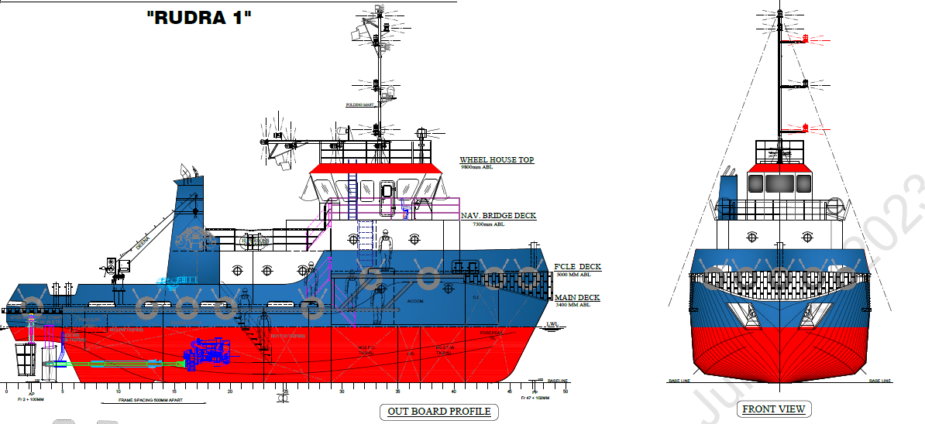

**General Arrangement is as under:-**

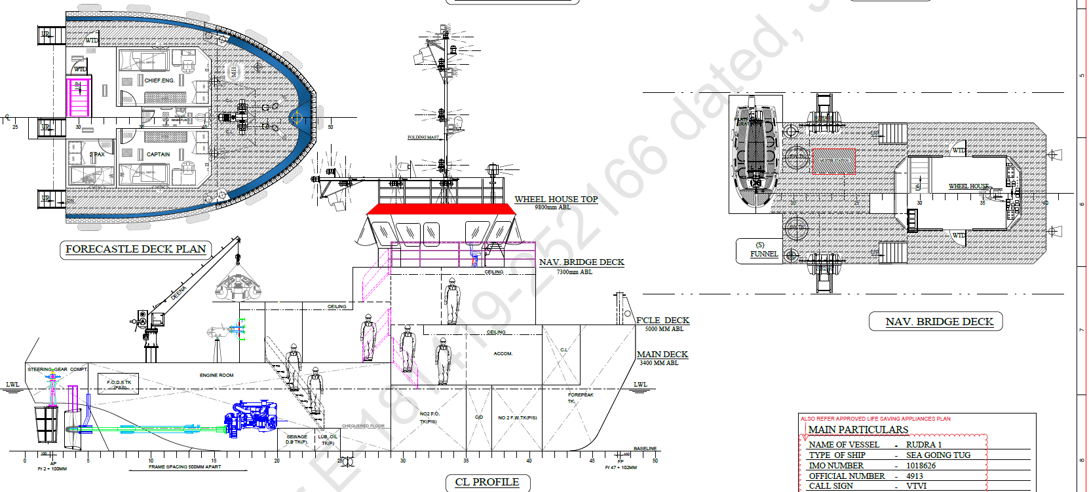

**General Arrangement is as under:-**

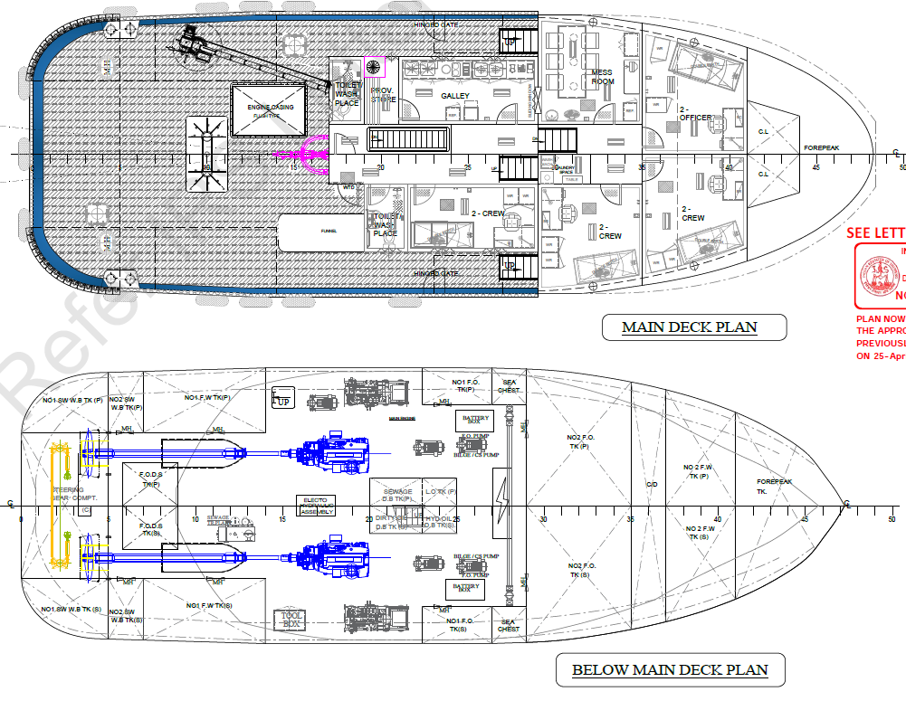

**3.3) COST OF TUG**

As per Shipbuilding Contract and Letter for the additional cost the Cost of 1 No. of MS Class Tug (Hull 119) is as under:-

| S. No | Particular of Project | Estimated Project Cost (Rs. in Lakhs) | GST @ 5%  (Rs. In Lakhs) | Total Cost  (Rs. In Lakhs) |
| --- | --- | --- | --- | --- |
| 1. | Basic cost of Tug boat | 851.00 | 42.55 | 893.55 |
| 2. | Additional cost for modifications & changes | 31.74 | 1.59 | 33.33 |
|  | **Total** | **882.74** | **44.14** | **926.88** |

**OBSERVATIONS:-**

* State Bank of India, SME Chembur (Diamond Garden) Branch has sanctioned Term Load of Rs 6.00 Crores vide as per Arrangement Letter SME-1 for sanction of Credit facilities dated 28.12.2022 made between M/s. Racon Marine Pvt. Ltd. and Relationship Manager, SBI, SME Chembur (Diamond Garden) Branch, Chembur, Mumbai-400 071 vide Letter No. SBI/SMEC/AR/2023-24/.

**3.4) APPOINTMENT OF SHIPBUILDER: -**

Company has appointed M/s. Essfour Engineering Pvt. Ltd. (Builder) and the Shipbuilding Contract dated 27.01.2023 made between M/s. Essfour Engineering Pvt. Ltd. (Builder) and   
M/s. Racon Marine Pvt. Ltd. (“Owner”) for the construction of 1 No. of MS Class Tug (Hull No. 119). Essfour Engineering Private Limited is a Shipbuilder all type of Ship and ship repairs. The total cost of Shipbuilding Contract is Rs. 8,51,00,000.00/- excluding GST @ 5%. The payment terms is as under:-

| S. No | Particular of Project | % of Payment | Amount (Rs.) |
| --- | --- | --- | --- |
| 1. | 1st Instalment shall be paid upon the date of execution of Contract | 5% | 42,55,000 |
| 2. | 2nd Instalment shall be paid upon approval of midship section and GA by Class | 10% | 85,10,000 |
| 3. | 3rd Instalment shall be paid upon Keel laying witness by Class | 25% | 2,12,75,000 |
| 4. | 4th Instalment shall be paid upon Completion of 50% Hull Erection & arrival of Main Engines and Gear Box & Stern Gear | 20% | 1,70,20,000 |
| 5. | 5th Instalment shall be paid upon launching of Tug authorised by Class | 20% | 1,70,20,000 |
| 6. | 6th Instalment shall be paid upon completion of inclining experiment of the Tug by class | 10% | 85,10,000 |
| 7. | 7th Instalment shall be paid upon Completion of sea trail of the Tug | 10% | 85,10,000 |
|  | **Total** | **100%** | **8,51,00,000** |

**OBSERVATIONS: -**

* Company has appointed the Contractors for the proposed Tug.
* Construction of Tug is going on.

**3.5) DETAIL TECHNICAL SPECIFICATION OF TUG:-**

The detailed technical specification of the Tug is as under:-

| S. No | Item Description | Specification | Qty | Capacity |
| --- | --- | --- | --- | --- |
|  | **Propulsion Package** |  |  |  |
| 1. | Main Engine | Volvo Penta D 13 | 2 | 600 BHP Unit approved IRS |
| 2. | Gear box | DONG | 2 | 3.98 ; 1 Unit approved IRS |
| 3. | Propeller shaft | Forged steel saft,  EN-19 or SUS 304 | 2 | IRS Unit Approved |
| 4. | Propeller | Manganese bronze fixed pitch 4 bladed | 2 | IRS Unit Approved |
| 5. | Steam tube | ST 53.2 | 2 | Complete with water lubricated bearings gland  packing |
| 6. | A Bracket | ST 53.2 | 2 | IRS Unit Approved |
|  | **GENERATORS** |  |  |  |
| 1. | Diesel Alternators | Perkins + Maclte | 2 | 62.5 KVA X2 IRS Approved |
|  | **PUMPS** |  |  |  |
| 1. | Bilge / Ballast / Fire / GS pump | ROYSONS | 2 | motor driven, 35  cum/hr, 40 MWC. |
| 2. | F.O Transfer pump | KIRLOSKAR | 1 | Motor driven 10 cum/hr 20 MWC Class approved |
| 3. | Sewage transfer pump | KIRLOSKAR | 1 | Motor driven 1 cum/hr 18 MWC |
| 4. | chain locker hand pump | standard | 1 | Capacity 91 ipm |
| 5. | E/R Bridge pump | Semi rotary hand  pump | 1 | Capacity 91 ipm |
| 6. | FW Transfer pump | KIRLOSKAR | 1 | Motor driven 1 cum/hr 20 MWC |
| 7. | Sewage treatment plant | Class approved | 1 | Techni SPA Spain |
| 8. | Oily water separator | Class approved | 1 | H2O USA |
|  | **DECK MACHINERY** |  |  |  |
| 1. | Anchor windlass | Cable lifter with warping drum IRS Approved | 1 | Electrical 10 m/min 2 cable  lifter and 2 warping rums 17.5 MM chain cable grade 2 IRS Approved |
| 2. | Anchor chain cables | Class approved | 10 | Full set |
| 3. | Mooring line | Polypropylene | 3 | 80 meter each breaking strength 34 KN |
| 4. | Stockless Bow Anchors | Class approved | 2 | 200 kg each |
| 5. | Chain stopper | Class approved | 2 | To suit 17.5 mm chain cable |
| 6. | Steering gear | Electro hydraulic type with emergency manual  helm pump | 2 | HY DRIVE Australia IRS Unit Approved |
| 7. | Rudder assembly | Steel plate type  rudder | 2 | IRS Unit  Approved |
| 8. | Towing winch | Class approved | 1 | 15 ton pull |
|  | **ANODES** |  |  |  |
| 1. | Anodes | Zinc anodes | 32 | 5 kg weight each |
|  | **CONTROL PANELS** |  |  |  |
| 1. | Remote control panel for  main engine |  | 2 |  |
| 2. | Steering control with  steering indicator |  | 1 |  |
| 3. | Engine alarm AV Displays and emergency shut off | Engine manufacturer  supply | 2 |  |
| 4. | Main switchboard | Class approved | 1 | with Synchronising  Panel |
| 5. | 230 V TPN Distribution  board | Standard | 1 |  |
| 6. | 24V DC Distribution board | Standard | 1 |  |
| 7. | Navigation light panel | Standard | 1 |  |
| 8. | Shore supply panel | Standard | 1 |  |
| 9. | E/R Supply fan starter | Standard | 1 | 3.7 KW |
| 10. | Bilge/ballast/Fire/GS pump starter | Standard | 2 | 3.7 KW |
| 11. | Aux machinery room supply fan starter | Standard | 1 | 1KW |
| 12. | FW Pump starter | Standard | 1 | 1 KW |
| 13. | F O Pump starter | Standard | 1 | 1KW |
| 14. | Sewage pump starter | Standard | 1 | 1KW |
| 15. | Air horn switch | Standard | 1 |  |
| 16. | General alarm button | Standard | 1 |  |
| 17. | Flood light switch | Standard | 2 |  |
| 18. | Searchlight switch | Standard | 1 |  |
| 19. | Switch for compass | Standard | 1 |  |
| 20. | Switch & sockets for Nav & common equipment | Standard | 1 |  |
| 21. | Fire alarm button | Standard | 1 |  |
| 22. | F O Pump shut off switch | Standard | 1 |  |
| 23. | Fire pump ON Switch | Standard | 1 |  |
|  | **Navigational & Communication Equipment** | | | |
| 1. | Magnetic compass | Standard | 1 | Optical reflector type |
| 2. | VHF Radio | Standard | 2 | Capable of RX Tx on Ch,6.13 and 16 |
| 3. | Portable VHF | Standard | 3 | Capable of RX Tx on Ch,6.13 and 16 |
| 4. | SART | Standard | 1 | 9GHz band |
| 5. | EPIRB | Standard | 1 |  |
| 6. | NAVTEX Receiver | Standard | 1 |  |
| 7. | MF/HF Radio | Standard | 1 |  |
| 8. | Spare magnetic compass | Standard | 1 |  |
| 9. | Radar X Band | Standard | 1 | X band 180 mm display 24 mm range |
| 10. | GPS Navigator | Standard | 2 |  |
| 11. | Rudder angle indicator | To be supply by steering gear manufacturer | 1 |  |
| 12. | Aneroid barometer | Standard | 1 |  |
| 13. | Air horn | Standard | 1 |  |
| 14. | Brass bell | Standard |  |  |
| 15. | Aldis Lamp/Search light | Standard | 1 |  |
| 16. | Binoculars | Standard | 1 |  |
| 17. | Marine clock | Standard | 1 |  |
| 18. | INMARSATIC | Standard | 2 |  |
|  | **LSA ITEMS** |  |  |  |
| 1. | Life raft | Inflatable type  SOLAS Pack 8 | 2 | Capacity 12 persons |
| 2. | Life Buoys | Self Igniting type | 3 |  |
| With Lifeline | 1 |  |
| standard | 2 |  |
| 3. | Life jacket | With reflective  tape & whistle | 20 |  |
| 4. | General alarm bell | standard | 1 |  |
| 5. | Rocket parachute | standard | 6 |  |
| 6. | Red hand flares | standard | 4 |  |
| 7. | Orange smoke flares | standard | 1 |  |
| 8. | Rescue Boat Rigid type | Class approved | 1 |  |
| 9. | Emergency Instruction |  | 1 |  |
| 10. | First Aid Kit |  | 1 |  |
| 11. | AIS transponder | Class B Type | 1 |  |
|  | **Fire Fighting Items** |  |  |  |
| 1. | FIRE Hydrant | 65 NB Instantaneous coupling | 4 |  |
| 2. | Fire hose with nozzle | 65 NB X 18 M | 4 |  |
| 3. | Foam fire extinguishers | Capacity 9 ltrs | 3 |  |
| 4. | DCP Fire extinguishers | Capacity 5 kg | 3 |  |
| 5. | Water fire extinguishers | Capacity 9 ltrs | 2 |  |
| 6. | Fire Axe |  | 1 |  |
| 7. | Sand box | 0.3 cum capacity |  |  |
| 8. | General/ Fire Alarm Bell |  | 2 |  |
| 9. | Fire bucket |  | 3 |  |
| 10. | Spare charge |  | 1 |  |
| 11. | CO2 Firefighting system |  | 1 |  |
|  | **NAVIGATIONAL LIGHTS** |  |  |  |
| 1. | Mast head light | Colour ; white | 1 | Duplex type |
| 2. | Anchor light | Colour ; white | 1 | Duplex type |
| 3. | Side light | Colour ; Green & Red | 2 | Duplex type |
| 4. | Stern light | Colour ; white | 1 | Duplex type |
| 5. | Signal light | Red ; 3 & white ; 1 | 4 | Single tier lights |
| 6. | Search light | 1000W Capacity | 1 |  |
|  | **DAY SIGNALS** |  |  |  |
| 1. | Black bell | Dia 600 mm | 3 |  |
| 2. | Black diamond | D1 : 600 mm, D2 : 1200 mm | 1 |  |
| 3. | Black cylinder | D : 600 mm H : 1200 mm | 1 |  |
|  | **Electrical Fittings** |  |  |  |
| 1. | LED Internal lights | IP -44 enclosure |  | To Owners choice |
| 2. | LED Internal lights | IP -65 enclosure |  | To Owners choice |
| 3. | LED TV | Standard |  |  |
| 4. | Satellite DTH Dish | Standard |  |  |
| 5. | Flood light | 500W | 2 |  |
| 6. | Toilet exhaust fan | Standard | 3 |  |
| 7. | Cabin passage fan (crew  room) | Standard | 4 |  |
| 8. | Wall mounted fan | 10’’ | 9 | For crew bunk |
|  |  | Standard | 2 | For crew mess room |
|  |  | Standard | 6 | W/H and pilot rest room |
| 9. | Spilt AC | Capacity : 1.5 ton | 3 |  |
|  |  | Capacity : 2 ton | 3 |  |
|  | **PIPING SYSTEM** |  |  |  |
|  | **BILGE & BALLAST & FIRE SYSTEM** | |  |  |
| 1. | Straight type globe valve | Class approved CS/SS | 2 | 150 NB |
| 2. | Angle type globe valve | Class approved CS/SS | 2 | 65 NB |
| 3. | Angle type globe valve | Class approved CS/SS | 2 | 40 NB for  generator |
| 4. | SDNR Valve | Class approved CS/SS | 2 | 80 NB (OBD) |
| 5. | SDNR Valve | Class approved CS/SS | 2 | 40 NB for generator |
| 6. | Gate valve | Class approved CS/SS | 1 | 50 NB for forepeak WB tank |
| 7. | Butterfly valve | CI/SS | 2 | 150NB |
| 8. | Gate valve | CI/GM | 3 | 80NB |
| 9. | Gate valve | CI/GM | 5 | 65NB |
| 10. | Gate valve | CI/GM | 4 | 50NB |
| 11. | SDNR Valve | CI/GM | 2 | 80 NB |
| 12. | SDNR Valve | CI/GM | 8 | 65 NB |
| 13. | SDNR Valve | CI/GM | 8 | 50 NB |
| 14. | Isolation valve globe | CI/GM | 1 | 65 NB fire line |
| 15. | Basket strainer with housing | Steel SS Strainer | 2 | 150 NB main suction strainer |
| 16. | Basket strainer with housing | Steel housing/SS  Strainer | 2 | 40 NB Aux suction strainer |
| 17. | Basket strainer with housing | Steel SS Strainer | 2 | 80 NB Bilge system |
| 18. | Mud box | Galvanised | 2 | 65 NB |
| 19. | Mud box | Galvanised | 2 | 50 NB |
| 20. | Foot Valve | MS | 8 | 50 NB |
| 21. | Bell mouth | Galvanised | 1 | 50 NB |
|  | **AIR & SOUNDING PIPE** |  |  |  |
| 1. | Air pipe vent head- Weighted type with wire  gauze | Galvanised | 5 | 65 NB |
| 2. | Air pipe vent head- Weighted type with wire  gauze | Galvanised | 1 | 100 NB |
|  | **SANITARY SYSTEM** |  |  |  |
| 1. | SDNR Valve | Class approved  CS/SS | 1 | 80 NB |
| 2. | Globe Valve | CI/GM | 2 | 40 NB |
|  | **ELECTRICAL CABLES** |  |  |  |
| 1. | GI Cable tray size 50 X 50  mm |  | 90 | meter |
| 2. | GI Cable tray size 150 X 50 mm |  | 180 | meter |
| 3. | GI Cable tray size 100 X 50 mm |  | 180 | meter |
| 4. | MS Flat bar 50 MM X 5 MM |  | 300 | Meter |
| 5. | MS Flat bar 32 MM X 5 MM |  | 500 | Meter |
| 6. | GI Conduit pipe 50 NB for making cable goose neck at w/H top |  | 28 | meter |
| 7. | GI Conduit pipe 32 NB for  making cable goose neck |  | 72 | meter |
| 8. | Cable Gland coaming 350 |  | 18 | Nos |
|  | MM X 150 MM |  |  |  |
| 9. | Cable pipe coaming 200 MM |  | 18 | Nos |
| 10. | Cable pipe coaming 100 MM |  | 12 | Nos |
| 11. | GI Elbow 50 NB 90 DEG (for W/H Mast battery & anchor windlass Goose neck) |  | 18 | No |
| 12. | GI Elbow 50 NB 90 DEG |  | 48 | No |
| 13. | MS Angle 50 X 5 MM |  | 72 | meter |
| 14. | MS Angle 40 X 5 MM |  | 54 | meter |
| 15. | 2C X 1.5 SQ MM Copper  cable |  | 1200 | meter |
| 16. | 2C X 1.0 SQ MM Copper  cable |  | 500 | meter |
| 17. | 2C X 25 SQ MM Copper cable (Actual cable length to be checked for battery bank 250 AH) |  | 50 | meter |
| 18. | 3C X 1.5 SQ MM Copper  cable |  | 800 | meter |
| 19. | 4C X 25 SQ MM Copper cable (Actual cable length to be checked for DG1, DG2 & shore supply box) |  | 120 | meter |
| 20. | 4C X 4 SQ MM Copper cable |  | 100 | meter |
| 21. | Earthing wire 4 sqmt (green color) |  | 100 | meter |
| 22. | Cable Gland PG 13.5 |  | 92 | Nos |
| 23. | Cable Gland PG 16 |  | 62 | Nos |
| 24. | Cable Gland PG 19 |  | 2 | Nos |
| 25. | Double Compression cable Gland 25 mm |  | 2 | Nos |
| 26. | Double Compression cable Gland 32 mm |  | 25 | Nos |
| 27. | Bootiace 1.5 sqmt Cu pin  type |  | 600 | Nos |
| 28. | Bootiace 2.5 sqmt Cu pin  type |  | 55 | Nos |
| 29. | 25 sqmt Ring type Cu Lug hole dia 10 mm |  | 16 | Nos |
| 30. | Bootiace 1.5 sqmt Cu pin  type |  | 100 | Nos |
| 31. | 1.5 sqmt Cu Ring type hole dia 6 mm |  | 80 | Nos |
| 32. | 25 sqmt Ring type Cu Lug hole dia 10 mm |  | 30 | Nos |
| 33. | 4 sqmt Cu pin type Lug |  | 10 | Nos |
|  | **STEEL MATERIALS** |  |  |  |
| 1. | Steel Plates and sections | IRS Approved  Grade A | 1 | Lot |
|  | **PIPE MATERIALS** |  |  |  |
| 1. | Pipe & pipe fittings | MS Sch.40/Sch.80 |  | Lot |
| 2. | Owner Furnished materials for ship operation |  |  | Prior to ship  delivery |
| 3. | Flags ,Charts, Almanac |  |  |  |
| 4. | Cutlery Crockery |  |  |  |
| 5. | Linen Mattress |  |  |  |
| 6. | Cooking Utensils provision |  |  |  |
| 7. | Provisions |  |  |  |
| 8. | Rope & Deck Inventory |  |  |  |
| 9. | Oils & Lubricants |  |  |  |
| 10. | Additional spares if any |  |  |  |
| 11. | Tools & Portable lifting  equipment |  |  |  |
| 12. | Medicine kit |  |  |  |
| 13. | Stores Inventory |  |  |  |
|  | **Accommodation Materials** | |  |  |
| 1. | Bulking Lining panels 50  mm B-15 |  | 450 | Sq.Mt |
| 2. | Celling panels |  | 300 | Sq.Mt |
| 3. | Linoleum sheet | 2 mm thick | 300 | Sq.Mt |
| 4. | Latex underlay | 8-10 mm thick | 300 | Sq.Mt |
| 5. | Vitrified tiles for Galley &  toilet | 1’ x 1’ | 90 | Sq.Mt |
| 6. | Cement underlay for tiles | 25 mm thick | 90 | Sq.Mt |
| 7. | Wire mesh | 1’ x 1’ | 90 | Sq.Mt |
| 8. | 50 mm thick Thermal  Rockwool Insulation | Class approved 50  kg/cm3 | 500 | Sq.Mt |
| 9. | 25 mm thick Thermal  Rockwool Insulation | Class approved 50  kg/cm3 | 150 | Sq.Mt |
| 10. | 50 mm thick A-60 Rockwool Insulation | Class approved 80  kg/cm3 | 200 | Sq.Mt |
| 11. | 25 mm thick A-60 Rockwool | Class approved 80 | 65 | Sq.Mt |
|  | Insulation | kg/cm3 |  |  |
| 12. | Porthole | Class approved  350 dia | 13 |  |
| 13. | Windows | Class approved  Assorted size | 20 |  |
| 14. | Furniture & loose furnishing |  | 1 |  |
| 15. | Steel weather light door | Class approved  1800 x 700 clear opening | 12 | Nos |
| 16. | A-60 Door | Class approved  1800 x 700 clear opening | 1 | Nos |
| 17. | A-0 Door | Class approved 1800 x 700 clear opening | 1 | Nos |
| 18. | C Class Door | clear opening 1800  x 700 | 5 | Nos |
| 19. | C Class Door | clear opening 1750  x 600 | 1 | Nos |
|  | **FOUNDATIONS** |  |  |  |
| 1. | Angle bar 65x65x6 | MSB Foundation | 48 | Mtrs |
| 2. | Angle bar 50x50x6 | Distribution board | 18 | Mtrs |
| 3. | M12X50 SS bolts, nuts  washers |  | 56 | nos |
| 4. | M10X50 SS bolts, nuts  washers |  | 18 | nos |
| 5. | M10X40 SS bolts, nuts  washers |  | 6 | nos |
| 6. | M16X65 SS bolts, nuts  washers |  | 30 | nos |
| 7. | M16X4=40 SS bolts, nuts  washers |  | 4 | nos |
| 8. | Angle bar 50x50x6 | Battery box foundation | 36 | mtrs |

**3.6) COST FOR MODIFICATION & CHANGERS: -**

As per Letter for Cost towards additional & Alteration of Yard 119 issued by M/s. Essfour Engineering Pvt. Ltd. (Builder) dated 10.09.2023, the Cost for Modification & Changes is as under:-

| S. No | Description | Material/Equipment cost (Rs.) | Labour/service charges (Rs.) |
| --- | --- | --- | --- |
| 1 | Tank augmentation from 30 KL to 60 KL mainly connections, double jacketing the FO tank etc. | 92,040.0 | 1,08,675.0 |
| 2 | Piping work for FO tank. | 25,636.0 | 38,400.0 |
| 3 | Painting of the new equipment | 29,414.0 | 36,767.0 |
| 4 | Accommodation (2 person cabin) | 69,030.0 | 81,507.0 |
| 5 | Towing winch and wire rope | 18,60,000.0 | 82,032.0 |
| 6. | Sea water Hydropore– to consume sea water for flushing instead of fresh water | 4,25,250.0 | 2,25,000.0 |
| 7. | Design charges | - | 1,00,000.0 |
|  | **Sub Total** | **25,01,370.0** | **6,72,381.0** |
|  | **Grand Total** | **31,73,751.0** | |

**OBSERVATIONS: -**

* The above cost is excluding GST @ 5%.
* **Towing Winch:** Initially it was proposed to install a towing hook, this is less effective than the replaced towing winch. The towing winch proposed is Indian Register (IR) Class approved for safety of crew and efficient operations. The clients also prefer a Tug with towing winch rather than tugs with a plain hook.
* **Hydropore:** The proposal is to install Hydropore, so that Seawater can be utilised in place of Freshwater in Flush tanks. This will reduce usage/ wastage of Freshwater and the number of days the vessels at sea will be increased. The Freshwater capacity is 47 Tons (1.5 Ton consumption per day will give 30 days endurance).
* **Fuel Oil:** The capacity of Fuel oil is 60 KL (80% capacity can only be loaded i.e. 48 KL), the calculated consumption is 1.5 KL per day, which means the vessel can easily stay at sea for 30 days (45 KL per month consumption). The augmentation of FO is for increase her endurance. The Original plan was for 30 KL. By utilizing one of the ballast tanks for FO the company has extended the “stay at sea”.
* **Separate cabin for Seismic Surveyors/ observers:** Need to provide an additional cabin to accommodate 2 Surveyors for continued stay in the vessel for the survey purpose. This will be an additional factor for the clients to consider the vessel for charter/hire.

**3.7)** **STATUTORY COMPLIANCES: -**

Status of Approvals and clearances is as under: -

| S. No. | Description | Status |
| --- | --- | --- |
| A | Technical (IR Class) |  |
| 1 | Contract signing with class | Completed |
| 2 | Approval of GA Plan | Completed |
| 3 | Approval of midship | Completed |
| 4 | Approval of preliminary stability | Completed |
| 5 | Inclining test | Pending |
| 6 | Issuance of class certificates | Pending |
| **B** | **Statutory India Flag** |  |
| 1 | Application for name approval | Approved |
| 2 | Application for International call sign | Approved |
| 3 | Application for MMSI number | Approved |
| 4 | Application for IMO number | Approved |
| 5 | Application for ship station license | Applied |
| 6 | Marking carving inspection | Post Launching |
| 7 | Issuance of SMD | Post Launching |
| 8 | Issuance of Registry | On completion of the vessel |

**3.8) IMPLEMENTATION SCHEDULE: -**

Implementation Schedule is as under:-

| S. No. | Activity | Original Time Frame | Remark |
| --- | --- | --- | --- |
| 1 | Signing of Agreement | 27th January 2023 | Completed |
| 2 | Date of keel lay | 19th April 2023 | Done |
| 3 | Hull completion | 10th October 2023 | 75% Completed |
| 4 | Launching | 15th November 2023 | Delay |
| 5 | Final Delivery | 15th December 2023 | Delay |

**OBSERVATIONS: -**

* During the Date and time of Visit the Construction of Hull is going on.

**3.9) INSURANCE: -**

Company has not provided the Insurance Copy

**OBSERVATIONS: -**

* Company must take insurance policy for the Construction.

1. **TUG CONSTRUCTION**

#### 4.1) COST OF TUG

As per Shipbuilding Contract and Letter for the additional cost the Cost of 1 No. of MS Class Tug (Hull 119) is as under:-

| S. No | Particular of Project | Estimated Project Cost (Rs. in Lakhs) | GST @ 5%  (Rs. In Lakhs) | Total Cost  (Rs. In Lakhs) |
| --- | --- | --- | --- | --- |
| 1. | Basic cost of Tug boat | 851.00 | 42.55 | 893.55 |
| 2. | Additional cost for modifications & changes | 31.74 | 1.59 | 33.33 |
|  | **Total** | **882.74** | **44.14** | **926.88** |

#### 4.2) EXPENDITURE ON PROJECT: -

As per Letter for the confirmation of receipt of payment from RMPL towards construction 15 Ton Bollard Pull Tug MS Class IX (Y-119) issued by M/s. Essfour Engineering Pvt. Ltd. (Builder) dated 15.12.2023, the Cost incurred by RMPL is as under:-

|  |  |  |  |
| --- | --- | --- | --- |
| S. No. | Date | UTR No. | Cost Incurred (₹) |
| 1. | 14.03.2023 | SBINH23073315757 | 50,00,000 |
| 2. | 14.03.2023 | SBINH23073315756 | 50,00,000 |
| 3. | 28.03.2023 | SBINH23087225197 | 50,00,000 |
| 4. | 28.03.2023 | SBINH23087225226 | 50,00,000 |
| 5. | 22.05.2023 | SBINH23142676539 | 30,00,000 |
|  |  | **Total** | **2,30,00,000** |

**The expenditure on Cost on Project as on 15.12.2023 is Rs. 2,30,00,000/-**

**OBSERVATIONS: -**

* The Construction of Hull is 75% Completed.
* 80% of machinery is arrived and Kept at Yard of Shipbuilder and Supplier in the near by premises.
* Engine, Gerabox, Panels etc. are arrived at site.

1. **PHOTOGRAPHS**

|  |  |
| --- | --- |
|  |  |
|  |  |
|  |  |
|  |  |
|  |  |
|  |  |
|  |  |
|  |  |
|  |  |
|  |  |
|  |  |
|  |  |
|  |  |
|  |  |
|  |  |
|  |  |
|  |  |
|  |  |
|  |  |
|  |  |
|  |  |
|  |  |
|  |  |
|  |  |
|  |  |
|  |  |
|  |  |
|  |  |

1. **NOTES, LIMITATIONS, DISCLAIMERS & CAVEATS**

#### Notes, Limitations, Disclaimers & Caveats forms important part of the report.

* The Lender’s independent engineer report is made to review the progress of project activities and to prepare the detail report outlining all activities completed along with the status.
* Our Engineer has visited the project site 1st Time on 21.12.2023 with a view to ascertain and certify the quantity and amount of work progressively undertaken by the borrower till 21.12.2023.
* LIE progress report is based on the physical verification of the site on 21.12.2023, invoices provided, discussions held with the Plant Head of the Company and information and explanation given & documents provided. Accordingly, the percentage of work of completion of project activities is worked out. The photographs are enclosed.
* The Company has provided the necessary documents. LIE has referred the same for preparation of report.
* During the date and time of our visit construction of Tug was going on and it can be clearly seen from the photographs enclosed.
* The Credit details in other bank accounts are not verified by us and we have relied on documents issued by the party.
* Our report does not cover verification of ownership, title clearance, or legality and subject to adequacy of engineering / structural design.
* Our report does not cover verification of ownership, title clearance, or legality and subject to adequacy of engineering / structural design. The report is delayed as compared with the visit date because of delay in receipt of documents.
* It should be noted that VCIPL’s project progress assessments are based upon the facts and evidence available at the time of assessment and the documents provided. The lenders should do the progress assessment from time to time.
* The legal documents pertaining to the ownership of the properties has been referred to on its face value and that is presumed that Bank /financer have got the same verified through its legal counsel. We do not certify the veracity of the documents. This report does not certify valid or legal or marketable title of any of the parties over the property. Our report does not cover verification of ownership, title clearance, or legality and subject to adequacy of engineering / structural design.
* Our report is only for the use of the party to whom it is addressed, and no responsibility is accepted to any third party for the whole or any part of its contents.
* It is presumed that the soft copies of documents are taken from the originals duly tested and verified at the party’s end.
* The progress report is made based on our visit, information furnished, discussions, documents made available at the time of visit. We presume optimistically that the project assessed by us will be a top success project. In case on a future date if the project does not come up to an expectation of the lenders and borrowers, due to various factors i.e., socio, economic and political factors in this region and country, any decrease in projections, profits, non-repayment of regular installments of loan and interest thereon, the VCIPL should not be held responsible on a future date. The market scenario in India at particular and the whole world at large is at volatile trend since last many months and future cannot be anticipated as of date.
* Our report should be read along with disclaimers. We have given our opinion as the percentage of work completion of the project as on date of visit to the project site.

1. **SUMMARY**

#### 7.1) WORK COMPLETION FOR THE PROJECT: -

progress is as under: -

| S. No | Particular | Remark | % of Work | % of Work Completed till 21.12.2023 |
| --- | --- | --- | --- | --- |
| 1. | Execution of Contract | Done | 5% | 5% |
| 2. | Approval of midship section and GA by Class | Done | 10% | 10% |
| 3. | Keel laying witness by Class | Done | 25% | 25% |
| 4. | Completion of 50% Hull Erection & arrival of Main Engines and Gear Box & Stern Gear | 75% of Hull Erection done and arrival of Main Engines and Gear Box & Stern Gear | 20% | 25% |
| 5. | launching of Tug authorised by Class | Pending | 20% | 0 |
| 6. | Completion of inclining experiment of the Tug by class | Pending | 10% | 0 |
| 7. | Completion of sea trail of the Tug | Pending | 10% | 0 |
|  |  | **Total** | **100%** | **60%** |

1. **OPINION**

Based on the physical inspection and verification of Construction site, information and explanation given to us and the documents referred by us; we are of the opinion that the progress of 1 No. of MS Class Tug Boat to be carried out by Essfour Engineering Pvt. Ltd. (“Builder”) located at Cortalim, Quelossim, Cortalim-Racaim-Loutulim-Borim Road, PIN Code-403 710, State- Goa, County-India belonging to **M/s. Racon Marine Pvt. Ltd.**  is 60 % completed till 21.12.2023 as per our information provided by the party, observation made during LIE 1st visit to the project site on 21.12.2023 subject to observations made in the main report.

**Date:-23.12.2023**

**Place:- Mumbai**

**For Vastukala Consultants (I) Pvt. Ltd.**

|  |
| --- |
| **Umang A Patel** |
| **Registered Valuer**  **Chartered Engineer (India)**  **Reg. No. IBBI/RV/04/2019/10803** |