Vastu/Nashik/01/2024/006639/2304741
30/15-443-CCBS
Date: 30.01.2024

To, `
The Branch Manager,
State Bank of India
RACC Nashik Branch
RBO.2, The Wave Building, 1 st Floor, Opposite Shell Petrol Pump, Pathardi Road,
Nashik – 422 010, State – Maharashtra, Country – India.

Sub: Vetting of Extra Amenities

Sir,

With reference to above subject, we have evaluated the Extra Amenities for Residential Flat No. C - 204, Second Floor, Wing - C, “ Rushiraj Galaxy ”, Survey No.197/1 to 10 ( P) 198/199/1/200(P)/201,Plot No. 5+6, Near Adumber Banquet Lawns, Gayatri Nagar, Vaiduwadi, Village - Mhasrul, Taluka & District – Nashik, PIN – 422 004, State – Maharashtra, Country – India belongs to M/s.Rushiraj Realtors Name of Proposed Purchaser: Ms.Kaveri Yashwant Bagul & Mr.Kunal Laxman Bahiram.

We have verified the rates quoted as per current market rates. Details of work and Extra Amenities considered as per copy of Extra Amenities issued by Ms.Kaveri Yashwant Bagul & Mr.Kunal Laxman Bahiram (First Party) and Shri.Ketan Pravinchandra Trivedi (Second Party) received on dated 28.01.2024. The Extra Amenities amount is Rs.4,00,000/- ( Rupees Four Lakh Only. )

The said Cost Vetting Certificate is valid upto next 6 months Only.

Thanking you

Sincerely yours

Manoj B. Chalikwar
Registered Valuer
Chartered Engineer (India)
Reg. No. CAT-I-F-1763
Reg. No. IBBI/RV/07/2018/10366
BOB Empanelment No.: ZO:MZ:ADV:46:941
Encl: Valuation report.

Agreement for Extra Amenities
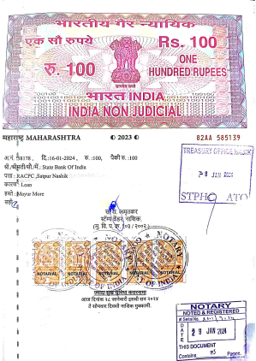
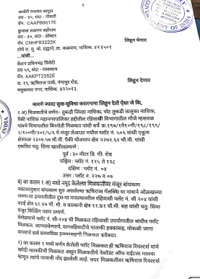

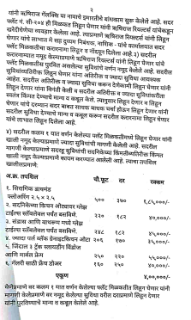
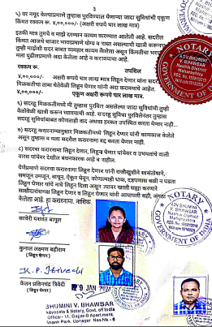

The Extra Amenities amount is Rs.4,00,000/- (Rupees Four Lakh Only)

