Vastu/Nashik/01/2024/006628/2304729
30/3-431-RPBS
Date: 30.01.2024

To, `
The Branch Manager,
Bank of Baroda
Regional Office Nashik Road Branch
BSNL Building, Datta Mandir Road, Nashik Road,
Nashik -422 101, State - Maharashtra, Country - India.

Sub: Vetting of Extra Work

Sir,

With reference to above subject, we have evaluated the Extra Work for Residential Flat No. A - 603, Sixth Floor, A-Wing "Millennium Tower", Survey No. 200/ 6/ 1, Plot No.1A, Behind Laxminarayan Yeola Pathaini Sarees, Sai Nagar, Ayodhya Nagari, SaiNagar Road, Village – Nashik, Taluka- Nashik, District - Nashik, PIN Code – 422 003, State – Maharashtra, Country – India belongs to Name of Owner: Mr. Mayur Mejarsing Pardeshi & Mrs. Shamlee Mayur Pardeshi.

We have verified the rates quoted as per current market rates. Details of work and Extra Work considered as per copy of Agreement for Extra Work issued by Mr. Mayur Mejarsing Pardeshi & Mrs. Shamlee Mayur Pardeshi. (First Party) and M/s. Nasa Constructions. (Second Party) received on dated 29.01.2024. The Extra Work amount is Rs.8,00,000/- (Rupees Eight Lakh Only)

The said Cost Vetting Certificate is valid upto next 6 months Only.

Thanking you

Sincerely yours

Manoj B. Chalikwar
Registered Valuer
Chartered Engineer (India)
Reg. No. CAT-I-F-1763
Reg. No. IBBI/RV/07/2018/10366
BOB Empanelment No.: ZO:MZ:ADV:46:941
Encl: Valuation report.

Cost Sheet of Extra Work
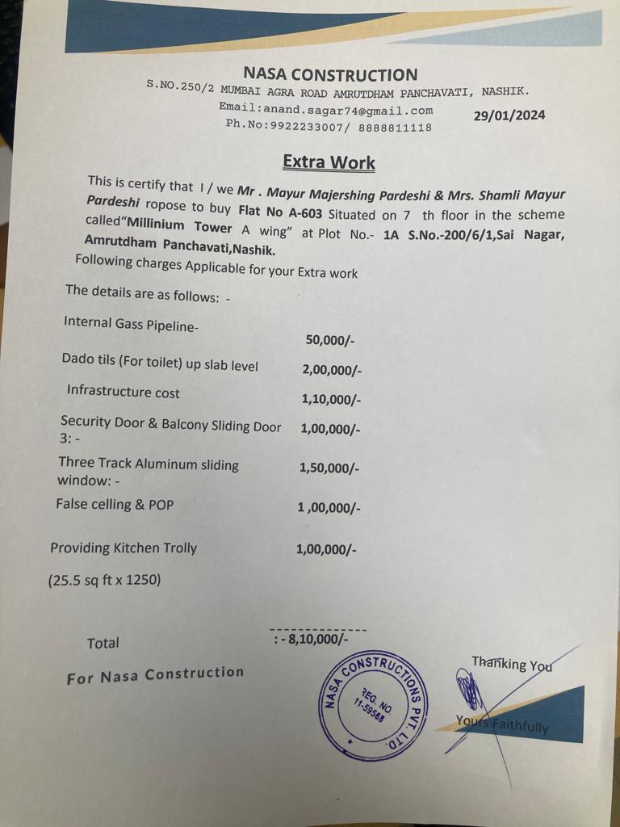

The Extra Amenities amount is Rs.8,00,000/- (Rupees Eight Lakh Only. )

