Vastu/Nashik/01/2023/28773/44599 03/05-13-RPV Date: 29.01.2024

**Structural Stability Report**

Residential Land and **Bungalow on Plot No.14**, Ground + First Floor, Survey No.908/3/14, Opposite Sai Coaching Classes, Mauli Nagari, Dnyaneshwar Nagar, Vidya Nagar, Village – Nashik, Taluka & District - Nashik, PIN Code – 422 010, State – Maharashtra, Country – India belongs to **Shri. Vasant Damodhar Palve.**

This is to certify that on visual inspection, it appears that the structure of **"Bungalow on Plot No.14"** is in normal condition and the future life can be reasonably takes under normal condition and with proper periodic repairs & maintenance is about 40 years.

**General Information**:

|  |  |  |
| --- | --- | --- |
| **A.** | **Introduction** | |
| 1 | Name of Building | **" Bungalow on Plot No.14"** |
| 2 | Property Address | Residential Land and **Bungalow on Plot No.14**, Ground + First Floor, Survey No.908/3/14, Opposite Sai Coaching Classes, Mauli Nagari, Dnyaneshwar Nagar, Vidya Nagar, Village – Nashik, Taluka & District - Nashik, PIN Code – 422 010, State – Maharashtra, Country – India belongs to **Shri.Vasant Damodhar Palve.** |
| 3 | Type of Building | Bungalow |
| 4 | No. of Floors | Ground + 1st Upper Floor |
| 5 | Whether stilt / podium / open parking provided | Open Car Parking |
| 6 | Type of Construction | R.C.C. Framed Structure |
| 7 | Type of Foundation | R.C.C. Footing |
| 8 | Thickness of the External Walls | 6’ thick brick walls both sides plastered |
| 9 | Type of Compound | Brick Masonry Walls |
| 10 | Year of Construction | 2003 (As per Full Occupancy Certificate- Ground Floor) |
| 11 | Present age of building | 20 years |
| 12 | Residual age of the building | 40 years Subject to proper, preventive periodic maintenance & structural repairs. |
| 13 | No. of Flats | - |
| 14 | Methodology adopted | As per visual site inspection |

|  |  |  |
| --- | --- | --- |
| **B.** | **External Observation of the Building** | |
| 1 | Plaster | Good |
| 2 | Chajjas | Good |
| 3 | Plumbing | Good |
| 4 | Cracks on the external walls | Not Found |
| 5 | Filling cracks on the external walls | Not Found |
| 6 | Cracks on columns & beams | Not Found |
| 7 | Vegetation | Not Found |
| 8 | Leakages of water in the drainage pipes or water pipes | Not Found |
| 9 | Dampness external in the wall due to leakages | Not Found |
| 10 | Any other observation about the condition of external side of the building | The external condition of the structure is in Average condition |
| **C** | **Internal Observation of the common areas of the building and captioned premises** | |
| 1 | Beams (Cracks & Leakages) | Not found |
| 2 | Columns (Cracks & Leakages) | Not found |
| 3 | Ceiling (Cracks & Leakages) | Not found |
| 4 | Leakages inside the property | Not Found |
| 5 | Painting inside the property | External Wall Plaster and Painting Condition is Good. |
| 6 | Maintenance of staircase & cracks | Good |

|  |  |  |
| --- | --- | --- |
| **D** | **Common Observation** | |
| 1 | Structural Audit of the Building Under Bye – Laws No. 77 of the Model Bye Laws (Co-Operative Societies Act / Rules) | As per bye Laws No. 77 of Co-Op. Societies bye Laws under the Act the society shall conduct a Structural Audit of the building of the society as follows |
| 2 | Remark | - |

|  |  |
| --- | --- |
| **E** | **Conclusion** |
| The captioned Bungalow is having Ground + 1s floor which are constructed in year 2003 (As per Full Occupancy Certificate- Ground Floor). Estimated future life under present circumstances is about 40 years’ subject to proper, preventive periodic maintenance & structural repairs.  The inspection dated 20.2.2023 reveals no structural damage or deterioration to the building. The building as well as the property is maintained in normal condition & will stand future life subject to proper, preventive periodic maintenance & Average structural repairs.  Our Observations about the structure are given above.  The above assessment is based on visual inspection only. | |

**Sharadkumar B. Chalikwar**

Govt. Reg. Valuer

Chartered Engineer (India)

Reg. No. (N) CCIT/1-14/52/2008-09

Encl: Valuation report.

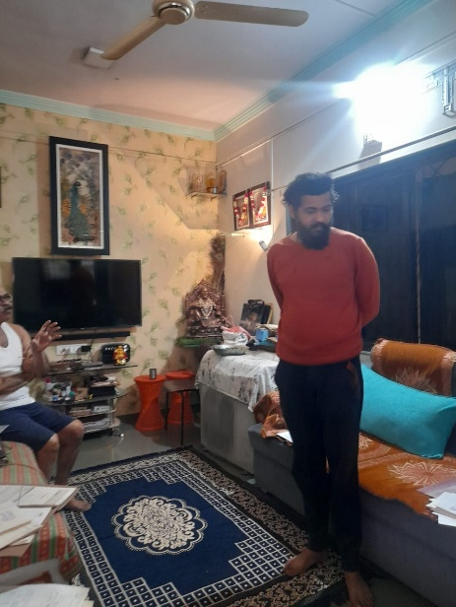**Actual Site Photographs**

