Vastu/Nashik/01/2024/006613/2304719
29/16-421-RPBS
Date: 29.01.2024

To, `
The Branch Manager,
Bank of Baroda
Regional Office Nashik Road Branch
BSNL Building, Datta Mandir Road, Nashik Road,
Nashik -422 101, State - Maharashtra, Country - India.

Sub: Vetting of Extra Amenities

Sir,

With reference to above subject, we have evaluated the Extra Amenities for Residential Flat No. 02, Stilt Floor, " Suvarna Varsha Apartment ", Survey No. 535/1/1, Plot No. 20, Near Uddhav Memorial Cancer Hospital, Sagar Nagar, Mumbai - Agra National Highway, Jatra Hotel, Village - Adgaon, Taluka & District - Nashik, PIN Code – 422004, State – Maharashtra, Country – India belongs to Name of Proposed Purchaser: Sau. Sunita Vasudev Sharma. Name of Owner: Shri. Valmik Daulat Rode

We have verified the rates quoted as per current market rates. Details of work and Extra Amenities considered as per copy of Agreement for Extra Amenities issued by Sau. Sunita Vasudev Sharma & Shri. Aakash Vasudev Sharma (First Party) and Shri. Valmik Daulat Rode. (Second Party) received on dated 24.01.2024. The Extra Amenities amount is Rs.3,00,000/- (Rupees Three Lakh Only)

The said Cost Vetting Certificate is valid upto next 6 months Only.

Thanking you

Sincerely yours

Manoj B. Chalikwar
Registered Valuer
Chartered Engineer (India)
Reg. No. CAT-I-F-1763
Reg. No. IBBI/RV/07/2018/10366
BOB Empanelment No.: ZO:MZ:ADV:46:941
Encl: Valuation report.

Agreement for Extra Amenities
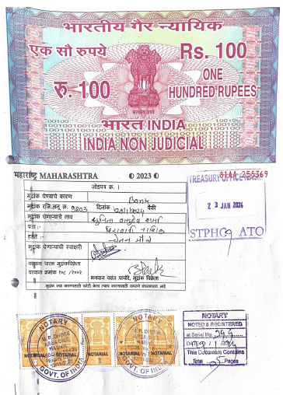
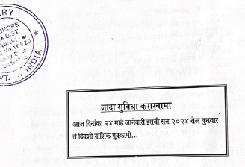

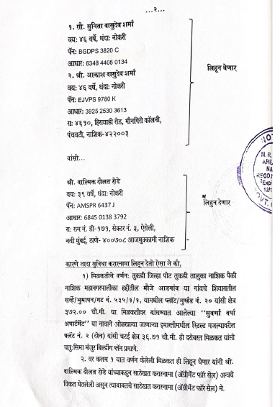

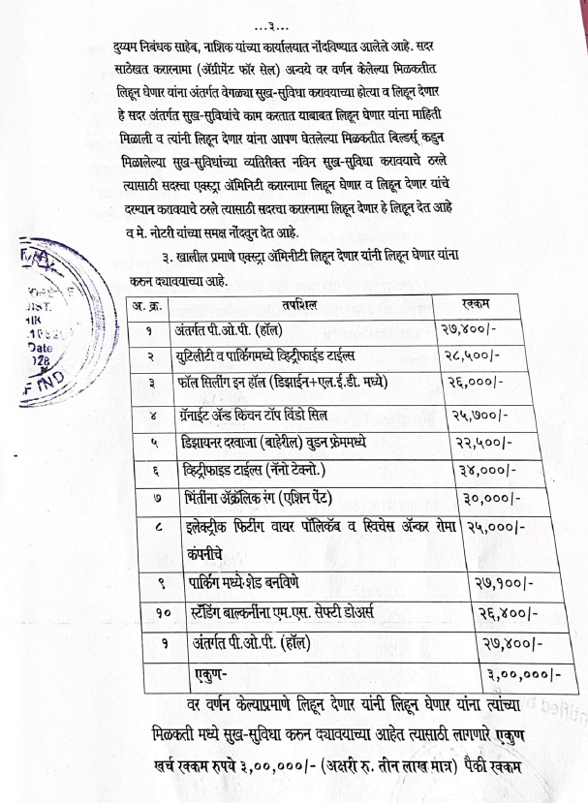
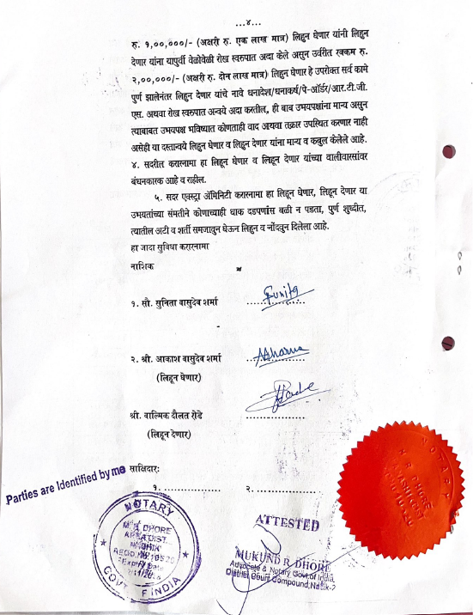

The Extra Amenities amount is Rs.3,00,000/- (Rupees Three Lakh Only. )

