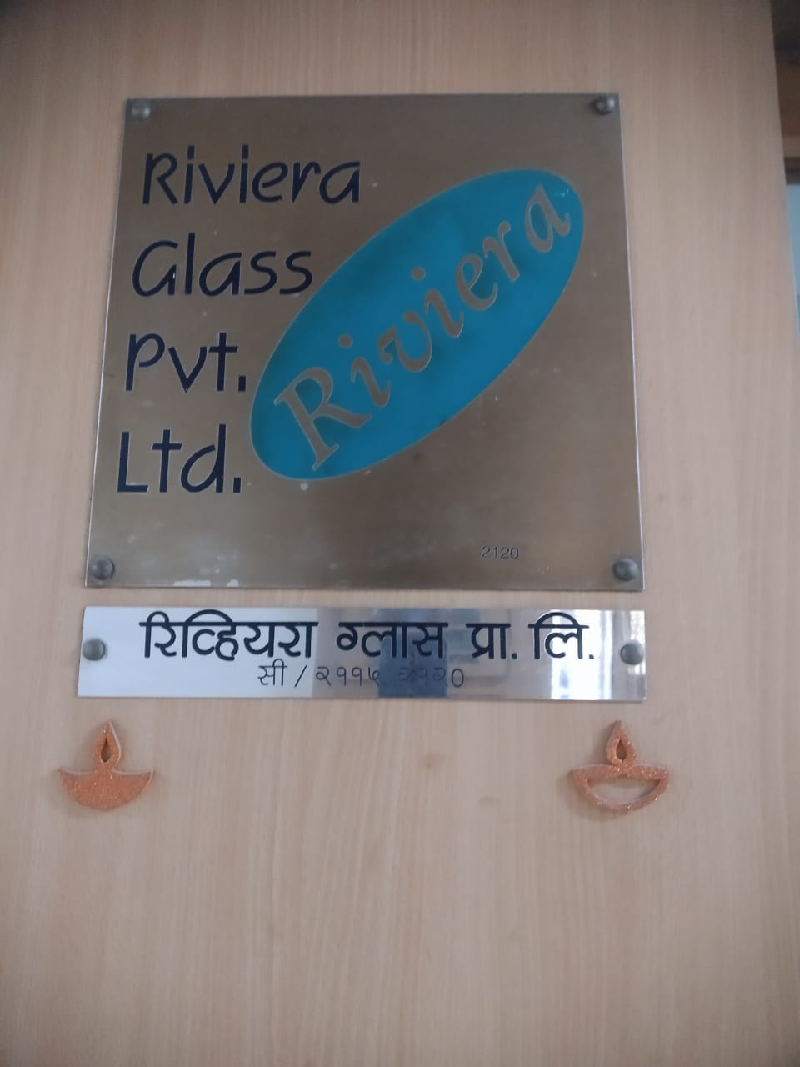

Report Prepared for : **M/s. Riviera Glass Pvt. Ltd.**

Report Prepared By : **Mr. Manoj B. Chalikwar – Govt. Registered Valuer**

Report Prepared By Manoj Baburao Chalikwar Umang Ashwin Patel Prashant Jain

Report Prepared By Manoj Baburao Chalikwar Umang Ashwin Patel Prashant Jain

Valuation of Office Nos. 2115, 2116 & 2120 for 11UA

# Contents

Contents 2

1. Executive Summary of Valuation 3

1.1. Appointment of Valuer: 3

1.2. Details of property for valuation: 4

1.3. Summary of Valuation: 5

2. Scope of Work: 6

3. Valuation Date and Report Date 6

4. Methodology 6

4.1. Basis (Bases) of Value 7

4.1.1. Determination of fair market value for inventory. 7

4.2. Premise of Value – Current Use / Existing Use 8

4.2.1. Current Use/Existing Use 8

5. Disclosure of Valuer’s Interest 8

6. About the Building: 8

6.1. The Building Oberori Garden Estates Amenities & Features: 8

6.2. Location Advantages: 9

7. Conditions and Major Assumptions: 9

7.1. Conditions: 9

7.2. Assumptions 9

7.3. Nature and Source of Information Used or Relied Upon: 10

7.4. Date of Site inspection / site Visit: 10

8. VALUATION REPORT IN RESPECT OF IMMOVABLE PROPERTY 11

8.1. Valuation Report 11

8.2. Actual site photographs 15

8.3. Route Map of the property 18

8.4. Ready Reckoner 2022 -23 19

9. Valuation as on 31.03.2023: 20

10. Conclusion 21

# Executive Summary of Valuation

Determination of fair market value (under Rule-11UA) for Office Nos. 2115, 2116 & 2120, 2nd Floor, Wing – C **“Oberoi Garden Estates”**, Off. Chandivli Farms Road, Chandivli, Andheri (East), Mumbai – 400 072 State - Maharashtra, Country – India.

## Appointment of Valuer:

Mr. N. V. Balakrishnan (Director) of M/s. Riviera Glass Pvt. Ltd. has appointed M/s Vastukala Consultants (I) Pvt. Ltd. - **Manoj B. Chalikwar** - Registered Valuer – Immovable Property to provide an opinion on Determination of fair market value (under Rule-11UA) for Office Nos. 2115, 2116 & 2120, 2nd Floor, Wing – C **“ Oberoi Garden Estates”**, Off. Chandivli Farms Road, Chandivli, Andheri (East), Mumbai – 400 072 State - Maharashtra, Country – India.

Vide Meeting as on 29.01.2024,

|  |  |
| --- | --- |
| Type of Assets | Immovable Properties |
| Name of the Valuer | **Manoj B. Chalikwar** |
| Registration number of the Valuer | Reg. No. IBBI/RV/07/2018/10366 |
| E-mail Id | [manoj@vastukala.org](mailto:manoj@vastukala.org) |
| Address | Vastukala Consultants (I) Pvt. Ltd., B1-001, U/B Floor, Boomerang, Chandivali Farm Road, Powai, Andheri (East), Mumbai – 400 072, State - Maharashtra, Country - India |

## Details of property for valuation:

**Office Nos. 2115 & 2120 :**

At the time of visit we observed that Office Nos. 2115 & 2120 was amalgamated with single entrance. The composition of amalgamated office is Entrance + 3 Cabins + Working Area + Pantry + Toilet. As per our physical measurement Carpet area of amalgamated Office is 782.00 Sq. Ft. As per Agreement area of office are as under:

|  |  |  |  |
| --- | --- | --- | --- |
| **Office Nos.** | **Built up area**  **(Sq. Ft.)** | **Built up area**  **(Sq. M.)** | **Super Built up area**  **(Sq. Ft.)** |
| 2115 | 432.00 | 40.13 | 540.00 |
| 2120 | 448.00 | 41.62 | 560.00 |

**Office Nos. 2116**

The composition of office is Working Area + Conference Room + Toilet. As per our physical measurement Carpet area of Office is 395.00 Sq. Ft. As per Agreement area of office are as under:

|  |  |  |  |
| --- | --- | --- | --- |
| **Office No.** | **Built up area**  **(Sq. Ft.)** | **Built up area**  **(Sq. M.)** | **Super Built up area**  **(Sq. Ft.)** |
| 2116 | 432.00 | 40.13 | 540.00 |

## Summary of Valuation:

|  |  |  |  |  |
| --- | --- | --- | --- | --- |
| Office Nos. | Built up area  (Sq. M.) | Rate / Sq. M. as on 31.03.2023 (` ) | Depreciated Rate / Sq. M. (` ) | Value (` ) |
| 2115 | 40.13 | 2,10,860.00 | 1,81,641.00 | 72,89,253.00 |
| 2120 | 41.62 | 2,10,860.00 | 1,81,641.00 | 72,89,253.00 |
| 2116 | 40.13 | 2,10,860.00 | 1,81,641.00 | 75,59,898.00 |
| Car Parking Nos. 25, 26 & 27 | 41.81 | 52,715.00 | 45,410.00 | 18,98,592.00 |
|  |  | **TOTAL** |  | **2,40,36,996.00** |



The value adopted or assessed or assessable by any authority of the Government for the purpose of payment of stamp duty in respect of the immovable property shall be **`** **2,40,36,996/- Say (Rupee Two Crore Forty Lakh Thirty-Six Thousand Nine Hundred Ninety-Six Only).**

# Scope of Work:

Mr. N. V. Balakrishnan (Director) of M/s. Riviera Glass Pvt. Ltd. has appointed M/s Vastukala Consultants (I) Pvt. Ltd. - **Manoj B. Chalikwar** - Registered Valuer – Immovable Property to provide an opinion on Determination of fair market value (under Rule-11UA) for offices:

* Office Nos. 2115, 2116 & 2120, 2nd Floor, Wing – C **“ Oberoi Garden Estates”**, Off. Chandivli Farms Road, Chandivli, Andheri (East), Mumbai – 400 072 State - Maharashtra, Country – India

# Valuation Date and Report Date

|  |  |
| --- | --- |
| Appointment Date | 29.01.2024 |
| Date of Visit | 29.01.2024 |
| Date of Valuation | 31.03.2023 |
| Date (last set of Data received) | 29.01.2024 |
| Date of Report | 31.01.2024 |

# Methodology

* *This Immovable Asset Valuation Report is carried out in the following sequence:*
* *Verification of the documents provided by Client*
* *Identification of missing information and requesting for the revised list of documents*
* *Overall Site inspection & Office visit*
* *Assessment of t*he value adopted or assessed or assessable by any authority of the Government for the purpose of payment of stamp duty in respect of the immovable property (**Value as on 31.03.2023**):

## Basis (Bases) of Value

*Bases of value (sometimes called standards of value) describe the fundamental premises on which the reported values will be based. It is critical that the basis (or bases) of value be appropriate to the terms and purpose of the valuation assignment, as a basis of value may influence or dictate a Valuer’s selection of methods, inputs and assumptions, and the ultimate opinion of value. As per the appointment by Client,* ***the basis of value for this assignment is Dept. Of Registration & Stamps, Maharashtra  Ready Reckoner rate for the year 2022- 2023*** *for calculation of Value as on 31.03.2023.*

### Determination of fair market value for inventory.

***As Per Income Tax Rule11UAB*** *defines* ***“fair market value of the inventory”*** *as*

*(i)  being an immovable property, being land or building or both, shall be the value adopted or assessed or assessable by any authority of the Central Government or a State Government for the purpose of stamp duty in respect of such immovable property on the date on which the inventory is converted into, or treated, as a capital asset;*

*(ii)  being jewellery, archaeological collections, drawings, paintings, sculptures, any work of art, shares or securities referred to in rule 11UA, shall be the value determined in the manner provided in sub-rule (1) of rule 11UA and for this purpose the reference to the valuation date in the rule 11U and rule 11UA shall be the date on which the inventory is converted into, or treated, as a capital asset;*

*(iii) being the property, other than those specified in clause (i) and clause (ii), the price that such property would ordinarily fetch on sale in the open market on the date on which the inventory is converted into, or treated, as a capital asset.]*

## Premise of Value – Current Use / Existing Use

*Premise of Value or Assumed Use describes the circumstances of how an asset or liability is used. Different bases of value may require a particular premise of value or allow the consideration of multiple Premises of Value. Some common Premises of Value are:*

* *Highest and best use (HABU)*
* *Current use/existing use*
* *Orderly liquidation*
* *Forced sale*

***We have used the Premise of ‘Current use / Existing use’ for this valuation assignment.***

### Current Use/Existing Use

*Current use/existing use is the current way an asset, liability, or group of assets and/or liabilities is used. The current use may be, but is not necessarily, also the highest and best use.*

# Disclosure of Valuer’s Interest

***I, Manoj B. Chalikwar*** *hereby declare that - I have no interest, either direct or indirect, in subject property. Further to state that I do not have relation or any connection with Promoters or Directors or any officer of the client company, directly or indirectly. Further to state that I am independent and in no way related to any officials of Company.*

# About the Building:

## The Building Oberori Garden Estates Amenities & Features:

*The Structure is a Stilt + 5 + 6 (part) upper floors building. The commercial building is known as Oberori Garden Estates. The building is used for commercial purpose. The building is having 2 lifts.*

## Location Advantages:

*The properyt is located in Chandivli, Andheri (East), Mumbai and well connected by major road(s) like Western Express Highway, Chandivli Road. The locality is well linked to several parts of Mumbai through the public transport network and important roads. Sakinaka Metro Station is 2 KM. and Chhatrapati Shivaji international airport is at a distance of around 4.9 KM. from property.*

# Conditions and Major Assumptions:

## Conditions:

This report is prepared on the request of client and this report only to be used in its entirety, and for the purpose stated in the report. No third parties should rely on the information or data contained in this report without written permission from the Valuer.

We have acknowledged that we have no present or contemplated financial interest in the Company. Our fees for this valuation are based upon our normal billing rates, and not contingent upon the results or the value or any other manner. We have no responsibility to modify this report for events and circumstances occurring subsequent to the date of this report.

We have used conceptually sound and generally accepted method, principle and procedures of International Valuation Standard determining the Stamp Duty Value estimate included in this report.

## Assumptions

The Opinion of valuer given in this report is based on information/ documents provided by client and we assumed the information to be accurate and complete.

We have not attempted to confirm whether or not the property has good title. We have assumed that the subject property has Good & Marketable Title which is free from any encumbrance.

## Nature and Source of Information Used or Relied Upon:

We have relied on following information, data and documents to form our opinion in report:

1. Copy of Agreement dated 17.08.2002 between Wellworth Developers (Developer) and Riviera Glass Pvt. Ltd. (Purchaser) – Office No. 2115
2. Copy of Agreement dated 23.11.1998 between Wellworth Developers (Developer) and Riviera Glass Pvt. Ltd. (Purchaser) – Office No. 2116
3. Copy of Agreement dated 17.08.2002 between Wellworth Developers (Developer) and Riviera Glass Pvt. Ltd. (Purchaser) – Office No. 2120
4. Copy of Occupancy Certificate vide No. CE / 3296 / BPES / AL dated 30.03.2000 issued by Municipal Corporation of Greater Mumbai.
5. Copy of Electricity Bill vide Bill No. 99378051248 dated 24.01.2024 in the name of Riviera Glass Pvt. Ltd.
6. Copy of Electricity Bill vide Bill No. 93004491323 dated 24.01.2024 in the name of Riviera Glass Pvt. Ltd.

## Date of Site inspection / site Visit:

In view to have first-hand information regarding the assets to be valued following persons inspected the subject property as under:

|  |  |  |  |
| --- | --- | --- | --- |
| Valuers Representative | Client Representative | Type of Property | Date of Visit |
| Umang Ashwin Patel (Director) | Mr. N. V. Balakrishnan (Director)  (Contact No. – 98202 83227 | Offices | 29.01.2024 |
| Ms. Meetali Rasal (Engineer) |

# VALUATION REPORT IN RESPECT OF IMMOVABLE PROPERTY

## Valuation Report

|  |  |  |  |  |  |  |  |  |
| --- | --- | --- | --- | --- | --- | --- | --- | --- |
| I | **General** | | | | | | | |
| 1. | Purpose for which the valuation is made | | | | : | As per Client Request to Assess the value adopted or assessed or assessable by any authority of the government for the purpose of payment of stamp duty in respect of the immovable property. | | |
| 2. | a) | Date of inspection | | | : | 29.01.2024 | | |
|  | b) | Date on which the valuation is made | | | : | 31.01.2024 | | |
|  | Address of the property | | | | : | Office Nos. 2115, 2116 & 2120, 2nd Floor, Wing – C **“ Oberoi Garden Estates”**, Off. Chandivli Farms Road, Chandivli, Andheri (East), Mumbai – 400 072 State - Maharashtra, Country – India | | |
| 4. | Name of the owner(s) and his / their address (es) with Phone no. (details of share of each owner in case of joint ownership) | | | | : | **M/s. Riviera Glass Pvt. Ltd.**  Contact Person :  Mr. N. V. Balakrishnan (Director) Contact No. - 9820283227 | | |
| 5. | Brief description of the property (Including Leasehold / freehold etc.) | | | | : |  | | |
|  | **Office Nos. 2115 & 2120 :**  At the time of visit we observed that Office Nos. 2115 & 2120 was amalgamated with single entrance. The composition of amalgamated office is Entrance + 3 Cabins + Working Area + Pantry + Toilet  **Office Nos. 2116**  The composition of office is Working Area + Conference Room + Toilet | | | | | | | |
| 6. | Location of property | | | | : |  | | |
|  | a) | | Plot No. / Survey No. | | : | - | | |
|  | b) | | Door No. | | : | Office Nos. 2115, 2116 & 2120 | | |
|  | c) | | C. T.S. No. / Village | | : | CTS Nos. 47, 47/1-20, village Chandivli & CTS Nos. 17 & 18 of Village Saki | | |
|  | d) | | Ward / Taluka | | : | Taluka - Kurla | | |
|  | e) | | Mandal / District | | : | Mumbai Suburban District | | |
| 7. | Postal address of the property | | | | : | Office Nos. 2115, 2116 & 2120, 2nd Floor, Wing – C **“ Oberoi Garden Estates”**, Off. Chandivli Farms Road, Chandivli, Andheri (East), Mumbai – 400 072 State - Maharashtra, Country – India | | |
| 8. | City / Town | | | | : | Mumbai | | |
|  | Residential area | | | | : | Yes | | |
|  | Commercial area | | | | : | Yes | | |
|  | Industrial area | | | | : | No | | |
| 9. | Classification of the area | | | | : |  | | |
|  | i) High / Middle / Poor | | | | : | Middle Class | | |
|  | ii) Urban / Semi Urban / Rural | | | | : | Urban | | |
| 10. | Coming under Corporation limit / Village Panchayat / Municipality | | | | : | Municipal Corporation of Greater Mumbai | | |
| 11. | Whether covered under any State / Central Govt. enactments (e.g., Urban Land Ceiling Act) or notified under agency area/ scheduled area / cantonment area | | | | : | No | | |
| 12. | **Boundaries of the property** | | | **As per Draft Agreement** | | | **As per Site** | |
|  | North | | | Details not available | | | Chandivli Farm Road | |
|  | South | | | Details not available | | | Slum | |
|  | East | | | Details not available | | | Chandivli Studio | |
|  | West | | | Details not available | | | Boomerang Building | |
| 14.1 | Dimensions of the site | | | |  | N. A. as the land is irregular in shape | | |
|  |  | | | |  | A As per the Deed | | B Actuals |
|  | North | | | | : | - | | - |
|  | South | | | | : | - | | - |
|  | East | | | | : | - | | - |
|  | West | | | | : | - | | - |
| 14.2 | Latitude, Longitude & Co-ordinates of property | | | | : | 19°06'48.6"N 72°53'38.7"E | | |
| 14. | Extent of the site | | | | : | Office Nos. 2115 & 2120 -782.00 Sq. Ft.  Office No. 2116 - 395.00 Sq. Ft.  (Carpet area as per actual site measurement)  **Area as per Agreement area are as under:**   |  |  |  |  | | --- | --- | --- | --- | | **Office Nos.** | **Built up area**  **(Sq. Ft.)** | **Built up area**  **(Sq. M.)** | **Super Built up area**  **(Sq. Ft.)** | | 2115 | 432.00 | 40.13 | 540.00 | | 2116 | 432.00 | 40.13 | 540.00 | | 2120 | 448.00 | 41.62 | 560.00 | | Car parking – 3 Nos. of 150 Sq. ft. each | 450.00 | 41.81 | - | | | |
| 15. | Extent of the site considered for Valuation (least of 14A& 14B) | | | | : | **Area as per Agreement area are as under:**   |  |  |  |  | | --- | --- | --- | --- | | **Office Nos.** | **Built up area**  **(Sq. Ft.)** | **Built up area**  **(Sq. M.)** | **Super Built up area**  **(Sq. Ft.)** | | 2115 | 432.00 | 40.13 | 540.00 | | 2116 | 432.00 | 40.13 | 540.00 | | 2120 | 448.00 | 41.62 | 560.00 | | Car parking – 3 Nos. of 150 Sq. ft. each | 450.00 | 41.81 | - | | | |
| 16 | Whether occupied by the owner / tenant? If occupied by tenant since how long? Rent received per month. | | | | : | Owner occupied | | |
| **II** | **APARTMENT BUILDING** | | | |  |  | | |
|  | Nature of the Apartment | | | | : | Commercial | | |
|  | Location | | | | : |  | | |
|  | C.T.S. No. | | | | : | CTS Nos. 47, 47/1-20, village Chandivli & CTS Nos. 17 & 18 of Village Saki | | |
|  | Block No. | | | | : | - | | |
|  | Ward No. | | | | : | - | | |
|  | Village / Municipality / Corporation | | | | : | Village – Chandivli  Municipal Corporation of Greater Mumbai | | |
|  | Door No., Street or Road (Pin Code) | | | | : | Office Nos. 2115, 2116 & 2120, 2nd Floor, Wing – C **“Oberoi Garden Estates”**, Off. Chandivli Farms Road, Chandivli, Andheri (East), Mumbai – 400072 State - Maharashtra, Country – India | | |
|  | Description of the locality Residential / Commercial / Mixed | | | | : | Residential cum commercial | | |
|  | Year of Construction | | | | : | 2000 (As per Occupancy Certificate) | | |
|  | Number of Floors | | | | : | Stilt + 4 + 6 (part) Upper Floors | | |
|  | Type of Structure | | | | : | R.C.C. Framed Structure | | |
|  | Number of Dwelling units in the building | | | | : | Approx. 30 Offices on 2nd Floor | | |
|  | Quality of Construction | | | | : | Good | | |
|  | Appearance of the Building | | | | : | Good | | |
|  | Maintenance of the Building | | | | : | Good | | |
|  | Facilities Available | | | | : |  | | |
|  | Lift | | | | : | 2 lifts | | |
|  | Protected Water Supply | | | | : | Municipal Water supply | | |
|  | Underground Sewerage | | | | : | Connected to Municipal Sewerage System | | |
|  | Car parking - Open / Covered | | | | : | 3 car parking Nos. 25, 26 & 27 | | |
|  | Is Compound wall existing? | | | | : | Yes | | |
|  | Is pavement laid around the building | | | | : | Yes | | |

|  |  |  |  |
| --- | --- | --- | --- |
| **III** | **Office** |  |  |
| 1 | The floor in which the Office is situated | : | 2nd Floor |
| 2 | Door No. of the Office | : | Commercial Office Nos. 2115,2116 & 2120 |
| 3 | Specifications of the Office | : |  |
|  | Roof | : | R.C.C. Slab |
|  | Flooring | : | Proposed Vitrified tiles flooring |
|  | Doors | : | Teak wood door frame with flush doors |
|  | Windows | : | Powder coated aluminum sliding windows |
|  | Fittings | : | Concealed plumbing with C.P. fittings. Electrical wiring with concealed. |
|  | Finishing | : | Cement Plastering |
| 4 | House Tax | : |  |
|  | Assessment No. | : | Details not available |
|  | Tax paid in the name of: | : | Details not available |
|  | Tax amount: | : | Details not available |
| 5 | Electricity Service connection No.: | : | Consumer No. 9000 0088 7319 &  Consumer No. 9000 0009 8303 |
|  | Meter Card is in the name of: | : | Riviera Glass Pvt. Ltd. |
| 6 | How is the maintenance of the Office? | : | Good |
| 7 | Sale Deed executed in the name of | : | Riviera Glass Pvt. Ltd. |
| 8 | What is the undivided area of land as per Sale Deed? | : | Details not available |
| 9 | What is the plinth area of the Office? | : | **Area as per Agreement area are as under:**   |  |  |  |  | | --- | --- | --- | --- | | **Office Nos.** | **Built up area**  **(Sq. Ft.)** | **Built up area**  **(Sq. M.)** | **Super Built up area**  **(Sq. Ft.)** | | 2115 | 432.00 | 40.13 | 540.00 | | 2116 | 432.00 | 40.13 | 540.00 | | 2120 | 448.00 | 41.62 | 560.00 | | Car parking – 3 Nos. of 150 Sq. ft. each | 450.00 | 41.81 | - | |
| 10 | What is the floor space index (app.) | : | As per MCGM norms |
| 11 | What is the Carpet Area of the Office? | : | Office Nos. 2115 & 2120 -782.00 Sq. Ft.  Office No. 2116 - 395.00 Sq. Ft.  (Carpet area as per actual site measurement) |
| 12 | Is it Posh / I Class / Medium / Ordinary? | : | Middle Class |
| 13 | Is it being used for Residential or Commercial purpose? | : | Commercial purpose |

## Actual site photographs

**Actual Site Photographs – Office Nos. 2115 & 2120**

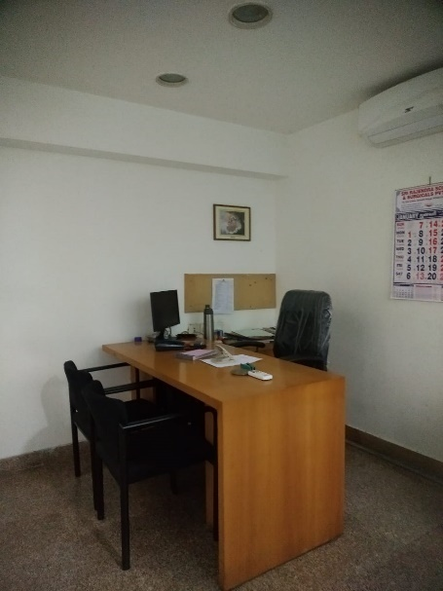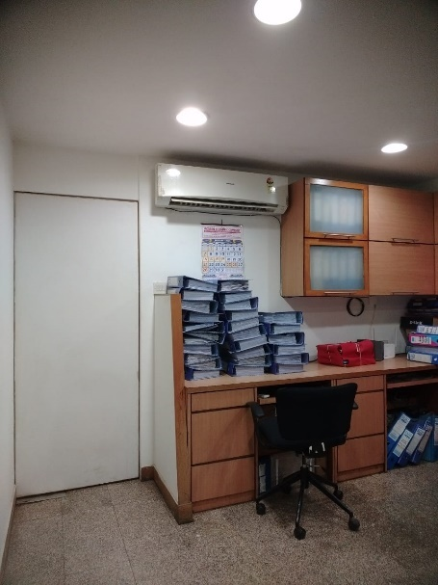

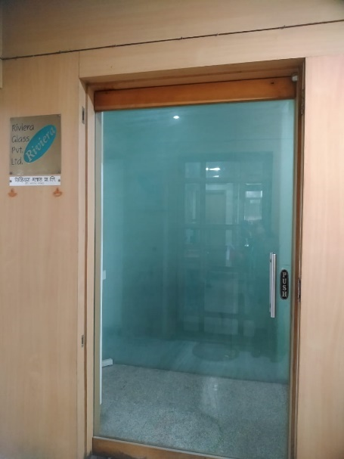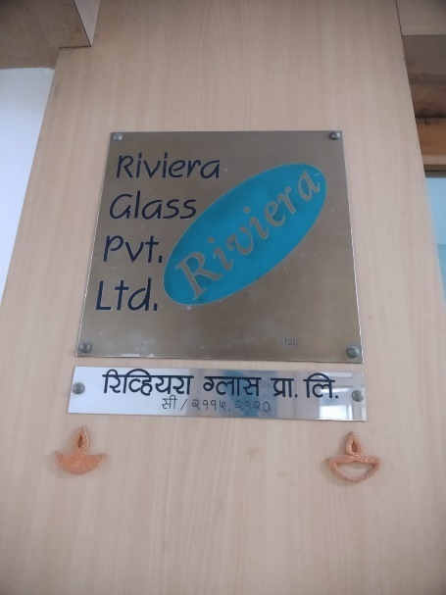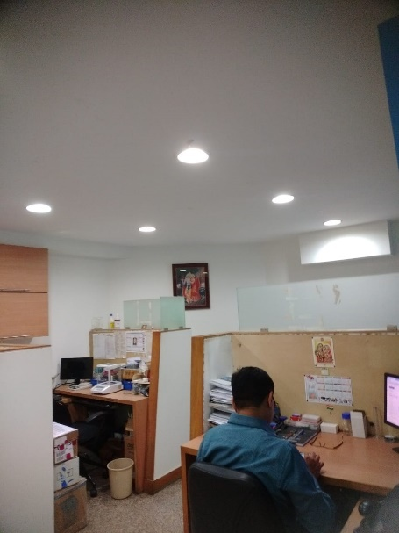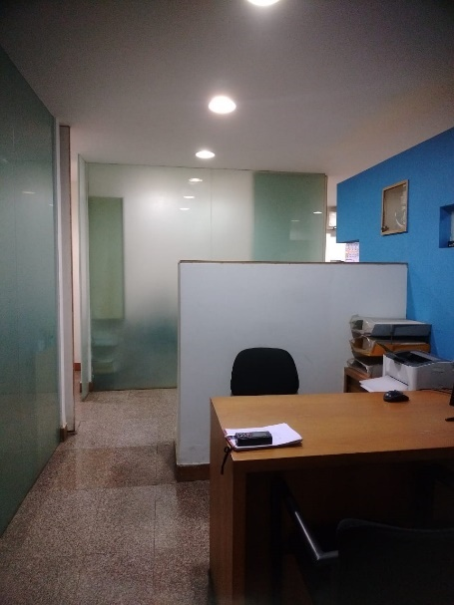**Actual Site Photographs – Office No. 2116**

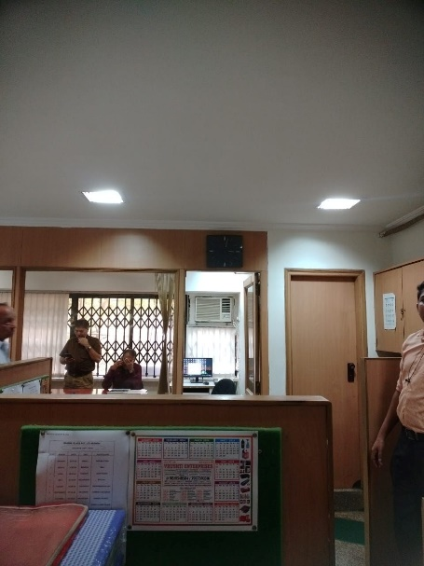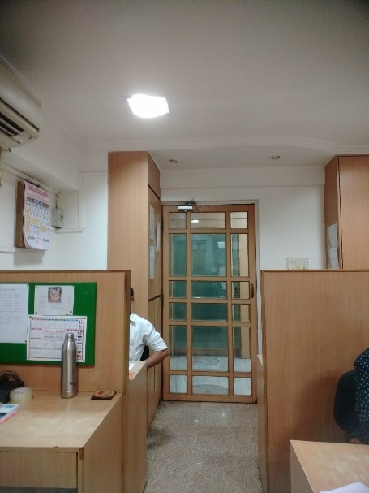

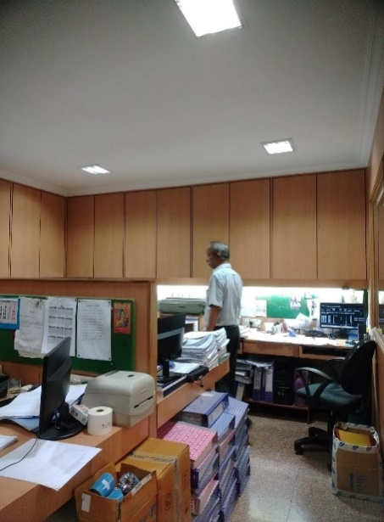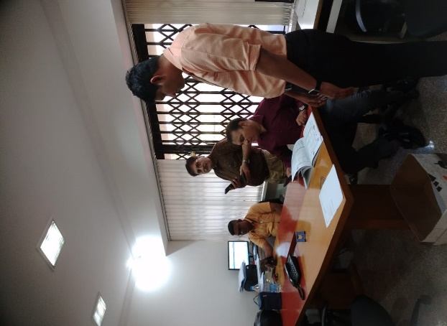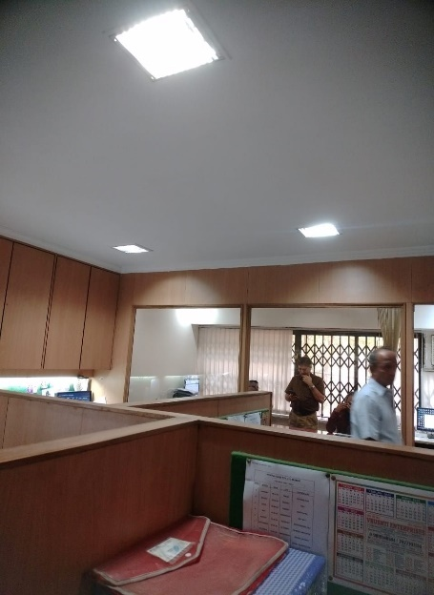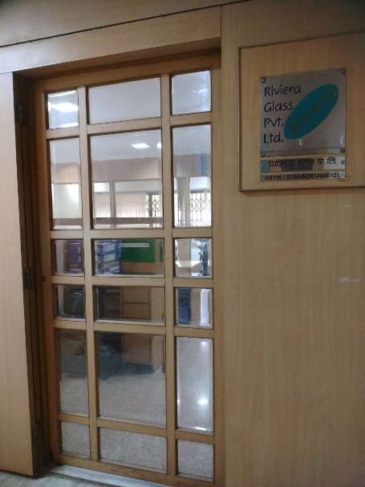

**Actual Site Photographs – External**

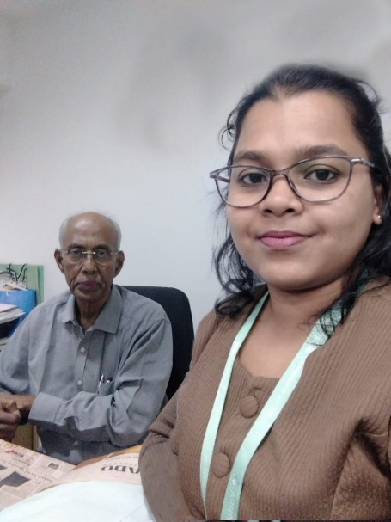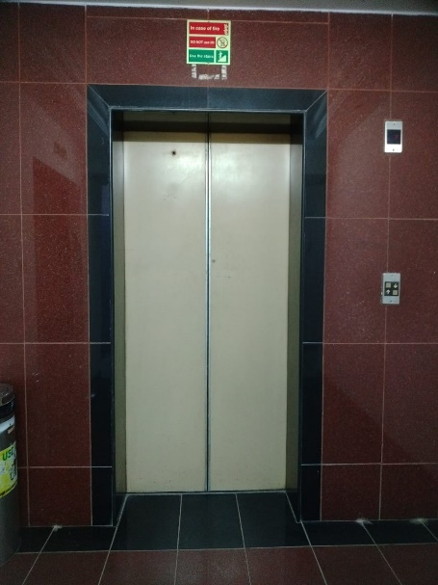

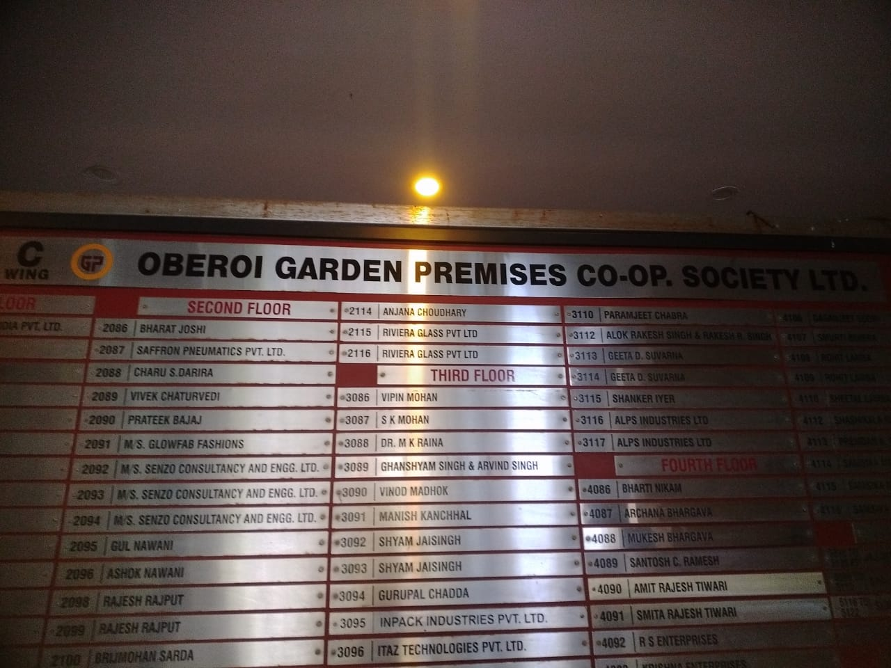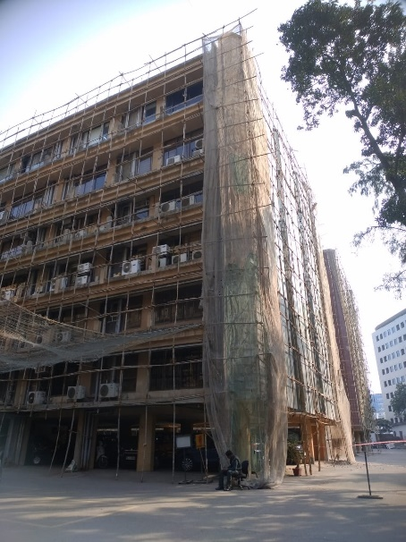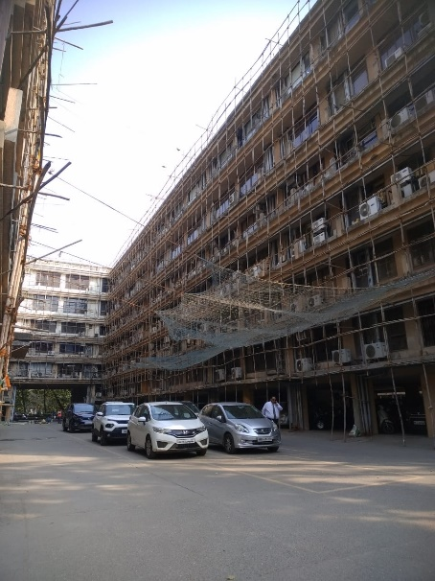

## Route Map of the property

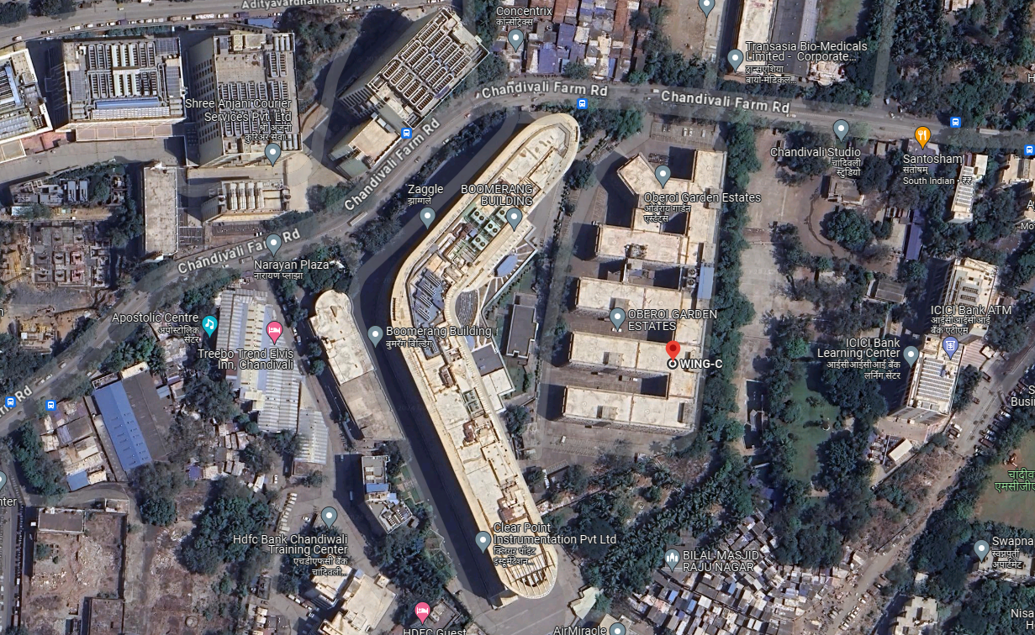**Site u/r**

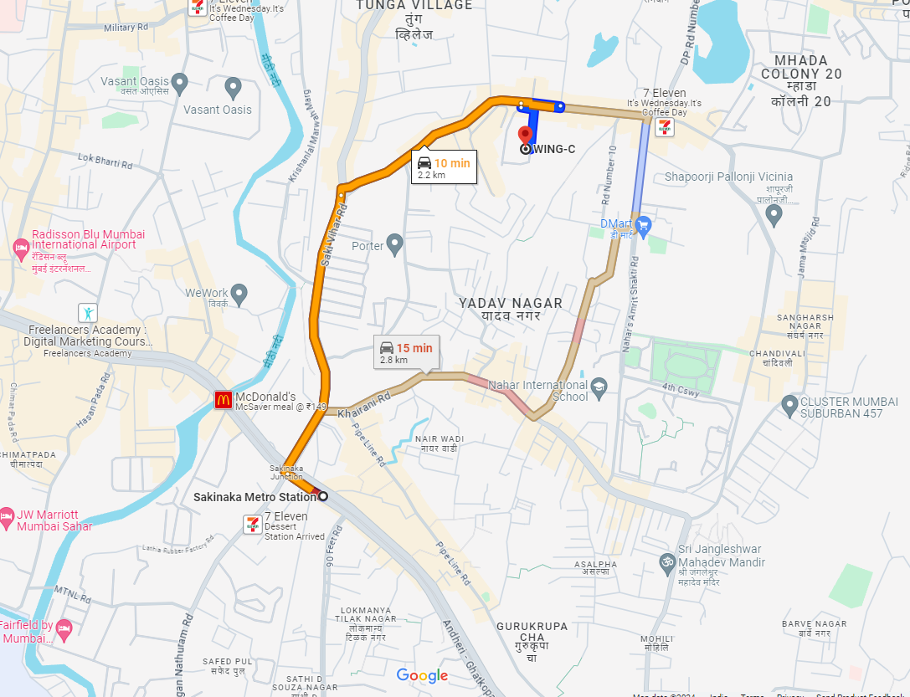

Latitude Longitude: **19°06'48.6"N 72°53'38.7"E**

**Note:** The Blue line shows the route to site from nearest Metro station (Sakinaka – 2.8 Km.)

## Ready Reckoner 2022 -23

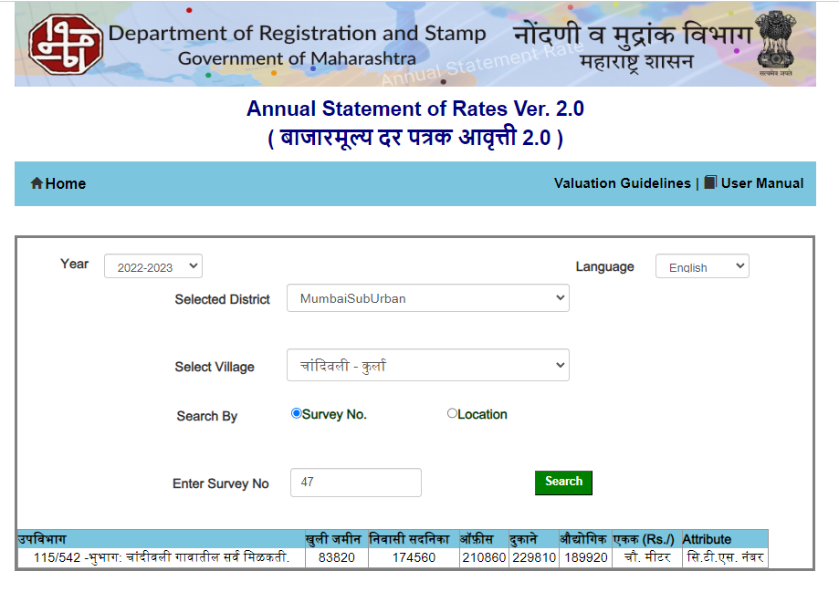

# Valuation as on 31.03.2023:

|  |  |  |  |  |
| --- | --- | --- | --- | --- |
| **Office Nos.** | **Built up area**  **(Sq. M.)** | **Rate / Sq. M. as on 31.03.2023 (` )** | **Depreciated Rate / Sq. M. (` )** | **Value (` )** |
| 2115 | 40.13 | 2,10,860.00 | 1,81,641.00 | 72,89,253.00 |
| 2120 | 41.62 | 2,10,860.00 | 1,81,641.00 | 72,89,253.00 |
| 2116 | 40.13 | 2,10,860.00 | 1,81,641.00 | 75,59,898.00 |
| Car Parking Nos. 25, 26 & 27 | 41.81 | 52,715.00 | 45,410.00 | 18,98,592.00 |
|  |  | **TOTAL** |  | **2,40,36,996.00** |

|  |  |
| --- | --- |
|  | **Sq. M.** |
| Stamp Duty Ready Reckoner Market Rate for **Office** | 2,10,860.00 |
| No increase as office located on 2nd floor | 0.00 |
| **Stamp Duty Ready Reckoner Market Value Rate (A)** | 2,10,860.00 |
| Stamp Duty Ready Reckoner Market Value Rate for **Land (B)** | 83,820.00 |
| The difference between land rate and building rate (A – B = C) | 1,27,040.00 |
| Depreciation Percentage as per table (D) [100% - 23%]  (Age of the Building – 23 Years) | 77% |
| **Rate to be adopted after considering depreciation [B + (C x D)]** | **1,81,641.00** |
| **For car parking 25% of depreciated rate considered** | **45,410.00** |

# Conclusion

|  |  |
| --- | --- |
| Name of Client | M/s. Riviera Glass Pvt. Ltd. |
| Asset being Valued | Commercial Office Nos. 2115, 2116 & 2120 |
| Valuation Currency | Indian Rupees (INR) / ` |
| Purpose of Valuation | Value as on 31.03.2023 |
| Valuation Standards Referred | Income Tax – Rule 11UA |
| Basis of Value | Stamp Duty Value |
| Premises for value | Existing and Current Use |
| Valuation Date | 31.03.2023 |
| Valuation Approach | Composite Rate as per Ready Reckoner |
| Valuation Methodology | Market value (Stamp duty) |
| Value of Assets | ` **2,40,36,996.00** |

|  |
| --- |
| Manoj B. Chalikwar |
| Registered Valuer  Chartered Engineer (India)  Reg. No. IBBI / RV / 07/2018/10366  Reg. No. CAT-I-F-1763 |