Vastu/Nashik/06/32014/2301224
22/20-325-RYBS
Date: 25.01.2024

To,
The Branch Manager,
State Bank of India
RACPC Nashik Branch
1st Floor, Patel Plaza, N.D. Patel Road,
Opp. BSNL, Landmark Seawoods Navratna Hotel,
Nashik - 422001, State – Maharashtra, Country – India.

Sub: Vetting of Extra Amenities

Sir,

With reference to above subject, we have evaluated the Extra Amenities for Residential Row House No.7, Ground + First Floor, Gat No.2639/2/2/2644, Plot No.15, Near Sanskruti Boutique, Ganesh Nagar, At – Ozar, Taluka - Niphad, District - Nashik, PIN Code - 422 207, State - Maharashtra, Country - India. belongs to Name of Owner: Mr. Amol Nandu Madhe.

We have verified the rates quoted as per current market rates. Details of Extra Amenities considered as per copy of Extra Amenities Agreement between Mr. Amol Nandu Madhe (First Party). Mr. Prathmesh Bhagwan Pagar. (Second Party) received on dated 10.01.2024. The Extra Amenities amount is Rs. 2,80,000/- (Rupees Two Lakh Eighty Thousand Only)

The said Cost Vetting Certificate is valid upto next 6 months Only.

Thanking you

Sincerely yours

Sharadkumar B. Chalikwar

Govt. Reg. Valuer
Chartered Engineer (India)
Reg. No. (N) CCIT/1-14/52/2008-09
SBI Empanelment No.: SME/TCC/2021-22/85/13
Encl: Valuation report

Agreement for Extra Amenities
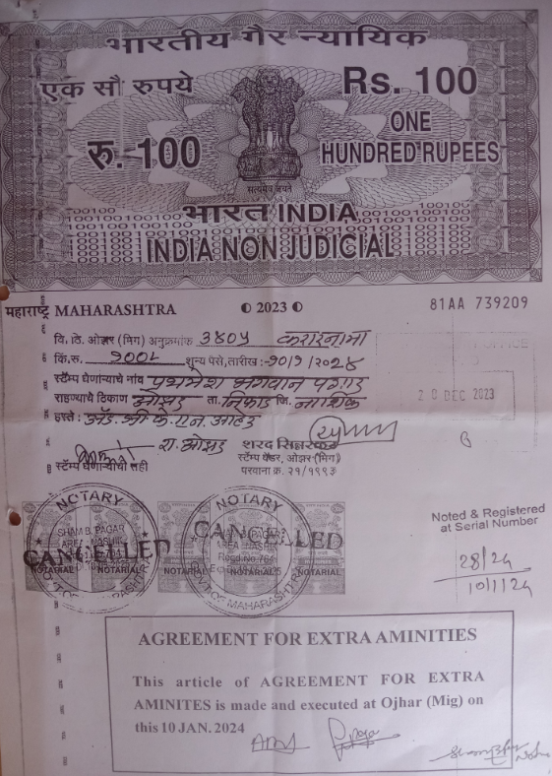
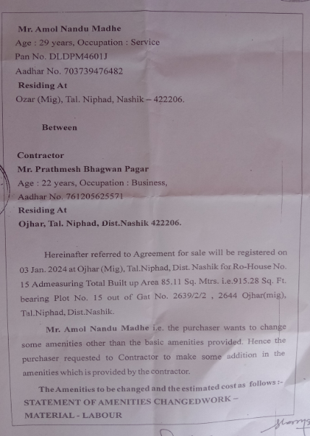

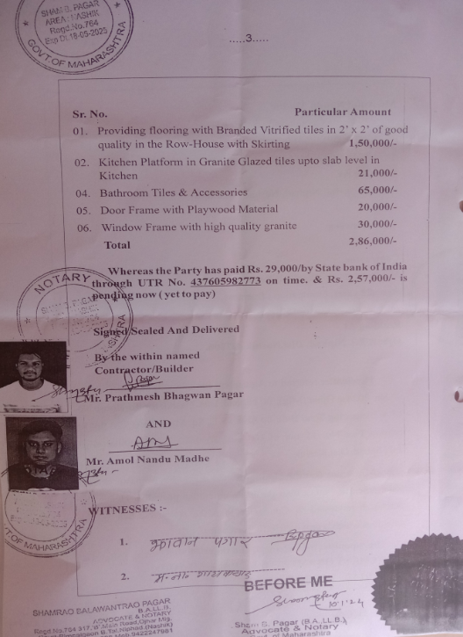

The Extra Amenities amount is Rs. 2,80,000/- (Rupees Two Lakh Eighty Thousand Only)

