Vastu/Nashik/06/32014/2301224
22/20-325-RYBS
Date: 24.01.2024

To,
The Branch Manager,
Bank of Baroda
Regional Office
BSNL Building, Datta Mandir Road, Nashik Road,
Nashik, PIN – 422 101, State - Maharashtra, Country - India.

Sub: Vetting of Extra Amenities

Sir,

With reference to above subject, we have evaluated the Extra amenities For Residential Flat No. 501, Fifth Floor, C - Wing, " Avadh Elite ", Gat No. 275, Behind Burkule Hall, More Mala, Ekdant Nagar, Ambad - Trimurti Chowk Link Road, Village - Ambad Khurd, Taluka & District - Nashik, PIN Code – 422 010, State – Maharashtra, Country – India. belongs to Mr. Sushant Shashikant Ahire & Divya Sharad Jadhav (Alias), Mrs. Divya Sushant Ahire.

We have verified the rates quoted as per current market rates. Details of Extra Amenities considered as per copy of Extra Amenities Agreement between Mr. Sushant Shashikant Ahire & Divya Sharad Jadhav (Alias), Mrs. Divya Sushant Ahire. (First Party). M/s. Akshar Builders (Second Party) received on dated.20.01.2024. The Extra Amenities amount is Rs. 9,00,000/- (Rupees Nine Lakh Only)

The said Cost Vetting Certificate is valid upto next 6 months Only.

Thanking you

Sincerely yours

Manoj B. Chalikwar
Registered Valuer
Chartered Engineer (India)
Reg. No. CAT-I-F-1763
Reg. No. IBBI/RV/07/2018/10366
BOB Empanelment No.: ZO:MZ:ADV:46:941
Encl: Valuation report.

Agreement for Extra Amenities
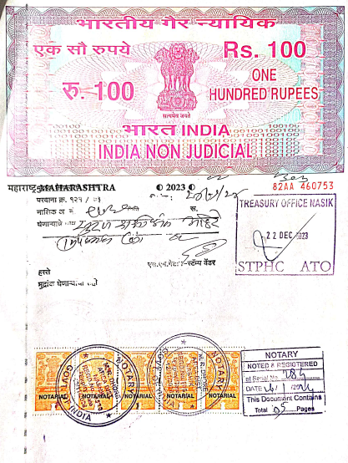
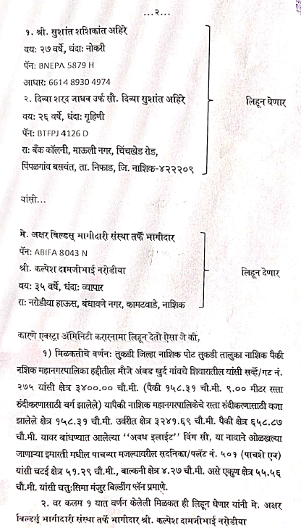

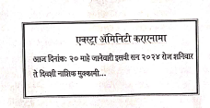

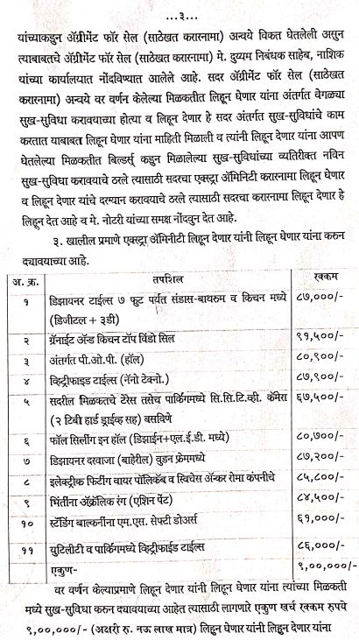
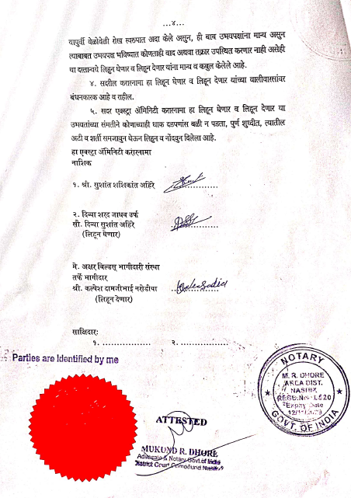

The Extra Amenities amount is Rs. 9,00,000/- (Rupees Nine Lakh Only)

