Vastu/Nashik/01/2024/006543/2304647
24/16-349-RPBS
Date: 24.01.2024

To, `
The Branch Manager,
Bank of Baroda
Regional Office Nashik Road Branch
BSNL Building, Datta Mandir Road, Nashik Road,
Nashik -422 101, State - Maharashtra, Country - India.

Sub: Vetting of Extra Amenities

Sir,

With reference to above subject, we have evaluated the Extra Amenities for Residential Flat No. 03, Second Floor, " Shree Ganesh Apartment ", Survey No. 55/ 1, Plot No. 38+39, Near Shreekrishna Nagar Garden, Old Saikheda Road, Pandit Borade Marg, Village - Panchak, Taluka & District - Nashik, PIN Code – 422 101, State – Maharashtra, Country – India belongs to Name of Proposed Purchaser: Sau. Surekha Suresh Hullale. Name of Owner: Smt. Nanda Anjanaappa Telangi & Shri. Prashant Anjanaappa Telangi, Hemalatha Anjanaappa Telangi.

We have verified the rates quoted as per current market rates. Details of work and Extra Amenities considered as per copy of Agreement for Extra Amenities issued by Sau. Surekha Suresh Hullale (First Party) and Sau. Sangita Rajesh Shaharkar (Second Party) received on dated 22.12.2023. The Extra Amenities amount is Rs.3,50,000/-
(Rupees Three Lakh Fifty Thousand Only)

The said Cost Vetting Certificate is valid upto next 6 months Only.

Thanking you

Sincerely yours

Manoj B. Chalikwar
Registered Valuer
Chartered Engineer (India)
Reg. No. CAT-I-F-1763
Reg. No. IBBI/RV/07/2018/10366
BOB Empanelment No.: ZO:MZ:ADV:46:941
Encl: Valuation report.

Agreement for Extra Amenities
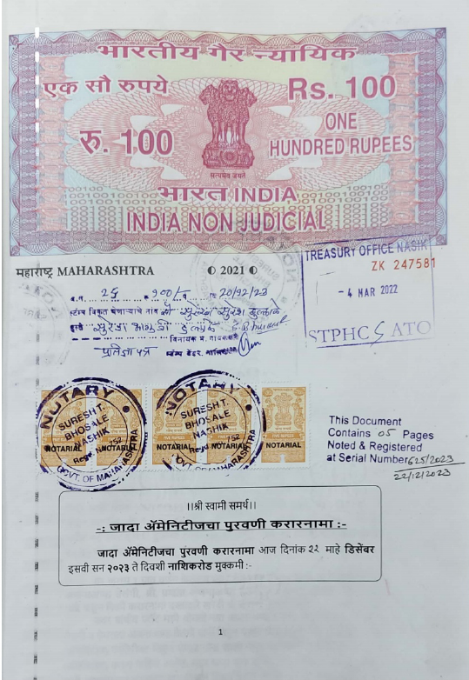
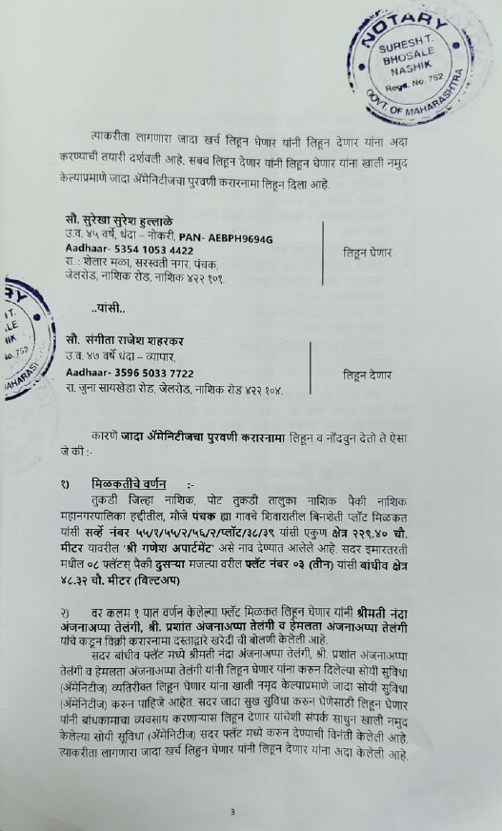

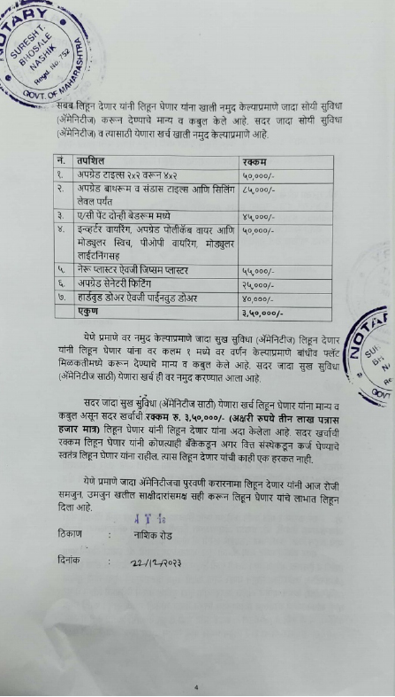
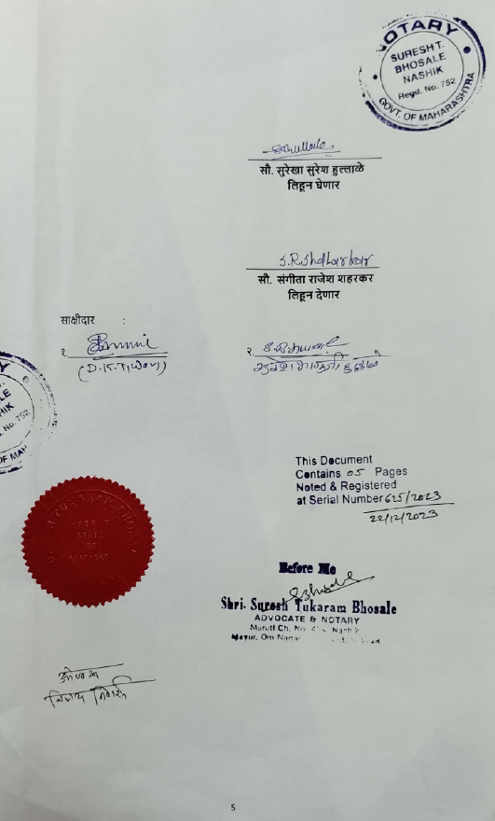

The Extra Amenities amount is Rs.3,50,000/- (Rupees Three Lakh Fifty Thousand Only. )

