Vastu/Nashik/01/2024/006541/2304645
24/14-347-CCBS
Date: 24.01.2024

To, `
The Branch Manager,
Bank of Baroda
Regional Office Nashik Road Branch
BSNL Building, Datta Mandir Road, Nashik Road,`
Nashik -422 101, State - Maharashtra, Country - India.

Sub: Vetting of Extra Amenities

Sir,

With reference to above subject, we have evaluated the Extra Amenities for Residential Flat No.404, Fourth Floor , B-Wing, " Someshwar Heights Apartment ", Survey No.764/4/1, Plot No.28+29+30+31, Near Nivrutti Dada Jagtap Garden , Jagtap Nagar, Untwadi , Village – Nashik, Taluka & District - Nashik, PIN Code – 422 008, State – Maharashtra, Country – India belongs to Shri.Sanjay Jadhavbhai Bhorniya. Name of Proposed Purchaser: Sau.Vaishali Charudatta Bhamare & Shri.Charudatta Jagannath Bhamare.

We have verified the rates quoted as per current market rates. Details of work and Extra Amenities considered as per copy of Notarized Agreement between Sau.Vaishali Charudatta Bhamare & Shri.Charudatta Jagannath Bhamare (First Party) and Sau.Aashlesha Avish Patil (Second Party) received on dated 20.01.2024. The Extra Amenities amount is Rs.5,00,000/- (Rupees Five Lakh Only)

The said Cost Vetting Certificate is valid upto next 6 months Only.

Thanking you

Sincerely yours

Sharadkumar B. Chalikwar
Govt. Reg. Valuer
Chartered Engineer (India)
Reg. No. (N) CCIT/1-14/52/2008-09
Encl: Vetting report..

Agreement for Extra Amenities
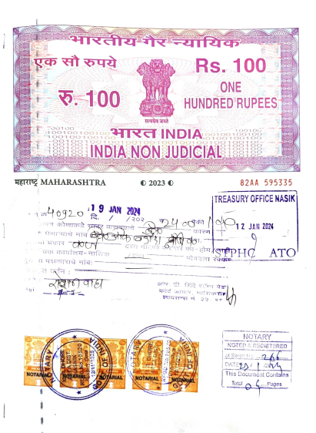


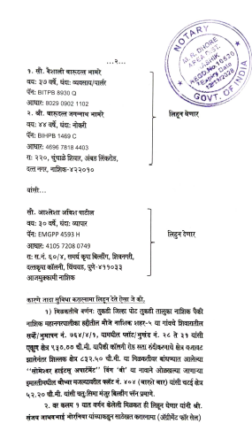
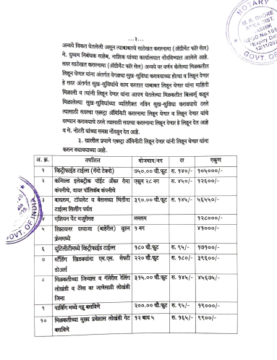

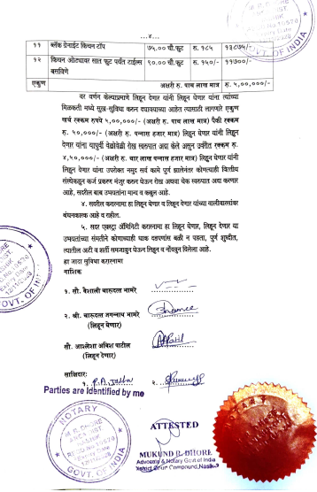

The Extra Amenities amount is Rs.5,00,000/- (Rupees Five Lakh Only.)

