Valuation Report of the Immovable Property
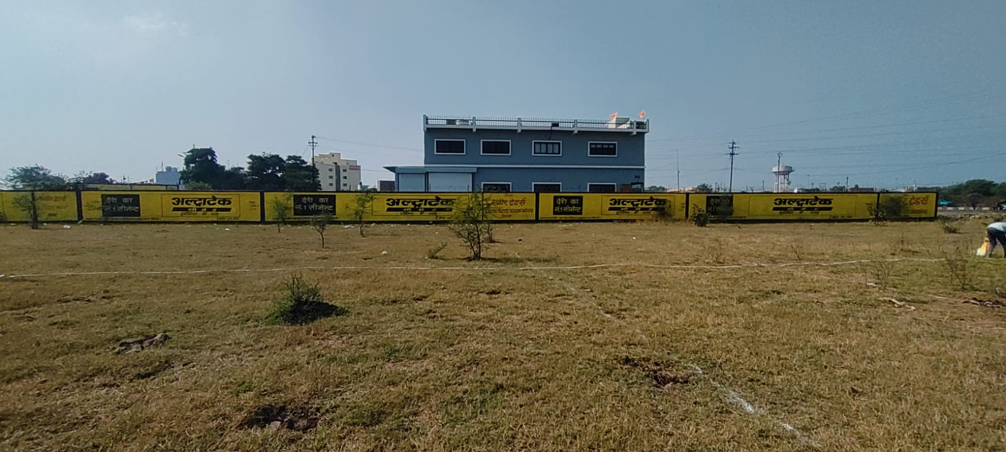

Details of the property under consideration:

Name of Proposed Purchaser/Client: Shri. Farhan Ahmed S/o Shri. Jafar Ahmed

Name of Owner/Seller: Shri. Laxman S/o. Vishandas Sachdev,
Smt. Manisha W/o. Laxman Sachdev,
Shri. Sunil Sachdev S/o. Vishandas Sachdev &
Smt. Annie W/o. Sunil Sachdev

Industrial Land - Paiki Part No. 6, Survey No. 22/1/2/Min-1 & 22/Min-1, “Industrial Area”, Patwari Halka No. 02,
Rau - Pithampur Road, Village Bheslay, Tehsil - Mhow, District - Indore,
PIN – 453 332, State – Madhya Pradesh, Country – India

Latitude Longitude - 22°37’20.1”N 75°43’44.5”E

Valuation Done for:
Bank of Maharashtra
Vijay Nagar Branch
L. G. 01, Mangal City Mall, A.B. Road Indore, PIN – 452 008,
State – Madhya Pradesh, Country – India

Vastu/Indore/01/2024/006517/2304670
25/4-372-BSA
Date: 25.01.2024

VALUATION OPINION REPORT

The property of Industrial Land - Paiki Part No. 6, Survey No. 22/1/2/Min-1 & 22/Min-1, “Industrial Area”, Patwari Halka No. 02, Rau - Pithampur Road, Village Bheslay, Tehsil - Mhow, District - Indore, PIN – 453 332, State – Madhya Pradesh, Country - India belongs to Shri. Laxman S/o. Vishandas Sachdev, Smt. Manisha W/o. Laxman Sachdev, Shri. Sunil Sachdev S/o. Vishandas Sachdev & Smt. Annie W/o. Sunil Sachdev. The Proposed Purchaser/Client is Shri. Farhan Ahmed S/o Shri. Jafar Ahmed.

Boundaries of the property.

North | : | Remaining Part of this Land
South | : | Remaining Part of this Land
East | : | Road
West | : | Remaining Part of this Land

Considering various parameters recorded, existing economic scenario, and the information that is available with reference to the development of neighborhood and method selected for valuation, we are of the opinion that, the property premises can be assessed and valued for banking purpose at ` 1,12,00,000/- (Rupees One Crore Twelve Lakh Only).

The valuation of the property is based on the documents produced by the concern. Legal aspects have not been taken into considerations while preparing this valuation report.

Hence certified

Manoj B. Chalikwar
Registered Valuer
Chartered Engineer (India)
Reg. No. CAT-I-F-1763
BOM Emp. No. AX40/Empanelment: Valuer/VCPL/2021-22
Encl: Valuation report.

VALUATION REPORT IN RESPECT OF IMMOVABLE PROPERTY

1. | Date of Inspection | : | 20.01.2024
2. | Purpose of valuation | : | As per request from Bank of Maharashtra, Vijay Nagar Branch, Indore to assess Fair Market Value of the property under reference for Banking purpose.
3. | Name and address of the Valuer. | : | Manoj B. Chalikwar  Vastukala Consultants (I) Pvt. Ltd.  106, 1st Floor, Gold Star Tower, Opp. Treasure Island Mall, M.G. Road, Indore – 452 001
4. | Copy Of Documents Handed Over to The Valuer by The Bank |  | - Draft Contract Deed between Shri. Laxman S/o. Vishandas Sachdev, Smt. Manisha W/o. Laxman Sachdev, Shri. Sunil Sachdev S/o. Vishandas Sachdev & Smt. Annie W/o. Sunil Sachdev (the Seller) AND Shri. Farhan Ahmed S/o Shri. Jafar Ahmed (the Proposed Purchaser).  - Sale Deed, Registration No. MP179092020A1387823 dated 13.07.2020 between Shri. Ratikant S/o. Shri. Milanchand Ji Mandal, Shri. Utam Mandal S/o. Shri. Ratikant Ji Mandal, Smt. Kumari Sumita D/o. Shri. Ratikant Ji Mandal & Smt. Madhumita Yadav W/o. Shri. Mahendra Kumar Yadav (the Seller) AND Shri. Laxman S/o. Shri. Vishndas Sachdev, Smt. Manisha W/o. Shri. Laxman Sachdev, Shri. Sunil Sachdev S/o. Shri. Vishndas Sachdev, & Smt. Any W/o. Shri. Sunil Sachdev. (the Purchaser)  - Diversion Order, Memo No. 2203 1006 203 dated 01.09.2022. Issued by Court Sub – Divisional Officer, District Indore.
- 5. | Details of enquiries made/ visited to govt. Offices for arriving fair market value. | : | Market analysis and as per sub-registrar value.
- 6. | Factors for determining its market value. | : | Location, development of surrounding area, facilities provided and its prevailing market rate.
- 7. | Any Critical Aspects Associated with Property | : | No
- 8. | Present/Expected Income from the property | : | N.A., as the property is open plot
 | Property Details: | :
- 9. | Name(s) of the Owner and Postal address of the property under consideration. | : | Name of Proposed Purchaser / Client:  Shri. Farhan Ahmed S/o Shri. Jafar Ahmed  Name of Owner/Seller:  Shri. Laxman S/o. Vishandas Sachdev,  Smt. Manisha W/o. Laxman Sachdev, Shri. Sunil Sachdev S/o. Vishandas Sachdev &  Smt. Annie W/o. Sunil Sachdev
 |  | : | Industrial Land - Paiki Part No. 6, Survey No. 22/1/2/Min-1 & 22/Min-1, “Industrial Area”, Patwari Halka No. 02, Rau - Pithampur Road, Village Bheslay, Tehsil - Mhow, District - Indore, PIN – 453 332, State – Madhya Pradesh, Country – India.  Contact Person:  Niraj Ji (Broker)  Contact No.: +91 89669 62386
- 10. | If the property is under joint ownership/ co-ownership share of each such owner/ are the share is undivided. | : | Joint Ownership (Owner/Seller)  Details of Ownership share is not available.
- 11. | Brief description of the property. | :
The immovable property comprising of freehold industrial land. The property is located in a developing area having basic infrastructure, well connected by road and train. It is located at 21.3 KM. travelling distance from Indore Junction Railway station.

Land:
As per Draft Contract Deed, the land area is 371.74 Sq. M. i.e. 4,000.00 Sq. Ft., which is considered for valuation.
The Land is temporarily demarcated on site.
- 12. | Location of the property.  (C.T.S. No., Survey No., Hissa No., Plot No., etc.). | : | Paiki Part No. 6, Survey No. 22/1/2/Min-1 & 22/Min-1
- 13. | Boundaries of the property | :
- 13. |  |  | As per Actual |  | As per Draft Contract Deed
- 13. | North | : | Remaining Part of this Land |  | Remaining Part of this Land
- 13. | South | : | Remaining Part of this Land |  | Remaining Part of this Land
- 13. | East | : | 20 Ft. Road |  | 20 Ft. Road
- 13. | West | : | Remaining Part of this Land |  | Remaining Part of this Land
- 14. | Route map | : | Enclosed
- 15. | Any specific identification marks | : | Colony Water Tank
- 16. | Whether covered under Corporation/ Panchayat/ Municipality. | : | Gram Panchayat Bheslay, Tehsil Mhow, District Indore.
- 17. | Whether covered under any land ceiling of State/ Central Government. | : | No
- 18. | Is the land freehold/ leasehold. | : | Freehold
- 19. | Are there any restrictive covenants in regard to use of Land? If so attach a copy of the covenant. | : | As per Sale Deed
- 20. | Type of the property- Whether | :
 | Residential | : | No
 | Industrial | : | Yes
 | Commercial | : | No
 | Institutional | : | No
 | Government | : | No
 | Non – Government | : | No
 | Other (Specify) | : | N.A.
- 21. | In case of Agricultural land
 | Any conversion to House site is obtained | : | N.A.
 | Whether the land is dry or wet. | : | N.A.
 | Availability of irrigation facilities | : | N.A.
 | Type of crops grown | : | N.A.
 | Annual yield or income. | : | N.A.
- 22. | Year of acquisition/ purchase. | : | N.A., Agreement of sale yet to be made.
- 23. | Whether the property is occupied by owner or tenant. If occupied by tenant since how long he is staying, and the amount of rent being paid. | : | Open plot of land and under Owner’s possession.
- 24. | Classification of the site. | :
 | a. Population group. | : | Semi Urban
 | b. High/ Middle/ Poor class | : | Middle class
 | c. Residential/ nonresidential. | : | Industrial
 | d. Development of surrounding area. | : | Developing
 | e. Possibility of any threat to the property. (Floods, calamities etc.). | : | No
- 25. | Proximity of civic amenities.  (Like school, hospital, bus stop, market etc.). | : | All available near by
- 26. | Level of the land (Plain, rock etc.) | : | Plain
- 27. | Terrain of the Land. | : | Leveled
- 28. | Shape of the land (Square/ rectangle etc.). | : | Rectangular
- 29. | Type of use to which it can be put (for construction of house, factory etc.). | : | Industrial Purpose
- 30. | Any usage restrictions on the property. | : | Industrial
- 31. | Whether the plot is under town planning approved layout? | : | Yes
- 32. | Whether the building is intermittent or corner? | : | Intermittent
- 33. | Whether any road facility is available? | : | Yes
- 34. | Type of road available (B.T. / Cement Road etc.). | : | Cement Concrete Road
- 35. | Front Width of the Road? | : | More than 20 ft.
- 36. | Source of water & water potentiality. | : | At present not available at site
- 37. | Type of Sewerage System. | : | At present not available at site
- 38. | Availability of power supply. | : | At present not available at site
- 39. | Advantages of the site. | : | Located in developing residential area
- 40. | Disadvantages of the site. | : | No
- 41. | Give instances of sales of immovable property in the locality on a separate sheet, indicating the name & address of the property, registration No. sale price and area of land sold. | : | As per Sub-Registrar of Assurance records
 | Valuation of the property:
42. | 1) Dimensions of the plot | :
43. | 2) Total area of the plot | : | 4,000.00 Sq. Ft.  (As per Draft Contract Deed)
44. | 3) Prevailing Market Rate/Price trend of the Property in the locality/city from property search sites viz magickbricks.com, 99acres.com, makaan.com etc. if available | : | ` 2,000/- to ` 3,000/- per sq. ft. for industrial plot Online price indicator of industrial land not found hence price indicator for commercial Land is attached.
45. | 4) Government Rate obtained from the online government records of Land | : | ` 4,500/- per Sq. M.  i.e. ` 418/- per Sq. Ft.
46. | Building |  | N.A., as the property is open plot of land only
47. | - Government Value
 | Particulars | : | Area in Sq. Ft. | Rate in ` |  | Value in `
 | Land | : | 4,000.00 | 418/- |  | 16,72,000/-
 | Building | : | N.A., as the property is open plot of land only
 | Total |  |  |  |  | 16,72,000/-
 | 5) Assessed/ adopted rate of valuation. |  | ` 2,800/- per Sq. Ft. for Industrial Open Plot
48. | - Fair Market Value
 | Particulars | : | Area in Sq. Ft. | Rate in ` |  | Value in `
 | A) Land |  | 4,000.00 | 2,800/- |  | 1,12,00,000/-
 | B) Building |  | N.A., as the property is open plot of land only
 | 6) Estimated value of the land. | : | ` 1,12,00,000/-
 | a. Technical details of the Building:
- 49. | Type of Building (Residential/ Commercial/ Industrial). | : | N.A., as the property is open plot of land only
- 50. | Year of construction. | : | N.A.
- 51. | Future life of the property. | : | N.A.
- 52. | No. of floors and height of each floor including basement. | : | N.A.
- 53. | Plinth area of each floor | : | N.A.
- 54. | Type of construction.  (Load bearing/ R.C.C. / Steel framed). |  | N.A.
 | Condition of the building. | :
- 55. | External (excellent/ good/ normal/ poor). | : | N.A.
- 56. | Internal (excellent/ good/ normal/ poor). | : | N.A.
 | Remarks | :
- 57. | b. Specifications of Construction:
 | Foundation. | : | N.A.
 | Basement. | : | N.A.
 | Superstructure. | : | N.A.
 | Joinery/ Doors & Windows. | : | N.A.
 | RCC work. | : | N.A.
 | Plastering. | : | N.A.
 | Flooring, Skirting. | : | N.A.
 | Kitchen Pantry Platform | : | N.A.
 | Whether any weather proof course is provided. | : | N.A.
 | Drainage. | : | N.A.
 | Compound wall (Height, length and type of construction). | : | N.A.
 | Electric installation (Type of wire, Class of fittings) | : | N.A.
 | Plumbing installation (No. of water closets & wash basins etc.) | : | N.A.
 | Bore well. | : | N.A.
 | Wardrobes, if any. | : | N.A.
 | Development of open area | : | N.A.

1,

 | Summary of Valuation
 | Total Value of the Property | ` 1,12,00,000/-
 | Realizable Value | ` 1,00,80,000/-
 | Forced/ Distress Sale value. | ` 89,60,000/-
 | Insurable value of the property | N.A. as the property is open plot of land only.
e) | Remarks

Justification for price /rate
The Market Value of the property is based on facts of markets discovered by us during our enquiries, however the government rate value in this case is less than the market value arrived by us. We are of the opinion that the value arrive by us will prove to be correct if an Auction of the subject property is carried out. As far as Market Value in Index II is concerned, it is not possible to comment on same, may be government rates are fixed by sampling during same point of time in part and whereas, Market values change every month.
In most of the cases the actual deal amount or Transaction value is not reflected in Index II because of various Market practices. As Valuer, we always try to give a value which is correct reflection of actual transaction value irrespective of any factors in market.

Actual site photographs
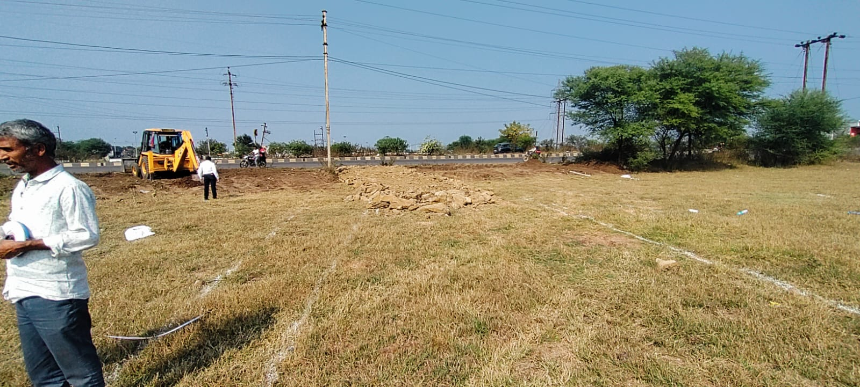
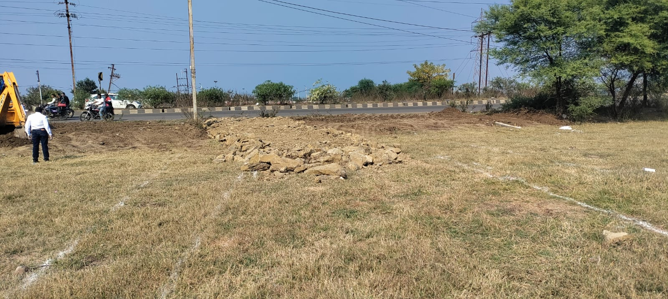
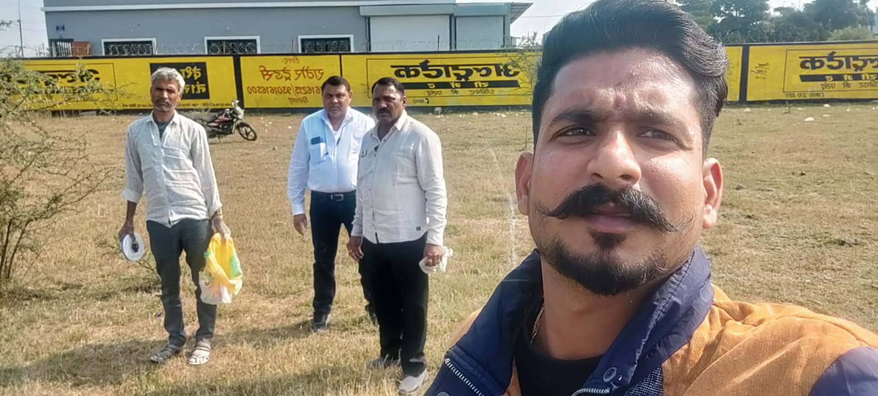
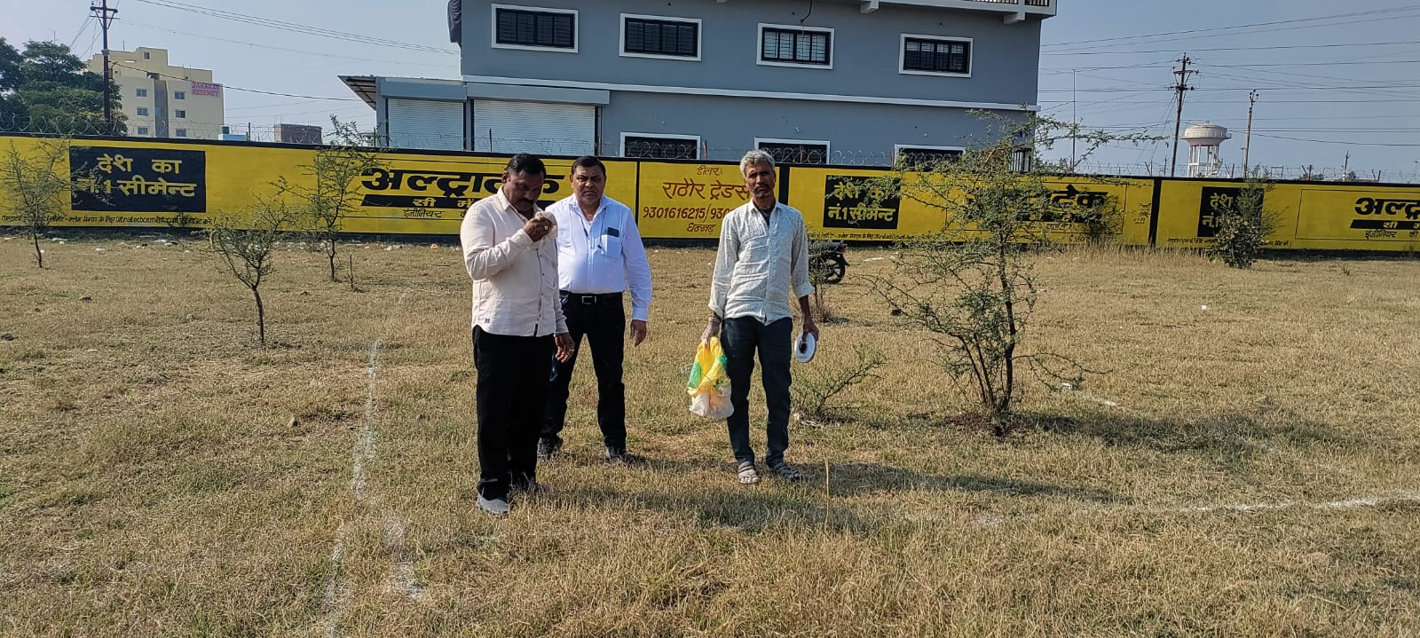
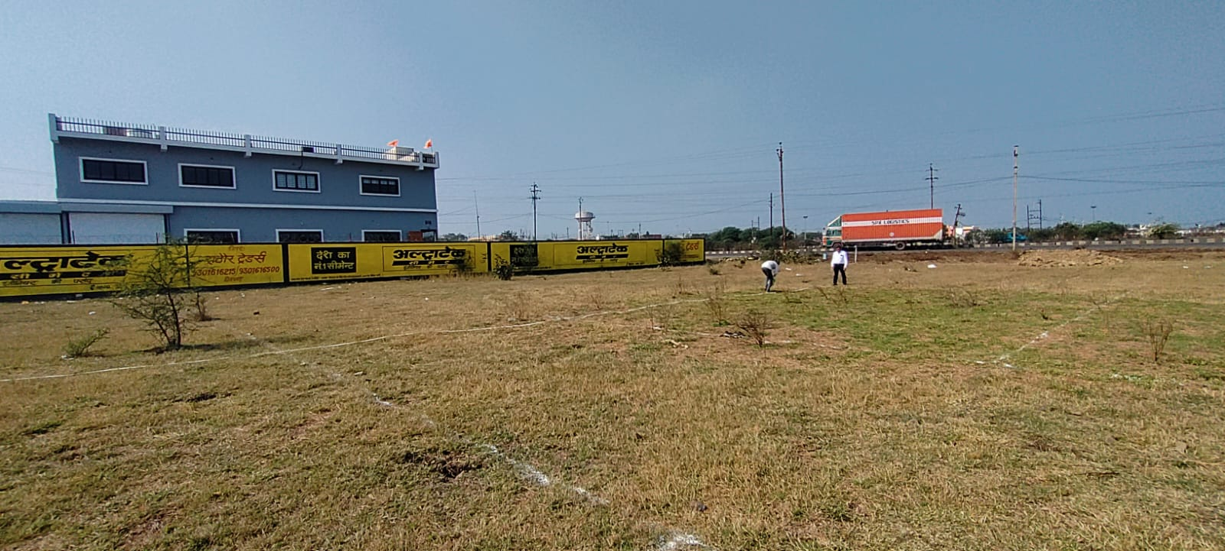

Route Map of the property
Site u/r
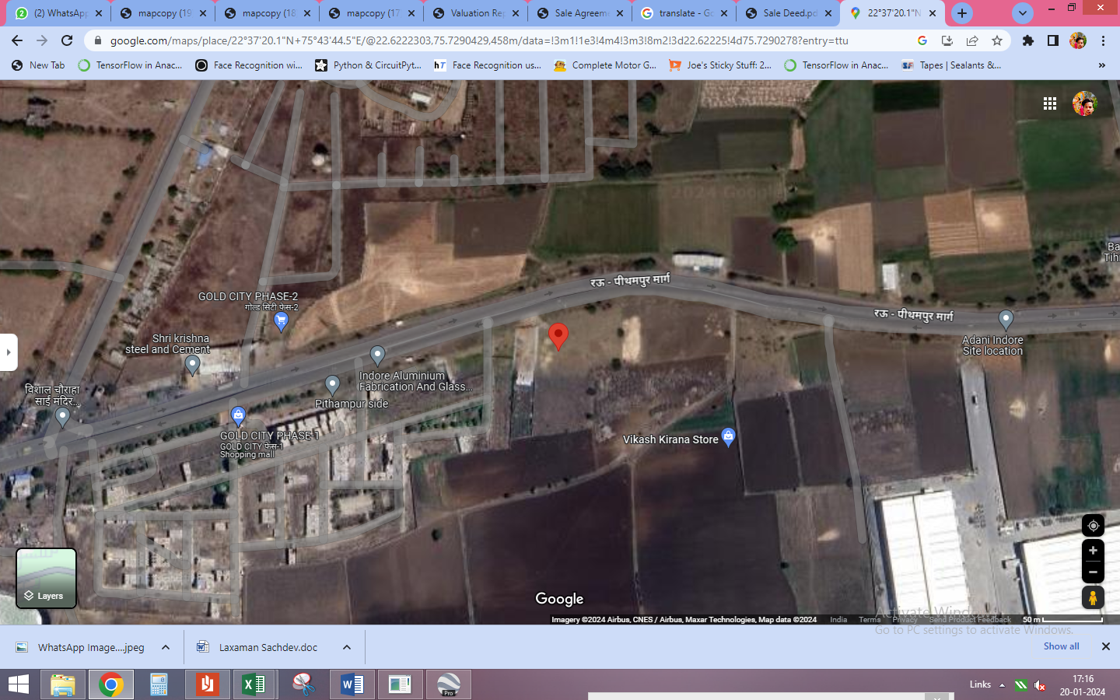

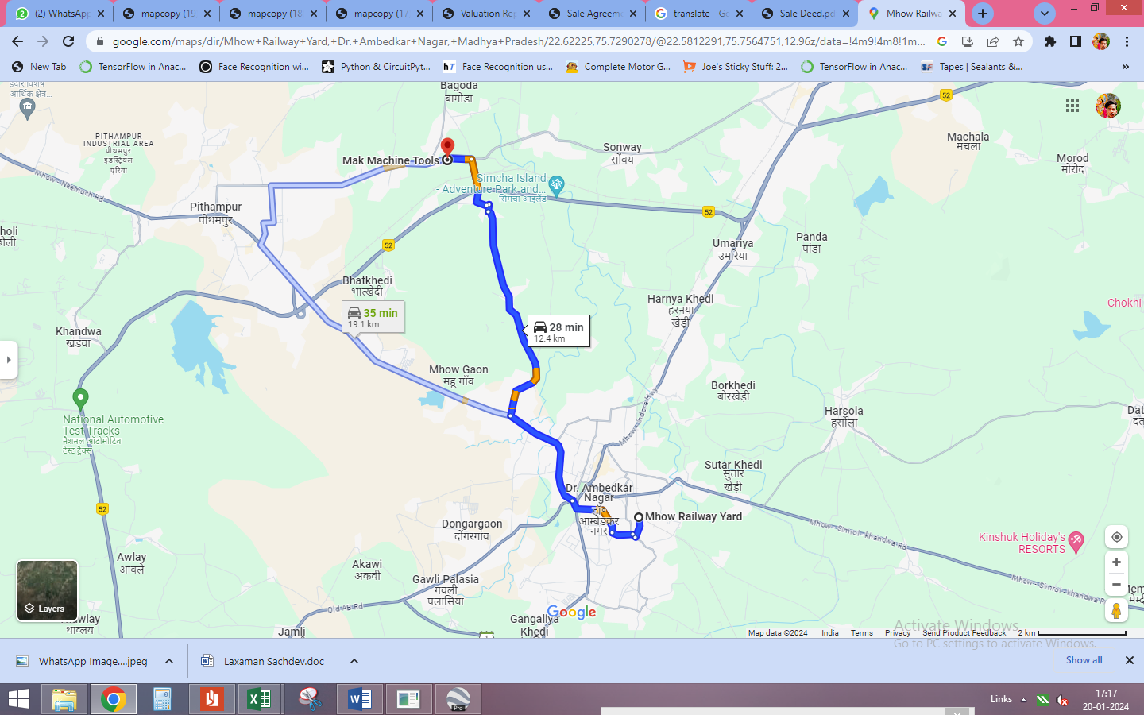

Latitude Longitude - 22°37’20.1”N 75°43’44.5”E
Note: The Blue line shows the route to site from nearest Railway Station (Mhow Railway Station – 12.4 KM.)
Government Guideline Rate
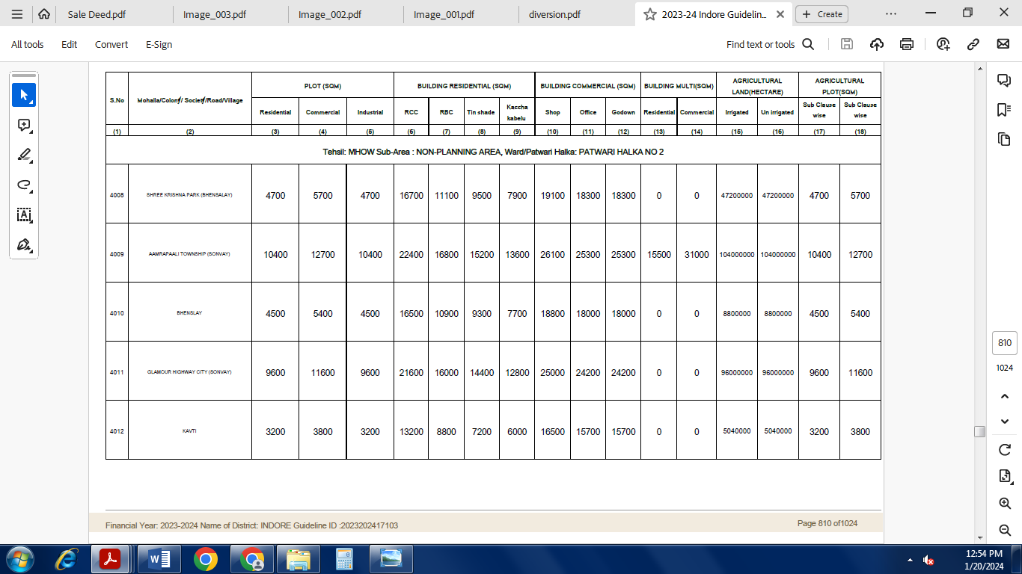

Price Indicators
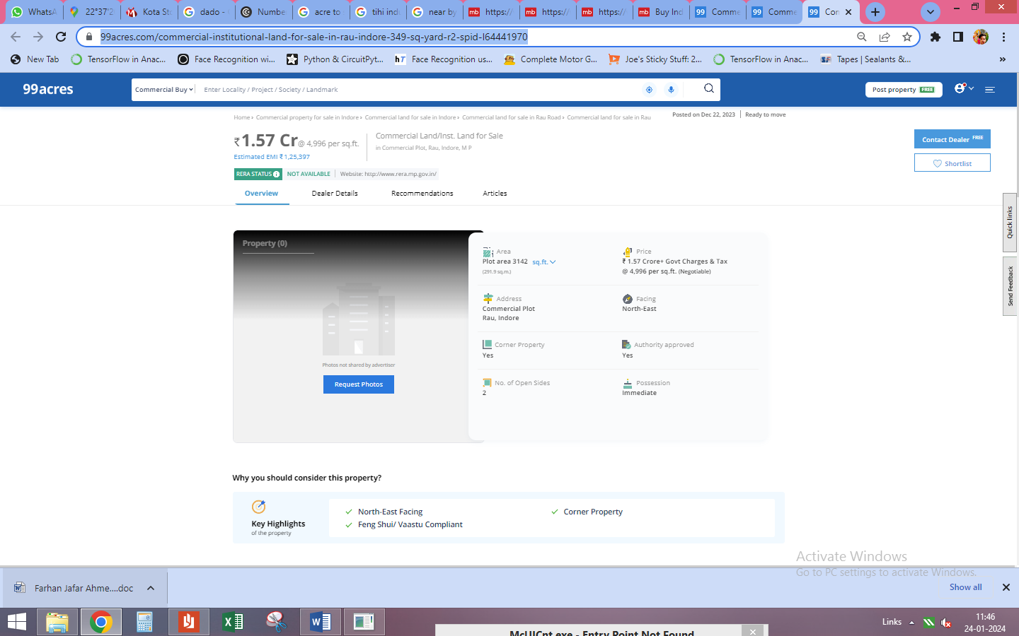

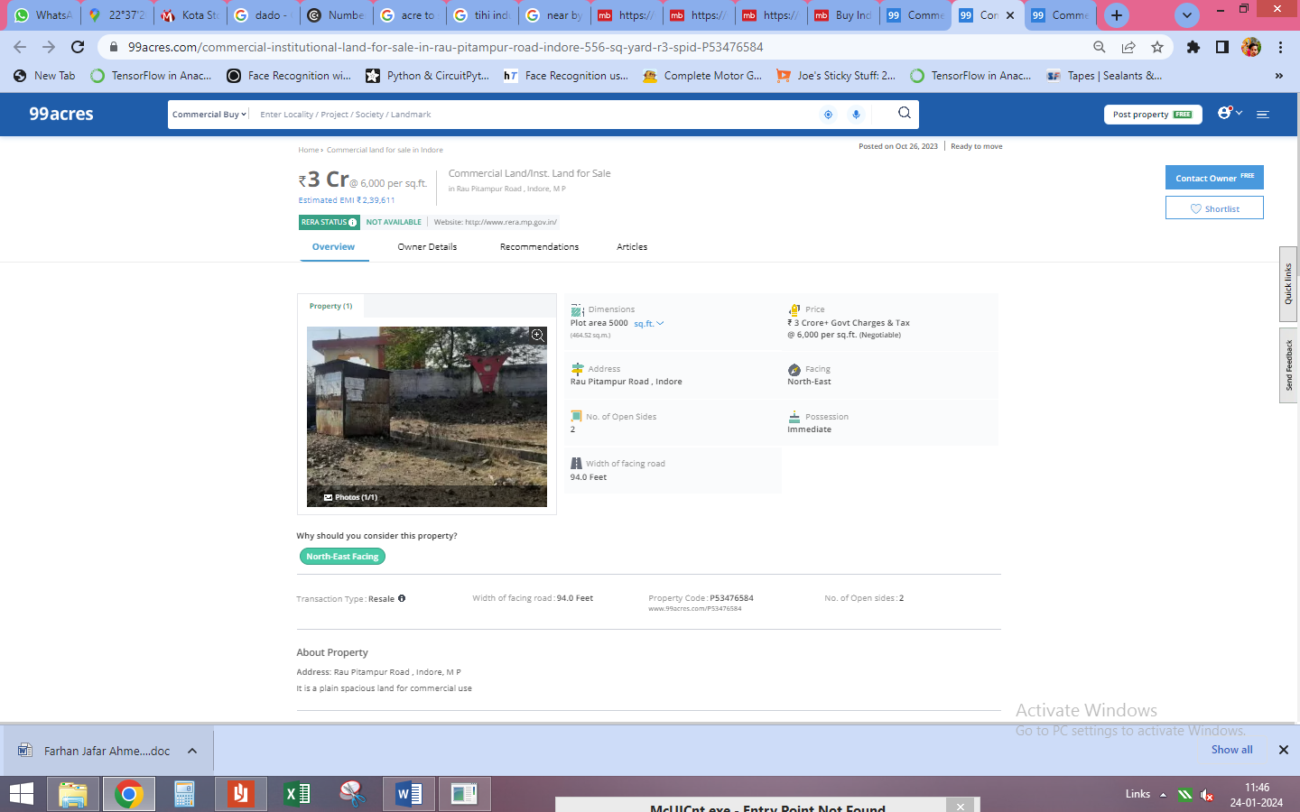

DEFINITION OF VALUE FOR THIS SPECIFIC PURPOSE

This exercise is to assess Fair Market Value of the property under reference for purpose as on 25th January 2024.

The term Fair Market Value is defined as

"The most probable price, as of a specified date, in cash, terms equivalent to cash, or in other precisely revealed terms for which the specified property rights would sell after reasonable exposure in a competitive market under all conditions requisite to a fair sale, with the buyer and seller each acting prudently knowledgeably and for self-interest assuming that neither is under undue duress"

Fundamental assumptions and conditions presumed in this definition are:

- Buyer and seller are motivated by self-interest.

- Buyer and seller are well informed and are acting prudently.

- The property is exposed for a reasonable time on the open market.

- Payment is made in cash or equivalent or in specified financing terms.

ASSUMPTIONS, CAVEATS, LIMITATION AND DISCLAIMERS
- We assume no responsibility for matters of legal nature affecting the property appraised or the title thereto, nor do we render our opinion as to the title, which is assumed to be good and marketable.
- The property is valued as though under responsible ownership.
- It is assumed that there are no hidden or unapparent conditions of the subsoil or structure that would render it more or less valuable. No responsibility is assumed for such conditions or for engineering that might be required to discover such factors.
- There is no direct/ indirect interest in the property valued.
- The rates for valuation of the property are in accordance with the Govt. approved rates and prevailing market rates.

Manoj B. Chalikwar
Registered Valuer
Chartered Engineer (India)
Reg. No. CAT-I-F-1763
BOM Emp. No. AX40/Empanelment: Valuer/VCPL/2021-22

