Vastu/Nashik/06/32014/2301224
22/20-325-RYBS
Date: 19.01.2024

To,
The Branch Manager,
Bank of Baroda
Regional Office
BSNL Building, Datta Mandir Road, Nashik Road,
Nashik, PIN – 422 101, State - Maharashtra, Country - India.

Sub: Vetting of Extra Amenities

Sir,

With reference to above subject, we have evaluated the Extra amenities For Residential Flat No. 16, Fourth Floor, A - Wing, " Vedant - III ", Survey No. 290/ 9/ 1 & 290/ 9/ 2, Plot No.1 & 2, Behind Dr. Wagh Dental Care Clinic, Buddha Vihar, Hari Vishwa Balaji Road, Ekta Green Villa Road, Village – Pathardi, Taluka & District - Nashik, PIN Code – 422 010, State – Maharashtra, Country – India. belongs Name of Proposed Purchaser: Shri. Sameer Dattatreya Purkar Name of Owner: New Akshara Construction.

We have verified the rates quoted as per current market rates. Details of Extra Amenities considered as per copy of Extra Amenities Agreement between Shri. Sameer Dattatreya Purkar. (First Party). Shri. Sachin Laxman Jadhav (Second Party) received on dated.15.01.2024. The Extra Amenities amount is Rs. 8,00,000/- (Rupees Eight Lakh Only)

The said Cost Vetting Certificate is valid upto next 6 months Only.

Thanking you

Sincerely yours

Manoj B. Chalikwar
Registered Valuer
Chartered Engineer (India)
Reg. No. CAT-I-F-1763
Reg. No. IBBI/RV/07/2018/10366
BOB Empanelment No.: ZO:MZ:ADV:46:941
Encl: Valuation report.

Agreement for Extra Amenities
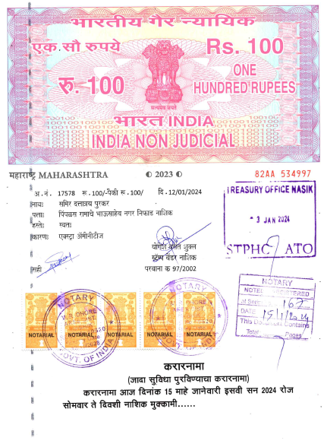
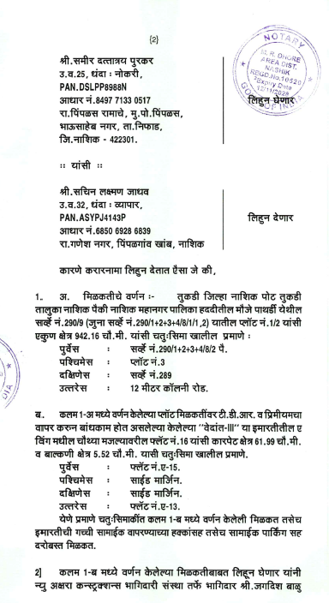

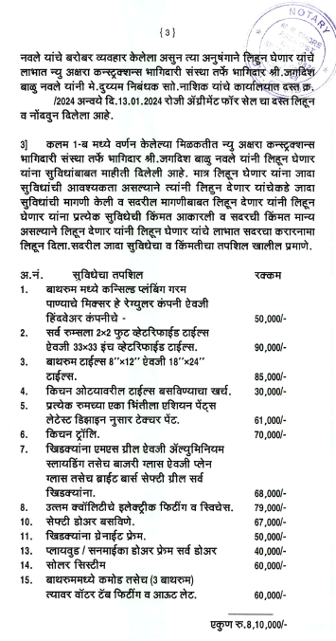
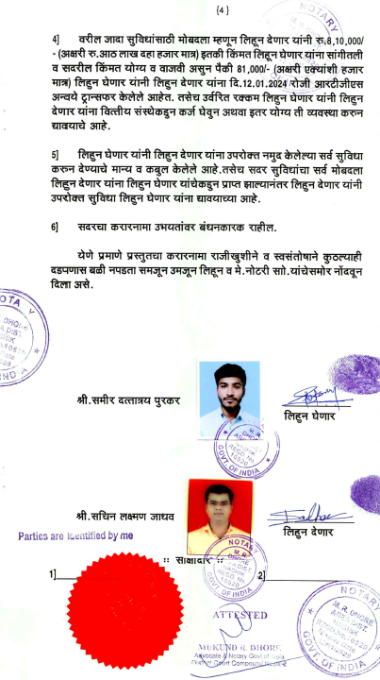

The Extra Amenities amount is Rs. 8,00,000/- (Rupees Eight Lakh Only)

