Vastu/Nashik/03/2023833/30490/46262
22/24-455-RPV
Date: 16.01.2024

To, `
The Branch Manager,
Bank of Baroda
Regional Office Nashik Road Branch
BSNL Building, Datta Mandir Road, Nashik Road,
Nashik -422 101, State - Maharashtra, Country - India.

Sub: Vetting of Extra Amenities

Sir,

With reference to above subject, we have evaluated the Extra Amenities for Residential Flat No. 03, Second Floor, " Samruddhi Exclusive Apartment ", Survey No. 181/ A/ 2/ A/ 1, Plot No. 18, Opp. To Dave Farsan Mart, Damodar Nagar, Hirawadi Road, Adgaon Naka, Village - Nashik, Taluka & District - Nashik, PIN Code – 422003, State – Maharashtra, Country – India belongs to Name of Owner: Shri. Kiran Kashinath Kapadane & Sau. Aasha Kiran Kapadane.

We have verified the rates quoted as per current market rates. Details of work and Extra Amenities considered as per copy of Agreement for Extra Amenities issued by Shri. Kiran Kashinath Kapadane (First Party) and Sau. Aasha Kiran Kapadane (Second Party) received on dated 03.01.2024. The Extra Amenities amount is Rs.5,00,000/- ( Rupees Five Lakh Only. )

The said Cost Vetting Certificate is valid upto next 6 months Only.

Thanking you

Sincerely yours

Manoj B. Chalikwar
Registered Valuer
Chartered Engineer (India)
Reg. No. CAT-I-F-1763
Reg. No. IBBI/RV/07/2018/10366
BOB Empanelment No.: ZO:MZ:ADV:46:941
Encl: Valuation report.

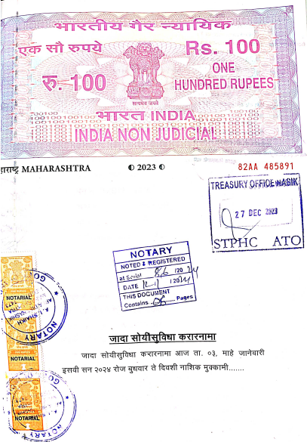
Agreement for Extra Amenities
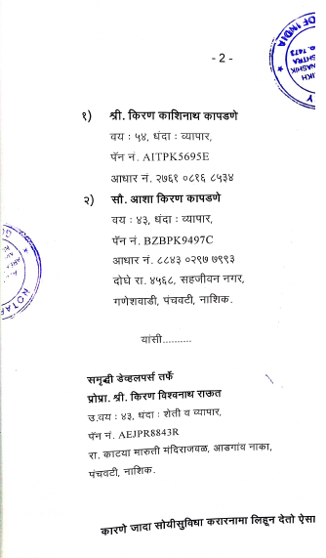

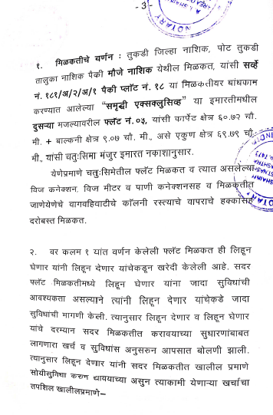
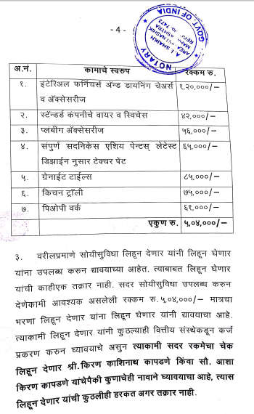

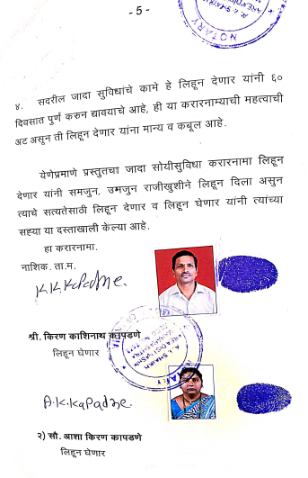
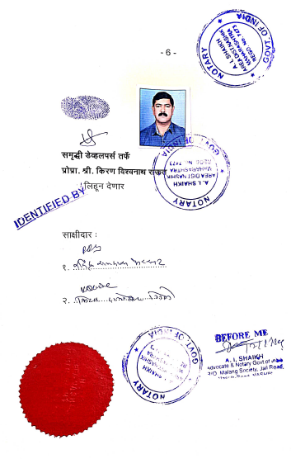

The Extra Amenities amount is Rs.5,00,000/- ( Rupees Five Lakh Only. )

