COST VETTING REPORT
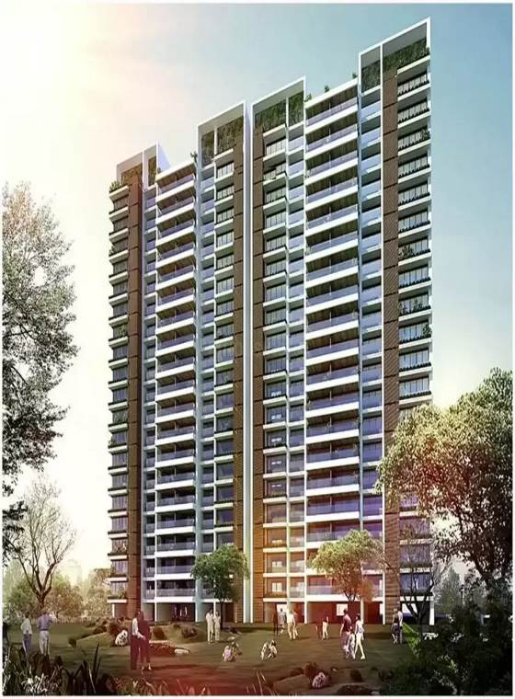

Details of the property under consideration:

Name of Project: "One Meraki Wing C"

"One Meraki Wing C" Proposed Residential Building on Plot bearing, CTS No. 619/14, 619/15, 619/21A & 619/21B, Motibaug, Opp. R.K Studio, V.N Purav Marg, Village – Borla, Chembur (West),
Mumbai – 400 071, State - Maharashtra, Country – India

Latitude Longitude: 19°02’54.3”N 72°54’29.6”E

Valuation Done for:
State Bank of India
SME Chembur Branch
Unit No. 11, Building No. 11, Ground Floor, Corporate Park, Sion Trombay Road,
Chembur, Mumbai, Pin Code – 400 071, State - Maharashtra, Country – India

Vastu/SBI/Mumbai/01/2024/6373/2304531
15/03-233-PY
Date: 15.01.2024

To,
The Branch Manager,
State Bank of India
SME Chembur Branch
Unit No. 11, Building No. 11,
Ground Floor, Corporate Park,
Sion Trombay Road, Chembur,
Mumbai, Pin Code – 400 071,
State - Maharashtra, Country – India.

Sub: Cost Vetting for "One Meraki Wing C" at Chembur (West), Mumbai, Pin Code – 400 071

Dear Sir,
In accordance with your Mail as stated above, we enclose our Report on Cost Vetting for "One Meraki Wing C", Proposed Residential Building on Plot bearing, CTS No. 619/14, 619/15, 619/21A & 619/21B, Motibaug, Opp. R.K Studio, V.N Purav Marg, Village – Borla, Chembur (West), Mumbai – 400 071, State - Maharashtra, Country - India.
The project is being developed by M/s. Meraki Habitats LLP formerly known as M/s. Shiv Sabari Developers. They have backed by professionals who have a strong background in real estate industry. The board comprises entrepreneurs who have the needed expertise and real-time experience across fields including finance, marketing, construction etc.
M/s. Meraki Habitats LLP formerly known as M/s. Shiv Sabari Developers is developing a Residential cum Commercial Building Project on plot bearing on CTS No. 619/14, 619/15, 619/21A & 619/21B, Motibaug, Opp. R.K Studio, V.N Purav Marg, Village – Borla, Chembur (West). Project is comprising in 3 Phases. 1st Phase – Commercial Building No. 3, 2nd Phase – Residential Building No. 1 (Wing A & B) & 3rd Phase – Residential Building No. 1 (Wing C to E) & Building No. 2 (Wing A & B).
Phase 3 Residential Building No. 1 of Wing C is proposed of 3 Basement + Ground Floor + 1st Part Podium floor + 2nd to 19th Upper Residential Floors with total RERA carpet area of 68,660.00 Sq. Ft. which consists 2 BHK & 3 BHK units with total 68 nos. of flats along with Yoga Hall, Swimming Pool, Fitness Centre, Society Office, Kids Play Area, Meditation Area, & Other Amenities.
In this regard, SBI, SME Chembur Branch, Unit No. 11, Building No. 11, Ground Floor, Corporate Park, Sion Trombay Road, Chembur, Mumbai, Pin Code – 400 071, has approached Vastukala Consultants (I) Pvt. Ltd. (VCIPL) to conduct a Cost Vetting of the said project.
Our analysis of the cost vetting is enclosed in this report. This Report forms an integral whole and cannot be split in parts. The outcome of the report/ study can only lead to proper conclusions if the Report as a whole is taken into account.
The information used by Vastukala Consultants (I) Pvt. Ltd. (VCIPL) in preparing this report has been obtained from a variety of sources and other relevant documents provided by the client & bank. As agreed, we have performed our cost vetting exercise with the data available related to the business, considering the market prospects and projections. Our results are dependent on documents provided by client & bank, the underlying assumptions, which has been analyzed at a broader level by VCIPL while assessing their reasonableness.
Total Project Cost for the completion of Project will be ` 97.22 Cr.

For Vastukala Consultants (I) Pvt. Ltd.

Manoj B. Chalikwar
Registered Valuer
Chartered Engineer (India)
Reg. No. IBBI / RV / 07/2018/10366
Reg. No. CAT-I-F-1763
SBI Empanelment No.: SME/TCC/2021-22/86/3
About the Project:
Proposed Residential Building on Plot bearing, CTS No. 619/14, 619/15, 619/21A & 619/21B, Motibaug, Opp. R.K Studio, V.N Purav Marg, Village – Borla, Chembur (West), Mumbai – 400 071. It is about 2 Km. walking distance from Chembur Railway station. Near R. K. Studio.

Area Statement as per Approved Plan

I | Area Statement
1) | Gross area of Plot | 19916.05
a) | Area of Reservation in Plot
b) | Area of Road Set back
c) | Area of DP Road
2) | Deduction for
A | For reservation/road area
a) | Road set-back area to be handed over (100%) (Regulation no. 16)
b) | Proposed d p road to be handed over (100%) (Regulation no. 16)
c) | Reservation area to be handed over as per AR (Regulation no. 17)
 | Existing Recreation Ground Reservation area (plot) | 2623.00
 | Reservation Play Ground area (plot) to be handed over (Regulation no 17 of DCR 2034) | 408.05
 | Reservation Garden area (plot) to be handed over (Regulation no 17 of DCPR 2034) | 2939.50
d) | Encroachment area | 133.00
B | For amenity area
a) | Area of amenity plot/plots to be handed over as per dcr 14(a)
b) | Area of amenity plot/plots to be handed over as per dcr 14(b)
c) | Area of amenity plot/plots to be handed over as per dcr 15
d) | Area of amenity plot/plots to be handed over as per dcr 35
C | Deduction for existing built-up area to be retained if any
a) | Land component of existing BUA as per regulation under which the development was allowed
3) | Total deduction (2(A) +2(B) +2(C)) | 6103.55
4) | Balance area of plot (1 minus 3) | 13812.50
4A | ADD FOR F.S.I AS PER PROPOSED ACCOMODATION AND RESERVATION
 | Existing Recreation Ground Reservation area (plot)
 | Reservation Garden area (plot) to be handed over (Regulation no 17)
 | Reservation Garden area (plot) to be handed over (Regulation no 17) | 2496.19
5) | Plot area under development (4 + 2 A(a)) | 16308.69
6) | Zonal (basic) FSI (1 or 1.33) | One
7) | Permissible built-up area as per zonal (basic) FSI (5*6) | 16308.69
8) | Built up area equal to area of land handed over as per 3(a) of regulation 30(a)
9) | Built up area in Lieu of cost of construction of built-up amenity to be handed over
10) | Built up area due to additional FSI on payment of premium as per table no 12-regulation no 30(a) | 8154.35
11) | Built up area due to additional FSI on payment of premium as per table no 12-regulation no 30(a)3 | 111188.54
12) | Reservation Garden area plot to be handed over (Regulation no. 17)
12(a) | TDR generated Amenity area set-off as per regulation 14(B) | 1702.72
13) | Incentive FSI as per regulation 30(18)
14) | Permissible built-up area | 37354.3
b) | Proposed built up area in building no. 1 | 21600.36
c) | Proposed built up area in building no. 2
d) | Proposed built up area in building no. 3 | 12337.97
15 | Total Proposed built up area in building no 31(3) | 33938.33
16 | Fungible commentary area as per regulation 31(3)
a) | i) Permissible Fungible Compensatory Commercial Area Rehab component without charging premium
b) | ii) Fungible Compensatory Commercial area availed for Rehab component without charging premium
c) | i) Permissible Fungible Compensatory Commercial Area Rehab component without charging premium
d) | ii) Fungible Compensatory Commercial area availed for Rehab component without charging premium
e) | i) Permissible Fungible Compensatory Commercial Area Rehab component without charging premium
17 | ii) Fungible Compensatory Commercial Residential area availed on payment of premium | 11878.42
18 | Total Fungible Compensatory area by charging premium | 11878.42
II | Total Built up Area proposed including Fungible Compensatory Area (15 + 16(a)(ii) + 16(b)(ii) | 45816.75
A | FSI consumed on Net Plot (15/4)
a) | Other Requirements
b) | Reservation/Designation
c) | Name of Reservation
d) | Area of Reservation affecting the plot
e) | Area of Reservation land to be handed over as per Regulation No. 17
(B) | Built up area of Amenity to be handed over as per Regulation No.17
 | Area /Built up Amenity to be handed over as per Regulation No
 | (I) 14(A)
 | (ii) 14(b)
 | (iii) 15
(C) | Requirement of Recreational Open Space in Layout/ Plot as per Regulation No. 27
(D) | Tenement Statement
 | (i) Proposed built up area (13 above) | 21600.36
 | (ii) Less deduction of Non-residential area (Shop etc)
 | (iii) Area available for tenements ((i) minus(ii)) | 21600.36
 | (iv) Tenements permissible (Density of tenements/hectare) | 972Nos
 | (v) Total number of Tenements proposed on the plot | 283 Nos
(E) | Parking Statement
 | (i) Parking required by regulations for
 | Car
 | Scooter/Motor Cycle | 446 Nos
 | Outsider (Visitor)
 | (i) Covered garage permissible
 | (iii) Covered Garages proposed
 | Car
 | Scooter/Motor Cycle
 | Outsider (Visitor)
 | (iv) Total parking provided | 792 Nos
(F) | Transport Vehicle Parking
 | (i) Space for transport vehicle parking required by Regulations
 | (ii) Total No. of transport vehicles parking spaces provided

Construction Area as per Approved Plan
Sr. No | Floor Nos. | Built Up Area in Sq. M. | Balcony/FB/ Terrace Area/ Chhajja in Sq. M. | Staircase & Lift Area in Sq. M. | Refuge Area in Sq. M. | Stilt Area in Sq. M. | Meter Room/ Electric room / DG Room area in Sq. M. | Other Area/ Gents Toilet/Fitness Centre in Sq. M. | Total Area in Sq. M.
1 | Basement 1 | - | - | - | - | 1,761.59 | - | - | 1,761.59
2 | Basement 2 | - | - | - | - | 1,761.59 | - | - | 1,761.59
3 | Basement 3 | - | - | - | - | 1,761.59 | - | - | 1,761.59
4 | Ground Floor | - | - | 72.40 | - | 1,717.52 | 70.76 | - | 1,860.68
5 | 1st Podium Floor | 86.08 | - | 72.40 | - | - | - | 635.62 | 794.10
6 | 2nd Floor | 413.37 | 12.27 | 71.12 | - | - | - | - | 496.76
7 | 3rd Floor | 413.37 | 12.27 | 71.12 | - | - | - | - | 496.76
8 | 4th Floor | 413.37 | 12.27 | 71.12 | - | - | - | - | 496.76
9 | 5th Floor | 413.37 | 12.27 | 71.12 | - | - | - | - | 496.76
10 | 6th Floor | 413.37 | 12.27 | 71.12 | - | - | - | - | 496.76
11 | 7th Floor | 302.21 | 2.04 | 71.12 | 112.72 | - | - | 3.37 | 491.46
12 | 8th Floor | 414.92 | 12.27 | 71.12 | - | - | - | - | 498.31
13 | 9th Floor | 413.37 | 12.27 | 71.12 | - | - | - | - | 496.76
14 | 10th Floor | 413.37 | 12.27 | 71.12 | - | - | - | - | 496.76
15 | 11th Floor | 413.37 | 12.27 | 71.12 | - | - | - | - | 496.76
16 | 12th Floor | 413.37 | 12.27 | 71.12 | - | - | - | - | 496.76
17 | 13th Floor | 413.37 | 12.27 | 71.12 | - | - | - | - | 496.76
18 | 14th Floor | 304.13 | 2.04 | 71.12 | 110.79 | - | - | 3.37 | 491.45
19 | 15th Floor | 414.92 | 12.27 | 71.12 | - | - | - | - | 498.31
20 | 16th Floor | 413.37 | 12.27 | 71.12 | - | - | - | - | 496.76
21 | 17th Floor | 413.37 | 12.27 | 71.12 | - | - | - | - | 496.76
22 | 18th Floor | 413.37 | 12.27 | 71.12 | - | - | - | - | 496.76
23 | 19th Floor | 413.37 | 12.27 | 71.12 | - | - | - | - | 496.76
24 | Terrace | - | - | 39.15 | - | - | - | - | 39.15
 | Total | 7,309.44 | 200.34 | 1,464.11 | 223.51 | 7,002.29 | 70.76 | 642.36 | 16,912.81

Project Cost
Sr. No. | Particulars | Total Estimated Amount in ` | Total Estimated Amount  in ` Cr.
1 | Land Cost
 | Acquisition Cost of Land or Development Rights, and Legal Cost. | 12,50,00,430.00 | 12.50
 | Rent to Tenants, Lease premium, Lease Rent, interest cost incurred or payable on Land Cost | - | -
 | Amount of Premium payable to obtain development rights, FSI, additional FSI, fungible area, and any other incentive under DCR from Local Authority or State Government or any Statutory Authority. | 13,02,00,000.00 | 13.02
 | Acquisition cost of TDR (if any)
2 | Cost of Construction
- I | Estimated construction cost of sale building including site development and infrastructure for the same. | 55,81,22,598.00 | 55.81
 | On site expenditure for development of entire project excluding cost of construction as per(i) above,
a. | Architect Fees & Consultant fees | 55,81,226.00 | 0.56
b. | Admin Cost includes salaries, site overheads, development works, cost of services (including water, electricity, sewerage, drainage, layout roads etc.), cost of machineries and equipment including its hire and maintenance cost, consumables etc. All costs directly incurred to complete the construction of the entire phase of the project registered. | 3,06,96,743.00 | 3.07
c. | Marketing Cost | 5,34,83,175.00 | 5.35
3 | Interest during the Project | 6,91,00,000.00 | 6.91
4. | Contingency Charges | - | -
 | GRAND TOTAL | 97,21,84,172.00 | 91.22

Manoj B. Chalikwar
Registered Valuer
Chartered Engineer (India)
Reg. No. IBBI / RV / 07/2018/10366
Reg. No. CAT-I-F-1763
SBI Empanelment No.: SME/TCC/2021-22/86/3

Comments on each element of Cost of Project: -
- Land Cost:
As per Present Ready Reckoner rate the Entire Project Land Value is ` 114.78 Cr. considering Land Rate @ ` 83,100.00 per Sq. M. & Net Plot Area of 13,812.50 Sq. M.
As per information shared by the developer proportionate Cost of land for C Wing building is ` 12,50,00,430.00 i.e., ` 12.50 Cr. which is 12.86% of Total Project Cost.

Sr. No. | Land Cost: | Amount (in `)
1 | Payment to Land Owners | 43,71,53,000.00
2 | Payment to Tenants | 30,40,88,299.00
3 | Stamp Duty | 3,86,02,044.00
4 | Tenancy Purchase Cost & Other Cost | 6,85,64,179.00
 | Total Land Cost | 84,84,07,522.00
As per Conveyance Deed.

Sr. No. | Particulars | Land Cost (in Rs.) | BUA | % of Land Covered
1 | Arena (Commercial) | 21,96,07,901.47 | 16,122.03 | 28%
2 | One Meraki -Wing A & B | 19,82,40,325.86 | 14,171.63 | 25%
3 | One Meraki -Wing C | 12,50,00,430.49 | 7,223.11 | 13%
4 | One Meraki -Wing D | 13,51,44,430.49 | 7,223.11 | 13%
5 | One Meraki -Wing E | 7,98,41,530.97 | 5,861.39 | 10%
6 | Platina | 9,05,72,902.70 | 6,649.21 | 12%
TOTAL |  | 84,84,07,522.00 | 57,250.48 | 100%
As per information from client, 13% of land is covered for Wing C so proportionate land cost for One Meraki – Wing C Project is ` 12,50,00,430.00 i.e., ` 12.50 Cr.
- Building Cost of Construction:
Construction area of Wing C = 16,912.81 Sq. M. i.e., 1,82,049.44 Sq. Ft.
Total estimated cost for construction of Building (includes cost of RCC work, manpower, lift, material, painting, finishing work, site development, etc.) is ` 50,73,84,180.00 i.e., ` 50.74 Cr. which comes ` 30,000.00 per Sq. M. on construction area for building and cost for construction for deep excavation & piling work is ` 5,07,38,418.00 i.e., ` 5.07 Cr. which is 10% of Cost of Construction.
Hence, total cost of construction (Cost of Construction of Building + Cost of Deep Excavation & Piling Work) is ` 55,81,22,598.00 i.e., ` 55.81 Cr. which is 57.41% of Total Project Cost.
VCIPL opinion the construction cost of 30,000/- Per Sq. M. which is in line with Market-Trend.
Particulars | Rate per Sq. M.
Excavation Work | 2,000.00
Total RCC Work | 15,000.00
Final Finishing Work | 7,000.00
Other Work | 6,000.00
Cost of Construction | 30,000.00
Deep Excavation & Piling Work | 10% of total Cost of construction

- Approval Charges:
The Total Approval Cost (Fungible Cost & Development Cess Premium) as per challan is ` 13,02,00,000.00 i.e., ` 13.02 Cr.
Sr. No. | Particulars | Total Cost (`.) | Total Cost (`. In Cr.)
1 | Scrutiny Fees (New Proposals U/S 337 & 342 | 14,00,000.00 | 0.14
2 | Development Cess 33(7) | 4,25,00,000.00 | 4.25
3 | Premium for Staircase, Lift, Lift Lobby area | 1,00,00,000.00 | 1.00
4 | Premium for .50 % Addition F.S. I | 27,00,000.00 | 0.27
5 | Premium for Fungible F.S. I | 1,40,00,000.00 | 1.40
6 | I.O.D Deposit | 1,00,000.00 | 0.01
7 | Premium for deficiency in Open Space | 3,00,000.00 | 0.03
8 | Labour Welfare Cess (ADM -1%) | 3,00,000.00 | 0.03
9 | Other deficiency Premium | 35,00,000.00 | 0.35
10 | Miscellaneous | 3,75,00,000.00 | 3.75
11 | 5% Premium for TDR Utilizations | 20,00,000.00 | 0.20
12 | Labour Welfare Cess (Tax/Fund - 99%) | 28,00,000.00 | 0.28
13 | Permissible additional 0.50 F.S. I Dharavi redevelopment project (DRP) | 1,00,000.00 | 0.01
14 | Premium for paved/ perforated RG | 50,00,000.00 | 0.50
15 | Premium for conversion of zone from I to R/ C reg 14 B | 55,00,000.00 | 0.55
16 | MSRDC share towards Fungible FSI reg 31(3) | 25,00,000.00 | 0.25
17 | MSRDC Share towards 0.50 Addi. FSI reg 30 | 14,00,000.00 | 0.14
 | Total Cost | 13,02,00,000.00 | 13.02
As per information shared by the developer proportionate approval cost for single building is ` 13,02,00,000.00 i.e., ` 13.02 Cr., hence bifurcation for the same is not provided to us, which is 13.39% of Total Project Cost.

- Architect Cost, RCC & Other Professional Charges:
The total Architect charges of ` 55,81,226.00 i.e., ` 0.56 Cr. is 1% of total construction cost & it is line up with Market trend.
The professional charge consists of Architect & Legal which in market is in the range of 3% - 6% of Total Construction cost of the project.

- Administrative Expenses:
Salaries, site overheads, development works, cost of services (including water, electricity, sewerage, drainage, layout roads etc.), cost of machineries and equipment including its hire and maintenance cost, consumables etc. All costs directly incurred to complete the construction of the entire phase of the project registered is estimated 5.5% of total cost of construction which comes to ` 3,06,96,743.00 i.e., ` 3.07Cr.
The admin charges which in market is in the range of 4% - 6% of Total Construction cost of the project.

- Marketing Expenses:
Marketing costs directly incurred to complete the construction of the entire phase of the project registered is estimated at 2.25% of total Sale income from the project which comes to ` 5,34,83,175.00 i.e., ` 5.35 Cr.
The marketing charge consists of brokerage & commission which in market is in the range of 1% - 3% of Total Sale income of the property.

- Interest Costs:
The Interest cost for the term loan is ` 6,91,00,000.00 i.e., ` 6.91 Cr., which is 7.11% of total project cost.
As per information provided by the client.

Observation and Construction: -
Total estimated cost of project i.e., ` 97,21,84,172.00 (Rupees Ninety Seven Crore Twenty One Lakh Eighty Four Thousand One Hundred Seventy Two Only) i.e. ` 97.22 Cr. is fair & reasonable.
The project cost is including land premium payable to concern authorities, Fungible FSI Premium, Cost of Construction of Sale Building, on site expenses including admin & marketing expenses, premiums / charges to be paid to competent authority and Bank interest, etc. we have not independently verified interest cost hence not consider in cost vetting.
Total estimated cost of construction for Sale Building for sanctioned plan up to 3 Basement + Ground Floor + 1st to 19th Upper Floor is ` 50,73,84,180.00 i.e., ` 50.74 Cr. which comes ` 30,000.00 per Sq. M. on construction area for building and cost for construction for deep excavation & piling work is ` 5,07,38,418.00 i.e., ` 5.08 Cr. which is 10% of Cost of Construction. Hence, total cost of construction (Cost of Construction of Building + Cost of Deep Excavation & Piling Work) is ` 55,81,22,598.00 i.e., ` 55.81 Cr., which is fair & reasonable considering the present status of project, type & quality of construction & specification of the building materials to be used, height of the structure, amenities to be provided in proposed building.

Assumptions & Remarks-
- The adequacy of Engineering / Structural design is beyond the scope of our assignment.
- Estimated project completion date is 31/12/2026. The cost is certified based on the assumptions that the project will be completed within time frame. Few assumptions are made regarding inflation & cost rise etc. during construction period.
Photocopy of following document is provided to us & this report should be read along with it:
- Copy of Deed of Conveyance dated 17.01.2017 b/w M/s. Natraj Realcon Pvt. Ltd. (The Vendors) And M/s. Shiv Sabari Developers (The Purchaser)
- Copy of Deed of Conveyance dated 31.03.2006 b/w Mr. Fatema Ali Sutarwala & 6 others (The Vendors) And M/s. Shiv Sabari Developers (The Purchaser)
- Copy of Development Permission Certificate No. Dy. Ch.E./B.P./4024/E.S. dated on 27.08.2021 issued by Municipal Corporation of Greater Mumbai
- Copy of IOD No. CHE/ES/0840/M/W/337(NEW) issued by Municipal Corporation of Greater Mumbai
- Copy of 1st Commencement Certificate No. CHE/ES/0840/M/W/337(NEW) dated 29.12.2023 issued by Municipal Corporation of Greater Mumbai
(C.C. up to top of Stilt Slab of Wing C of Building No. 1, as per approved IOD plans dated 28.12.2021)
- Copy of Approved Plans No. CHE/ES/0840/M/W/337(NEW) dated 28.12.2021 issued by Municipal Corporation of Greater Mumbai
Approval Upto: 3 Basement + Ground Floor + 1st Podium Floor + 2nd to 19th Upper Floors
- Copy of 2nd Commencement Certificate No. CHE/ES/0840/M/W/337(NEW) dated 29.12.2023 issued by Municipal Corporation of Greater Mumbai
(C.C. for 3 Basement + Ground Floor + 1st Podium Floor + 2nd to 19th Upper Floors (Full C.C.) of Wing C, as per approved plans dated 28.12.2021)
- Copy of CA Certificate dated 08.01.2024 issued by M/s. K. F. Jetsey & Co.
- Copy of CA Certificate dated 02.08.2023 issued by M/s. K. F. Jetsey & Co.
- Copy of Title Report dated 14.11.2020 issued by M/s. J Law Associates.
- Copy of Name Change Certificate dated 06.01.2022 from M/s. Shiv Sabari Developers to M/s. Meraki Habitats LLP.
- Copy of RERA Certificate No. P51800050796 dated 03.05.2023 issued by Maharashtra Real Estate Regulatory Authority.

Actual Site Photographs
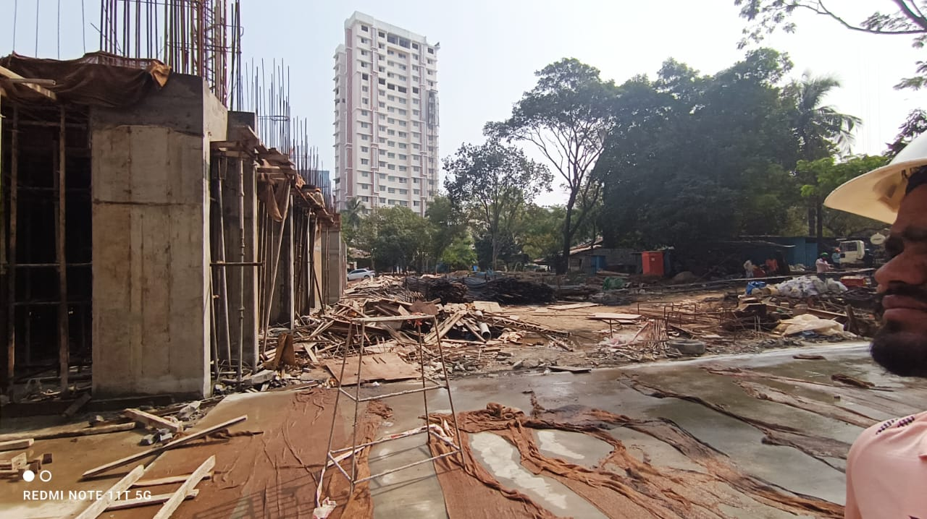

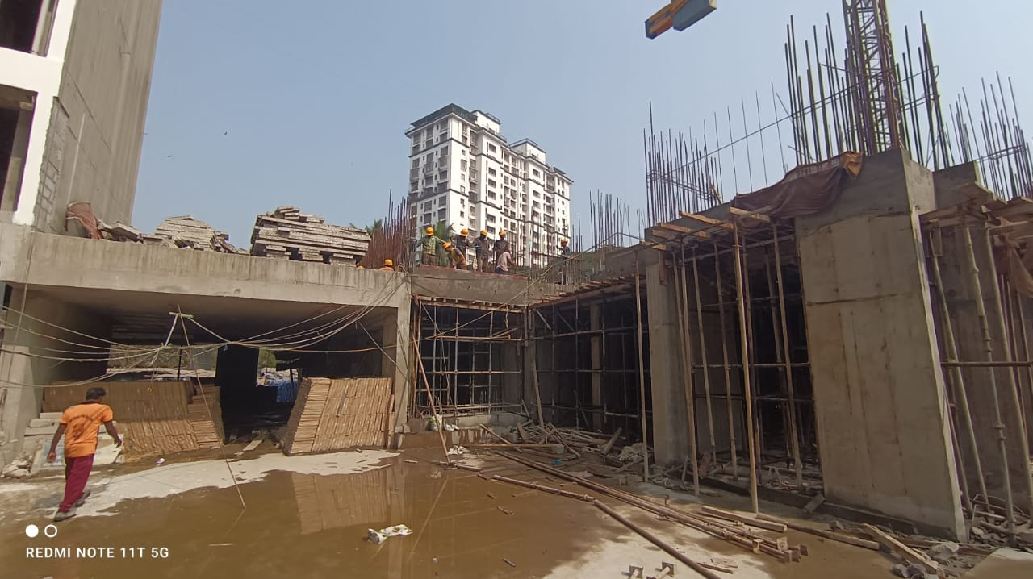

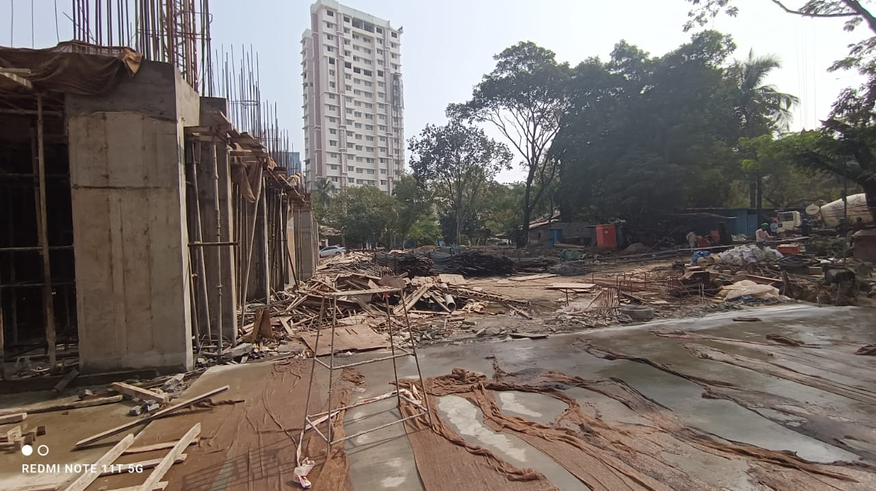

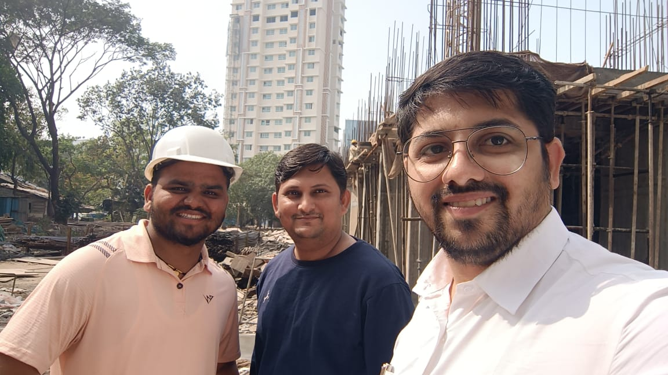

Route Map of the property
Site u/r

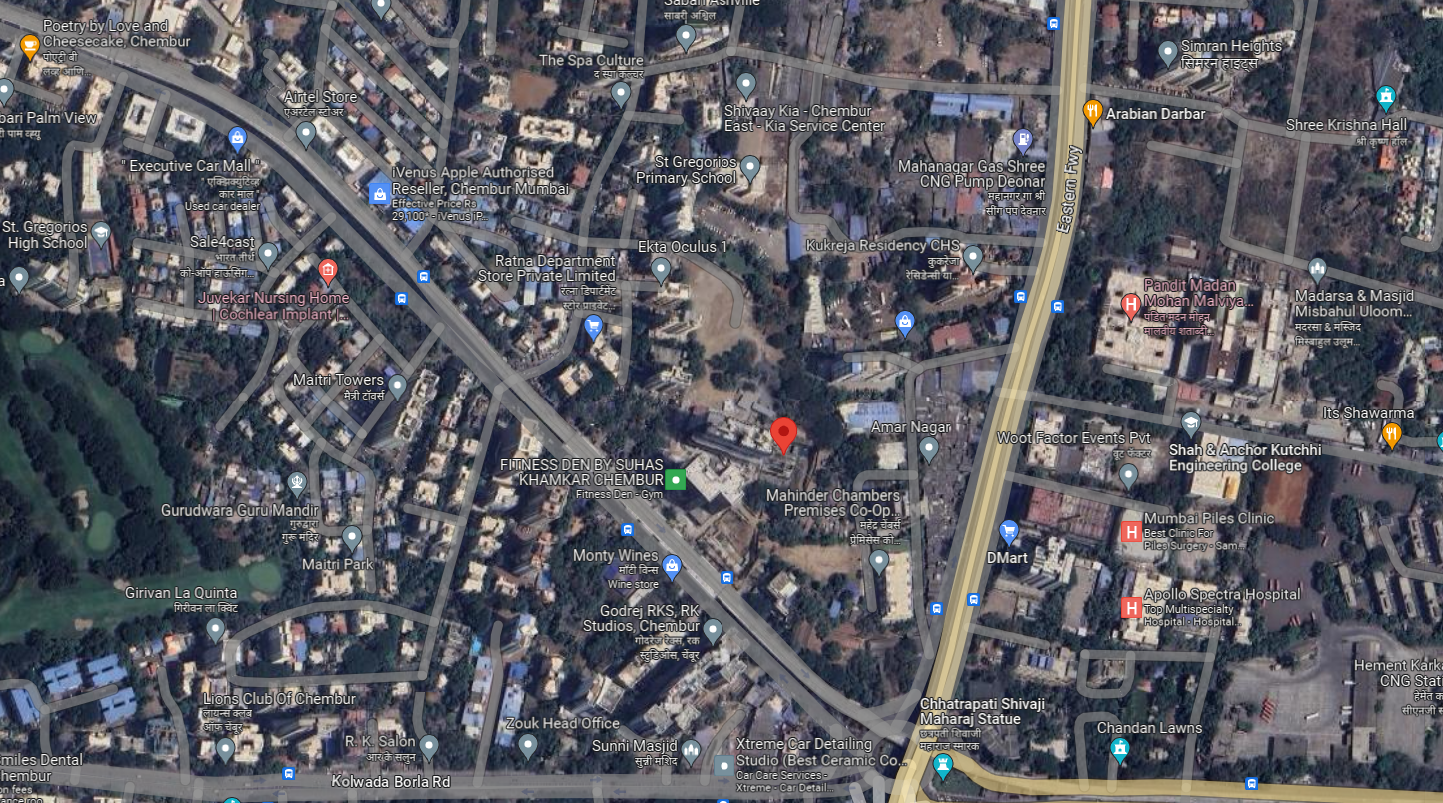

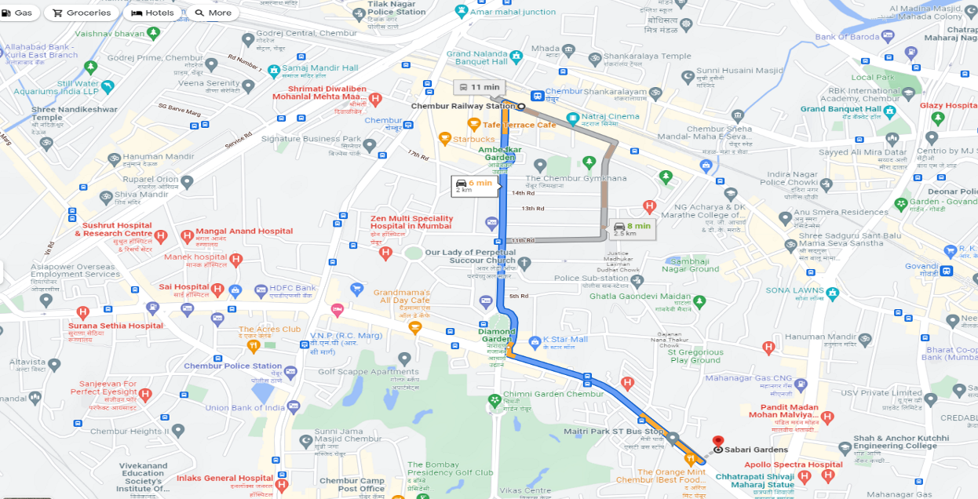

Latitude Longitude: 19°02'54.3"N 72°54'29.6"E

Note: The Blue line shows the route to site from nearest railway station (Chembur – 2.0 Km.)

