Vastu/Mumbai/08/2022/42114
12/09-186-PY
Date: 10.08.2022
State Bank Of India
SARB Churchgate
6th Floor, International 16, Maharshi Karve Road,
Churchgate, Mumbai - 400020,

State - Maharashtra, Country - India

DESKTOP VALUATION REPORT

Reference: Our Valuation Report No. 26689/42764 – 22/13-333-VSM dated 22.09.2022
Owner’s Name: Mr. R. B. Vinod Kumar
Property Address: Commercial Unit No. 1036 (pat), 1037, 1038, 1039 (part), 1040, 1041 & 1042 (part), 1st Floor, Wing – A, “Oberoi Garden Premises Co-Op. Soc. Ltd.”, Oberoi Garden Estates, Off. Chandivali Farm Road, Chandivali, Sakinaka, Andheri (East), Mumbai - 400 072, State – Maharashtra, Country – India
Property Value as on date:
Unit Nos. | Built Up Area  in Sq. Ft. | Rate /  (`) per Sq. Ft. | Fair Market Value  (`) | Realizable Value  (`) | Distress Value  (`)
1036 (pat), 1037, 1038, 1039 (part) | 1,372.00 | 14,500.00 | 1,98,94,000.00 | 1,69,09,900.00 | 1,39,25,800.00
1040, 1041 & 1042 (part) | 1,248.00 | 14,500.00 | 1,80,96,000.00 | 1,53,81,600.00 | 1,26,67,200.00
TOTAL |  |  | 3,79,90,000.00 | 3,22,91,500.00 | 2,65,93,000.00

Fair market value of the property is ` 3,79,90,000.00 (Rupees Three Crore Seventy Nine Lakh Ninety Thousand Only), Realizable value of the property is ` 3,22,91,500.00 (Rupees Three Crore Twenty Two Lakh Ninety One Thousand Five Hundred Only) and Distress value of the property is ` 2,65,93,000.00 (Rupees Two Crore Sixty Five Lakh Ninety Three Thousand Only).

Hence certified

Sharadkumar B. Chalikwar
Govt. Reg. Valuer
Chartered Engineer (India)
Reg. No. (N) CCIT/1-14/52/2008-09
SBI Empanelment No.: SME/TCC/2017-18/942/178
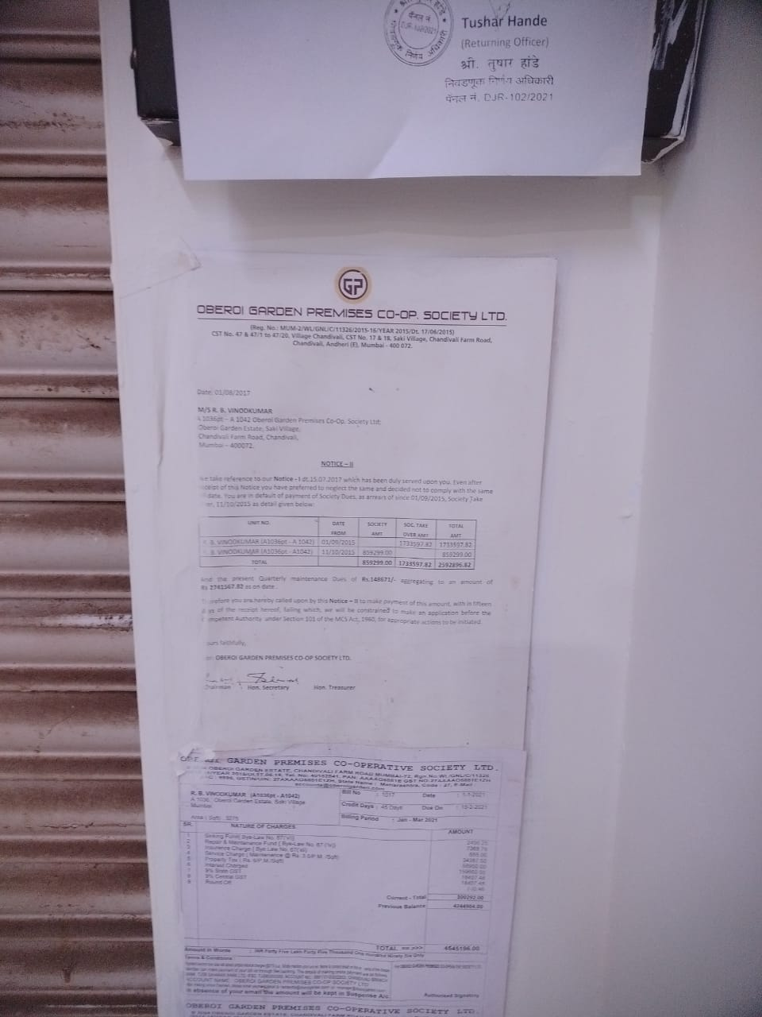
External Photographs
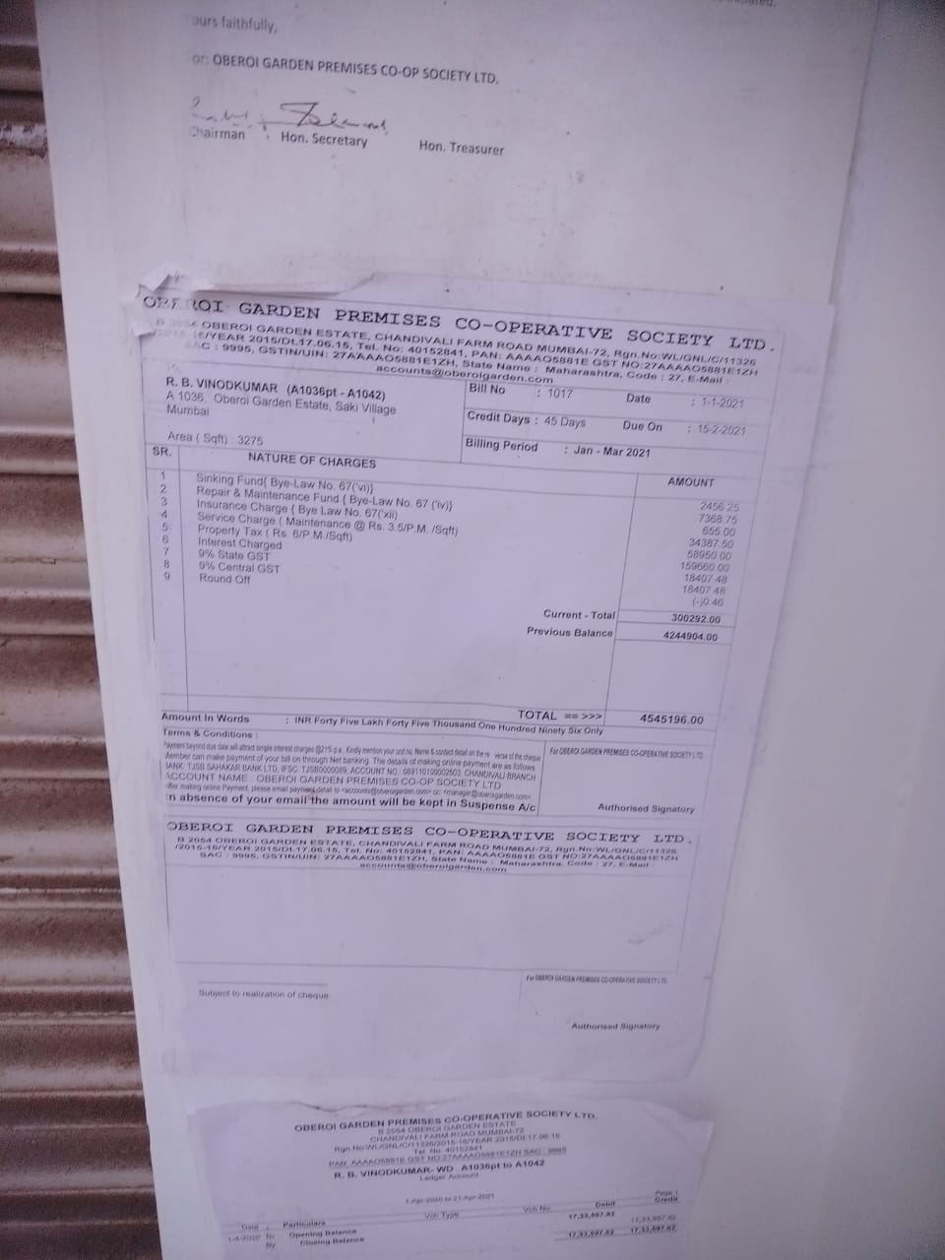
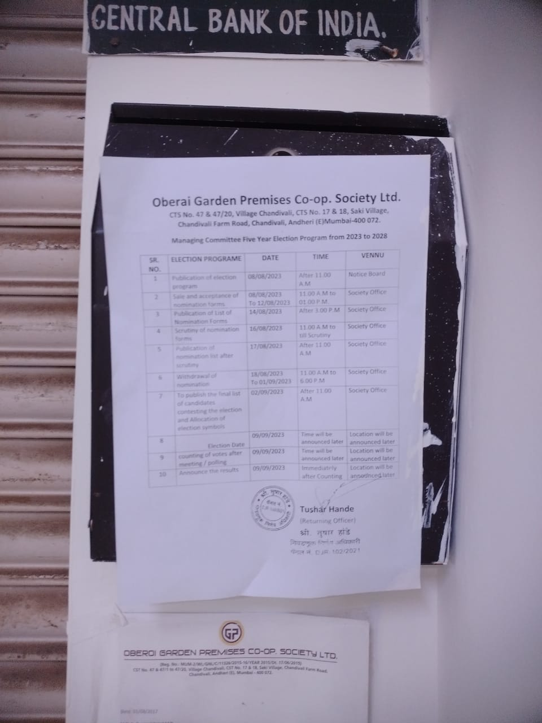

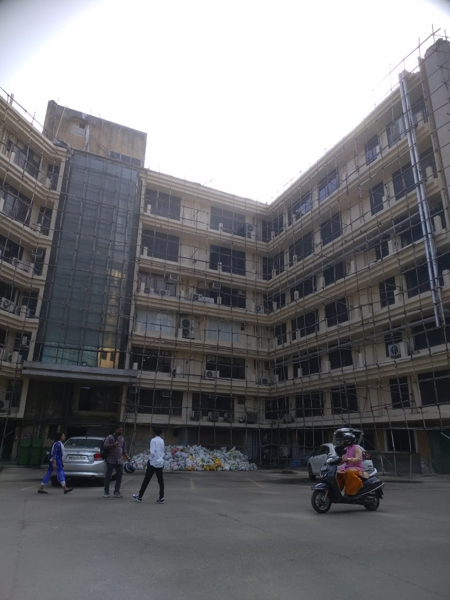
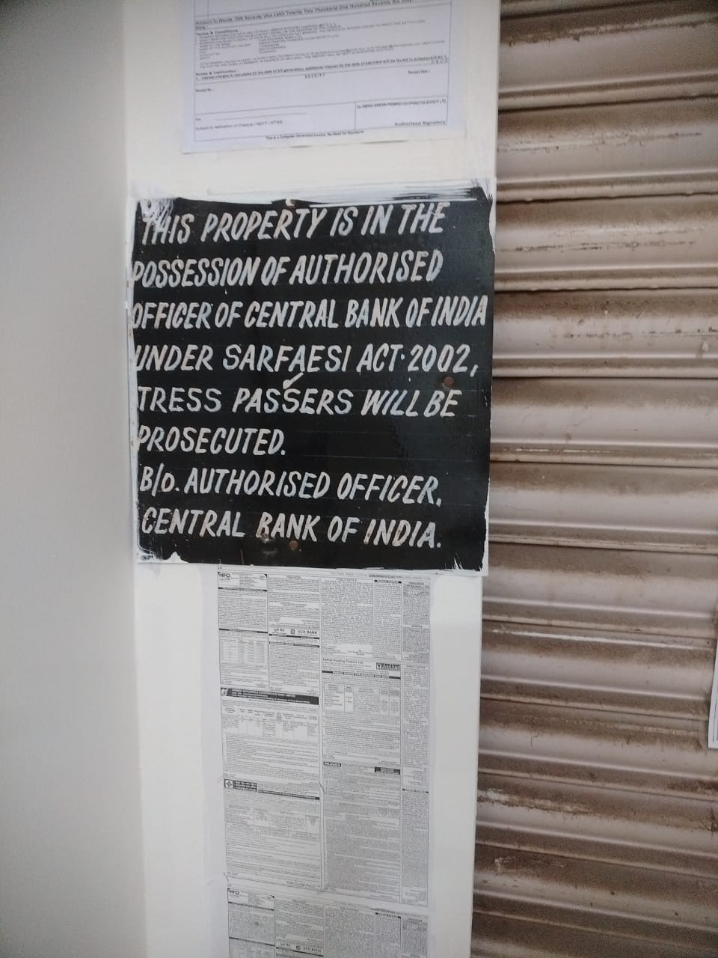
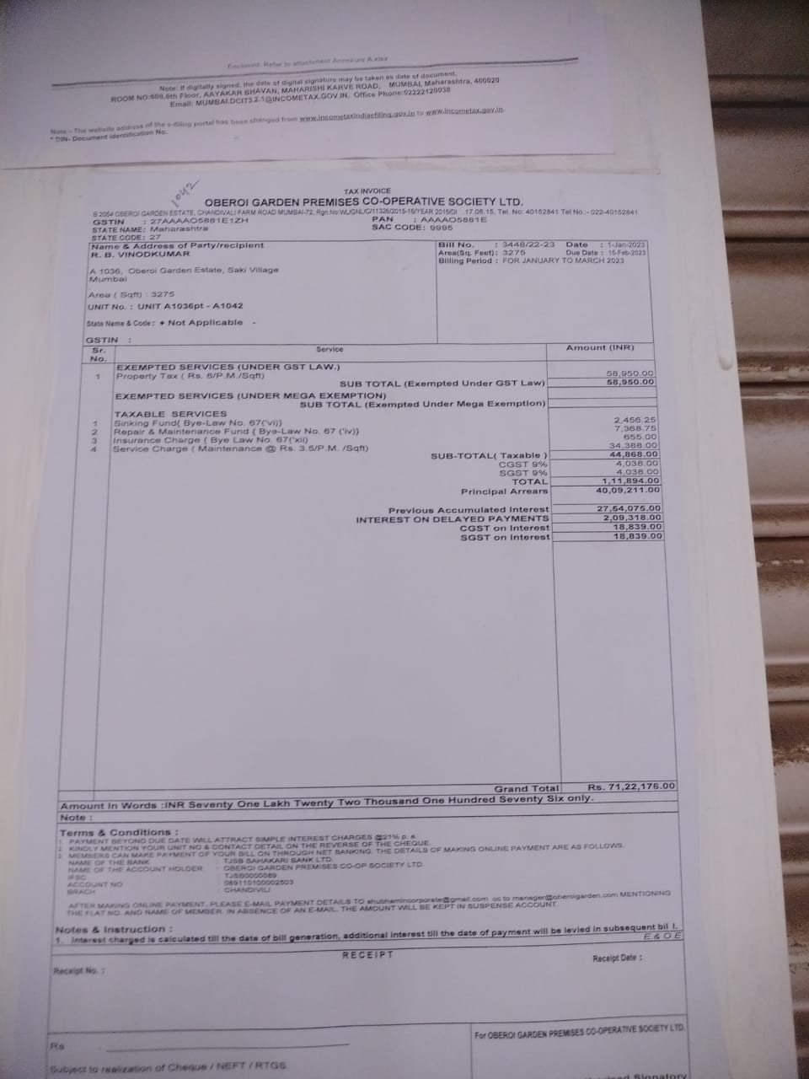
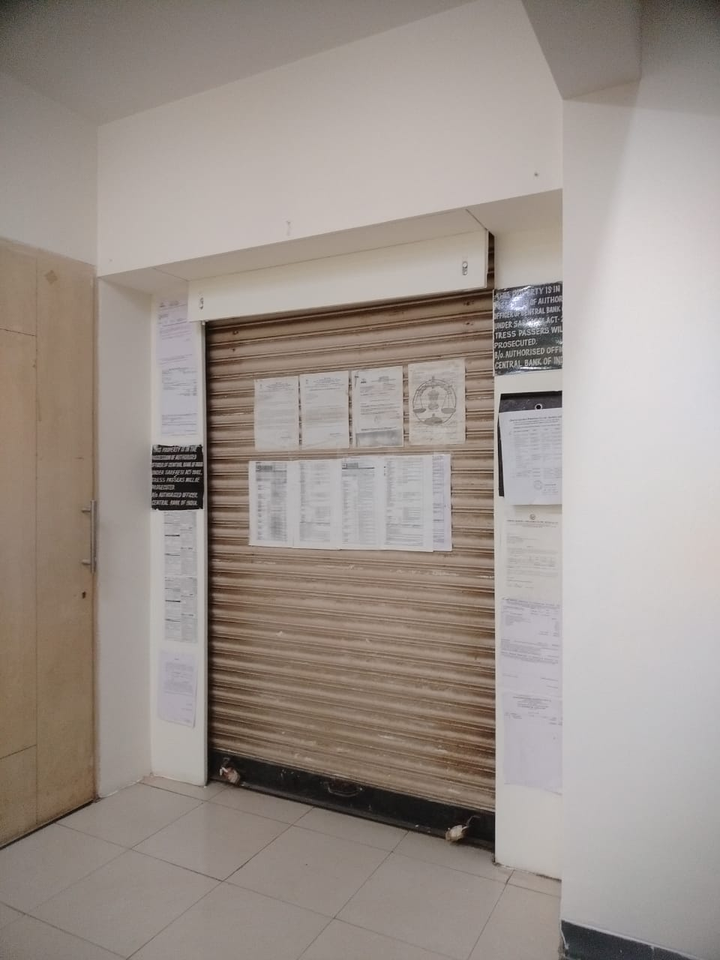
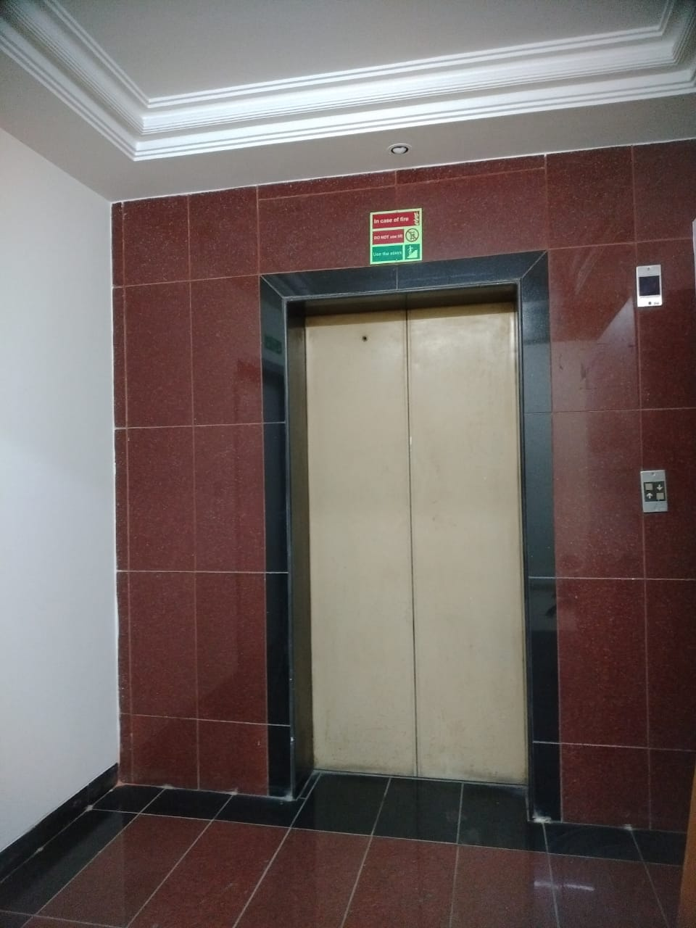
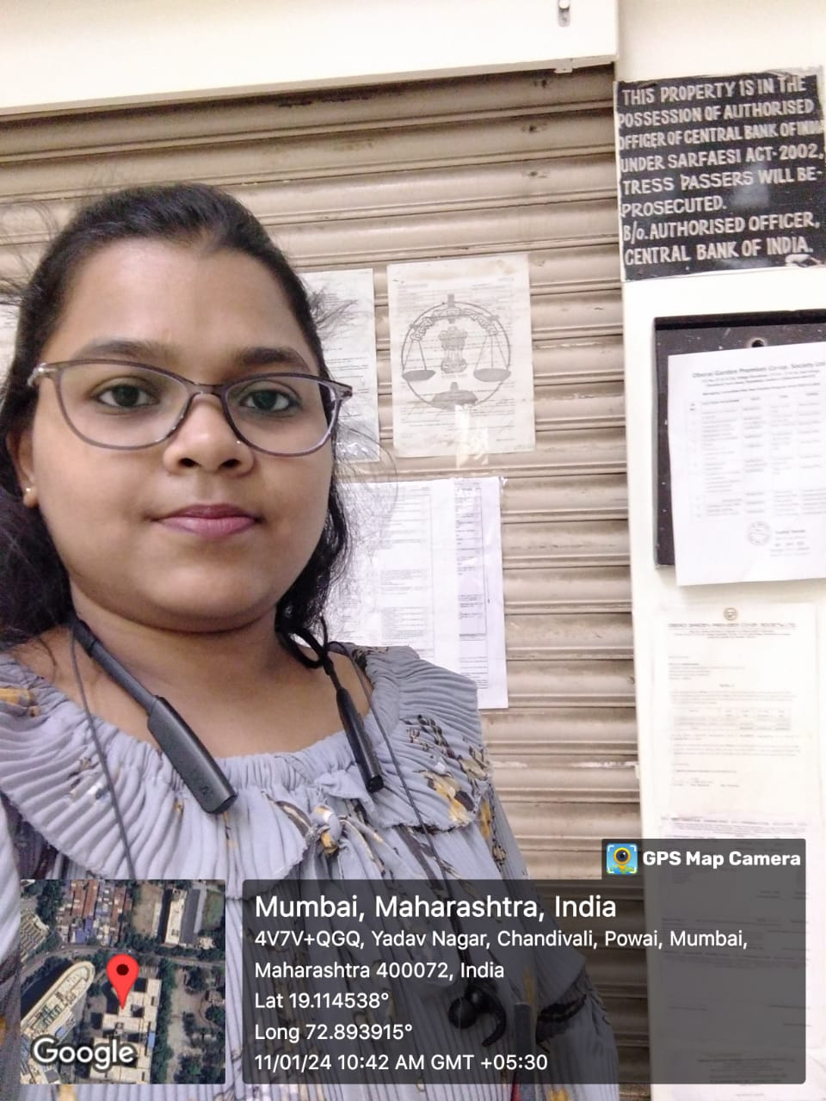

Price Indicators
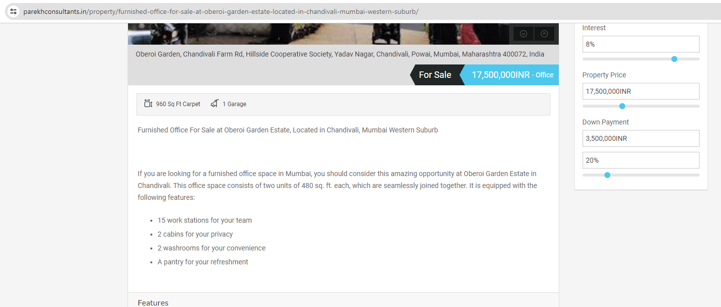

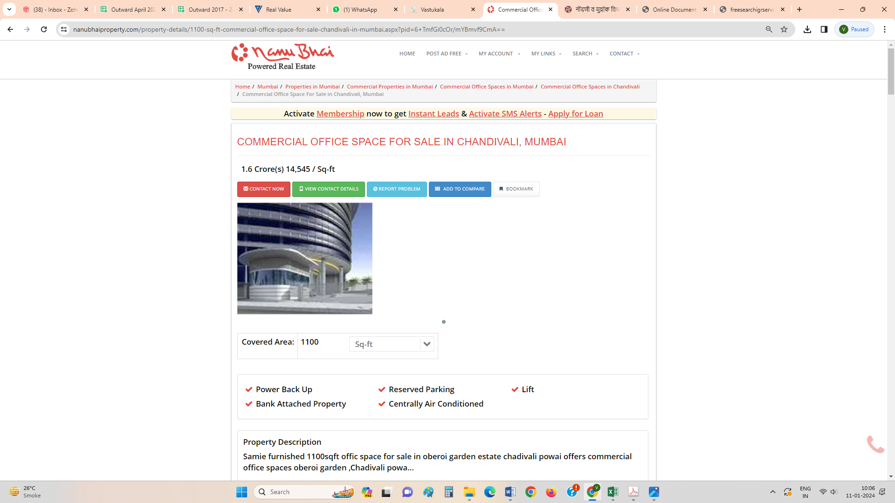

Sale Instance
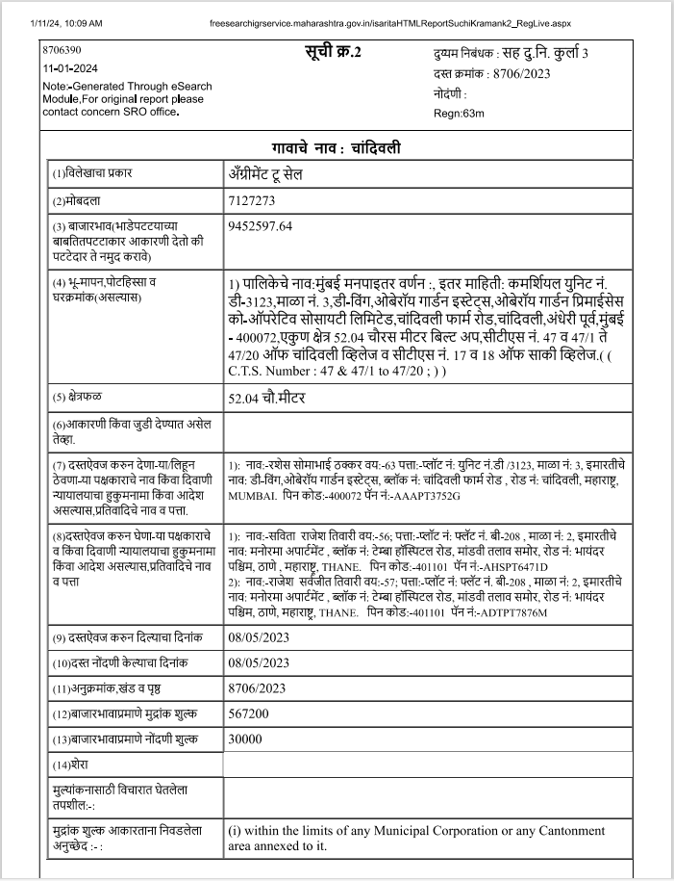

Sale Instance

