Vastu/Nashik/09/3966/2302672
22/9-316-CHVBS
Date: 09.01.2024

To,
The Branch Manager
Union Bank of India
Nashik City Branch
Navondar Sankul, 1366, M-1 Racca Colony, Sharanpur Road
Nashik – 422 002, State - Maharashtra, Country - lndia.

Sub: Vetting of Estimate

Sir,

With reference to above subject, we have evaluated the Estimate for Residential Land and Farm House on Gat No.211, Ground Floor + First Floor Beside Ghadge Patil Collage, Bhatkudgaon – Dhorjalgaon Road, At – Dhorjalgaon, Taluka- Shevgaon, District - Ahmednagar,PIN - 414 501, State - Maharashtra, Country – India belongs to Mr.Sukdev Tatyaba Karad.

We have verified the rates quoted as per current market rates. Details of Estimate considered as per copy of Estimate Provided by Ar. Shankar Buchade received on dated 04.09.2024. The Estimate amount is Rs.75,00,000/- (Rupees Seventy Five Lakh Only.)

Note:1) The said Cost Vetting Certificate is valid upto next 6 months Only.

Thanking you

Sincerely yours

Manoj B. Chalikwar
Registered Valuer
Chartered Engineer (India)
Reg. No. CAT-I-F-1763
Reg. No. IBBI/RV/07/2018/10366
BOB Empanelment No.: ZO:MZ:ADV:46:941
Encl: Valuation Report

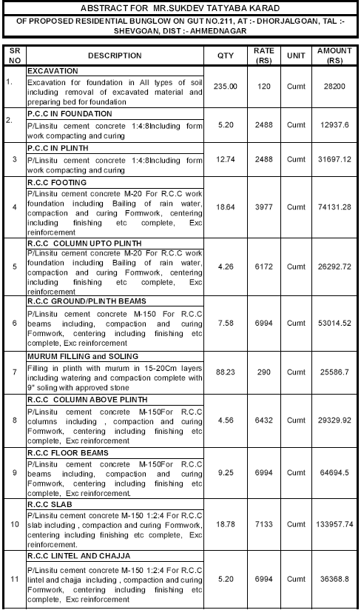
Estimate
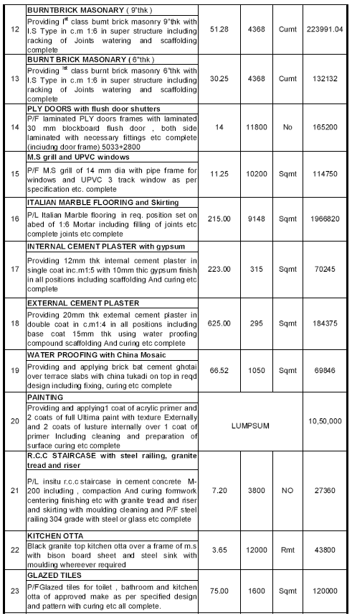

Estimate
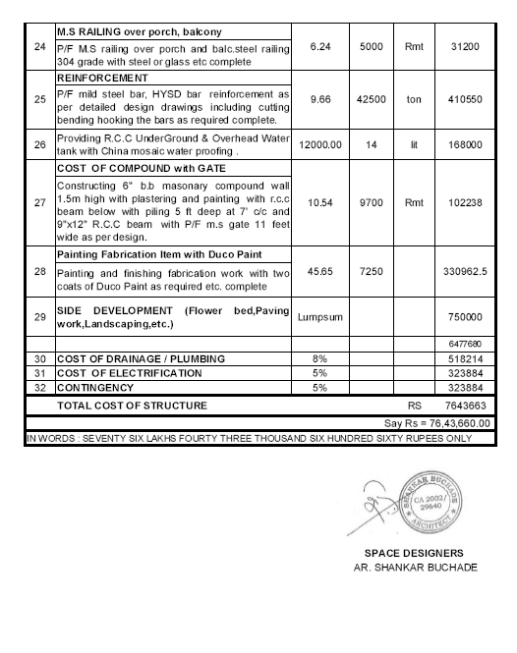

Estimate
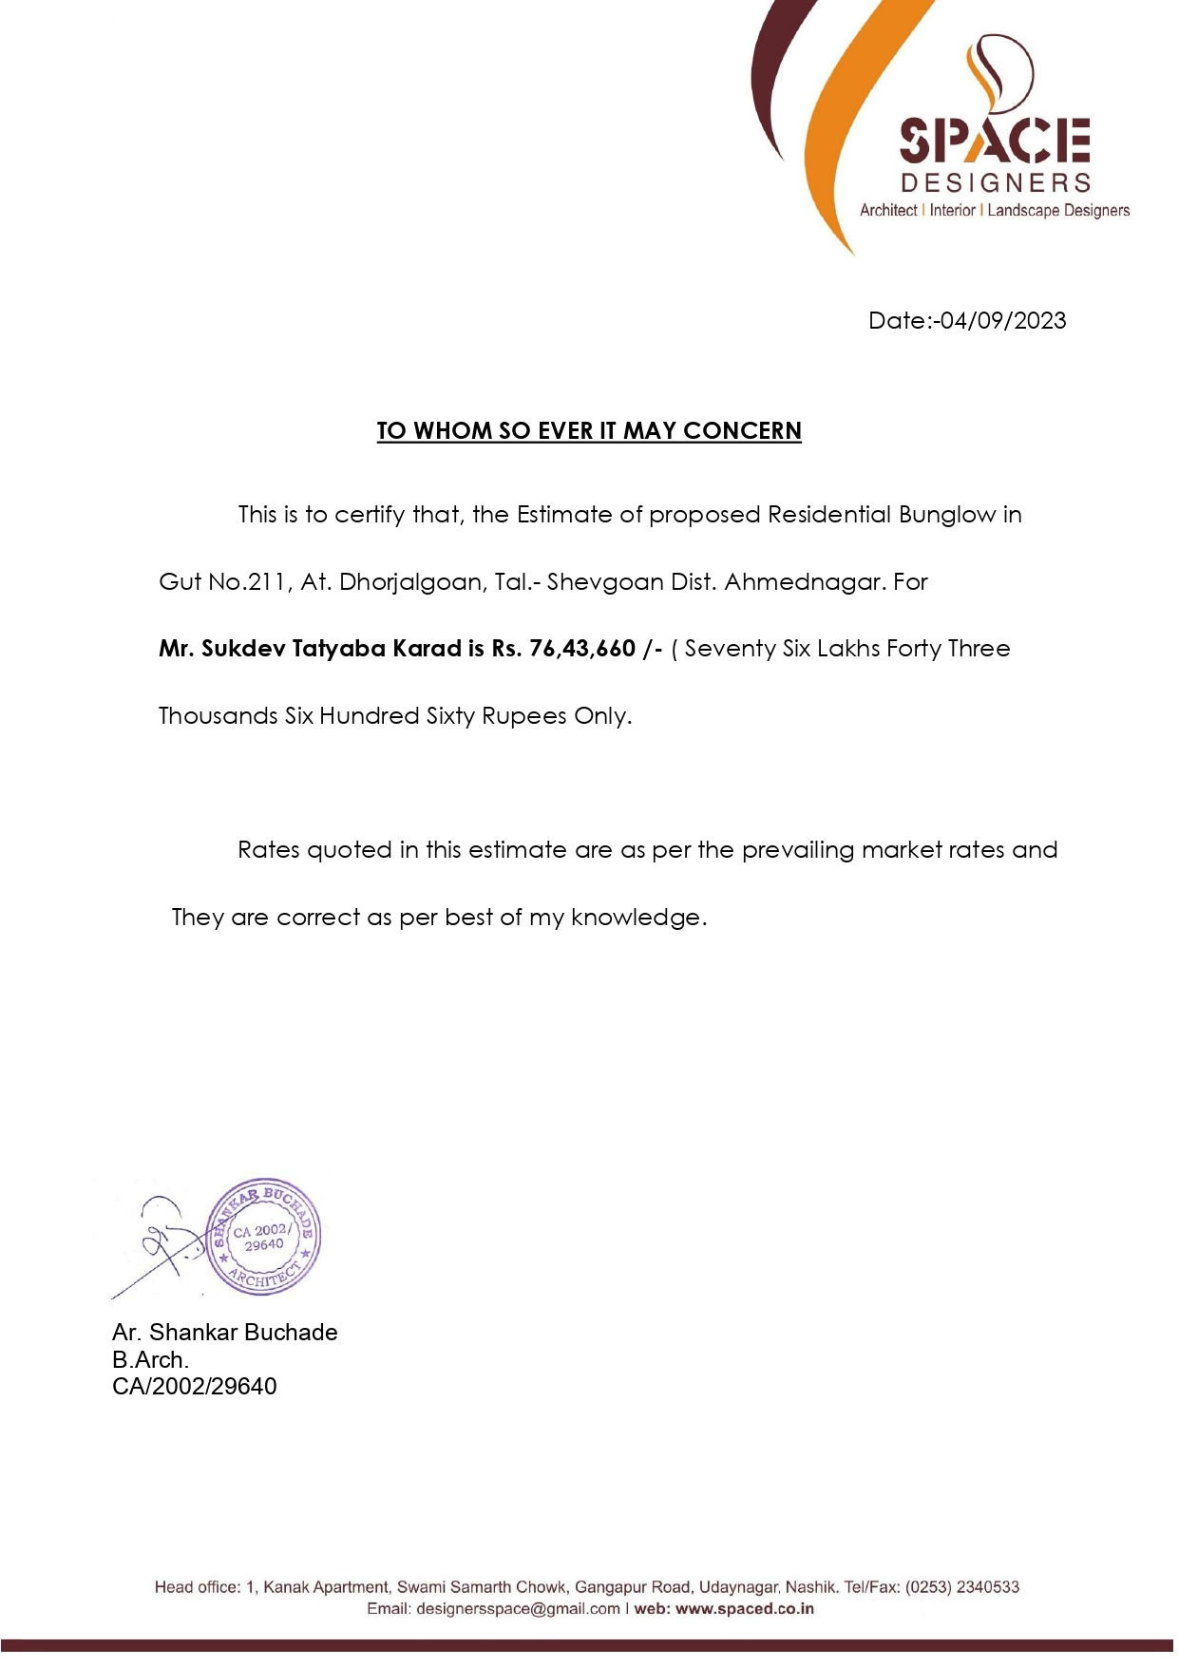

The Estimate amount is Rs.75,00,000/- (Rupees Seventy Five Lakh Only.)

