Vastu/Nashik/01/2024/006202/2304412
08/24-114-RYBS
Date:08.01.2023

To,
The Branch Manager,
Bank of Baroda
Regional Office
BSNL Building, Datta Mandir Road, Nashik Road,
Nashik, PIN – 422 101, State - Maharashtra, Country - India.

Sub: Vetting of Extra Work

Sir,

With reference to above subject, we have evaluated the Extra Work For Residential Flat No. 15, Fifth Floor, " Sagar Nakshatra Aparment ", Survey No. 247/ 2/ 1A, Plot No. 01, Near Sainath Nagar Garden, Sai Nagar, Ayodhya Nagari, Dr. Nanasaheb Dharmadhikari Marg, Amrutdham, Village - Nashik, Taluka & District - Nashik, PIN Code – 422003, State – Maharashtra, Country – India. belongs to Name of Proposed Purchaser: Mr. Ashok Prabhuram Balotiya &
Mrs. Kaushalya Ashok Balotiya. Name of Owner: M/s. Nasa Construction Pvt. Ltd.

We have verified the rates quoted as per current market rates. Details of Extra Work considered as per copy of Extra Work Cost Sheet between Mr. Ashok Prabhuram Balotiya & Mrs. Kaushalya Ashok Balotiya. (First Party). Mr M/s. Nasa Construction Pvt. Ltd. (Second Party) received on dated.03.01.2024. The Extra Work amount is Rs. 4,32,000/- (Rupees Four Lakh Thirty-Two Thousand Only)

The said Cost Vetting Certificate is valid upto next 6 months Only.

Thanking you

Sincerely yours

Manoj B. Chalikwar
Registered Valuer
Chartered Engineer (India)
Reg. No. CAT-I-F-1763
Reg. No. IBBI/RV/07/2018/10366
BOB Empanelment No.: ZO:MZ:ADV:46:941
Encl: Valuation report.

Extra Work Cost Sheet
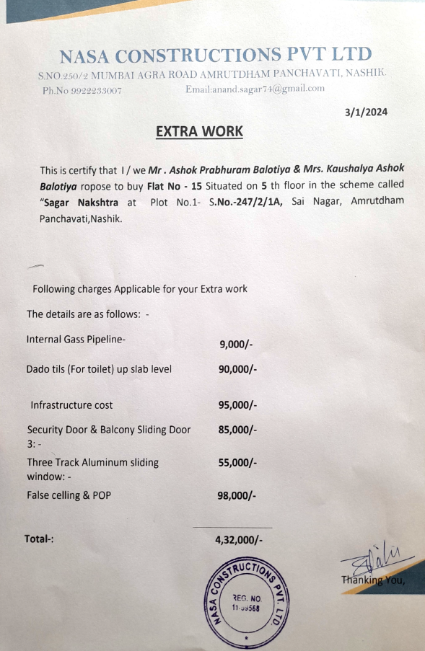

The Extra Work amount is Rs. 4,32,000/- (Rupees Four Lakh Thirty-Two Thousand Only)

