Vastu/Mumbai/01/2024/6199/2304406  
08/18-108-PRVS  
 Date: 08.01.2024

**Structural Stability Report**

Structural Observation Report of Residential Flat No. 14 (Flat No. 104 As per site), 1st Floor, Type – D, Building No. D/7, **"Satyam Shantinagar Co-Op. Hsg. Soc. Ltd.",** Sector – 2, Shanti Nagar, Mira Road (East), Thane – 401 107, State – Maharashtra, Country – India.

Name of Owner: **Mr. Laxmidas Gangji Bhanushali**

This is to certify that on visual inspection, it appears that the structure of the at **"Satyam Shantinagar Co-Op. Hsg. Soc. Ltd."**, is in normal condition and the future life can be reasonably taken under good condition and with proper periodic repairs & maintenance is about 24 years.

**General Information**:

|  |  |  |
| --- | --- | --- |
| **A.** | **Introduction** | |
| 1 | Name of Building | **"Satyam Shantinagar Co-Op. Hsg. Soc. Ltd."** |
| 2 | Property Address | Residential Flat No. 14 (Flat No. 104 As per site), 1st Floor, Type – D, Building No. D/7, **"Satyam Shantinagar Co-Op. Hsg. Soc. Ltd.",** Sector – 2, Shanti Nagar, Mira Road (East), Thane – 401 107, State – Maharashtra, Country – India. |
| 3 | Type of Building | Residential used |
| 4 | No. of Floors | Ground + 4 Upper Floors |
| 5 | Whether stilt / podium / open parking provided | Open Car Parking |
| 6 | Type of Construction | R.C.C. Framed Structure |
| 7 | Type of Foundation | R.C.C. Footing |
| 8 | Thickness of the External Walls | 9” thick brick walls both sides plastered |
| 9 | Type of Compound | Brick Masonry Walls |
| 10 | Year of Construction | 1988 (As per Occupancy Certificate) |
| 11 | Present age of building | 36 years |
| 12 | Residual age of the building | 24 years Subject to proper, preventive periodic maintenance & structural repairs. |
| 13 | No. of flats (Per Floor) | 4 Flats on 1st Floor |
| 14 | Methodology adopted | As per visual site inspection |

|  |  |  |
| --- | --- | --- |
| **B.** | **External Observation of the Building** | |
| 1 | Plaster | Normal condition |
| 2 | Chajjas | Normal condition |
| 3 | Plumbing | Normal condition |
| 4 | Cracks on the external walls | Not found |
| 5 | Filling cracks on the external walls | Not found |
| 6 | Cracks on columns & beams | Not found |
| 7 | Vegetation | Not found |
| 8 | Leakages of water in the drainage pipes or water pipes | Not found |
| 9 | Dampness external in the wall due to leakages | Not found |
| 10 | Any other observation about the condition of external side of the building | Structural Stability Report from licensed structural engineers not provided for our verification. |
| **C** | **Internal Observation of the common areas of the building and captioned premises** | |
| 1 | Beams (Cracks & Leakages) | Not found |
| 2 | Columns (Cracks & Leakages) | Not found |
| 3 | Ceiling (Cracks & Leakages) | Cracks found at many places |
| 4 | Leakages inside the property | Not found |
| 5 | Painting inside the property | Dampness found in the flat at few locations.  Plaster is pilled out in the flat at many places. |
| 6 | Maintenance of staircase & cracks | Normal |

|  |  |  |
| --- | --- | --- |
| **D** | **Common Observation** | |
| 1 | Structural Audit of the Building Under Bye – Laws No. 77 of the Model Bye Laws (Co-Operative Societies Act / Rules) | As per bye Laws No. 77 of Co-Op. Societies bye Laws under the Act the society shall conduct a Structural Audit of the building of the society as follows |
| 2 | Remark | 1. No Structural Audit Report is furnished for the perusal. 2. Flat is in average condition. |

|  |  |
| --- | --- |
| **E** | **Conclusion** |
| The captioned building is having Ground + 4 Upper Floors which are constructed in year 1988 As per Occupancy Certificate. Estimated future life under present circumstances is about 24 years subject to proper, preventive periodic maintenance & structural repairs.  The inspection dated 07.01.2024 of building. The building is in normal condition and the property is maintained in average condition & will stand future life subject to proper, preventive periodic maintenance & Good structural repairs.  Our Observations about the structure are given above.  The above assessment is based on visual inspection only. Separate structural audit from licensed structural engineers is advised to assess exact balance life of structure. | |

## Sharadkumar B. Chalikwar

Govt. Reg. Valuer

Chartered Engineer (India)

Reg. No. (N) CCIT/1-14/52/2008-09

Cosmos Emp. No. H.O./Credit/67/2019-20

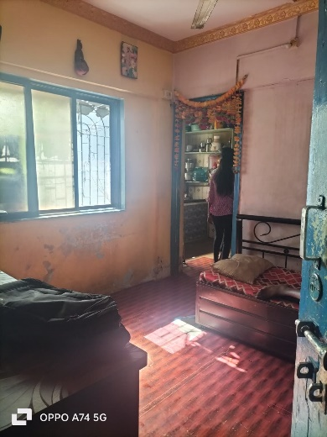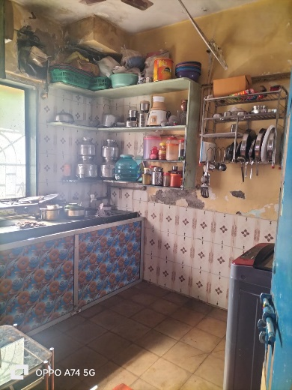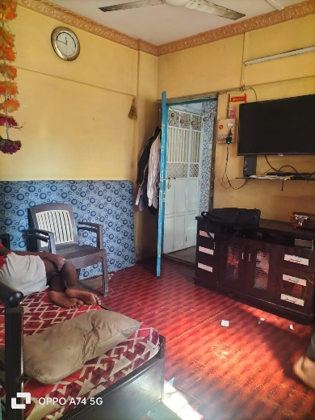**Actual site photographs**

