**Valuation Report of the Immovable Property**

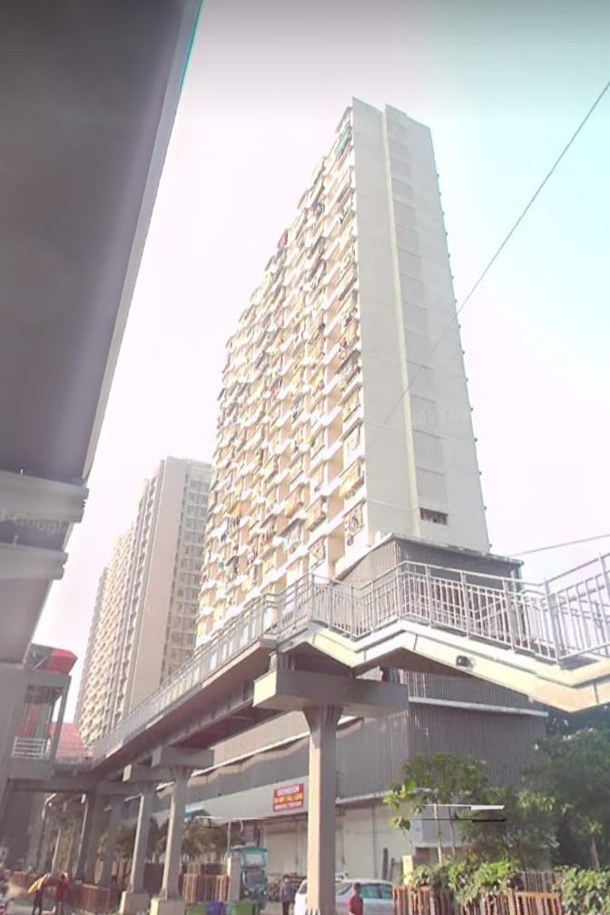

**Details of the property under consideration:**

**Name of Owner : Shri. Devang Shah**

Residential Flat No. 1104,11th Floor, Wing - F, **“Sumukh Hills”**, Western Express Highway, Village - Aakurli, Kandiwali East, District – Mumbai, Pin – 400 101, State – Maharashtra, Country – India.

**Latitude Longitude - 19°11'56.5"N 72°51'37.9"E**

**Valuation Done for:**

**Private Clients**

Vastu/Mumbai/12/2023/5876/2303074

18/18-271-KPBM

Date: 09.01.2024

**VALUATION OPINION REPORT**

This is to certify that the property Residential Flat No. 1104,11th Floor, Wing - F, **“Sumukh Hills”**, Western Express Highway, Village - Aakurli, Kandiwali East, District – Mumbai, Pin – 400 101, State – Maharashtra, Country – India belongs to **Shri. Devang Shah**

|  |  |
| --- | --- |
| Boundaries of the property. | |
| North | Open Plot |
| South | Slum |
| East | Western Express Highway |
| West | Slum |

Considering various parameters recorded, existing economic scenario, and the information that is available with reference to the development of neighbourhood and method selected for valuation, we are of the opinion that, the property premises can be assessed and valued for **Immigration Visa Application** purpose at

**In ` 1,11,96,500.00 (Rupees One Cores Eleven Lakh Ninety Five Thousand Five Hundred Only).**

**In C$ 1,79,976.71 (Canadian One Lakhs Seventy Nine Thousand Nine Hundred Seventy-Six Only).**

**Note: at conversion rate of 1 Indian Rupee equals to 0.016 Canadian Dollar as on 09.01.2024**

The valuation of the property is based on the documents produced by the concern. Legal aspects have not been taken into considerations while preparing this report.

Hence certified

**Manoj B. Chalikwar**

Registered Valuer

Chartered Engineer (India)

Reg. No. CAT-I-F-1763

Encl: Valuation report.

**VALUATION REPORT IN RESPECT OF IMMOVABLE PROPERTY**

|  |  |  |  |  |
| --- | --- | --- | --- | --- |
| 1 | Date of Inspection | | 08.01.2024 | |
| 2 | Purpose of valuation | | As per request from Private Clients, to assess Fair Market Value of the property under reference for **Immigration Visa Application** purpose | |
| 3 | Name and address of the Valuer | | **Manoj B. Chalikwar**  **Vastukala Consultants (I) Pvt. Ltd.**  B1-001, U/B Floor, **Boomerang**, Chandivali Farm Road, Powai, Andheri (East), Mumbai – 400 072.  Dial: +91 22 28131324/25  Email: mumbai@vastukala.org | |
| 4 | List of Documents Handed Over to The Valuer by The Customer:   1. Copy of Agreement for Sale dated 04.12.2014 Between M/s. Yogsiddhi Developers (The Promoters) & Shri. Devang Shah (The Purchaser) 2. Copy of Commencement certificate dated 10.04.2013 reference no SRA / ENG / 1977 / RS / STGL AP issued by SRA | | | |
| 5 | Details of enquiries made/ visited to government offices for arriving fair market value. | | Market analysis | |
| 6 | Factors for determining its market value. | | Location, development of surrounding area, type of construction, construction specifications, age of building, condition of the premises & building, facilities provided and its prevailing market rate. | |
| 7 | ANY CRITICAL ASPECTS ASSOCIATED WITH PROPERTY | | No | |
| 8 | Present/Expected Income from the property | | ` 28,000.00 Expected rental income per month.  C$ 450.26 Expected rental income per month. | |
|  | **Property Details** | |  | |
| 9 | Name(s) of the Owner | | **Shri. Devang Shah** | |
|  | Address | | Residential Flat No. 1104,11th Floor, Wing - F, **“Sumukh Hills”**, Western Express Highway, Village - Aakurli, Kandiwali East, District – Mumbai, Pin – 400 101, State – Maharashtra, Country – India. | |
| 10 | If the property is under joint ownership/ co-ownership share of each such owner/ are the share is undivided. | | Sole Ownership | |
| 11 | Brief description of the property. | | The property is a Residential Flat located on 11th Floor. The composition of Flat is 1 Bedroom + Living Room + Kitchen + 2 Toilets + Passage **(i.e. 1 BHK with 2 Toilets)**. It is at walking distance from Akurli Metro station. | |
|  | **If under construction, extent of completion** | | **N.A.** | |
| 12 | Location of the property (C.T.S. No., Survey No., Hissa No., Plot No., etc.). | | CTS No. 147 of Village – Akurli | |
| 13 | **Boundaries** | | **As on site** | **As per documents** |
|  | North | | Open Plot | Details not available |
|  | South | | Slum | Details not available |
|  | East | | Western Express Highway | Details not available |
|  | West | | Slum | Details not available |
| 14 | Matching of Boundaries | | - | |
| 15 | Route map | | Enclosed | |
| 16 | Any specific identification marks | | Opposite Samta Nagar Police Station | |
| 17 | Whether covered under Corporation/ Panchayat / Municipality. | | Municipal Corporation of Greater Mumbai | |
| 18 | Whether covered under any land ceiling of State/ Central Government. | | No | |
| 19 | Is the land freehold/ leasehold. | | Freehold | |
| 20 | Are there any restrictive covenants in regard to use of Land? If so attach a copy of the covenant. | | As Per Agreement | |
| 21 | Type of the property | | Residential | |
| 22 | Year of acquisition/ purchase. | | 04.12.2014 | |
| 23 | Purchase value as per document | | ` 65,00,000/- | |
| 24 | Whether the property is occupied by owner or tenant. If occupied by tenant since how long he is staying and the amount of rent being paid. | | Owner Occupied | |
| 25 | Classification of the site | |  | |
|  | 1. Population group | | Urban | |
|  | 1. High/ Middle/ Poor class | | Middle Class | |
|  | 1. Residential / Commercial | | Residential | |
|  | 1. Development of surrounding area | | Developed | |
|  | 1. Possibility of any threat to the property (Floods, calamities etc.). | | No | |
| 26 | Proximity of civic amenities (like school, hospital, bus stop, market etc.). | | Near By | |
| 27 | Level of the land (Plain, rock etc.) | | Plain | |
| 28 | Terrain of the Land. | | Levelled | |
| 29 | Shape of the land (Square/ rectangle etc.). | | Regular | |
| 30 | Type of use to which it can be put (for construction of house, factory etc.). | | Residential Flat | |
| 31 | Whether the plot is under town planning approved layout? | | Information not Available | |
| 32 | Whether the building is intermittent or corner? | | Corner | |
| 33 | Whether any road facility is available? | | Yes | |
| 34 | Type of road available (B.T/Cement Road etc.). | | Concrete Road | |
| 35 | Front Width of the Road? | | 30 M. Wide Road | |
| 36 | Source of water & water potentiality. | | Municipal Water Supply | |
| 37 | Type of Sewerage System. | | Connected to Municipal Sewerage System | |
| 38 | Availability of power supply. | | Yes | |
| 39 | Advantages of the site. | | Located in developed area | |
| 40 | Disadvantages of the site. | | No | |
| 41 | Give instances of sales of immovable property in the locality on a separate sheet, indicating the name & address of the property, registration No. sale price and area of land sold. | | As per Sub-Registrar of Assurance records | |
|  | **Valuation of the property:** | | | |
| 42 | Total area of the Residential Flat | | Carpet Area in Sq. Ft. = 439.00  (Area as per Actual Site Measurement)  Carpet Area in Sq. Ft. = 457.00  (Area as per Agreement)  Built Up Area in Sq. Ft. = 548.00  (Carpet Area + 20% loading on Agreement for Sale) | |
| 43 | Prevailing market rate. | | ` 24,500.00 per Sq. Ft. on Carpet Area | |
| 44 | Floor Rise Rate per Sq. Ft. | | ` 0.00 | |
| 45 | PLC Rate per Sq. Ft. | | ` 0.00 | |
| 46 | Total Rate per Sq. Ft. | | ` 24,500.00 per Sq. Ft. on Carpet Area | |
| 47 | Value of the property | | **` 1,11,96,500.00** | **C$ 1,79,976.71** |
| 48 | The realizable value of the property (90%) | | **` 1,00,76,850.00** | **C$ 1,62,042.00** |
| 49 | Distress value of the property (80%) | | **` 89,57,200.00** | **C$ 1,44,037.33** |
| 50 | Insurance value of the property | | **` 12,79,600.00** | **C$ 20,576.76** |
|  | **Technical details of the building:** | | | |
| 51 | Type of building (Residential/ Commercial/ Industrial). | | Residential | |
| 52 | Year of construction. | | 2024 (As Informed to us) | |
| 53 | Future life of the property. | | 60 years Subject to proper, preventive periodic maintenance and structural repairs. | |
| 54 | No. of floors and height of each floor including basement. | | Ground + 22nd Upper Floors. 11th Floor is having 4 Residential Flats. Provision for 2 lifts. | |
|  | **Type of construction** | | | |
| 55 | (Load bearing/ R.C.C./ Steel framed) | | R.C.C. Framed Structure | |
|  | **Condition of the building.** | | | |
| 56 | External (excellent/ good/ normal/ poor) | | Good | |
| 57 | Internal (excellent/ good/ normal/ poor). | | Good | |
| 58 | Whether the Residential Flat is constructed strictly according to the sanctioned plan, details of variations noticed if any and effect of the same on the valuation | | Copy of Approved Building plans were not provided and not verified. | |
| 59 | **Remarks** |  | | |
|  | **Specifications of Construction:** | | | |
| **sr.** | **Description** | | **11th Floor** | |
| A | Foundation | | R.C.C. Foundation | |
| B | Basement | | No | |
| C | Superstructure | | R.C.C. frame work with 9-inch-thick B. B. Masonry for external walls. 6-inch-thick B.B. Masonry for internal walls | |
| D | Joinery/Doors/Windows | | Teakwood door framed with flush doors; Powder coated aluminium sliding windows | |
| E | RCC Work | | R.C.C. Framed Structure | |
| F | Plastering | | Cement Plastering with POP false ceiling | |
| G | Flooring, Skirting | | Verified tiles flooring | |
| H | Kitchen Platform | | Granite kitchen platform | |
| I | Whether any proof course is provided? | | Yes | |
| J | Drainage | | Connected to Municipal Sewerage System | |
| K | Compound Wall (Height, length and type of construction) | | 5.6" Height | |
| L | Electric Installation (Type of wire, Class of construction) | | Concealed | |
| M | Plumbing Installation (No. of closets and wash basins etc.) | | Concealed | |
| N | Bore Well | | Not Provided | |
| O | Wardrobes, if any | | Yes | |
| P | Development of open area | | Open Parking, Chequered tile in open spaces, etc. | |
|  | **Valuation of proposed construction/ additions/ renovation if any:** | | | |
| 60 | **SUMMARY OF VALUATION:** | |  | |
|  | Part I Land | | N.A. as composite method is used for valuation | |
|  | Part II Building | | **` 1,11,96,500.00** | **C$ 1,79,976.71** |
|  | Part III Other amenities/ Miscellaneous | | ` 0.00 | |
|  | Part IV Proposed construction | | ` 0.00 | |
|  | **TOTAL.** | | **` 1,11,96,500.00** | **C$ 1,79,976.71** |
|  | **Calculation:** | | | |
| **1** | **Construction** | |  | |
| 1.01 | Built up Area of Residential Flat | | 548.00 Sq. Ft. | |
| 1.02 | Rate per Sq. Ft. | | ` 2,800.00 | |
| 1.03 | Cost of Construction = (1.01x1.02) | | ` 15,34,400.00 | |
| **2** | **Value of property** | |  | |
| 2.01 | Carpet Area of Residential Flat | | 457.00 Sq. Ft. | |
| 2.02 | Rate per Sq. Ft. | | ` 24,500.00 | |
| 2.03 | Value of Residential Flat = (2.01x2.02) | | **` 1,11,96,500.00** | **C$ 1,79,976.71** |
| **3** | **Total value of the property.** | | **` 1,11,96,500.00** | **C$ 1,79,976.71** |

I certify that,

I/ my authorized representative has inspected the subject property on 08.01.2024

The rates for valuation of the property are in accordance with the prevailing market rates.

There is no direct/ indirect interest in the property valued.

The fair value of the property as on 09.01.2024 is

**In 1,11,96,500.00 (Rupees One Cores Eleven Lakh Ninety Five Thousand Five Hundred Only).**

**In C$ 1,79,976.71 (Canadian One Lakhs Seventy Nine Thousand Nine Hundred Seventy-Six Only).**

**Note: at conversion rate of 1 Indian Rupee equals to 0.016 Canadian Dollar as on 09.01.2024**

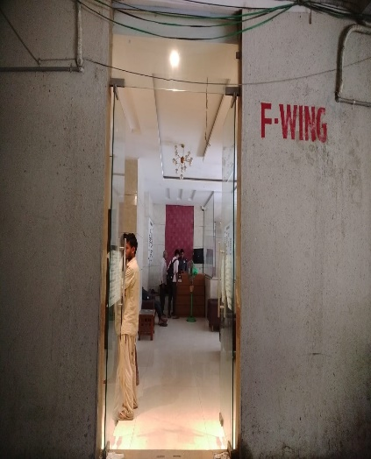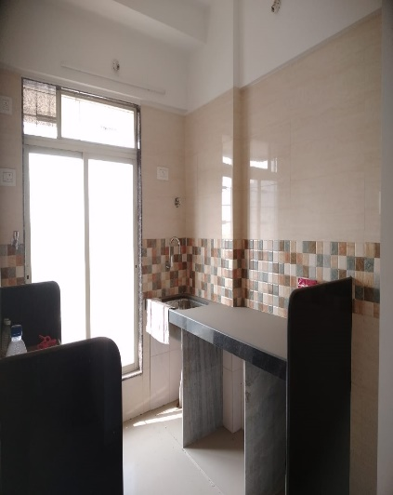**Actual site photographs**

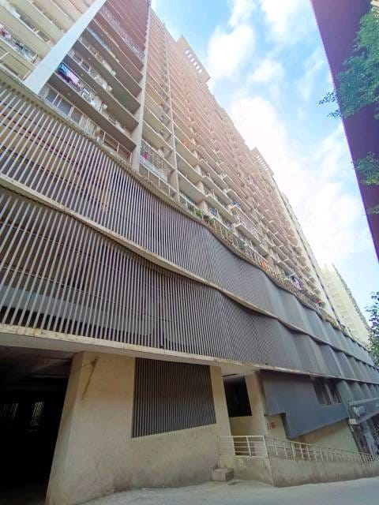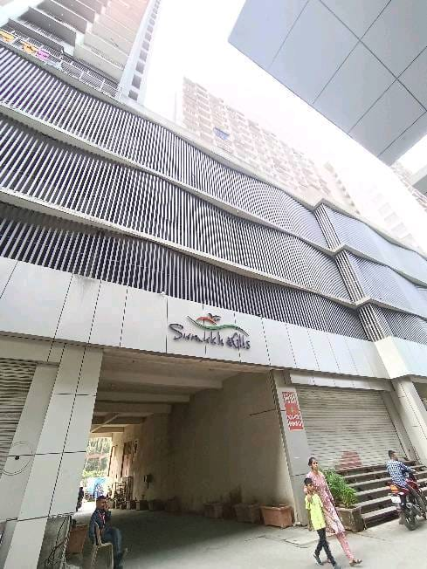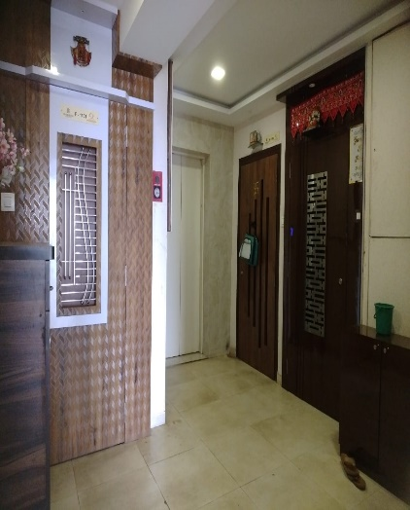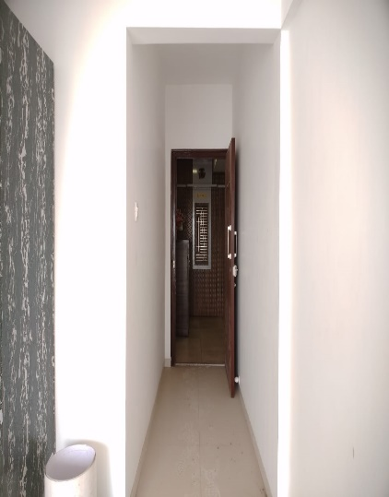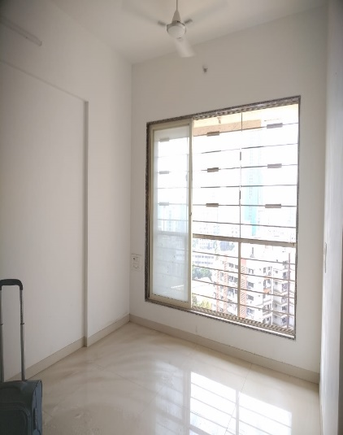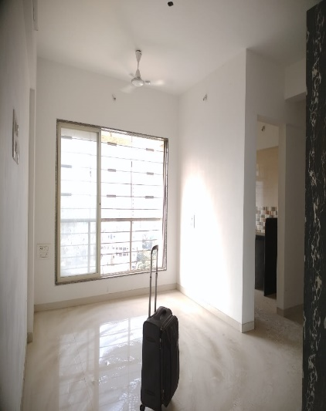

**Route Map of the property**

**Site u/r**

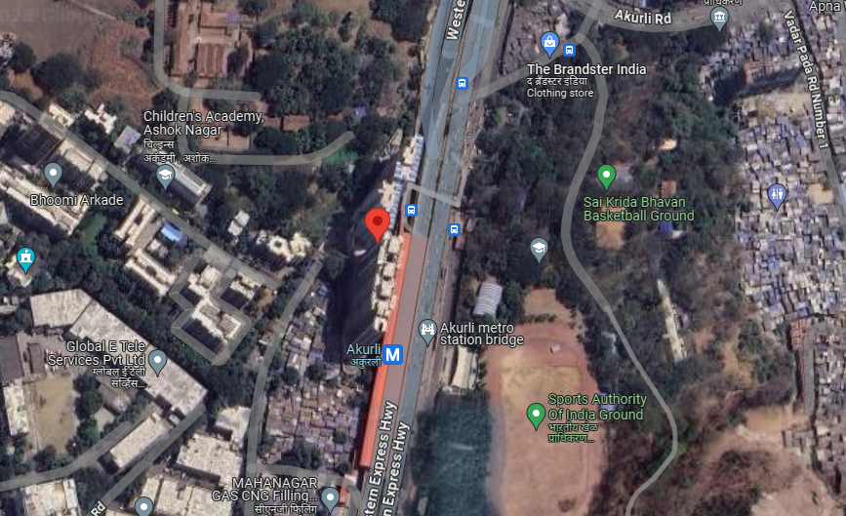

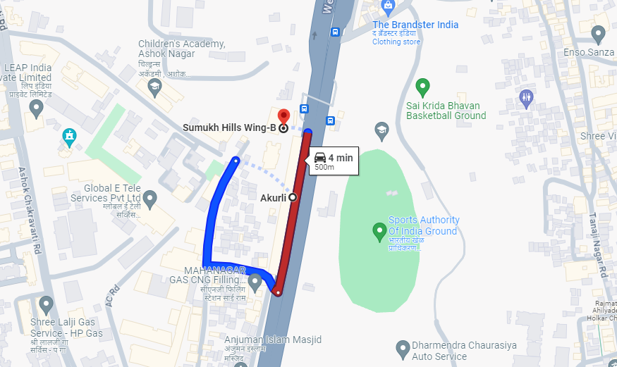

**Latitude Longitude - 19°11'56.5"N 72°51'37.9"E**

**Note**: The Blue line shows the route to site from nearest Metro station – (Akurli – 500 mtr.)

**Currency Rate**

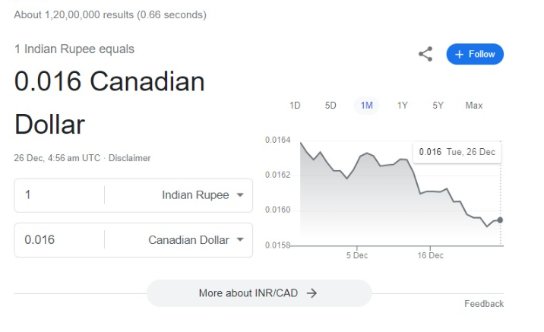

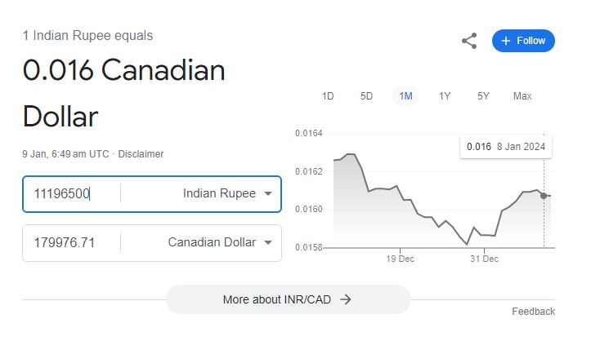

**Price Comparative**

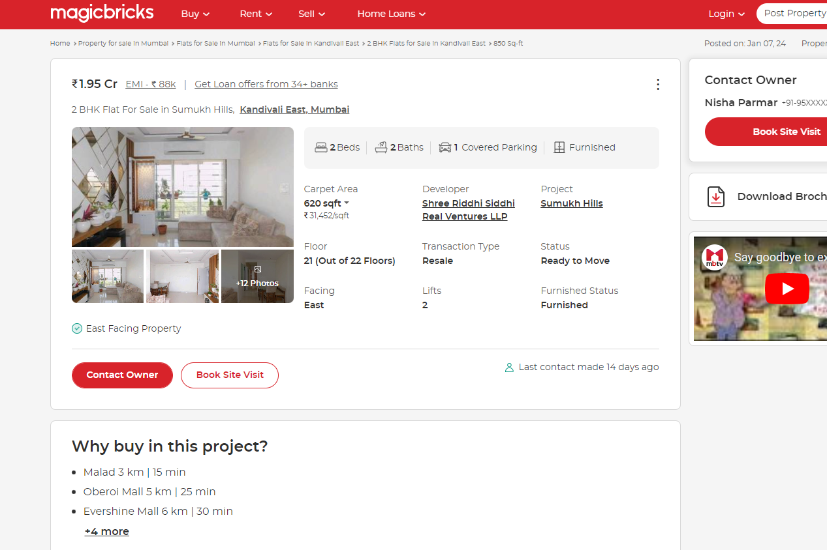

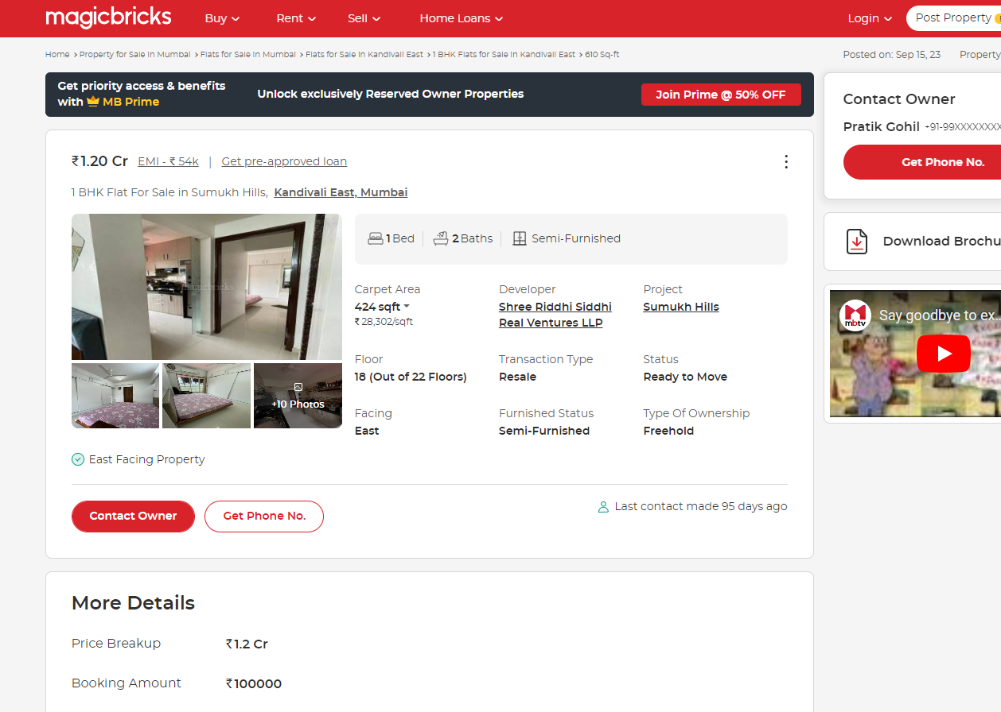

**Price Comparative**

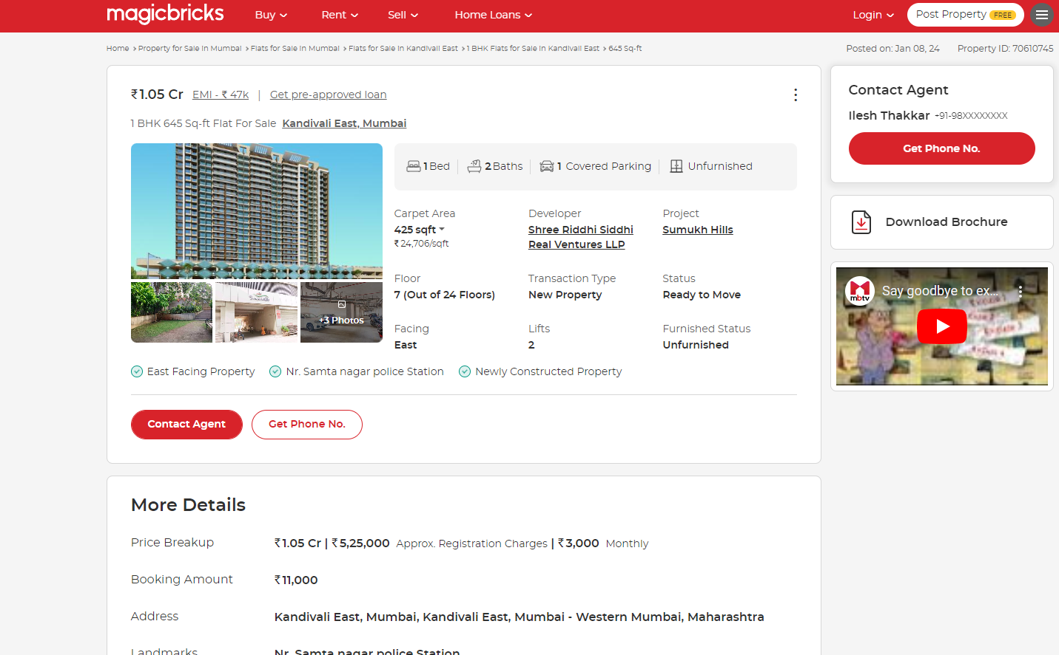

(` 24,700.00 Sq. Ft. Rate on Carpet Area)

**It can be seen that the rates of the Residential Apartments in the nearby area ranges from ` 24,000.00 to ` 25,000.00 per Sq. Ft on Carpet Area. Hence, we have considered ` 24,500.00 per Sq. Ft on Carpet Area as Fair Market Rate for Property under Consideration.**

**DEFINITION OF VALUE FOR THIS SPECIFIC PURPOSE**

This exercise is to assess Fair Market Value of the property under reference for **Immigration Visa Application** purpose as on dated **09th Jan. 2024.**

The term Fair Market Value is defined as

*"The most probable price, as of a specified date, in cash, terms equivalent to cash, or in other precisely revealed terms for which the specified property rights would sell after reasonable exposure in a competitive market under all conditions requisite to a fair sale, with the buyer and seller each acting prudently knowledgeably and for self-interest assuming that neither is under undue duress"*

Fundamental assumptions and conditions presumed in this definition are:

1. Buyer and seller are motivated by self-interest.
2. Buyer and seller are well informed and are acting prudently.
3. The property is exposed for a reasonable time on the open market.
4. Payment is made in cash or equivalent or in specified financing terms.

**ASSUMPTIONS, CAVEATS, LIMITATION AND DISCLAIMERS**

1. We assume no responsibility for matters of legal nature affecting the property appraised or the title thereto, nor do we render our opinion as to the title, which is assumed to be good and marketable.
2. The property is valued as though under responsible ownership.
3. It is assumed that there are no hidden or unapparent conditions of the subsoil or structure that would render it more or less valuable. No responsibility is assumed for such conditions or for engineering that might be required to discover such factors.
4. There is no direct/ indirect interest in the property valued.
5. The rates for valuation of the property are in accordance with the prevailing market rates.

**DECLARATION OF PROFESSIONAL FEES CHARGED**

We hereby declare that; our professional fees are not contingent upon the valuation findings. However, if the statute AND/OR clients demands that, the fees should be charged on the percentage of assessed value then, with the full knowledge of the AND/OR end user, it is being charged accordingly.

**VALUATION OF THE PROPERTY PREMISES**

Considering various parameters recorded herein above, existing economic scenario, and the information that is available with reference to the development of neighbourhood and method selected for valuation, we are of the opinion that, the property premises can be assessed and valued for Visa Application Purpose as on day for **In 1,11,96,500.00 (Rupees One Cores Eleven Lakh Ninety Five Thousand Five Hundred Only).**

**In C$ 1,79,976.71 (Canadian One Lakhs Seventy Nine Thousand Nine Hundred Seventy-Six Only).**

**Note: at conversion rate of 1 Indian Rupee equals to 0.016 Canadian Dollar as on 09.01.2024**

**Manoj B. Chalikwar**

Registered Valuer

Chartered Engineer (India)

Reg. No. CAT-I-F-1763

**The Indian Institution of Valuers Certificate**

