Vastu/Nashik/01/2024/006165/2304370
06/4-72-RPBS
Date: 06.01.2024

To, `
The Branch Manager,
Bank of Baroda
Regional Office Nashik Road Branch
BSNL Building, Datta Mandir Road, Nashik Road,
Nashik -422 101, State - Maharashtra, Country - India.

Sub: Vetting of Extra Amenities

Sir,

With reference to above subject, we have evaluated the Extra Amenities for Residential Flat No. 6, Third Floor,"Swanand Apartment ", Survey No. 889/ 5/ 1/ (1+2+3+4)/ 8, Plot No.8, Opposite Ekta Colony Udyan, Kishor Nagar, Pandav Nagari, Pathardi Road, Village - Nashik, Taluka & District - Nashik, PIN Code – 422009, State – Maharashtra, Country – India. belongs to Name of Proposed Purchaser : Shri. Sanjay Narayan Kulkarni. Name of Owner: Shri. Vivek Suryakant Dhopade & Sau. Rama Vivek Dhopade.
We have verified the rates quoted as per current market rates. Details of work and Extra Amenities considered as per copy of Agreement for Extra Amenities issued by Shri. Sanjay Narayan Kulkarni (First Party) and Shri. Ramesh Kisansing Pardeshi (Second Party) received on dated 05.01.2024. The Extra Amenities amount is Rs.3,00,000/- (Rupees Three Lakh Only. )

The said Cost Vetting Certificate is valid upto next 6 months Only.

Thanking you

Sincerely yours

Manoj B. Chalikwar
Registered Valuer
Chartered Engineer (India)
Reg. No. CAT-I-F-1763
Reg. No. IBBI/RV/07/2018/10366
BOB Empanelment No.: ZO:MZ:ADV:46:941
Encl: Valuation report.

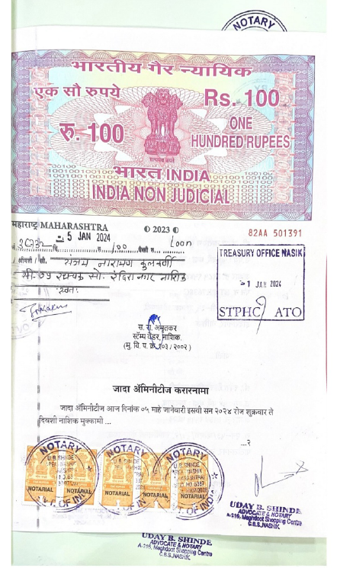
Agreement for Extra Amenities
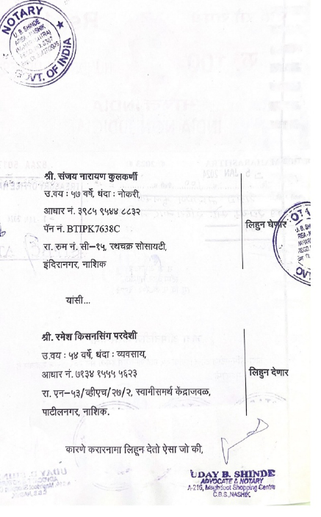

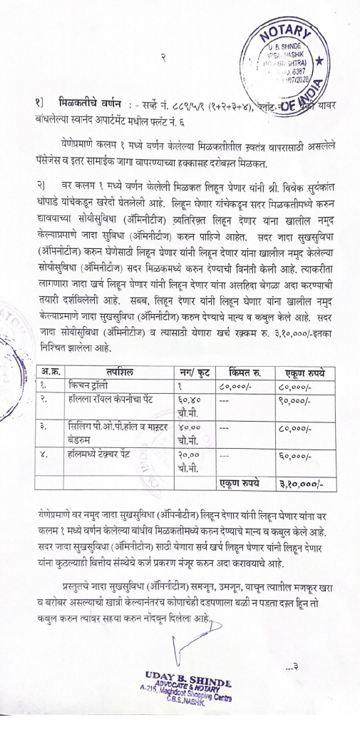
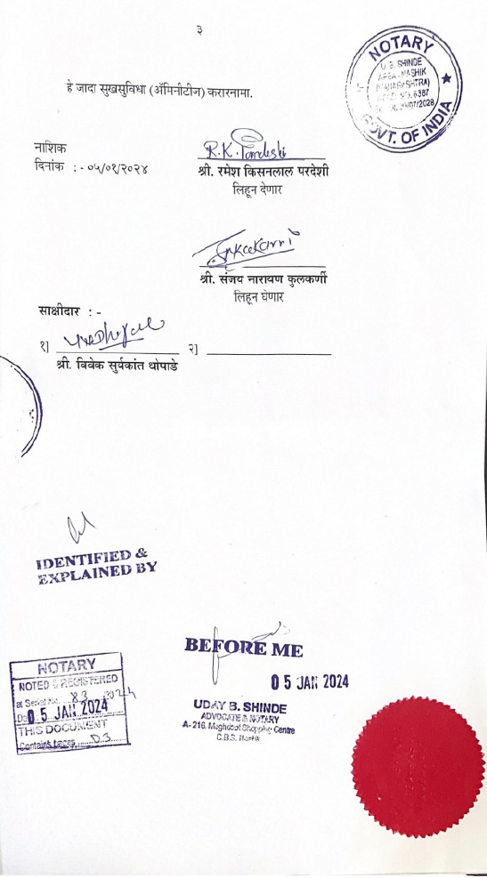

The Extra Amenities amount is Rs.3,00,000/- (Rupees Three Lakh Only)

