6th LENDERS INDEPENDENT ENGINEER REPORT

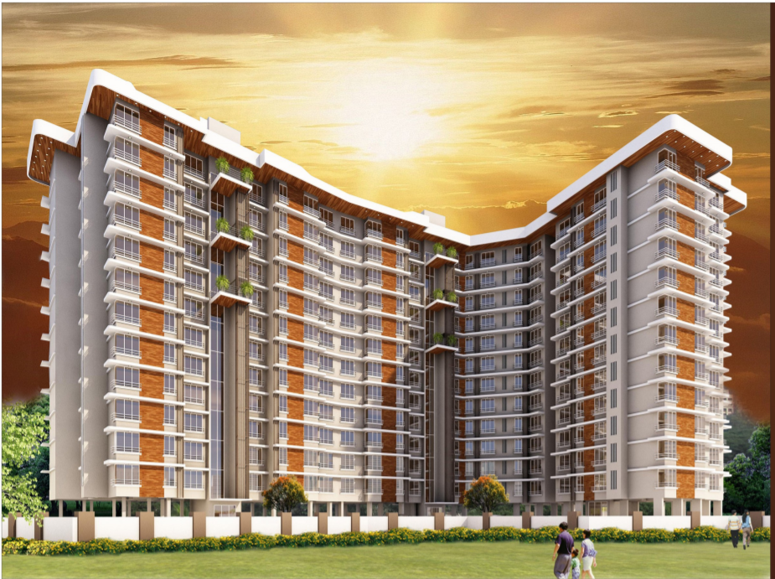

**Details of the property under consideration:**

**Name of Project: Aryavrat Project**

"**Aryavrat Project**", Proposed Redeveloped of Property on Land Bearing Final Plot No. 240 (part) of

TSP -IV of Mahim Division, Palan Sojpal Building "B", S. K. Bole Road, Dadar (West), Mumbai,

Pin Code - 400 028, State - Maharashtra, Country - India

**Latitude Longitude: 19°01'13.0"N 72°50'20.3"E**

Valuation Prepared for:

State Bank of India

SME – Vashi Turbhe Branch

Sector 19, Ground Floor, Central Facility Building, Phase – II, Vashi,

Navi Mumbai – 400 705, State - Maharashtra, Country – India

Vastu/SBI/Mumbai/01/2024/6084/2304327

03/14-29-PY

Date: - 03.01.2024

FIFTH LENDERS INDEPENDENT ENGINEER REPORT

**To,**

**State Bank of India**

SME - Vashi Turbhe Branch

Sector 19, Ground Floor,

Central Facility Building, Phase – II,

Vashi, Navi Mumbai – 400 705,

State - Maharashtra, Country – India.

Subject: Construction of Residential Building "Aryavrat Project", Proposed Redeveloped of Property on Land Bearing Final Plot No. 240 (part) of TSP -IV of Mahim Division, Palan Sojpal Building "B", S. K. Bole Road, Dadar (West), Mumbai, Pin Code - 400 028, State - Maharashtra, Country - India.

**Ref:** You’re Request for Lenders Independent Engineer Report of under Construction Building.

**Dear Sir,**

**The Construction work as per approved plan was in progress during the site visit on 19th December 2023. Total expenditure occurred as per CA Certificate actual total expenditure occurred as on 30/09/2022 is ` 132.86 Cr.**

Overall Physical progress of the rehab cum sale building construction as on 19/12/2023 is 53.47% as per physical site inspection.

**DECLARATION**

1. The information furnished in the report is based on our site visit Dated 19/12/2023 & Document Provided by Client.
2. Vastukala 5th LIE Report of the project dated 25.02.2023.
3. I have no direct and indirect interest in the property examined for report.
4. I have not been found guilty of misconduct in my professional capacity.

**Sharadkumar B. Chalikwar**

Govt. Reg. Valuer

Chartered Engineer (India)

Reg. No. (N) CCIT/1-14/52/2008-09

Encl.: LIE report

# Purpose & Methodology

• State Bank of India Banks and financial institutions require monitoring & an independent review of the progress of the sanctioned projects

**VCIPL** undertakes such study to independently review the progress of the project and put forward a comprehensive analysis

# Advantages:

* Assurance on present practices
* Identification of risk
* Analyzing the performance of third parties
* Recommendations

# The Methodology

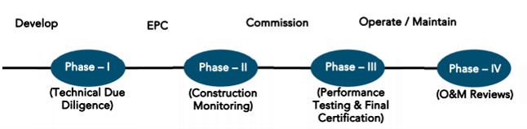

**6th LENDERS INDEPENDENT ENGINEER REPORT**

**OF**

**"Aryavrat Project"**

**"Aryavrat Project", Proposed Redeveloped of Property on Land Bearing Final Plot No. 240 (part) of TSP -IV of Mahim Division, PalanSojpal Building "B", S. K. Bole Road, Dadar (West), Mumbai, Pin Code - 400 028,**

**State - Maharashtra, Country – India**

**Latitude Longitude: 19°01'13.0"N 72°50'20.3"E**

**NAME OF DEVELOPER: M/s. Chintamani Land and Housing LLP**

|  |
| --- |
| Pursuant to instructions from State of India, SME Vashi Turbhe Branch, Navi Mumbai we have duly visited, inspected, surveyed & assessed the above said property on **19th December 2023** to determine the fair & reasonable market value of the said property/project as on Quarter ending **30th September 2023** for LIE purpose.  **1. Location Details:**  The property is situated at Final Plot No. 240 (part) of TSP -IV of Mahim Division, PalanSojpal Building "B", S. K. Bole Road, Dadar (West), Mumbai, Pin Code - 400 028. It is about 500 M. walking distance from Dadar railway station of Western railway line. Surface transport to the property is by buses, Auto, taxis & private vehicles. The property is in developed locality. All the amenities like shops, banks, hotels, markets, schools, hospitals, etc. are all available in the nearby locality. The locality is higher middle class & developed. |

1. **Developer Details:**

|  |  |
| --- | --- |
| **Name of builder** | **M/s. Chintamani Land and Housing LLP** |
| **Project Rera Registration Number** | **P51900024338** |
| **Registered office address** | Office No. 60/62, Mirza Street, Mumbai - 400 003, State - Maharashtra, Country – India. |
| **Contact details** | **Contact Person:**  **Mr. Manish Patel (Mobile No. 8286518638)** |
| **E – mail ID and website** | [accounts@chintamaniestates.com](mailto:accounts@chintamaniestates.com)  [www.chintamaniestates.com](http://www.chintamaniestates.com) |

**3. Boundaries of the Property:**

|  |  |
| --- | --- |
| **Direction** | **Particulars** |
| **On or towards North** | C - Wing Palan Sojpal Building |
| **On or towards South** | SK Bole Road |
| **On or towards East** | A - Wing Palan Sojpal Building |
| **On or towards West** | Datta Niwas & Gyan Mandir Road |

# Introduction

**As per Information on site M/s. Chintamani Land and Housing LLP** has acquired land by conveyance agreement Dt.01.08.2012 admeasuring **3,145.50 Sq. M.** bearing Final Plot No. 240 (part) of TSP -IV of Mahim Division, Palan Sojpal Building "B", S. K. Bole Road, Dadar (West), Mumbai, Pin Code - 400 028, State - Maharashtra, Country – India**.** For the Redevelopment of residential Building.

# Area Statement:

# Land:

|  |  |  |
| --- | --- | --- |
| **Date** | **Particular** | **Area in Sq. M.** |
| 01.08.2012 | Final Plot No. 240 (part) | 3,145.50 |

1. Copy of Agreement for Development Registered with Sub Registrar No. BBE - 2 / 5770 / 2012 dated 01.08.2012 between Mr. Sureshchandra alias Kishor Ratanshi Shah, Mr. Indra Kishor Shah & others (the Owners) AND M/s. Kumar Housing and Land Development (the Developers).

# Building Area (As per Concession Plan):

| **Sr. No.** | **PROFORMA – A** | **Total** |
| --- | --- | --- |
| 1 | Plot Area |  |
|  | Area as per Triangular Calculation | 3145.51 |
| 2 | Deduction for |  |
|  | a) Road Set back area | 162.82 |
|  | b) Proposed Road Area |  |
|  | c) Any Reservation (R. G. & P.G.) |  |
|  | d) % amenity spaces as per DCR 56/57 (Sub Plot) |  |
|  | e) other |  |
| 3 | Balance Area of The Plot (1-2) | 2982.69 |
| 4 | Deductions for 15% R.G. / 10% Amenity space (if deductible for Ind) |  |
| 5 | Net Area of the Plot (3-4) | 2982.69 |
| 6 | Additions for Floor Space Index  a) 100% for D. P. Road / Set back, b) 33% as per DCR 32, c) % as per DCR 33 ( ), d) other | 162.82 |
| 7 | Total Area (5 + 6) | 3145.51 |
| 8 | For Space Index Permissible (As per Statement) |  |
| 9 | For Space Index credit available by Development Rights (Restricted to % of the balance area vide 3 above DCR No. |  |
| 10 | Permissible Floor Area (As per Statement) | 9436.53 |
| 10A | 5% additional FSI | 243.5 |
| 11 | Existing Floor Area |  |
| 12 | Proposed Built up Area (Permissible) | 9680.03 |
| 13 | Excess Balcony area taken in the Floor Space Index |  |
| 14A | Purely Residential Built up Area | 9311.39 |
| 14B | Remaining Non Residential Built up area | 350.87 |
| 14 | Total Built up Area Proposed (14A+14B) (As per old approved plan dated Prior to 06.01.2012 | 9662.26 |
| 15 | FSI Consumed on net holding = 14/3 |  |
| B | Details of FSI availed as per DCR 31 (3) | Proposed |
| 1 | Fungible Built up area component proposed vide DCPR 31(3) purely residential = | 2413.61 |
| 2 | Fungible Built up area component proposed vide DCPR 31(3) for Non residential = | 9.11 |
| 3 | Total Fungible Built up area vide DCPR 31(3) = (B.1+B.2) Rehab | 2422.72 |
|  | Total Gross Built up area Proposed (14 + B.3) | 12084.98 |

# List of Approvals:

1. Copy of IOD No. CHE / CITY / 1110 / GN / 337 / New dated 05.09.2019 issued by Municipal Corporation of Greater Mumbai.
2. Copy of IOD Certificate No. CHE / CITY / 1110 / GN / 337 / New dated 07.12.2017 issued by Municipal Corporation of Greater Mumbai.
3. Copy of 1st Commencement Certificate No. CHE / CTY / 1110 / G / N / 337 / NEW / CC / 1 / NEW dated 07.12.2017 issued by Municipal Corporation of Greater Mumbai. This CC is issued up to top of Plinth level as per Zero FSI IOD issued on 05.09.2019.
4. Copy of Plans (Concession Drawing) No. CHE / CITY / 1110 / GN / 337 / New dated 07.07.2020 issued by Municipal Corporation of Greater Mumbai.

|  |  |
| --- | --- |
| Wing | Number of Floors |
| A | 2 Basements + Ground (part) + Stilt (part) + 1st to 17th upper floors. |
| B | 2 Basements + Ground (part) + Stilt (part) + 1st to 21st upper floors. |

1. Copy of 2nd Commencement Certificate No. CHE / CTY / 1110 / G / N / 337 / NEW / FCC / 1 / NEW dated 30.12.2021 issued by Municipal Corporation of Greater Mumbai. This CC is issued up to 15th floor of Wing A & 21st floor of Wing B valid upto 20.09.2022.
2. Copy of Approved Plan No. CHE / CITY / 1110 / GN / 337 / New dated 28.06.2021 issued by Municipal Corporation of Greater Mumbai.

|  |  |
| --- | --- |
| Wing | Number of Floors |
| A | 2 Basements + Ground (part) + Stilt (part) + 1st to 17th upper floors. |
| B | 2 Basements + Ground (part) + Stilt (part) + 1st to 21st upper floors. |

1. Copy of Amended Approved Plan No. CHE / CITY / 1110 / GN / 337 / New dated 23.06.2023 issued by Municipal Corporation of Greater Mumbai.

|  |  |
| --- | --- |
| Wing | Number of Floors |
| A | 2 Basements + Ground (part) + Stilt (part) + 1st to 16th upper floors. |
| B | 2 Basements + Ground (part) + Stilt (part) + 1st to 22nd upper floors. |

# LEVEL OF COMPLETION:

# Rehab cum Sales Building (A & B Wing)

| **Sr. No** | **Floor** | **Construction area as per plan (Sq. ft.)** | **Completed area (Sq. ft.)** | **Work Completion as on 13.10.2022** |
| --- | --- | --- | --- | --- |
| 1 | Basement 1 | 17,084.73 | 17,084.73 | Wing A & B slab work, block work & plaster work are completed |
| 2 | Basement 2 | 17,084.73 | 17,084.73 | Wing A & B slab work, block work & plaster work are completed |
| 3 | Ground / Stilt Floor | 20,313.93 | 20,313.93 | Wing A: Slab work, Blockwork, Plaster work, Gypsum work, Door Frame & Window Frames are completed  Wing B: Slab work is completed, Block work, Plaster work, Gypsum work, Tiling work, Door Frame, Window Frames works are Completed |
| 2 | 1st Floor | 9,407.41 | 9,407.41 | Wing A: Slab work, Blockwork, Plaster work, Gypsum work, Door Frame & Window Frames are completed  Wing B: Slab work is completed, Block work, Plaster work, Gypsum work, Tiling work, Door Frame, Window Frames works are Completed |
| 3 | 2nd Floor | 9,980.27 | 9,980.27 | Wing A: Slab work, Blockwork, Plaster work, Gypsum work, Door Frame & Window Frames are completed  Wing B: Slab work is completed, Block work, Plaster work, Gypsum work, Tiling work, Door Frame, Window Frames works are Completed |
| 4 | 3rd Floor | 9,980.27 | 9,980.27 | Wing A: Slab work, Blockwork, Plaster work, Gypsum work, Door Frame & Window Frames are completed  Wing B: Slab work is completed, Block work, Plaster work, Gypsum work, Tiling work, Door Frame, Window Frames works are Completed |
| 5 | 4th Floor | 9,980.27 | 9,980.27 | Wing A: Slab work, Blockwork, Plaster work, Gypsum work, Door Frame & Window Frames are completed  Wing B: Slab work is completed, Block work, Plaster work, Gypsum work, Tiling work, Door Frame, Window Frames works are Completed |
| 6 | 5th Floor | 9,980.27 | 9,980.27 | Wing A: Slab work, Blockwork, Plaster work, Gypsum work, Door Frame & Window Frames are completed  Wing B: Slab work is completed, Block work, Plaster work, Gypsum work, Tiling work, Door Frame, Window Frames works are Completed |
| 7 | 6th Floor | 9,980.27 | 9,980.27 | Wing A: Slab work, Blockwork, Plaster work, Gypsum work, Door Frame & Window Frames are completed  Wing B: Slab work is completed, Block work, Plaster work, Gypsum work, Tiling work, Door Frame, Window Frames works are Completed |
| 8 | 7th Floor | 9,980.27 | 9,980.27 | Wing A: Slab work, Blockwork, Plaster work, Gypsum work, Door Frame & Window Frames are completed  Wing B: Slab work is completed, Block work, Plaster work, Gypsum work, Tiling work, Door Frame, Window Frames works are Completed |
| 9 | 8th Floor | 10,056.48 | 10,056.48 | Wing A: Slab work, Blockwork, Plaster work, Gypsum work, Door Frame & Window Frames are completed  Wing B: Slab work is completed, Block work, Plaster work, Gypsum work, Tiling work, Door Frame, Window Frames works are Completed |
| 10 | 9th Floor | 10,086.08 | 10,086.08 | Wing A: Slab work is completed  Wing B: Slab work is completed, Block work, Plaster work, Gypsum work, Tiling work, Door Frame, Window Frames works are Completed |
| 11 | 10th Floor | 10,086.08 | 10,086.08 | Wing A: Slab work is completed  Wing B: Slab work is completed, Block work, Plaster work, Gypsum work, Tiling work, Door Frame, Window Frames works are Completed |
| 12 | 11th Floor | 10,086.08 | 10,086.08 | Wing A: Slab work is completed  Wing B: Slab work is completed, Block work, Plaster work, Gypsum work, Tiling work, Door Frame, Window Frames works are Completed |
| 13 | 12th Floor | 10,220.74 | 10,220.74 | Wing A: Slab work is completed  Wing B: Slab work is completed, Block work, Plaster work, Gypsum work, Tiling work, Door Frame, Window Frames works are Completed |
| 14 | 13th Floor | 10,220.74 | 5,110.37 | Wing B: Slab work is completed, Block work, Plaster work, Gypsum work, Tiling work, Door Frame, Window Frames works are Completed |
| 15 | 14th Floor | 10,220.74 | 5,110.37 | Wing B: Slab work is completed, Block work, Plaster work, Gypsum work, Tiling work, Door Frame, Window Frames works are Completed |
| 16 | 15th Floor | 10,417.18 | 5,208.59 | Wing B: Slab work is completed, Block work, Plaster work, Gypsum work, Tiling work, Door Frame, Window Frames works are Completed |
| 17 | 16th Floor | 10,274.24 | 5,137.12 | Wing B: Slab work is completed, Block work, Plaster work, Gypsum work, Tiling work, Door Frame, Window Frames works are Completed |
| 18 | 17th Floor | 8,176.33 | 4,088.17 | Wing B: Slab work is completed, Block work, Plaster work, Gypsum work, Tiling work, Door Frame, Window Frames works are Completed |
| 19 | 18th Floor | 5,438.29 | 2,719.15 | Wing B: Slab work is completed, Block work, Plaster work, Gypsum work, Tiling work, Door Frame, Window Frames works are Completed |
| 20 | 19th Floor | 4,544.78 | 2,7272.39 | Wing B: Slab work is completed, Block work, Plaster work, Gypsum work, Door Frame, Window Frames works are Completed and tiling work is in progress. |
| 21 | 20th Floor | 4,588.59 |  |  |
| 22 | 21st Floor | 3,157.83 |  |  |
| 23 | Terrace Area / OHT | 788.25 |  |  |
| 24 | Fitness | 2,792.61 |  |  |
| 25 | STP | 1,752.70 |  |  |
| Total Area in Sq. ft. | | 2,46,680.19 | 2,03,954.03 |  |

# Details of the Project as Financed By SBI:

# Project Cost: (As per C.A. Certificate)

|  |  |  |
| --- | --- | --- |
| **Particulars** | **Estimated Cost**  **(In Cr.)** | **Incurred Cost**  **(In Cr.) CA Certificate dated 16.10.2023 issued by M/s. D. J. Shah & Associates LLP** |
| Land Cost | 23.67 | 23.98 |
| Land clearance, temporary transit accommodation & overhead cost | 18.00 | 26.74 |
| Construction cost of Building | 75.93 | 49.22 |
| Premium Cost & BMC / FSI/ GOM Charges/ fees/ security Deposits | 24.29 | 16.38 |
| On- site expenditure for development / Marketing / Advance for Project/ Administrative Cost / Fixed Assets | 11.11 | 11.95 |
| Interest Cost | 13.68 | 4.59 |
| **Total** | **166.98** | **132.86** |

* **The Builder has incurred about 23.98 Cr. as Land cost, 26.74 Cr. as rent cost, 49.22 Cr. as construction cost, 16.38 Cr. for approval cost, 11.95 r. as on-site expenditure cost, 4.59 Cr. as interest cost as per C.A. certificate issued by M/s. D. J. Shah & Associates LLP dated 31.10.2023.**

# Cost of Construction as on 30th September 2022 for (Wing A & B):

|  |  |  |  |  |  |  |  |
| --- | --- | --- | --- | --- | --- | --- | --- |
| Plinth Area Calculation | | | | | | | |
| Sr. No. | Floor | Construction area as per plan (Sq. ft.) | Completed area (Sq. ft.) | Rate per Sq. ft. | Full Value after completion | Percentage of work completed | Actual Expenditure till date in ` |
| 1 | Basement 1 | 17,084.73 | 17,084.73 | 3,600.00 | 6,15,05,028.00 | 60.00% | 3,69,03,017.00 |
| 2 | Basement 2 | 17,084.73 | 17,084.73 | 3,600.00 | 6,15,05,028.00 | 60.00% | 3,69,03,017.00 |
| 3 | Ground / Stilt Floor | 20,313.93 | 20,313.93 | 3,000.00 | 6,09,41,790.00 | 50.00% | 3,04,70,895.00 |
| 4 | 1st Floor | 9,407.41 | 9,407.41 | 3,000.00 | 2,82,22,230.00 | 70.00% | 1,97,55,561.00 |
| 5 | 2nd Floor | 9,980.27 | 9,980.27 | 3,000.00 | 2,99,40,810.00 | 70.00% | 2,09,58,567.00 |
| 6 | 3rd Floor | 9,980.27 | 9,980.27 | 3,000.00 | 2,99,40,810.00 | 70.00% | 2,09,58,567.00 |
| 7 | 4th Floor | 9,980.27 | 9,980.27 | 3,000.00 | 2,99,40,810.00 | 70.00% | 2,09,58,567.00 |
| 8 | 5th Floor | 9,980.27 | 9,980.27 | 3,000.00 | 2,99,40,810.00 | 70.00% | 2,09,58,567.00 |
| 9 | 6th Floor | 9,980.27 | 9,980.27 | 3,000.00 | 2,99,40,810.00 | 70.00% | 2,09,58,567.00 |
| 10 | 7th Floor | 9,980.27 | 9,980.27 | 3,000.00 | 2,99,40,810.00 | 70.00% | 2,09,58,567.00 |
| 11 | 8th Floor | 10,056.48 | 10,056.48 | 3,000.00 | 3,01,69,440.00 | 70.00% | 2,11,18,608.00 |
| 12 | 9th Floor | 10,086.08 | 10,086.08 | 3,000.00 | 3,02,58,240.00 | 60.00% | 1,81,54,944.00 |
| 13 | 10th Floor | 10,086.08 | 10,086.08 | 3,000.00 | 3,02,58,240.00 | 60.00% | 1,81,54,944.00 |
| 14 | 11th Floor | 10,086.08 | 10,086.08 | 3,000.00 | 3,02,58,240.00 | 60.00% | 1,81,54,944.00 |
| 15 | 12th Floor | 10,220.74 | 10,220.74 | 3,000.00 | 3,06,62,220.00 | 60.00% | 1,83,97,332.00 |
| 16 | 13th Floor | 10,220.74 | 5,110.37 | 3,000.00 | 3,06,62,220.00 | 35.00% | 1,07,31,777.00 |
| 17 | 14th Floor | 10,220.74 | 5,110.37 | 3,000.00 | 3,06,62,220.00 | 35.00% | 1,07,31,777.00 |
| 18 | 15th Floor | 10,417.18 | 5,208.59 | 3,000.00 | 3,12,51,540.00 | 35.00% | 1,09,38,039.00 |
| 19 | 16th Floor | 10,274.24 | 5,137.12 | 3,000.00 | 3,08,22,720.00 | 35.00% | 1,07,87,952.00 |
| 20 | 17th Floor | 8,176.33 | 4,088.17 | 3,000.00 | 2,45,28,990.00 | 35.00% | 85,85,147.00 |
| 21 | 18th Floor | 5,438.29 | 2,719.15 | 3,000.00 | 1,63,14,870.00 | 35.00% | 57,10,205.00 |
| 22 | 19th Floor | 4,544.78 | 2,272.39 | 3,000.00 | 1,36,34,340.00 | 35.00% | 47,72,019.00 |
| 23 | 20th Floor | 4,588.59 |  | 3,000.00 | 1,37,65,770.00 | 0.00% | - |
| 24 | 21st Floor | 3,157.83 |  | 3,000.00 | 94,73,490.00 | 0.00% | - |
| 25 | OHT | 788.25 |  | 3,000.00 | 23,64,750.00 | 0.00% | - |
| 26 | Fitness | 2,792.61 |  | 3,000.00 | 83,77,830.00 | 0.00% | - |
| 27 | STP | 1,752.70 |  | 2,300.00 | 40,31,210.00 | 0.00% | - |
| **Total Area** | | **2,46,680.16** | **2,03,954.03** |  | **75,93,15,266.00** | **53.47%** | **40,60,21,580.00** |

##### Note: Details of work completed is as per site visit dated 19.12.2023 but report is prepared for 30th September quarter 2023.

* **As per site inspection, wing B building slab work is completed upto 19th Floors and wing A building slab work is completed upto 12th floors.**
* **Amended building approval drawings for wing B building & wing A building was submitted to us and has building permission for 22nd Floors and 16th Floors respectively.**
* **As bank as sanctioned the loan for the 21st floor of wing B building & 17th floor wing A building.**
* **Hence for the LIE Report we have considered the 21st floor of wing B building & 17th floor wing A building.**
* **Revised approval for Sale building for 17th floor must be taken approval from MCGM.**

|  |  |  |
| --- | --- | --- |
| **Particulars** | **Estimated Cost**  **(In Cr.)** | **Incurred Cost**  **(In Cr.) CA Certificate dated 16.10.2023 issued by M/s. D. J. Shah & Associates LLP** |
| Land Cost | 23.67 | 23.98 |
| Land clearance, temporary transit accommodation & overhead cost | 18.00 | 26.74 |
| Construction cost of Building | 75.93 | 49.22 |
| Premium Cost & BMC / FSI/ GOM Charges/ fees/ security Deposits | 24.29 | 16.38 |
| On- site expenditure for development / Marketing / Advance for Project/ Administrative Cost / Fixed Assets | 11.11 | 11.95 |
| Interest Cost | 13.68 | 4.59 |
| **Total** | **166.98** | **132.86** |

Note: As per plinth area, calculation the work completed is up to 53.47% of total work, which comes to ` 40.60 Cr. However, company has incurred cost of ` 49.22 Cr. Which is inclusive of material on site.

# % of Fund Utilised till 30th September 2022

|  |  |  |  |  |
| --- | --- | --- | --- | --- |
| Particulars | Estimated Project Cost (in Cr.) | Incurred cost as on 30.09.2023 | % of Estimated Project Cost | % of Incurred Cost |
| Land Cost | 23.67 | 23.98 | 101.31% | 14.36% |
| Land clearance, temporary transit accommodation & overhead cost | 18.00 | 26.74 | 148.56% | 16.01% |
| Construction cost of Building | 75.93 | 49.22 | 64.82% | 29.48% |
| Premium Cost & BMC / FSI/ GOM Charges/ fees/ security Deposits | 24.29 | 16.38 | 67.44% | 9.81% |
| On- site expenditure for development / Marketing / Advance for Project/ Administrative Cost/ Fixed Assets | 11.11 | 11.95 | 104.73% | 7.16% |
| Interest Cost | 13.68 | 4.59 | 33.55% | 2.75% |
| Total | **166.98** | **132.86** | **79.57%** | **79.57%** |

Based on above Calculation it is found that Project Cost incurred till date is Completed 66.09% of the Total Project Cost.

# Means of Finance:

|  |  |  |
| --- | --- | --- |
| **Sr. No.** | **Particulars** | **Exp. Cumulative (Cr.)** |
|  | Equity share capital / Quassi Loan from Promoter | 91.51 |
|  | Sales (Advance from customer) | 12.95 |
|  | Secured loans | 20.53 |
|  | Unsecured loans | 11.97 |
|  | **Total** | **136.95** |

The Details of the Means of Finance are provided by CA Certificate dated as on 16.10.2023.

# Mandatory Arrangements:

|  |  |  |
| --- | --- | --- |
| **Sr. No.** | **Particulars** | **Status** |
|  | Rainwater Harvesting | To be executed after RCC Structure |
|  | Firefighting System | To be executed after RCC Structure |
|  | Solid Waste Management | To be executed after RCC Structure |

# Quality of Construction:

|  |  |  |
| --- | --- | --- |
| **Sr. No.** | **Particulars** | **Status** |
|  | Soundness of Structures | N.A. as Construction work is in progress |
|  | Look of Structures | N.A. as Construction work is in progress |
|  | Quality of Material Used | Good |
|  | Safety Measures for Construction/labour | Taken Care by Contractor |

# Schedule V/s. Actual Progress:

| **Activity** | **Date of Implementation** | **Date of Completion** | **Status** |
| --- | --- | --- | --- |
| Land |  |  | Completed |
| Development of Land |  |  | Completed |
| Foundation Work |  |  | Completed |
| Basement 1 |  |  | Completed |
| Basement 2 |  |  | Completed |
| Ground Floor Slab |  |  | Slab work is completed |
| 1st Floor Slab | Wing A: 30.04.2022 | Wing A: 05.05.2022  Wing B: 12.01.2022 | Wing A & B: Slab work is completed |
| 2nd Floor Slab | Wing A: 15.05.2022 | Wing B: 28.01.2022 | Wing A & B: Slab work is completed |
| 3rd Floor Slab | Wing A: 30.05.2022 | Wing B: 11.02.2022 | Wing A & B: Slab work is completed |
| 4th Floor Slab | Wing A: 14.06.2022 | Wing B: 23.02.2022 | Wing A & B: Slab work is completed |
| 5th Floor Slab | Wing A: 29.06.2022 | Wing B: 07.03.2022 | Wing A & B: Slab work is completed |
| 6th Floor Slab | Wing A: 14.07.2022 | Wing B: 19.03.2022 | Wing A & B: Slab work is completed |
| 7th Floor Slab | Wing A: 29.07.2022 | Wing B: 31.03.2022 | Wing A & B: Slab work is completed |
| 8th Floor Slab | Wing A: 13.08.2022  Wing B: 14.04.2022 | Wing B: 12.04.2022 | Wing A & B: Slab work is completed |
| 9th Floor Slab | Wing A: 28.08.2022  Wing B: 28.04.2022 | Wing B: 28.04.2022 | Wing A & B: Slab work is completed |
| 10th Floor Slab | Wing A: 12.09.2022  Wing B: 12.05.2022 | Wing B: 15.05.2022 | Wing A & B: Slab work is completed |
| 11th Floor Slab | Wing A: 27.09.2022  Wing B: 26.05.2022 | Wing B: 31.05.2022 | Wing A & B: Slab work is completed |
| 12th Floor Slab | Wing A: 12.10.2022  Wing B: 09.06.2022 |  | Wing A & B: Slab work is completed |
| 13th Floor Slab | Wing A: 27.10.2022  Wing B: 25.06.2022 |  | Wing B Slab work is completed |
| 14th Floor Slab | Wing A: 11.11.2022  Wing B: 10.07.2022 |  | Wing B Slab work is completed |
| 15th Floor Slab | Wing A: 26.11.2022  Wing B: 26.07.2022 |  | Wing B Slab work is completed |
| 16th Floor Slab | Wing A: 11.12.2022  Wing B: 09.08.2022 |  | Wing B Slab work is completed |
| 17th Floor Slab | Wing A: 26.12.2022  Wing B: 25.08.2022 |  | Wing B Slab work is completed |
| 18th Floor Slab | Wing B: 08.09.2022 |  | Wing B Slab work is completed |
| 19th Floor Slab | Wing B: 23.09.2022 |  | Wing B Slab work is completed |
| 20th Floor Slab | Wing B: 07.10.2022 |  | Wing B Shuttering work is in progress |
| 21st Floor Slab | Wing B: 21.10.2022 |  |  |
| Block work /Internal Plaster work | 01.02.2022 |  | Wing B: 1st to 8th block work is completed |
| Terrace Parapet wall / Overhead water tank / Lift Machine room / compound wall / External Plaster work |  |  |  |
| Electric Work |  |  |  |
| Water Proofing |  |  |  |
| Plumbing Work |  |  |  |
| Tiling / Marble Flooring |  |  |  |
| Door Frames |  |  |  |
| Window Installation |  |  |  |
| Staircase Flooring |  |  |  |
| Staircase Railing |  |  |  |
| Refuge Area Flooring |  |  |  |
| Internal Painting |  |  |  |
| External Painting |  |  |  |
| Lift Work |  |  |  |
| Fire Fighting Installation |  |  |  |
| Stack Parking |  |  |  |
| CP Fitting & Sanitary Work |  |  |  |
| Final Finishing & Fitting |  |  |  |

# Action initiated to complete the project in time:

**For Rehab & Sales Building:**

Wing A: 12th Floor Slab work is completed.

Wing B: Till 19th floor slab work is completed.

**The developers have Major work on themselves only hence (all Manpower (Labour Contractor) and material resources) shall be enhanced by the Developer to meet the TimeLine. Detail periodically progress report needs to be checked for timely completion of project.**

**Multiple activists to be done for achieving the timely progress & detail periodically bar chart is to be submitted for the further next quarter.**

# Comments related to cost overrun if any:

The cost of Rehab cum Sales Building is ` 166.98 Cr., the project cost will overrun as the project is delay.

# Balance investment required for completion of project:

We opinion amount of **` 34.12 Cr.** Will be required to complete the Project.

# Mandatory Approval Status:

|  |  |  |  |  |
| --- | --- | --- | --- | --- |
| **Sr. No.** | **Particulars** | **Name of Department** | **Status** | **Order Details** |
| **1A** | IOD of Building | Municipal Corporation of Greater Mumbai | Obtained and available at site | CHE/CITY/1110/GN/337/New dated 07.12.2017 |
| **1B** | IOD of Building | Municipal Corporation of Greater Mumbai | Obtained and available at site | CHE/CITY/1110/GN/337/New dated 05.09.2019 |
| **1C** | Approved Plan | Municipal Corporation of Greater Mumbai | Obtained and available at site | CHE/CITY/1110/GN/337/New dated 05.09.2019 |
| **1D** | Amended Approved Plan | Municipal Corporation of Greater Mumbai | Obtained and available at site | CHE/CITY/1110/GN/337/NEW dated 23.06.2023 |
| **2A** | First C.C. | Municipal Corporation of Greater Mumbai | Obtained and available at site | CHE/CTY/1110/G/N/337/NEW/CC/1/NEW dated 07.12.2017. |
| **2B** | Second C.C. | Municipal Corporation of Greater Mumbai | Obtained and available at site | CHE / CTY / 1110 / G / N / 337 / NEW / FCC / 1 / NEW dated 30.12.2021. This CC is issued up to 15th floor of Wing A & 21st floor of Wing B valid upto 20.09.2022. |
| **2C** | Third C.C. | Municipal Corporation of Greater Mumbai | Obtained and available at site | CHE / CITY / 1110 / GN / 337 / New dated 28.06.2021 |
| **2D** | Fourth C.C. | Municipal Corporation of Greater Mumbai | Obtained and available at site | CHE / CTY / 1110 / G / N / 337 / NEW / FCC / 1 / NEW dated 30.12.2021. This CC is extended upto 15th floor of Wing A and 21st floor of Wing B as per amended approval plan dated 28.06.2021. |
| **2E** | Fifth C.C. | Obtained and available at site | Pending |  |
| **3** | Occupancy | Municipal Corporation of Greater Mumbai | Pending (Project is not completed) |  |

# Status Insurance Coverage:

Information not provided by the Client.

# Assumptions & Remarks:

* The adequacy of Engineering / Structural design is beyond the scope of our assignment.
* Estimated project completion date is 30/12/2023 for Rehab & Sales Building. The cost is certified based on the assumptions that the project will be completed within period. Few assumptions were made regarding inflation & cost rise etc. during construction period.

**Sharadkumar B. Chalikwar**

Govt. Reg. Valuer

Chartered Engineer (India)

Reg. No. (N) CCIT/1-14/52/2008-09

**About the Project:**

|  |  |  |  |
| --- | --- | --- | --- |
| **1. Introduction** | | |  |
| a) | Project Name  (With Address & Phone Nos.) | | "Aryavrat Project", Proposed Redeveloped of Property on Land Bearing Final Plot No. 240 (part) of TSP -IV of Mahim Division, Palan Sojpal Building "B", S. K. Bole Road, Dadar (West), Mumbai, Pin Code - 400 028, State - Maharashtra, Country – India  Contact Person:  Mr. Manish Patel (Mobile No. 8286518638) |
| b) | Purpose of Valuation | | As per request from State Bank of India, Vashi Turbhe Branch, Navi Mumbai to assess fair market value of the Project for LIE purpose. |
| c) | Date of Inspection of Property | | 19.12.2023 |
| d) | Date of LIE Report | | 03.01.2024 |
| e) | Name of the Developer of Property  (in case of developer built properties) | | **M/s. Chintamani Land and Housing LLP**  Office No. 60/62, Mirza Street, Mumbai - 400 003, State - Maharashtra, Country – India. |
| **2. Physical Characteristics of the Property** | | | |
| a) | Location of the Property | | "Aryavrat Project", Proposed Redeveloped of Property on Land Bearing Final Plot No. 240 (part) of TSP -IV of Mahim Division, Palan Sojpal Building "B", S. K. Bole Road, Dadar (West), Mumbai, Pin Code - 400 028, State - Maharashtra, Country – India |
| Brief description of the property | |  |
|  | **TYPE OF THE BUILDING**   1. **Rehab cum Sales Building**  |  |  | | --- | --- | | Wing | Number of Floors | | A | 2 Basements + Ground (part) + Stilt (part) + 1st to 17th upper floors as per approved plan. | | B | 2 Basements + Ground (part) + Stilt (part) + 1st to 21st upper floors as per approved plan. |   Rehab & Sales Building work is given on contract based for labour contract. Developer has grant to the labour contractor do the work of construction and completion includes Concrete work, Reinforcement work, Masonry, Internal Plaster, External Plaster and other miscellaneous work such as repairing, joints b/w concrete and masonry surface, etc. Bill must be paid on measurement of construction area. All the material requires for construction are provided by the Developer.  Lift & lift installation contract is not finalized till now.  Firefighting work contract is not finalized.  **PROPOSED DATE OF COMPLETION & FUTURE LIFE:**  Expected completion date as per RERA is 30th December 2023. | | |
|  | Nearby landmark | | Near INOX Mall |
| Postal Address of the Property | | "Aryavrat Project", Proposed Redeveloped of Property on Land Bearing Final Plot No. 240 (part) of TSP -IV of Mahim Division, Palan Sojpal Building "B", S. K. Bole Road, Dadar (West), Mumbai, Pin Code - 400 028, State - Maharashtra, Country – India |
|  | Area of the plot/land  (Supported by a plan) | Plot Area: 3145.51 Sq. M. | |
| Type of Land: Solid, Rocky, Marsh land, reclaimed land, Water-logged, Land locked. | Solid land | |
|  | Independent access/approach to the property etc. | Yes | |
| Google Map Location of the Property with a neighborhood layout map | Provided | |
|  | Details of roads abutting the property | 90.00 M. wide Rao Bahadur S. K. Bole Road | |
| Description of adjoining property | Located in Higher Middle-class locality | |
| Plot No. Survey No. | Final Plot No. 240 (part) of TSP -IV of Mahim Division | |
| Ward/Village/Taluka | TPS IV, Mahim Division | |
| Sub-Registry/Block | Mumbai – 1 | |
| District | Mumbai | |
| b) | **Boundaries of the Plot** |  | |
|  | |  |  |  | | --- | --- | --- | |  | **As per Agreement** | **Actual** | | **North** | FP No. 227 TPS IV Mahim Division | C - Wing Palan Sojpal Building | | **South** | SK Bole Road | SK Bole Road | | **East** | FP No. 239 TPS IV Mahim Division | A - Wing PalanSojpal Building | | **West** | FP No. 242 TPS IV Mahim Division | Datta Niwas & Gyan Mandir Road | | | |

|  |  |
| --- | --- |
| **4. Document Details and Legal Aspects of Property:** | |
| a) | Ownership Documents (**Building Permission, Commencement Certificate & Status of Plan)** |
|  | Sale Deed, Gift Deed, Lease Deed |
| 1. Copy of Affidavit cum Declaration dated 06.11.2019 |
| 1. Copy of Name Fresh Certificate of Incorporation Consequent upon Change of Name dated 08.07.2015 the name of M/s. Chintamani Land and Housing LLP |
| 1. Copy of MHADA NOC No. R / NOC / F- 2316 / 1186 / MBRRB - 1 dated 10.02.2015 of M/s. Kumar Housing and Land Development |
| 1. Copy of Memorandum of Understanding for April 2014 |
| 1. Copy of LLP Agreement date 11.04.2014 between Kumar Urban Development Ltd. (1st part) AND Kumar Housing Corporation Ltd. (the Second Part) AND KUL Developers Pvt. Ltd. (the 3rd Part) & others |
| 1. Copy of Agreement for Development Registered with Sub Registrar No. BBE - 2 / 5770 / 2012 dated 01.08.2012 between Mr. Suresh Chandra alias Kishor Ratanshi Shah, Mr. Indra Kishor Shah & others (the Owners) AND M/s. Kumar Housing and Land Development (the Developers) |
| 1. Copy of Deed of Partnership dated 15.03.2012 M/s. Kumar Urban Development Ltd. (the Party of the First Part) AND M/s. Kumar Housing Corporation Ltd. (the Party of the Second) |
| 1. Copy of Authority Letter dated 01.08.2012 |
| 1. Copy of Non-Encumbrances Certificate of M/s. Chintamani Land and Housing LLP dated 05.11.2019 |
| 1. Copy of RERA Registration Certificate of Project No. P51900024338 (Tower Wing - A & B) issued by Maharashtra Real Estate Regulatory Authority |
| 1. Copy of Title Certificate & Search Report from Adv. S. R. Mishra dated 24.02.2016 |
| 1. Copy of CA Certificate dated 07.09.2020 issued by D. J. Shah & Associates Chartered Accountants |
| 1. Copy of Commencement Certificate No. CHE / CTY / 1110 / G / N / 337 / NEW / CC / 1 / NEW dated 07.12.2017 issued by Municipal Corporation of Greater Mumbai. **This CC is issued upto top of Plinth level as per Zero FSI IOD issued on 05.09.2019** |
| 1. Copy of IOD No. CHE / CITY / 1110 / GN / 337 / New dated 05.09.2019 issued by Municipal Corporation of Greater Mumbai |
| 1. Copy of IOD Certificate No. CHE / CITY / 1110 / GN / 337 / New dated 07.12.2017 issued by Municipal Corporation of Greater Mumbai |
| 1. Copy of Plans (Concession Drawing) No. CHE / CITY / 1110 / GN / 337 / New dated 07.07.2020 issued by Municipal Corporation of Greater Mumbai  |  |  | | --- | --- | | Wing | Number of Floors | | A | 2 Basements + Ground (part) + Stilt (part) + 1st to 17th upper floors. | | B | 2 Basements + Ground (part) + Stilt (part) + 1st to 21st upper floors. | |
| 1. Copy of Bills till 31.07.2020 |
| 1. Copy of Bills from 01.08.2020 to 31.12.2021 |
| 1. Copy of CA Certificate dated 06.01.2022 issued by D. J. Shah & Associates Chartered Accountants |
| 1. Copy of 2nd Commencement Certificate No. CHE / CTY / 1110 / G / N / 337 / NEW / FCC / 1 / NEW dated 30.12.2021 issued by Municipal Corporation of Greater Mumbai. This CC is issued up to 02th floor of Wing A & 21st floor of Wing B valid upto 20.09.2022. |
| 1. Copy of Approved Plan No. CHE / CITY / 1110 / GN / 337 / New dated 28.06.2021 issued by Municipal Corporation of Greater Mumbai.  |  |  | | --- | --- | | Wing | Number of Floors | | A | 2 Basements + Ground (part) + Stilt (part) + 1st to 17th upper floors. | | B | 2 Basements + Ground (part) + Stilt (part) + 1st to 21st upper floors. | |
|  | 1. Copy of Bills from 01.01.2022 to 31.03.2022 |
| 1. Copy of CA Certificate dated 06.04.2022 issued by D. J. Shah & Associates Chartered Accountants |
| 1. Copy of Architect Certificate dated 20.03.2022 issued by M/s. Irani Architects. |
| 1. Copy of Engineer Certificate dated 06.04.2022 issued by Mr. Chandrakant T. Pandeshwar |
| 1. Copy of Bills from 01.04.2022 to 30.06.2022 |
| 1. Copy of CA Certificate dated 07.07.2022 issued by D. J. Shah & Associates Chartered Accountants |
| 1. Copy of Architect Certificate dated 23.06.2022 issued by M/s. Irani Architects. |
| 1. Copy of Engineer Certificate dated 06.07.2022 issued by Mr. Chandrakant T. Pandeshwar |

|  |  |
| --- | --- |
| b) | **Documents verified for present LIE report** |
|  | 1. Copy of Bills from 01.07.2022 to 30.09.2022 |
| 1. Copy of CA Certificate dated 18.10.2022 issued by D. J. Shah & Associates Chartered Accountants |

**Actual Site Photographs**

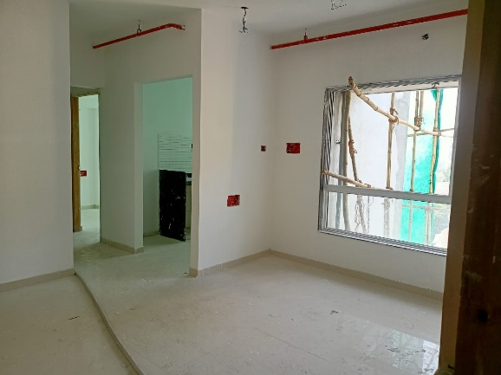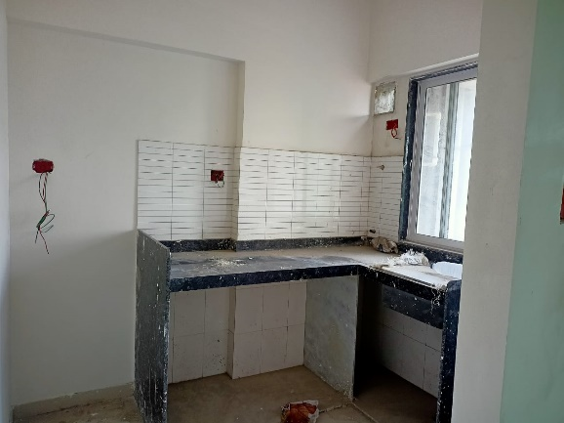

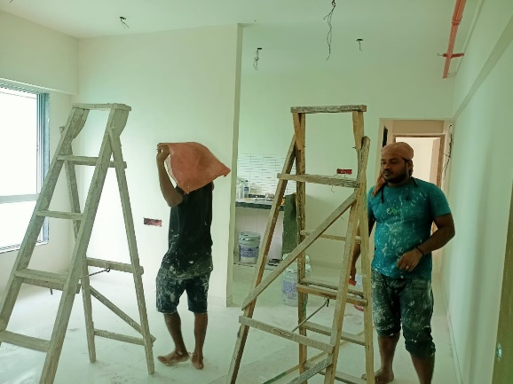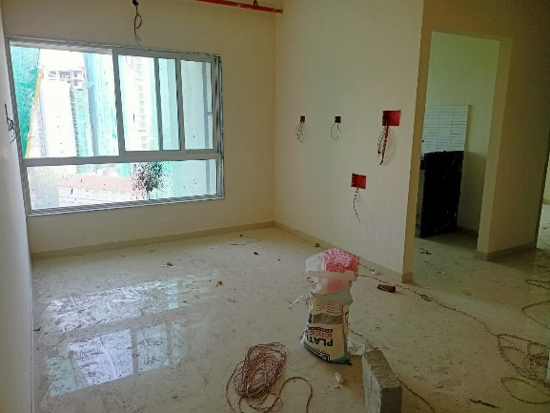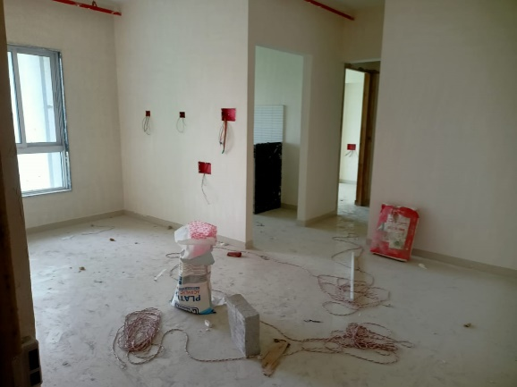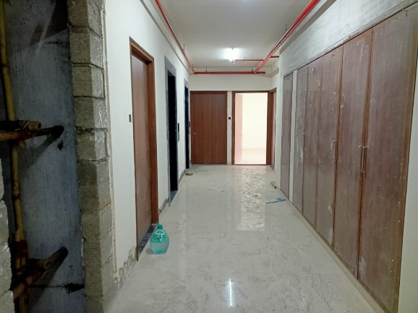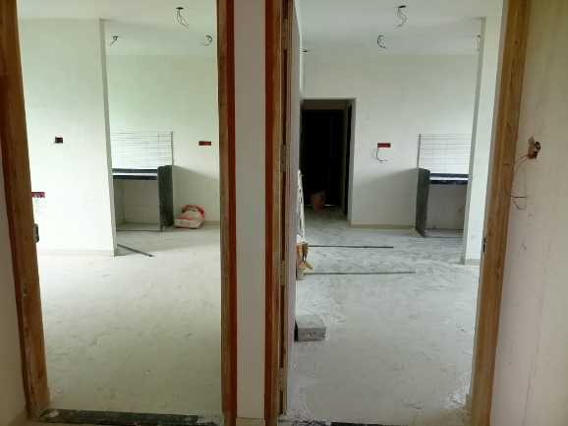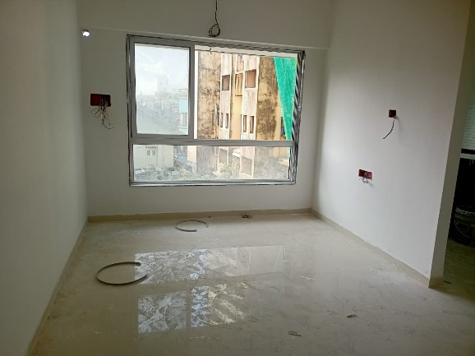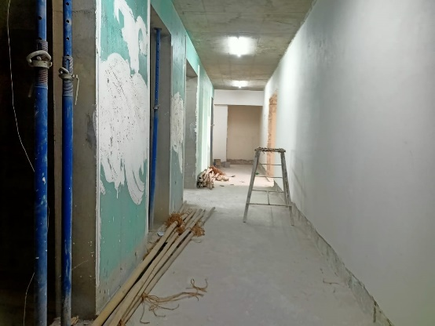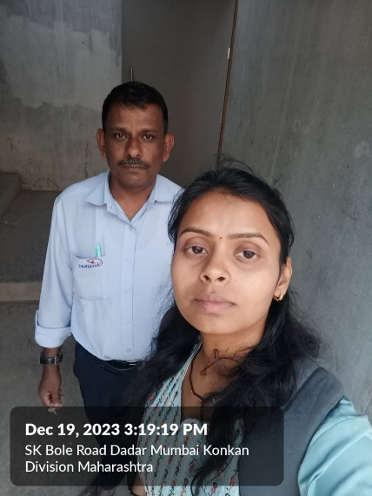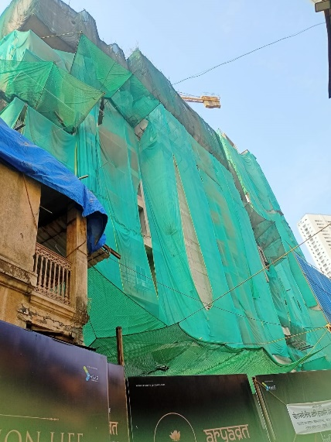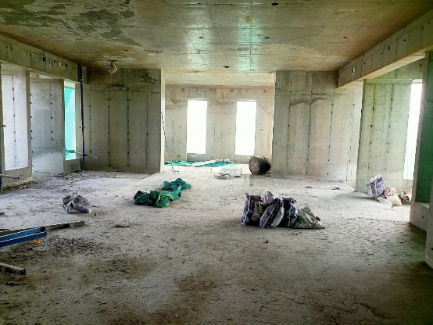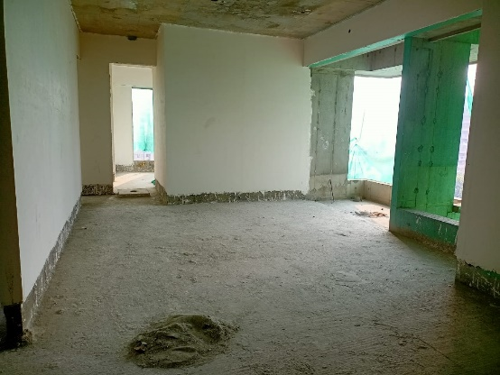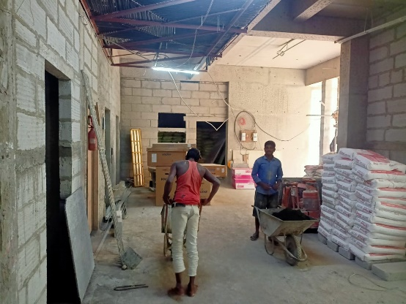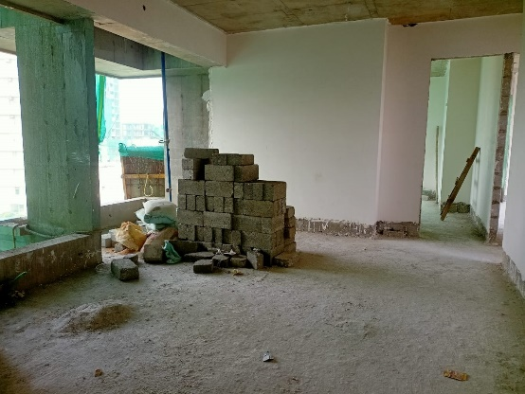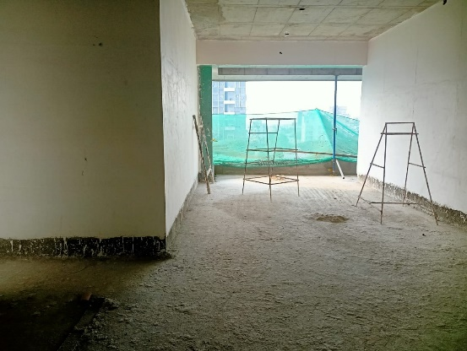**Actual Site Photographs**

**Route Map of the property**

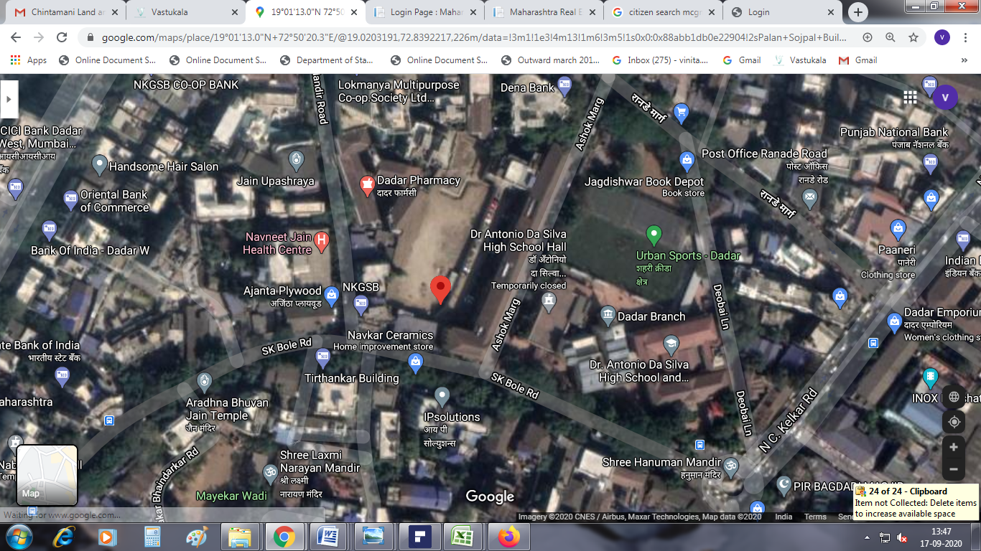**Site u/r**



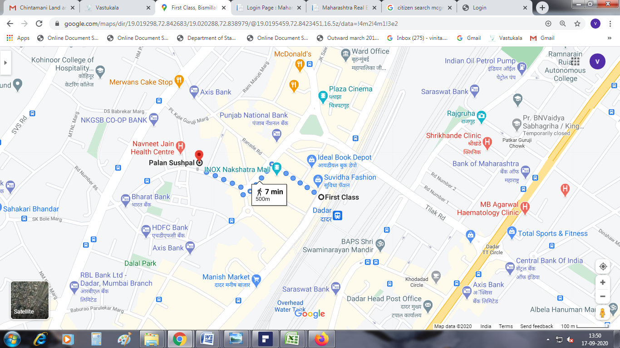

## Latitude Longitude: 19°01'13.0"N 72°50'20.3"E

Note: The Blue line shows the route to site from nearest railway station (Dadar Station –500 M.