Vastu/Nashik/126/2023/2304278
30/9-507-RYBS
Date: 30.12.2023

To,
The Branch Manager,
Union Bank of India
Gangapur Road Branch
Shree Ganesh Avenue, Chunchale Road,
Nashik - 422 013, State – Maharashtra, Country – India

Sub: Vetting of Work

Sir,

With reference to above subject, we have evaluated the Extra Work for Residential Flat No. 13, Fourth Floor, " Radhe Residency Apartment ", Survey No.175/ 3, Plot No. 12, Near Tuljabhavani Mandir, Gunjal Baba Nagar, Hirawadi Road, Village - Nashik, Taluka & District - Nashik, PIN Code – 422003, State – Maharashtra, Country – India. belongs to Name of Proposed Purchaser: Shri. Manoj Vaman Pawar & Sau. Manisha Manoj Pawar. Name of Owner: M/s. Jai Gurudev Enterprises.

We have verified the rates quoted as per current market rates. Details of Extra Amenities considered as per copy of Agreement of Extra Work between Mr. Manoj Vaman Pawar (First Party). Mr. Jayprakash Mahipat Yadav (Second Party) received on dated 30.12.2023. The Extra Work amount is Rs. 1,50,000/- (Rupees One Lakh Fifty Thousand Only)

The said Cost Vetting Certificate is valid upto next 6 months Only.

Thanking you

Sincerely yours

Sharadkumar B. Chalikwar
Govt. Reg. Valuer
Chartered Engineer (India)
Reg. No. (N) CCIT/1-14/52/2008-09

Agreement of Extra Work
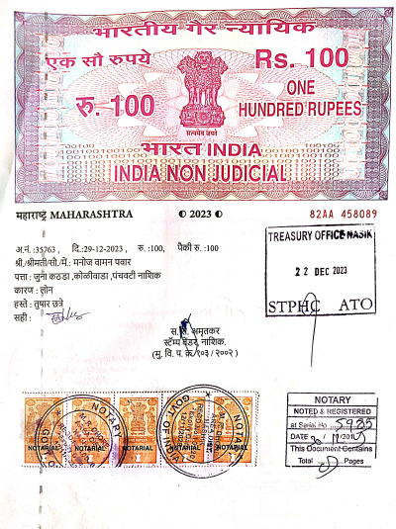
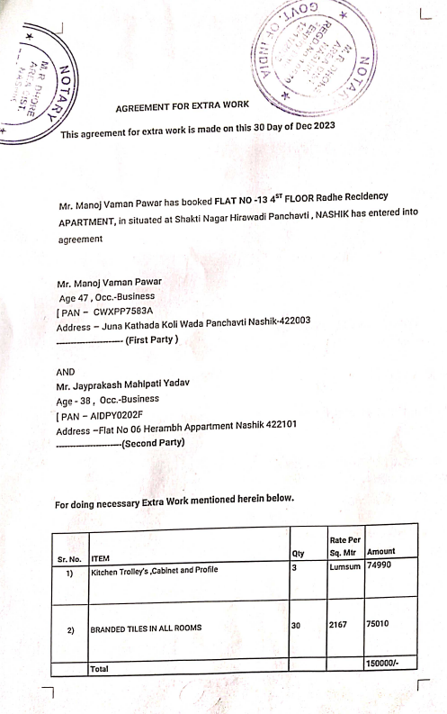

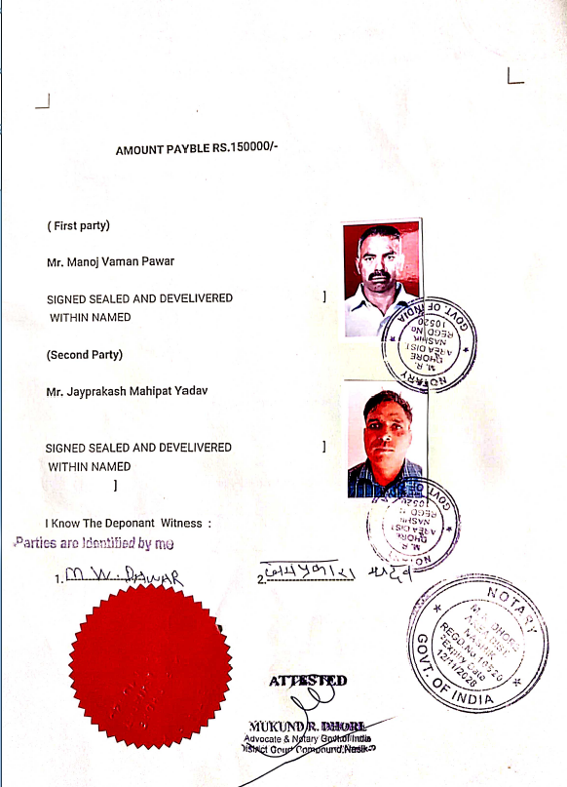

The Extra Amenities amount is Rs1,50,000/- (Rupees One Lakh Fifty Thousand Only)

