Valuation Report of the Immovable Property
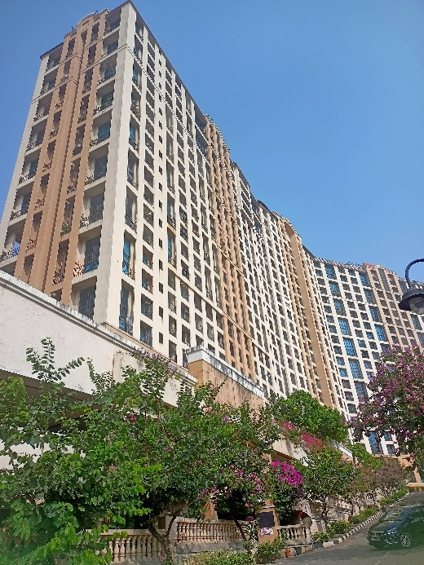

Details of the property under consideration:

Name of Owner: Mr. Nikhil R. Sahajwani & Mrs. Devika N. Sahajwani

Residential Duplex Flat No. 1104, 11th & 12th Floor, Wing – A, Building No. 7, "Amalfi", Raheja Exotica Amalfi Sicily Capri Co-op. Hsg. Soc. Ltd., Off. Malad Madh Road, Village – Erangal, Malad (West),
Mumbai – 400 061, State – Maharashtra, Country – India.

Latitude Longitude - 19°08'55.8"N 72°47'47.8"E

Valuation Done for:
The Zoroastrian Co-operative Bank Ltd.
Bandra (West) Branch
Darvesh Royal, Master Vinayak Road (Perry Road), Bandra (West), Mumbia – 400 050,
State – Maharashtra, Country – India.

Vastu/Mumbai/01/2024/6013/2304388
06/22-90-SBSK
Date: 06.01.2024

VALUATION OPINION REPORT

This is to certify that the property bearing Residential Duplex Flat No. 1104, 11th & 12th Floor, Wing – A, Building No. 7, "Amalfi", Raheja Exotica Amalfi Sicily Capri Co-op. Hsg. Soc. Ltd., Off. Malad Madh Road, Village – Erangal, Malad (West), Mumbai – 400 061, State – Maharashtra, Country – India belongs to Mr. Nikhil R. Sahajwani & Mrs. Devika N. Sahajwani.

Boundaries of the property.
North | Open Plot
South | Swimming Pool & Club house
East | Open Plot & Internal Road
West | Internal Road & Sorento Building

Considering various parameters recorded, existing economic scenario, and the information that is available with reference to the development of neighbourhood and method selected for valuation, we are of the opinion that, the property premises can be assessed and Fair Market Value for this particular purpose at ` 2,03,36,000.00 (Rupees Two Crore Three Lakh Thirty Six Thousand Only).

The valuation of the property is based on the documents produced by the concern. Legal aspects have not been taken into considerations while preparing this report.

Hence certified

Manoj B. Chalikwar
Registered Valuer
Chartered Engineer (India)
Reg. No. CAT-I-F-1763
TZCBL Emp. No. Ref: ZCBL/CO/AUD/19-20/100
Encl.: Valuation report
VALUATION REPORT IN RESPECT OF IMMOVABLE PROPERTY
1 | Date of Inspection | : | 06.01.2024
2 | Purpose of valuation | : | As per request from The Zoroastrian Co-operative Bank Ltd, Bandra (West) Branch, Fair Market Value of the property under reference for Bank Loan Purpose
3 | Name and address of the Valuer | : | Manoj B. Chalikwar  Vastukala Consultants (I) Pvt. Ltd.  B1-001, U/B Floor, Boomerang, Chandivali Farm Road, Powai, Andheri (East), Mumbai – 400 072.
4 | List of Documents Handed Over to The Valuer by The Bank  - Copy of Agreement for Sale dated 28.12.2009 Between Raheja Universal Pvt. Ltd. (the Vendors) and Mr. Nikhil R. Sahajwani & Mrs. Devika N. Sahajwani (the Purchasers).  - Copy of Full Occupancy Certificate No. CHE / 9452 / BP (WS) / AP dated 27.06.2014 issued by Municipal Corporation of Greater Mumbai for Residential Building No. 7, comprising of Wing A & Wing B of 2 Level Podium + Stilt + 1st to 20th Upper Floors & Wing C of 3 Level Podium + Stilt + 1st to 20th Upper Floors.  - Copy of Commencement Certificate No. CHE / 9452 / BP (WS) / AP dated 29.01.2007 issued by Municipal Corporation of Greater Mumbai.
5 | Details of enquiries made/ visited to government Office for arriving fair market value. | : | Market analysis and as per sub-registrar value.
6 | Factors for determining its market value. | : | Location, development of surrounding area, type of construction, construction specifications, age of building, condition of the premises & building, facilities provided and its prevailing market rate.
7 | ANY CRITICAL ASPECTS ASSOCIATED WITH PROPERTY | : | No
8 | Present/Expected Income from the property | : | ` 51,000.00 Expected rental income per month
 | Property Details | :
9 | Name(s) of the Owner and Postal address of the property under consideration. | : | Mr. Nikhil R. Sahajwani & Mrs. Devika N. Sahajwani
 |  | : | Address: Residential Duplex Flat No. 1104, 11th & 12th Floor, Wing – A, Building No. 7, "Amalfi", Raheja Exotica Amalfi Sicily Capri Co-op. Hsg. Soc. Ltd., Off. Malad Madh Road, Village – Erangal, Malad (West), Mumbai – 400 061, State – Maharashtra, Country – India.  Contact Person:  Mr. Arun Mishra (Staff)  Contact No. 9321982247
10 | If the property is under joint ownership/ co-ownership share of each such owner/ are the share is undivided. | : | Joint Ownership  Details of ownership share is not available
11 | Brief description of the property. | : | The Residential Duplex Flat under reference is situated on 11th & 12th Floor. The composition of flat on 11th Floor is Living Room + Dining + 1 Bedroom + Kitchen + Toilet + Passage + Balcony + Dry Balcony Area Internal Staircase to the upper floor & on 11th Floor is 1 Bedroom + Toilet + Balcony. The property is at 13.8 Km. travelling distance from nearest railway station Malad.
12 | Location of the property (C.T.S. No., Survey No., Hissa No., Plot No., etc.). | : | CTS No. 1965, 2053B, 2053C, 2053C-1, 2053D, 2053E, 2055B, 2055C of Village – Erangal
13 | Boundaries | : | As per Site |  |  |  | As per Documents
 | North | : | Open Plot |  |  |  | Details not available
 | South | : | Swimming Pool & Club house |  |  |  | Details not available
 | East | : | Open Plot & Internal Road |  |  |  | Details not available
 | West | : | Internal Road & Sorento Building |  |  |  | Details not available
14 | Matching of Boundaries | : | N.A.
15 | Route map | : | Enclosed
16 | Any specific identification marks | : | Near Saina Resort
17 | Whether covered under Corporation/ Panchayat/ Municipality. | : | Municipal Corporation of Greater Mumbai
18 | Whether covered under any land ceiling of State/ Central Government. | : | No
19 | Is the land freehold/ leasehold? | : | Freehold
20 | Are there any restrictive covenants in regard to use of Land? If so, attach a copy of the covenant. | : | As per Agreement
21 | Type of the property | : | Residential
22 | Year of acquisition/ purchase. | : | 28.12.2009
23 | Purchase value as per document | : | ` 63,85,000.00
24 | Whether the property is occupied by owner or tenant. If occupied by tenant since how long he is staying and the amount of rent being paid. | : | Owner Occupied
25 | Classification of the site | :
 | - Population group | : | Urban
 | - High/ Middle/ Poor class | : | Middle Class
 | - Residential/ Non-Residential | : | Residential
 | - Development of surrounding area | : | Developed Area
 | - Possibility of any threat to the property (Floods, calamities etc.). | : | No
26 | Proximity of civic amenities (like school, hospital, bus stop, market etc.). | : | All Available near by
27 | Level of the land (Plain, rock etc.) | : | Plain
28 | Terrain of the Land. | : | Levelled
29 | Shape of the land (Square/ rectangle etc.). | : | Irregular
30 | Type of use to which it can be put (for construction of house, factory etc.). | : | Residential purpose
31 | Whether the plot is under town planning approved layout? | : | Information not Available
32 | Whether the building is intermittent or corner? | : | Intermittent
33 | Whether any road facility is available? | : | Yes
34 | Type of road available (B.T/Cement Road etc.). | : | B.T. Road
35 | Front Width of the Road? | : | 06.00 M. Wide Road
36 | Source of water & water potentiality. | : | Municipal Water supply
37 | Type of Sewerage System. | : | Connected to Municipal Sewerage System
38 | Availability of power supply. | : | Yes
39 | Advantages of the site. | : | Located in developed area
40 | Disadvantages of the site. | : | No
41 | Give instances of sales of immovable property in the locality on a separate sheet, indicating the name & address of the property, registration No. sale price and area of land sold. | : | As per Sub-Registrar of Assurance records
 | Valuation of the property:
42 | Total area of the Residential Flat | : | Area as per actual site measurement are as under:  Area in Sq. Ft. 11th Floor 12th Floor  Carpet Area 524.00 200.00  Balcony Area 32.00 17.00  Dry Balcony Area 28.00 -  Total Area 584.00 217.00  Carpet Area in Sq. Ft. = 734.00  Built Up Area in Sq. Ft. = 992.00  (Area as per Agreement for Sale)
43 | Prevailing market rate. | : | ` 20,500.00 per Sq. Ft. Rate on Built Up Area (Including Car Parking)
44 | Floor Rise Rate per Sq. Ft. | : | ` 0.00
45 | PLC Rate per Sq. Ft. | : | ` 0.00
46 | Total Rate per Sq. Ft. | : | ` 20,500.00 per Sq. Ft. Rate on Built Up Area (Including Car Parking)
47 | Guideline rate obtained from the Stamp Duty Ready Reckoner. | : | ` 1,33,276.00 per Sq. M. i.e.  ` 12,382.00 per Sq. Ft.
47a | Guideline rate (after deprecation) | : | ` 1,23,931.00 per Sq. M. i.e.  ` 11,513.00 per Sq. Ft.
48 | Government Value | : | ` 1,14,20,896.00
 |  |  | Area in  Sq. Ft. |  | Rate |  |  | Value
 | Built up area | : | 992.00 |  | ` 11,513.00 |  |  | ` 1,14,20,896.00
49 | Value of the property
 |  |  | Area in Sq. Ft. |  |  | Rate |  |  | Value
 | Carpet Area | : | 992.00 |  |  | ` 20,500.00 |  |  | ` 2,03,36,000.00
 | Total Value of the Property |  |  |  |  |  |  |  | ` 2,03,36,000.00
50 | The realizable value of the property | : | ` 1,83,02,400.00
51 | Distress value of the property | : | ` 1,62,68,800.00
52 | Insurable value of the property | : | ` 26,78,400.00
 | Technical details of the building:
53 | Type of building (Residential / Commercial / Industrial). | : |  | Residential
54 | Year of construction. | : |  | 2014 (As per Occupancy Certificate)
55 | Future life of the property. | : |  | 50 years Subject to proper, preventive periodic maintenance & structural repairs.
56 | No. of floors and height of each floor including basement. | : |  | 2 Level Podium + Stilt + 1st to 20th Upper Floors  11th Floor is having 13 Flats.
 | Type of construction
57 | (Load bearing/ R.C.C./ Steel framed) | : |  | R.C.C. Framed Structure
 | Condition of the building.
58 | External (excellent/ good/ normal/ poor) | : |  | Good
59 | Internal (excellent/ good/ normal/ poor). | : |  | Good
60 | Whether the Residential Flat is constructed strictly according to the sanctioned plan, details of variations noticed if any and effect of the same on the valuation | : |  | As Occupancy Certificate is received may be assumed that the construction is as per sanctioned plan
 | Remarks:
61 | Specifications of Construction:
sr. | Description | : |  | 11th Floor
a | Foundation | : |  | R.C.C. Foundation
b | Basement | : |  | No
c | Superstructure | : |  | R.C.C. frame work with 9-inch-thick B. B. Masonry for external walls 6-inch thick B.B. Masonry for internal walls
d | Joinery/Doors/Windows | : |  | Teak Wood door framed with flush door; Powder coated aluminium sliding windows
e | RCC Work | : |  | R.C.C. Framed Structure
f | Plastering | : |  | Cement Plastering with POP false ceiling
g | Flooring, Skirting | : |  | All rooms are finished with Vitrified & Marble flooring. Toilets are finished with ceramic tiles flooring & full height glazed tiles dado.
h | Pantry Platform | : |  | Granit kitchen platform
i | Whether any proof course is provided? | : |  | Yes
j | Drainage | : |  | Connected to Municipal Sewerage System
k | Compound Wall (Height, length and type of construction) | : |  | 5'6" High, R.C.C. columns with B. B. Masonry wall
l | Electric Installation (Type of wire, Class of construction) | : |  | Concealed Electrification
m | Plumbing Installation (No. of closets and wash basins etc.) | : |  | Concealed Plumbing
n | Bore Well | : |  | Not found
o | Wardrobes, if any | : |  | No
p | Development of open area | : |  | Cemented road in open spaces, etc.
 | Valuation of proposed construction/ additions/ renovation if any:
62 | SUMMARY OF VALUATION: | :
 | Part I Land | : |  | ` 0.00
 | Part II Building | : |  | ` 2,03,36,000.00
 | Part III Other amenities/ Miscellaneous | : |  | ` 0.00
 | Part IV Proposed construction | : |  | ` 0.00
 | TOTAL. | : |  | ` 2,03,36,000.00
 | Calculation:
1 | Construction | :
1.01 | Built Up Area of Residential Flat | : |  | 992.00 Sq. Ft.
1.02 | Rate per Sq. Ft. | : |  | ` 2,700.00
1.03 | Cost of Construction = (1.01x1.02) | : |  | ` 26,78,400.00
2 | Value of property | :
2.01 | Built Up Area of Residential Flat | : |  | 992.00 Sq. Ft.
2.02 | Rate per Sq. Ft. | : |  | ` 20,500.00
2.03 | Floor Rise Rate per Sq. Ft. | : |  | ` 0.00
2.04 | PLC Rate per Sq. Ft. | : |  | ` 0.00
2.05 | Total Rate per Sq. Ft. | : |  | ` 20,500.00
2.06 | Value of Residential Flat = (2.01x2.05) | : |  | ` 2,03,36,000.00
3 | The value of the property. | : |  | ` 2,03,36,000.00

I certify that,
I/ my authorized representative, has inspected the subject property on 06.01.2024. Mr. Arun Mishra (Staff) has shown the property.
The rates for valuation of the property are in accordance with the Govt. approved rates and prevailing market rates.
There is no direct/ indirect interest in the property valued.
The fair value of the property as on 06.01.2024 is ` 2,03,36,000.00 (Rupees Two Crore Three Lakh Thirty Six Thousand Only).
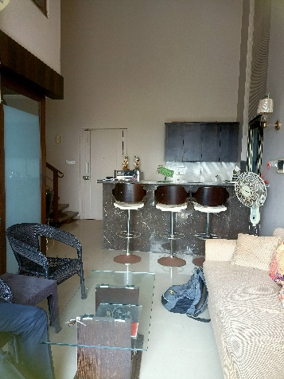
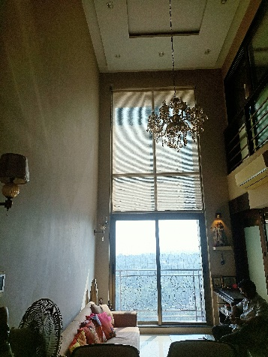
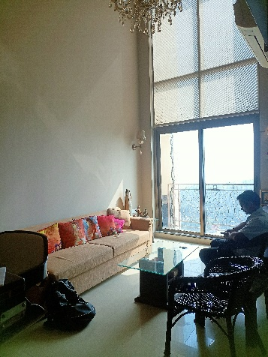
Actual site photographs

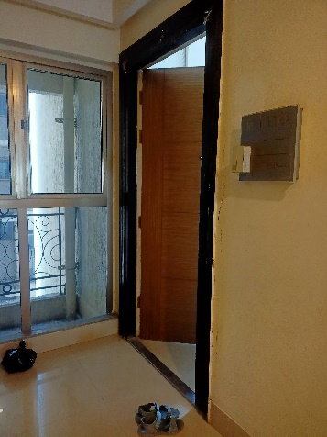
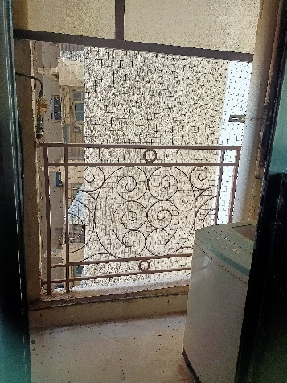
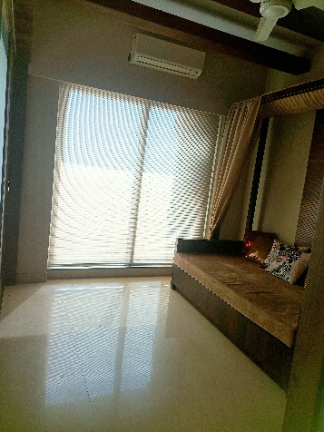
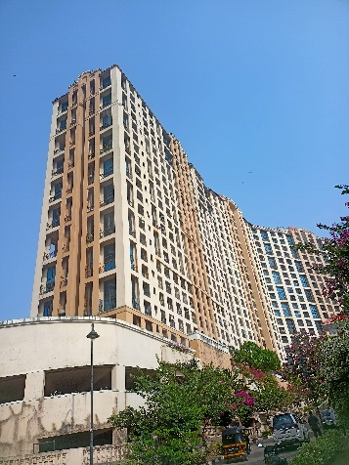
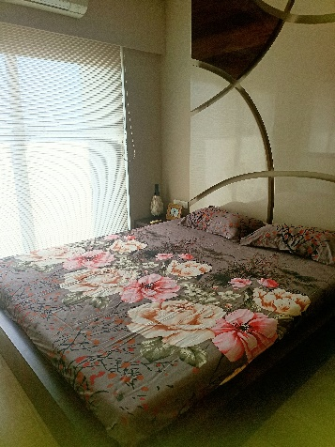
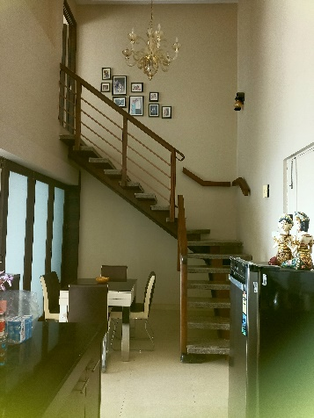
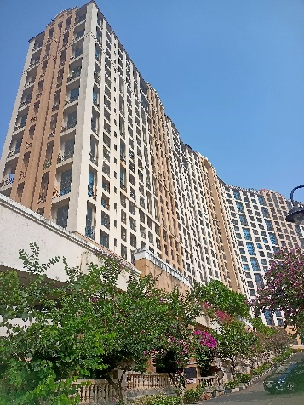
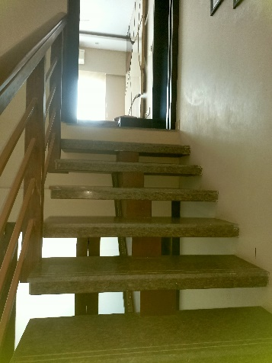
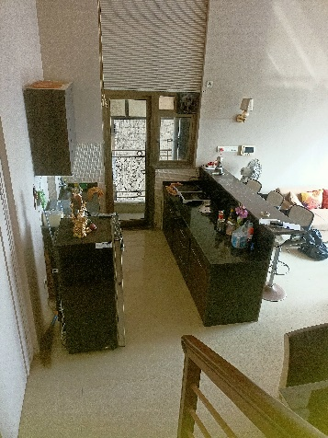
Route Map of the property
Site u/r
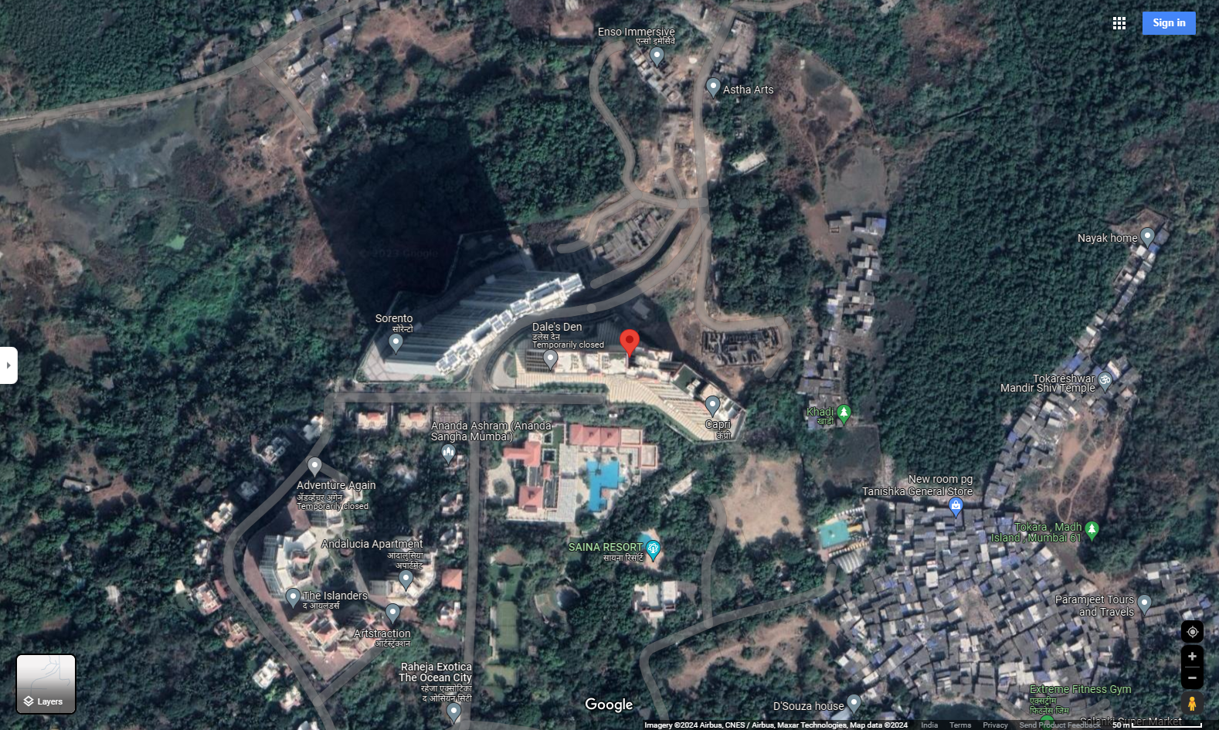

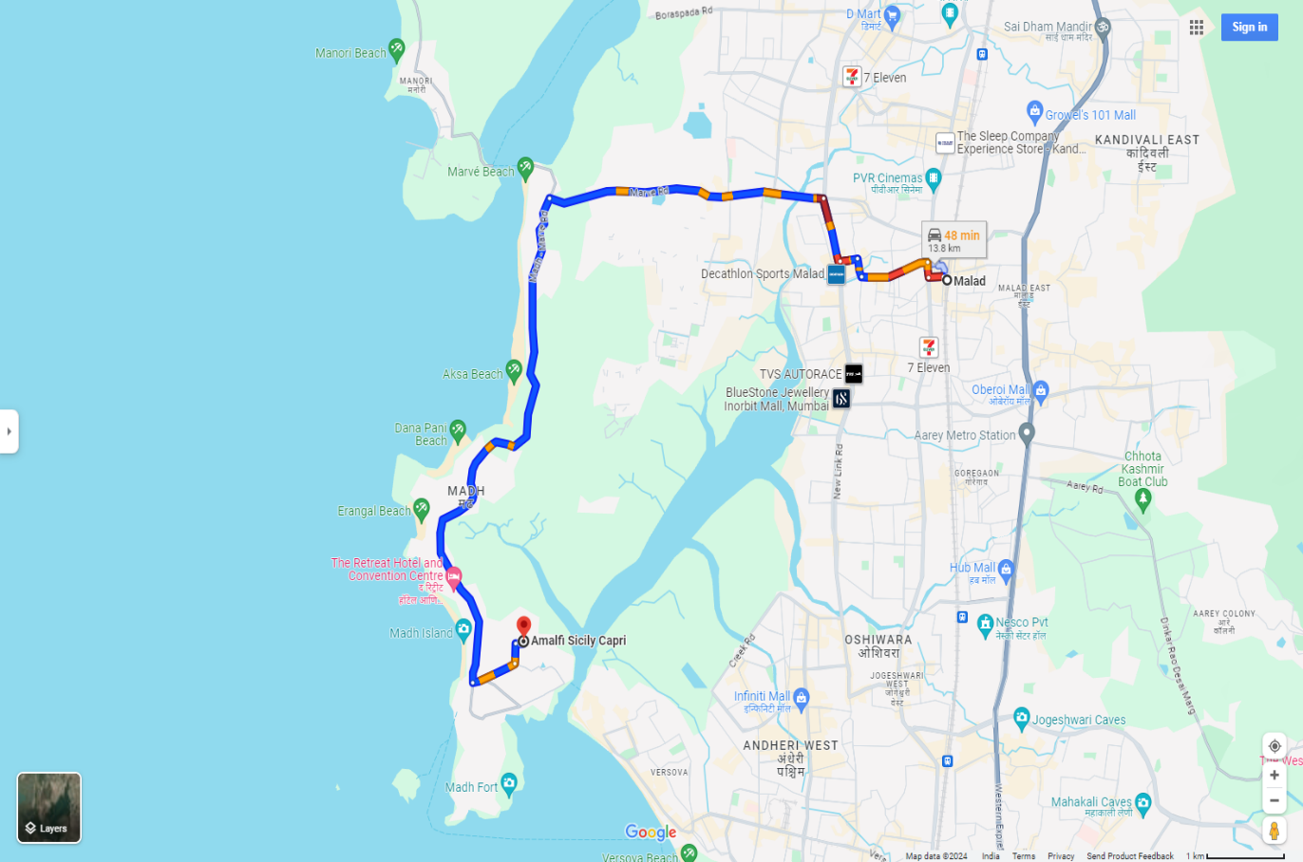

Latitude Longitude - 19°08'55.8"N 72°47'47.8"E
Note: The Blue line shows the route to site from nearest railway station (Goregaon – 13.8 Km.)

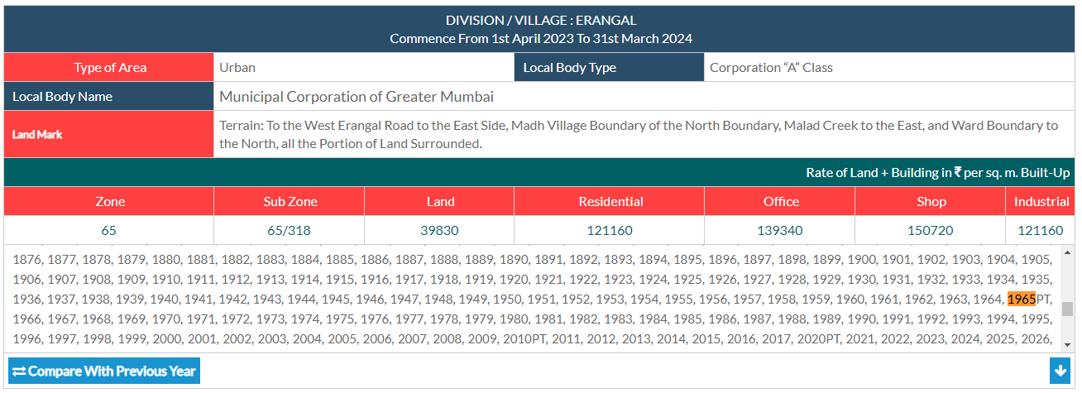
Ready Reckoner Rate

Stamp Duty Ready Reckoner Market Value Rate for Flat | 1,21,160.00
Increase by 10% on Flat Located on 11th Floor | 12,116.00
Stamp Duty Ready Reckoner Market Value Rate (After Increase) (A) | 1,33,276.00 | Sq. Mtr. | 12,382.00 | Sq. Ft.
Stamp Duty Ready Reckoner Market Value Rate for Land (B) | 39,830.00
The difference between land rate and building rate (A – B = C) | 93,446.00
Depreciation Percentage as per table (D) [100% - 10%]  (Age of the Building – 10 Years) | 90%
Rate to be adopted after considering depreciation [B + (C x D)] | 1,23,931.00 | Sq. Mtr. | 11,513.00 | Sq. Ft.

Multi-Storied building with Lift
For residential premises / commercial unit / office on above floor in multistoried building, the rate mentioned in the ready reckoner will be increased as under:

 | Location of Flat / Commercial Unit in the building | Rate
a) | On Ground to 4 Floors | No increase for all floors from ground to 4 floors
b) | 5 Floors to 10 Floors | Increase by 5% on units located between 5 to 10 floors
c) | 11 Floors to 20 Floors | Increase by 10% on units located between 11 to 20 floors
d) | 21 Floors to 30 Floors | Increase by 15% on units located between 21 to 30 floors
e) | 31 Floors and above | Increase by 20% on units located on 31 and above floors

Table – D: Depreciation Percentage Table

Completed Age of Building in Years | Value in percent after depreciation
 | R.C.C. Structure / other Pukka Structure | Cessed Building, Half or Semi – Pukka Structure & Kaccha Structure.
0 to 2 Years | 100% | 100%
Above 2 & up to 5 Years | 95% | 95%
Above 5 Years | After initial 5 year for every year 1% depreciation is to be considered. However maximum deduction available as per this shall be 70% of Market Value rate | After initial 5 year for every year 1.5% depreciation is to be considered. However maximum deduction available as per this shall be 85% of Market Value rate

Price Indicators
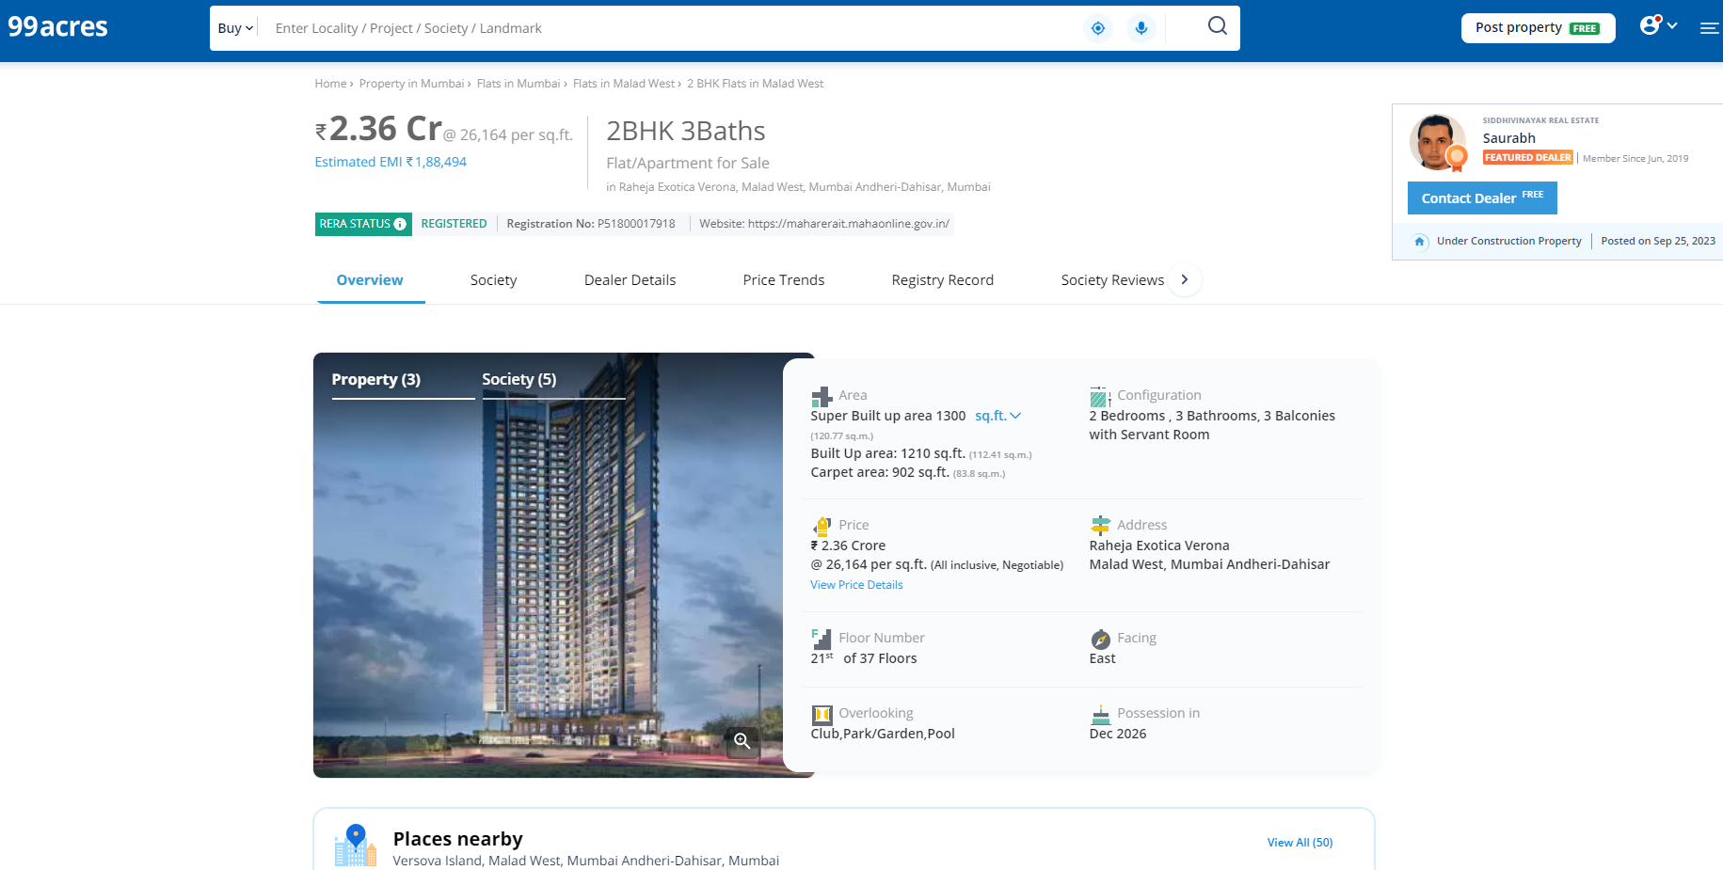

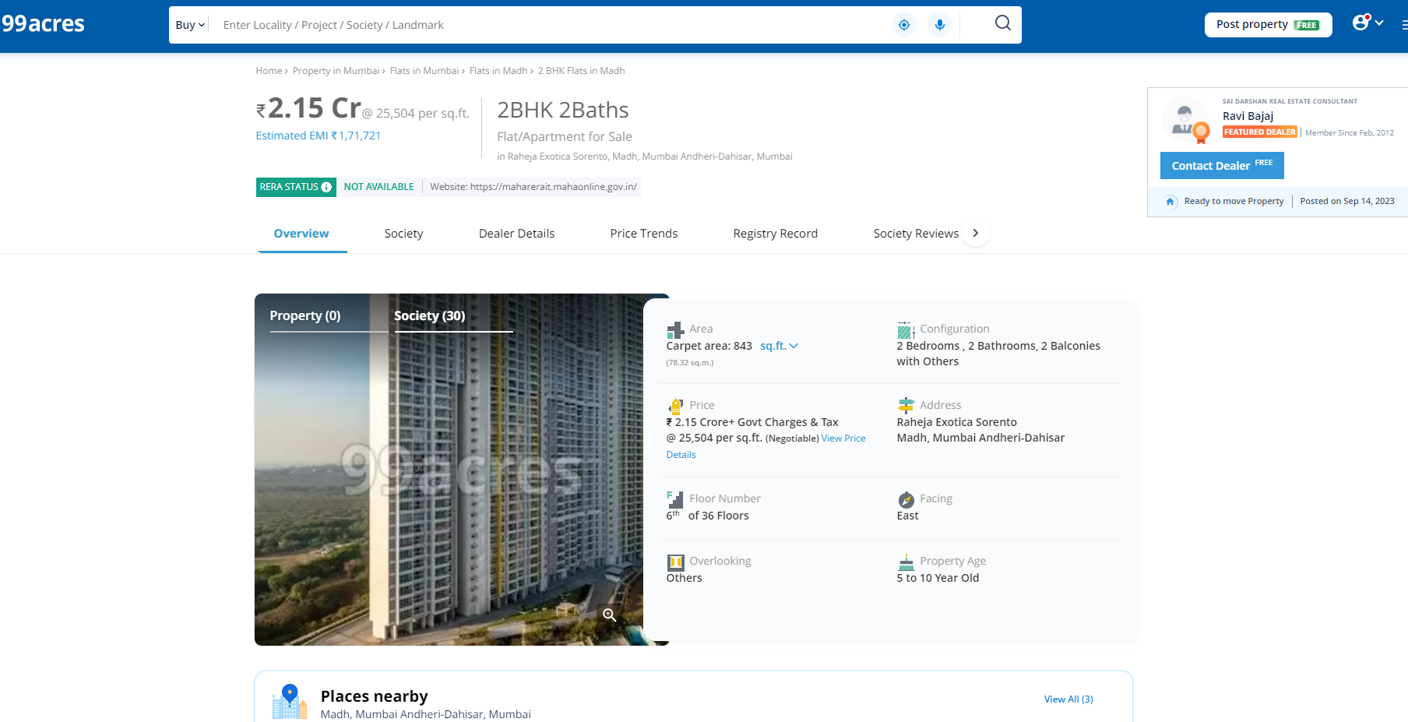
Price Indicator
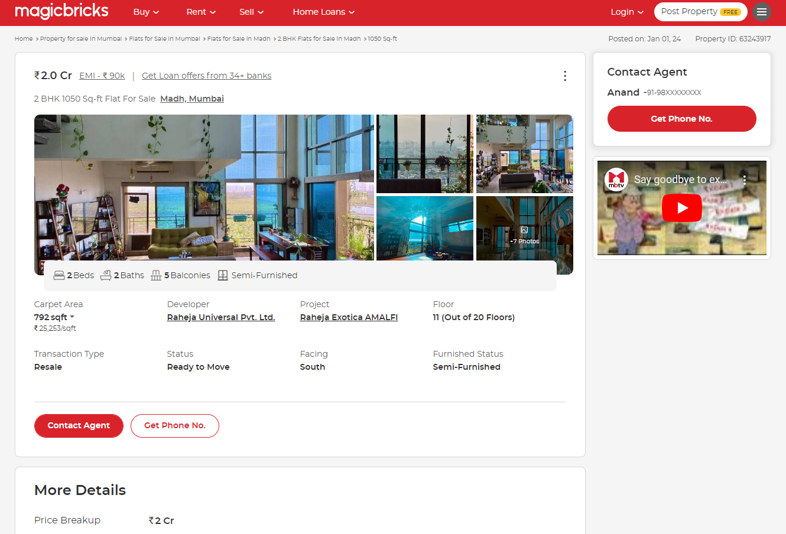

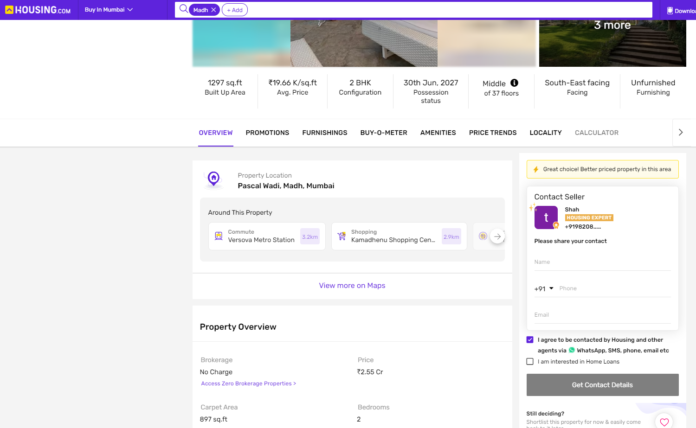

Sale Instance
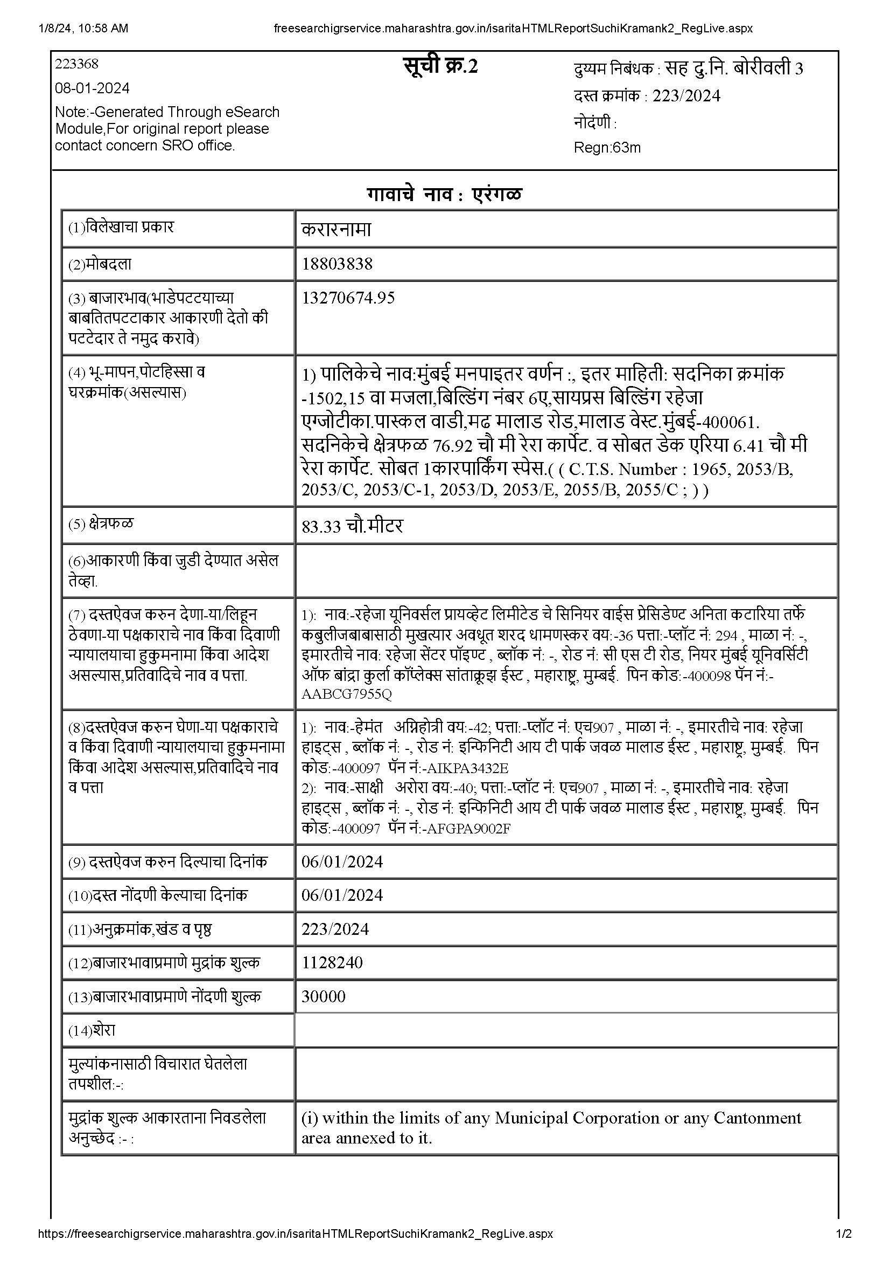

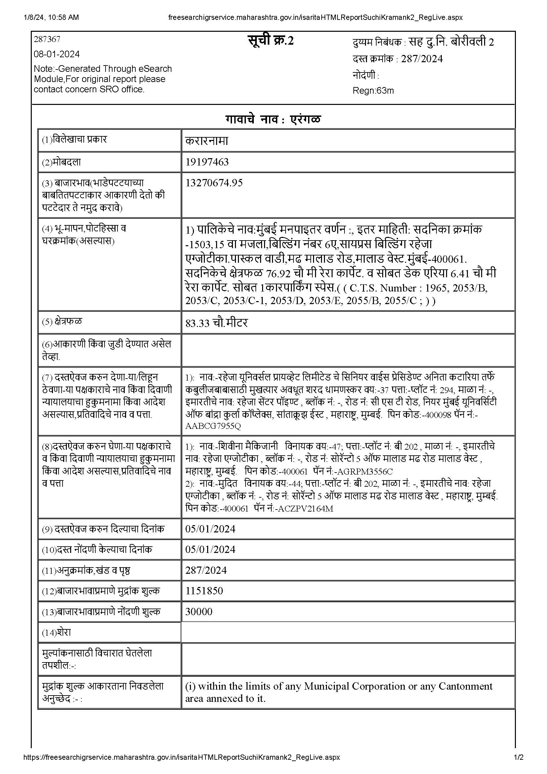
Sale Instance

DEFINITION OF VALUE FOR THIS SPECIFIC PURPOSE

This exercise is to assess Fair Market Value of the property under reference for Fair Market Value purpose as on dated 06th January 2024.

The term Fair Market Value is defined as

"The most probable price, as of a specified date, in cash, terms equivalent to cash, or in other precisely revealed terms for which the specified property rights would sell after reasonable exposure in a competitive market under all conditions requisite to a fair sale, with the buyer and seller each acting prudently knowledgeably and for self-interest assuming that neither is under undue duress"

Fundamental assumptions and conditions presumed in this definition are:

- Buyer and seller are motivated by self-interest.

- Buyer and seller are well informed and are acting prudently.

- The property is exposed for a reasonable time on the open market.

- Payment is made in cash or equivalent or in specified financing terms.

ASSUMPTIONS, CAVEATS, LIMITATION AND DISCLAIMERS
- We assume no responsibility for matters of legal nature affecting the property appraised or the title thereto, nor do we render our opinion as to the title, which is assumed to be good and marketable.
- The property is valued as though under responsible ownership.
- It is assumed that there are no hidden or unapparent conditions of the subsoil or structure that would render it more or less valuable. No responsibility is assumed for such conditions or for engineering that might be required to discover such factors.
- There is no direct/ indirect interest in the property valued.
- The rates for valuation of the property are in accordance with the Govt. approved rates and prevailing market rates.

DECLARATION OF PROFESSIONAL FEES CHARGED

We hereby declare that, our professional fees are not contingent upon the valuation findings. However, if the statute AND/OR clients demands that, the fees should be charged on the percentage of assessed value then, with the full knowledge of the AND/OR end user, it is being charged accordingly.

VALUATION OF THE PROPERTY PREMISES

Considering various parameters recorded herein above, existing economic scenario, and the information that is available with reference to the development of neighbourhood and method selected for valuation, we are of the opinion that, the property premises can be assessed and valued for this particular purpose at ` 2,03,36,000.00 (Rupees Two Crore Three Lakh Thirty Six Thousand Only).

Manoj B. Chalikwar
Registered Valuer
Chartered Engineer (India)
Reg. No. CAT-I-F-1763
TZCBL Emp. No. Ref: ZCBL/CO/AUD/19-20/100

