Valuation Report of the Immovable Property

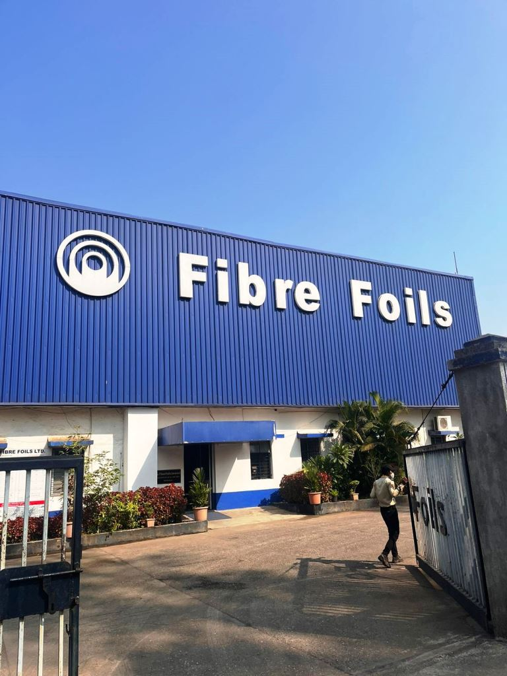

**Details of the property under consideration:**

Name of Owner: **M/s. Fibre Foils Limited**

Industrial Land & Factory Building at Gut No. 182, Survey Nos. 11/1, 11/2, 11/3, 12/2, 12/3, 12/4, 13/1

Near Shree Steel Company, Off Khopoli - Pen Road, Village Dheku, Taluka Khalapur, District – Raigad

PIN – 410 203, State - Maharashtra, Country – India

# Latitude Longitude - 18°46'59.2"N 73°18'08.0"E

# 

**Valuation Done for:**

**Cosmos Bank**

# Dadar (West) Branch

# Horizon Bldg.,1st Floor, Ranade Road & Gokhale Road, Dadar (West), Mumbai – 400 028,

# State – Maharashtra, Country – India

Vastu/Mumbai/01/2023/5959/2301706

21/2-331-JABS Date: 03.01.2024

# VALUATION OPINION REPORT

The property bearing Industrial Land & Factory Building at Gut No. 182, Survey Nos. 11/1, 11/2, 11/3, 12/2, 12/3, 12/4, 13/1, Near Shree Steel Company, Off Khopoli Pen Road, Village Dheku, Taluka Khalapur, District – Raigad, PIN – 410 203, State - Maharashtra, Country – India belongs to **M/s. Subh Nen Ply Private Limited.**

**Boundaries of the property.**

|  |  |  |  |
| --- | --- | --- | --- |
| **Building** | : | **As per actual site** | **As per Documents** |
| North | : | Shree Durga Paints - Factory | Details not available |
| South | : | Internal Road | Details not available |
| East | : | Shree Steel Wire Ropes | Details not available |
| West | : | Open Plot | Details not available |

Considering various parameters recorded, existing economic scenario, and the information that is available with reference to the development of neighborhood and method selected for valuation, we are of the opinion that, the property premises can be assessed and valued for banking purpose for –

|  |  |  |  |  |
| --- | --- | --- | --- | --- |
| **Particulars** | **Fair Market Value In (₹)** | **Realizable Value In (₹)** | **Distress Sale Value In (₹)** | **Insurable Value In**  **(₹)** |
| Industrial Land & Factory Building | 32,57,65,500.00 | 29,31,88,950.00 | 26,06,12,400.00 | 82,14,443.00 |

The valuation of the property is based on the documents produced by the concern. Legal aspects have not been taken into considerations while preparing this valuation report.

Hence certified

## Manoj B. Chalikwar

## Registered Valuer

## Chartered Engineer (India)

## Reg. No. CAT-I-F-1763

## Cosmos Emp. No. H.O./Credit/67/2019-20

Encl. Valuation Report

Valuation Report of Industrial Land & Factory Building at Gut No. 182, Survey Nos. 11/1, 11/2, 11/3, 12/2, 12/3, 12/4, 13/1, Near Shree Steel Company, Off Khopoli Pen Road, Village Dheku, Taluka Khalapur, District – Raigad, PIN – 410 203, State – Maharashtra, Country – India.

*Form 0-1*

*(See Rule 8 D)*

REPORT OF VALUATION OF IMMOVABLE PROPERTY (OTHER THAN AGRICULTURAL LANDS, PLANTATIONS, FORESTS, MINES AND QUARRIES)

GENERAL:

|  |  |  |  |
| --- | --- | --- | --- |
| 1 | Purpose for which the valuation is made | | To assess the Fair Market Value as on 03.01.2024 for Bank Loan Purpose |
| 2 | Date of inspection | | 29.12.2023 |
|  | Name of the owner/ owners | | **M/s. Fibre Foils Limited** |
| 4 | If the property is under joint ownership / co-ownership, share of each such owner. Are the shares undivided? | | Limited Company Ownership |
| 5 | Brief description of the property | | **Address:** Industrial Land & Factory Building at Gut No. 182, Survey Nos. 11/1, 11/2, 11/3, 12/2, 12/3, 12/4, 13/1, Near Shree Steel Company, Off Khopoli Pen Road, Village Dheku, Taluka Khalapur, District – Raigad, PIN – 410 203, State – Maharashtra, Country – India.  **Contact Person:**  Mr. Suresh Shinde (Accountant)  Contact No. +91 9819304137  **Landmark:** Near Colour Roof India Limited |
| 6 | Location, street, ward no | | Near Shree Steel Company, Off Khopoli Pen Road, Village Dheku, Taluka Khalapur, District – Raigad |
| 7 | Survey/ Plot no. of land | | Gut No. 182, Survey Nos. 11/1, 11/2, 11/3, 12/2, 12/3, 12/4, 13/1 |
| 8 | Is the property situated in residential/ commercial/ mixed area/ industrial area? | | Industrial Area |
| 9 | Classification of locality-high class/ middle class/poor class | | Middle Class |
| 10 | Proximity to civic amenities like schools, Hospitals, Offices, market, cinemas etc. | | All the amenities are available in the vicinity |
| 11 | Means and proximity to surface communication by which the locality is served | | Served by Buses, Taxies, Auto and Private cars |
|  | *LAND* | |  |
| 12 | Area of land supported by documentary proof. Shape, dimension and physical features | | Land Area – 30,550 Sq. M.  (Area as per Documents)  Gut No. 182   |  |  |  | | --- | --- | --- | | Survey No. | Area in Hector | Ara I n Sq. M. | | 11/1 | 0-62-7 | 6,270.00 | | 11/2 | 0-37-6 | 3,760.00 | | 11/3 | 0-37-0 | 3,700.00 | | 12/2 | 0-31-6 | 3,160.00 | | 12/3 | 0-26-6 | 2,660.00 | | 12/4 | 0-49-8 | 4,980.00 | | 13/1 | 0-60-2 | 6,020.00 | | **Total** | **3-05-50** | **30,550.00** | |
| 13 | Roads, Streets or lanes on which the land is abutting | | Off Khopoli - Pen Road |
| 14 | If freehold or leasehold land | | Freehold |
| 15 | If leasehold, the name of Lessor/lessee, nature of lease, date of commencement and termination of lease and terms of renewal of lease. | | N. A. |
| (i) Initial premium | |
| (ii) Ground rent payable per annum | |
| (iii) Unearned increase payable to the Lessor in the event of sale or transfer | |
| 16 | Is there any restriction covenant in regard to use of land? If so attach a copy of the covenant. | | Industrial |
| 17 | Are there any agreements of easements? If so, attach a copy of the covenant | | Information not available |
| 18 | Does the land fall in an area included in any Town Planning Scheme or any Development Plan of Government or any statutory body? If so, give Particulars. | | Information not available |
| 19 | Has any contribution been made towards development or is any demand for such contribution still outstanding? | | Information not available |
| 20 | Has the whole or part of the land been notified for acquisition by government or any statutory body? Give date of the notification. | | No |
| 21 | Attach a dimensioned site plan | | Copy of Approved Site Plan not available for our verification. |
|  | *IMPROVEMENT* | |  |
| 22 | Attach plans and elevations of all structures standing on the land and a lay-out plan. | | Information not available |
| 23 | Furnish technical details of the building on a separate sheet (The Annexure to this form may be used) | | Attached |
| 24 | Is the building owner occupied/tenanted/both? | | Owner Occupied in the name of M/s. Fibre Foils Limited |
|  | If the property owner occupied, specify portion and extent of area under owner-occupation | | N.A. |
| 25 | What is the Floor Space Index permissible and Percentage actually utilized? | | Floor Space Index permissible - As per local norms  Percentage actually utilized – Details not available |
| 26 | *RENTS* | |  |
|  | (i) | Names of tenants/ lessees/ licensees, etc. | N.A. |
|  | (ii) | Portions in their occupation | N.A. |
|  | (iii) | Monthly or annual rent/ compensation / license fee, etc. paid by each | N.A. |
|  | (iv) | Gross amount received for the whole property | N.A. |
| 27 | Are any of the occupants related to, or close to business associates of the owner? | | N. A. |
| 28 | Is separate amount being recovered for the use of fixtures, like fans, geysers, refrigerators, cooking ranges, built-in wardrobes, etc. or for services charges? If so, give details | | N. A. |
| 29 | Give details of the water and electricity charges, if any, to be borne by the owner | | N. A. |
| 30 | Has the tenant to bear the whole or part of the cost repairs and maintenance? Give particulars | | N. A. |
| 31 | If a lift is installed, who is to bear the cost of maintenance and operation- owner or tenant? | | N. A. |
| 32 | If a pump is installed, who is to bear the cost of maintenance and operation- owner or tenant? | | N. A. |
| 33 | Who has to bear the cost of electricity charges for lighting of common space like entrance hall, stairs, passage, compound, etc. owner or tenant? | | N. A. |
| 34 | What is the amount of property tax? Who is to bear it? Give details with documentary proof | | N. A. |
| 35 | Is the building insured? If so, give the policy no., amount for which it is insured and the annual premium | | N. A. |
| 36 | Is any dispute between landlord and tenant regarding rent pending in a court of rent? | | N. A. |
| 37 | Has any standard rent been fixed for the premises under any law relating to the control of rent? | | N. A. |
|  | *SALES* | |  |
| 38 | Give instances of sales of immovable property in the locality on a separate sheet, indicating the Name and address of the property, registration No., sale price and area of land sold. | | As per sub registrar of assurance records |
| 39 | Land rate adopted in this valuation | | ` 6,500.00 per Sq. M. |
| 40 | If sale instances are not available or not relied up on, the basis of arriving at the land rate | | Online Price Indicators, Location, development of surrounding area, type of land and construction, construction specifications, age of building, condition of the premises & building, facilities provided and its prevailing market rate. |
|  | *COST OF CONSTRUCTION* | |  |
| 41 | Year of commencement of construction and year of completion | | Year of Construction (Approx.) – 1993 (As per site information) |
| 42 | What was the method of construction, by contract / By employing Labour directly / both? | | Information not available |
| 43 | For items of work done on contract, produce copies of agreements | | Information not available |
| 44 | For items of work done by engaging Labour directly, give basic rates of materials and Labour supported by documentary proof. | | Information not available |
|  | **Remark**:  As there are no approved building plans, building completion certificate / occupancy certificate have been provided for verification. For the purpose of valuation, we have considered the land area as per documents and constructed area as per site measurement for valuation. | | |

*PART II- VALUATION*

GENERAL:

Under the instruction of Cosmos Bank, Dadar (West) Branch to assess fair market value as on 03.01.2024 for Industrial Land & Factory Building at Gut No. 182, Survey Nos. 11/1, 11/2, 11/3, 12/2, 12/3, 12/4, 13/1, Near Shree Steel Company, Off Khopoli Pen Road, Village Dheku, Taluka Khalapur, District – Raigad, PIN – 410 203, State – Maharashtra, Country – India belongs to **M/s. Fibre Foils Limited.**

**We are in receipt of the following documents:**

|  |  |
| --- | --- |
| 1 | Copy of 7/12 Revenue Extract, Gut No. / Sub-Division: 182 of Village - Dheku, Taluka - Khalapur, District – Raigad. |
| 2 | Copy of Electricity Bill, Consumer No. 030829018345 dated 05.12.2023 in the name of M/s. Fibre Foils Limited. |
| 3 | Copy of Property Tax Bill for assessment year 2023/24 dated 31.07.2023 issued by Group Gram Panchayat Sajgaon. |
| 4 | Copy of Agreement dated 17.11.1984 between M/s. Fibre Foils Limited (Purchaser) AND Smt. Rambai Tatya Patil & Shri. Baban Tukaram Patil (Seller) – Survey No. 13/1 & 11/1 |
| 5 | Copy of Agreement dated 17.11.1984 between M/s. Fibre Foils Limited (Purchaser) AND Shri. Kashinath Dagadu Patil (Seller) – Survey No. 11/3 |
| 6 | Copy of Agreement dated 17.11.1984 between M/s. Fibre Foils Limited (Purchaser) AND Shri. Dugha Dagadu Patil (Seller) – Survey No. 11/2, 12/2, 12/3 |
| 7 | Copy of Agreement dated 12.02.1986 between M/s. Fibre Foils Limited (Purchaser) AND Smt. Sitabai Kondu Shende (Seller) – Survey No. 12/4 |

**LOCATION:**

The said building is located at bearing Gut No. 182, Survey Nos. 11/1, 11/2, 11/3, 12/2, 12/3, 12/4, 13/1 of Village Dheku, Taluka Khalapur, District – Raigad. The property falls in Industrial Zone. It is at a travelling distance of 6.8 km. travelling distance from Khopoli railway station.

**BUILDING:**

The property under reference is main factory building of Ground floor RCC framed structure with 9" thick external walls and 6" thick internal brick walls. The walls are having sand faced plaster from outside. The building external condition is good. The building is used for Industrial purpose. Other Ancillary structures are D. G. Shed (Unitlity), Canteen, Gas Shed and Security cabin etc.

**As per site measurement, area is as below.**

|  |  |  |  |  |  |
| --- | --- | --- | --- | --- | --- |
| **Sr. No.** | **Particulars** | **Carpet Area in sq. Ft.** | **Built-up Area (CA + 20% loading)** |  |  |
| 1 | Production Area | 180.2548 | 216.30576 |  |  |
| 2 | Admin Block (Office) | 90.4428 | 108.53136 |  |  |
| 3 | Entrance | 289.296 | 347.1552 |  |  |
| 4 | Passage | 107.7118 | 129.25416 |  |  |
| 5 | WC (2 Numbers) | 50.82 | 60.984 |  |  |
| 6 | Conference Room | 249.984 | 299.9808 |  |  |
| 7 | Cabin | 131.2248 | 157.46976 |  |  |
| 8 | Staff Working Area | 541.744 | 650.0928 |  |  |
| 9 | Quality Control Lab | 267.0435 | 320.4522 |  |  |
| 10 | Storage Area | 8635.7016 | 10362.84192 |  |  |
| 11 | Paper Roll Storage | 39375 | 47250 |  |  |
| 12 | LCC (Storage) | 5231.9271 | 6278.31252 |  | |
| 13 | Can - 1 (Storage) | 9552.796 | 11463.3552 |  |  |
| 14 | Press Shop (Manufacturing Unit) | 1916.4014 | 2299.68168 |  |  |
|  |  | 527.2895 | 632.7474 |  |  |
| 15 | Can -2 (Manufacturing Unit) | 718.3165 | 861.9798 |  |  |
|  |  | 509.9679 | 611.96148 |  |  |
| 16 | Adhesive Department | 1403.5344 | 1684.24128 |  |  |
| 17 | Canteen | 3084.3684 | 3701.24208 |  |  |
| 18 | Utility Area (D. G. shed) | 1310.7207 | 1572.86484 |  |  |
| 19 | Security Cabin | 95.939 | 115.1268 |  |  |
| 20 | MFT Area | 14125.70355 | 16950.84426 |  |  |
| 21 | LPG Shed | 599.8165 | 719.7798 |  |  |
|  | **Total** | **88,996.00425** | **1,06,795.2051** |  |  |
|  | Loft Area | 6738.3512 | 8086.02144 |  |  |
|  |  | 1882.3572 | 2258.82864 |  |  |
|  | **Total** | **8,620.7084** | **10,344.85008** |  |  |
|  | **Grand Total** | **97,616.71265** | **1,17,140.0552** |  |  |

**As per site measurement Total Carpet Area is 97617.71 Sq. Ft. with 20% loading Built up area comes to 1,17,140.00 Sq. Ft., which is considered for valuation.**

**Valuation as on 3rd January 2024:**

1. **Land Valuation:**

|  |  |  |  |
| --- | --- | --- | --- |
| **Fair Market Value** |  | | |
| A) Land | **Area in Sq. M.** | **Rate in `** | **Fair Market Value in `** |
| 30,550.00 | 6,500/- | **19,85,75,000/-** |

1. **Valuation of Structures.**

The Built-up area of the building : As per valuation table below

**Deduct Depreciation:**

Year of Construction of the building : Approx. 1993 (As per site information)

Expected total life of building : 60 Years

Age of the building as on 2024 : Approx. 30 Years

Cost of Construction : As per valuation table below

Depreciation : As per valuation table below

Amount of depreciation : As per valuation table below

**Depreciated cost of construction** : As per valuation table below

**Government Value:**

|  |  |  |  |
| --- | --- | --- | --- |
| **Particulars** | **Area in Sq. M.** | **Rate in `** | **Value in `** |
| Land | 30,550.00 | 3,630/- | 11,08,96,500/- |
| Structure | As per valuation table | | 9,66,40,500/- |
| **Total** |  |  | **20,75,37,000/-** |

**B) Structure**

|  |  |  |  |  |  |  |  |  |
| --- | --- | --- | --- | --- | --- | --- | --- | --- |
| **Particulars** | **Built up Area in**  **Sq. Ft** | **Year of Const.** | **Total Life of Structure** | **Replacement Rate** (`) | **Age Of Build.** | **Depreciated Rate** (`) | **Depreciated Value** (`) | **Full Value** (`) |
| Ground Floor with Mezzanine | 117140.00 | 1993 | 60 | 1500/- | 30 Years | 825/- | 9,66,40,500**/-** | 17,57,10,000**/-** |
| **Total** |  |  |  |  |  |  | **9,66,40,500/-** | **17,57,10,000/-** |

|  |  |  |  |
| --- | --- | --- | --- |
| Land Development |  | | |
| Land | **Area in Sq. M.** | **Rate in `** | **Fair Market Value in `** |
| 30,550.00 | 1,000/- | **3,05,50,000/-** |

**TOTAL VALUE OF THE PROPERTY:**

|  |  |
| --- | --- |
| **Particulars** | **Value (`)** |
| **Land** | 19,85,75,000.00 |
| **Land Development** | 3,05,50,000.00 |
| **Building** | 9,66,40,500.00 |
| **Fair Market Value** | **32,57,65,500.00** |
| **Realizable Value** | **29,31,88,950.00** |
| **Distress Sale Value** | **26,06,12,400.00** |
| **Insurable value**  **(Depreciated Cost of Construction (9,66,40,500/-) – Subsoil structure cost (15%)** | **82,14,443.00** |

Taking into consideration above said facts, we can evaluate the value of Industrial Land & Factory Building at Gut No. 182, Survey Nos. 11/1, 11/2, 11/3, 12/2, 12/3, 12/4, 13/1, Near Shree Steel Company, Off Khopoli Pen Road, Village Dheku, Taluka Khalapur, District – Raigad, PIN – 410 203, State - Maharashtra, Country – India for this particular purpose at **` 32,57,65,500.00 (Rupees Thirty Two Crore Fifty Seven Lakh Sixty Five Thousand Five Hundred Only)** as on **3rd January 2024.**

**NOTES**

1. I, Manoj B. Chalikwar with my experience and ability to judgment I am of the considered opinion that the fair market value of the property as on 3rd January 2024 is ` 32,57,65,500.00 (Rupees Thirty Two Crore Fifty Seven Lakh Sixty Five Thousand Five Hundred Only). Value varies with time and purpose and hence this value should not be referred for any purpose other than mentioned in this report.
2. This valuation is done on the basis of information, which the valuer has obtained by information provided by the client about the premises and location of the surrounding area and also prevailing rates in the surrounding area, and further subject to document as mentioned in valuation report.
3. This valuer should not be held responsible for authentication of documents, clear title and other such related matters. For that purpose, Latest Legal Opinion should be sought.

*PART III- DECLARATION*

I hereby declare that

* + 1. The information furnished in part I is true and correct to the best of my knowledge and belief;
    2. I have no direct or indirect interest in the property valued:

ANNEXURE TO FORM 0-1

Technical details Building

|  |  |  |
| --- | --- | --- |
| 1. | No. of floors and height of each floor | Ground floor structure with mezzanine area |
| 2. | Plinth area floor wise as per IS- 1225 | N.A. as the said property is a N.A. Land with ground floor structures only |
| 3 | Year of construction | Approx. 1993 (As per site information) |
| 4 | Estimated future life | 30 Years Subject to proper, preventive periodic maintenance & structural repairs |
| 5 | Type of construction- load bearing walls/RCC frame/ steel frame | RCC & Load bearing Structure |
| 6 | Type of foundations | R.C.C. foundation |
| 7 | Walls | All external walls are 9” thick and partition walls are 6” thick. |
| 8 | Partitions | 6” thick brick wall |
| 9 | Doors and Windows | M.S. rolling shutters, powder coated Allumnium sliding windows |
| 10 | Flooring | Vitrified, Kota and PCC flooring |
| 11 | Finishing | Cement plastering |
| 12 | Roofing and terracing | RCC, G.I. & ACC sheet roof |
| 13 | Special architectural or decorative features, if any | N.A. |
| 14 | |  |  | | --- | --- | | (i) | Internal wiring – surface or conduit | | (ii) | Class of fittings: Superior/ Ordinary/ Poor. | | Industrial type electrification |
| 15 | Sanitary installations   |  |  | | --- | --- | | (i) | No. of water closets | | (ii) | No. of lavatory basins | | (iii) | No. of urinals | | (iv) | No. of sinks |   Class of fittings: Superior colored / superior white/ordinary. | As per requirements |
| 16 | Compound wall  Height and length  Type of construction | Yes |
| 17 | No. of lifts and capacity | No lift |
| 18 | Underground sump – capacity and type of construction | As per requirements |
| 19 | Over-head tank Location, capacity Type of construction | As per requirements |
| 20 | Pumps- no. and their horse power | As per requirements |
| 21 | Roads and paving within the compound approximate area and type of paving | Tar Road |
| 22 | Sewage disposal – whereas connected to public sewers, if septic tanks provided, no. and capacity | Connected to Gram Panchayat Sewerage System |
| 23 | General Remarks |  |
|  |  | |

**Actual site photographs**

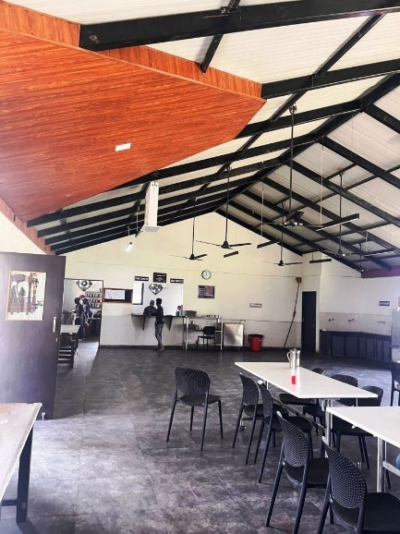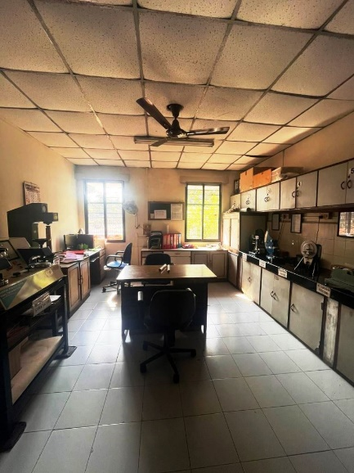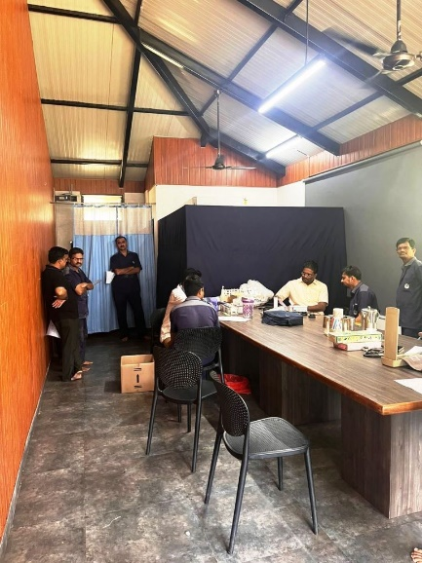

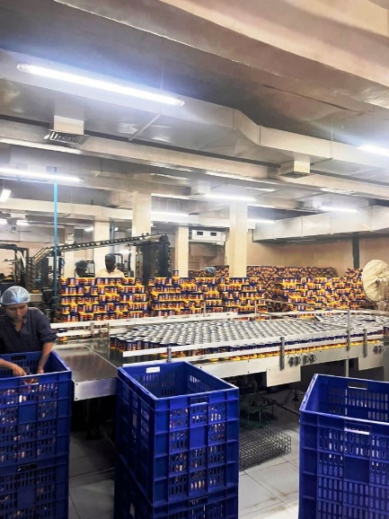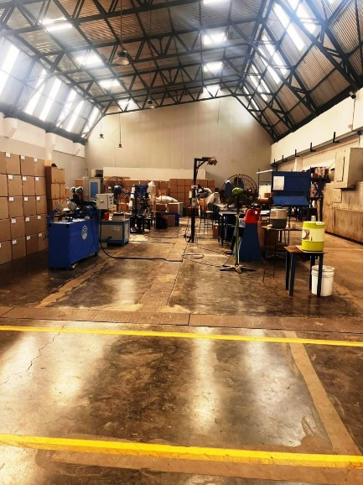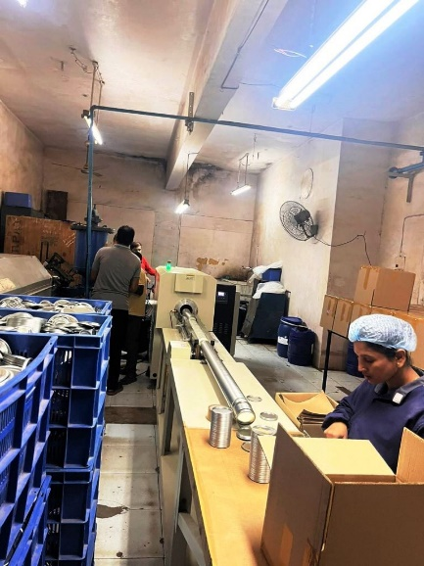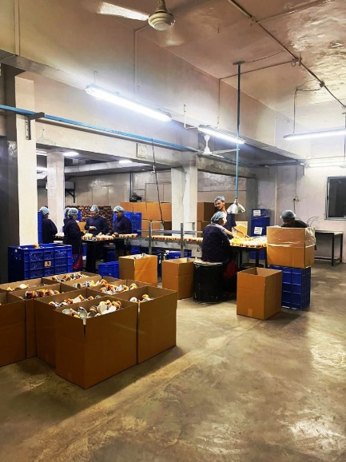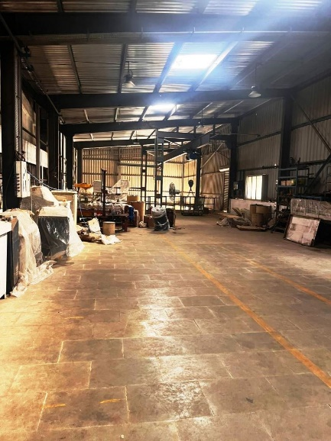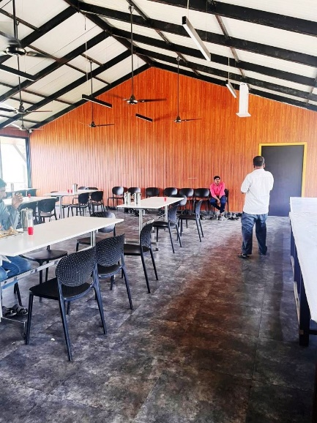

**Actual site photographs**

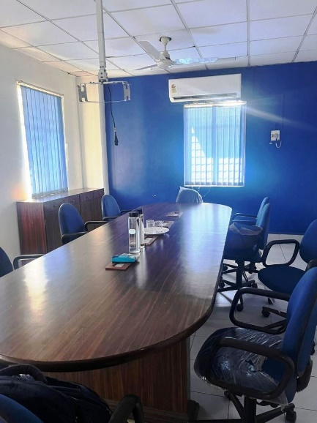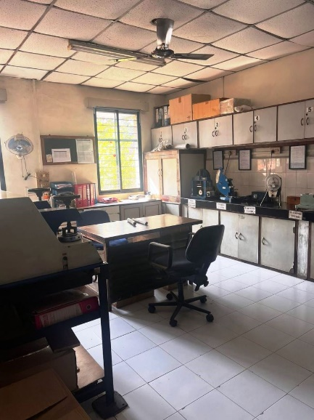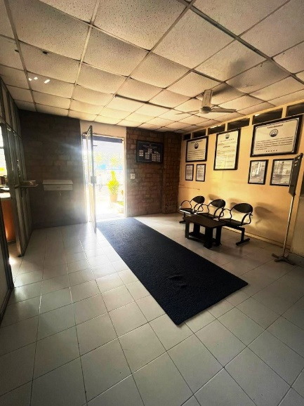

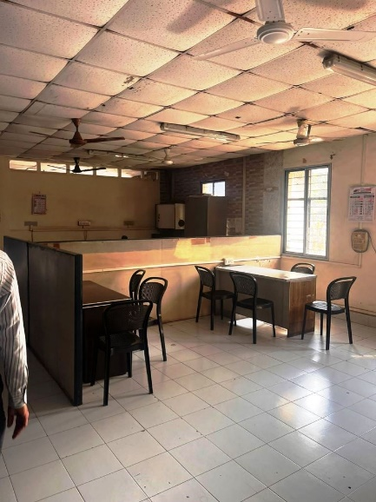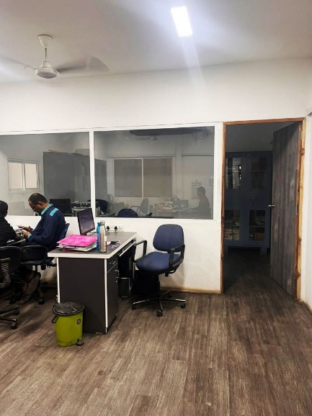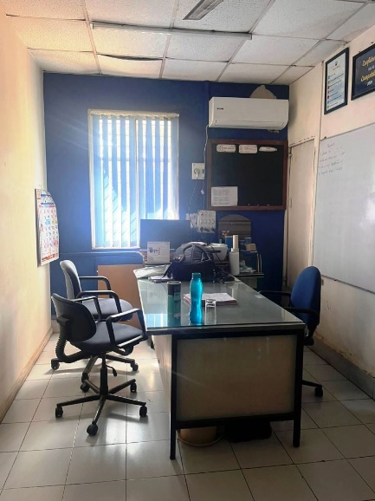

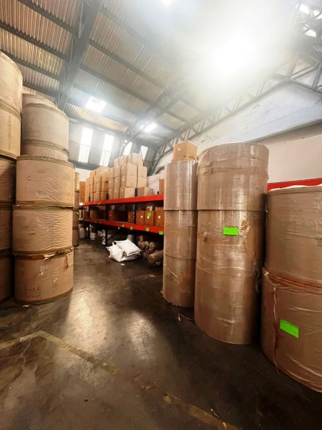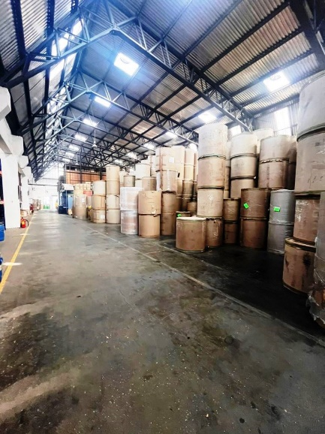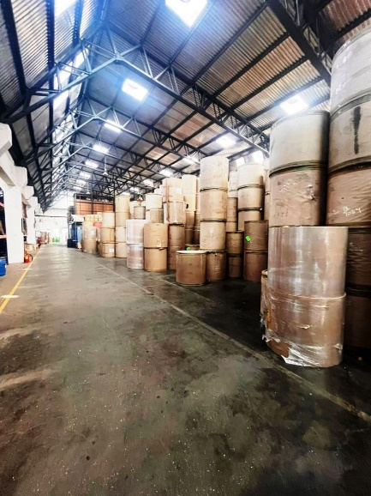

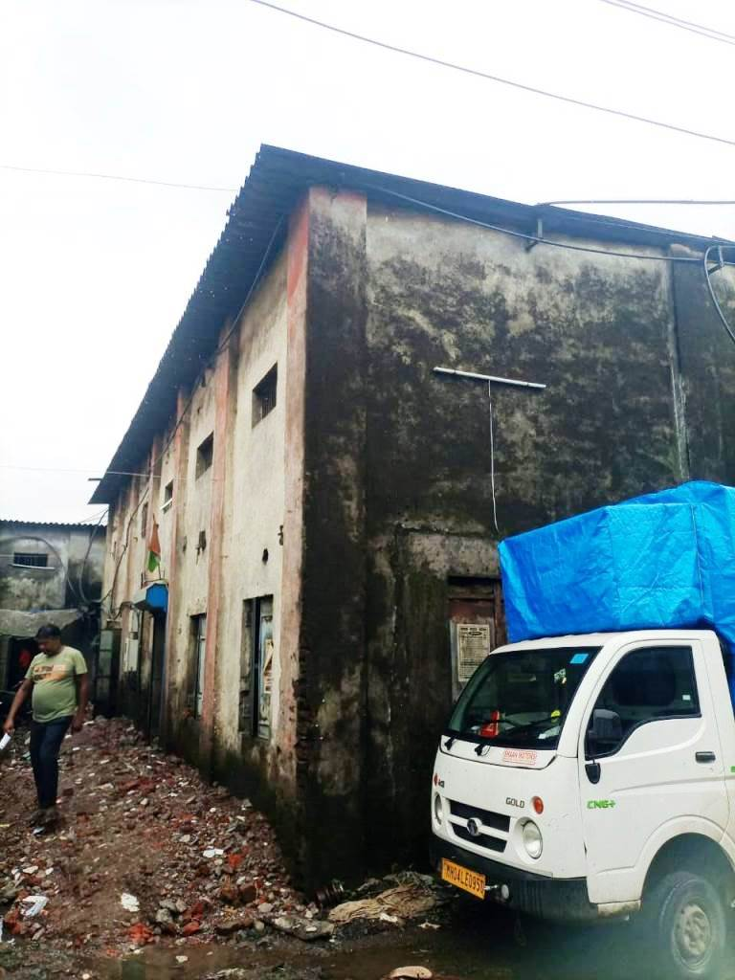

**Actual site photographs**

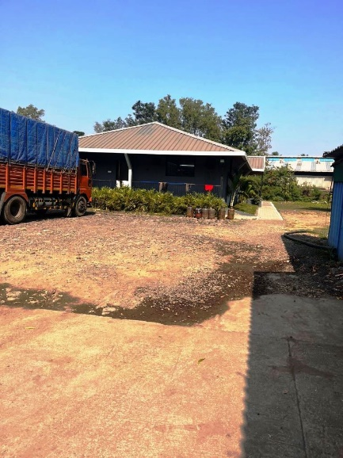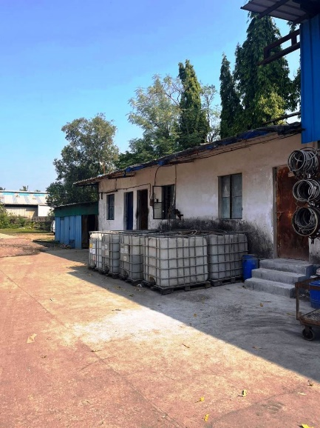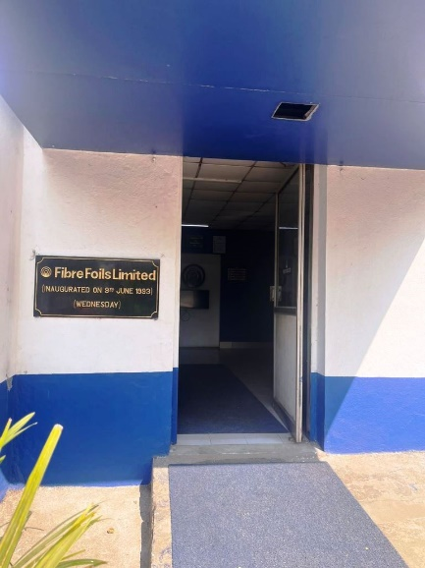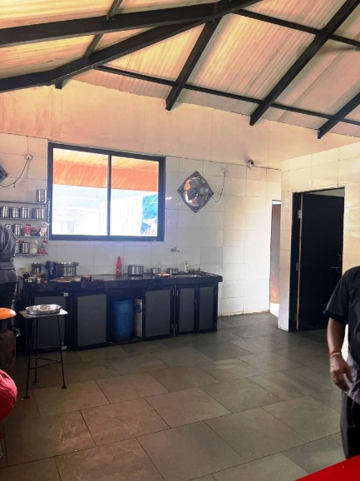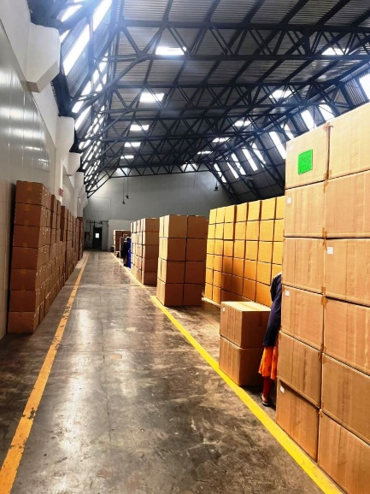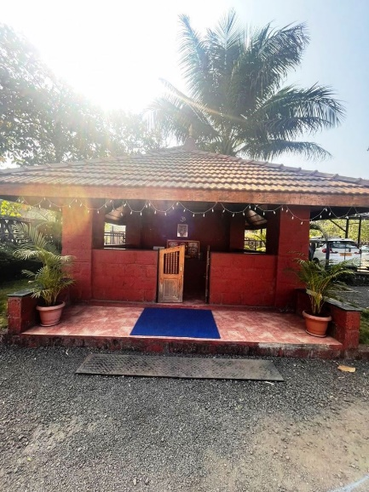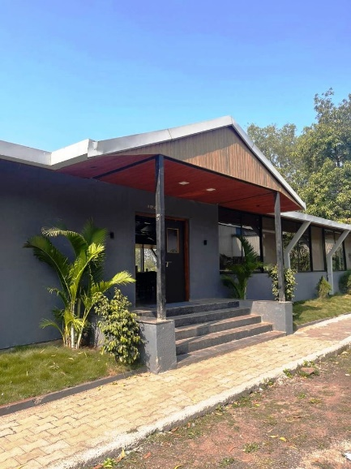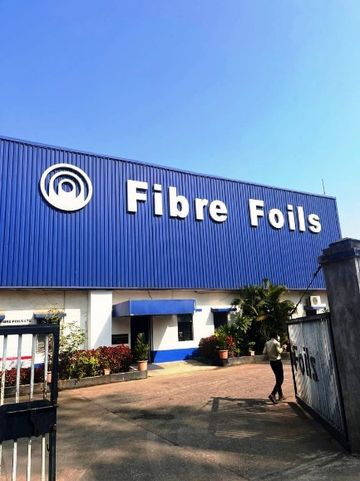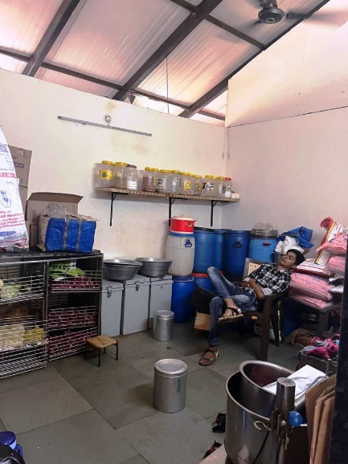

**Route Map of the property**

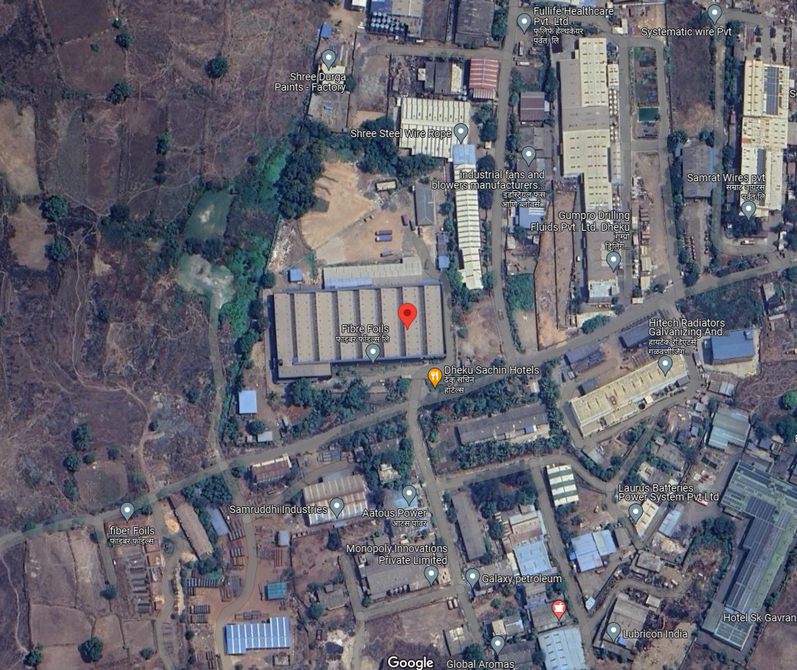**Site u/r**

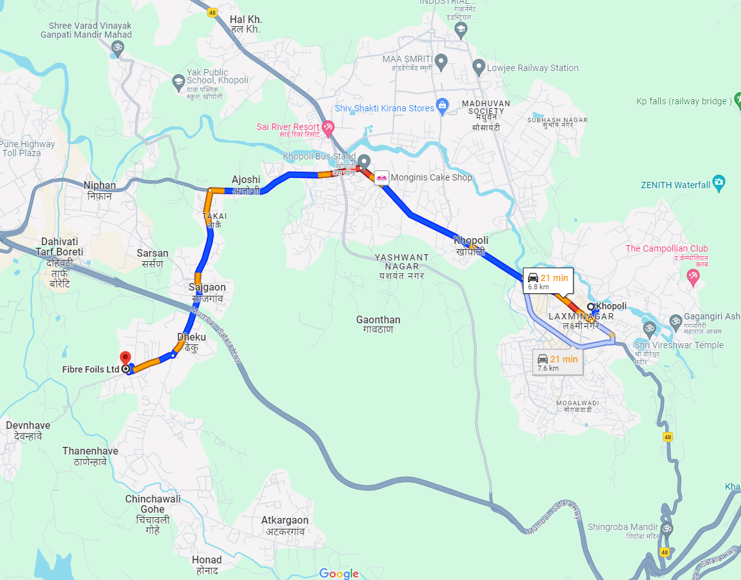

# Latitude Longitude - 18°46'59.2"N 73°18'08.0"E

**Note:** The Blue line shows the route to site from nearest Metro station (Khopoli – 6.8 km)

**READY RECKONER RATE**

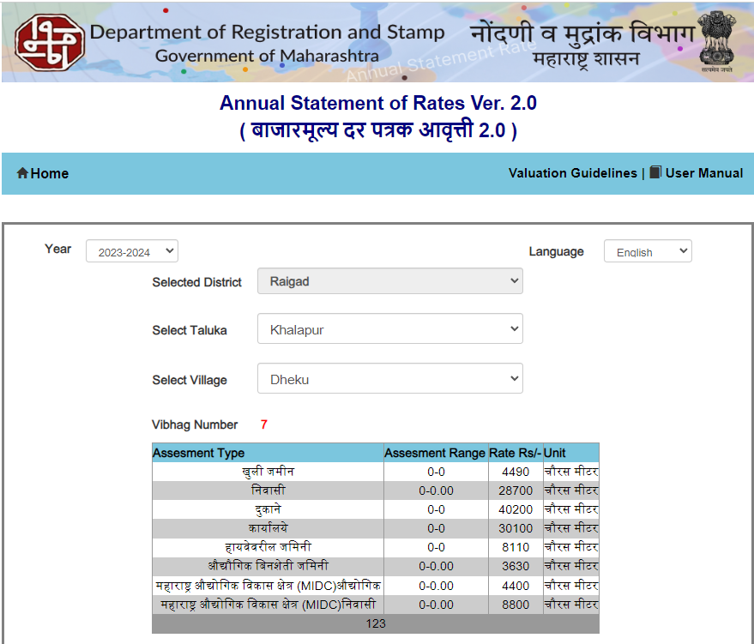

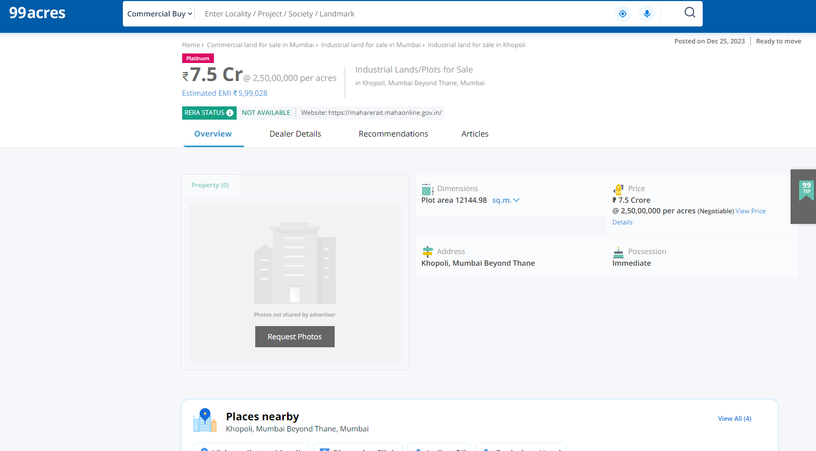**Price Indicators**

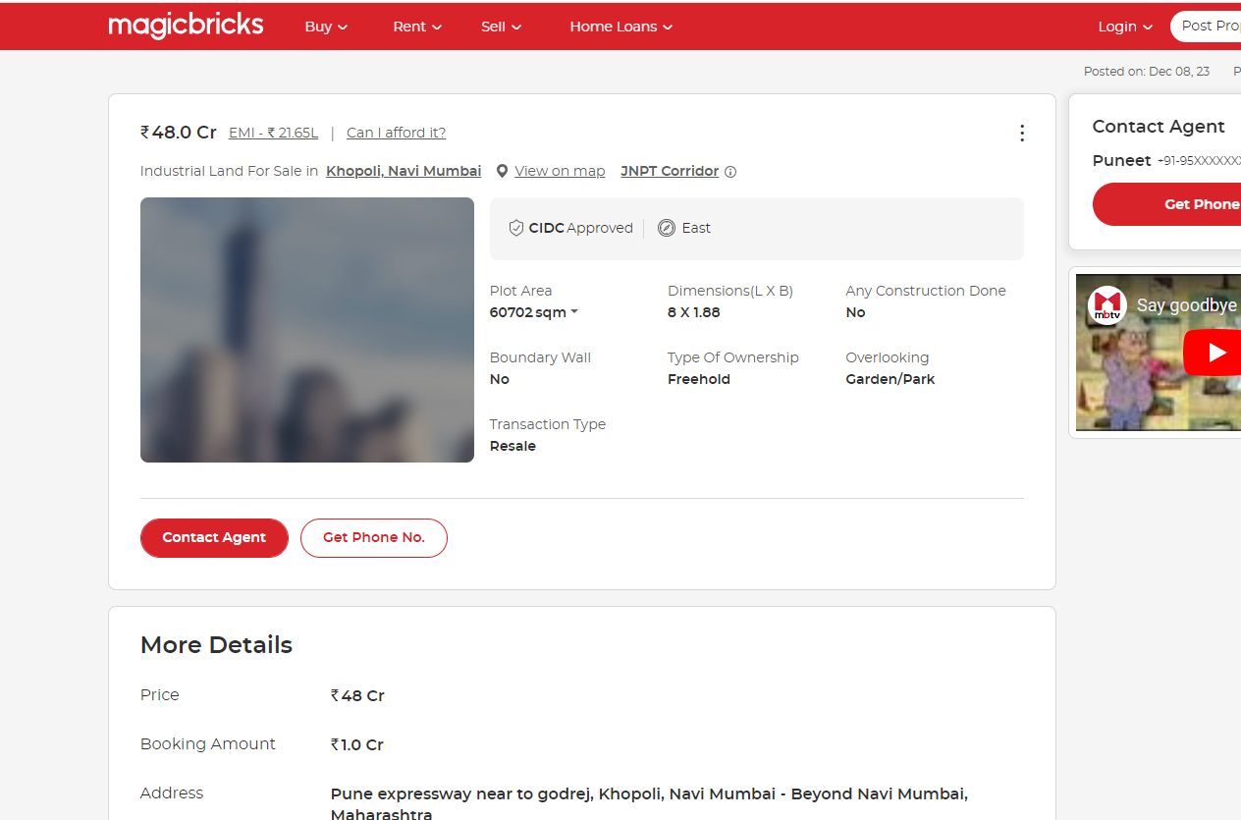

**DEFINITION OF VALUE FOR THIS SPECIFIC PURPOSE**

This exercise is to assess **Fair Market Value** of the property under reference as on **3rd January 2024.**

The term **Fair Market Value** is defined as

*“The most probable price, as of a specified date, in cash, terms equivalent to cash, or in other precisely revealed terms for which the specified property rights would sell after reasonable exposure in a competitive market under all conditions requisite to a fair sale, with the buyer and seller each acting prudently knowledgeably and for self-interest assuming that neither is under undue duress”.*

Fundamental assumptions and conditions presumed in this definition are:

1. Buyer and seller are motivated by self-interest.

2. Buyer and seller are well informed and are acting prudently.

3. The property is exposed for a reasonable time on the open market.

4. Payment is made in cash or equivalent or in specified financing terms.

#### UNDER LYING ASSUMPTIONS

1. We assume no responsibility for matters of legal nature affecting the property appraised or the title thereto, nor do we render our opinion as to the title, which is assumed to be good and marketable.

2. The property is valued as though under responsible ownership.

3. It is assumed that the property is free of liens and encumbrances.

4. It is assumed that there are no hidden or unapparent conditions of the subsoil or structure that would render it more or less valuable. No responsibility is assumed for such conditions or for engineering that might be required to discover such factors.

5. There is no direct/ indirect interest in the property valued

6. The rates for valuation of the property are in accordance with the Govt. approved rates and prevailing market rates.

##### DECLARATION OF PROFESSIONAL FEES CHARGED

We hereby declare that, our professional fees are not contingent upon the valuation findings. However, if the statute AND/OR clients demands that, the fees should be charged on the percentage of assessed value then, with the full knowledge of the AND/OR end user, it is being charged accordingly.

# VALUATION OF THE PROPERTY PREMISES

Considering various parameters recorded herein above, existing economic scenario, and the information that is available with reference to the development of neighborhood and method selected for valuation, we are of the opinion that, the property premises can be assessed and valued for banking purpose as on day for ` 32,57,65,500.00 (Rupees Thirty Two Crore Fifty Seven Lakh Sixty Five Thousand Five Hundred Only).

## Manoj B. Chalikwar

## Registered Valuer

## Chartered Engineer (India)

## Reg. No. CAT-I-F-1763

## Cosmos Emp. No. H.O./Credit/67/2019-20