COST VETTING REPORT
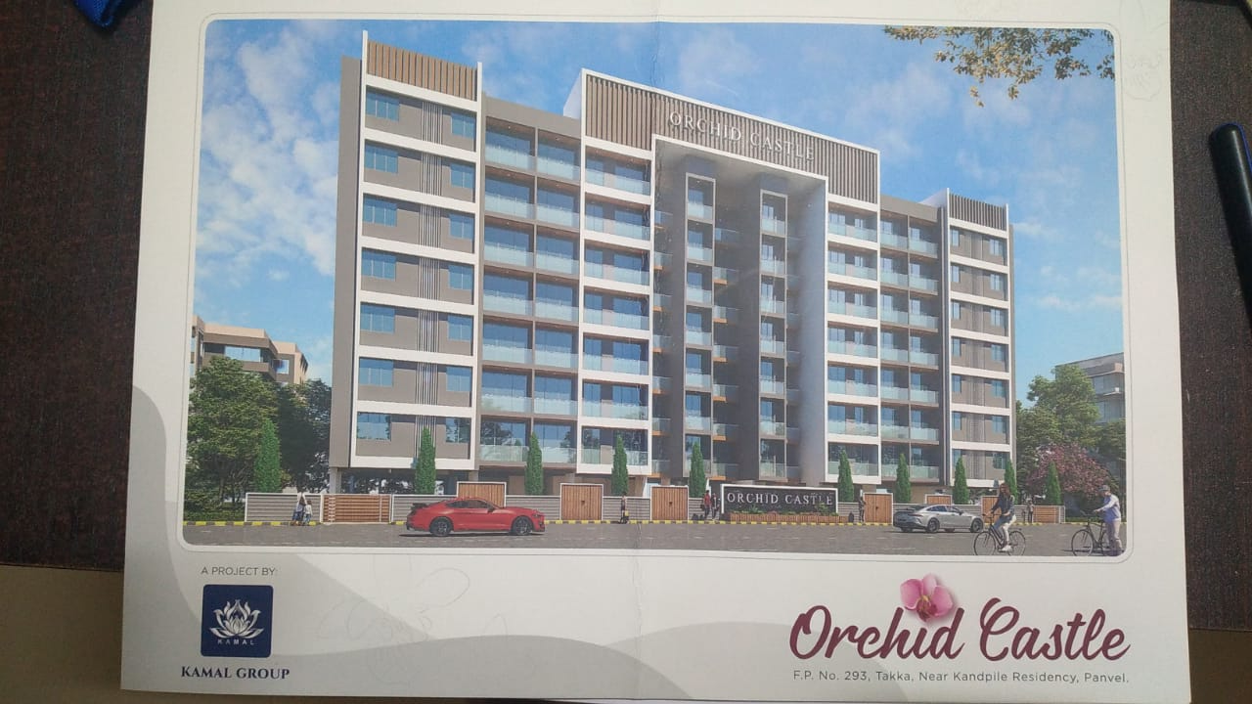

Details of the property under consideration:

Name of Project: "Orchid Castle"

"Orchid Castle", Proposed Residential building on Plot bearing Plot No. 293, Takka Colony, Lokmanya Nagar, Village – Panvel, Navi Mumbai, Taluka – Panvel, District – Raigad, Pin Code – 410 206, State – Maharashtra,
Country – India

Latitude Longitude: 18°58'57.9"N 73°07'01.5"E

Valuation Done for:
State Bank of India
SME - Vashi Turbhe Branch
Sector 19, Ground Floor, Central Facility Building, Phase – II, Vashi,
Navi Mumbai – 400 705, State - Maharashtra, Country – India

Vastu/SBI/Mumbai/01/2024/5949/2304311
02/09-13-PY
Date: 02.01.2023

To,
The Branch Manager,
State Bank of India
SME - Vashi Turbhe Branch
Sector 19, Ground Floor,
Central Facility Building, Phase – II,
Vashi, Navi Mumbai – 400 705,
State - Maharashtra, Country – India

Sub: Cost Vetting Report for "Orchid Castle" at Panvel, Navi Mumbai, Pin Code – 410 206.

Dear Sir,
In accordance with your letter of engagement as stated above, we enclose our Report on Cost Vetting for "Orchid Castle", Proposed Residential building on Plot bearing Plot No. 293, Takka Colony, Lokmanya Nagar, Village – Panvel, Navi Mumbai, Taluka – Panvel, District – Raigad, Pin Code – 410 206, State – Maharashtra, Country – India.
M/s. Priyal Properties, a Partnership Firm. The firm is in operation for over the last 10 years, M/s Priyal Properties, a Builders & Developers has created a history of success by building a robust portfolio for itself by delivering dream homes to affordable homes in and around Panvel area. The firm has established ourselves as one of the most preferred real estate developers.
M/s. Priyal Properties is developing a Residential building on Plot bearing Plot No. 293, Takka Colony, Lokmanya Nagar, Village – Panvel, Navi Mumbai, Taluka – Panvel, District – Raigad, Pin Code – 410 206, State – Maharashtra, Country – India. Project is comprising of Residential Building.
Residential Building is proposed of Ground Floor + Mezzanine Floor + 1st Commercial Floor + 2nd to 4th Podium Floors + 5th to 19th Upper Residential Floors with total RERA carpet area of 57,521.00 Sq. Ft. which consists 2 BHK, 3 BHK, Offices and Shops units with 80 nos. of Sell flats, 5 nos. of Sell Offices and 5 nos. of Sell Shops providing with Fitness Centre, Society Office, & Other Amenities.
In this regard, SBI, SME - Vashi Turbhe Branch, Sector 19, Ground Floor, Central Facility Building, Phase – II, Vashi, Navi Mumbai – 400 705, has approached Vastukala Consultants (I) Pvt. Ltd. (VCIPL) to conduct a Cost Vetting of the said project.

Our analysis of the cost vetting is enclosed in this report. This Report forms an integral whole and cannot be split in parts. The outcome of the report/ study can only lead to proper conclusions if the Report as a whole is taken into account.
The information used by Vastukala Consultants (I) Pvt. Ltd. (VCIPL) in preparing this report has been obtained from a variety of sources and other relevant documents provided by the client & bank. As agreed, we have performed our cost vetting exercise with the data available related to the business, considering the market prospects and projections. Our results are dependent on documents provided by client & bank, the underlying assumptions, which has been analyzed at a broader level by VCIPL while assessing their reasonableness.
Total Project Cost for the completion of Project will be ` 21.86 Cr.

For Vastukala Consultants (I) Pvt. Ltd.

Manoj B. Chalikwar
Registered Valuer
Chartered Engineer (India)
Reg. No. IBBI / RV / 07/2018/10366
Reg. No. CAT-I-F-1763
SBI Empanelment No.: SME/TCC/2021-22/86/3
About the Project:
Proposed Residential building on Plot bearing Plot No. 293, Takka Colony, Lokmanya Nagar, Village – Panvel, Navi Mumbai, Taluka – Panvel, District – Raigad, Pin Code – 410 206. It is about 1.40 Km. walking distance from Panvel Railway station

Area Statement as per Approved Plan
 | AREA STATEMENT | SQ. M.
1 | Area of Plot | 1,690.00
 | (Minimum Area of a, b, c to bc considered)
 | (a) As pre ownership document (P card) | 1,690.00
 | (b) as per measurement sheet | 1,690.38
 | (c) as per site | 1,690.38
2 | Deduction for
 | (a) Proposed D.P / D.P Road Widening area / Service Road/ highway widening | -
 | (b) any D.P. Reservation Area | -
 | (Total a + b) | -
3 | Balance Area of Plot (1-2) | 1,690.00
4 | Amenity Space (if applicable)
 | (a) Required - (5% of 3) | -
 | (b) Adjustment of 2 (b), if any | -
 | (c) Balanced proposed | -
5 | Net Plot Area (3-4 (c )) | 1,690.00
6 | Recreational Open space (if applicable)
 | (a) Required - (10% of 3) | -
 | (b) Proposed | -
7 | Internal Road Area | -
8 | Potable area (if applicable) | -
9 | Built Up area with reference to basic F.S.I. as per front road width (sr. no. 5 x 1.1 basic FSI) | 1,859.00
10 | Addition of FSI on payment premium
 | (a) Maximum permissible premium FSI - based on road width / TOD Zone
 | (b) Proposed FSI on payment of premium | 845.00
11 | In-situ FSI / TDR loading
 | (a) In - situ area against D.P. Road [2.0 x Sr. No. 2(a)], if any
 | (b) In- situ area against amenity space if handed over [2.00 or 1.85 x Sr. No. 4 (b) and / or (c)
 | (c) TDR area Permissible | 1,098.50
 | (c 1) TDR area Proposed | -
 | (d) Total in-situ / TDR loading Proposed (11 (c1) | -
12 | Additional FSL area under Chapter No. 7
13 | Total entitlement of FSI in the proposal
 | (a) [9 + 10(b) + 11(d)] or 12 whichever is applicable | 2,704.00
 | (c) Ancillary Area FSI upto 60% with payment of charges (Resi) | 1,622.40
 | (c1) Ancillary Area proposed | 1,588.57
 | (d) Total entitlement (a + b + c) | 4,326.40
14 | Maximum utilization limit of FSJ (building potential) Permissible as per road width} (as per regulation No. 6.1 or 6.2 or 6.3 or 6.4 as applicable) x 1.6 or 1.8
15 | Total Built up Area in proposal (excluding)
 | (a) Existing Built Up area
 | (b) proposed Built up area (as per P-LINE) | 4,292.57
 | (c) Total (a + B) | 4,292.57
16 | F.S.I. Consumed (15/13) should not be more than serial no. 14 above)
17 | Total Tenement
 | (a) Residential Unit | 74.00
 | (b) Commercial Unit
18 | Balanced F.S.I. | 33.83

Construction Area as per Approved Plan for Building

Sr. No. | Floor | Total Construction Area in Sq. M. | Total Construction Area in Sq. Ft.
1 | Ground Floor | 693.83 | 7,468.36
3 | 1st Floor | 693.83 | 7,468.36
4 | 2nd Floor | 693.83 | 7,468.36
5 | 3rd Floor | 693.83 | 7,468.36
6 | 4th Floor | 693.83 | 7,468.36
7 | 5th Floor | 693.83 | 7,468.36
8 | 6th Floor | 693.83 | 7,468.36
9 | Terrace | 275.87 | 2,969.46
Total Area |  | 5,132.67 | 55,248.02

Project Cost
Sr. No. | Particulars | Total Estimated Amount in ` | Total Estimated Amount  in ` Cr.
1 | Land Cost
 | Acquisition Cost of Land or Development Rights, and Legal Cost. | 24,85,000.00 | 24.85
 | Rent to Tenants, Lease premium, Lease Rent, interest cost incurred or payable on Land Cost | - | -
 | Amount of Premium payable to obtain development rights, FSI, additional FSI, fungible area, and any other incentive under DCR from Local Authority or State Government or any Statutory Authority. | 1,27,27,407.00 | 1.27
 | Acquisition cost of TDR (if any) | - | -
2 | Cost of Construction
 | Estimated construction cost of sale building including site development and infrastructure for the same. | 13,81,20,042.00 | 13.81
 | On site expenditure for development of entire project excluding cost of construction as per(i) above,
a. | Architect Fees & Consultant fees | 69,06,002.00 | 0.69
b. | Admin Cost includes salaries, site overheads, development works, cost of services (including water, electricity, sewerage, drainage, layout roads etc.), cost of machineries and equipment including its hire and maintenance cost, consumables etc. All costs directly incurred to complete the construction of the entire phase of the project registered. | 82,87,203.00 | 0.83
c. | Marketing Cost | 95,28,000.00 | 0.95
3 | Interest during the Project | 3,50,00,000.00 | 3.50
4. | Contingency Charges | 55,24,802.00 | 0.55
 | GRAND TOTAL: | 21,85,78,456.00 | 21.86

Manoj B. Chalikwar
Registered Valuer
Chartered Engineer (India)
Reg. No. IBBI / RV / 07/2018/10366
Reg. No. CAT-I-F-1763
SBI Empanelment No.: SME/TCC/2021-22/86/3

Comments on each element of Cost of Project: -
- Land Cost:
As per Present Ready Reckoner rate the Project Land Value is ` 4.09 Cr. considering Land Rate @ ` 24,200.00 per Sq. M. & Net Plot Area of 1,690.00 Sq. M.
As per document purchase cost of land & stamp duty cost is ` 24,85,000.00 i.e., ` 24.85 Cr. which is 1.14% of Total Project Cost.
Sr. | Agreement Name | Date | Particulars | Total Cost in ` | Incurred Cost in `
1 | Sale Deed | 31.01.2007 | Purchase | 21,00,000.00 | 21,00,000.00
2 | Sale Deed | 31.01.2007 | Stamp Duty | 3,53.500.00 | 3,53,500.00
3 | Sale Deed | 31.01.2007 | Reg. Fees | 30,000.00 | 30,000.00
4 | Sale Deed | 31.01.2007 | Reg. Fees | 1,500.00 | 1,500.00
TOTAL |  |  |  | 24,85,000.00 | 24,85,000.00

- Building Cost of Construction for Building:
Construction Area of Building = 5,132.67 Sq. M. i.e., 55,248.02 Sq. Ft.
Total estimated cost for construction of Building (includes cost of RCC work, manpower, lift, material, painting, finishing work, site development, etc.) is ` 13,81,20,042.00 i.e., ` 13.81 Cr. which comes ` 2,500.00 per Sq. Ft. on construction area for building.
The total construction area is 55,248.02 Sq. Ft.., projected cost of ` 13.81 Cr is 63.19% of total project cost
VCIPL opinion the construction cost of 2,500/- Per Sq. Ft. which is in line with Market-Trend.
Particulars | Rate per Sq. Ft.
Excavation Work | 150.00
RCC Work | 1,500.00
Final Finishing Work | 500.00
Other Work | 350.00
Cost of Construction | 2,500.00

- Approval Charges:
The Total Approval Cost (Fungible Cost & Development Cess Premium & TDR Cost) as per architect letter will be ` 1,27,27,407.00 i.e., ` 1.27Cr. which is 5.82% of Total Project Cost. Builder has paid ` 1.02 Cr.
Sr. No. | Particulars | Total Cost in ` | Incurred Cost in `
1 | Development Charges | 96,46,237.00 | 96,46,237.00
2 | Labour Cess | 5,81,170.00 | 5,81,170.00
3 | OC Charges | 25,00,000.00 | -
TOTAL |  | 1,27,27,407.00 | 1,02,27,407.00
As per information provided by developer.

- Architect Cost, RCC & Other Professional Charges:
The total Architect charges of ` 69,06,002.00 i.e., ` 0.69 Cr. is 5% of construction cost of building & it is line up with Market trend.
The professional charge consists of Architect & Legal which in market is in the range of 2% - 5% of Total Construction cost of the project.

- Administrative Expenses:
Salaries, site overheads, development works, cost of services (including water, electricity, sewerage, drainage, layout roads etc.), cost of machineries and equipment including its hire and maintenance cost, consumables etc. All costs directly incurred to complete the construction of the entire phase of the project registered is estimated 6% of construction cost of building which comes to ` 82,87,203.00 i.e., ` 0.83 Cr.
The admin charges which in market is in the range of 4% - 6% of Total Construction cost of the project.

- Marketing Expenses:
Marketing costs directly incurred to complete the construction of the entire phase of the project registered is estimated at 2% of total Sale income from the project which comes to ` 95,28,000.00 i.e., ` 0.95 Cr.
The marketing charge consists of brokerage & commission which in market is in the range of 1% - 3% of Total Sale income of the property.

- Interest Costs:
The Interest cost for the term loan is ` 3,50,00,000.00 i.e., ` 3.50 Cr., which is 16.01% of total project cost.
As per information provided by the client.

- Contingency Costs:
The contingency charges estimated at 4% construction cost of building which comes to ` 55,24,802.00 i.e., ` 0.55 Cr.

Observation and Construction: -
Total estimated cost of project i.e., ` 21,85,78,456.00 (Rupees Twenty – One Crore Eighty – Five Lakh Seventy – Eight Thousand Four Hundred Fifty – Six Only) i.e., ` 21.86 Cr. is fair & reasonable.
The project cost is including land premium payable to concern authorities, Fungible FSI Premium, Cost of Construction of rehab & Sale Building, on site expenses including admin & marketing expenses, premiums / charges to be paid to competent authority and Bank interest, etc. we have not independently verified interest cost hence not consider in cost vetting.
As per present sanctioned building plan, permissible built-up area on the said plot is 7,835.15 Sq. M. The sale building is presently approved for Stilt Floor + 1st to 6th Upper Residential Floors only. Estimated cost of entire project of 6th upper floors is considered.
Total estimated cost of construction of Sales building is ` 13,81,20,042.00 i.e., ` 13.81 Cr. which comes ` 2,500.00 per Sq. Ft. on construction area for building, which is fair & reasonable considering the present status of project, type & quality of construction & specification of the building materials to be used, height of the structure, amenities to be provided in proposed building.

Assumptions & Remarks-
- The adequacy of Engineering / Structural design is beyond the scope of our assignment.
- Estimated project completion date is 31/12/2025. The cost is certified based on the assumptions that the project will be completed within time frame. Few assumptions are made regarding inflation & cost rise etc. during construction period.

Photo copy of following document is provided to us & this report should be read along with it:
- Copy of Deed of Sale dated 31.01.2007 between Mulla Abdul Majid Abdul Hamid & 13 Others (The Vendors) and M/s. Priyal Properties (The Purchaser) through registered agreement vide No. PVL-1/905/2007 dated 31.01.2007.
- Copy of Approved Plan No. Mouje – Panvel / Final Plot NO. 293 / G. R. / PMP / NRV / 16410 / G. K. 931/2023 dated 31.03.2023 issued by Panvel Municipal Corporation.
Approved upto: (Wing A & B) Stilt Floor + 1st to 6th Upper Residential Floors
- Copy of Commencement Certificate No. PMC/TP/Panvel/293/21-23/16410/961/2023 dated 31.03.2023 issued by City and Industrial Development Corporation of Maharashtra Ltd. (CIDCO).
(This CC is endorsed for the work for Stilt Floor + 1st to 6th Upper Residential Floors for Total Built – Up Area of 4,292.568 Sq. M.)
- Copy of No Objection Certificate for Height Clearance NOC ID No. NAVI/WEST/B/082521/572241 dated 29.10.2021 valid upto 28.10.2029 issued by Airports Authority of India.
- Copy of CA Certificate dated 23.11.2023 issued by M/s. Dipika Patel & Co.
- Copy of Property Card.

Actual Site Photographs
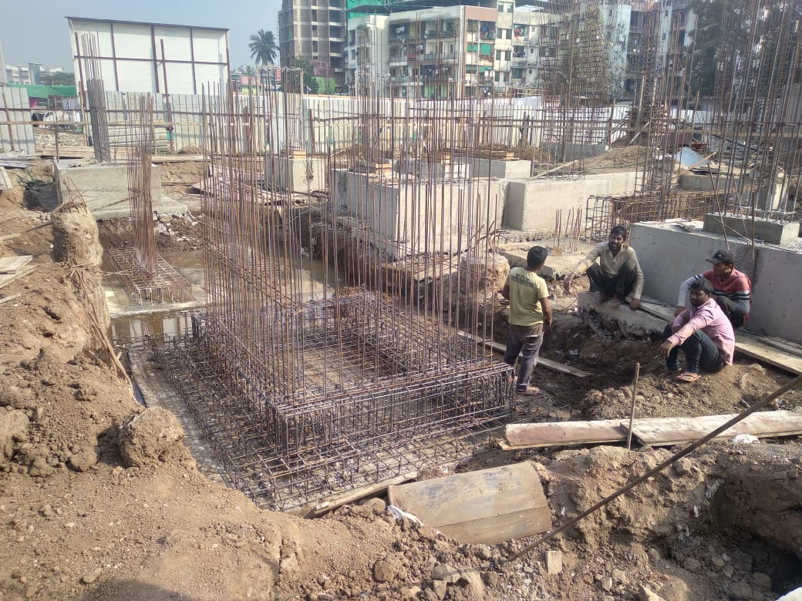
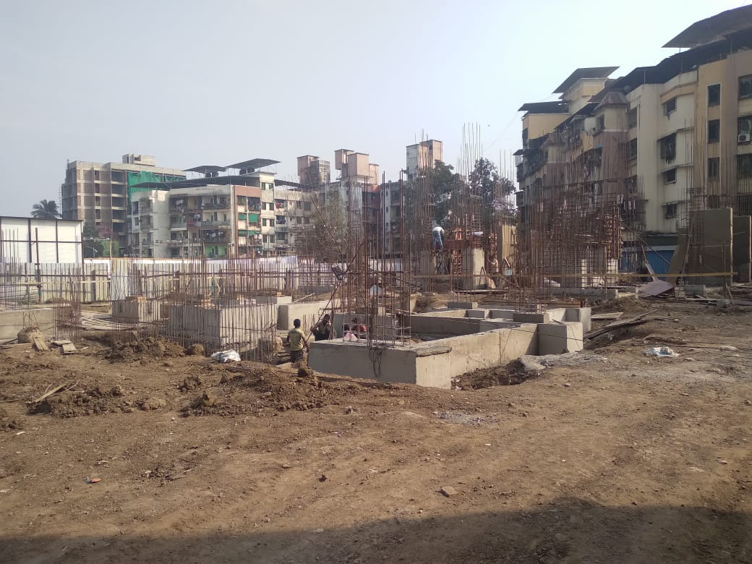
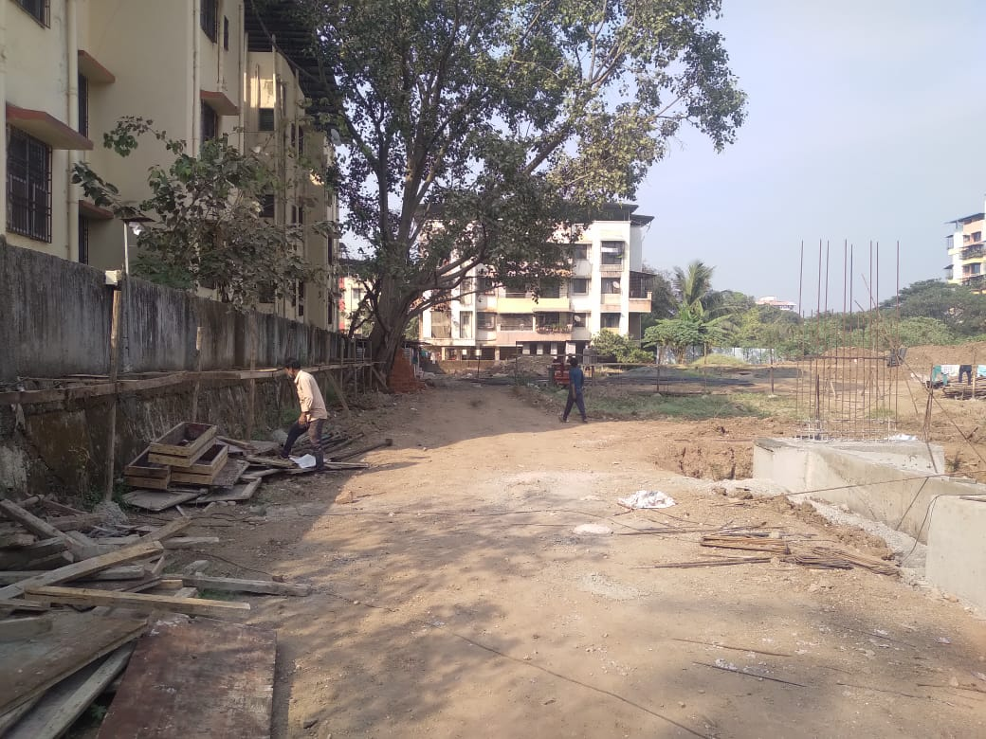
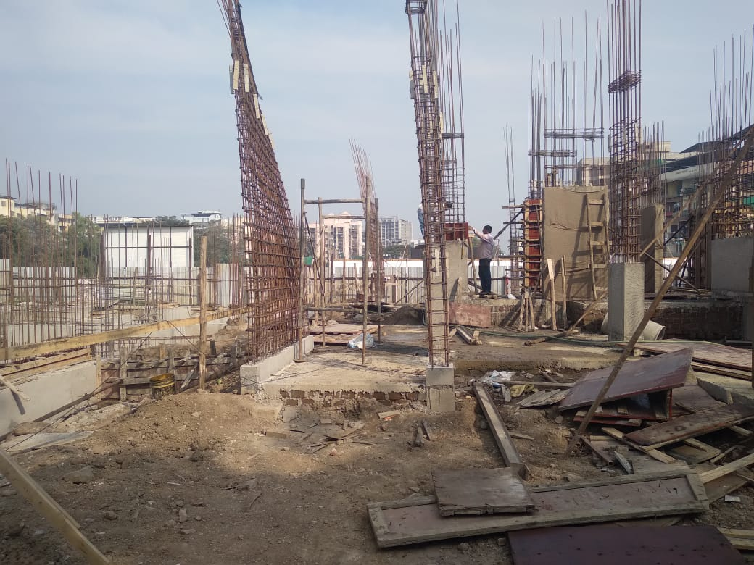
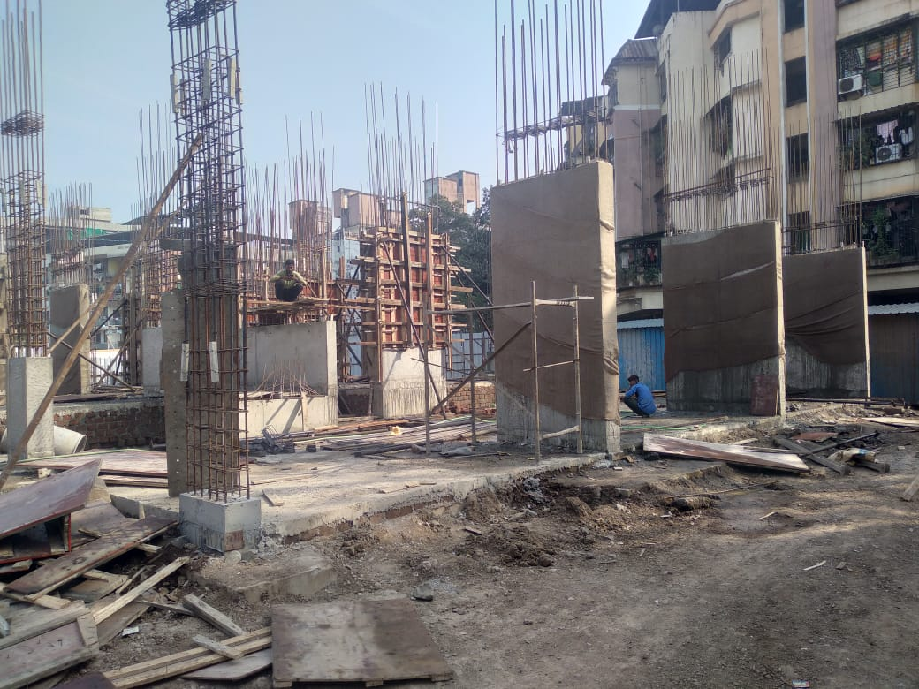
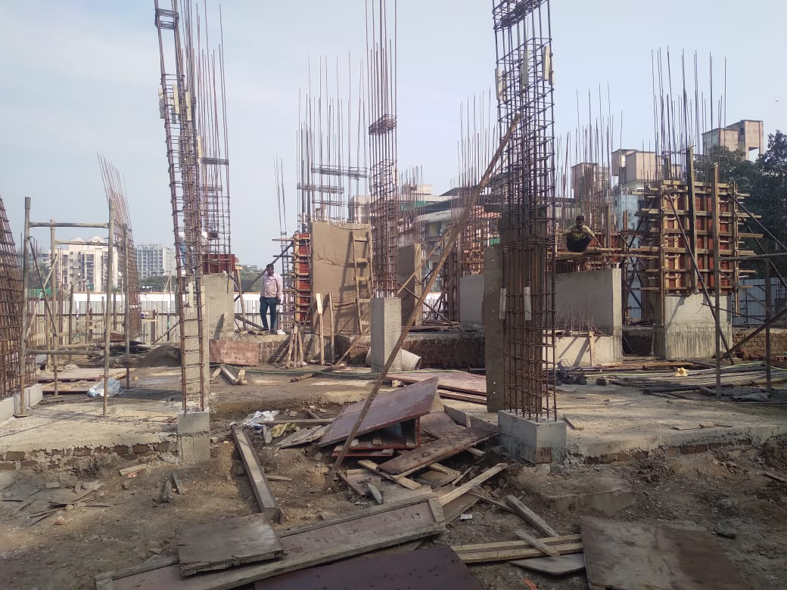
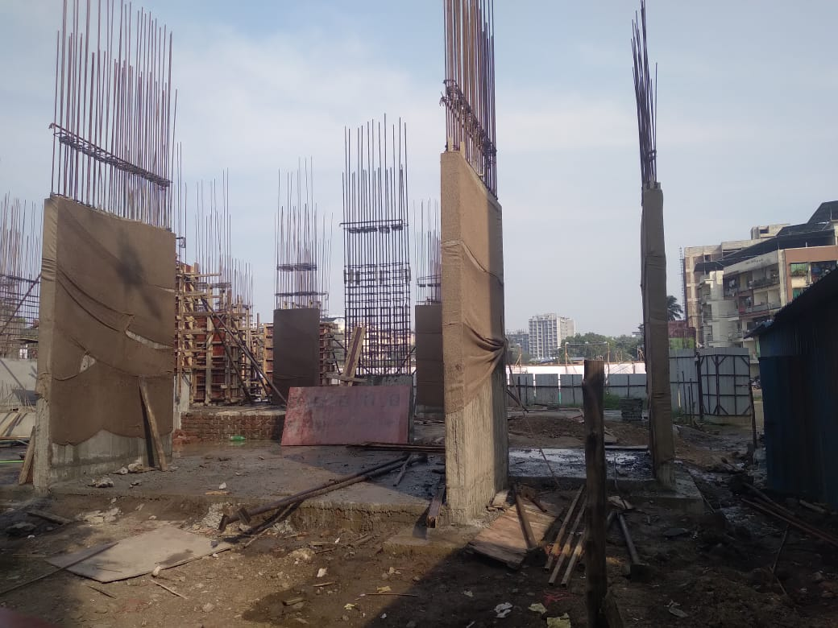
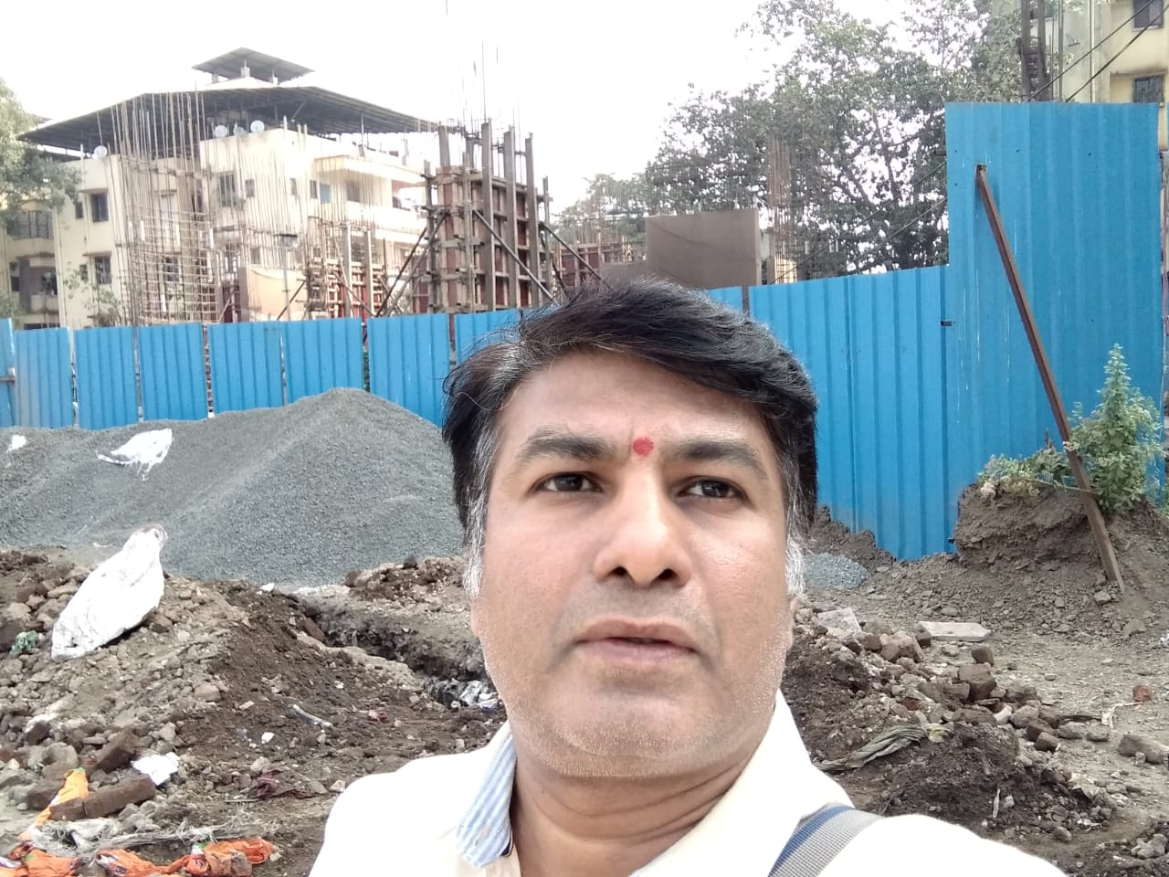
Route Map of the property
Site u/r
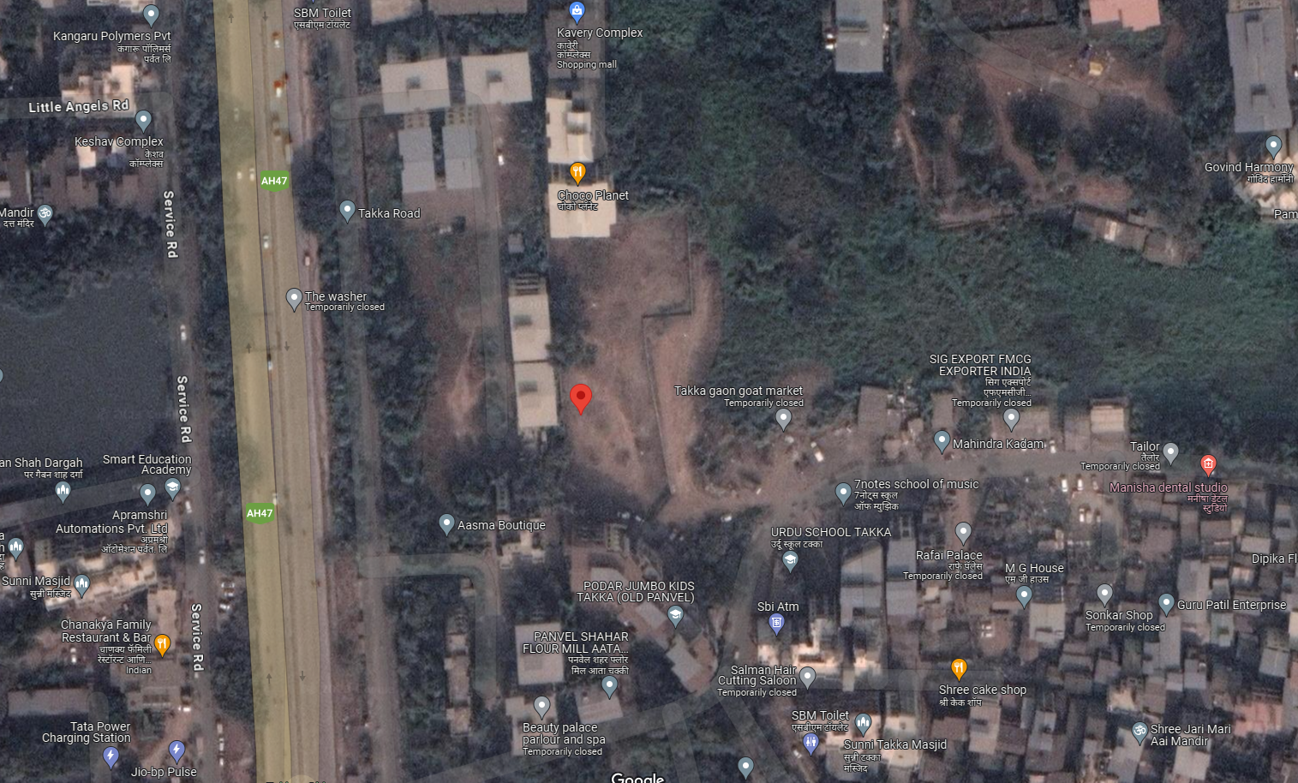

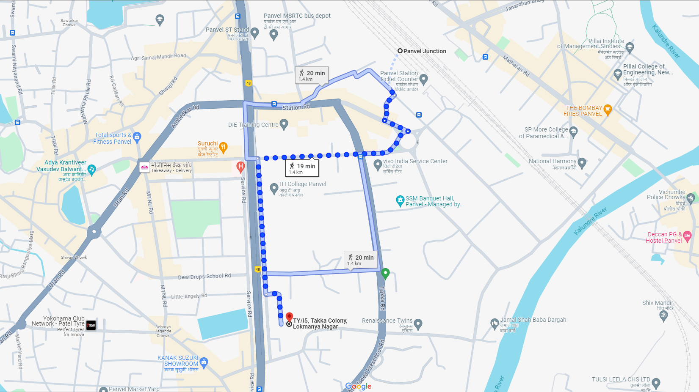

Latitude Longitude: 18°58'57.9"N 73°07'01.5"E
Note: The Blue line shows the route to site from nearest railway station (Panvel – 1.40 Km.)

