WORK PROGRESS REPORT

Details of the property under consideration:

Name of Project: "Sahil Infra"

"Sahil Infra", Proposed Residential cum Commercial Building bearing on Plot No. 03-R.C., Scheme No. 134, Ward No. 37 (Sai Kripa), Nipania, M.R. 10 Road, Gram Khajrana, Tehsil & District - Indore,
Pin Code – 452 010, State – Madhya Pradesh, Country – India

Latitude Longitude: 22°44'48.2"N 75°55'25.9"E

Valuation Done for:
Punjab National Bank
MID Corporate Centre
2nd Floor, C 21, Business Park, Opp. Raddison Hotel, Indore,
Pin Code - 452001, State – Madhya Pradesh, Country – India

Vastu/PNB/Indore/07/2023/2364/2301440
06/11-65-PY
Date: 06.07.2023

Work Progress Report

The property bearing "Sahil Infra", Proposed Residential cum Commercial Building bearing on Plot No. 03-R.C., Scheme No. 134, Ward No. 37 (Sai Kripa), Nipania, M.R. 10 Road, Gram Khajrana, Tehsil & District - Indore, Pin Code – 452 010, State – Madhya Pradesh, Country – India belongs to M/s. Sahil Infra.

Boundaries of the property.
North | 20th Road
South | Building
East | Shalimar Apartment
West | Allied Auto Agencies Maurti Authorised Services Station

As per Approved Plan / Sanctioned Letter the construction area as below:
Sr. No. | Floor | FAR Area in Sq. M. | NON - FAR Area in Sq. M. | Total Area in Sq. M.
1 | Basement 1 | - | 2,042.34 | 2,042.34
2 | Basement 2 | - | 2,042.34 | 2,042.34
3 | Ground Floor | 1,247.49 | 145.16 | 1,392.65
4 | Mezzanine Floor | - | 528.51 | 528.51
5 | Parking Floor | - | 2,042.34 | 2,042.34
6 | 1st Floor | 659.46 | 341.12 | 1,000.58
7 | 2nd Floor | 659.46 | 315.91 | 975.37
8 | 3rd Floor | 659.46 | 341.12 | 1,000.58
9 | 4th Floor | 659.46 | 315.91 | 975.37
10 | 5th Floor | 659.46 | 341.12 | 1,000.58
11 | 6th Floor | 659.46 | 315.91 | 975.37
12 | 7th Floor | 659.46 | 341.12 | 1,000.58
13 | Terrace | - | 91.28 | 91.28
TOTAL |  | 1,505.04 | 5,863.71 | 9,204.18

As per Amended Approved Plan the construction area as below:
Sr. No. | Floor | FAR Area in Sq. M. | NON - FAR Area in Sq. M. | Total Area in Sq. M.
1 | Basement 1 | - | 2,030.20 | 2,030.20
2 | Basement 2 | - | 2,030.20 | 2,030.20
3 | Ground Floor | 1,162.03 | 64.63 | 1,226.66
4 | Mezzanine Floor | - | 1,279.65 | 1,279.65
5 | Parking Floor | - | 2,030.20 | 2,030.20
6 | 1st Floor | 654.82 | 471.94 | 1,126.76
7 | 2nd Floor | 654.82 | 471.94 | 1,126.76
8 | 3rd Floor | 654.82 | 471.94 | 1,126.76
9 | 4th Floor | 654.82 | 471.94 | 1,126.76
10 | 5th Floor | 654.82 | 471.94 | 1,126.76
11 | 6th Floor | 654.82 | 471.94 | 1,126.76
12 | 7th Floor | 654.82 | 471.94 | 1,126.76
13 | 8th Floor | 654.82 | 471.94 | 1,126.76
14 | 9th Floor | 654.82 | 471.94 | 1,126.76
15 | 10th Floor | 654.82 | 471.94 | 1,126.76
16 | 11th Floor | 654.82 | 471.94 | 1,126.76
17 | 12th Floor | 686.51 | 460.87 | 1,147.38
18 | 13th Floor | 428.75 | 346.64 | 775.39
19 | Terrace | - | 194.54 | 194.54
TOTAL |  | 9,480.31 | 13,628.27 | 23,108.58

Hence, for the work progress report, we considered the project upto 7th Residential floor as per sanctioned letter.
The project proposed is under construction, which is considered for project approval. Building consists of proposed 2 Basements + Ground Floor + Mezzanine Floor + Parking Floor + 1st to 7th Upper Residential Floors. The work completion stage is as follows:
Sr. No. | Particulars | Final Percentage | Actual Percentage | Remark
1 | RCC Footing/Foundation | 5.00 | 5.00 | Completed
2 | RCC Plinth | 5.00 | 5.00 | Completed
3 | Full Building RCC | 40.00 | 40.00 | Basement 1 & 2, Ground Floor, Mezzanine Floor, Parking Floor, 1st to 7th Upper Floor Slab work is completed
4 | Internal Brick work | 7.00 | 7.00 | Basement 1 & 2, Ground Floor, Mezzanine Floor, Parking Floor, 1st to 7th Upper Floor Brick work is completed
5 | External Brickwork | 7.00 | 7.00
6 | Internal plastering | 3.50 | 3.50 | Basement 1 & 2, Ground Floor, Mezzanine Floor, Parking Floor, 1st to 7th Upper Floor plastering work is completed
7 | External plastering | 3.50 | 3.50
8 | Doors & Windows | 5.00
9 | Flooring, Tiling, Kitchen Platform | 10.00
10 | Internal painting | 1.50
11 | External painting | 1.50
12 | Electrification, plumbing & Sanitary installation | 5.00
13 | Lift Installation | 2.00
14 | Passage, Staircase & Lobby development | 2.00
15 | External developments / Final finishing work | 2.00
Total |  | 100.00 | 71.00

As per Cost Vetting Report Ref. No. Vastu/SBI/Mumbai/08/2022/26145/42374, 27/14-441-PYM Dated 27.08.2022, Estimate Total Cost of Construction of Building was ` 30,13,57,800.00.

As per site inspection dated 15.12.2023 work completion percentage is 71.00% and cost of construction as on date is (` 30,13,57,800.00 X 71.00%) = ` 21,39,64,038.00

The report of the property is based on the site visit dated 15.12.2023 & documents produced by the concern. Construction work going as per approved plan only. Legal aspects have not been taken into considerations while preparing this report.

As per Amend Approved Plan, the project cost of construction will increase and hence, so revised sanctioned of the project will be considered for the further work progress report.

Hence certified

For Vastukala Consultants (I) Pvt. Ltd.

Manoj B. Chalikwar
Registered Valuer
Chartered Engineer (India)
Reg. No. CAT-I-F-1763
PNB Emp. No. ZO: SAMD:1138
Route Map of the property

Site u/r
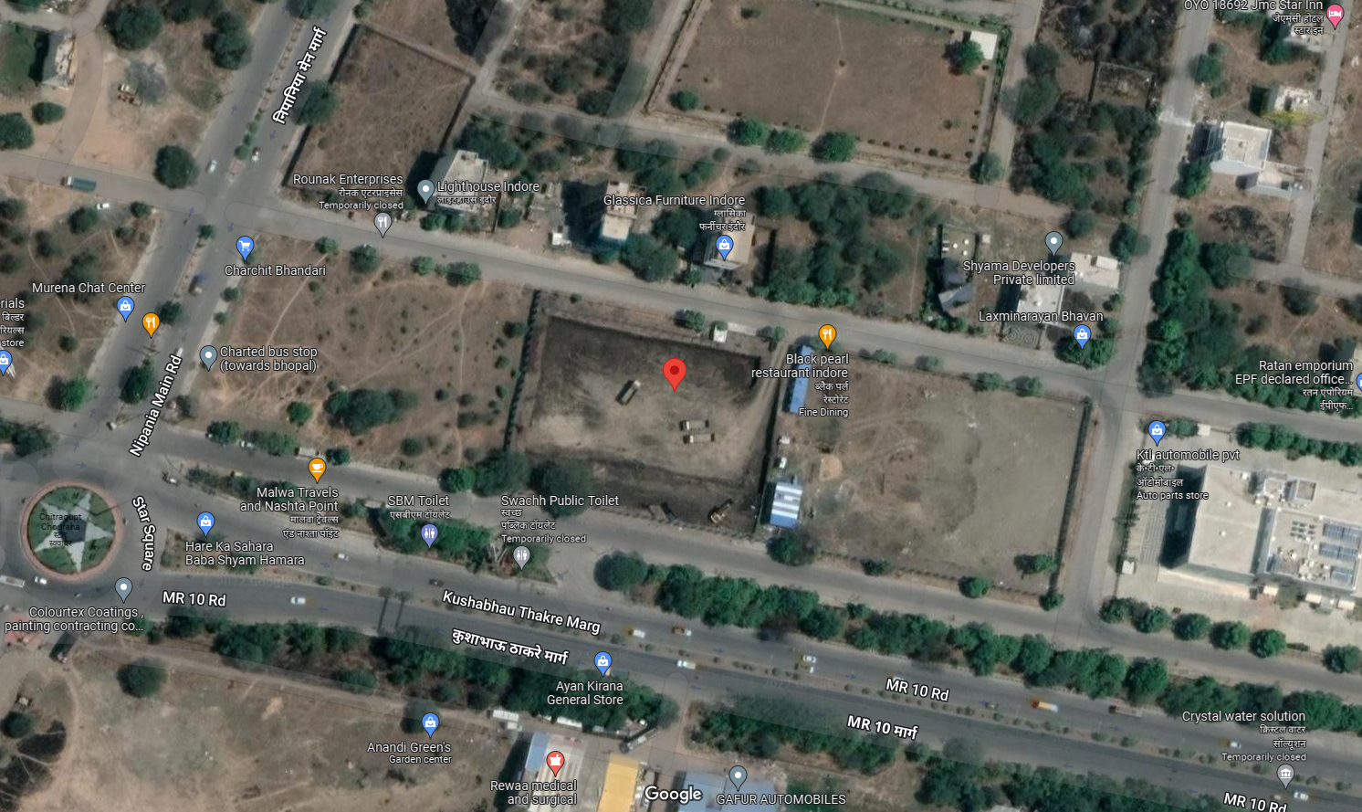

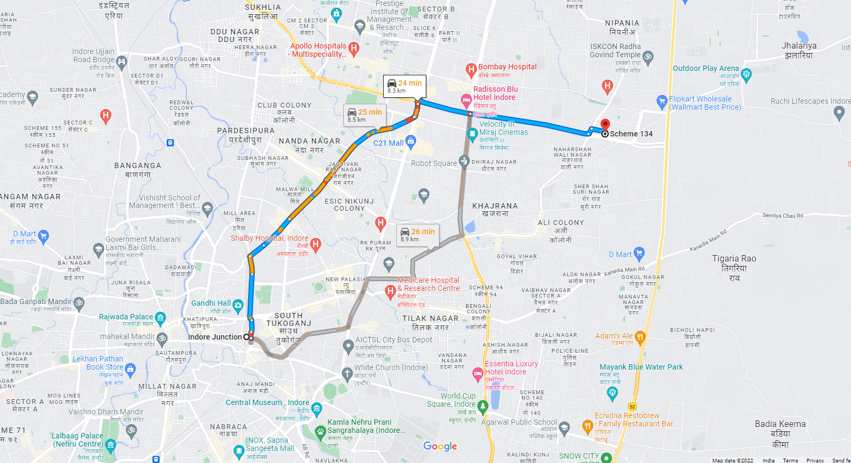

Longitude Latitude - 22°44'48.2"N 75°55'25.9"E
Note: The Blue line shows the route to site from nearest Railway Station (Indore Junction – 8.3 KM.)

