Valuation Report of the Immovable Property
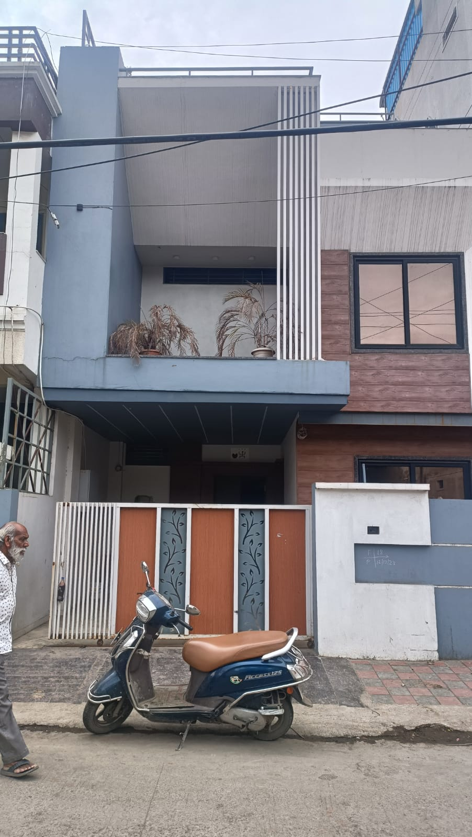

Details of the property under consideration:

Name of Proposed Purchasers / Client: Shri. Shushil Kumar Solanki S/o Shri. Rameshwar Solanki &
Shri. Sunil Kumar Solanki S/o Shri. Rameshwar Solanki

Name of Owner: Smt. Suniti Dutt W/o Late Shri. Sanjay Dutt,
Shri. Sagar Dutt S/o Late Shri. Sanjay Dutt &
Shri. Subh Dutt S/o Late Shri. Sanjay Dutt

Residential House on Plot No. 146, Scheme No. 77, Indore Ring Road,
Khajrana, Tehsil & District Indore, PIN – 452 016,
State – Madhya Pradesh, Country – India

Latitude Longitude : 22°43’29.5”N 75°54’26.7”E

Valuation Done for:

Union Bank of India
A.B. Road (Khajrana) Branch
“Fortuna” Plot No. 6, Road No. 2, Anoop Nagar, A. B. Road
Indore, PIN - 452 018, District - Indore, State – Madhya Pradesh, Country – India

Vastu/Indore/12/2023/005941/2304233
27/31-462-AKTA
Date: 26.12.2023

VALUATION OPINION REPORT

This is to certify that the property bearing Residential House on Plot No. 146, Scheme No. 77, Indore Ring Road, Khajrana, Tehsil & District Indore, PIN – 452 016, State – Madhya Pradesh, Country – India belongs to Smt. Suniti Dutt W/o Late Shri. Sanjay Dutt, Shri. Sagar Dutt S/o Late Shri. Sanjay Dutt & Shri. Subh Dutt S/o Late Shri. Sanjay Dutt. The Proposed Purchasers / Client is Shri. Shushil Kumar Solanki S/o Shri. Rameshwar Solanki & Shri. Sunil Kumar Solanki S/o Shri. Rameshwar Solanki.

Boundaries of the property.
North | : | Plot No. 147 Scheme No. 77
South | : | Plot No. 145 Scheme No. 77
East | : | Road
West | : | Plot No. 138 & 137 Scheme No. 77
Considering various parameters recorded, existing economic scenario, and the information that is available with reference to the development of neighborhood and method selected for valuation, we are of the opinion that, the property premises can be assessed for this particular purpose at

Particulars | Fair Market Value In (`) | Realizable Value In (`) | Distress Sale Value In (`) | Insurable Value In  (`)
Residential Row House | 99,74,000/- | 89,76,600/- | 79,79,200/- | 22,55,475/-

The valuation of the property is based on the documents produced by the concern. Legal aspects have not been taken into considerations while preparing this valuation report.

Hence certified
For Vastukala Consultants (I) Pvt. Ltd.

Sharadkumar B. Chalikwar
Govt. Reg. Valuer
Chartered Engineer (India)
Reg. No. (N) CCIT/1-14/52/2008-09
Encl: Valuation report.
Vastukala Consultants (I) Pvt. Ltd.
106, 1st Floor, Gold Star Tower, Opp. Treasure Island Mall, M.G. Road, Indore – 452 001

To,
The Branch Manager
Union Bank of India
A.B. Road (Khajrana) Branch
“Fortuna” Plot No. 6, Road No. 2
Anoop Nagar, A. B. Road
Indore, PIN - 452 018
State – Madhya Pradesh, Country – India

VALUATION REPORT (IN RESPECT OF RESIDENTIAL HOUSE)
I | General
1. | Purpose for which the valuation is made |  |  | : | To assess fair market value of the property for Bank Loan Purpose.
2. | a) | Date of inspection |  | : | 21.12.2023
 | b) | Date on which the valuation is made |  | : | 26.12.2023
3. | Copy of documents produced for perusal |  |  | : | - Contract Deed dated 03.11.2023 Between Smt. Suniti Datta W/o Late Shri. Sanjay Datta, Shri. Sagar Datta S/o Late Shri. Sanjay Datta & Shri. Shubh Datta S/o Late Shri. Sanjay Datta (The Seller) AND Shri. Shushil Kumar Solanki S/o Shri. Rameshwar Solanki and Shri. Sunil Kumar Solanki S/o Shri. Rameshwar Solanki (The Purchaser)  - Sale deed, E Registration No. MP179132017A1507530 dated 04.09.2017, Shri. Hariram Sanwliya S/o Shri. Sitaram Sanwliya (The Seller) Shri. Sanjay Datta S/o Shri. Shive Kumar Datta & Smt. Suniti Datta W/o Late Shri. Sanjay Datta (The Purchaser).  - Commencement Letter of Plot No. 146, Applicant Name Smt. Suniti Datta W/o Late Shri. Sanjay Datta, Memo No. PMT/IND/0152/2206/2021 dated 31.03.2021. Issued by Nagar Palika Nigam Indore.  - Approved Building Plan of Plot No. 146, Digitally issued by Indore Nagar Palika Nigam Indore.  - Lease Agreement dated 04.07.2009, From date 20.04.2009 for 30 Year Lease.  - Search Report for Proposed Purchaser Shri. Shushil Kumar Solanki S/o Shri. Rameshwar Solanki & Shri. Sunil Kumar Solanki S/o Shri. Rameshwar Solanki, Issued by Advocate Pankaj Yadav.
4. | Name of the owner(s) and his / their address (es) with Phone no. (details of share of each owner in case of joint ownership) |  |  | : | Name of Proposed Purchasers / Client:  Shri. Shushil Kumar Solanki S/o Shri. Rameshwar Solanki & Shri. Sunil Kumar Solanki S/o Shri. Rameshwar Solanki  Name of Owner:  Smt. Suniti Dutt W/o Late Shri. Sanjay Dutt,  Shri. Sagar Dutt S/o Late Shri. Sanjay Dutt &  Shri. Subh Dutt S/o Late Shri. Sanjay Dutt  Address: Residential House on Plot No. 146, Scheme No. 77, Indore Ring Road, Khajrana, Tehsil & District Indore, PIN – 452 016, State – Madhya Pradesh, Country – India.  Contact Person:  Mr. Shive Kumar Datta (Seller Relative)  Contact No. +91 90741 88888
5. | Brief description of the property (Including Leasehold / freehold etc.) |  |  | :
Property:
The immovable property comprising of Leasehold Land and structure thereof. The property is located in an under developed Residential area having basic infrastructure, well connected by road and train. It is located at 5.6 KM. travelling distance from Indore Railway Station.

Nearest Landmark: Nearby Mayur Hospital

The property is leased by Indore Development Authority Indore, for a term of 30 years commencing from 20.04.2009 and ending on 20.04.2039. The Balance Lease Period is 16 Years. After expiry, the lease is renewable for next 30 -30 Years.

Land:
As per Lease Deed / Site Inspection/ Sale Agreement, the plot area is 123.75 Sq. M. i.e. 1,331.00 Sq. Ft., which is considered for valuation.

Structure:
The property consists of Residential House is of Ground + 2 Floor. It is a R.C.C. Framed Structure with RCC beams, columns, slabs and RCC staircase provide for access to the upper floor.
The composition of the House
As per site inspection is as below -
Floor | Composition
Ground | Parking + Hall + Kitchen + Master Bedroom + Sitting Room + Wash Area + Toilet + Porch
First Floor | 3 Master Bed Room + Common Passage + Balcony
Second Floor | 2 Master Bed Room + Common Passage + Terrace Area

As per Approved Map is as below –
Floor | Composition
Ground | Porch + 2 Bed Room + Hall + Dining Room + Toilet + Lobby + Open Space
First Floor | 2 Bed Room + Study Room + Living Room + Toilet + Lobby + Balcony

As per site Inspection Area as below -
Floor | Carpet area per Sq. Ft.
Ground Floor | 807.00
First Floor | 809.00
Second Floor | 396.00
Total Carpet Area | 2,169.00
Carparking area on ground | 157.00

As per Approved Map Area Statement as below –
Floor | Residential FAR | Non FAR | Total Built up area
Ground Floor | 54.91 | 13.95 | 68.86
First Floor | 54.91 | 29.89 | 84.80
Terrace Floor | 0.00 | 10.69 | 10.69
Total Area in Sq. M. |  |  | 164.35
Total Area in Sq. Ft. |  |  | 1,769.00

Construction Area as per approved building plan is 1,769.00 Sq. Ft. which is considered for the purpose of valuation.
6. | Location of property |  |  | :
 | a) |  | Plot No. / Survey No. | : | Plot No. 146
 | b) |  | Door No. | : | Plot No. 146
 | c) |  | T.S. No. / Village | : | Khajrana
 | d) |  | Ward / Taluka | : | Ward No. 41 (Kailash Puri).
 | e) |  | Mandal / District | : | District - Indore
7. | Postal address of the property |  |  | : | Residential House on Plot No. 146, Scheme No. 77, Indore Ring Road, Khajrana, Tehsil & District Indore, PIN – 452 016, State – Madhya Pradesh, Country – India.
8. | City / Town |  |  | : | Indore
 | Residential area |  |  | : | Yes
 | Commercial area |  |  | : | No
 | Industrial area |  |  | : | No
9. | Classification of the area |  |  | :
 | i) High / Middle / Poor |  |  | : | Middle Class
 | ii) Urban / Semi Urban / Rural |  |  | : | Urban
10. | Coming under Corporation limit / Village Panchayat / Municipality |  |  | : | Nagar Palika Nigam Indore
11. | Whether covered under any State / Central Govt. enactments (e.g., Urban Land Ceiling Act) or notified under agency area/ scheduled area / cantonment area |  |  | : | No
12. | In Case it is Agricultural land, any conversion to House site plots is contemplated |  |  | : | N.A.
13. | Boundaries of the property
 | Building |  |  |  | As per actual site | As per Sale Documents
 | North |  |  |  | Plot No. 147 Scheme No. 77 | Plot No. 147 Scheme No. 77
 | South |  |  |  | Plot No. 145 Scheme No. 77 | Plot No. 145 Scheme No. 77
 | East |  |  |  | Road | 0.7 Meter Wide Road
 | West |  |  |  | Plot No. 138 & 137 Scheme No. 77 | Plot No. 138 & 137 Scheme No. 77
14.1 | Dimensions of the site
 |  |  |  |  | A  Sale deed |  | B Actuals
 | North |  |  | : | 7.50 Meter X 16.50 Meter
 | South |  |  | :
 | East |  |  | :
 | West |  |  | :
14.2 | Latitude, Longitude & Co-ordinates of Property |  |  | : | 22°43’29.5”N 75°54’26.7”E
15. | Extent of the site |  |  | : | Plot Area = 1,331.00.00 Sq. Ft.  (As per Sale Deed / Approved Plan)  Built up area = 1,769.00 Sq. Ft.  (As per Approved Building plan)
16. | Extent of the site considered for Valuation (least of 14A& 14B) |  |  | :
17. | Whether occupied by the owner / tenant? If occupied by tenant since how long? Rent received per month. |  |  | : | Vacant and under Owner’s possession
II | CHARACTERSTICS OF THE SITE
 | Classification of locality |  |  | : | Residential Area
 | Development of surrounding areas |  |  | : | Developed
 | Possibility of frequent flooding/ sub-merging |  |  | : | No
 | Feasibility to the Civic amenities like School, Hospital, Bus Stop, Market etc. |  |  | : | All available nearby
 | Level of land with topographical conditions |  |  | : | Levelled
 | Shape of land |  |  | : | Rectangular
 | Type of use to which it can be put |  |  | : | Residential
 | Any usage restriction |  |  | : | Residential
 | Is plot in town planning approved layout? |  |  | : | Yes
 | Corner plot or intermittent plot? |  |  | : | Intermittent
 | Road facilities |  |  | : | Yes
 | Type of road available at present |  |  | : | Cement Road
 | Width of road – is it below 20 ft. or more than 20 ft. |  |  | : | More than 20 ft.
 | Is it a Land – Locked land? |  |  | : | No
 | Water potentiality |  |  | : | Borewell and water tank available
 | Underground sewerage system |  |  | : | Connected to Municipal Sewerage System
 | Is Power supply is available in the site |  |  | : | Yes
 | Advantages of the site |  |  | : | Located in developed residential area
 | Special remarks, if any like threat of acquisition of land for publics service purposes, road widening or applicability of CRZ provisions etc.(Distance from sea-cost / tidal level must be incorporated) |  |  | : | No
Part – A (Valuation of land)
1 | Size of plot |  |  | : | Plot Area = 1,331.00 Sq. Ft.  (As per Sale Deed / Approved Plan)
 | North & South |  |  | : | 16.50 M.
 | East & West |  |  | : | 7.50 M.
2 | Total extent of the plot |  |  | : | Plot Area = 1,331.00 Sq. Ft.  (As per Sale Deed / Approved Plan)
3 | Prevailing market rate (Along With details / reference of at least two latest deals / transactions with respect to adjacent properties in the areas) |  |  | : | ` 5,000/- to ` 6,000/- per Sq. Ft.  Details of online listings are attached with the report.
4 | Guideline rate obtained from the Register’s Office (evidence thereof to be enclosed) |  |  | : | ` 35,000/- per Sq. M. i.e.  ` 3,252/- per Sq. Ft.
5 | Assessed / adopted rate of valuation |  |  | : | ` 5,500/- per Sq. Ft
6 | Estimated value of land (A) |  |  | : | ` 73,20,500/-
Part – B (Valuation of Building)
1 | Technical details of the building |  |  | :
 | - Type of Building (Residential / Commercial / Industrial) |  |  | : | Residential
 | - Type of construction (Load bearing / RCC / Steel Framed) |  |  | : | RCC framed structure
 | - Year of construction |  |  | : | 2022  Age of the House – 1 Year  Future Life of the property – 59 years Subject to proper, preventive periodic Maintenance & structural repairs.
 | - Number of floors and height of each floor including basement, if any |  |  | : | Ground + 2 Upper Floors
 | - Plinth area floor-wise |  |  | :
 | - Condition of the building |  |  | :
 | - Exterior – Excellent, Good, Normal, Poor |  |  | : | Normal
 | - Interior – Excellent, Good, Normal, Poor |  |  | : | Good
 | - Date of issue and validity of layout of approved map |  |  | : | Approved Building Plan of Plot No. 146, Digitally issued by Indore Nagar Palika Nigam Indore.
 | - Approved map / plan issuing authority |  |  | :
 | - Whether genuineness or authenticity of approved map / plan is verified |  |  | :
 | - Any other comments by our empanelled valuers on authentic of approved plan |  |  | : | No

Specifications of construction (floor-wise) in respect of
Sr. No. | Description
 | Foundation | : | RCC
 | Basement | : | N.A.
 | Superstructure | : | R.C.C. frame work with 9" thick B. B. Masonry for external walls. 6" Thk. B.B. Masonry for internal walls
 | Joinery / Doors & Windows (Please furnish details about size of frames, shutters, glazing, fitting etc. and specify the species of timber | : | Powder coated Aluminium sliding windows
 | RCC Works | : | Footings, Columns, Beams, Slabs
 | Plastering | : | Cement plastering with POP false ceiling
 | Flooring, Skirting, dado | : | Vitrified tiles flooring
 | Special finish as marble, granite, wooden paneling, grills etc. | : | Provided
 | Roofing including weather proof course | : | R.C.C. Slab roofing
 | Drainage | : | Connected to Local Sewerage System

2. | Compound Wall | :
 | Height | : | Not existing
 | Length | : | Not existing
 | Type of construction | : | Not existing
3. | Electrical installation | :
 | Type of wiring | : | Concealed wiring
 | Class of fittings (superior / ordinary / poor) | : | Superior
 | Number of light points | : | As per requirements
 | Fan points | : | As per requirements
 | Spare plug points | : | As per requirements
 | Any other item | :
4. | Plumbing installation
 | - No. of water closets and their type | : | As per requirements
 | - No. of wash basins | : | As per requirements
 | - No. of urinals | : | As per requirements
 | - No. of bath tubs | : | As per requirements
 | - Water meters, taps etc. | : | As per requirements
 | - Any other fixtures | :

Part – C (Extra Items) |  | : | Amount in `
 | Portico | : | Included in the Cost of Construction
 | Ornamental front door | :
 | Sit out / Verandah with steel grills | :
 | Overhead water tank | :
 | Extra steel / collapsible gates | :
 | Total

Part – D (Amenities) |  | : | Amount in `
 | Wardrobes | : | Included in the Cost of Construction
 | Glazed tiles | :
 | Extra sinks and bath tub | :
 | Marble / ceramic tiles flooring | :
 | Interior decorations | :
 | Architectural elevation works
 | Paneling works
 | Aluminum works
 | Aluminum hand rails
 | False ceiling
 | Total

Part – E (Miscellaneous) |  | : | Amount in `
 | Separate toilet room | : | Included in the Cost of Construction
 | Separate lumber room | :
 | Separate water tank / sump | :
 | Trees, gardening | :
 | Total

Part – F (Services) |  | : | Amount in `
 | Water supply arrangements | : | Included in the Cost of Construction
 | Drainage arrangements | :
 | Compound wall | :
 | C.B. deposits, fittings etc. | :
 | Pavement
 | Total

Government Value

Particulars | Area in Sq. Ft. | Rate in ` | Value in `
Plot | 1,331.00.00 | 3,252/- | 43,28,412/-
Structure | As per valuation table |  | 26,53,500/-
Total |  |  | 69,81,912/-
(B) Structure:
Floor | Built up area in  Sq. Ft. | Year Of Const. | Total Life of Structure | Replacement Rate (`) | Age Of Build. | Replacement Cost (`)
Ground floor | 1,769.00 | 2022 | 60 | 1,500/- | 1 | 26,53,500/-
Total |  |  |  |  |  | 26,53,500/-
Total abstract of the entire property
Part – A | Plot | : | ` 73,20,500/-
Part – B | Structure | : | ` 26,53,500/-
Part – C | Interior | : | -
Part - D | Amenities | : | -
Part – E | Pavement | : | -
Part – F | Services | :
 | Fair Market Value | : | ` 99,74,000/-
 | Realizable Value |  | ` 89,76,600/-
 | Distress Sale Value | : | ` 79,79,200/-
 | Insurable value | : | ` 22,55,475/-
Remarks

Justification for price /rate
The Market Value of the property is based on facts of markets discovered by us during our enquiries, however the government rate value in this case is less than the market value arrived by us. We are of the opinion that the value arrive by us will prove to be correct if an Auction of the subject property is carried out. As far as Market Value as per property document is concerned, it is not possible to comment on same, may be government rates are fixed by sampling during same point of time in part and whereas, Market values change every month.

In most of the cases the actual deal amount or Transaction value is not reflected in the property documents because of various Market practices. As Valuer, we always try to give a value which is correct reflection of actual transaction value irrespective of any factors in market.
We hope this will satisfy your requirements.

Method of Valuation / Approach
The replacement cost of the building (construction costs) minus the physical and functional depreciation. This approach is most commonly used for real estate properties that are not easily sold like schools, hospitals, and government buildings.

Land cost can be estimated using the Sales Comparison Approach by studying recent sales of land close to the subject property, and these sales should be comparable in size and location with subject property.

There are different ways to estimate replacement costs, the most common being finding out the cost to build a square foot of comparable properties multiplied by the total square footage of the building. The cost approach is commonly used for Residential House, Industrial Building and properties mentioned above.

As the property is Residential land and building thereof, we have adopted Cost approach / Land and Building Method for the purpose of valuation. The Price for similar type of property in the nearby vicinity is in the range of ` 5,000/- to ` 6,000/- per Sq. Ft. for land Considering the rate with attached report, current market conditions, demand and supply position, Land size, location, sustained demand for such Plot, all round development of commercial and residential application in the locality etc. We estimate ` 5,500/- per Sq. Ft. for Land with appropriate cost of construction for valuation.
The saleability of the property is: Average
Expected rental values per month: ` 20,000/- Expected Rental Income per month
Any likely income it may generate: Rental Income
Actual Site Photographs
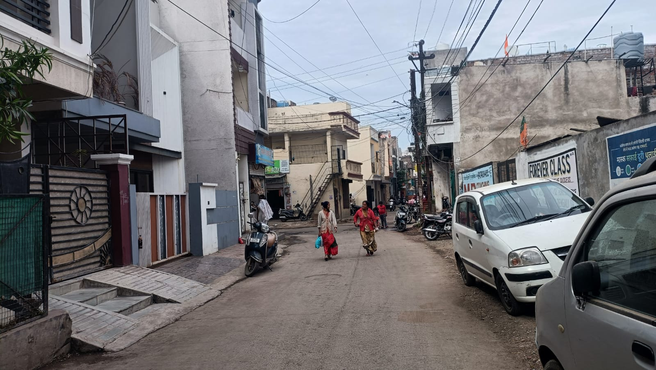
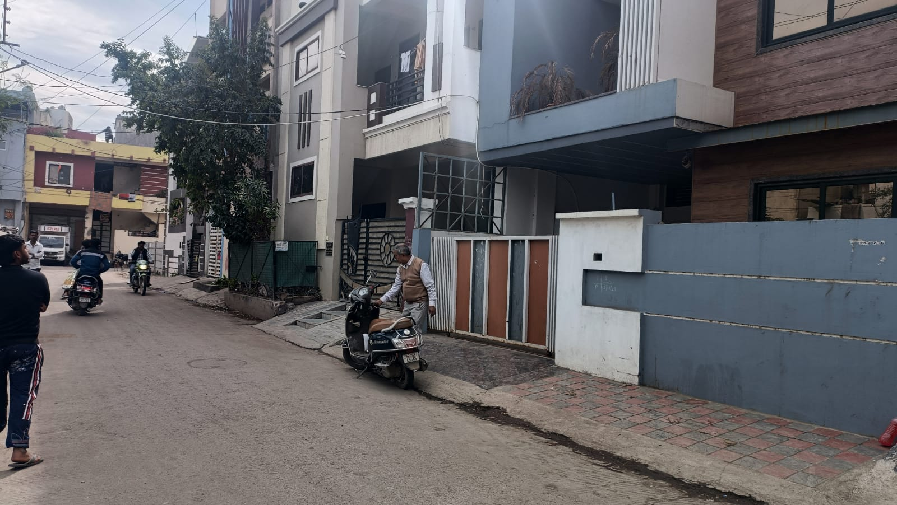

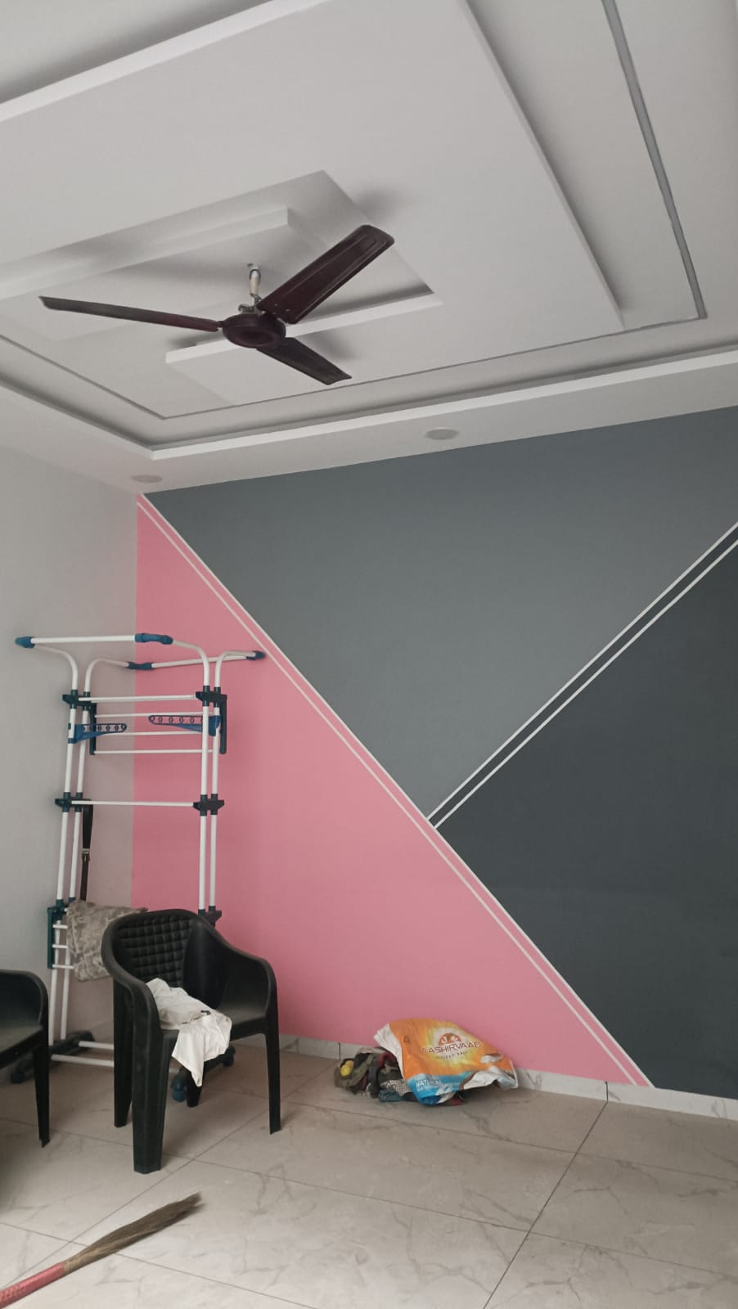
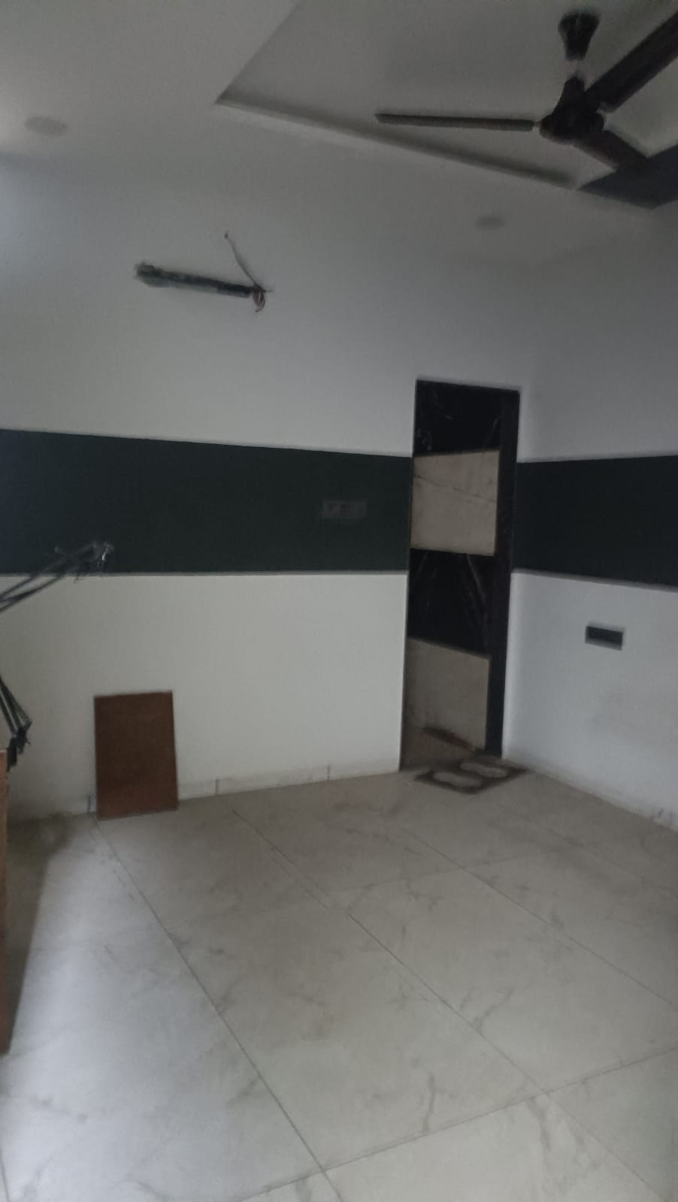
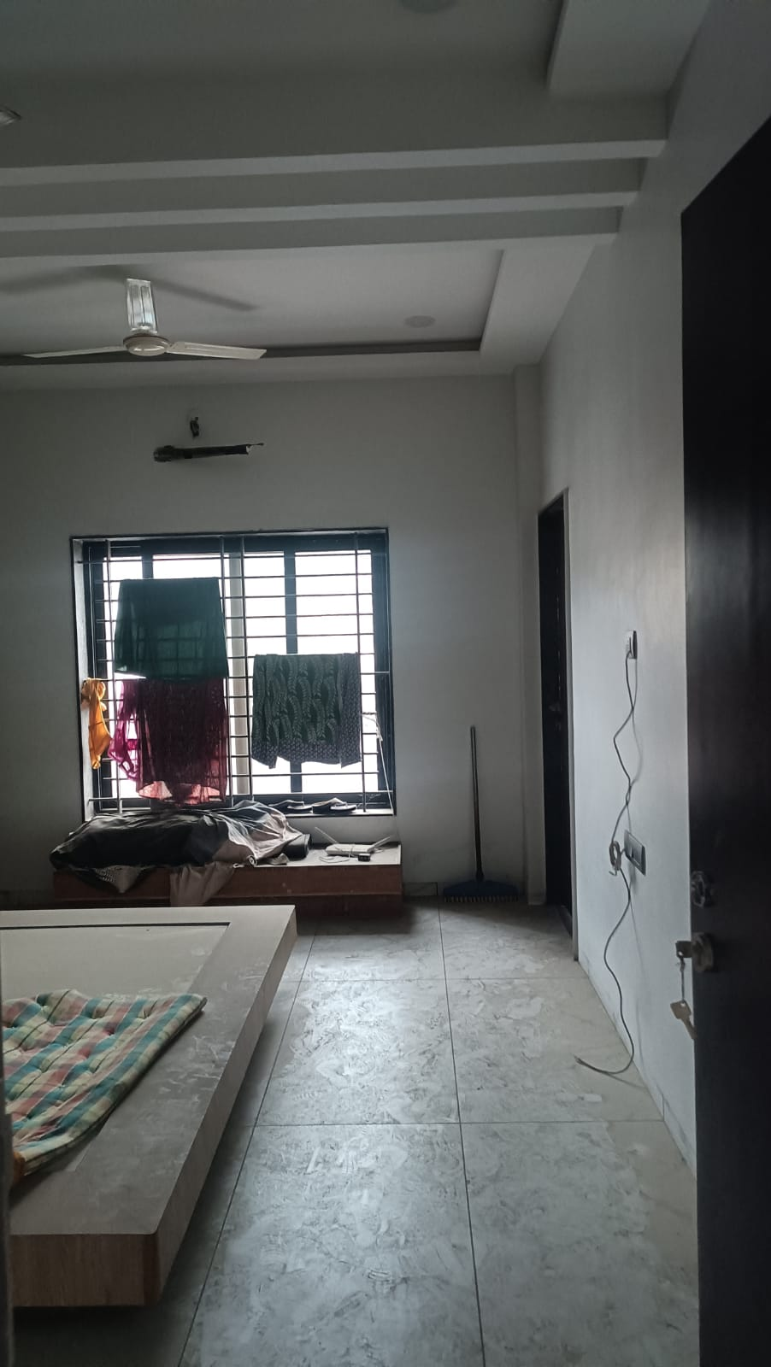
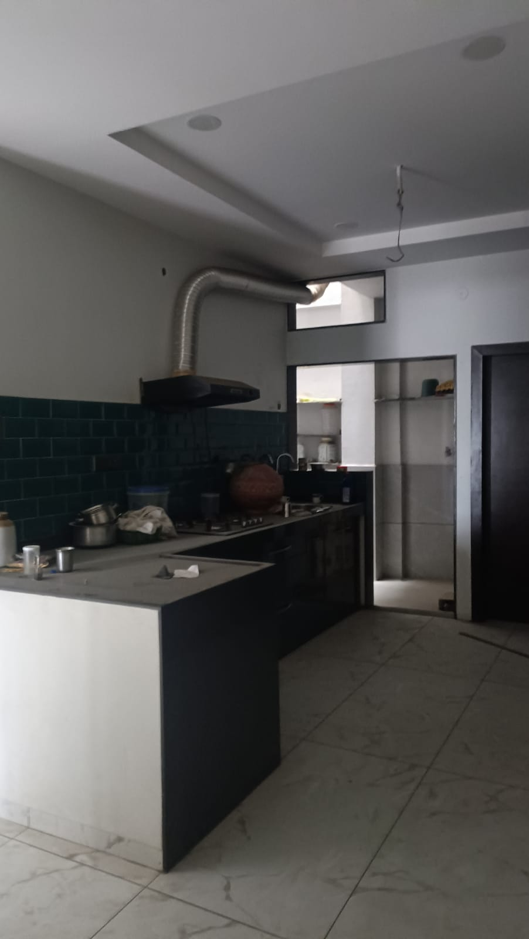
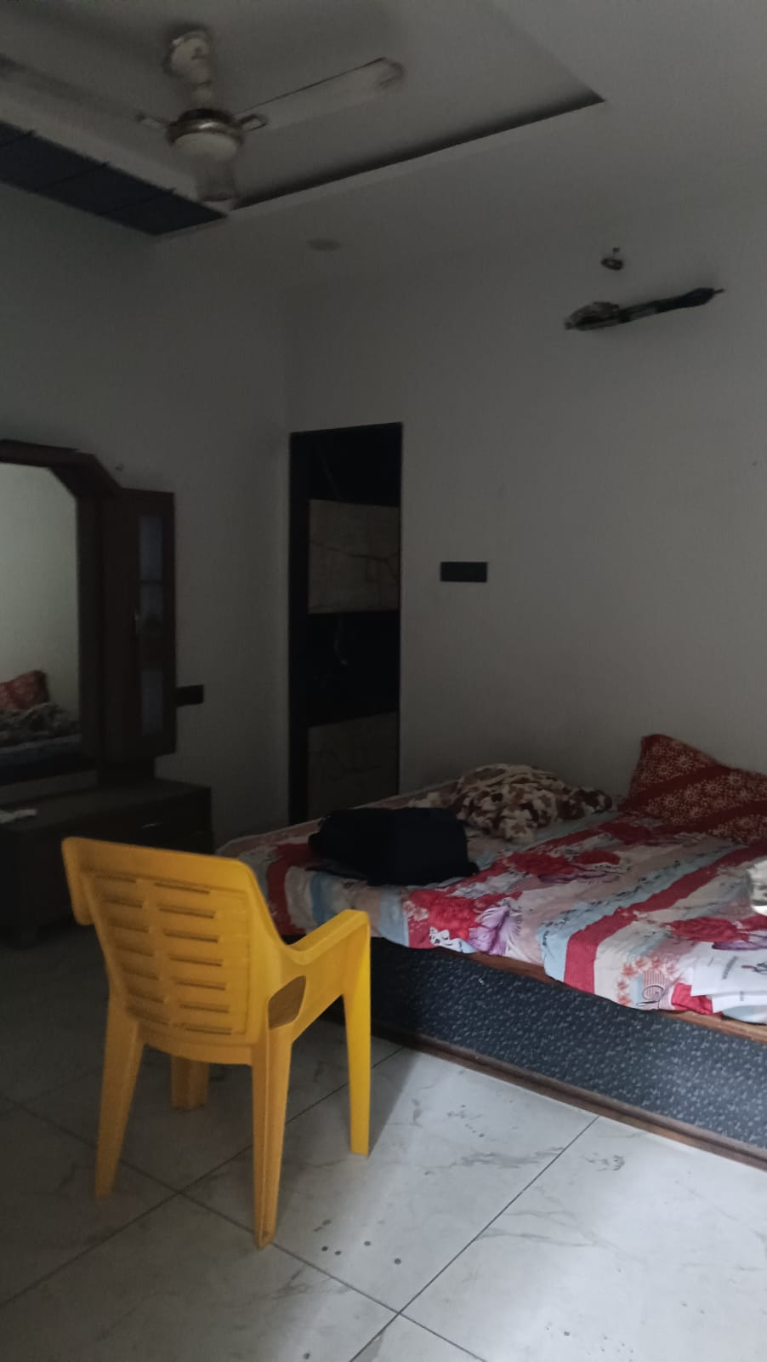
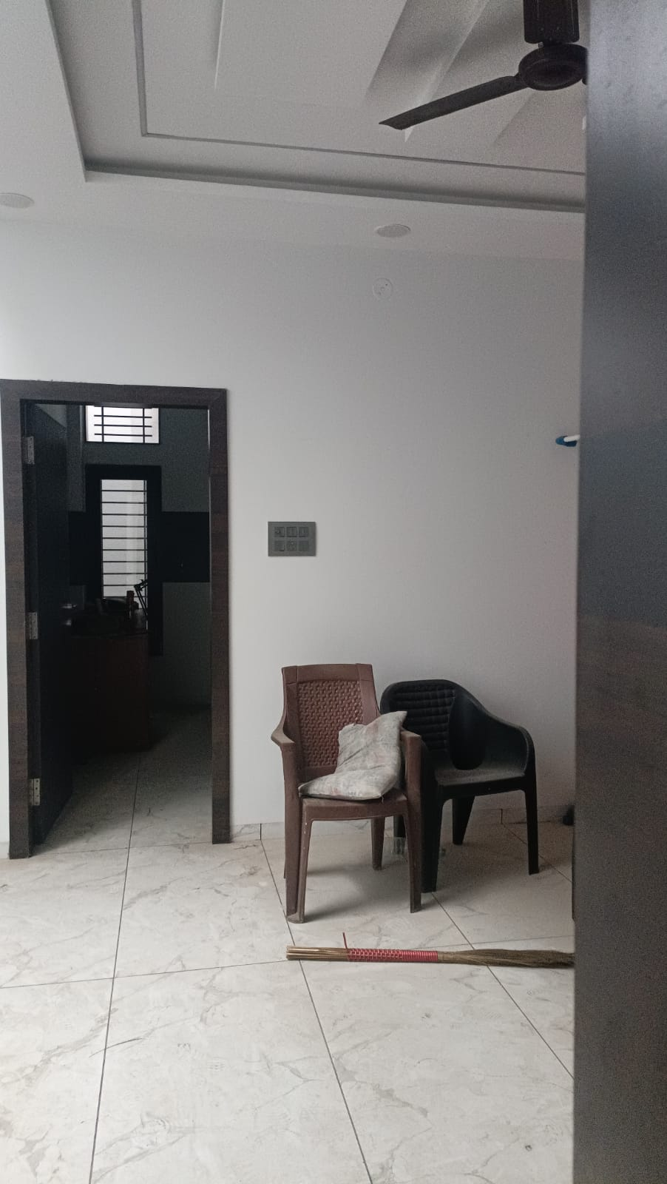
Actual Site Photographs
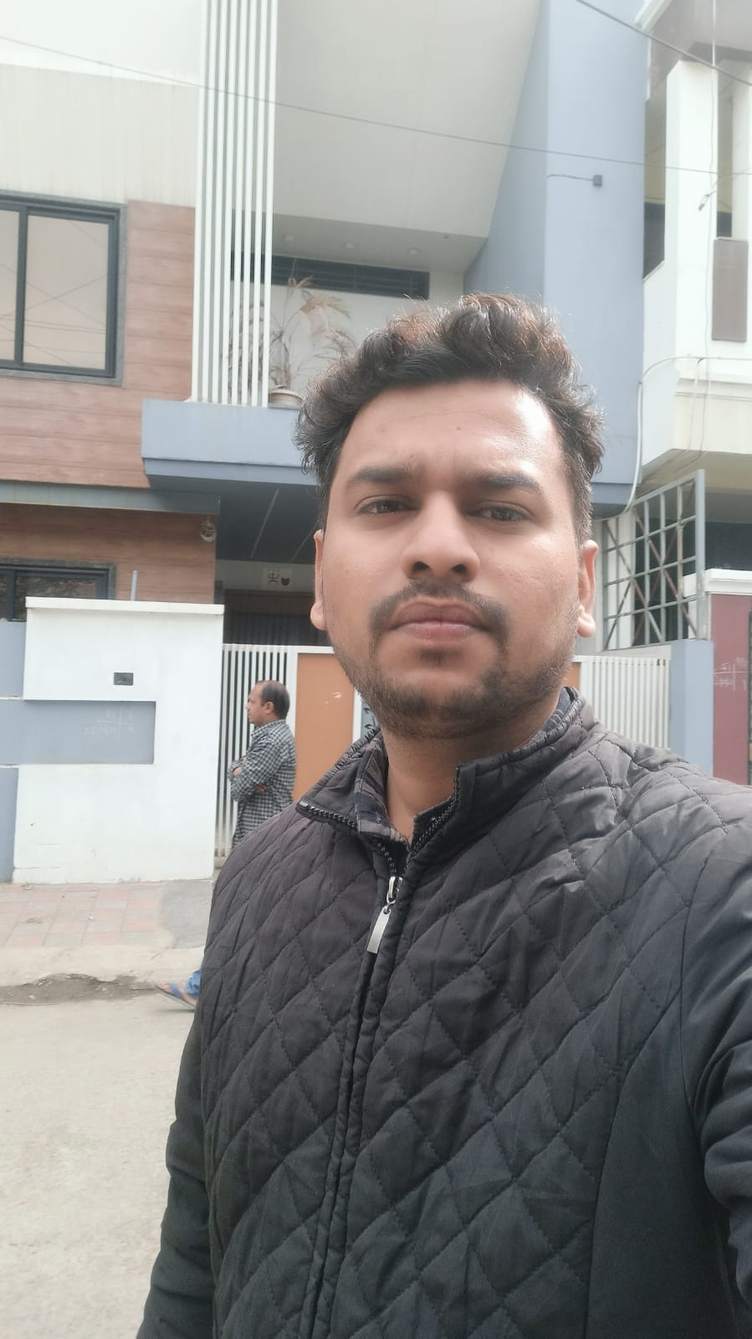
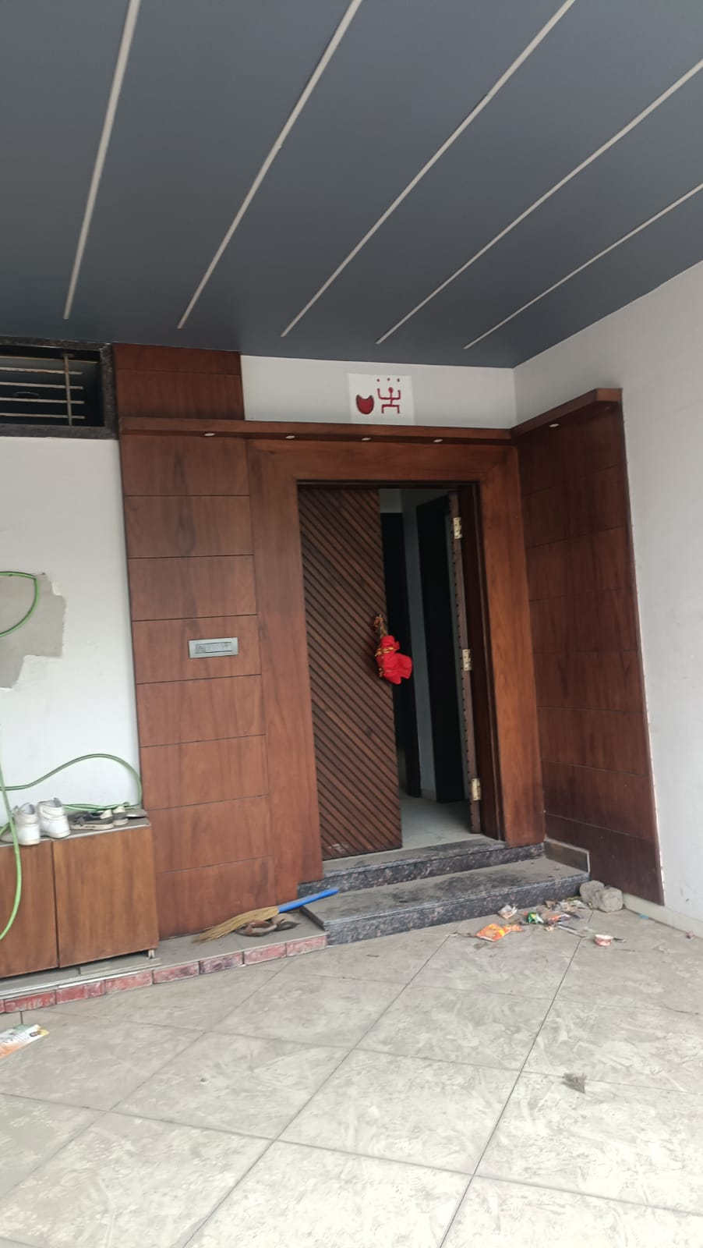
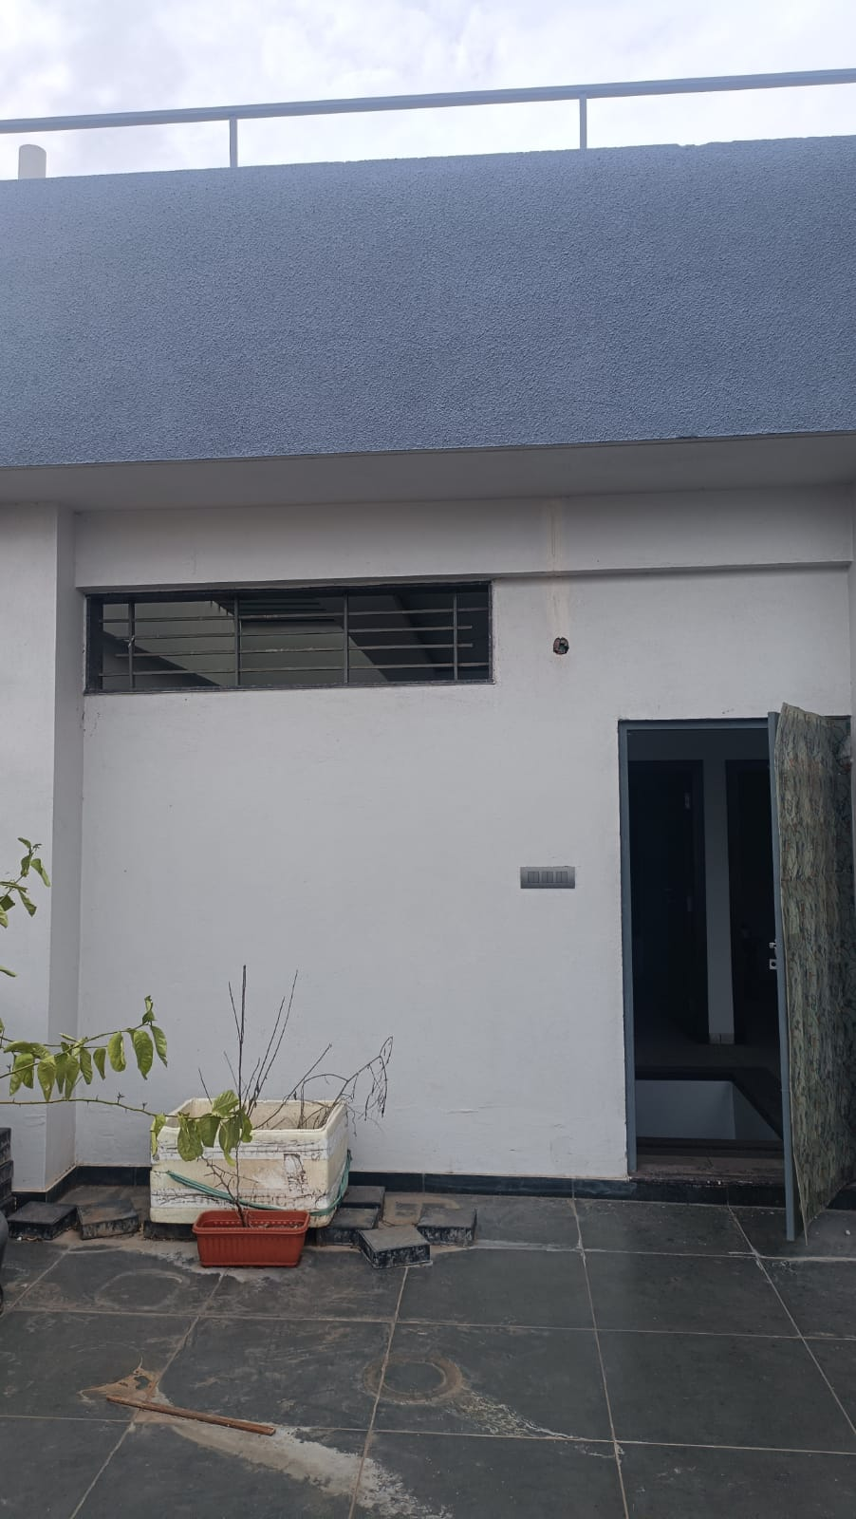

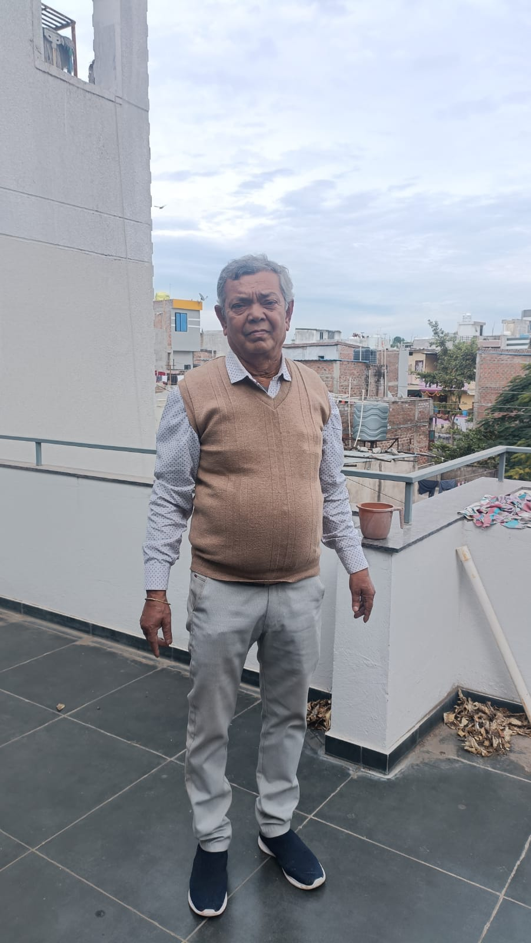
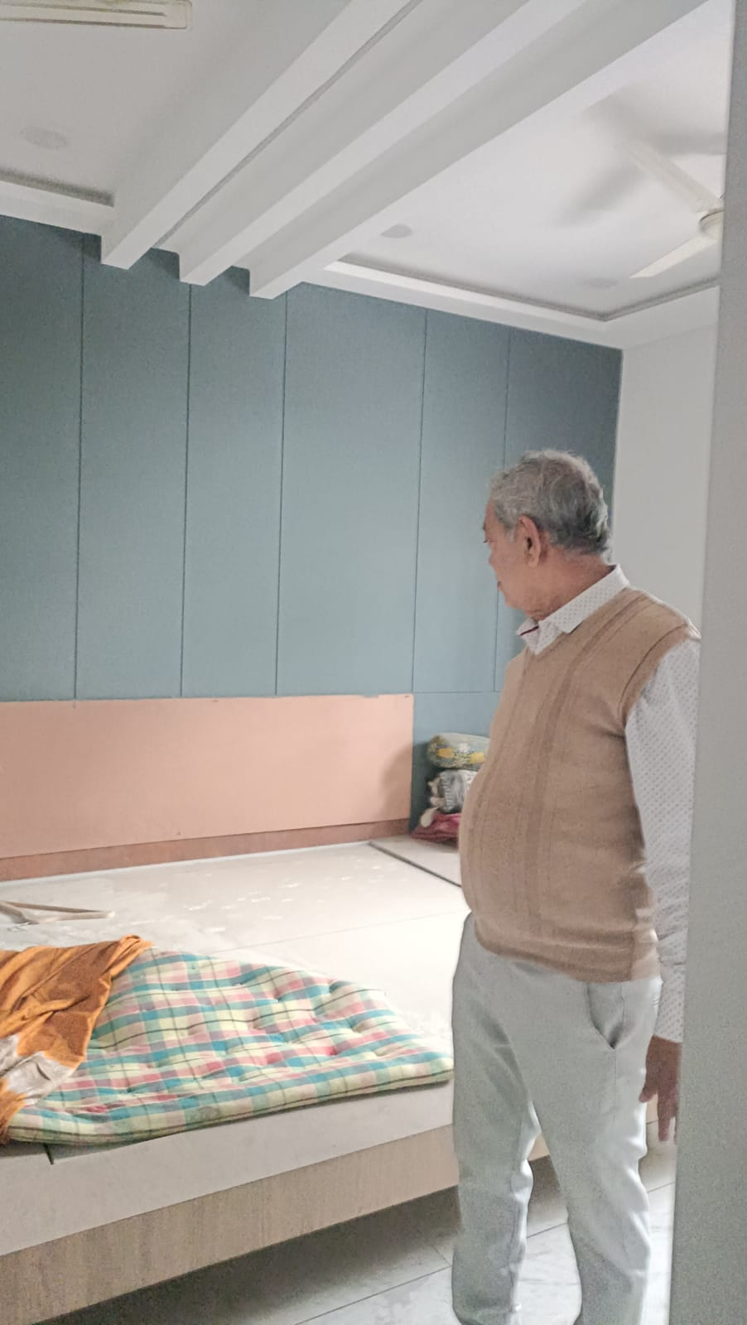
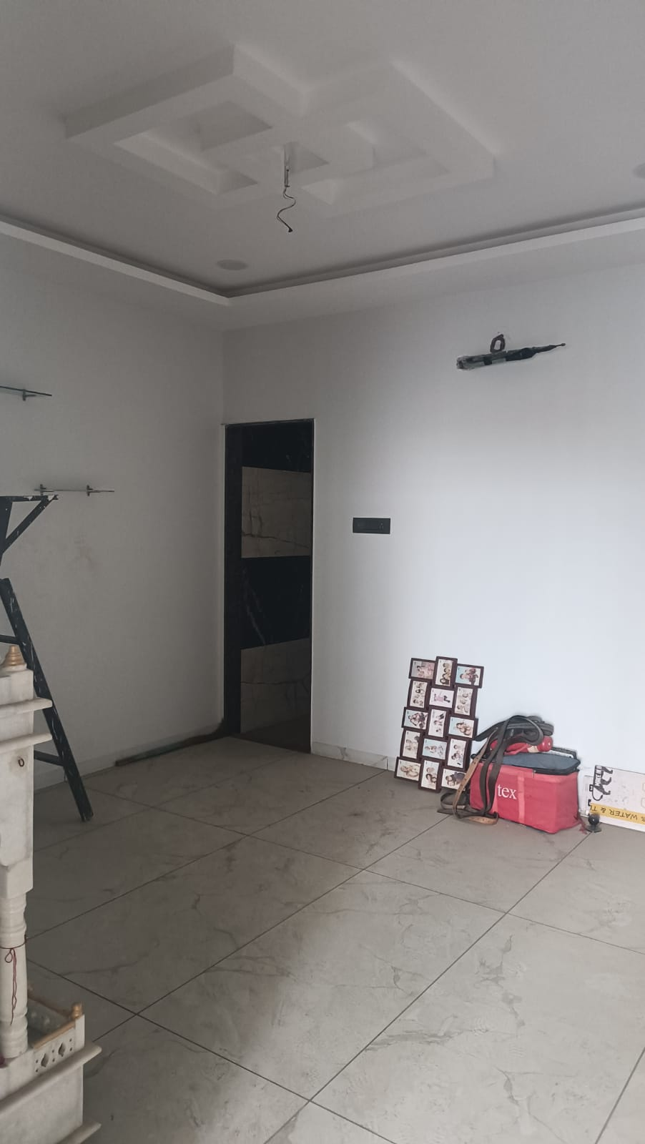

Route Map of the property
Site u/r
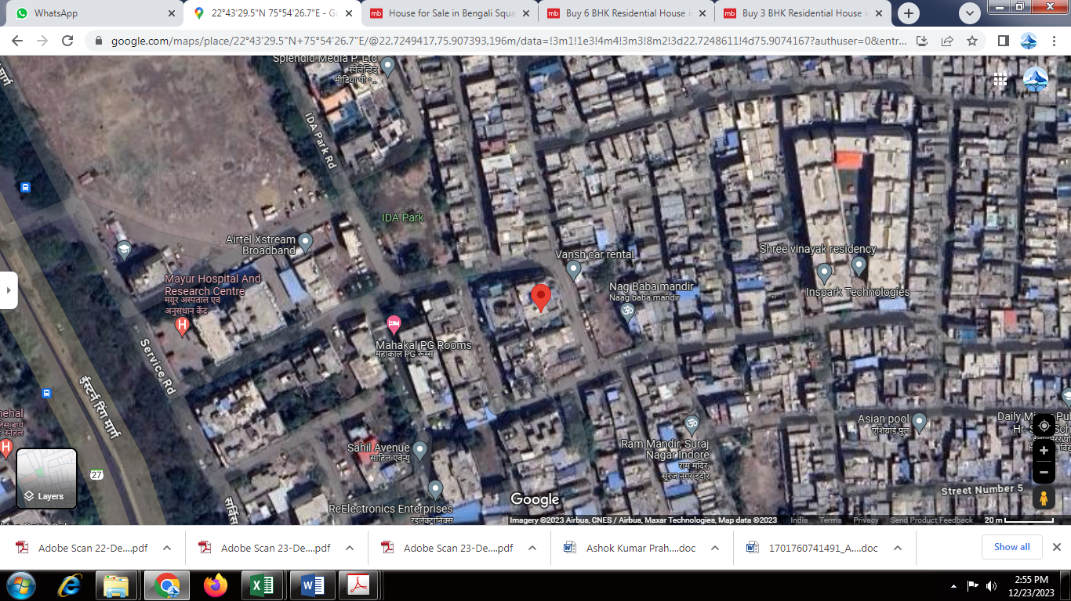

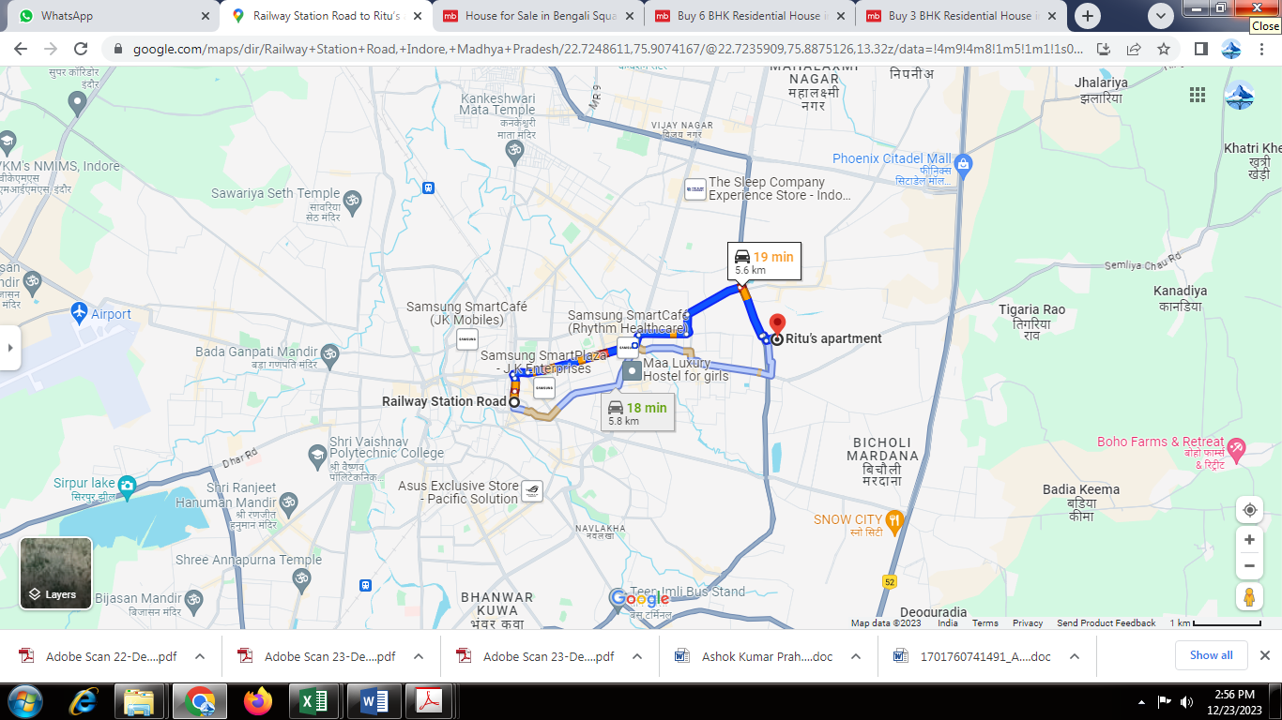

Latitude Longitude: 22°43’29.5”N 75°54’26.7”E

Note: The Blue line shows the route to site from nearest Railway Station (Indore Junction – 5.6 KM.)
Ready Reckoner Rate
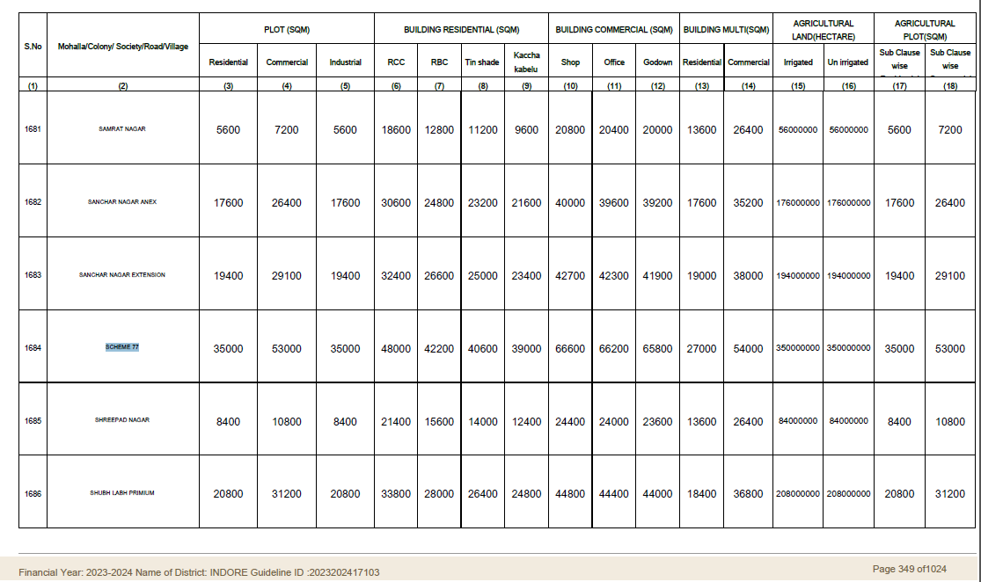

Price Indicators
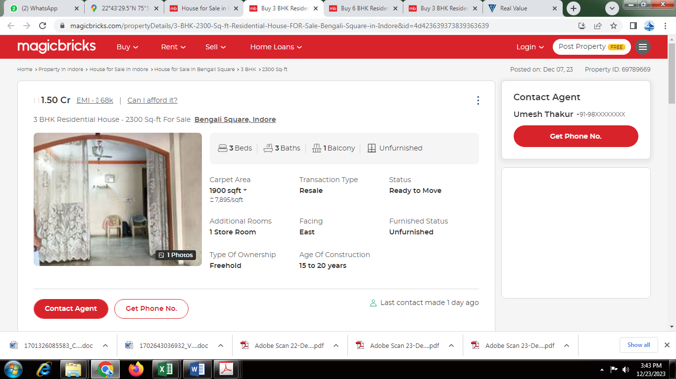

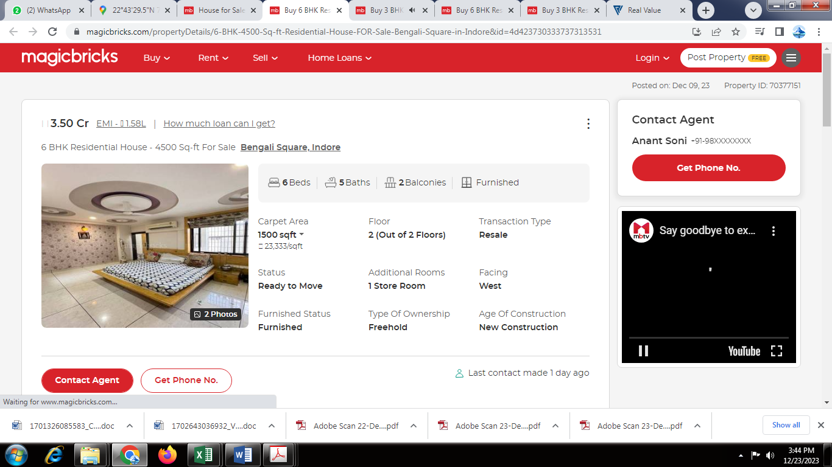

As a result of my appraisal and analysis, it is my considered opinion that the present Market value of the above property in the prevailing condition with aforesaid specifications is ` 99,74,000/- (Rupees Ninety-Nine Lakh Seventy-Four Thousand Only). The Realizable Value of the above property is ` 89,76,600/- (Rupees Eighty-Nine Lakh Seventy-Six Thousand Six Hundred Only). The distress value ` 79,79,200/- (Rupees Seventy-Nine Lakh Seventy Nine Thousand Two Hundred Only).

Place: Indore
Date: 26.12.2023
For Vastukala Consultants (I) Pvt. Ltd.

Sharadkumar B. Chalikwar
Govt. Reg. Valuer
Chartered Engineer (India)
Reg. No. (N) CCIT/1-14/52/2008-09
Encl: Valuation report.

The undersigned has inspected the property detailed in the Valuation Report dated _______________________

on ____________________. We are satisfied that the fair and reasonable market value of the property is

`_________________________ (Rupees ________________________________________________________

________________________________________only).

Date
Signature
(Name of the Branch Manager with Official seal)

Enclosures
 | Declaration From Valuers (Annexure- II) | Attached
 | Model code of conduct for valuer - (Annexure III) | Attached

Annexure-II
DECLARATION FROM VALUERS

I, hereby declare that:

- The information furnished in my valuation report dated 26.12.2023 is true and correct to the best of my knowledge and belief and I have made an impartial and true valuation of the property.

- I have no direct or indirect interest in the property valued;

- I/ my authorized representative have personally inspected the property on 21.12.2023 The work is not sub - contracted to any other valuer and carried out by myself.

- I have not been convicted of any offence and sentenced to a term of Imprisonment;

- I have not been found guilty of misconduct in my professional capacity.

- I have read the Handbook on Policy, Standards and procedure for Real Estate Valuation, 2011 of the IBA and this report is in conformity to the "Standards" enshrined for valuation in the Part - B of the above handbook to the best of my ability.

- I have read the International Valuation Standards (IVS) and the report submitted to the Bank for the respective asset class is in conformity to the "Standards" as enshrined for valuation in the IVS in "General Standards" and "Asset Standards" as applicable. The valuation report is submitted in the prescribed format of the bank.

- I abide by the Model Code of Conduct for empanelment of valuer in the Bank. (Annexure III - A signed copy of same to be taken and kept along with this declaration)

- I am registered under Section 34 AB of the Wealth Tax Act, 1957.

- I am valuer registered with Insolvency & Bankruptcy Board of India (IBBI).

- I am Chairman & Managing Director of the company, who is competent to sign this valuation report.

- Further, I hereby provide the following information.

Sr.  No. | Particulars | Valuer comment
 | Background information of the asset being valued; | The property belongs to Smt. Suniti Dutt W/o Late Shri. Sanjay Dutt, Shri. Sagar Dutt S/o Late Shri. Sanjay Dutt & Shri. Subh Dutt S/o Late Shri. Sanjay Dutt. The Proposed Purchasers / Client is Shri. Shushil Kumar Solanki S/o Shri. Rameshwar Solanki & Shri. Sunil Kumar Solanki S/o Shri. Rameshwar Solanki.
 | Purpose of valuation and appointing authority | As per the request from Union Bank of India, A.B. Road (Khajrana) Branch, Indore to assess fair market value of the property for Bank Loan purpose
 | Identity of the valuer and any other experts involved in the valuation; | Sharadkumar B. Chalikwar – Govt. Regd. Valuer  Dinesh Kanere – Reginal Technical Manager  Akshay Kumar Trivedi – Valuation Engineer  Akhilesh Yadav – Technical Manager
 | Disclosure of valuer interest or conflict, if any; | We have no interest, either direct or indirect, in the property valued. Further to state that we do not have relation or any connection with property owner / applicant directly or indirectly. Further to state that we are an independent Valuer and in no way related to property owner / applicant
 | Date of appointment, valuation date and date of report; | Date of Appointment – 21.12.2023  Valuation Date – 26.12.2023  Date of Report – 26.12.2023
 | Inspections and/or investigations undertaken; | Physical Inspection done on 21.12.2023
 | Nature and sources of the information used or relied upon; | - Market Survey at the time of site visit  - Ready Reckoner rates / Circle rates  - Online Price Indicators on real estate portals  - Enquiries with Real estate consultants
 | Procedures adopted in carrying out the valuation and valuation standards followed; | Cost Approach (For building construction)  Comparative Sales Method / Market Approach (For Land component)
 | Restrictions on use of the report, if any; | This valuation is for the use of the party to whom it is addressed and for no other purpose. No responsibility is accepted to any third party who may use or rely on the whole or any part of this valuation. The valuer has no pecuniary interest that would conflict with the proper valuation of the property.
 | Major factors that were taken into account during the valuation; | current market conditions, demand and supply position, Residential plot size, location, upswing in real estate prices, sustained demand for Residential plot, all round development of commercial and residential application in the locality etc.
 | Major factors that were not taken into account during the valuation; | Nil
 | Caveats, limitations and disclaimers to the extent they explain or elucidate the limitations faced by valuer, which shall not be for the purpose of limiting his responsibility for the valuation report. | Attached

Assumptions, Disclaimers, Limitations & Qualifications
Value Subject to Change
The subject appraisal exercise is based on prevailing market dynamics as on 26th December 2023 and does not take into account any unforeseeable developments which could impact the same in the future.

Our Investigations
We are not engaged to carry out all possible investigations in relation to the subject property. Where in our report we identify certain limitations to our investigations, this is to enable the reliant party to instruct further investigations where considered appropriate or where we recommend as necessary prior to reliance. Vastukala Consultants India Pvt. Ltd. (VCIPL) is not liable for any loss occasioned by a decision not to conduct further investigations

Assumptions
Assumptions are a necessary part of undertaking valuations. VCIPL adopts assumptions for the purpose of providing valuation advise because some matters are not capable of accurate calculations or fall outside the scope of our expertise, or out instructions. The reliant party accepts that the valuation contains certain specific assumptions and acknowledge and accept the risk of that if any of the assumptions adopted in the valuation are incorrect, then this may have an effect on the valuation.

Information Supplied by Others
The appraisal is based on the information provided by the client. The same has been assumed to be correct and has been used for appraisal exercise. Where it is stated in the report that another party has supplied information to VCIPL, this information is believed to be reliable but VCIPL can accept no responsibility if this should prove not to be so.

Future Matters
To the extent that the valuation includes any statement as to a future matter, that statement is provided as an estimate and/or opinion based on the information known to VCIPL at the date of this document. VCIPL does not warrant that such statements are accurate or correct.

Map and Plans
Any sketch, plan or map in this report is included to assist the reader while visualising the property and assume no responsibility in connection with such matters.

Site Details
Based on inputs received from Client's representative and site visit conducted, we understand that the subject property is currently a contiguous land parcel admeasuring 1,331.00 Sq. Ft. and structure thereof. It is a Lease plot of land. The property belongs to Smt. Suniti Dutt W/o Late Shri. Sanjay Dutt, Shri. Sagar Dutt S/o Late Shri. Sanjay Dutt & Shri. Subh Dutt S/o Late Shri. Sanjay Dutt. The Proposed Purchasers / Client is Shri. Shushil Kumar Solanki S/o Shri. Rameshwar Solanki & Shri. Sunil Kumar Solanki S/o Shri. Rameshwar Solanki. Further, VCIPL has assumed that the subject property is free from any encroachment and is available as on the date of the appraisal.

Property Title
Based on our discussion with the Client, we understand that the subject property is owned by Smt. Suniti Dutt W/o Late Shri. Sanjay Dutt, Shri. Sagar Dutt S/o Late Shri. Sanjay Dutt & Shri. Subh Dutt S/o Late Shri. Sanjay Dutt. The Proposed Purchasers / Client is Shri. Shushil Kumar Solanki S/o Shri. Rameshwar Solanki & Shri. Sunil Kumar Solanki S/o Shri. Rameshwar Solanki. For the purpose of this appraisal exercise, we have assumed that the subject property has a clear title and is free from any encumbrances, disputes and claims. VCIPL has made no further enquiries with the relevant local authorities in this regard and does not certify the property as having a clear and marketable title. Further, no legal advice regarding the title and ownership of the subject property has been obtained for the purpose of this appraisal exercise. It has been assumed that the title deeds are clear and marketable.

Environmental Conditions
We have assumed that the subject property is not contaminated and is not adversely affected by any existing or proposed environmental law and any processes which are carried out on the property are regulated by environmental legislation and are properly licensed by the appropriate authorities.

Town Planning
The permissible land use, zoning, achievable F.A.R., area statement adopted for purpose of this valuation is based on the information provided by the Client's representative and the same has been adopted for this valuation purpose. VCIPL has assumed the same to be correct and permissible. VCIPL has not validated the same from any authority.

Area
Based on the information provided by the Client, we understand that the subject property is a contiguous land parcel admeasuring 1,331.00 Sq. Ft. and structure thereof.

Condition & Repair
In the absence of any information to the contrary, we have assumed that there are no abnormal ground conditions, nor archaeological remains present which might adversely affect the current or future occupation, development or value of the property. The property is free from rat, infestation, structural or latent defect. No currently known deleterious or hazardous materials or suspect techniques will be used in the construction of or subsequent alteration or additions to the property and comments made in the property details do not purport to express an opinion about, or advise upon, the condition of uninspected parts and should not be taken as making an implied representation or statement about such parts.

Valuation Methodology
For the purpose of this valuation exercise, the valuation methodology used is Direct Comparison Approach Method and proposed Current Use / Existing Use premise is considered for this assignment.
The Direct Comparison Approach involves a comparison of the property being valued to similar properties that have actually been sold in arms - length transactions or are offered for sale. This approach demonstrates what buyers have historically been willing to pay (and sellers willing to accept) for similar properties in an open and competitive market and is particularly useful in estimating the value of the land and properties that are typically traded on a unit basis.
In case of inadequate recent transaction activity in the subject micro-market, the appraiser would collate details of older transactions. Subsequently, the appraiser would analyse rental / capital value trends in the subject micro-market in order to calculate the percentage increase / decrease in values since the date of the identified transactions. This percentage would then be adopted to project the current value of the same.
Where reliance has been placed upon external sources of information in applying the valuation methodologies, unless otherwise specifically instructed by Client and/or stated in the valuation, VCIPL has not independently verified that information and VCIPL does not advise nor accept it as reliable. The person or entity to whom the report is addressed acknowledges and accepts the risk that if any of the unverified information in the valuation is incorrect, then this may have an effect on the valuation.

Not a Structural Survey
We state that this is a valuation report and not a structural survey

Other
All measurements, areas and ages quoted in our report are approximate
Legal
We have not made any allowances with respect to any existing or proposed local legislation relating to taxation on realization of the sale value of the subject property. VCIPL is not required to give testimony or to appear in court by reason of this appraisal report, with reference to the property in question, unless arrangement has been made thereof. Further, no legal advice on any aspects has been obtained for the purpose of this appraisal exercise

Property specific assumptions
Based on inputs received from the client and site visit conducted, we understand that the subject property is currently contiguous land parcel admeasuring 1,331.00 Sq. Ft. and structure thereof.

ASSUMPTIONS, CAVEATS, LIMITATION AND DISCLAIMERS
- We assume no responsibility for matters of legal nature affecting the property appraised or the title thereto, nor do we render our opinion as to the title, which is assumed to be good and marketable.
- The property is valued as though under responsible ownership.
- It is assumed that the property is free of liens and encumbrances.
- It is assumed that there are no hidden or unapparent conditions of the subsoil or structure that would render it more or less valuable. No responsibility is assumed for such conditions or for engineering that might be required to discover such factors.
- There is no direct/ indirect interest in the property valued.
- The rates for valuation of the property are in accordance with the Govt. approved rates and prevailing market rates
Annexure - III

MODEL CODE OF CONDUCT FOR VALUERS
{Adopted in line with Companies (Registered Valuers and Valuation Rules, 2017)}
All valuers empanelled with bank shall strictly adhere to the following code of conduct:

Integrity and Fairness
- A valuer shall, in the conduct of his/its business, follow high standards of integrity and fairness in all his/its dealings with his/its clients and other valuers.
- A valuer shall maintain integrity by being honest, straightforward, and forthright in all professional relationships.
- A valuer shall endeavour to ensure that he/it provides true and adequate information and shall not misrepresent any facts or situations.
- A valuer shall refrain from being involved in any action that would bring disrepute to the profession.
- A valuer shall keep public interest foremost while delivering his services.

Professional Competence and Due Care
- A valuer shall render at all times high standards of service, exercise due diligence, ensure proper care and exercise independent professional judgment.
- A valuer shall carry out professional services in accordance with the relevant technical and professional standards that may be specified from time to time.
- A valuer shall continuously maintain professional knowledge and skill to provide competent professional service based on up-to-date developments in practice, prevailing regulations / guidelines and techniques.
- In the preparation of a valuation report, the valuer shall not disclaim liability for his/its expertise or deny his/its duty of care, except to the extent that the assumptions are based on statements of fact provided by the company or its auditors or consultants or information available in public domain and not generated by the valuer.
- A valuer shall not carry out any instruction of the client insofar as they are incompatible with the requirements of integrity, objectivity and independence.
- A valuer shall clearly state to his client the services that he would be competent to provide and the services for which he would be relying on other valuers or professionals or for which the client can have a separate arrangement with other valuers.

Independence and Disclosure of Interest
- A valuer shall act with objectivity in his/its professional dealings by ensuring that his/its decisions are made without the presence of any bias, conflict of interest, coercion, or undue influence of any party, whether directly connected to the valuation assignment or not.
- A valuer shall not take up an assignment if he/it or any of his/its relatives or associates is not independent in terms of association to the company.
- A valuer shall maintain complete independence in his/its professional relationships and shall conduct the valuation independent of external influences.
- A valuer shall wherever necessary disclose to the clients, possible sources of conflicts of duties and interests, while providing unbiased services.
- A valuer shall not deal in securities of any subject company after any time when he/it first becomes aware of the possibility of his / its association with the valuation, and in accordance with the Securities and Exchange Board of India (Prohibition of Insider Trading)Regulations,2015 or till the time the valuation report becomes public, whichever is earlier.
- A valuer shall not indulge in "mandate snatching" or offering "convenience valuations" in order to cater to a company or client's needs.
- As an independent valuer, the valuer shall not charge success fee. (Success fees may be defined as a compensation / incentive paid to any third party for successful closure of transaction. In this case, approval of credit proposals).
- In any fairness opinion or independent expert opinion submitted by a valuer, if there has been a prior engagement in an unconnected transaction, the valuer shall declare the association with the company during the last five years.
Confidentiality
- A valuer shall not use or divulge to other clients or any other party any confidential information about the subject company, which has come to his / its knowledge without proper and specific authority or unless there is a legal or professional right or duty to disclose.
Information Management
- A valuer shall ensure that he/ it maintains written contemporaneous records for any decision taken, the reasons for taking the decision, and the information and evidence in support of such decision. This shall be maintained so as to sufficiently enable a reasonable person to take a view on the appropriateness of his /its decisions and actions.
- A valuer shall appear, co-operate and be available for inspections and investigations carried out by the authority, any person authorised by the authority, the registered valuers organisation with which he/it is registered or any other statutory regulatory body.
- A valuer shall provide all information and records as may be required by the authority, the Tribunal, Appellate Tribunal, the registered valuers organisation with which he/it is registered, or any other statutory regulatory body.
- A valuer while respecting the confidentiality of information acquired during the course of performing professional services, shall maintain proper working papers for a period of three years or such longer period as required in its contract for a specific valuation, for production before a regulatory authority or for a peer review. In the event of a pending case before the Tribunal or Appellate Tribunal, the record shall be maintained till the disposal of the case.

Gifts and hospitality:
- A valuer or his / its relative shall not accept gifts or hospitality which undermines or affects his independence as a valuer.
Explanation: For the purposes of this code the term 'relative' shall have the same meaning as defined in clause (77) of Section 2 of the Companies Act, 2013 (18 of 2013).
- A valuer shall not offer gifts or hospitality or a financial or any other advantage to a public servant or any other person with a view to obtain or retain work for himself / itself, or to obtain or retain an advantage in the conduct of profession for himself / itself.
Remuneration and Costs.
- A valuer shall provide services for remuneration which is charged in a transparent manner, is a reasonable reflection of the work necessarily and properly undertaken, and is not inconsistent with the applicable rules.
- A valuer shall not accept any fees or charges other than those which are disclosed in a written contract with the person to whom he would be rendering service.
Occupation, employability and restrictions.
- A valuer shall refrain from accepting too many assignments, if he/it is unlikely to be able to devote adequate time to each of his/ its assignments.
- A valuer shall not conduct business which in the opinion of the authority or the registered valuer organisation discredits the profession.

For Vastukala Consultants (I)Pvt.Ltd.

Sharadkumar B. Chalikwar
Govt. Reg. Valuer
Chartered Engineer (India)
Reg. No. (N) CCIT/1-14/52/2008-09

