1st LENDERS INDEPENDENT ENGINEER REPORT
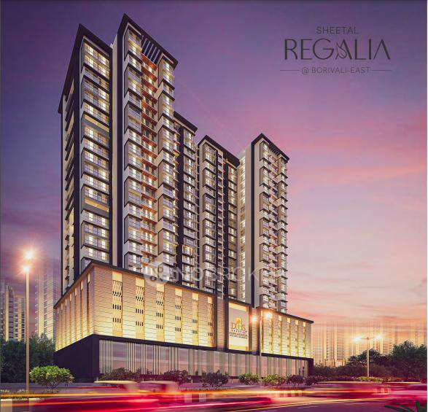

Details of the property under consideration:

Name of Project: “Sheetal Regalia”

"Sheetal Regalia", Proposed S. R. Scheme Commercial cum Residential building on Plot bearing C.T.S. No. 2293/B, Nensey Complex Building, Sant Dnyaneshwar Road & Western Expressway, Village – Dahisar, Borivali (East), Mumbai – 400 066, State – Maharashtra, Country – India

Latitude Longitude: 19°14'17.2"N 72°51'50.9"E

Valuation Prepared for:

State Bank of India
SME Chembur Branch
Unit No. 11, Building No. 11, Ground Floor, Corporate Park, Sion Trombay Road,
Chembur, Mumbai, Pin Code – 400 071, State - Maharashtra, Country – India

Vastu/SBI/Mumbai/12/2023/5917/2304206
27/04-435-PY
Date: - 27.12.2023

FIRST LENDERS INDEPENDENT ENGINEER REPORT
To,
State Bank of India
SME Chembur Branch
Unit No. 11, Building No. 11,
Ground Floor, Corporate Park,
Sion Trombay Road, Chembur,
Mumbai, Pin Code – 400 071,
State - Maharashtra, Country – India

Subject: Construction of Proposed S. R. Scheme Commercial cum Residential building on Plot bearing C.T.S. No. 2293/B, Nensey Complex Building, Sant Dnyaneshwar Road & Western Expressway, Village – Dahisar, Borivali (East), Mumbai – 400 066, State – Maharashtra, Country – India.

Ref: You’re Request for Lenders Independent Engineer Report of under Construction Building.
Dear Sir,
- As per your instruction, we have inspected the under-construction PTC and Sale Building project situated on plot bearing C.T.S. No. 2293/B, Nensey Complex Building, Sant Dnyaneshwar Road & Western Expressway, Village – Dahisar, Borivali (East), Mumbai – 400 066, State – Maharashtra, Country – India which is being developed by M/s. DGS Township Pvt. Ltd. in order to give the physical progress at site and to certify cost incurred towards project as on 31/10/2023.
- The Construction work as per approved plan was in progress during the site visit on 22nd November 2023.
- Status of work:
- For PTC Building (Building Name “Sheetal Sahayog”): Excavation work is in progress
- For Sales Building (Wing A & B): 4th Podium floor slab work is completed. 5th Podium Salb work is in progress.
- As per cost incurred certificate issued by CA Certificate actual total expenditure occurred as on 31/10/2023 is ` 101.06 Cr. for Commercial cum Residential of Sale Building (Wing A & B) is proposed of Ground Floor + 1st Commercial Floor + 2nd to 5th Podium Floor + 1st to 21st Habitable Residential Floors and PTC building at different location.
- Overall financial progress as per C.A. certificate including land cost as on 31/10/2023 is 34.87% estimated cost of project.
- Overall Physical progress of the sale building construction as on 22/11/2023 is 19.85% as per physical site inspection.

- Overall Physical progress of the PTC building construction as on 22/11/2023 is 0.00% as per physical site inspection.

DECLARATION
- The information furnished in the report is based on our 1st site visit Dated 22/11/2023 & Document Provided by Client.
- Vastukala Project Report of the project dated 12/09/2023.
- Vastukala Cost Vetting Report dated 12/09/2023.
- I have no direct and indirect interest in the property examined for report.
- I have not been found guilty of misconduct in my professional capacity.

Sharadkumar B. Chalikwar
Govt. Reg. Valuer
Chartered Engineer (India)
Reg. No. (N) CCIT/1-14/52/2008-09

Encl.: LIE report

Purpose & Methodology
• State Bank of India Banks and financial institutions require monitoring & an independent review of the progress of the sanctioned projects
VCIPL undertakes such study to independently review the progress of the project and put forward a comprehensive analysis

Advantages:
- Assurance on present practices
- Identification of risk
- Analyzing the performance of third parties
- Recommendations

The Methodology
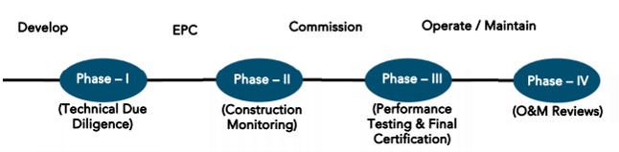
FIRST LENDERS INDEPENDENT ENGINEER REPORT
OF
"SHEETAL REGALIA"

"Sheetal Regalia", Proposed S. R. Scheme Commercial cum Residential building on Plot bearing
C.T.S. No. 2293/B, Nensey Complex Building, Sant Dnyaneshwar Road & Western Expressway,
Village – Dahisar, Borivali (East), Mumbai – 400 066, State – Maharashtra, Country – India

Latitude Longitude: 19°14'17.2"N 72°51'50.9"E

NAME OF DEVELOPER: M/s. DGS Township Pvt. Ltd.
Pursuant to instructions from State of India, SME Chembur Branch, Chembur we have duly visited, inspected, surveyed & assessed the above said property on 22nd November 2023 to determine the fair & reasonable market value of the said property/project as on Quarter ending 31st October 2023 for LIE purpose.

1. Location Details:
Proposed S. R. Scheme Commercial cum Residential building on Plot bearing C.T.S. No. 2293/B, Nensey Complex Building, Sant Dnyaneshwar Road & Western Expressway, Village – Dahisar, Borivali (East), Mumbai – 400 066. It is about 1.60 Km. travelling distance from Borivali (East) Railway station. Surface transport to the property is by buses, taxis & private vehicles. The property is in developed locality. All the amenities like shops, banks, hotels, markets, schools, hospitals, etc. are all available in the surrounding locality. The area is higher middle class & developed.

2. Developer Details:
Name of builder | M/s. DGS Township Pvt. Ltd.
Project Rera Registration Number | P51800048237
Registered office address | DGS house, 1st floor, Sheetal Krupa, Aarey Road, Walawalkar Street, Goregaon (E), Mumbai – 400 063, State - Maharashtra, Country – India
Contact details | Contact Person:  Mr. Prabudh Khandelwal (Consultants)  Mobile No. 7738001775  Mr. Deep Shah (Consultants)  Mobile No. 7977861026  Mr. Arvind Dwidedv (Project Manager)  Mobile No. 9164498569
E – mail ID and website
3. Boundaries of the Property:
Direction | Particulars
On or towards North | Shree Adinath Tower
On or towards South | Shree Jagadeeshwari Temple
On or towards East | Sant Dnyaneshwar Road
On or towards West | Western Expressway

Introduction
As per Information on site M/s. DGS Township Pvt. Ltd. has acquired land by Developer Agreement dated 25.03.2021 through registered agreement vide No. BRL-9-4505-2021 dated 26.03.2021 admeasuring area is 5,669.67 Sq. M. bearing CTS No. 190/A/6/2 (Part). For the Proposed Commercial cum Residential (Rehab cum Sale) Building.

Area Statement:

Land:
Date | Particular | Area in Sq. M.
21.12.2018 | CTS No. 190/A/6/2 | 5,669.67
TOTAL |  | 5,669.67

- Copy of Developer Agreement dated 25.03.2021 between M/s. Nensey Complex Building Co-operative Housing Society Ltd. (The Society) and M/s. DGS Township Pvt. Ltd. (The Developers) through registered agreement vide No. BRL-9-4505-2021 dated 26.03.2021.
- Copy of Supplementary Agreement dated 15.07.2022 between M/s. Nensey Complex Building Co-operative Housing Society Ltd. (The Society) and M/s. DGS Township Pvt. Ltd. (The Developers) through registered agreement vide No. BLR-9-11639-2022 dated 15.07.2022.

Building Area:

As per Approved Plan:
A | AREA OF PLOT | SQ.MT.
1 | Area Of Plot | 5,599.00
2 | Deduction For
a | Road Set Back Area | NIL
b | 5% Amenity Plot | 279.95
c | Total (=A+B) | 279.95
3 | Balance Area Plot (1-2c) | 5,319.05
4 | NET Area Plot for FSI Purpose | 5,319.05
5 | Maximum Permissible FSI on Plot | 4.00
6 | Maximum Permissible BUA on Plot | 21,276.20
7 | Basic Zonal FSI / BUA | 5,319.05
8 | PERMISSIBLE BUILT-UP AREA AS PER REGULATION 30(C) PROTECTED DEVELOPMENT) EXISTING BLDG (K)= 3360.04 SQ.MT (As Per Approved Plan U/No. CE/1537/BSII/A/R Dtd. 05.08.1974) EXISTING BLDG (L) = 4027.87 SQ.MT (As Per Approved Plan U/No. CE/1538/BSII/A/R OCC Granted Dtd. 31.05.1975) TOTAL BUA (BLDG-K+L) = 7387.91 SQ.MT  (7387.91-5319.05 = 2068.86 SQ.MT) | 2,068.86
9 | Balance FSI Potential (=7-8-9) | 13,888.29
10 | Sale Bua For Against PTC Area = 6944.145  (=110 Above X 50%) | 6,944.15
11 | Sale Incentive Bua Under Reg. 33(11)  (= 10 Above X 50%) | 6,944.15
12 | Details of FSI Availed as Per Reg. 33 (11) Of DCPR 2034 | SALE | INCENTIVE | ZONAL | TOTAL
a | Permissible BUA U/REG. 33(11) | 6,944.15 | 6,944.15 | 5,319.05 | 19,207.34
 |  |  | 12,263.20
b | Permissible Built-Up Area as Per Regulation 30 (C)  (Protected Development) |  | 2,068.86 |  | 2,068.86
c | TOTAL PERMISSIBLE BUA (12a + 12b) | 6,944.15 | 14,332.06 |  | 21,276.20
13 | Total Bua Proposed
a | PTC Built Up Area | 21,146.40
b | Existing Tenant Built Up Area = 5929.12
c | Sale Built Up Area = 15217.28
14 | FSI Consumed on Plot = 13/ 4 | 3.98
14 | PERMISSIBLE 35% FUNGIBLE B.U AREA (13 B+C X 35%) | 7,401.24
15 | Proposed Fungible Built up Area
a | Proposed Existing Tent Fungible Built up Area = 1971.99 | 1,971.99
b | Proposed Sale Fungible Built up Area = Nil
16 | Gross Built up Area (13+15) | 23,118.39

As per Architect Drawing Plan:
A | AREA OF PLOT | SQ.MT.
1 | Area Of Plot | 5599
2 | Deduction For
a | Road Set Back Area | NIL
b | 5% Amenity Plot | 279.95
c | Total (=A+B) | 279.95
3 | Balance Area Plot (1-2c) | 5319.05
4 | NET Area Plot for FSI Purpose | 5319.05
5 | Maximum Permissible FSI on Plot | 4
6 | Maximum Permissible BUA on Plot | 21276.2
7 | Basic Zonal FSI / BUA | 5319.05
8 | PERMISSIBLE BUILT-UP AREA AS PER REGULATION 30(C) (PROTECTED DEVELOPMENT) EXISTING BLDG (K)= 3360.04 SQ.MT (As Per Approved Plan U/No. CE/1537/BSII/A/R Dtd. 05.08.1974) EXISTING BLDG (L) = 4027.87 SQ.MT (As Per Approved Plan U/No. CE/1538/BSII/A/R OCC Granted Dtd. 31.05.1975) TOTAL BUA (BLDG-K+L) = 7387.91 SQ.MT  (7387.91-5319.05 = 2068.86 SQ.MT) | 2068.86
9 | Balance FSI Potential (=7-8-9) | 13888.29
10 | Sale Bua For Against PTC Area = 6944.145  (=110 Above X 50%) | 6944.145
11 | Sale Incentive Bua Under Reg. 33(11)  (= 10 Above X 50%) | 6944.145
12 | Details Of FSI Availed as Per Reg. 33 (11) Of DCPR 2034 | SALE | INCENTIVE | ZONAL | TOTAL
a | Permissible BUA U/REG. 33(11) | 6944.145 | 6944.145 | 5319.05 | 19207.34
 |  |  | 12263.195
b | Permissible Built-Up Area as Per Regulation 30 (C)  (Protected Development) |  | 2068.86 |  | 2068.86
c | TOTAL PERMISSIBLE BUA (12a + 12b) | 6944.145 | 14332.055 |  | 21276.2
13 | Total Bua Proposed
a | PTC Built Up Area | 21276.20
b | Existing Tent Built Up Area = 7225.36
c | Sale Built Up Area = 14050.84
14 | PERMISSIBLE 35% FUNGIBLE B.U AREA (13 B+C X 35%) | 7446.67
15 | Proposed Fungible Built up Area
a | Proposed Existing Tent Fungible Built UP Area = 2417.13 | 7332.59
b | Proposed Sale Fungible Built up Area = 4915.46
16 | Gross Built up Area (13+15) 28608.79 | 28608.79

List of Approvals:

- Copy of Sale Building IOA Letter No. R-N/PVT/0105/20220623/AP/S dated 19.09.2022 issued by Slum Rehabilitation Authority (SRA).
- Copy of 1st Sale Building Approved Plan No. RN/PVT/0105/20220623/AP/S dated 13.02.2023 issued by Slum Rehabilitation Authority (SRA).
Approved upto:
Wing A & B: Ground Floor + 1st Commercial Floor + 2nd to 5th Podium Floor + 1st to 16th Habitable Residential Floors
- Copy of Sale Building Concession / Architect Drawing Plan dated 23.12.2022 issued by Slum Rehabilitation Authority (SRA).
Sanctioned Upto:
Wing A & B: Ground Floor + 1st Commercial Floor + 2nd to 5th Podium Floor + 1st to 21st Habitable Residential Floors
- Copy of 1st Sale Building Commencement Certificate No. RN/PVT/0105/20220623/AP/S dated 04.10.2022 issued by Slum Rehabilitation Authority (SRA).
(This CC is endorsed for the work for Plinth Floor)
- Copy of 2nd Sale Building Commencement Certificate No. RN/PVT/0105/20220623/AP/S dated 13.02.2023 issued by Slum Rehabilitation Authority (SRA).
(This CC is re – endorsed as per approved amended plan dated 13.02.2023)
- Copy of 3rd Sale Building Commencement Certificate No. RN/PVT/0105/20220623/AP/S dated 12.05.2023 issued by Slum Rehabilitation Authority (SRA).
(This CC is further extended from Ground to 5th Amenity floor, 1st to 5th upper Resi. Floor of “A Wing’ & 1st to 4th Upper Resi. Floor of ‘B Wing’ as per approved amended plan dated 13.02.2023)
- Copy of Fire NOC Certificate No. FB/HR/R-4/140 dated 23.09.2022 issued Municipal Corporation of Greater Mumbai, Mumbai Fire Brigade.
- Copy of Height Clearance Certificate No. JUHU/WEST/B/112521/637084 dated 14.12.2021 valid upto 13.12.2029 issued by Airports Authority of India.
- Copy of Environmental Clearance Certificate No. SIA/MH/MIS/285552/2022 dated 30.05.2023 issued by State Environment Impact Assessment Authority (SEIAA), Maharashtra.
- Copy of Pollution Control Certificate No. Format1.0/CC/UAN No. 0000161904/CE/2305001444 dated 19.05.2023 issued by Maharashtra Pollution Control Board.

LEVEL OF COMPLETION:
For PTC Building (Building Name “Sheetal Sahayog”): Excavation work is in progress.
For Sales Building (Wing A & B): 4th Podium floor slab work is completed. 5th Podium Salb work is in progress.

PTC Buidling
Sr. No | Floor No. | Construction Area in Sq. Ft. | Completed Area in Sq. Ft. | % of work completed | Work Completion as on 22.10.2023
1 | Ground Floor + 1st to 23rd Floor | 74,747.00 | - | - | Exacavation work is in progress
Total |  | 74,747.00 | - | -
As per Architect Letter promoters have to hand-over built-up area / construction area equivalent to 6944.145 Sq. M. or 74,747 Sq. Ft. to SRA Authority in the form of PTC (Project Transit Camp). PTC building named is Sheetal Sahayog.

Sales Building (Wing A & B)
Sr. No | Floor No. | Construction Area in Sq. Ft. | Completed Area in Sq. Ft. | % of work completed | Work Completion as on 22.10.2023
1 | Excavation & Shore Piling |  |  | 100% | Work is Completed
2 | Ground Floor | 28,543.54 | 28,543.54 | 50% | Slab Work is completed
3 | 1st Comm. Floor | 29,453.21 | 29,453.21 | 50% | Slab Work is completed
4 | 2nd Podium Floor | 36,741.07 | 36,741.07 | 70% | Slab Work is completed
5 | 3rd Podium Floor | 36,741.03 | 36,741.03 | 70% | Slab Work is completed
6 | 4th Podium Floor | 36,741.03 | 36,741.03 | 70% | Slab Work is completed
7 | 5th Podium Floor | 6,424.28 | 3,212.14 | 35% | 50% Slab Work is completed
8 | 1st Floor | 14,132.49
9 | 2nd Floor | 17,783.53
10 | 3rd Floor | 17,783.53
11 | 4th Floor | 17,788.69
12 | 5th Floor | 17,788.69
13 | 6th Floor | 17,836.92
14 | 7th Floor | 17,897.95
15 | 8th Floor | 14,356.49
16 | 9th Floor | 18,014.09
17 | 10th Floor | 18,125.61
18 | 11th Floor | 18,125.61
19 | 12th Floor | 18,125.61
20 | 13th Floor | 18,125.61
21 | 14th Floor | 18,125.61
22 | 15th Floor | 17,205.39
23 | 16th Floor | 18,125.61
24 | 17th Floor | 18,125.61
25 | 18th Floor | 18,125.61
26 | 19th Floor | 18,125.61
27 | 20th Floor | 18,125.61
28 | 21st Floor | 14,873.61
29 | Terrace Floor / OHT / LMR | 4,721.31
Total |  | 5,46,082.46 | 1,71,432.02 | 19.85%

Details of the Project as Financed By SBI:

Estimated Project Cost: (As per Cost Vetting Report)
Particulars | Estimated Cost (in Cr.)
Land & Stamp Cost | 2.86
Rent Cost | 41.20
Construction Cost of PTC Building | 14.95
Construction Cost of Sale Building | 155.63
Approval Cost including Premium Cost / FSI / GOM Charges / fees & TDR Cost | 31.15
Architect Cost, RCC & Other Professional Cost | 2.56
Administrative Cost | 4.26
Marketing Cost | 8.09
Interest Cost (Bank Loan) | 23.99
Contingency Cost | 5.12
Total | 289.81

Project Cost: (as per C.A. Certificate)
Particulars | Incurred Cost (In Cr.) 31.10.2023 by M/s. Rajpurohit & Tiwari
Land & Stamp Cost | 2.86
Rent Cost | 18.48
Construction Cost of PTC Building | 5.90
Construction Cost of Sale Building | 52.51
Approval Cost including Premium Cost / FSI / GOM Charges / fees & TDR Cost | 14.92
Architect Cost, RCC & Other Professional Cost | 0.90
Administrative Cost | 0.95
Marketing Cost | 4.54
Interest Cost (Bank Loan) | -
Contingency Cost | -
Total | 101.06
- The Builder has incurred about 2.86 Cr. as land cost, 18.48 Cr. Rent Cost, 5.90 Cr. as construction cost of PTC building, 52.51 Cr. as construction cost of Rehab cum Sale building, 14.92 Cr. for approval of project, 0.90 Cr. for professional cost, 0.95 Cr. for admin cost, 4.54 Cr. for marketing cost till 31.10.2023 as per C.A. certificate issued by M/s. Rajpurohit & Tiwari dated 23.11.2023.

Project Cost: (as per Bills):
Particulars | Incurred Cost (in Cr.)
 | 31.10.2023 as per Bill (Inclusive GST)
Land Cost | 2.86
Rent Cost | 18.48
Construction cost of PTC Building | 5.90
Construction cost of Sale Building | 51.01
Approval Cost including Premium Cost / FSI / GOM Charges / fees & TDR Cost | 14.92
Architect Cost, RCC & Other Professional Cost | 1.00
Administrative Cost | 2.35
Marketing Cost | 4.54
Interest Cost | -
Contingency Cost | -
Total | 101.06
Note:

Land Cost:
Sr. No. | Agreement Name | Date | Particulars | Total Cost in ` | Incurred Cost in `
1 | Development Agreement | 15.07.2022 | Stamp Duty | 2,85,54,200.00 | 2,85,54,200.00
2 |  |  | Reg. Fees | 30,000.00 | 30,000.00
3 |  |  |  | 2,000.00 | 2,000.00
4 | Supplementary Agreement | 26.09.2021 | Stamp Duty | 500.00 | 500.00
5 | Power of Attorney | 27.04.2021 | Stamp Duty | 1,100.00 | 1,100.00
 | TOTAL |  |  | 2,85,87,800.00 | 2,85,87,800.00
As per agreement.
Summary of Bills
Sr. No. | Particulars | Amount in `  (till 31.10.2023) | Amount in ` (in Cr.)
1 | Construction Cost of PTC Building | 5,90,00,000.00 | 5.90
2 | Construction Cost of Sale Building | 51,01,49,549.00 | 51.01
3 | Rent Cost | 18,48,09,731.00 | 18.48
4 | Premium Cost / FSI / GOM Charges / fees / security Deposits & TDR Cost | 14,91,50,565.00 | 14.92
5 | Professional Cost | 99,95,500.00 | 1.00
6 | Administrative Cost | 2,34,75,495.00 | 2.35
7 | Marketing Cost | 4,54,25,154.00 | 4.54
TOTAL |  | 98,20,05,994.00 | 98.20
Note: Bills were provided by the client up to 31.10.2023

Interest Cost:
Sr. No | Particulars | Estimate Amount in ` | Incurred Amount in ` (till 31.10.2023) | Balance Amount in `
1 | Interest Cost | 23,99,00,000.00 | - | 23,99,00,000.00
TOTAL |  | 23,99,00,000.00 | - | 23,99,00,000.00

Cost of Construction as on 22nd November 2023:

PTC Building

Sr. | Floor | Total Construction Area in Sq. Ft. | Completed Area in Sq. Ft. | Rate per Sq. Ft. | Full Value after completion | % of work completed | Actual Expenditure till date in `
1 | Ground Floor + 1st to 23rd Floor | 28,543.54 | - | 2,000.00 | 8,13,49,102.22 | - | -
TOTAL |  | 5,46,082.46 | - |  | 1,55,63,35,011.00 | - | -

Rehab cum Sales Building (Wing A & B)
Sr. | Floor | Total Construction Area in Sq. Ft. | Completed Area in Sq. Ft. | Rate per Sq. Ft. | Full Value after completion | % of work completed | Actual Expenditure till date in `
1 | Ground Floor | 28,543.54 | 28,543.54 | 2,850.00 | 8,13,49,102.22 | 50% | 4,06,74,551.11
2 | 1st Commercial Floor | 29,453.21 | 29,453.21 | 2,850.00 | 8,39,41,649.30 | 50% | 4,19,70,824.65
3 | 2nd Podium Floor | 36,741.07 | 36,741.07 | 2,850.00 | 10,47,12,040.66 | 70% | 7,32,98,428.46
4 | 3rd Podium Floor | 36,741.03 | 36,741.03 | 2,850.00 | 10,47,11,936.36 | 70% | 7,32,98,355.45
5 | 4th Podium Floor | 36,741.03 | 36,741.03 | 2,850.00 | 10,47,11,936.36 | 70% | 7,32,98,355.45
6 | 5th Podium Floor | 6,424.28 | 3,212.14 | 2,850.00 | 1,83,09,192.64 | 35% | 64,08,217.42
7 | 1st Floor | 14,132.49 |  | 2,850.00 | 4,02,77,585.56
8 | 2nd Floor | 17,783.53 |  | 2,850.00 | 5,06,83,052.86
9 | 3rd Floor | 17,783.53 |  | 2,850.00 | 5,06,83,052.86
10 | 4th Floor | 17,788.69 |  | 2,850.00 | 5,06,97,778.01
11 | 5th Floor | 17,788.69 |  | 2,850.00 | 5,06,97,778.01
12 | 6th Floor | 17,836.92 |  | 2,850.00 | 5,08,35,212.77
13 | 7th Floor | 17,897.95 |  | 2,850.00 | 5,10,09,153.62
14 | 8th Floor | 14,356.49 |  | 2,850.00 | 4,09,15,982.25
15 | 9th Floor | 18,014.09 |  | 2,850.00 | 5,13,40,162.77
16 | 10th Floor | 18,125.61 |  | 2,850.00 | 5,16,57,980.63
17 | 11th Floor | 18,125.61 |  | 2,850.00 | 5,16,57,980.63
18 | 12th Floor | 18,125.61 |  | 2,850.00 | 5,16,57,980.63
19 | 13th Floor | 18,125.61 |  | 2,850.00 | 5,16,57,980.63
20 | 14th Floor | 18,125.61 |  | 2,850.00 | 5,16,57,980.63
21 | 15th Floor | 17,205.39 |  | 2,850.00 | 4,90,35,369.71
22 | 16th Floor | 18,125.61 |  | 2,850.00 | 5,16,57,980.63
23 | 17th Floor | 18,125.61 |  | 2,850.00 | 5,16,57,980.63
24 | 18th Floor | 18,125.61 |  | 2,850.00 | 5,16,57,980.63
25 | 19th Floor | 18,125.61 |  | 2,850.00 | 5,16,57,980.63
26 | 20th Floor | 18,125.61 |  | 2,850.00 | 5,16,57,980.63
27 | 21st Floor | 14,873.16 |  | 2,850.00 | 4,23,88,497.45
28 | Terrace / OHT | 4,721.31 |  | 2,850.00 | 1,34,55,721.19
TOTAL |  | 5,46,082.46 | 1,71,432.02 |  | 1,55,63,35,011.00 | 19.85% | 30,89,48,733.00

Note: Details of work completed is as per site visit dated 22.10.2023 but report is prepared for 31st October 2023.

Particulars | Estimated Cost  (In Cr.) | Incurred Cost (in Cr.) |  | Net
 |  | Issued dated 23.08.2023 till 31.07.2023 as per CA | As per Bills upto 31.10.2023
Land Cost | 2.86 | 2.86 | 2.86 | -
Rent Cost | 41.20 | 18.48 | 18.48 | -
Construction cost of PTC Building | 14.95 | 5.90 | 5.90 | -
Construction cost of Sale Building | 155.63 | 52.51 | 51.01 | -1.50
Approval Cost including Premium Cost / FSI / GOM Charges / fees & TDR Cost | 31.15 | 14.92 | 14.92 | -
Architect Cost, RCC & Other Professional Cost | 2.56 | 0.90 | 1.00 | 0.10
Administrative Cost | 4.26 | 0.95 | 2.35 | 1.40
Marketing Cost | 8.09 | 4.54 | 4.54 | -
Interest Cost | 23.99 | - | - | -
Contingency Cost | 5.12 | - | - | -
Total | 289.81 | 101.06 | 101.06 | 0.00

Note:
We have considered Other Expenses, Printing & Stationery, and Water Bills cost is consider in Admininstrative cost header but CA has considered them in cost of construction header .
We have considered Testing Charges, Geotechinal Report cost is consider in Professional sot header but CA has considered them in cost of construction header .

For PTC Building:
As per plinth area, calculation the work completed is up to 0.00% of total work, which comes to ` 0.00 Cr. for PTC building. However, company has incurred cost of ` 5.90 Cr. till 31.10.2023 as per bill which is inclusive of onsite material and for advance payment against to excavation work.

For Sale Building:
As per plinth area, calculation the work completed is up to 19.85% of total work, which comes to ` 30.89 Cr. for Rehab cum Sale building. However, company has incurred cost of ` 51.01 Cr. till 31.10.2023 as per bill which is inclusive of major purchase cost of 11.50 Cr. for Mivan Shuttering material, 4.30 Cr. for onsite material and 4.32 Cr. for advance payment against to suppliers and vendors.

Comparison of Cost incurred on dated 31.10.2023 & CA Certificate
Particulars | 31.10.2023 as per Bill | As per CA Certiifcate | Net | % of net amount
Land Cost | 2.86 | 2.86 | - | 0.00%
Rent Cost | 18.48 | 18.48 | - | 0.00%
Construction cost of PTC Building | 5.90 | 5.90 | - | 0.00%
Construction cost of Sale Building | 51.01 | 52.51 | -1.50 | -1.48%
Approval Cost including Premium Cost / FSI / GOM Charges / fees & TDR Cost | 14.92 | 14.92 | - | 0.00%
Architect Cost, RCC & Other Professional Cost | 1.00 | 0.90 | 0.10 | 0.10%
Administrative Cost | 2.35 | 0.95 | 1.40 | 1.39%
Marketing Cost | 4.54 | 4.54 | - | 0.00%
Interest Cost | - | - | - | 0.00%
Contingency Cost | - | - | - | 0.00%
Total | 101.06 | 101.06 | 0.00 | 0.00%

% of Fund Utilised till 31st October 2023
Particulars | Estimated Cost (in Cr.) | Incurred Cost as on 31.10.2023 | % of Incurred Cost | % of Estimated Project Cost
Land & Stamp Cost | 2.86 | 2.86 | 100.00% | 0.99%
Rent Cost | 41.20 | 18.48 | 44.86% | 6.38%
Construction Cost of PTC Building | 14.95 | 5.90 | 39.46% | 2.04%
Construction Cost of Sale Building | 155.63 | 51.01 | 32.78% | 17.60%
Approval Cost including Premium Cost / FSI / GOM Charges / fees & TDR Cost | 31.15 | 14.92 | 47.88% | 5.15%
Architect Cost, RCC & Other Professional Cost | 2.56 | 1.00 | 39.04% | 0.34%
Administrative Cost | 4.26 | 2.35 | 55.11% | 0.81%
Marketing Cost | 8.09 | 4.54 | 56.15% | 1.57%
Interest Cost (Bank Loan) | 23.99 | - | 0.00% | 0.00%
Contingency Cost | 5.12 | - | 0.00% | 0.00%
Total | 325.51 | 101.06 | 34.87% | 34.87%
Based on above Calculation it is found that total Project cost incurred is 34.87% of the Total Project Cost.

Means of Finance:
Sr. No. | Particulars | Exp. Cumulative (Cr.)
 | Equity share capital / Quassi Loan from Promoter | 8.60
 | Unsecured Loan | 28.50
 | Sales (Advance from customer) | 54.13
 | Working Capital | 9.83
 | Bank Laon Amount | -
 | Total | 101.05
The Details of the Means of Finance are provided by Client as on 31.10.2023.

Mandatory Arrangements:
Sr. No. | Particulars | Status
 | Rainwater Harvesting | To be executed after RCC Structure
 | Firefighting System | To be executed after RCC Structure
 | Solid Waste Management | To be executed after RCC Structure

Quality of Construction:
Sr. No. | Particulars | Status
 | Soundness of Structures | Executing as per approved Structural Design
 | Look of Structures | Good
 | Quality of Material Used | Good
 | Safety Measures for Construction/labour | Taken Care by Contractor

Schedule V/s. Actual Progress:
Activity | Date of Implementation | Date of Completion | Status
Land |  |  | Completed
Development of Land |  |  | Completed
Foundation Work |  |  | Completed
Ground Floor Slab |  |  | Slab work is Completed
1st Podium Slab |  |  | Slab work is Completed
2nd Podium Slab |  |  | Slab work is Completed
3rd Podium Slab |  |  | Slab work is Completed
4th Podium Slab |  |  | Slab work is Completed
5th Podium Slab |  |  | 50% Slab work is Completed
1st Floor Slab
2nd Floor Slab
3rd Floor Slab
4th Floor Slab
5th Floor Slab
6th Floor Slab
7th Floor Slab
8th Floor Slab
9th Floor Slab
10th Floor Slab
11th Floor Slab
12th Floor Slab
13th Floor Slab
14th Floor Slab
15th Floor Slab
16th Floor Slab
17th Floor Slab
18th Floor Slab
19th Floor Slab
20th Floor Slab
21st Floor Slab
Block work / Internal Plaster work
Terrace Parapet wall / Overhead water tank / Lift Machine room / compound wall / External Plaster work
Electric Work
Water Proofing
Plumbing Work
Tiling / Marble Flooring
Door Frames
Window Installation
Staircase Flooring
Staircase Railing
Refuge Area Flooring
Internal Painting
External Painting
Lift Work
Fire Fighting Installation
Stack Parking
CP Fitting & Sanitary Work
Final Finishing & Fitting
Work progress schedule is not shared by the developer.

Action initiated to complete the project in time:
For PTC Building (Building Name “Sheetal Sahayog”): Excavation work is in progress.
For Sales Building (Wing A & B): 4th Podium floor slab work is completed. 5th Podium Salb work is in progress.

Comments related to cost overrun if any:
The cost of Project is ` 289.81 Cr.

Balance investment required for completion of project:
We opinion amount of ` 188.75 Cr. Will be required to complete the Project.

Mandatory Approval Status:
Sr. No. | Particulars | Name of Department | Status | Order Details
1 | Letter of Intent (LOI) Building | Slum Rehabilitation Authority (SRA) | Obtained and available at site | R-N/PVT/0105/20220623/AP/S dated 19.09.2022
2 | Sale Building IOA | Slum Rehabilitation Authority (SRA) | Obtained and available at site | R-N/PVT/0105/20220623/AP/S dated 19.09.2022
3A | Sale Building Approved Plan | Slum Rehabilitation Authority (SRA) | Obtained and available at site | RN/PVT/0105/20220623/AP/S dated 13.02.2023  Approved upto:  Wing A & B: Ground Floor + 1st Commercial Floor + 2nd to 5th Podium Floor + 1st to 16th Habitable Residential Floors
3B | Amended Sale Building Approved Plan | Slum Rehabilitation Authority (SRA) | Pending
4A | First C.C. of Sale Building | Slum Rehabilitation Authority (SRA) | Obtained and available at site | RN/PVT/0105/20220623/AP/S dated 04.10.2022. This CC is endorsed for the work for Plinth Level
4B | Second C.C. of Sale Building | Slum Rehabilitation Authority (SRA) | Obtained and available at site | RN/PVT/0105/20220623/AP/S dated 13.02.2023. This CC is re – endorsed as per approved amended plan dated 13.02.2023
4C | Third C.C. of Sale Building | Slum Rehabilitation Authority (SRA) | Obtained and available at site | RN/PVT/0105/20220623/AP/S dated 12.05.2023. This CC is further extended from Ground to 5th Amenity floor, 1st to 5th upper Resi. Floor of “A Wing’ & 1st to 4th Upper Resi. Floor of ‘B Wing’ as per approved amended plan dated 13.02.2023
4D | Fourth C.C. of Sale Building | Slum Rehabilitation Authority (SRA) | Pending
5A | Occupancy of PTC Building | Slum Rehabilitation Authority (SRA) | Pending (Project is not completed)
5B | Occupancy of Sale Building | Slum Rehabilitation Authority (SRA) | Pending (Project is not completed)

Documents Required for Occupancy Certificate
- Notice u/s 337/342 of MMC Act, 1888 in prescribed format & application u/s 44/69 of MR&TP Act, 1966 along with complete set of plans (15 sets or as required in) as prescribed in the regulation 5(2) of DCR-1991, indicating therein the prominent roads, landmarks in the neighbourhood near the site under reference on the location plan as well as block plan.
- Form of supervision by Architect / Licensed Surveyor (L.S.) / Structural Engineer / Site Supervisor in the prescribed proforma.
- ULC Clearance if necessary.
- Property Register Card in words and in the name of applicant, issued along with City Survey Plan/ True Extract.
- Triangulation calculation for area of the plot, & Architect / L.S.'s certificate for area of the plot as prescribed in regulation 5(3 (ii) (c) of DCR-1991.
- Owner/ applicant's affidavit for area of the plot.
- Certified copy of General Body Resolution of Society wherever applicable or as the conditions may be.
- In case of GOVT. / MCGM land, NOC from Collector/ Concern Authority of Govt. / Estate dept. of MCGM.
- Survey Remarks & or B form from T.P.
- In case plot is to be developed by deriving a "Right of Way", a registered agreement from the concerned owner.
- Copy of approved layout / sub-division / Amalgamation along with terms & conditions.
- In case of no cutting of trees, Self-certification by Consultants & Developer for the same along with plan showing the details of tree on plot duly certified by both Architect/ L.S. & Developer.
- Formation level of Roads from E.E. (Roads) dept.
- Invert level of nearby manhole from E.E (Sewerage Operation) dept.
- Invert level remarks from E.E. (S.W.D.) dept. / Survey Remarks.
- Nalla Remarks from E.E. (S.W.D.) Dept., wherever required.
- Digitally signed, appointment and acceptance of all consultants appointed by developer, such as,
- Structural Engineer
- Site Supervisor
- Licensed Plumber (SWD, Water, and SP)
- Public Health Consultant (Rainwater Harvesting/PCO/SWM).
- Mech. & Elect. Consultant.
- Road Construction.
- Fire Safety.
- Traffic/parking.
- Horticulturist.
- Digitally signed, Remarks, design, planning, etc. from the respective consultant for the following.
- Third party certification parking arrangement and maneuverability.
- Internal SWD.
- Internal Water works and Rainwater harvesting.
- Internal Drainage Works.
- Internal Mechanical & Electrical.
- Structural design & plan showing the structural details for the proposed building.
- Detail Plan & Design for Sewerage Treatment Plant from consultant, wherever required.
- Internal Road.
- Horticulture.
- Solid Waste Management Plan.
- Registered comprehensive undertaking/ declaration from the developer agreeing to the Terms & Conditions of the approval.
- Copies of plan showing Demarcation for Regular/ sanctioned/ proposed lines and reservations through A.E. (Survey) jointly with DILR.
- Identification proforma with PAN Card of applicant, all consultants, Architects/L.S.

Status Insurance Coverage:
Information not provided

Remark:
As per General instruction from Slum Rehabilitation Authority (SRA), Further C. C. for Sale Building will be release after the completion of PTC Building.

Assumptions & Remarks:
- The adequacy of Engineering / Structural design is beyond the scope of our assignment.
- Estimated project completion date is 31/12/2028 for Rehab cum Sales Building respectively. The cost is certified based on the assumptions that the project will be completed within period. Few assumptions were made regarding inflation & cost rise etc. during construction period.

Sharadkumar B. Chalikwar
Govt. Reg. Valuer
Chartered Engineer (India)
Reg. No. (N) CCIT/1-14/52/2008

About the Project:
1. Introduction
a) | Project Name  (With Address & Phone Nos.) | "Sheetal Regalia", Proposed S. R. Scheme Commercial cum Residential building on Plot bearing C.T.S. No. 2293/B, Nensey Complex Building, Sant Dnyaneshwar Road & Western Expressway, Village – Dahisar, Borivali (East), Mumbai – 400 066, State – Maharashtra, Country – India  Contact Person:  Mr. Prabudh Khandelwal (Consultants)  Mobile No. 7738001775  Mr. Deep Shah (Consultants)  Mobile No. 7977861026  Mr. Arvind Dwidedv (Project Manager)  Mobile No. 9164498569
b) | Purpose of Valuation | As per request from State Bank of India, SME Chembur Branch to assess fair market value of the Project for LIE purpose.
c) | Date of Inspection of Property | 22.11.2023
d) | Date of LIE Report | 27.12.2023
e) | Name of the Developer of Property  (in case of developer built properties) | M/s. DGS Township Pvt. Ltd.  DGS house, 1st floor, Sheetal Krupa, Aarey Road, Walawalkar Street, Goregaon (E), Mumbai – 400 063, State - Maharashtra, Country – India
2. Physical Characteristics of the Property
a) | Location of the Property | "Sheetal Regalia", Proposed S. R. Scheme Commercial cum Residential building on Plot bearing C.T.S. No. 2293/B, Nensey Complex Building, Sant Dnyaneshwar Road & Western Expressway, Village – Dahisar, Borivali (East), Mumbai – 400 066, State – Maharashtra, Country – India
 | Brief description of the property
TYPE OF THE BUILDING
- Sale Building
No. of Floors | Ground Floor + 1st Commercial Floor + 2nd to 5th Podium Floor + 1st to 21st Habitable Residential Floors
Building type | Commercial cum Residential of Rehab cum Sale Building

- PTC Building
No. of Floors | Ground Floor + 1st to 23rd Upper Residential Floors
Building type | Residential of Rehab Building
As per Architect Letter promoters have to hand-over built-up area / construction area equivalent to 6944.145 Sq. M. or 74,747 Sq. Ft. to SRA Authority in the form of PTC (Project Transit Camp).

Rehab cum Sale Building work is given on contract based for RCC contract. Developer has grant to the contractor do the work of construction and completion includes Concrete work, Reinforcement work, Masonry, Internal Plaster, External Plaster and other miscellaneous work such as repairing, joints b/w concrete and masonry surface, etc. Bill must be paid on measurement of construction area exclusive of Steel, Cement & other construction material.
Lift & lift installation contract is not finalized till now.
Firefighting work contract is not finalized.

PROPOSED DATE OF COMPLETION & FUTURE LIFE:
Expected completion date as per RERA is 31st December 2028

ABOUT PROJECT:
Favourably located in Borivali East in Mumbai, Sheetal Regalia is a meticulously planned project. Enjoy a niche living experience in this complex with units available from Rs. 1.52 Cr - 2.56 Cr. This project has its expanse over an area of 1 Acre. A total of 150 are present in the project.
A professionally conceptualised Residential property, this state-of-the art project is visually appealing. The residential dwellings are in Under Construction state. The property features various unit types as Flat, which are constructed to offer complete satisfaction. The property units offer a comfortable space, and vary in size from 3 BHK Flat (1030.0 Sq. Ft. - 1432.0 Sq. Ft.), 2 BHK Flat (750.0 Sq. Ft. - 1020.0 Sq. Ft.). The project comprises of 3 well-executed towers which offer a nice view of the surroundings. The launch date of this much awaited project is 01 December 2022. Its official date of possession is 01 December 2028.
The commencement certificate of this well-planned project has been granted. The status of the occupancy certificate of this project not granted. Sheetal Regalia has been developed by the well-known builder DGS Group. Available with all facilities and amenities including Swimming Pool, Banquet Hall, Jogging and Strolling Track, Grand Entrance lobby, Kids play area, Indoor Games Room, Meditation Area, Cricket net practice, Sheetal Regalia is an ideal option to enjoy a contemporary lifestyle. Planning to invest in this exclusive property? You can visit the property at Sant Dnyaneshwar Marg Borivali East, Mumbai. The pin code for this project is 400066. With all modern conveniences at your disposal, Sheetal Regalia will ensure a quality living experience.
 | Postal Address of the Property | "Sheetal Regalia", Proposed S. R. Scheme Commercial cum Residential building on Plot bearing C.T.S. No. 2293/B, Nensey Complex Building, Sant Dnyaneshwar Road & Western Expressway, Village – Dahisar, Borivali (East), Mumbai – 400 066, State – Maharashtra, Country – India
 | Area of the plot/land  (Supported by a plan) | Net Plot area = 5,319.05 Sq. M.
 | Type of Land: Solid, Rocky, Marsh land, reclaimed land, Water-logged, Land locked. | Solid land
 | Independent access/approach to the property etc. | Yes
 | Google Map Location of the Property with a neighborhood layout map | Provided
 | Details of roads abutting the property | Proposed road of 30 M wide road
 | Description of adjoining property | Located in Higher Middle-class locality
 | Plot No. Survey No. | C.T.S. No. 2293/B
 | Ward/Village/Taluka | Village – Dahisar, Taluka – Borivali
 | Sub-Registry/Block | Mumbai Suburban
 | District | District - Mumbai Suburban
b) | Boundaries of the Plot
 | As per Agreement | As per RERA Certificate | Actual
North | Shree Adinath Tower | CTS NO 2367 | Shree Adinath Tower
South | Bank of India Quarters | CTS NO 2156 | Shree Jagadeeshwari Temple
East | Sant Dnyaneshwar Marg | Road | Sant Dnyaneshwar Road
West | Western Expressway | WE Highway | Western Expressway

4. Document Details and Legal Aspects of Property:
a) | Ownership Documents (Building Permission, Commencement Certificate & Status of Plan)
 | Sale Deed, Gift Deed, Lease Deed
 | - Copy of Developer Agreement dated 25.03.2021 between M/s. Nensey Complex Building Co-operative Housing Society Ltd. (The Society) and M/s. DGS Township Pvt. Ltd. (The Developers) through registered agreement vide No. BRL-9-4505-2021 dated 26.03.2021.
 | - Copy of Supplementary Agreement dated 15.07.2022 between M/s. Nensey Complex Building Co-operative Housing Society Ltd. (The Society) and M/s. DGS Township Pvt. Ltd. (The Developers) through registered agreement vide No. BLR-9-11639-2022 dated 15.07.2022.
 | - Copy of Sale Building IOA Letter No. R-N/PVT/0105/20220623/AP/S dated 19.09.2022 issued by Slum Rehabilitation Authority (SRA).
- Copy of 1st Sale Building Approved Plan No. RN/PVT/0105/20220623/AP/S dated 13.02.2023 issued by Slum Rehabilitation Authority (SRA).
Approved upto: Wing A & B: Ground Floor + 1st Commercial Floor + 2nd to 5th Podium Floor + 1st to 16th Habitable Residential Floors
- Copy of Sale Building Concession / Architect Drawing Plan dated 23.12.2022 issued by Slum Rehabilitation Authority (SRA).
Sanctioned Upto: Wing A & B: Ground Floor + 1st Commercial Floor + 2nd to 5th Podium Floor + 1st to 21st Habitable Residential Floors
- Copy of 1st Sale Building Commencement Certificate No. RN/PVT/0105/20220623/AP/S dated 04.10.2022 issued by Slum Rehabilitation Authority (SRA).
(This CC is endorsed for the work for Plinth Floor)
- Copy of 2nd Sale Building Commencement Certificate No. RN/PVT/0105/20220623/AP/S dated 13.02.2023 issued by Slum Rehabilitation Authority (SRA).
(This CC is re – endorsed as per approved amended plan dated 13.02.2023)
- Copy of 3rd Sale Building Commencement Certificate No. RN/PVT/0105/20220623/AP/S dated 12.05.2023 issued by Slum Rehabilitation Authority (SRA).
(This CC is further extended from Ground to 5th Amenity floor, 1st to 5th upper Resi. Floor of “A Wing’ & 1st to 4th Upper Resi. Floor of ‘B Wing’ as per approved amended plan dated 13.02.2023)
 | - Copy of Fire NOC Certificate No. FB/HR/R-4/140 dated 23.09.2022 issued Municipal Corporation of Greater Mumbai, Mumbai Fire Brigade.
 | - Copy of Height Clearance Certificate No. JUHU/WEST/B/112521/637084 dated 14.12.2021 valid upto 13.12.2029 issued by Airports Authority of India.
 | - Copy of Environmental Clearance Certificate No. SIA/MH/MIS/285552/2022 dated 30.05.2023 issued by State Environment Impact Assessment Authority (SEIAA), Maharashtra.
 | - Copy of Pollution Control Certificate No. Format1.0/CC/UAN No. 0000161904/CE/2305001444 dated 19.05.2023 issued by Maharashtra Pollution Control Board.
 | - Copy of CA Certificate dated 25.08.2023 issued by M/s. Rajpurohit & Tiwari Chartered Accountants.
 | - Copy of RERA Certificate No. P51800048237 dated 19.12.2022 issued by Maharashtra Real Estate Regulatory Authority.
 | - Copy of Architect Certificate for Sale Building Construction Area Statement issued by M/s. Arch View Associates.
 | - Copy of Architect Certificate for PTC Building Construction Area Statement issued by M/s. Arch View Associates.
 | - Copy of CA Certificate dated 23.11.2023 issued by M/s. Rajpurohit & Tiwari Chartered Accountants.
 | - Copy of Engineer Certificate dated 22.02.2023 issued by Dhaval H. Shah.
Actual Site Photographs As on 22.11.2023 (PTC Building)
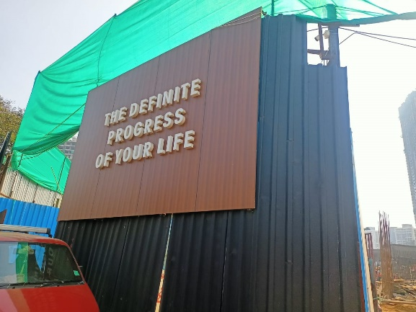
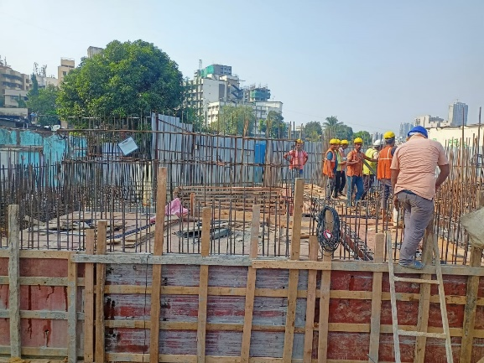
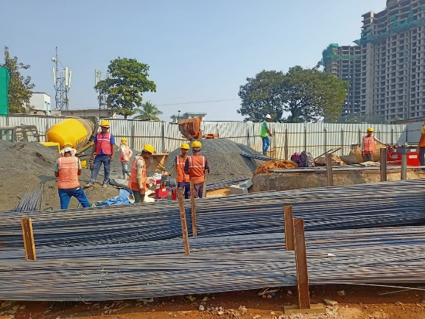
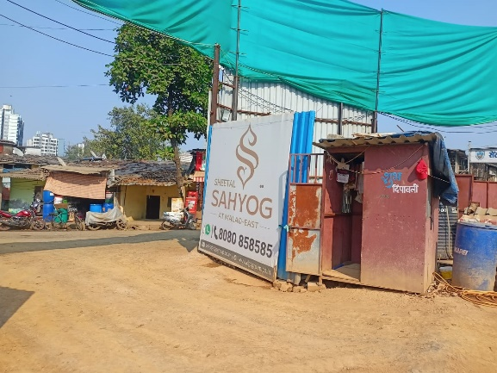
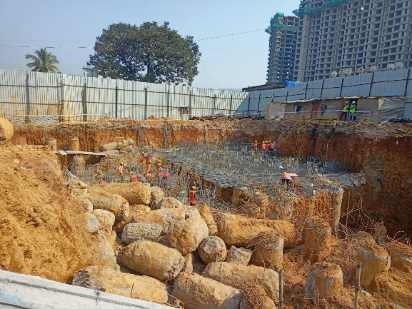
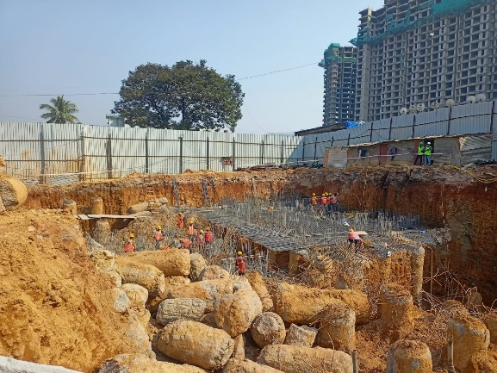
Actual Site Photographs As on 22.11.2023 (Sale Building)
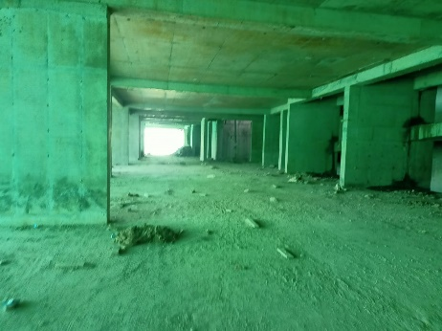
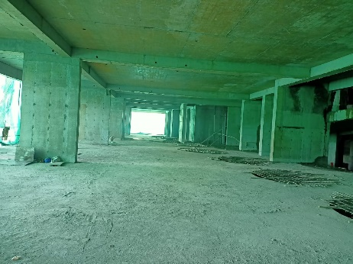
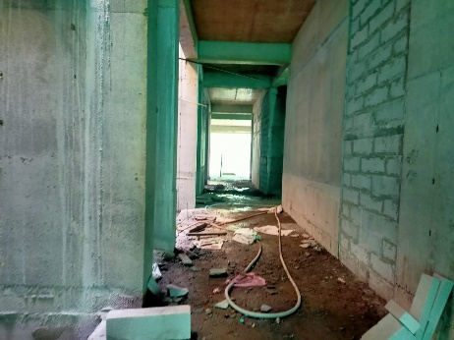
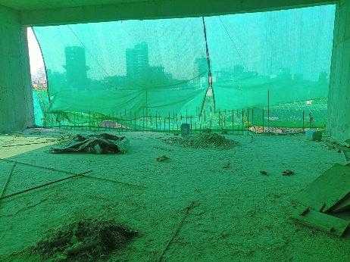
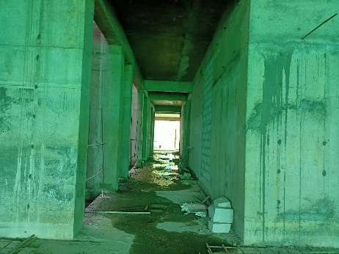
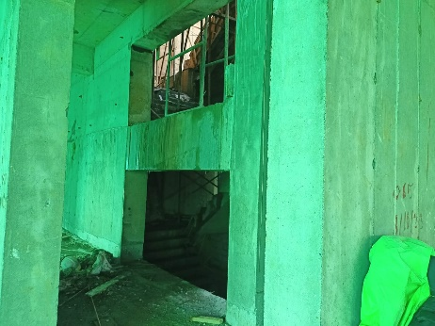
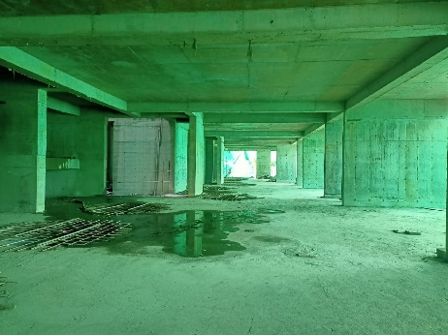
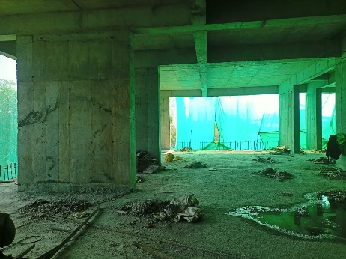
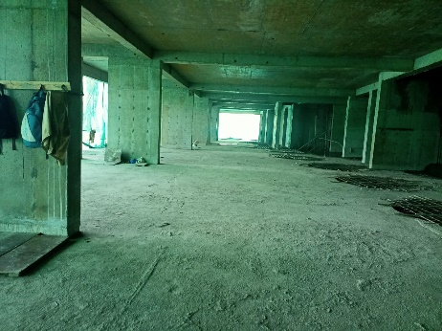
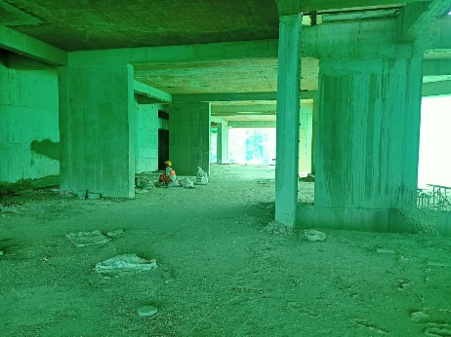
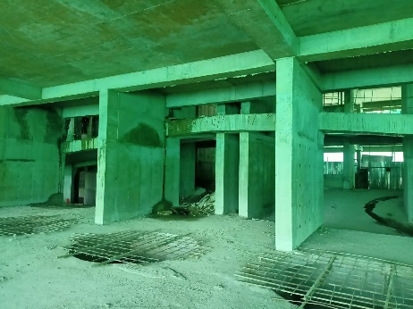
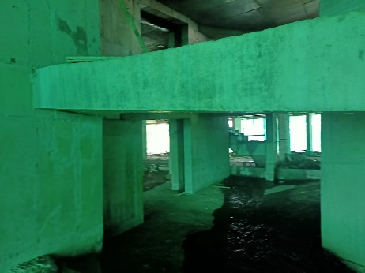
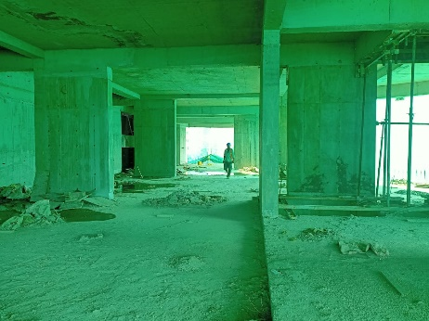
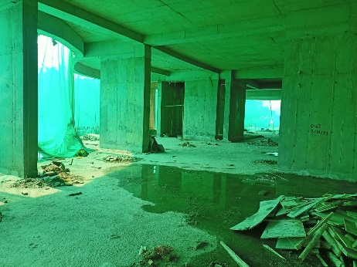
Actual Site Photographs As on 22.11.2023 (Sale Building)
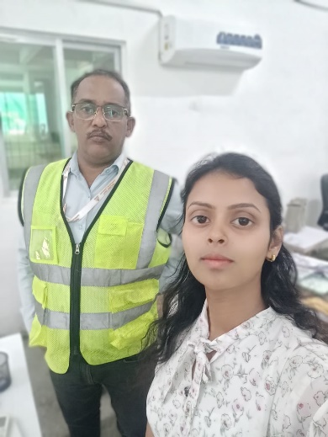
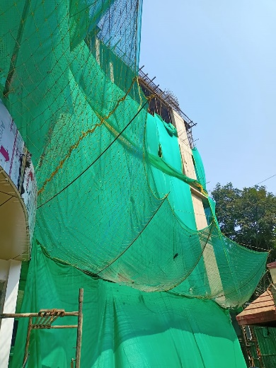
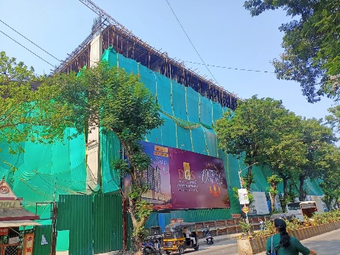
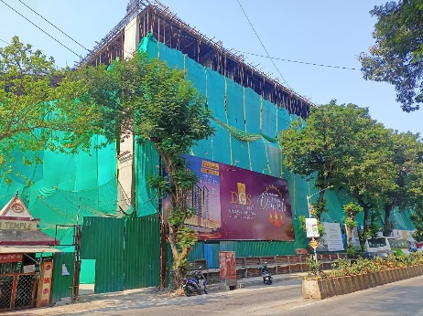
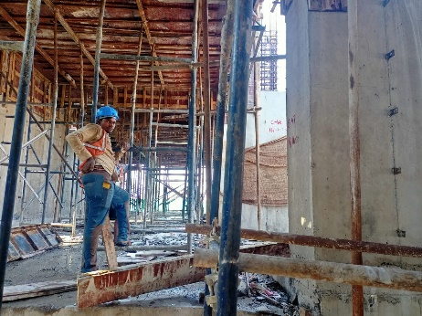
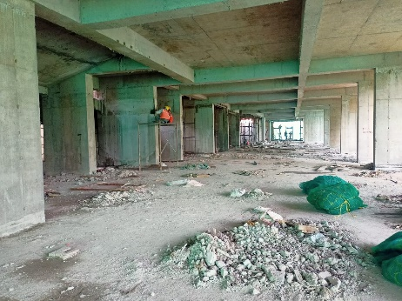
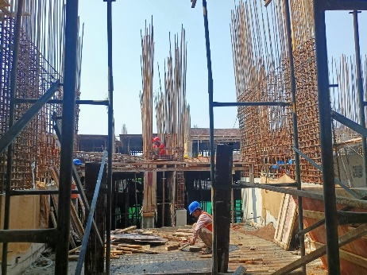
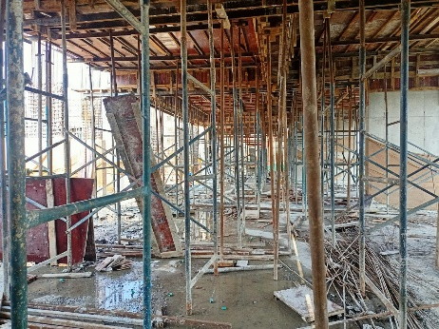
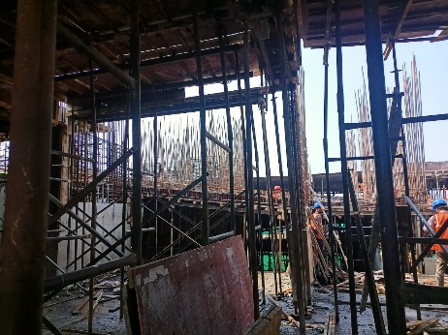
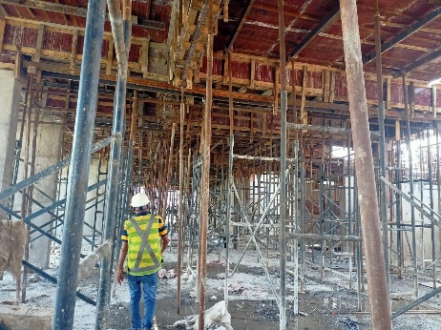
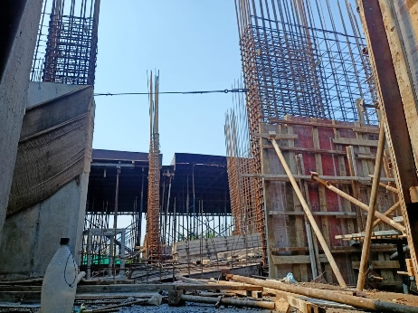
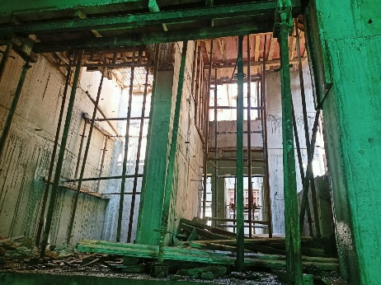
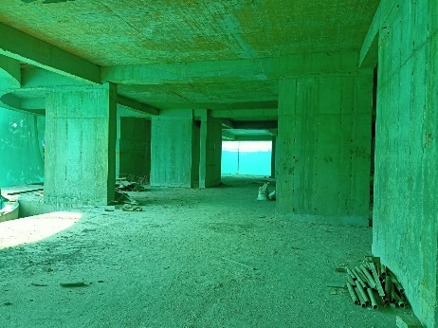
Route Map of the property
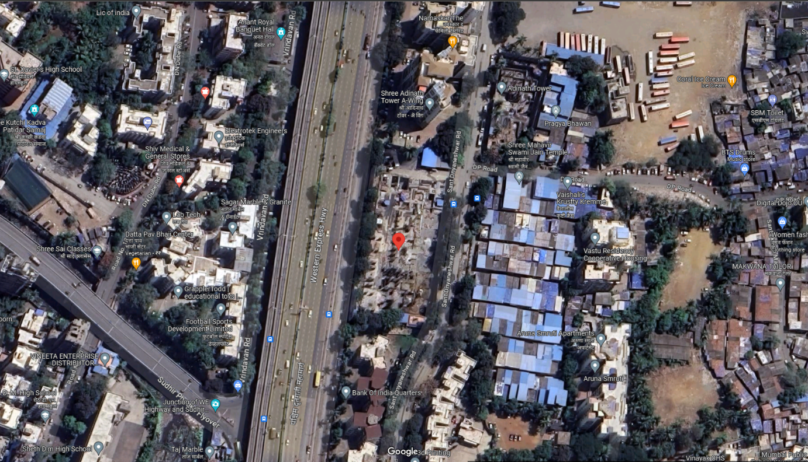
Site u/r

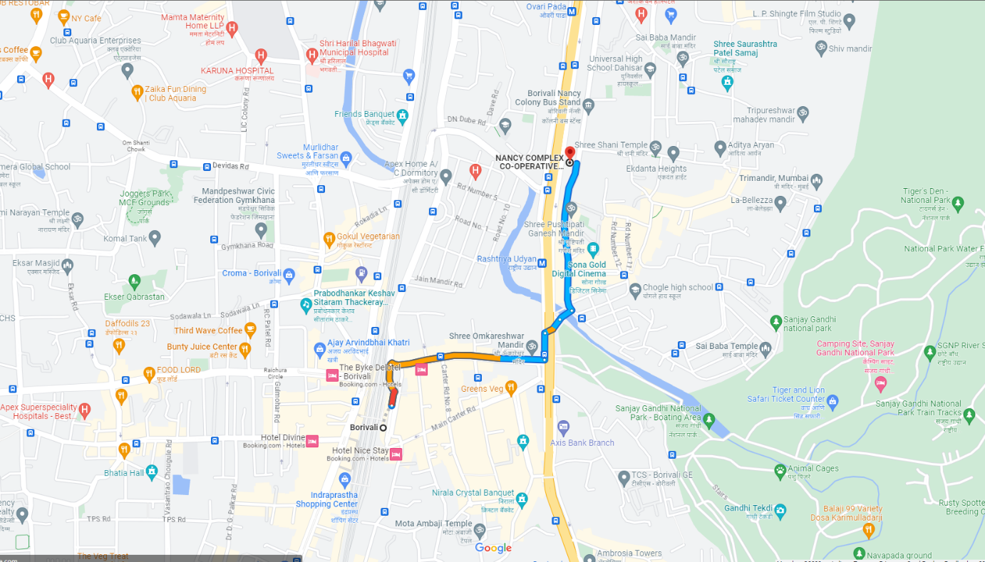

Latitude Longitude: 19°14'17.2"N 72°51'50.9"E

Note: The Blue line shows the route to site from nearest railway station (Borivali – 1.60 Km.)
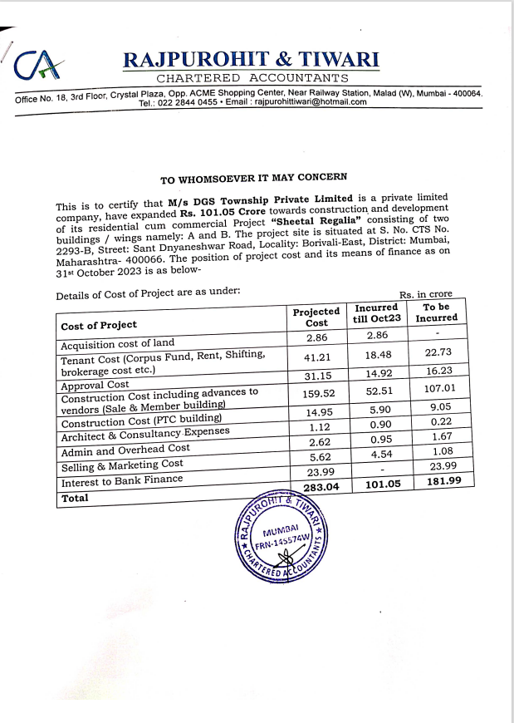
CA Certificate Dated 23.11.2023 till 31.10.2023

CA Certificate Dated 22.11.2023 till 31.10.2023
