Vastu/Nashik/09/3069/2302454
08/15-98-CHV
Date: 26.12.2023

To,
State Bank of India
RACC Nashik Branch
RBO.2, The Wave Building, 1st Floor, Opposite Shell Petrol Pump,
Pathardi Road, Nashik – 422 010, State – Maharashtra, Country – India.

Sub: Vetting of Estimate

Sir,

With reference to above subject, we have evaluated the Estimate for Residential Bungalow on Plot No.17, Ground + First + Second Floor, Survey No.535/1/1, Near Saileela Apartment, Sagar Village, Village – Adgaon, Taluka & District - Nashik, PIN Code - 422 003, State - Maharashtra, Country - India belongs Shri.Rajendra Ratan Jadhav.

We have verified the rates quoted as per current market rates. Details of Estimate considered as per copy of Estimate Provided by Aakruti Designer received on dated 26.12.2023. The Estimate amount is Rs.41,00,000/- (Rupees Forty One Lakh Only. )

Note:1) The said Cost Vetting Certificate is valid upto next 6 months Only.

Thanking you

Sincerely yours

Manoj B. Chalikwar
Registered Valuer
Chartered Engineer (India)
Reg. No. CAT-I-F-1763
SBI Empanelment No.: SME/TCC/2021-22/86/3
Encl: Valuation report.

Estimate
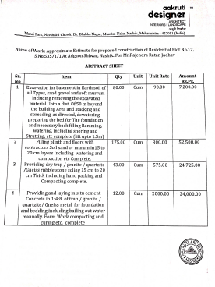
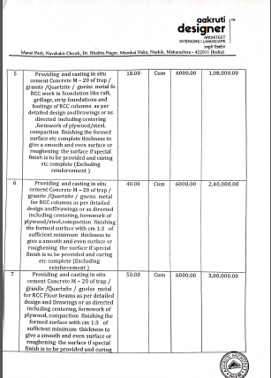

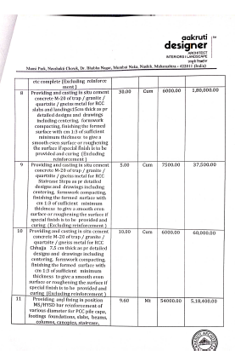
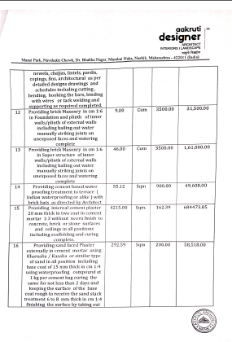

Estimate
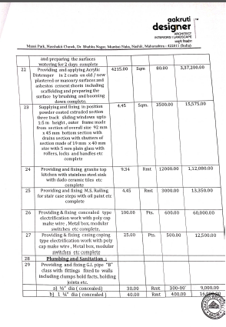
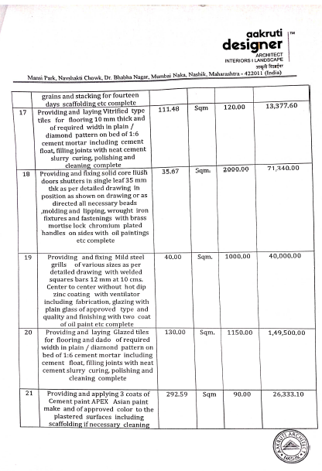

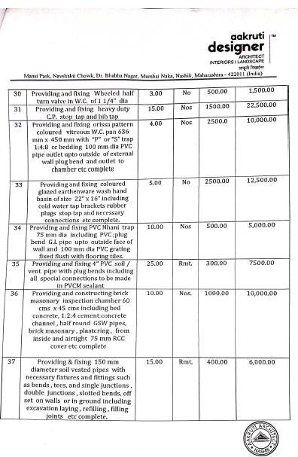
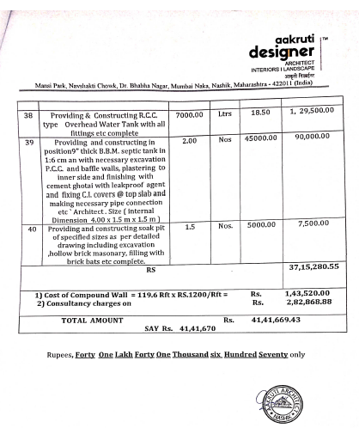

The Estimate amount is Rs.41,00,000/- (Rupees Forty One Lakh Only. )

