Vastu/Nashik/12/2023/005870/2304160
23/20-389-RYBS
Date: 23.12.2023

To,
The Branch Manager,
State Bank of India
RACPC Nashik Branch
1st Floor, Patel Plaza, N.D. Patel Road,
Opp. BSNL, Landmark Seawoods Navratna Hotel,
Nashik - 422001, State – Maharashtra, Country – India.

Sub: Vetting of Extra Amenities

Sir,

With reference to above subject, we have evaluated the Extra Amenities for Residential Row House No. 07, Ground + First + Second Floor, “ Shri Vallabh Row Houses ”, Survey No. 527+528+529+530, Plot No11+12/1 to 6, Near Kids Kingdom Pre School, Sagar Village, Mumbai - Agra National Highway, Jatra Hotel, Village – Adgaon, Taluka & District - Nashik, PIN Code - 422 003, State - Maharashtra, Country - India. belongs Name of Proposed Purchaser: Sau.Vaishali Rameshwar Wagh. Name of Owner: Shri. Gyandev Digambar patil & Sau. Meenakshi Bharat Patil.

We have verified the rates quoted as per current market rates. Details of Extra Amenities considered as per copy of Extra Amenities Agreement between Sau.Vaishali Rameshwar Wagh (First Party). Sau. Vrushali Rishikesh Patil (Second Party) received on dated 22.12.2023. The Extra Amenities amount is Rs. 4,00,000/- (Rupees Four Lakh Only)

The said Cost Vetting Certificate is valid upto next 6 months Only.

Thanking you

Sincerely yours

Sharadkumar B. Chalikwar

Govt. Reg. Valuer
Chartered Engineer (India)
Reg. No. (N) CCIT/1-14/52/2008-09
SBI Empanelment No.: SME/TCC/2021-22/85/13
Encl: Valuation report

Agreement for Extra Amenities
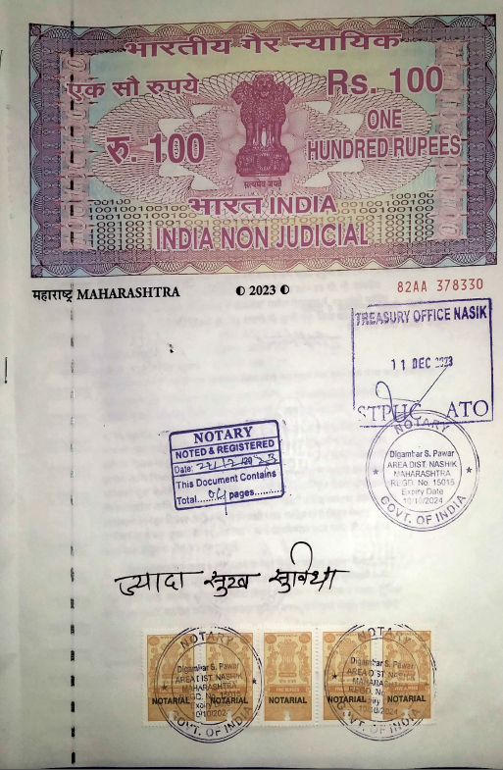
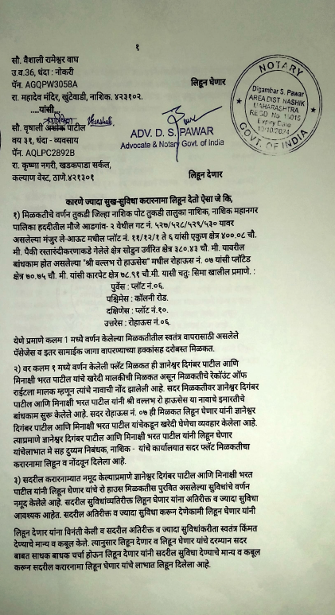

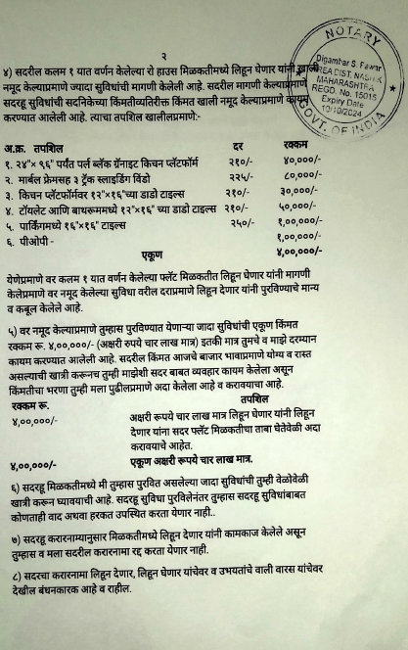
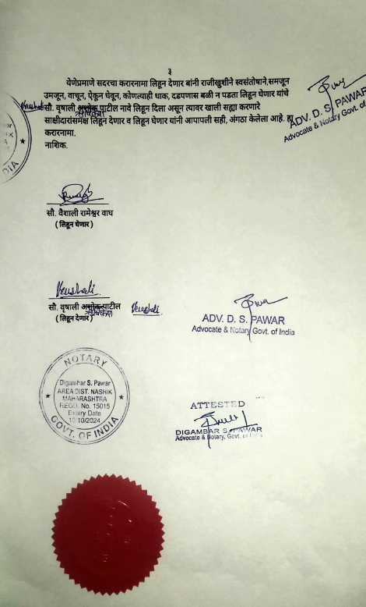

The Extra Amenities amount is Rs. 4,00,000/- (Rupees Four Lakh Only)

