Vastu/Nashik/06/32014/2301224
22/20-325-RYBS
Date: 22.12.2023

To,
The Branch Manager,
Bank of Baroda
Regional Office
BSNL Building, Datta Mandir Road, Nashik Road,
Nashik, PIN – 422 101, State - Maharashtra, Country - India.

Sub: Vetting of Extra Amenities

Sir,

With reference to above subject, we have evaluated the Extra amenities For Residential Flat No. A - 602, Sixth Floor, A-Wing "Millennium Tower", Survey No. 200/ 6/ 1, Plot No.1A, Behind Laxminarayan Yeola Pathaini Sarees, Sai Nagar, Ayodhya Nagari, SaiNagar Road, Village – Nashik, Taluka- Nashik, District - Nashik, PIN Code – 422 003, State – Maharashtra, Country – India. belongs to Name of Owner: Shri. Shivraj Shashikant Patil & Sau. Meena Shashikant Patil.

We have verified the rates quoted as per current market rates. Details of Extra Amenities considered as per copy of Extra Amenities Agreement between Shri. Shivraj Shashikant Patil & Sau. Meena Shashikant Patil. (First Party). Mr. Laxman Vitthal Gangurde (Second Party) received on dated 21.12.2023. The Extra Amenities amount is Rs. 10,00,000/- (Rupees Ten Lakh Only)

The said Cost Vetting Certificate is valid upto next 6 months Only.

Thanking you

Sincerely yours

Manoj B. Chalikwar
Registered Valuer
Chartered Engineer (India)
Reg. No. CAT-I-F-1763
Reg. No. IBBI/RV/07/2018/10366
BOB Empanelment No.: ZO:MZ:ADV:46:941
Encl: Valuation report.

Agreement for Extra Amenities
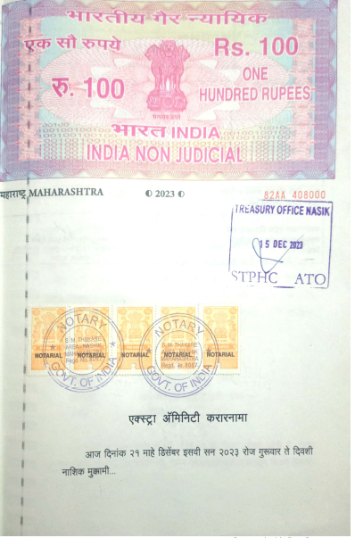
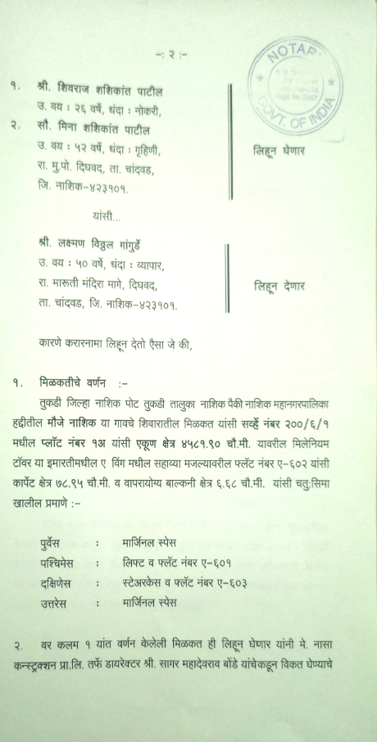

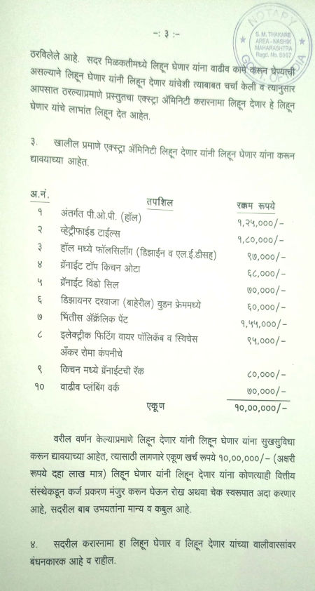
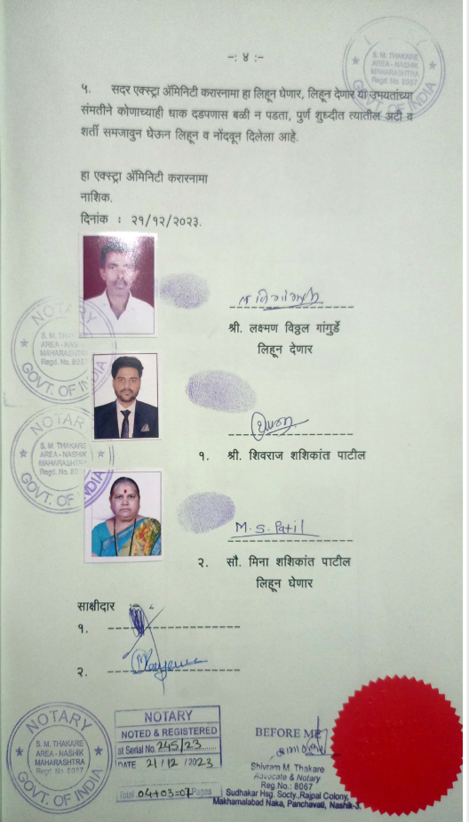

The Extra Amenities amount is Rs. 10,00,000/- (Rupees Ten Lakh Only)

