Vastu/Nashik/12/2023/005834/2304127
22/11-356 -RPBS
Date: 22.12.2023

To, `
The Branch Manager,
Bank of Baroda
Regional Office Nashik Road Branch
BSNL Building, Datta Mandir Road, Nashik Road,
Nashik -422 101, State - Maharashtra, Country - India.

Sub: Vetting of Cost Sheet

Sir,

With reference to above subject, we have evaluated the Vetting of Cost Sheet for Residential Row House No. 1, Ground + 2nd upper Floor, “Shree Shyam Row Houses”, Survey No. 381 / 1B / 2 / 3 / 4 / 1, Plot No. 44+45+46/05, Near Nilkantheshwar Mahadev Mandir, Village – Makhamalabad, Taluka & District - Nashik, PIN Code – 422 004, State – Maharashtra, Country – India belongs to Name of Owner: Shri. Nirav Hareshbhai Vamja. Name of Client / Proposed Purchaser: Shri. Sagar Suresh Pawar & Smt. Punam Sagar Pawar.

We have verified the rates quoted as per current market rates. Details of work and Vetting of Cost Sheet considered as per copy of Cost Sheet issued by Sagar Suresh Pawar (First Party) and Sapna Niraj Vamja (Second Party) received on dated 22.12.2023. The Extra Amenities amount is Rs. 3,03,000 /- (Rupees Three Lakh Three Thousand Only).

The said Cost Vetting Certificate is valid upto next 6 months Only.

Thanking you

Sincerely yours

Manoj B. Chalikwar
Registered Valuer
Chartered Engineer (India)
Reg. No. CAT-I-F-1763
Reg. No. IBBI/RV/07/2018/10366
BOB Empanelment No.: ZO:MZ:ADV:46:941
Encl: Valuation report.

Cost Sheet
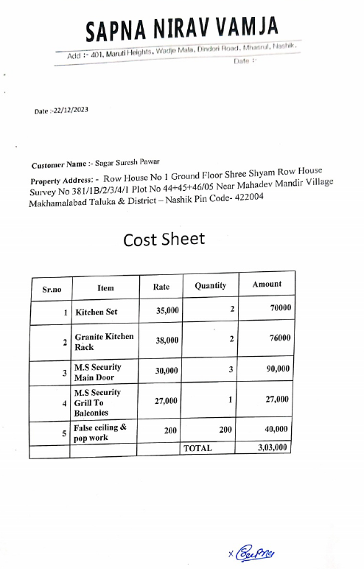

The Extra Amenities amount is Rs. 3,03,000/- (Rupees Three Lakh Three Thousand Only)

