Vastu/Nashik/03/2023833/30490/46262
22/24-455-RPV
Date: 22.12.2023

To, `
The Branch Manager,
Bank of Baroda
Regional Office Nashik Road Branch
BSNL Building, Datta Mandir Road, Nashik Road,
Nashik -422 101, State - Maharashtra, Country - India.

Sub: Vetting of Extra Amenities

Sir,

With reference to above subject, we have evaluated the Extra Amenities for Residential Flat No. A - 803, 8th Floor, A - Wing, " Shreebramhand Apartment ", Survey No. 843/ 3, Plot No. 7 to 9/ 842/ 3/ 1, Near Metro Wholesale Mall, Ashirvad Nagar, Uttara Nagar, Tapovan Link Road, Village - Nashik, Taluka & District - Nashik, PIN Code – 422011, State – Maharashtra, Country – India belongs to Name of Owner: Mr. Omkar Gopal Joshi & Mrs. Anvi Omkar Joshi.

We have verified the rates quoted as per current market rates. Details of work and Extra Amenities considered as per copy of Agreement for Extra Amenities issued by Shri. Omkar Gopal Joshi & Sau. Anvi Omkar Joshi (First Party) and Sau. Naziya Emtiyaz Momin (Second Party) received on dated 21.12.2023. The Extra Amenities amount is Rs.10,50,000/- ( Rupees Ten Lakh Fifty Thousand Only. )

The said Cost Vetting Certificate is valid upto next 6 months Only.

Thanking you

Sincerely yours

Manoj B. Chalikwar
Registered Valuer
Chartered Engineer (India)
Reg. No. CAT-I-F-1763
Reg. No. IBBI/RV/07/2018/10366
BOB Empanelment No.: ZO:MZ:ADV:46:941
Encl: Valuation report.

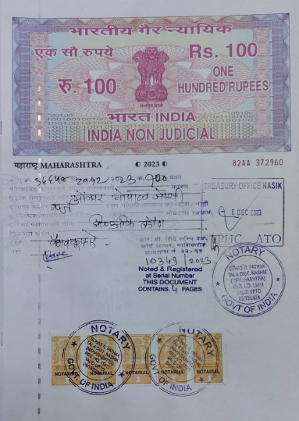
Agreement for Extra Amenities
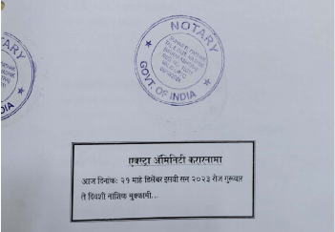

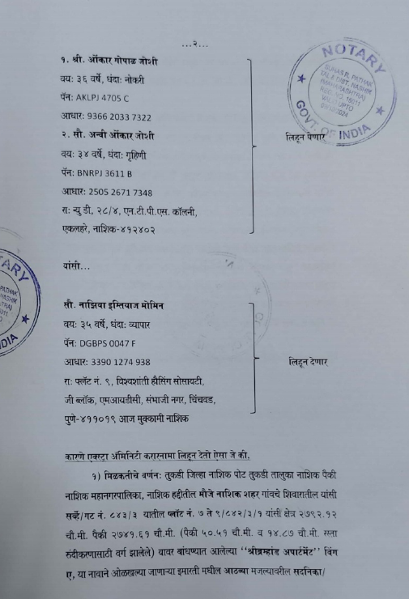

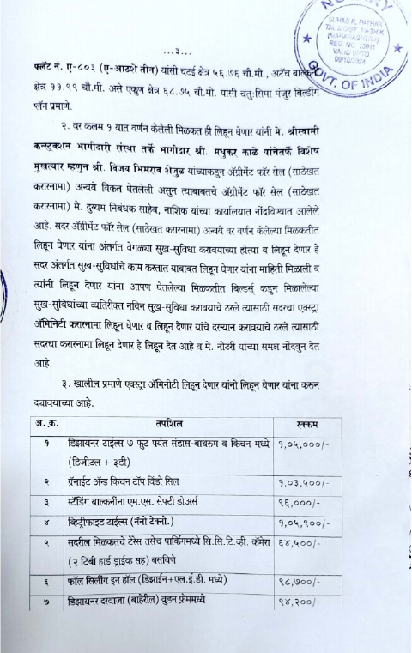
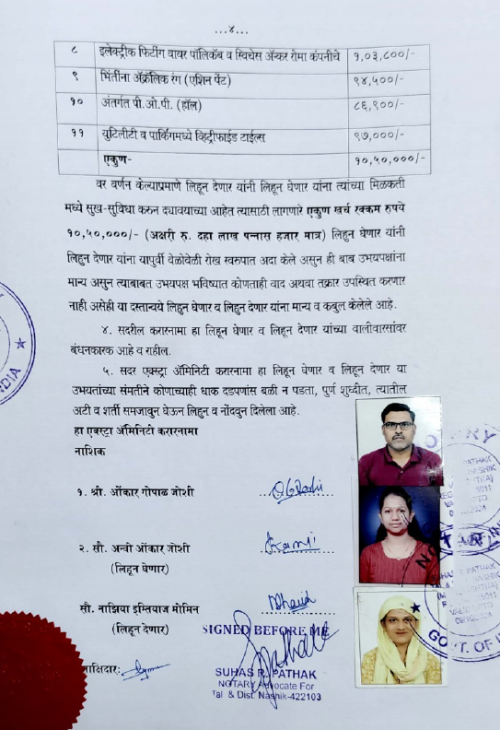

The Extra Amenities amount is Rs. 10,50,000/- ( Rupees Ten Lakh Fifty Thousand Only. )

