Vastu/Nashik/12/005779/2304088
20/23-317-RYBS
Date: 20.12.2023

To,
The Branch Manager,
Bank of Baroda
Regional Office
BSNL Building, Datta Mandir Road, Nashik Road,
Nashik, PIN – 422 101, State - Maharashtra, Country - India.

Sub: Vetting of Extra Work

Sir,

With reference to above subject, we have evaluated the Extra Work for Residential Flat No.9, Third Floor, " Lotus Park ", Survey No. 213, Plot No. 30, Behind Bhagwati Shopping Centre & Fitness Zone, Opp. to. RK-C Building, Viman Nagar, Deola - Nashik Road, Village - Ozar, Taluka- Niphad, District - Nashik, PIN Code – 422 206, State – Maharashtra, Country – India belongs Mr. Mayur Nanasaheb Mandlik & Mrs. Pranita Mayur Mandlik.

We have verified the rates quoted as per current market rates. Details of Extra Work considered as per copy of Extra Work Agreement between Mr. Mayur Nanasaheb Mandlik & Mrs. Pranita Mayur Mandlik (First Party). Mr. Abhishek Balasaheb Deshmukh (Second Party) received on dated 19.12.2023. The Extra Work amount is Rs. 3,50,000/- (Rupees Three Lakh Fifty Thousand Only)

The said Cost Vetting Certificate is valid upto next 6 months Only.

Thanking you

Sincerely yours

Manoj B. Chalikwar
Registered Valuer
Chartered Engineer (India)
Reg. No. CAT-I-F-1763
Reg. No. IBBI/RV/07/2018/10366
BOB Empanelment No.: ZO:MZ:ADV:46:941
Encl: Valuation report.

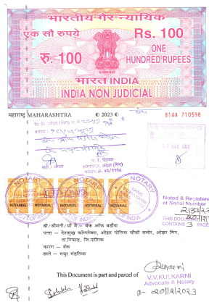
Agreement for Extra Work
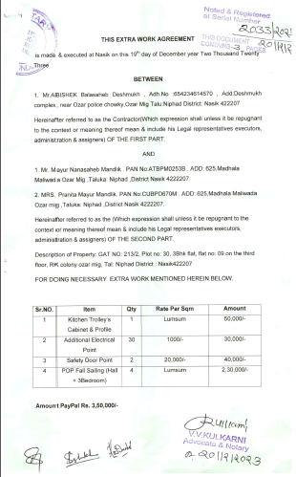

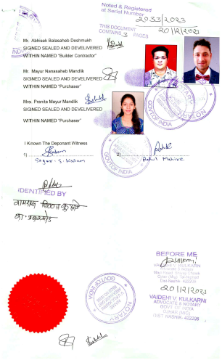

The Extra Work amount is Rs. 3,50,000/- (Rupees Three Lakh Fifty Thousand Only)

