Vastu/Nashik/03/2023833/30490/46262
22/24-455-RPV
Date: 20.12.2023

To, `
The Branch Manager,
State Bank of India
Adgaon Branch
Vibhuti, Plot No. 1, Survey No.501, Nashik-Agra Road, Adgaon Shivar,
Nashik - 422003, State – Maharashtra, Country – India.

Sub: Vetting of Extra Amenities

Sir,

With reference to above subject, we have evaluated the Extra Amenities for Residential Flat No. 06, Second Floor, "Shiv Orchid", Survey No. 47/ 6B/ 3 + 47/ 6A/ 1/ 1, Plot No. 03, Near Viraj Sweets, Vijay Nagar, Indra Gandhi Nagar, Jai Bhavani Road, Village – Deolali, Taluka & District - Nashik, PIN Code – 422 101, State – Maharashtra, Country – India belongs to Name of Owner: Shri. Santosh Ganpat Gosavi & Sau. Sonali Santosh Gosavi.

We have verified the rates quoted as per current market rates. Details of work and Extra Amenities considered as per copy of Extra Amenities issued by Shri. Santosh Ganpat Gosavi & Sau. Sonali Santosh Gosavi (First Party) and Sau. Suvarna Nitin Jagale (Second Party) received on dated 09.12.2023. The Extra Amenities amount is Rs.5,70,000/- ( Rupees Five Lakh Seventy Thousand Only. )

The said Cost Vetting Certificate is valid upto next 6 months Only.

Thanking you

Sincerely yours

Manoj B. Chalikwar
Registered Valuer
Chartered Engineer (India)
Reg. No. CAT-I-F-1763
Reg. No. IBBI/RV/07/2018/10366
BOB Empanelment No.: ZO:MZ:ADV:46:941
Encl: Valuation report.

Agreement for Extra Amenities
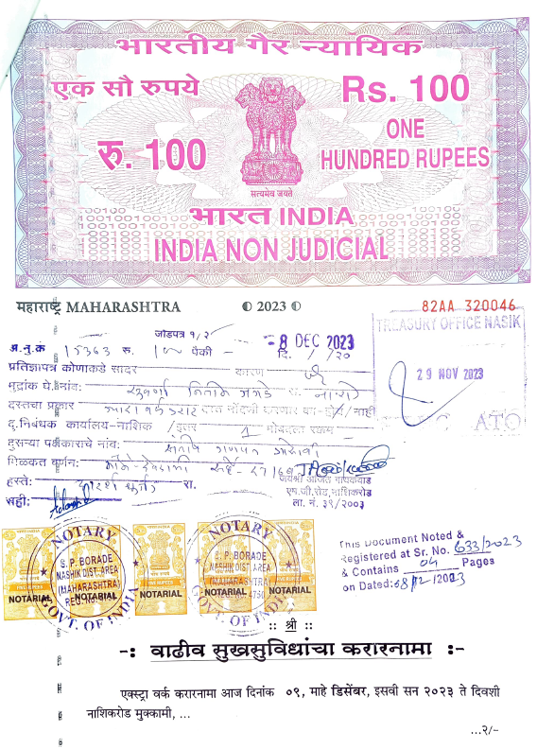
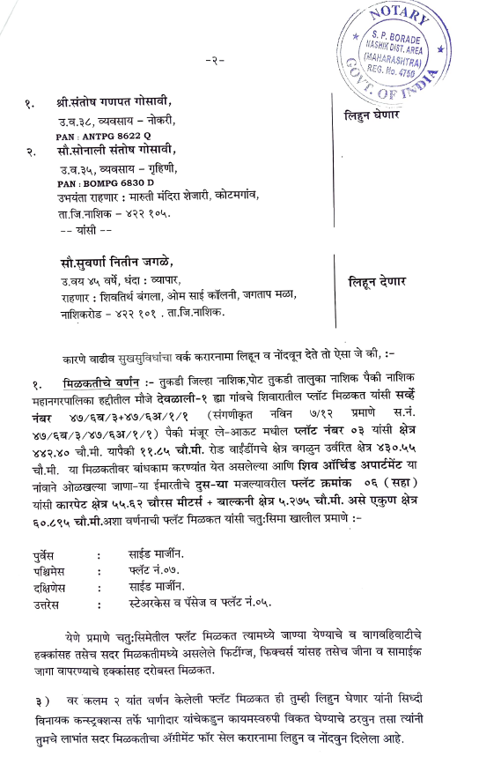

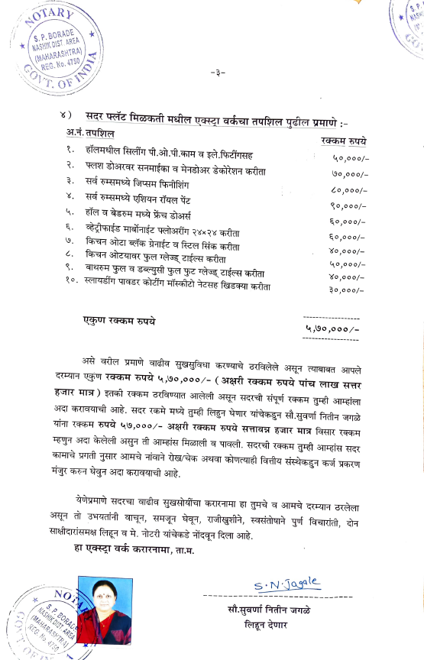
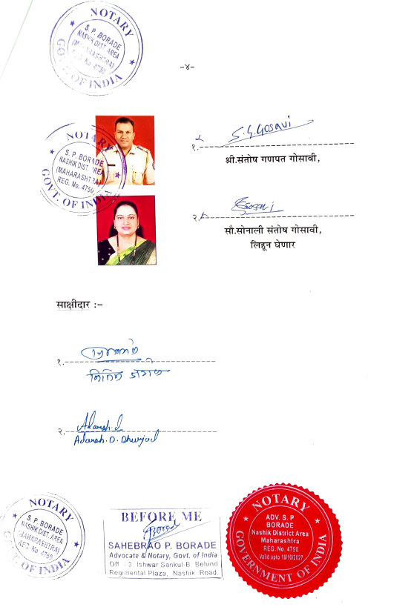

The Extra Amenities amount is Rs.5,70,000/- ( Rupees Five Lakh Seventy Thousand Only. )

