Vastu/Nashik/03/2023833/30490/46262
22/24-455-RPV
Date: 19.12.2023

To, `
The Branch Manager,
Bank of Baroda
Regional Office Nashik Road Branch
BSNL Building, Datta Mandir Road, Nashik Road,
Nashik -422 101, State - Maharashtra, Country - India.

Sub: Vetting of Cost Sheet

Sir,

With reference to above subject, we have evaluated the Cost Sheet for Residential Flat No. 04, First Floor, " Shiv Angan", Survey No. 30/ 3A/ 1/ 1/ 143, Plot No. 04, Behind APMC Market Yard, Near Sai Residency, Samarth Nagar, Peth Road, Village - Makhmalabad, Taluka & District - Nashik, PIN Code – 422004, State – Maharashtra, Country – India belongs to Name of Proposed Purchaser: Shri. Chandrakant Dnyameshwar Nikam & Sau. Apeksha Chandrakant Nikam. Name of Owner: Shri. Rameshbhai Waljibhai Kotadiya & Shri. Nitin Rameshbhai Kotadiya.

We have verified the rates quoted as per current market rates. Details of work and Cost Sheet considered as per copy of Cost Sheet issued by Shri. Chandrakant Dnyameshwar Nikam (First Party) and Shri. Rameshbhai Waljibhai Kotadiya & Shri. Nitin Rameshbhai Kotadiya (Second Party) received on dated August 2023. The Extra Amenities amount is Rs.1,70,000/- ( Rupees One Lakh Seventy Thousand Only. )

The said Cost Vetting Certificate is valid upto next 6 months Only.

Thanking you

Sincerely yours

Manoj B. Chalikwar
Registered Valuer
Chartered Engineer (India)
Reg. No. CAT-I-F-1763
Reg. No. IBBI/RV/07/2018/10366
BOB Empanelment No.: ZO:MZ:ADV:46:941
Encl: Valuation report.

Cost Sheet
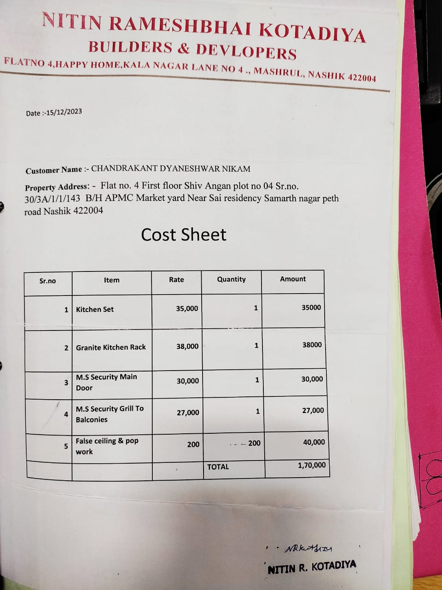

The Extra Amenities amount is Rs.1,70,000/- ( Rupees One Lakh Seventy Thousand Only. )

