Vastu/Nashik/06/32014/2301224
22/20-325-RPV
Date: 18.12.2023

To,
The Branch Manager,
Union Bank of India
Nashik Highway Branch
Shop No. 2, 3, 4, Sagar Plaza, Amrut Dham, Panchavati, Nashik – 422 003,
State – Maharashtra, Country – India.

Sub: Vetting of Extra Work

Sir,

With reference to above subject, we have evaluated the Extra Amenities for Residential Land and Row House No. 3 On Gut No.490/2/13/Plot/13, Ground Floor + 2nd Floor, Near Jatra Bakers Cake Shop, Sri Ram Nagar, Konark Nagar, Mumbai - Agra National Highway, Village – Adgaon. Taluka & District - Nashik, PIN Code – 422 006, State – Maharashtra, Country – India belongs to Shri. Parag Pralhad Khairnar. Name of Proposed Purchaser: Shri. Yogesh Shivaji Shelar & Sau. Vaishali Yogesh Shelar.

We have verified the rates quoted as per current market rates. Details of Extra Work considered as per copy of Extra Work Agreement between Mr. Yogesh Shivaji Shelar (First Party). Mr. Satish Raosaheb Rahinj (Second Party) received on dated 13.12.2023. The Extra Work amount is Rs. 4,00,000/- (Rupees Four Lakh Only)

The said Cost Vetting Certificate is valid upto next 6 months Only.

Thanking you

Sincerely yours

Sharadkumar B. Chalikwar
Govt. Reg. Valuer
Chartered Engineer (India)
Reg. No. (N) CCIT/1-14/52/2008-09

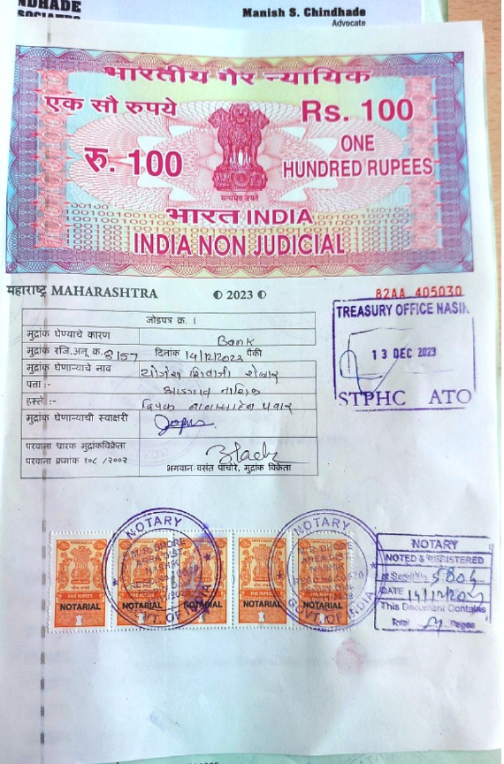
Agreement for Extra Work
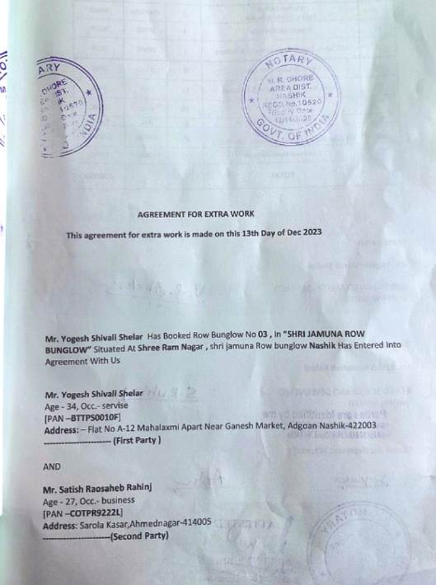

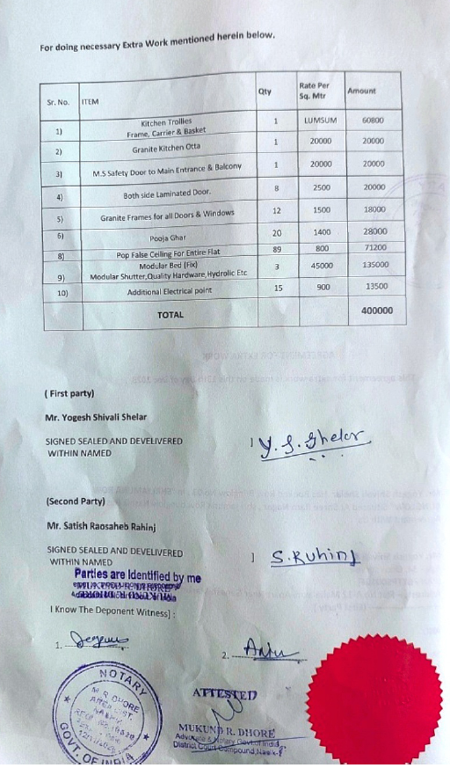

The Extra Amenities amount is Rs. 4,00,000/- (Rupees Four Lakh Only)

