Valuation Report of the Movable and Immovable Property
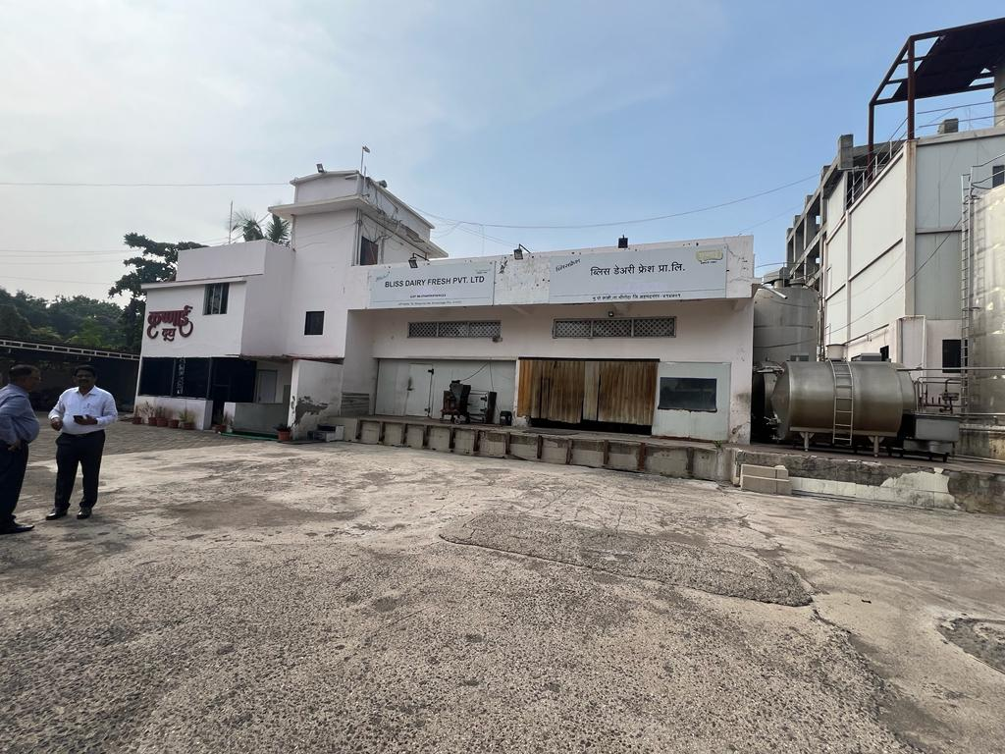

Details of the property under consideration:

Name of Owner: M/s. Bliss Dairy Fresh Pvt. Ltd.

Land & Building and Plant & Machinery bearing Gat No. 1148/2, Village – Kashti, Taluka – Shrigonda,
District – Ahmednagar, PIN – 414 701, State - Maharashtra, Country– India

Latitude Longitude - 18°31'24.7"N 74°34'54.5"E

Valuation Done for:

Cosmos Bank
Regional Office, Dadar (West) Branch
36/A, Maru Niketan, D. L. Vaidya Road, Dadar (West), Mumbai – 400028,
State - Maharashtra, Country – India

Vastu/Mumbai/12/2023/005703/31806
12/05-104-AUM
Date: 20.12.2023

VALUATION OPINION REPORT

The property bearing Land & Building and Plant & Machinery bearing Gat No. 1148/2, Village – Kashti, Taluka – Shrigonda, District – Ahmednagar, PIN – 414 701, State - Maharashtra, Country– India belongs to M/s. Bliss Dairy Fresh Pvt. Ltd.

Boundaries of the property |  | Actual Site | As per Sale Deed
North | : | Open plot | Gat Nos. 1149 and 1151
South | : | Open plot | Gat Nos. 1146 and 1147
East | : | Ahmednagar – Daund Road | Nagar –Daund Road
West | : | Open plot | Gat No. 1152

Considering various parameters recorded, existing economic scenario, and the information that is available with reference to the development of neighbourhood and method selected for valuation, we are of the opinion that, the property premises can be assessed and valued for SARFAESI Securitisation and Reconstruction of Financial Assets and Enforcement of Security Interest Act, 2002 purpose as below
Particulars | Fair Market Value In  (`) | Realizable Value In (`) | Distress Sale Value In (`)
A) Value of Land | 11,64,00,000.00 | 9,89,40,000.00 | 8,14,80,000.00
B) Value of Structure | 1,66,96,554.00 | 1,41,92,071.00 | 1,16,87,588.00
C) Value of Land Development | 75,00,000.00 | 63,75,000.00 | 52,50,000.00
Total Value of Land and Building | 14,05,96,554.00 | 11,95,07,071.00 | 9,84,17,588.00
D) Value of Plant & Machinery | 2,70,85,000.00 | 2,30,22,250.00 | 1,89,59,500.00
TOTAL VALUE OF LAND & BUILDING AND PLANT & MACHINERY | 16,76,81,554.00 | 14,25,29,321.00 | 11,73,77,088.00

The valuation of the property is based on the documents produced by the concern. Legal aspects have not been taken into considerations while preparing this valuation report.

Hence certified

Sharadkumar B. Chalikwar
Govt. Reg. Valuer
Chartered Engineer (India)
Reg. No. IBBI/RV/07/2019/11744

Reg. No. (N) CCIT/1-14/52/2008-09

Encl: Valuation report in Form – 01

Valuation Report of Land & Building and Plant & Machinery bearing Gat No. 1148/2, Village – Kashti, Taluka – Shrigonda, Dist. - Ahmednagar, State - Maharashtra, Country – India, belongs to M/s. Bliss Dairy Fresh Pvt. Ltd.
Form 0-1

(See Rule 8 D)

REPORT OF VALUATION OF IMMOVABLE PROPERTY (OTHER THAN AGRICULTURAL LANDS, PLANTATIONS, FORESTS, MINES AND QUARRIES)

GENERAL:

1 | Purpose for which the valuation is made |  | To assess the Fair Market Value as on 18.12.2023 SARFAESI Securitisation and Reconstruction of Financial Assets and Enforcement of Security Interest Act, 2002 purpose.
2 | Date of inspection |  | 16.12.2023
3 | Name of the owner/ owners |  | M/s. Bliss Dairy Fresh Pvt. Ltd.
4 | If the property is under joint ownership / co-ownership, share of each such owner. Are the shares undivided? |  | Pvt. Ltd. Company ownership
5 | Brief description of the property |  | Land & Building and Plant & Machinery bearing Gat No. 1148/2, Village – Kashti, Taluka – Shrigonda, Dist. –Ahmednagar - 414 701, State - Maharashtra, Country – India.
6 | Location, street, ward no |  | Ahmednagar – Daund Highway
7 | Survey/ Plot no. of land |  | Gat No. 1148/2
8 | Is the property situated in residential/ commercial/ mixed area/ industrial area? |  | Mixed area
9 | Classification of locality-high class/ middle class/poor class |  | Middle Class
10 | Proximity to civic amenities like schools, Hospitals, Offices, market, cinemas etc. |  | All the amenities are available in the vicinity
11 | Means and proximity to surface communication by which the locality is served |  | Served by Buses, Auto, and Private vehicles.
 | LAND
12 | Area of land supported by documentary proof. Shape, dimension and physical features |  | 97R i.e. 9,700.00 Sq. M.  (As per Sale Deed)
13 | Roads, Streets or lanes on which the land is abutting |  | East Side: Nagar –Daund Road
14 | If freehold or leasehold land
15 | If leasehold, the name of Lessor/lessee, nature of lease, date of commencement and termination of lease and terms of renewal of lease. |  | N.A., Freehold Land
 | (i) Initial premium
 | (ii) Ground rent payable per annum
 | (iii) Unearned increase payable to the Lessor in the event of sale or transfer
16 | Is there any restriction covenant in regard to use of land? If so attach a copy of the covenant. |  | As per documents
17 | Are there any agreements of easements? If so attach a copy of the covenant |  | Information not available
18 | Does the land fall in an area included in any Town Planning Scheme or any Development Plan of Government or any statutory body? If so give Particulars. |  | Local authority
19 | Has any contribution been made towards development or is any demand for such contribution still outstanding. |  | Information not available
20 | Has the whole or part of the land been notified for acquisition by government or any statutory body? Give date of the notification. |  | No
21 | Attach a dimensioned site plan |  | Attached
 | IMPROVEMENTS
22 | Attach plans and elevations of all structures standing on the land and a lay-out plan. |  | Attached
23 | Furnish technical details of the building on a separate sheet (The Annexure to this form may be used) |  | Attached
24 | Is the building owner occupied/tenanted/both? |  | Vacant and under Bank’s Possession
 | If the property owner occupied, specify portion and extent of area under owner-occupation |  | N.A.
25 | What is the Floor Space Index permissible and Percentage actually utilized? |  | F.S.I.- As per local norms  F.S.I. % actually utilized - Information not available
26 | RENTS
 | (i) | Names of tenants/ lessees/ licensees, etc. | N.A.
 | (ii) | Portions in their occupation | N.A.
 | (iii) | Monthly or annual rent /compensation/license fee, etc. paid by each | N.A.
 | (iv) | Gross amount received for the whole property | N.A.
27 | Are any of the occupants related to, or close to business associates of the owner? |  | N.A.
28 | Is separate amount being recovered for the use of fixtures, like fans, geysers, refrigerators, cooking ranges, built-in wardrobes, etc. or for services charges? If so, give details |  | N. A.
29 | Give details of the water and electricity charges, if any, to be borne by the owner |  | Information not available
30 | Has the tenant to bear the whole or part of the cost repairs and maintenance? Give particulars |  | N.A.
31 | If a lift is installed, who is to bear the cost of maintenance and operation- owner or tenant? |  | N.A.
32 | If a pump is installed, who is to bear the cost of maintenance and operation- owner or tenant? |  | Information is not available
33 | Who has to bear the cost of electricity charges for lighting of common space like entrance hall, stairs, passage, compound, etc. owner or tenant? |  | M/s. Bliss Dairy Fresh Pvt. Ltd.
34 | What is the amount of property tax? Who is to bear it? Give details with documentary proof |  | Information not available
35 | Is the building insured? If so, give the policy no., amount for which it is insured and the annual premium |  | Information not available
36 | Is any dispute between landlord and tenant regarding rent pending in a court of rent? |  | N. A.
37 | Has any standard rent been fixed for the premises under any law relating to the control of rent? |  | N. A.
 | SALES
38 | Give instances of sales of immovable property in the locality on a separate sheet, indicating the Name and address of the property, registration No., sale price and area of land sold. |  | As per sub registrar of assurance
39 | Land rate adopted in this valuation |  | `12,000.00 Per Sq. M.
40 | If sale instances are not available or not relied up on, the basis of arriving at the land rate |  | Online Price Indicators, Location, development of surrounding area, type of land and construction, size of land, access to main road, construction specifications, age of building, condition of the premises & building, facilities provided and its prevailing market rate.
 | COST OF CONSTRUCTION
41 | Year of commencement of construction and year of completion |  | Commencement of construction -1994 and 2017
42 | What was the method of construction, by contract/By employing Labour directly/ both? |  | Information not available
43 | For items of work done on contract, produce copies of agreements |  | Information not available
44 | For items of work done by engaging Labour directly, give basic rates of materials and Labour supported by documentary proof. |  | Information not available

PART II- VALUATION

GENERAL:
Under the instruction of COSMOS Bank, Regional Office Dadar (West) to assess fair market value as on 10th December 2019 for Land & Building and Plant & Machinery bearing Gat No. 1148/2, Village – Kashti, Taluka – Shrigonda, Dist. –Ahmednagar - 414 701, State - Maharashtra, Country – India belongs to M/s. Bliss Dairy Fresh Pvt. Ltd.
We are in receipt of the following documents:
Copy of Sale Deed, Reg. No. 1742/2020 dated 19.06.2020
Copy of Sale Deed, Reg. No. 1206/2020 dated 23.03.2020
Copy of Deed of Confirmation, Reg. No. 1794/2020 dated 22.06.2020
Copy of Composite Deed of Mortgage & Hypothecation, Reg. No. 1743/2020 dated 18.06.2020
Copy of Reconveyance Deed, Reg. No. 1447/2020 dated 02.06.2020
Copy of Search Report dated 25.07.2019
Copy of Gav Namuna 8-A
Copy of Revenue Extract 7/12
Copy of Form 27, Annual Return for the year ending from the 1st January 2018 and ending on 31 December 2018
Copy of Form 01 dated 26.06.2019
Copy of License No. 11517033000541 dated 11.10.2017 issued by Food and Drug Administration, Govt. of Maharashtra. Period of validity 10.10.2022
Copy of Application for Consent / Authorization issued by Maharashtra Pollution Control Board.
Copy of N.A. Order 12.03.1993 issued by Upvibhagiya Adhikari Karjat.
Copy of Lease deed dated 09.12.1993
Copy of Tax Invoice dated 22.02.2019 for Erection & Commissioning Charges for Boiler, Air Preheater, Dust Collector, Chimney
Copy of Tax Invoice dated 22.02.2019 for Supply of material for 3TPH 17.5KG/CM2G
Copy of Tax Invoice dated 22.02.2019 for packing and forwarding on supply material.
Details of machinery provided by the company.

PROPERTY:
The said property is located bearing Gat No. 1148/2, Village – Kashti, Taluka – Shrigonda, Dist. - Ahmednagar, State - Maharashtra, Country – India. The land is converted into Non – Agricultural industrial use. The said property have very good value and building potentialities as it is situated nearer to highway.

PLOT:
The brick masonry wall in cement mortar of height about 4/5’ with M.S. grills on top have been provided for all sides with 2 Nos. MS gates. Levelling and filling is done of land. Internal roads are available. Interlock paver blocks are found around building.

As per Sale Deed, plot area is 0H97R i.e. 9,700 Sq. M, which is considered for valuation.

BUILDING:

The composition of structures is as under:

Structure | Description | Year of construction | Future Life  in years | Area  (Sq. M.)
Plant building | Ground floor RCC framed structure with RCC slab | 1994 | 31 | 422.75
Office building | Ground + 1 upper floor RCC framed structure with RCC slab. It consists of Ceramic flooring, Concealed wiring and plumbing, wooden framed glass doors, Aluminium sliding windows | 1994 | 31 | 285.76
Security cabin | Ground floor RCC framed structure with RCC slab | 1994 | 31 | 18.02
Industrial shed | RCC shed with Color coated sheet roof | 1994 | 21 | 567.54
Ice factory building | RCC framed with Color coated sheet roofing | 2017 | 54 | 59.17
By-product Ice cream section building | Ground + 2 upper floor RCC framed with Color coated sheet roofing | 1994 | 31 | 398.78
Temple and Sabha Mandap | RCC framed structure with RCC slab | 1994 | 21 | 67.10
RCC water tank | - | 1994 | - | 13000 liters
Open sheds | - | 1994 | 21 | 243.00

Valuation as on 20th December 2023:
- Land Valuation
The Land area as per Sale Deed : 9,700.00 Sq. M.
Ready Reckoner Rate : `1,300.00 per Sq. M.
Portal for land
Prevailing market rate : `12,000.00 per Sq. M.
Value of the Land (A) : `11,64,00,000.00
- Building Valuation
Sr. No. | Structure | Type | Floor | Area in Sq. M. | Estimated Replacement Rate in ` | Depreciated Replacement Rate in ` | Depreciated Replacement Value in ` | Insurable Value  in `
 | Plant building | RCC | Ground | 422.75 | 19,000.00 | 10,735.00 | 45,38,221.00 | 80,32,250.00
 | Office building | RCC | Ground + 1 | 285.76 | 23,000.00 | 12,995.00 | 37,13,451.00 | 65,72,480.00
 | Security cabin | RCC | Ground | 18.02 | 15,000.00 | 8,475.00 | 1,52,720.00 | 2,70,300.00
 | Industrial shed | RCC | Ground | 567.54 | 10,500.00 | 5,019.00 | 28,48,483.00 | 59,59,170.00
 | Ice factory building | RCC | Ground | 59.17 | 8,000.00 | 7,280.00 | 4,30,758.00 | 4,73,360.00
 | By-product Ice cream section building | RCC | Ground + 2 | 398.78 | 15,500.00 | 8,758.00 | 34,92,515.00 | 61,81,090.00
 | Temple and sabhamandap | RCC | Ground | 67.10 | 18,000.00 | 8,604.00 | 5,77,328.00 | 12,07,800.00
 | RCC water tank in ltrs. | - | - | 13000 | - | 10.00 | 1,30,000.00 | 1,30,000.00
 | Open sheds | - | - | 243.00 | 7,000.00 | 3,346.00 | 8,13,078.00 | 17,01,000.00
 |  |  |  |  |  | TOTAL | 1,66,96,554.00 | 3,05,27,450.00

- Land Development

Land development such as brick masonry compound wall, M.S. gate, plot filling, plot levelling, garden, internal roads, paving around building with paver blocks, machinery foundation and other miscellaneous items. | ` 75,00,000.00

- Plant and Machinery

S. No. | Description | Original Cost in ` | Fair Market Value in `
1 | Plant & Machinery | 3,60,51,147.00 | 36,05,115.00
2 | Plant & Machinery | 16,58,058.00 | 11,35,770.00
3 | Plant & Machinery | 6,94,322.00 | 5,06,855.00
4 | Plant & Machinery | 30,933.00 | 23,973.00
5 | Boiler #TPH 17.5 Kg/Cm2G | 41,35,094.00 | 33,90,777.00
6 | Cold Room | 8,00,000.00 | 5,84,000.00
7 | Condense Plant | 6,98,272.00 | 5,41,161.00
8 | Condense Plant | 48,541.00 | 39,804.00
9 | Condense Plant | 2,05,78,702.00 | 1,50,22,452.00
10 | DG Set | 14,51,000.00 | 10,59,230.00
11 | Electric Installation | 19,28,701.00 | 6,26,828.00
12 | Refrigeration Box | 4,54,787.00 | 82,689.00
13 | Refrigeration Box | 9,200.00 | 2,576.00
14 | Refrigeration Box | 31,726.00 | 10,311.00
15 | Refrigeration Box | 8,25,000.00 | 4,53,750.00
 |  | 6,93,95,483.00 | 2,70,85,291.00
 |  | FMV | 2,70,85,000.00
 |  | RV | 2,30,22,250.00
 |  | DSV | 1,89,59,500.00

Fair value of the Subject property:
Particulars | Fair Market Value In  (`) | Realizable Value In (`) | Distress Sale Value In (`)
A) Value of Land | 11,64,00,000.00 | 9,89,40,000.00 | 8,14,80,000.00
B) Value of Structure | 1,66,96,554.00 | 1,41,92,071.00 | 1,16,87,588.00
C) Value of Land Development | 75,00,000.00 | 63,75,000.00 | 52,50,000.00
Total Value of Land and Building | 14,05,96,554.00 | 11,95,07,071.00 | 9,84,17,588.00
D) Value of Plant & Machinery | 2,70,85,000.00 | 2,30,22,250.00 | 1,89,59,500.00
TOTAL VALUE OF LAND & BUILDING AND PLANT & MACHINERY | 16,76,81,554.00 | 14,25,29,321.00 | 11,73,77,088.00

Taking into consideration above said facts, we can evaluate the value of Gat No. 1148/2, Village – Kashti, Taluka – Shrigonda, Dist. - Ahmednagar, State - Maharashtra, Country – India belongs to M/s. Bliss Dairy Fresh Pvt. Ltd. for this particular purpose at ` 16,76,81,554.00 (Amount in words Rupees Sixteen Crore Seventy Six Lakh Eighty One Thousand Five Hundred Fifty Four Only) as on 20thDecember 2023.

NOTES

I, Sharadkumar B. Chalikwar with my experience and ability to judgment I am of the considered opinion that the fair market value of the property as on 20th December 2023 is ` 16,76,81,554.00 (Amount in words Rupees Sixteen Crore Seventy Six Lakh Eighty One Thousand Five Hundred Fifty Four Only) Value varies with time and purpose and hence this value should not be referred for any purpose other than mentioned in this report.

This valuation is done on the basis of information, which the valuer has obtained by information provided by the client about the premises and location of the surrounding area and also prevailing rates in the surrounding area, and further subject to document as mentioned in valuation report.

This valuer should not be held responsible for authentication of documents, clear title and other such related matters. For that purpose, Latest Legal Opinion should be sought.

PART III- DECLARATION

I hereby declare that

The information furnished in part I is true and correct to the best of my knowledge and belief;

I have no direct or indirect interest in the property valued:

Date: 20.12.2023

Place: Mumbai

Sharadkumar B. Chalikwar
Govt. Reg. Valuer
Chartered Engineer (India)
Reg. No. IBBI/RV/07/2019/11744

Reg. No. (N) CCIT/1-14/52/2008-09

ANNEXURE TO FORM 0-1

Technical details Main Building
1. | No. of floors and height of each floor | As per building description
2. | Plinth area floor wise as per IS 3361-1966 | Plot area – 9,700.00 Sq. M.  (As per Sale Deed)  Structure - As per valuation table
3 | Year of construction | 1994 and 2017
4 | Estimated future life | 21 to 54 years (As per Brief Description) subject to periodic maintenance& structural repairs
5 | Type of construction- load bearing walls/RCC frame/ steel frame | As per building description
6 | Type of foundations | R.C.C.
7 | Walls | All external walls are 9” thick and partition walls are 6” thick.
8 | Partitions | 6” thick brick wall
9 | Doors and Windows | M.S. gate, Wooden framed glass doors, M.S. rolling shutter, Aluminium sliding windows
10 | Flooring | Ceramic flooring
11 | Finishing | Internal walls are finished with Partly Neeru Finish. External walls are finished with sand faced plaster.
12 | Roofing and terracing | RCC and AC sheet roof
13 | Special architectural or decorative features, if any | No
14 | (i) Internal wiring – surface or conduit  (ii) Class of fittings: Superior/ Ordinary/ Poor. | Industrial wiring and Concealed wiring  Ordinary
15 | Sanitary installations  (i) No. of water closets  (ii) No. of lavatory basins  (iii) No. of urinals  (iv) No. of sinks  Class of fittings: Superior colored / superior white/ordinary. | As per requirement having ordinary class of fitting
16 | Compound wall  Height and length  Type of construction | The brick masonry wall in cement mortar of height about 4/5’ with M.S. grills on top have been provided for all sides with MS gate.
17 | No. of lifts and capacity | No
18 | Underground sump – capacity and type of construction | Information not available
19 | Over-head tank  Location, capacity  Type of construction | Provided
20 | Pumps- no. and their horse power | Yes, as per requirement
21 | Roads and paving within the compound approximate area and type of paving | Interlock paver block in open spaces, etc.
22 | Sewage disposal – whereas connected to public sewers, if septic tanks provided, no. and capacity | Connected to local sewer line.
23 | General Remarks

For the purpose of valuation, we have considered the Land area as per Sale Deed only.

Approved Plan copy not provided for our verification. Hence, we have considered the Built up area as per previous valuation report which is verified by us.

Sharadkumar B. Chalikwar
Govt. Reg. Valuer
Chartered Engineer (India)
Reg. No. IBBI/RV/07/2019/11744

Reg. No. (N) CCIT/1-14/52/2008-09

Actual site photographs of Land and Building
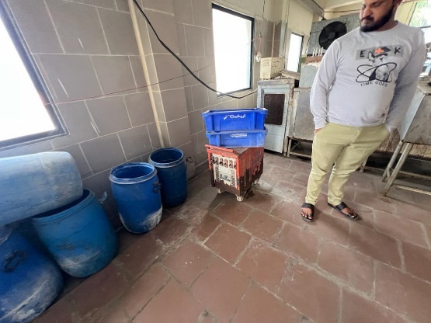
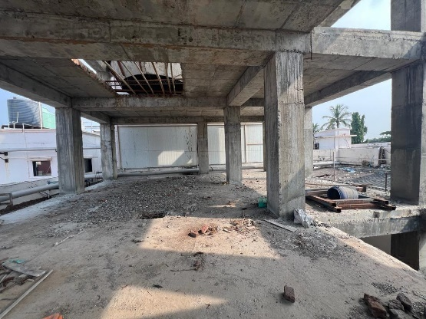
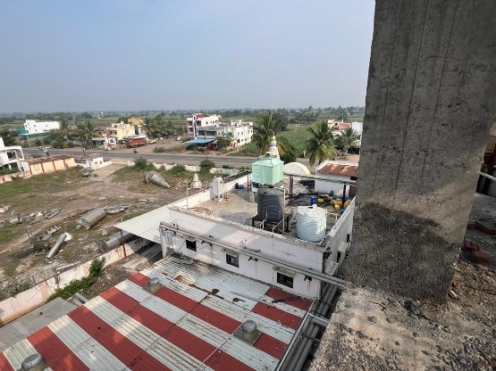
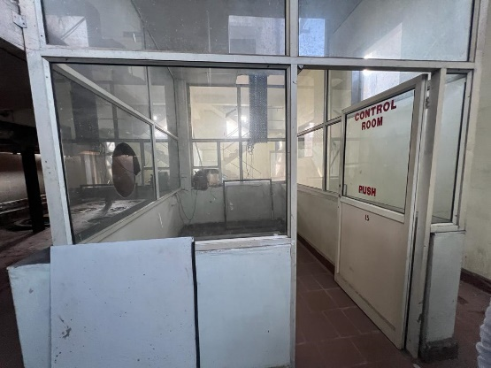
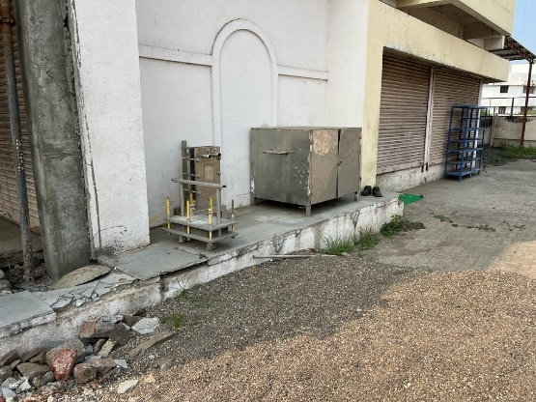

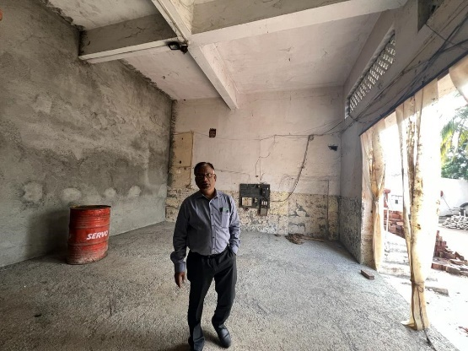

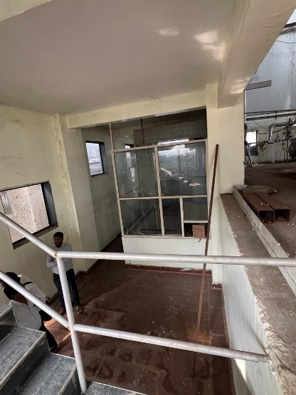
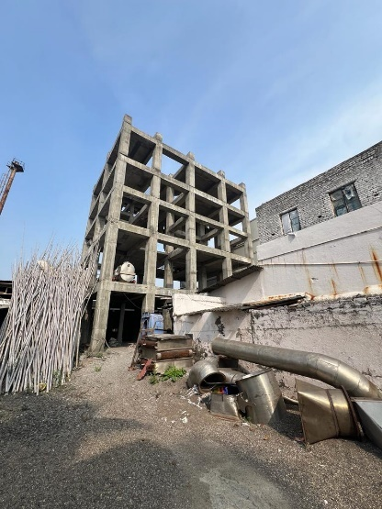
Actual site photographs of Land and Building
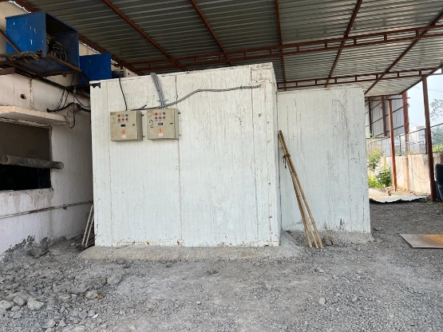
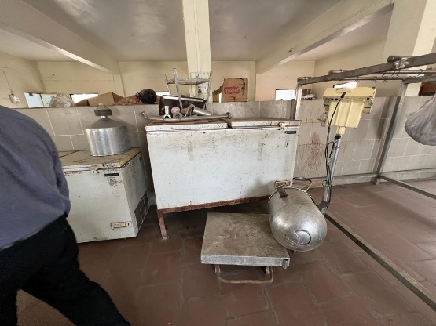
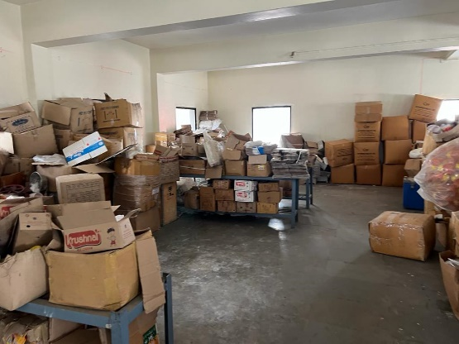
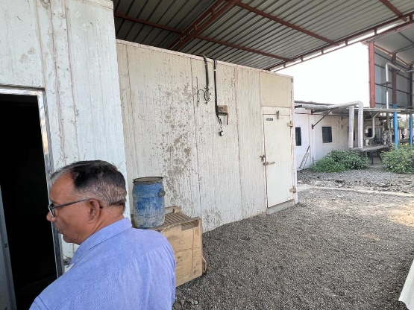
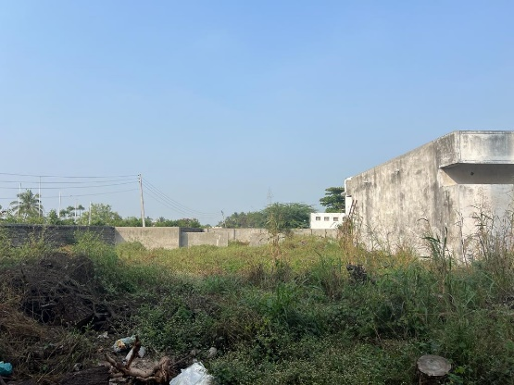
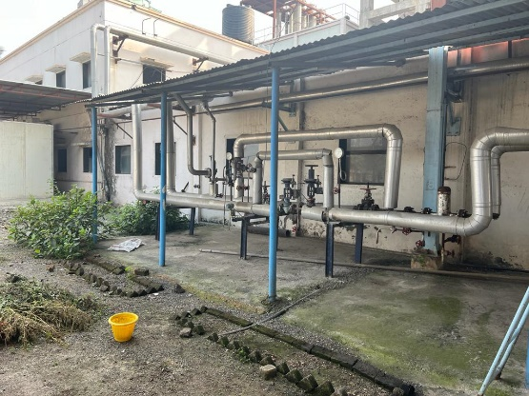
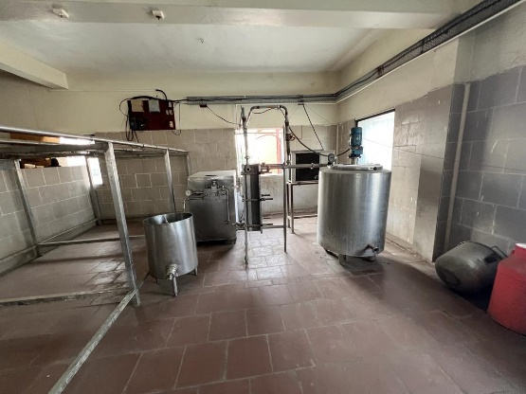
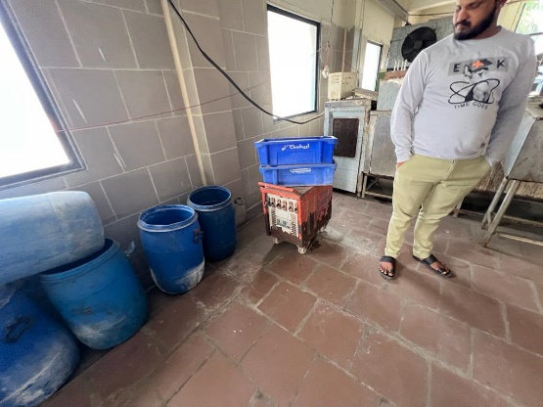
Actual site photographs of Land and Building

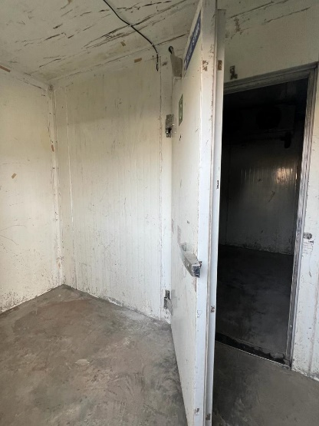
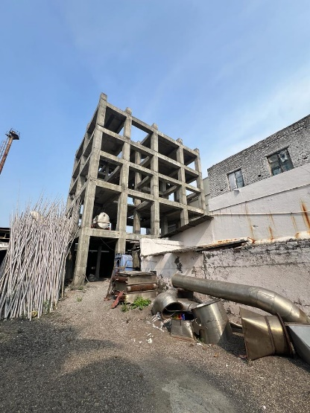
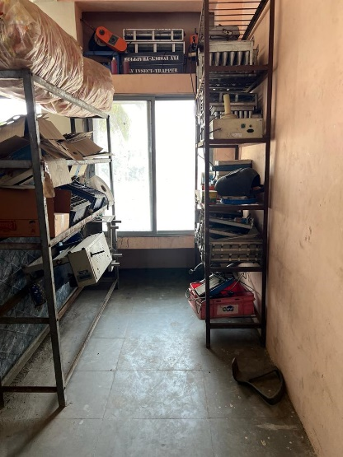
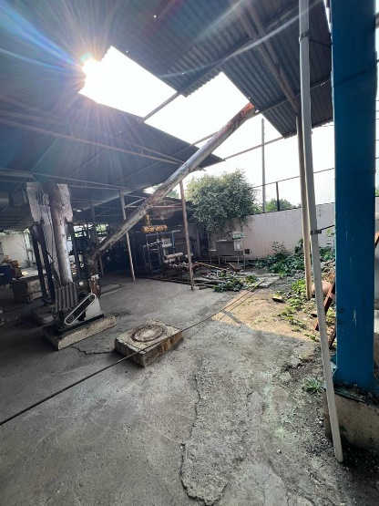
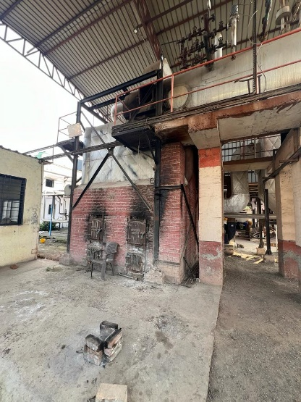
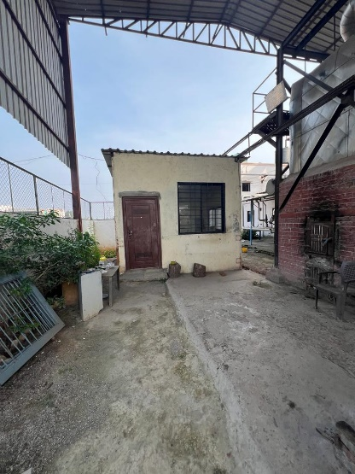
Actual site photographs of Land and Building

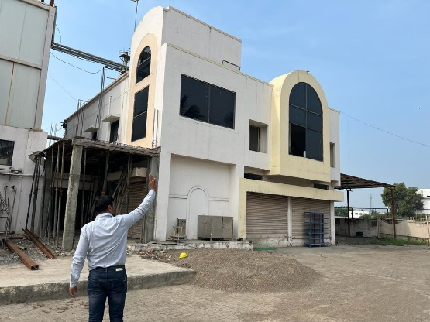
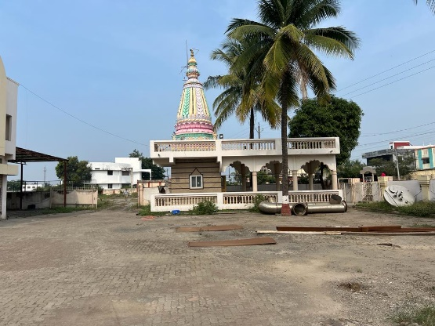
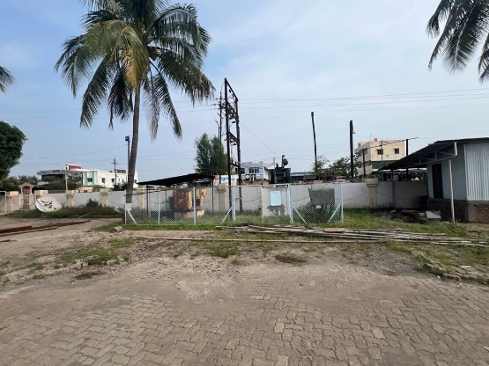
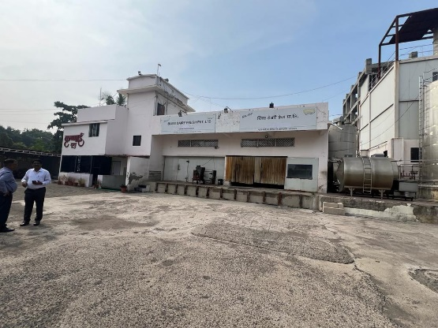
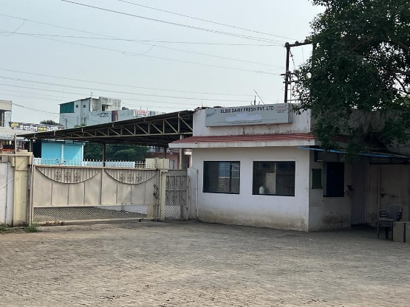
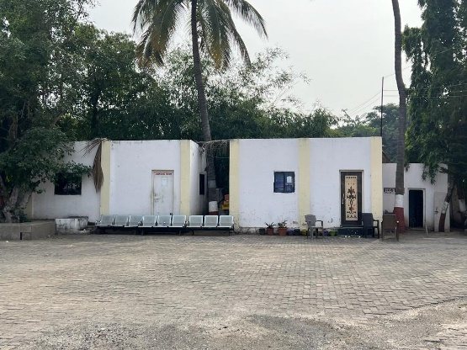
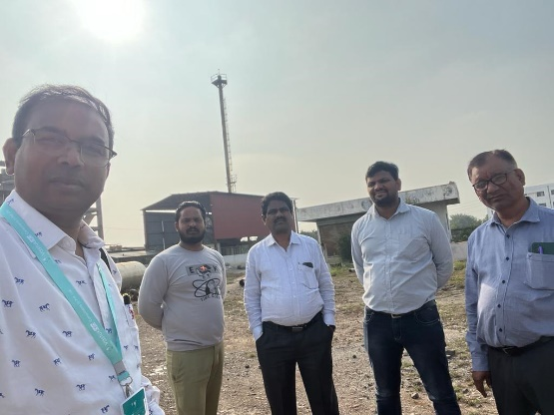
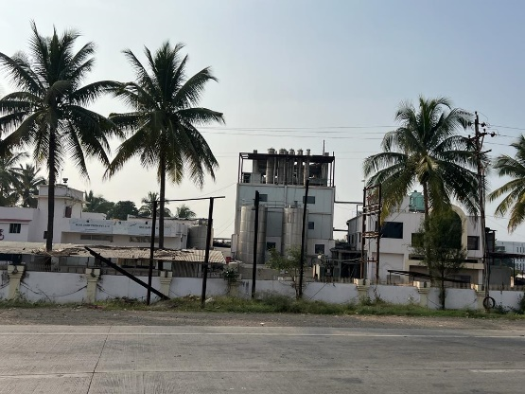
Actual site photographs of Plant and Machinery
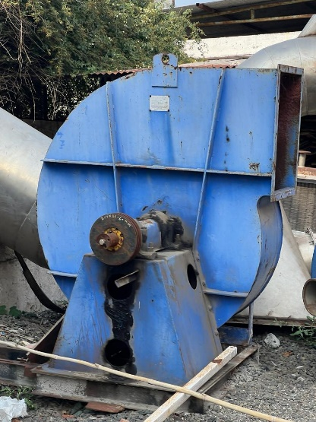
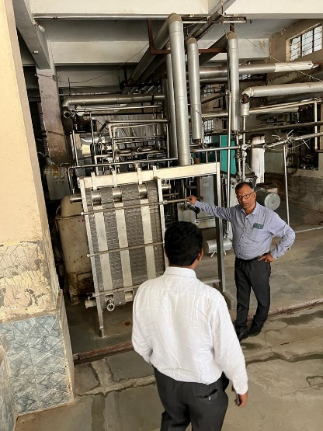
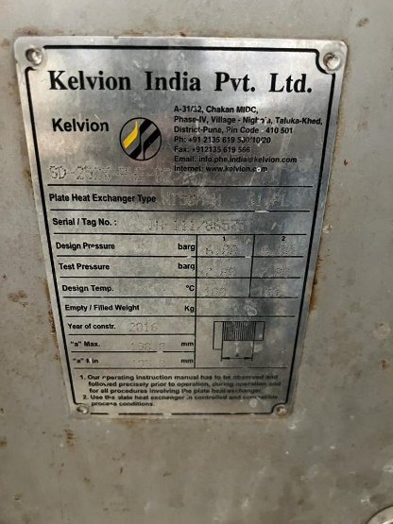
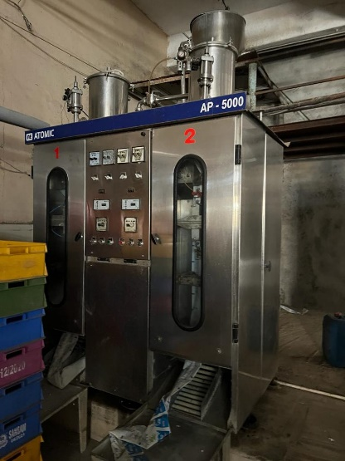
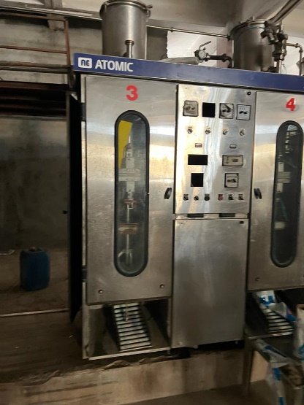
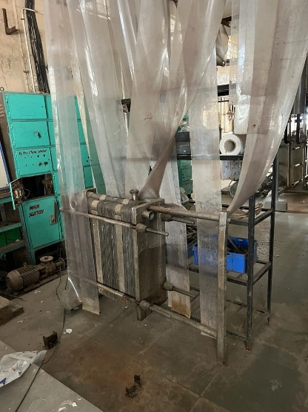

Actual site photographs of Plant And Machinery
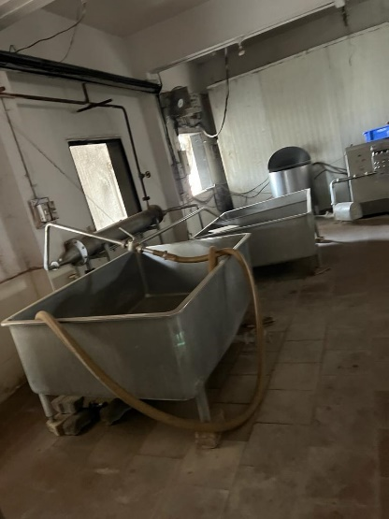
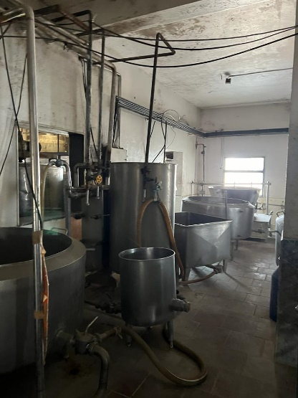
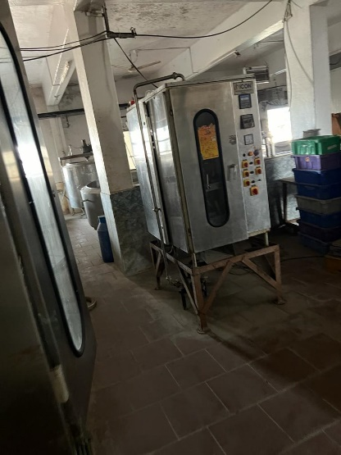
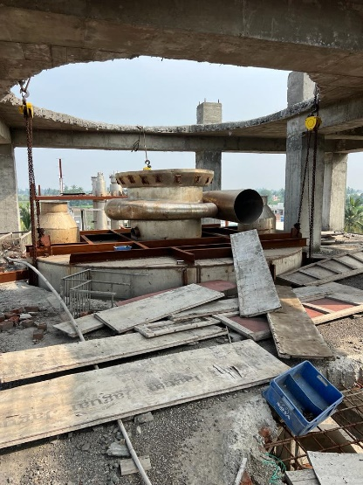
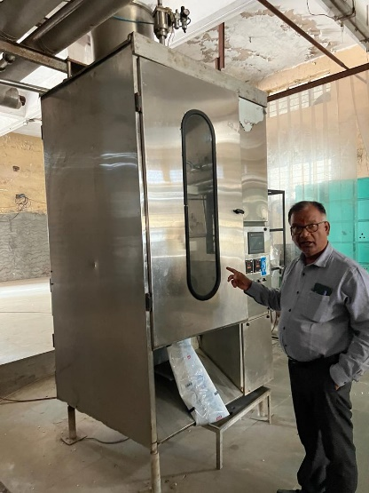
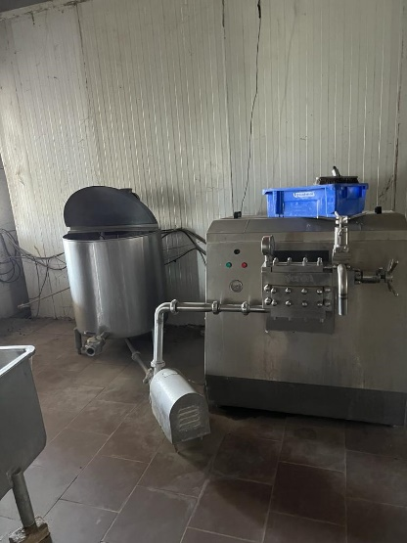
Actual site photographs of Plant And Machinery
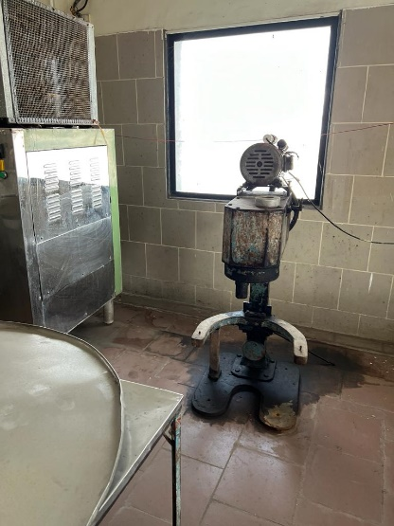
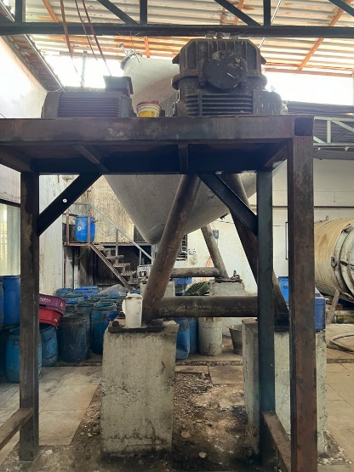
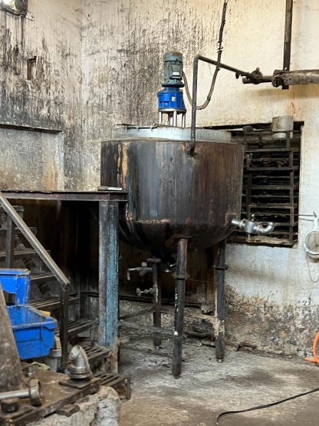
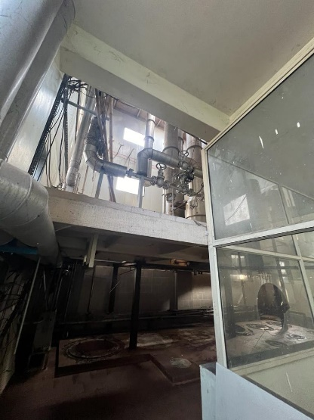
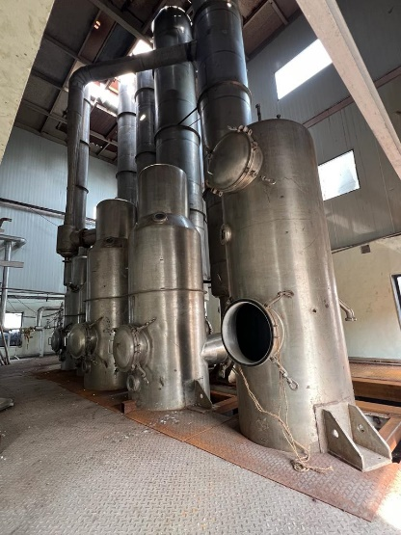
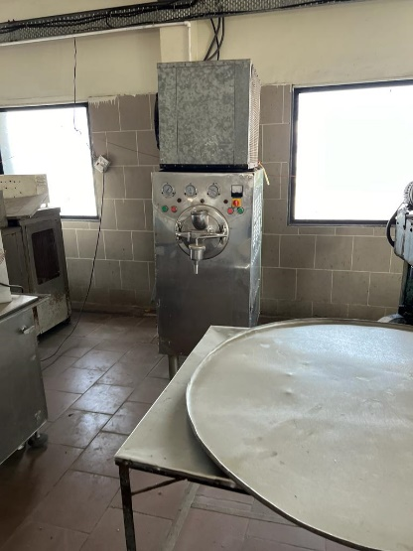
Actual site photographs of Plant And Machinery
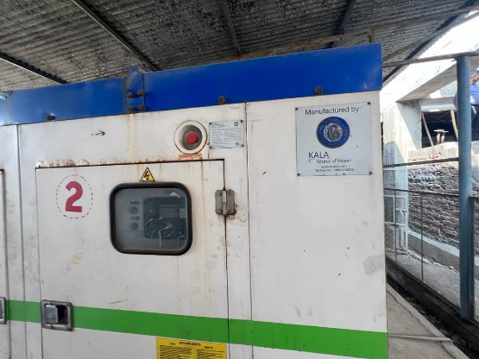
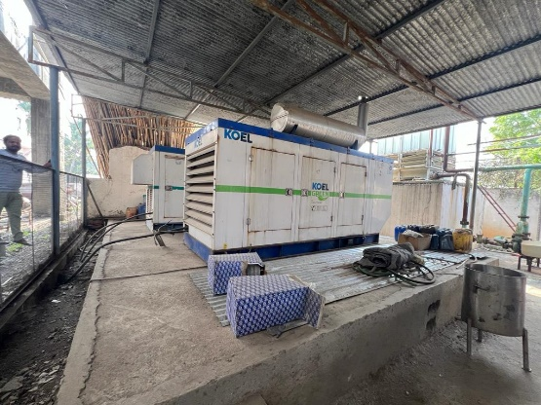
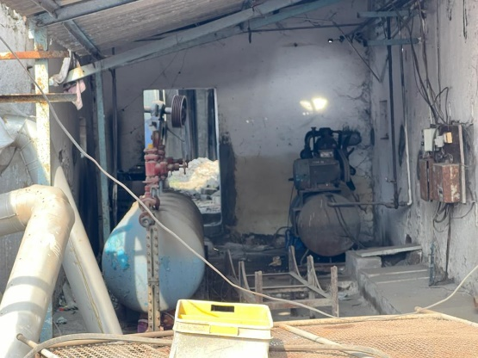
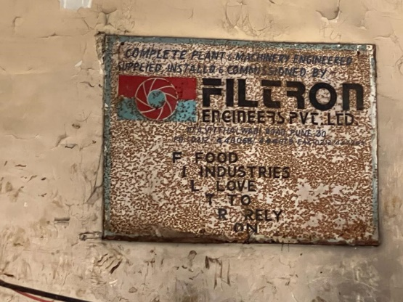
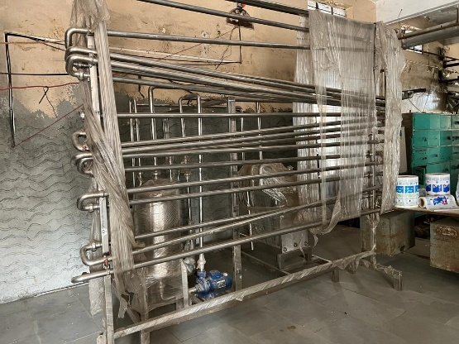
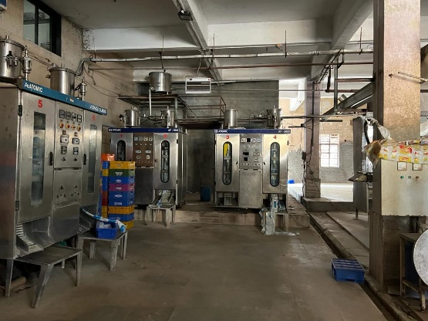
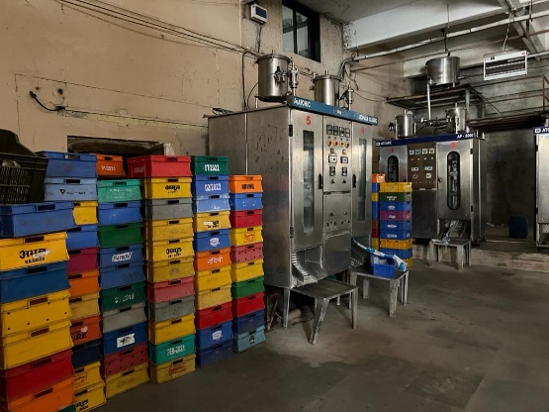
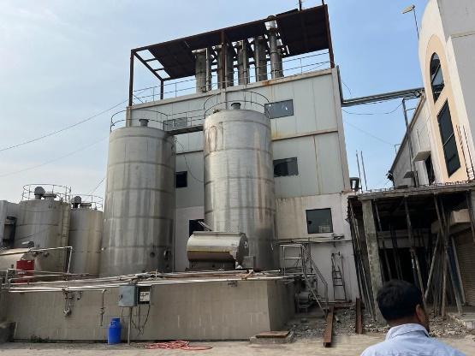

Route Map of the property
Site u/r
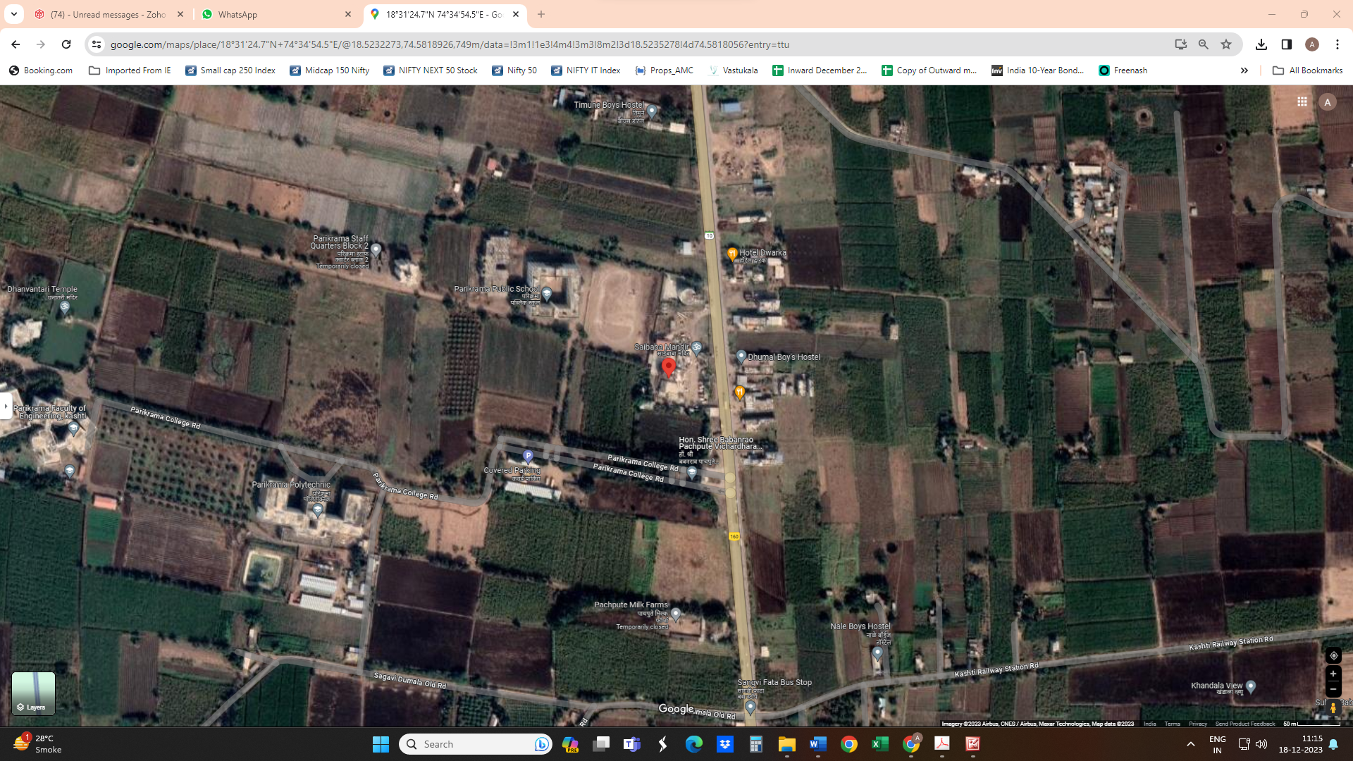

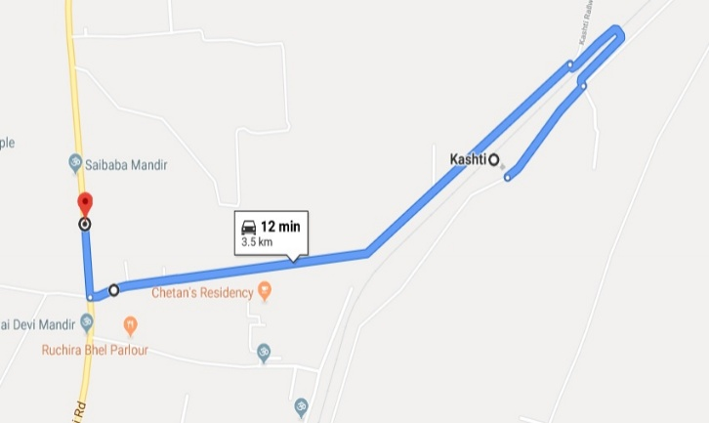

Latitude Longitude - 18°31'24.7"N 74°34'54.5"E
Note: The Blue line shows the route to site from nearest railway station (Kashti– 3.5 KM.)

Ready Reckoner Rate
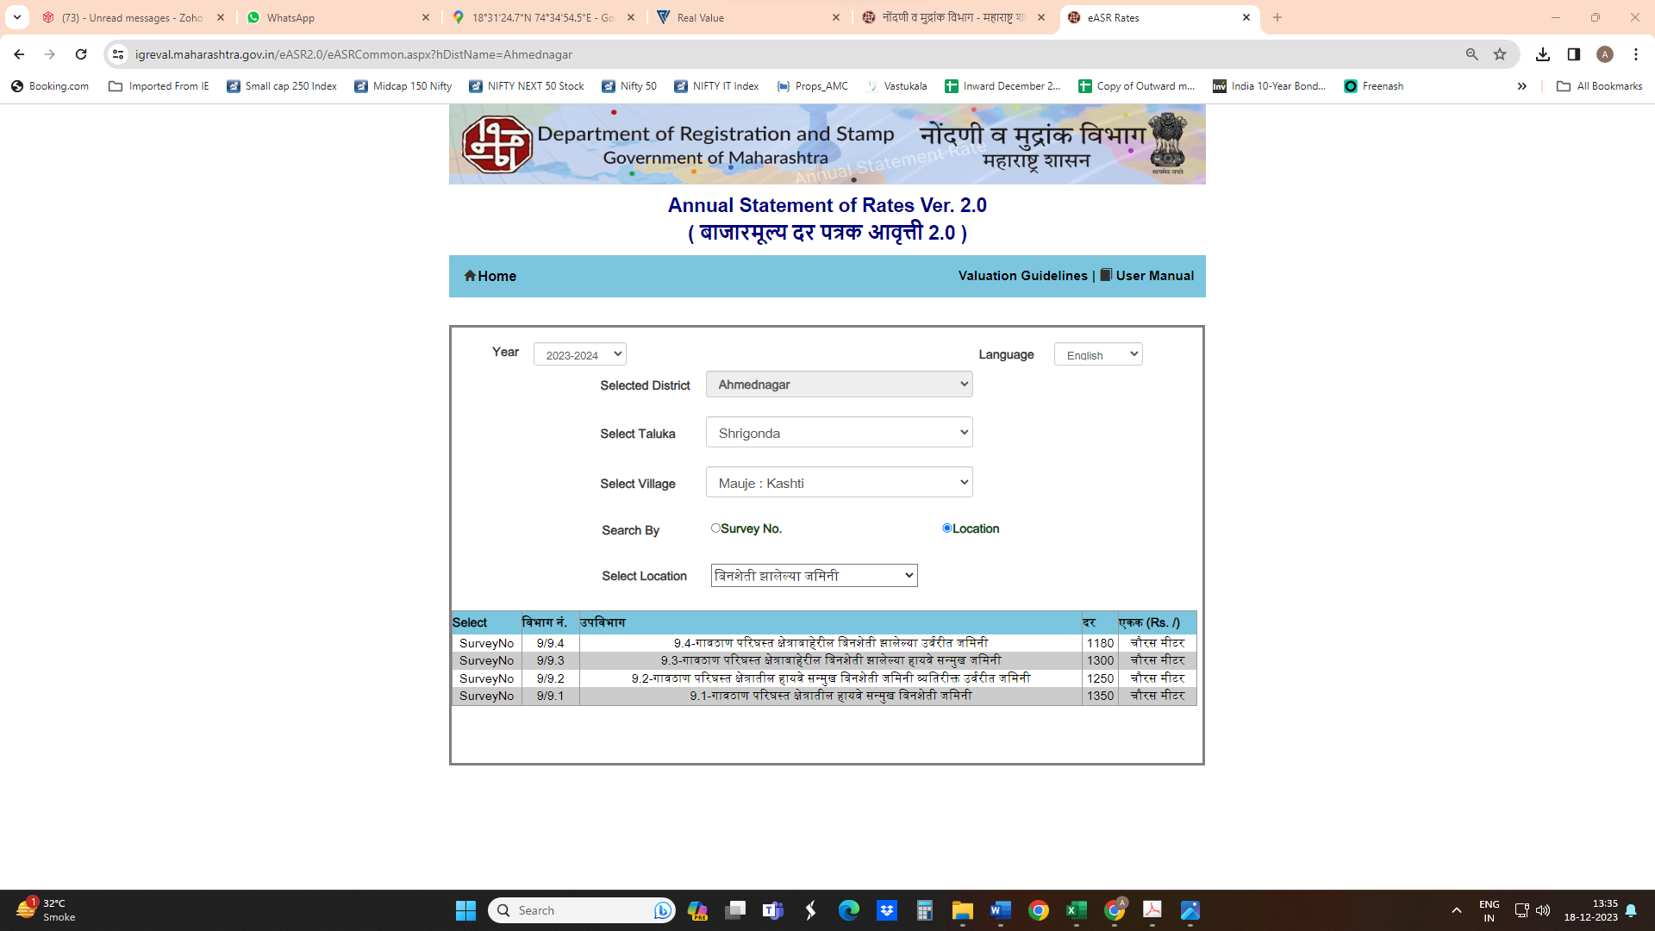
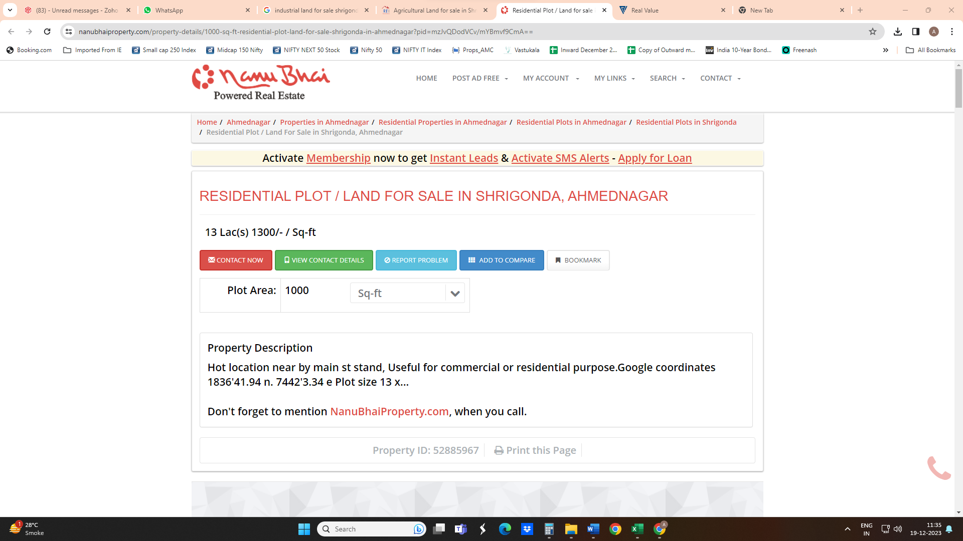
Price Indicators

DEFINITION OF VALUE FOR THIS SPECIFIC PURPOSE

This exercise is to assess Fair Market Value of the property under reference as on 20th December 2023.

The term Fair Market Value is defined as

“The most probable price, as of a specified date, in cash, terms equivalent to cash, or in other precisely revealed terms for which the specified property rights would sell after reasonable exposure in a competitive market under all conditions requisite to a fair sale, with the buyer and seller each acting prudently knowledgeably and for self-interest assuming that neither is under undue duress”.
Fundamental assumptions and conditions presumed in this definition are:

1. Buyer and seller are motivated by self-interest.

2. Buyer and seller are well informed and are acting prudently.

3. The property is exposed for a reasonable time on the open market.

4. Payment is made in cash or equivalent or in specified financing terms.

UNDER LYING ASSUMPTIONS
1. We assume no responsibility for matters of legal nature affecting the property appraised or the title thereto, nor do we render our opinion as to the title, which is assumed to be good and marketable.
2. The property is valued as though under responsible ownership.
3. It is assumed that the property is free of liens and encumbrances.
4. It is assumed that there are no hidden or unapparent conditions of the subsoil or structure that would render it more or less valuable. No responsibility is assumed for such conditions or for engineering that might be required to discover such factors.

Sharadkumar B. Chalikwar
Govt. Reg. Valuer
Chartered Engineer (India)
Reg. No. IBBI/RV/07/2019/11744

Reg. No. (N) CCIT/1-14/52/2008-09

DECLARATION OF PROFESSIONAL FEES CHARGED
We hereby declare that, our professional fees are not contingent upon the valuation findings. However, if the statute AND/OR clients demands that, the fees should be charged on the percentage of assessed value then, with the full knowledge of the AND/OR end user, it is being charged accordingly.

VALUATION OF THE PROPERTY PREMISES

Considering various parameters recorded, existing economic scenario, and the information that is available with reference to the development of neighbourhood and method selected for valuation, we are of the opinion that, the property premises can be assessed and valued for SARFAESI Securitisation and Reconstruction of Financial Assets and Enforcement of Security Interest Act, 2002 purpose as below
Particulars | Fair Market Value In  (`) | Realizable Value In (`) | Distress Sale Value In (`)
A) Value of Land | 11,64,00,000.00 | 9,89,40,000.00 | 8,14,80,000.00
B) Value of Structure | 1,66,96,554.00 | 1,41,92,071.00 | 1,16,87,588.00
C) Value of Land Development | 75,00,000.00 | 63,75,000.00 | 52,50,000.00
Total Value of Land and Building | 14,05,96,554.00 | 11,95,07,071.00 | 9,84,17,588.00
D) Value of Plant & Machinery | 2,70,85,000.00 | 2,30,22,250.00 | 1,89,59,500.00
TOTAL VALUE OF LAND & BUILDING AND PLANT & MACHINERY | 16,76,81,554.00 | 14,25,29,321.00 | 11,73,77,088.00

Sharadkumar B. Chalikwar
Govt. Reg. Valuer
Chartered Engineer (India)
Reg. No. IBBI/RV/07/2019/11744

Reg. No. (N) CCIT/1-14/52/2008-09

