Valuation Report of the Immovable Property

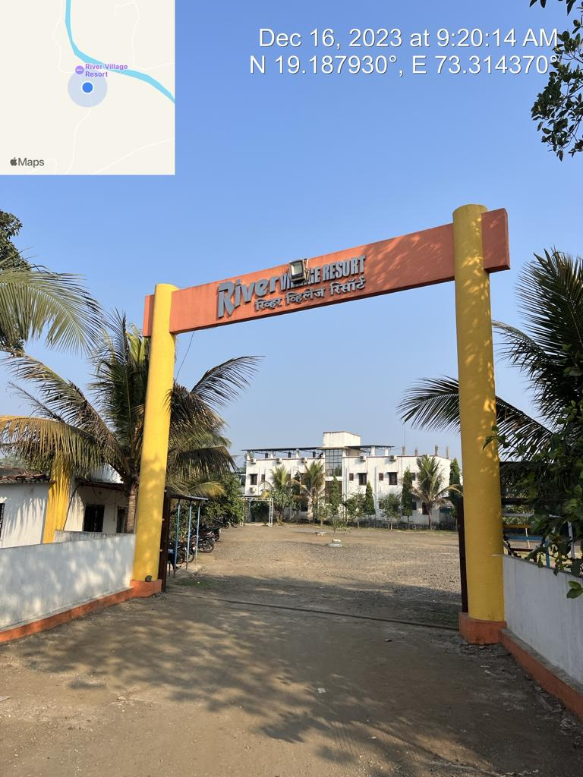

**Details of the property under consideration:**

Name of Owner: **Mr. Vishwanath Ramchandra Panvelkar**

**Land & Building known as “River Village Resort”** on Gut Nos. 54/4, 54/5, Barvi Dam Road,

Patil Pada**,** , Village – Sagaon, Taluka – Ambernath, District – Thane – 421 503,

State – Maharashtra, Country – India

# Latitude Longitude - 19°11'19.5"N 73°18'51.1"E

# 

**Valuation Prepared for:**

**Cosmos Bank**

**Ambarnath Branch**

Panvelkar Pride, Shop Nos. 1 To 4, Plot Nos. 63-64, CTS No. 4740, Near Hutatma Chawk, Ambernath (East),

State – Maharashtra, Country – India

Vastu/Mumbai/12/2023/5668/2304078

20/13-307-VSU Date: 20.12.2023

# VALUATION OPINION REPORT

The property bearing **Land & Building known as “River Village Resort”** on Gut Nos. 54/4, 54/5, Barvi Dam Road, Patil Pada**,** Village – Sagaon, Taluka – Ambernath, District – Thane – 421 503, State – Maharashtra, Country – India belongs to **Mr. Vishwanath Ramchandra Panvelkar.**

|  |  |  |
| --- | --- | --- |
| **Boundaries of the property.** | | |
| North | : | River | |
| South | : | Road | |
| East | : | Open Plot | |
| West | : | Open Plot | |

Considering various parameters recorded, existing economic scenario, and the information that is available with reference to the development of neighborhood and method selected for valuation, we are of the opinion that, the property premises can be assessed and valued for banking purpose as below –

|  |  |
| --- | --- |
| **Particulars** | **Value (`)** |
| **Fair Market Value** | **12,61,25,000.00** |
| **Realizable Value** | **11,35,12,500.00** |
| **Distress Sale Value** | **10,09,00,000.00** |
| **Insurance Value** | **1,73,62,950.00** |

The valuation of the property is based on the documents produced by the concern. Legal aspects have not been taken into considerations while preparing this valuation report.

Hence certified

## Sharadkumar B. Chalikwar

Govt. Reg. Valuer

Chartered Engineer (India)

Reg. No. (N) CCIT/1-14/52/2008-09

Encl: Valuation report in Form – 01

**Land & Building known as “River Village Resort”** on Gut Nos. 54/4, 54/5, Barvi Dam Road,

Patil Pada**,** Village – Sagaon, Taluka – Ambernath, District – Thane – 421 503,

State – Maharashtra, Country – India

*Form 0-1*

*(See Rule 8 D)*

REPORT OF VALUATION OF IMMOVABLE PROPERTY (OTHER THAN AGRICULTURAL LANDS, PLANTATIONS, FORESTS, MINES AND QUARRIES)

GENERAL:

|  |  |  |  |
| --- | --- | --- | --- |
| 1 | Purpose for which the valuation is made | | To assess the Fair Market Value as on 20.12.2023 for Bank loan Purpose |
| 2 | Date of inspection | | 16.12.2023 |
|  | Name of the owner/ owners | | **Mr. Vishwanath Ramchandra Panvelkar** |
| 4 | If the property is under joint ownership / co-ownership, share of each such owner. Are the shares undivided? | | Sole ownership |
| 5 | Brief description of the property | | **Land & Building known as “River Village Resort”** on Gut Nos. 54/4, 54/5, Barvi Dam Road, Patil Pada**,** , Village – Sagaon, Taluka – Ambernath, District – Thane – 421 503, State – Maharashtra, Country – India |
| 6 | Location, street, ward no | | Barvi Dam Road |
| 7 | Survey/ Plot no. of land | | Gut Nos. 54/4, 54/5 |
| 8 | Is the property situated in residential/ commercial/ mixed area/ industrial area? | | Residential cum commercial area |
| 9 | Classification of locality-high class/ middle class/poor class | | Middle Class |
| 10 | Proximity to civic amenities like schools, Hospitals, Offices, market, cinemas etc. | | All the amenities are available in the vicinity |
| 11 | Means and proximity to surface communication by which the locality is served | | Served by Buses and Private cars |
|  | *LAND* | |  |
| 12 | Area of land supported by documentary proof. Shape, dimension and physical features | | Plot area – 18,820.00 Sq. M.  (Area as per N.A. Order) |
| 13 | Roads, Streets or lanes on which the land is abutting | | 16 M wide road |
| 14 | If freehold or leasehold land | | Freehold |
| 15 | If leasehold, the name of Lessor/lessee, nature of lease, date of commencement and termination of lease and terms of renewal of lease. | | Not applicable |
| (i) Initial premium | | Not applicable |
| (ii) Ground rent payable per annum | | Not applicable |
| (iii) Unearned increase payable to the Lessor in the event of sale or transfer | | Not applicable |
| 16 | Is there any restriction covenant in regard to use of land? If so attach a copy of the covenant. | | Commercial Holiday Resorts & Holiday Homes |
| 17 | Are there any agreements of easements? If so, attach a copy of the covenant | | Information not available |
| 18 | Does the land fall in an area included in any Town Planning Scheme or any Development Plan of Government or any statutory body? If so, give Particulars. | | No |
| 19 | Has any contribution been made towards development or is any demand for such contribution still outstanding? | | Information not available |
| 20 | Has the whole or part of the land been notified for acquisition by government or any statutory body? Give date of the notification. | | No |
| 21 | Attach a dimensioned site plan | | Copy of Approved Plan vide No. SPL / PLN / BP / Mouje Sagaon / Taluka Ambernath / SSThane / 2255 / dated 30.11.2019 for commercial purpose (Holiday Resorts & Holiday Homes) issued by Town Planning, Thane. |
|  | *IMPROVEMENT* | |  |
| 22 | Attach plans and elevations of all structures standing on the land and a lay-out plan. | | Attached |
| 23 | Furnish technical details of the building on a separate sheet (The Annexure to this form may be used) | | Attached |
| 24 | Is the building owner occupied/tenanted/both? | | Owner Occupied in the name and style of River Village Resort |
|  | If the property owner occupied, specify portion and extent of area under owner-occupation | | Owner Occupied in the name and style of River Village Resort |
| 25 | What is the Floor Space Index permissible and Percentage actually utilized? | | As per Approved Plan   |  |  |  | | --- | --- | --- | | **Particulars** | **Permissible**  **F.A.R.** | **Consumed**  **F.A.R.** | | Gut Nos. 54/4 & 54/5 | 0.20 | 0.061 | |
| 26 | *RENTS* | |  |
|  | (i) | Names of tenants/ lessees/ licensees, etc. | N.A. |
|  | (ii) | Portions in their occupation | N.A. |
|  | (iii) | Monthly or annual rent/ compensation / license fee, etc. paid by each | N.A. |
|  | (iv) | Information not available | N.A. |
| 27 | Are any of the occupants related to, or close to business associates of the owner? | | N.A. |
| 28 | Is separate amount being recovered for the use of fixtures, like fans, geysers, refrigerators, cooking ranges, built-in wardrobes, etc. or for services charges? If so, give details | | N.A. |
| 29 | Give details of the water and electricity charges, if any, to be borne by the owner | | Information not available |
| 30 | Has the tenant to bear the whole or part of the cost repairs and maintenance? Give particulars | | N.A. |
| 31 | If a lift is installed, who is to bear the cost of maintenance and operation- owner or tenant? | | N.A. |
| 32 | If a pump is installed, who is to bear the cost of maintenance and operation- owner or tenant? | | N.A. |
| 33 | Who has to bear the cost of electricity charges for lighting of common space like entrance hall, stairs, passage, compound, etc. owner or tenant? | | N.A. |
| 34 | What is the amount of property tax? Who is to bear it? Give details with documentary proof | | Information not available |
| 35 | Is the building insured? If so, give the policy no., amount for which it is insured and the annual premium | | Information not available |
| 36 | Is any dispute between landlord and tenant regarding rent pending in a court of rent? | | N.A. |
| 37 | Has any standard rent been fixed for the premises under any law relating to the control of rent? | | As per TMC norms |
|  | *SALES* | |  |
| 38 | Give instances of sales of immovable property in the locality on a separate sheet, indicating the Name and address of the property, registration No., sale price and area of land sold. | | As per sub registrar of assurance |
| 39 | Land rate adopted in this valuation | | ` 5,000.00 Per Sq. M. including land development such as plot levelling, plot filling, M.S. gate, compound wall, garden, swimming pool and other miscellaneous items. |
| 40 | If sale instances are not available or not relied up on, the basis of arriving at the land rate | | Online Price Indicators, Location, development of surrounding area, type of land and construction, construction specifications, age of building, condition of the premises & building, facilities provided and its prevailing market rate. |
|  | *COST OF CONSTRUCTION* | |  |
| 41 | Year of commencement of construction and year of completion | | 2021 (As per site information) |
| 42 | What was the method of construction, by contract / By employing Labour directly / both? | | Information not available |
| 43 | For items of work done on contract, produce copies of agreements | | Information not available |
| 44 | For items of work done by engaging Labour directly, give basic rates of materials and Labour supported by documentary proof. | | Information not available |

*PART II- VALUATION*

GENERAL:

Under the instruction of Cosmos Bank, Ambernath Branch, to assess fair market value as on **20th December 2023** for **Land & Building known as “River Village Resort”** on Gut Nos. 54/4, 54/5, Barvi Dam Road, Patil Pada**,** , Village – Sagaon, Taluka – Ambernath, District – Thane – 421 503, State – Maharashtra, Country – India belongs to **Mr. Vishwanath Ramchandra Panvelkar.**

We are in receipt of the following documents:

|  |  |
| --- | --- |
|  | Copy of 7/12 Revenue Extract |
|  | Copy of N.A. Order vide No. O. No. SPL / BP / Mouje Sagaon / Taluka Ambernath / SSThane / 2255 / dated 30.11.2019 for commercial purpose (Holiday Resorts & Holiday Homes) issued by Town Planning, Thane for permission to commencement of work. |
|  | Copy of Sale Deed dated 21.06.2013 between Mr. Vishwanath Ramchandra Panvelkar (Purchaser) and Dahyabhai Ratanshi Patel and 3 others (Sellers) for Gut Nos. 54/5, 54/3A & 10/5 |
|  | Copy of Sale Deed dated 21.06.2013 between Mr. Vishwanath Ramchandra Panvelkar (Purchaser) and Mr. Louis Itur Vaity & Annie Lousi Vaity (Sellers) for Gut Nos. 13/2, 54/4 & 10/4A |
|  | Copy of Approved Plan vide No. SPL / PLN / BP / Mouje Sagaon / Taluka Ambernath / SSThane / 2255 / dated 30.11.2019 for commercial purpose (Holiday Resorts & Holiday Homes) issued by Town Planning, Thane. |

**Land:**

The plot under valuation is freehold plot for the commercial purpose having Holiday Resorts & Holiday Homes. Sale Deed dated 21.06.2013 between Mr. Vishwanath Ramchandra Panvelkar (Purchaser) and Dahyabhai Ratanshi Patel and 3 others (Sellers) is for Gut Nos. **54/5**, 54/3A & 10/5 and Sale Deed dated 21.06.2013 between Mr. Vishwanath Ramchandra Panvelkar (Purchaser) and Mr. Louis Itur Vaity & Annie Lousi Vaity (Sellers) is for Gut Nos. 13/2, **54/4** & 10/4A. Area details of the same are as under:

|  |  |
| --- | --- |
| **Gut No.** | **Plot area (Sq. M.)** |
| **54/5** | **8,400.00** |
| 54/3A | 1,150.00 |
| 10/5 | 7,810.00 |
| **Total** | **17,360.00** |
|  |  |
| 13/2 | 1,000.00 |
| **54/4** | **10,420.00** |
| 10/4A | 3,570.00 |
| **Total** | **14,990.00** |

N.A. Order is obtained only for Gut Nos. 54/4 and 54/5. We have considered the area and plot as per N.A. Order. Gut Nos. 54/4 & 54/5 are amalgamated. Separate demarcation of each plot is not available at site. **As per Approved Plan / N.A. Order Plot area are as under and considered for valuation.**

|  |  |
| --- | --- |
| **Gut No.** | **Plot area (Sq. M.)** |
| 54/4 | 10,420.00 |
| 54/5 | 8,400.00 |
| **Total** | **18,820.00** |

**Structure:**

As per site structures and measurement are as under

|  |  |
| --- | --- |
| **Particulars** | **Carpet area (Sq. Ft.)** |
| **Building No. 1 - Total 12 Rooms**  **(Outer Measurement)** | 1,785.00 |
| Measurement of 1 room | 173.00 |
| Balcony | 363.00 |
|  |  |
| **Building No. 2**  **Total 12 rooms (Outer Measurement)** | 2,430.00 |
| 4 rooms of same area | 270.00 |
| Balcony | 383.00 |
| 8 rooms of same area | 244.00 |
| Balcony | 46.00 |
|  |  |
| **Bungalow – Ground + 1 upper floor** |  |
| **Ground floor** |  |
| Carpet | 776.00 |
| Passage & staircase | 113.00 |
| Waranda | 494.00 |
| **First floor** |  |
| Carpet | 843.00 |
| Staircase | 113.00 |
| Balcony | 24.00 |
|  |  |
| **Building No. 3 (Not mentioned in the plan)** |  |
| Type R1 – 12 rooms | 258.00 |
| Ground Balcony | 625.00 |
| 1st floor Balcony | 938.00 |
| Type R2 – 4 rooms | 200.00 |
| Ground Balcony | 3,438.00 |
| 1st floor Balcony | 3,750.00 |
|  |  |
| ACC sheet S. Room | 843.00 |
| ACC sheet Kitchen | 606.00 |
| RCC Canteen | 1,517.00 |
| Office + Reception | 325.00 |
| Dormitory Rooms | 4,900.00 |
| RCC Toilet Block near swimming pool | 600.00 |
| ACC Electric Room | 232.00 |
| ACC Toilet block | 440.00 |

The resort is finished partly vitrified tiles flooring. 6" thick B. B. Masonry internal walls with cement plastering. Amenities such as Power coated sliding windows, Glass Wooden frame door with M. S. gate, Concealed type Wiring and plumbing.

**As per Approved Plan, the construction area as under and considered for valuation –**

|  |  |  |
| --- | --- | --- |
| **Building / Type No.** | **Floor / Purpose** | **Built up area (Sq. M.)** |
| **A/1** | Ground + 1 upper floor – Rest Room | 282.55 |
| B/1 | Ground + 1 upper floor – Rest Room | 282.55 |
| C/1 | Ground Floor – Rest Room | 397.30 |
| D/1 | Ground + 1 upper floor – Bungalow | 197.40 |
| E/1 | Ground Floor – Changing Room | 41.25 |
| **Total** |  | **1,201.05** |

1. **Land Valuation**

|  |  |
| --- | --- |
| **Gut No.** | **Plot area (Sq. M.)** |
| 54/4 | 10,420.00 |
| 54/5 | 8,400.00 |
| **Total** | **18,820.00** |
| Rate adopted for valuation | 5,000.00 |
| **Value** | **9,41,00,000.00** |

1. **Valuation of Structures.**

The Built-up area of the building : As per valuation table below

**Deduct Depreciation:**

Year of Construction of the building : As mentioned below

Expected total life of building : As mentioned below

Age of the building as on 2023 : 2021

Cost of Construction : As per valuation table below

Depreciation : N.A. as age of building is below 5 years.

Amount of depreciation : N.A. as age of building is below 5 years.

**Depreciated cost of construction** : As per valuation table below

|  |  |  |  |  |
| --- | --- | --- | --- | --- |
| **Particulars** | **Built up Area in**  **Sq. M.** | **Estimated Replacement Rate in `** | **Depreciated Replacement Rate in `** | **Replacement Value in `** |
| Ground + 1 upper floor – Rest Room | 282.55 | 18,000.00 | Nil | 50,85,900.00 |
| Ground + 1 upper floor – Rest Room | 282.55 | 18,000.00 | Nil | 50,85,900.00 |
| Ground Floor – Rest Room | 397.30 | 15,000.00 | Nil | 59,59,500.00 |
| Ground + 1 upper floor – Bungalow | 197.40 | 18,000.00 | Nil | 35,53,200.00 |
| Ground Floor – Changing Room | 41.25 | 18,000.00 | Nil | 7,42,500.00 |
|  |  |  | **TOTAL** | **2,04,27,000.00** |

1. **Cost of Interior**

|  |  |
| --- | --- |
| **Particulars** | **Built up Area in Sq. M.** |
| Ground + 1 upper floor – Rest Room | 282.55 |
| Ground + 1 upper floor – Rest Room | 282.55 |
| Ground Floor – Rest Room | 397.30 |
| Ground + 1 upper floor – Bungalow | 197.40 |
| **Total** | **1,159.80** |
| Rate adopted for valuation | 10,000.00 |
| **Cost of interior** | **1,15,98,000.00** |

**Government Value**

|  |  |  |  |
| --- | --- | --- | --- |
| **Particulars** | **Area in Sq. M.** | **Rate in `** | **Value in `** |
| Land | 18,820.00 | 850.00 | 1,59,97,000.00 |
| Structure | As per valuation table | | 2,04,27,000.00 |
| **Total** |  |  | **3,64,24,000.00** |

**TOTAL VALUE OF THE PROPERTY:**

|  |  |
| --- | --- |
| **Particulars** | **Value (`)** |
| Cost of Land | 9,41,00,000.00 |
| Cost of Buildings | 2,04,27,000.00 |
| Cost of Interior | 1,15,98,000.00 |
| **Total Fair Market Value** | **12,61,25,000.00** |
| **Realizable Value** | **11,35,12,500.00** |
| **Distress Sale Value** | **10,09,00,000.00** |
| **Insurance Value** | **1,73,62,950.00** |

Taking into consideration above said facts, we can evaluate the value of **Land & Building known as “River Village Resort”** on Gut Nos. 54/4, 54/5, Barvi Dam Road, Patil Pada**,** Village – Sagaon, Taluka – Ambernath, District – Thane – 421 503, State – Maharashtra, Country – India for this particular purpose at **` 12,61,25,000.00 (Amount in words Rupees Twelve Crore Sixty One Lakh Twenty Five Thousand Only)** as on **20th December 2023.**

**NOTES**

1. I, Sharadkumar B. Chalikwar with my experience and ability to judgment I am of the considered opinion that the fair market value of the property as on 20th December 2023 is ` 12,61,25,000.00 (Amount in words Rupees Twelve Crore Sixty One Lakh Twenty Five Thousand Only).
2. Value varies with time and purpose and hence this value should not be referred for any purpose other than mentioned in this report.
3. This valuation is done on the basis of information, which the valuer has obtained by information provided by the client about the premises and location of the surrounding area and also prevailing rates in the surrounding area, and further subject to document as mentioned in valuation report.
4. This valuer should not be held responsible for authentication of documents, clear title and other such related matters. For that purpose, Latest Legal Opinion should be sought.

*PART III- DECLARATION*

I hereby declare that

* + 1. The information furnished in part I is true and correct to the best of my knowledge and belief;
    2. I have no direct or indirect interest in the property valued:

ANNEXURE TO FORM 0-1

Technical details Main Building

|  |  |  |
| --- | --- | --- |
| 1. | No. of floors and height of each floor | As per brief description |
| 2. | Plinth area floor wise as per IS- 1225 | Plot Area = 18,820.00 Sq. M.  Structure - As per valuation table |
| 3 | Year of construction | Year – 2021  (As per site information) |
| 4 | Estimated future life | 58 Years Subject to proper, preventive periodic maintenance and structural repairs. |
| 5 | Type of construction- load bearing walls/RCC frame/ steel frame | As per brief description |
| 6 | Type of foundations | R.C.C. with AC sheet roofing |
| 7 | Walls | All external walls are 9” thick and partition walls are 6” thick. |
| 8 | Partitions | 6” thick brick wall |
| 9 | Doors and Windows | As per brief description |
| 10 | Flooring | As per brief description |
| 11 | Finishing | Internal walls are finished with Neeru Finish. External walls are finished with sand faced plaster. |
| 12 | Roofing and terracing | RCC slabs and A.C. sheet roofing on top |
| 13 | Special architectural or decorative features, if any | No |
| 14 | |  |  | | --- | --- | | (i) | Internal wiring – surface or conduit | | (ii) | Class of fittings: Superior/ Ordinary/ Poor. | | Concealed wiring  Ordinary |
| 15 | Sanitary installations   |  |  | | --- | --- | | (i) | No. of water closets | | (ii) | No. of lavatory basins | | (iii) | No. of urinals | | (iv) | No. of sinks |   Class of fittings: Superior colored / superior white/ordinary. | As per requirement of resort  Ordinary |
| 16 | Compound wall  Height and length  Type of construction | Compound wall of R.C.C. columns with Brick Masonry wall |
| 17 | No. of lifts and capacity | No lift |
| 18 | Underground sump – capacity and type of construction | R.C.C. |
| 19 | Over-head tank Location, capacity Type of construction | R.C.C. |
| 20 | Pumps- no. and their horse power | Information not available |
| 21 | Roads and paving within the compound approximate area and type of paving | Concrete cement finish in open spaces, etc. |
| 22 | Sewage disposal – whereas connected to public sewers, if septic tanks provided, no. and capacity | Connected to local sewer line |

**Actual site photographs**

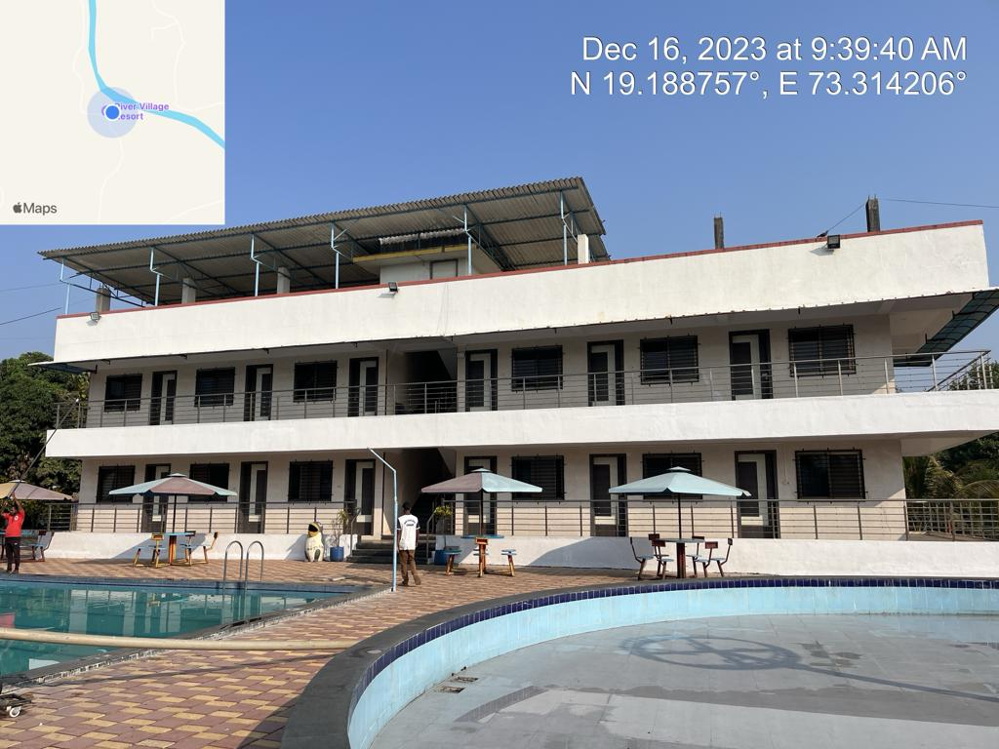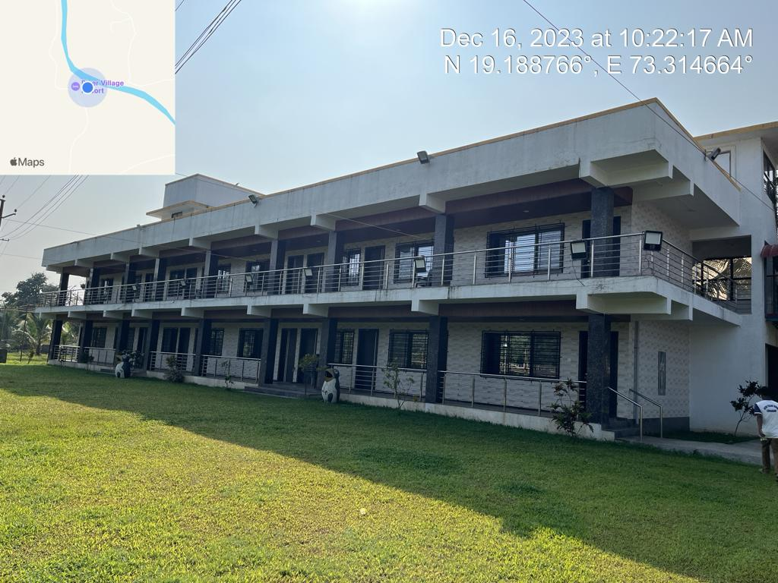

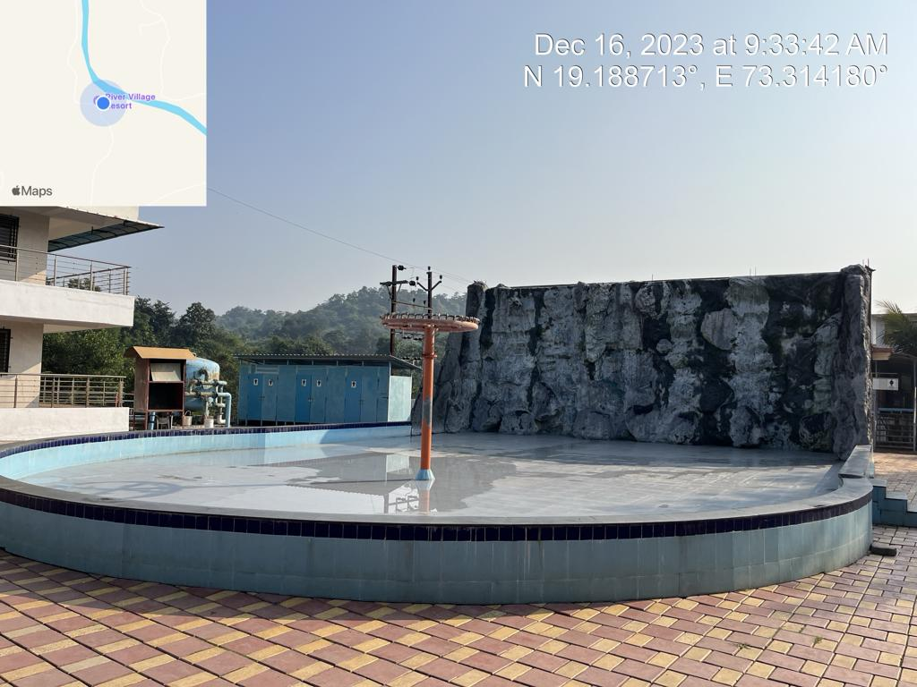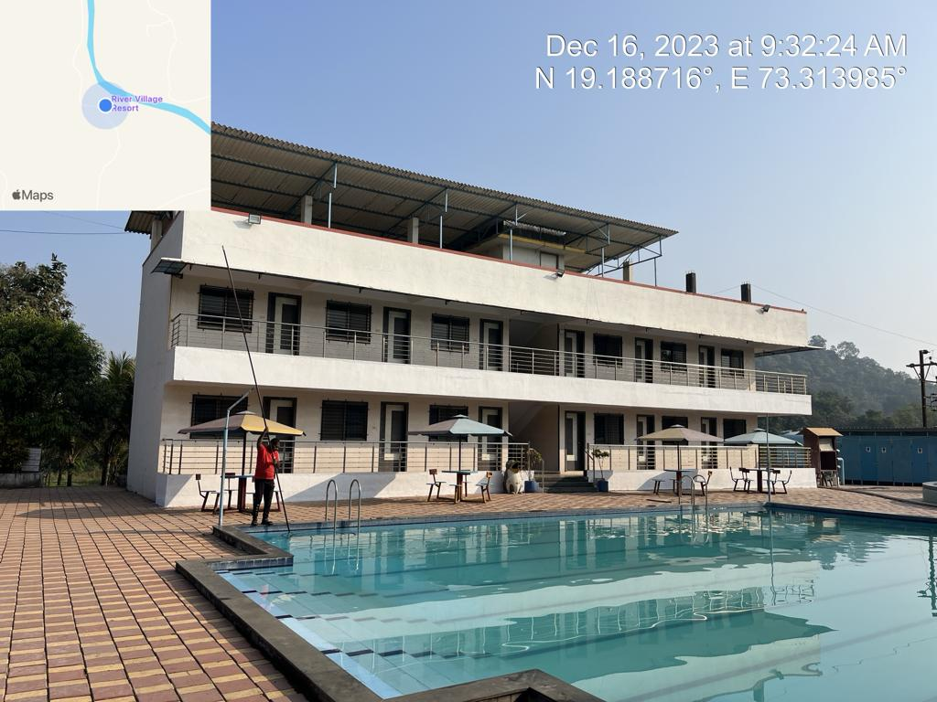

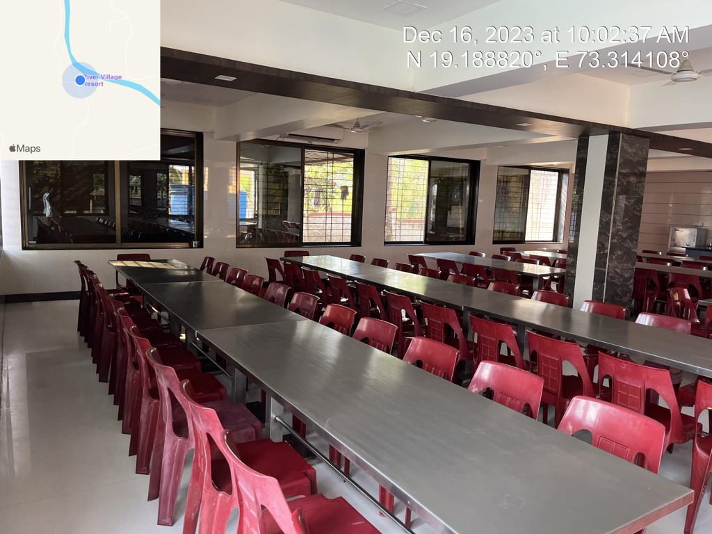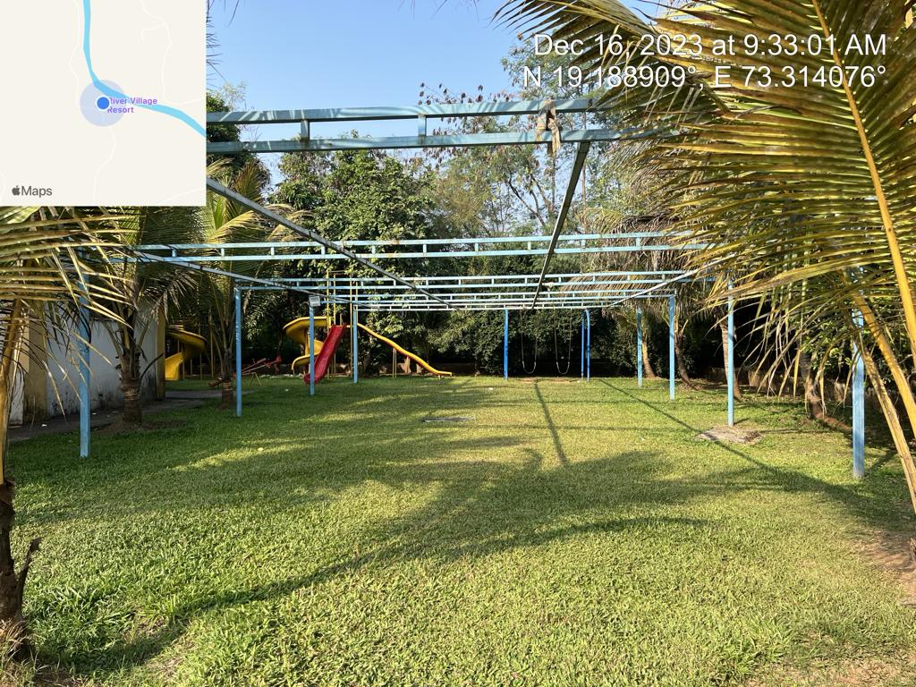

**Actual site photographs**

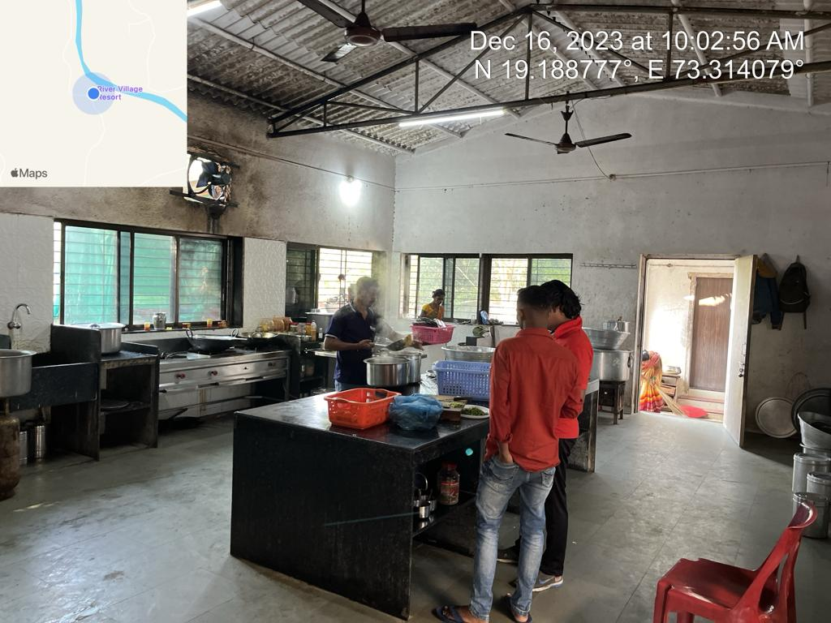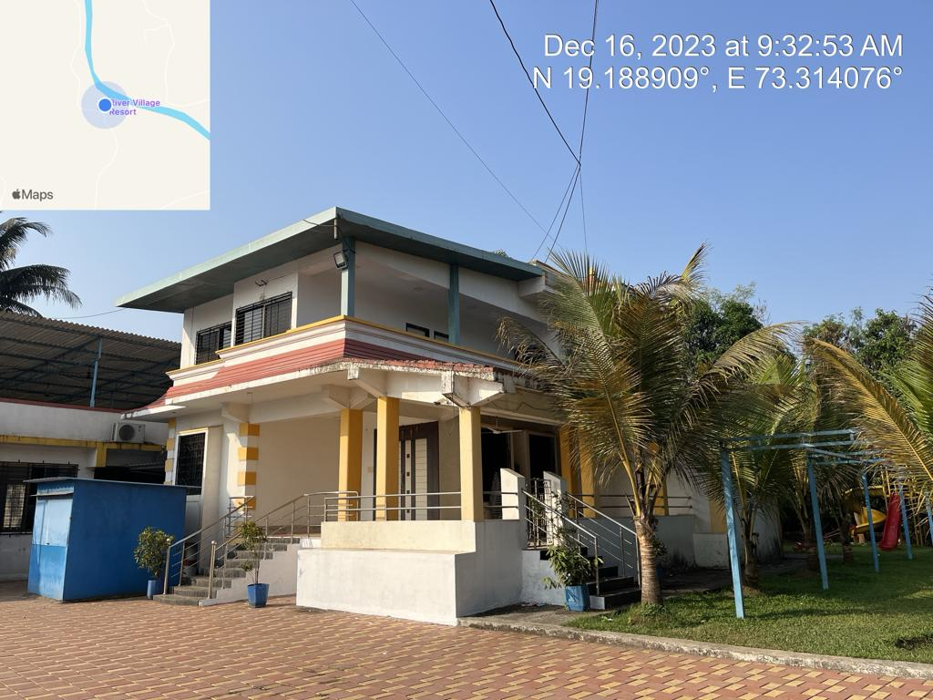

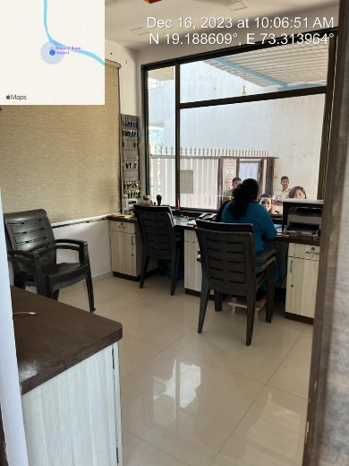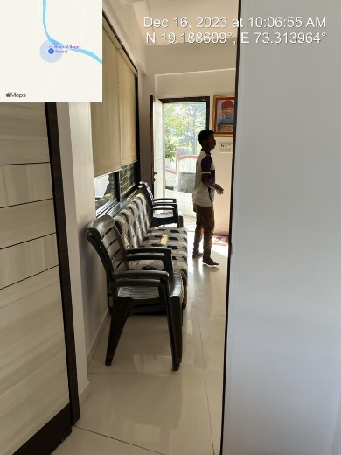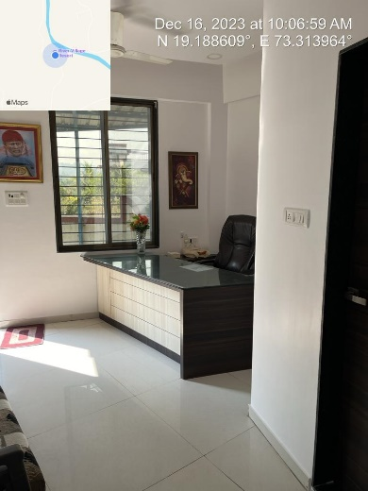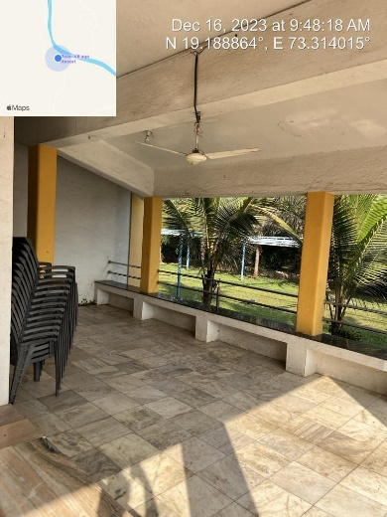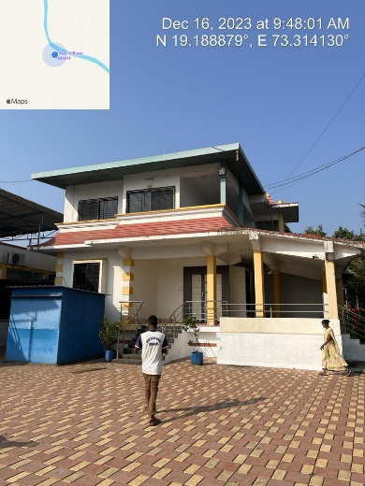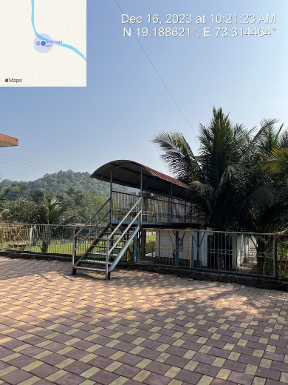

**Actual site photographs**

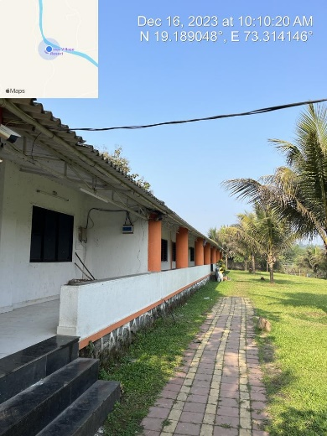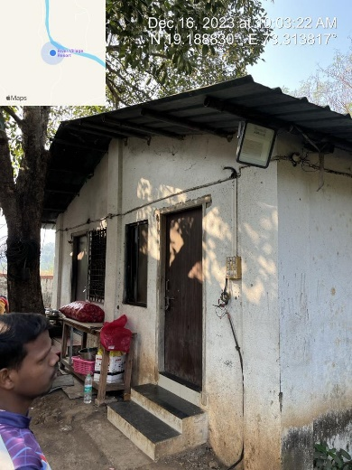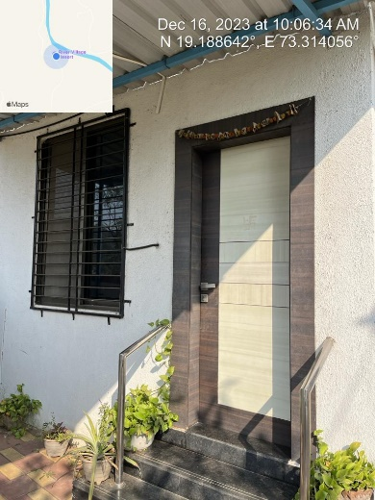

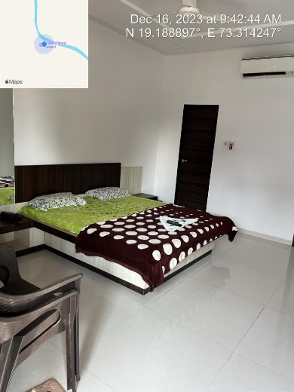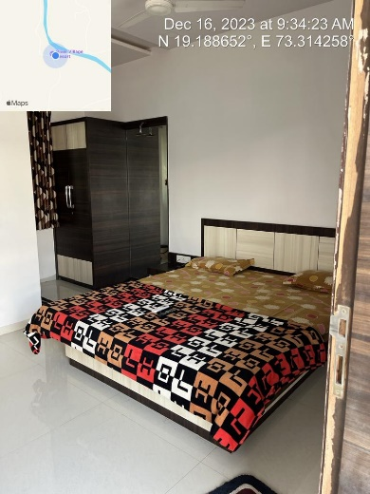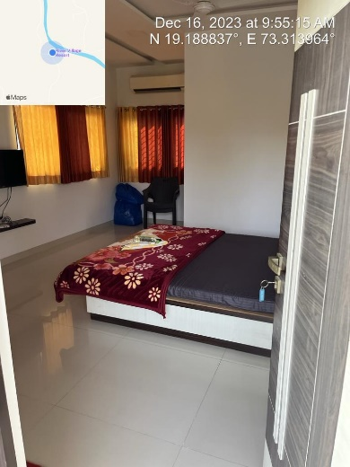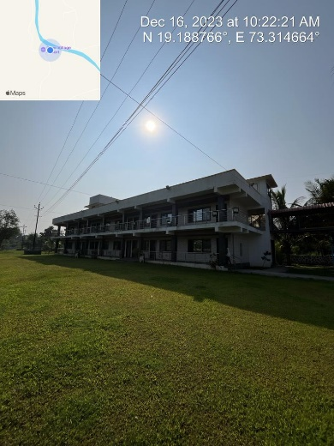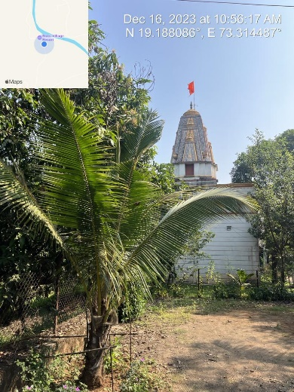

**Actual site photographs**

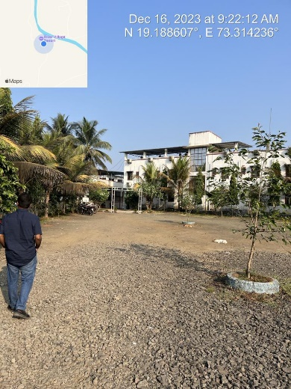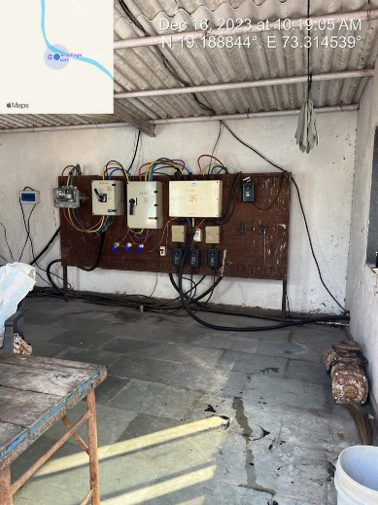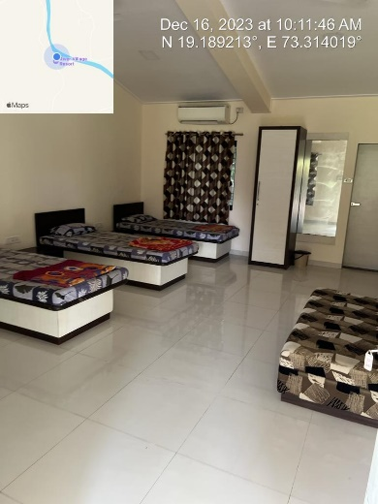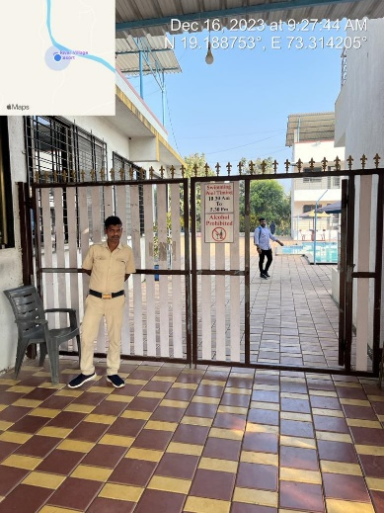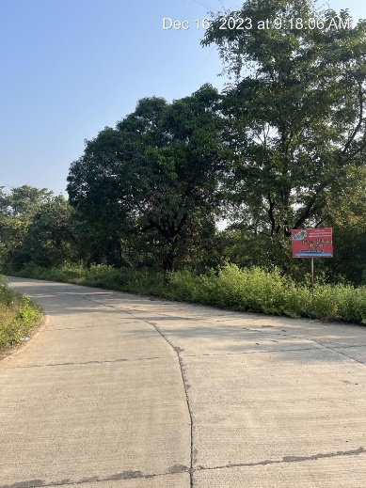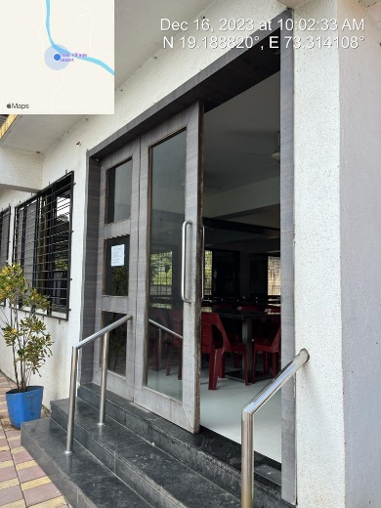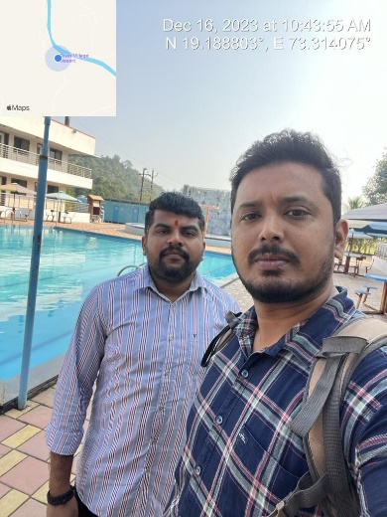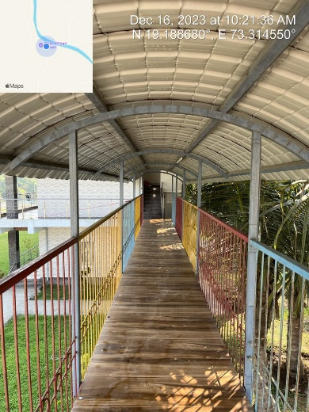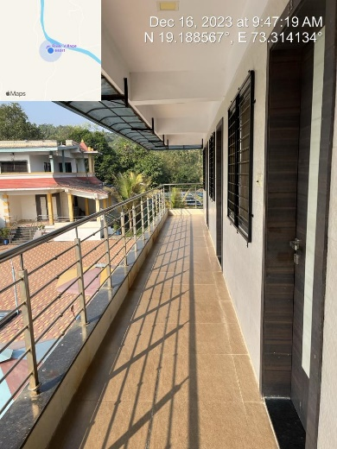

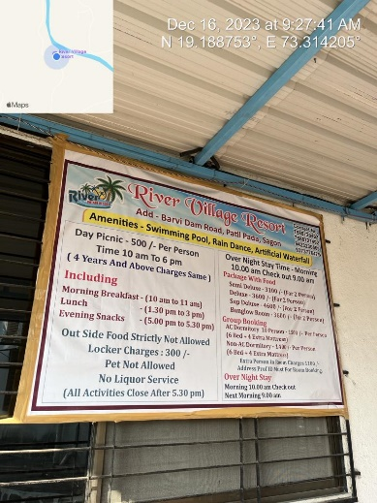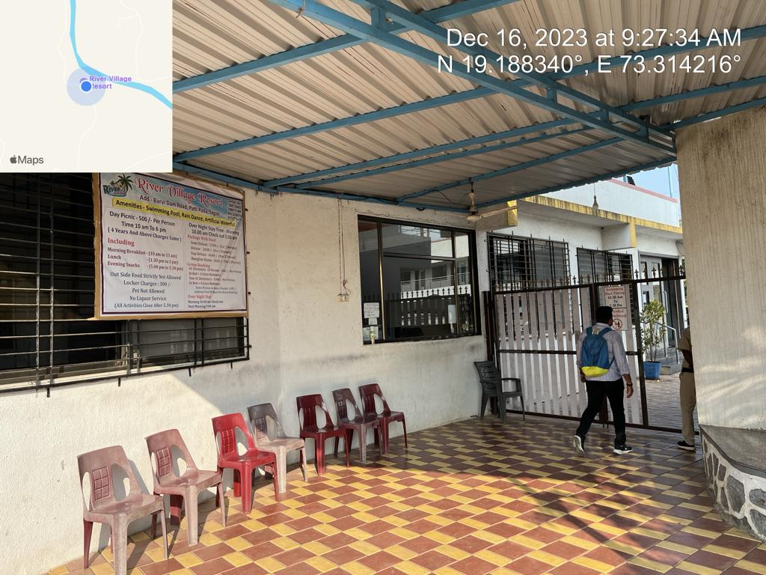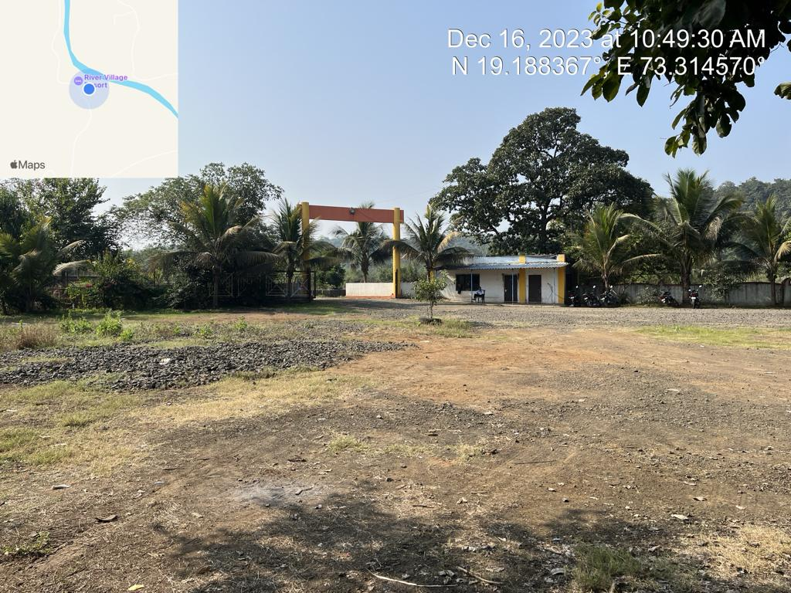**Actu**  **al site photographs**

**Route Map of the property**

**Site u/r**

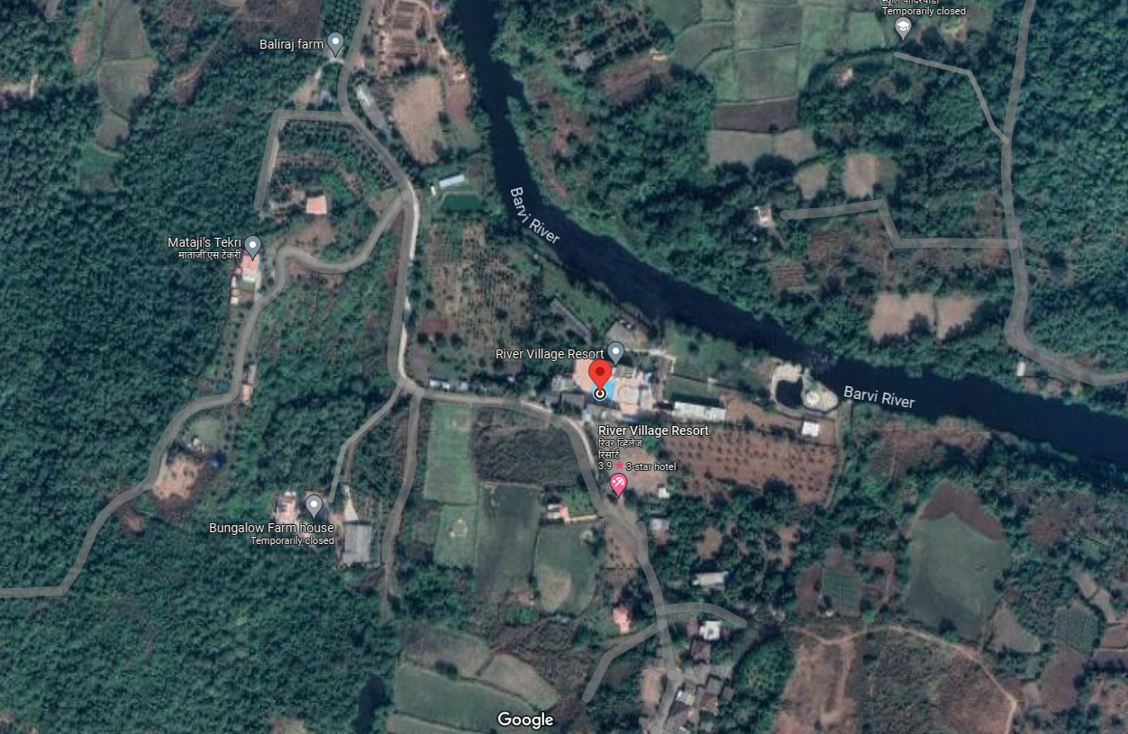

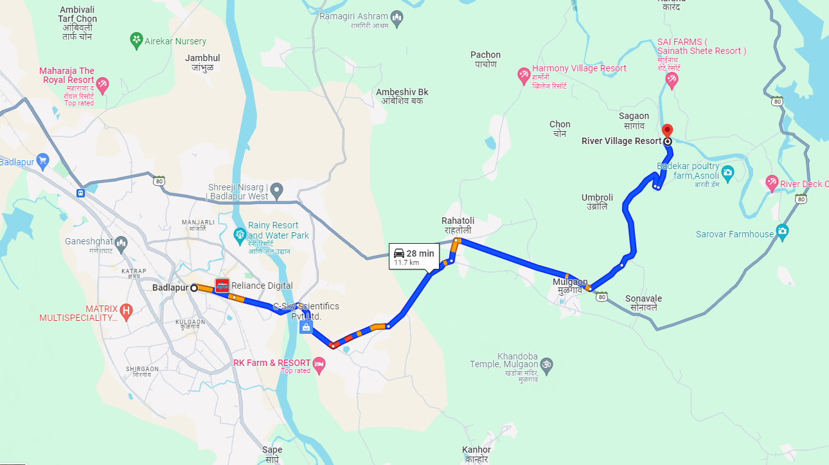

# Latitude Longitude - 19°11'19.5"N 73°18'51.1"E

# Note: The Blue line shows the route to site from nearest Railway Station (Balapur – 11.7 KM.)

**READY RECKONER RATE**

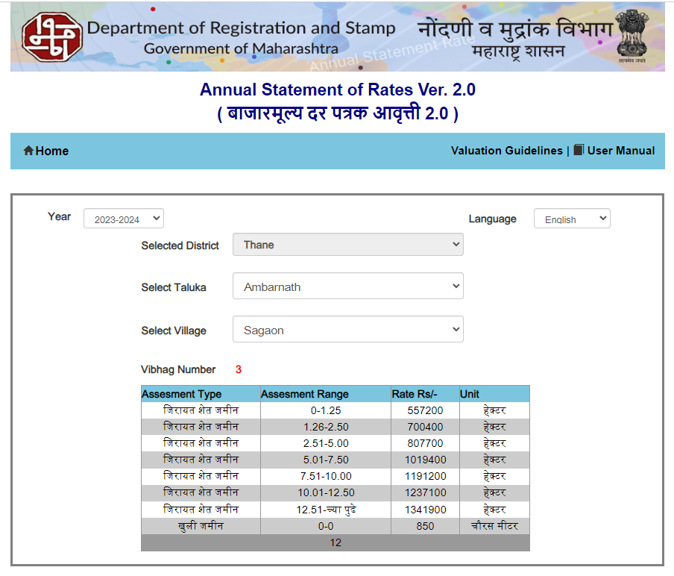

**Price Indicators**

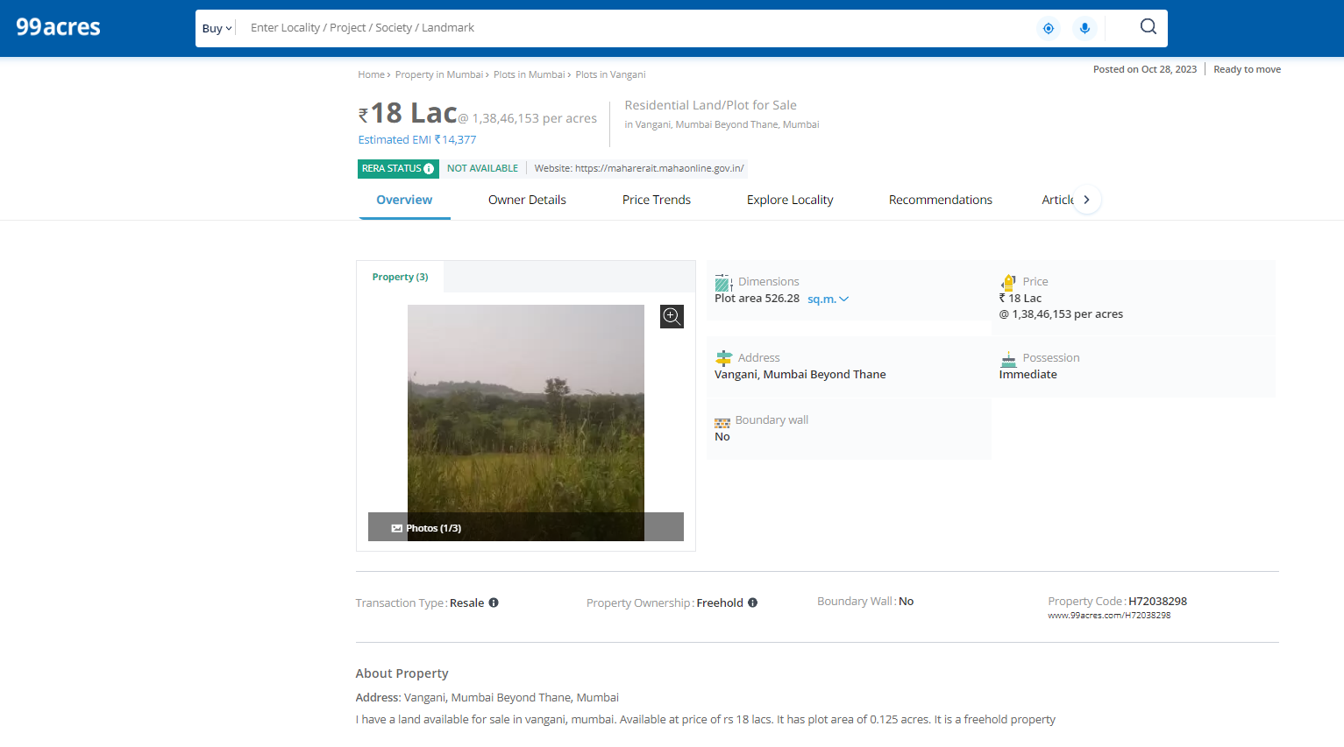

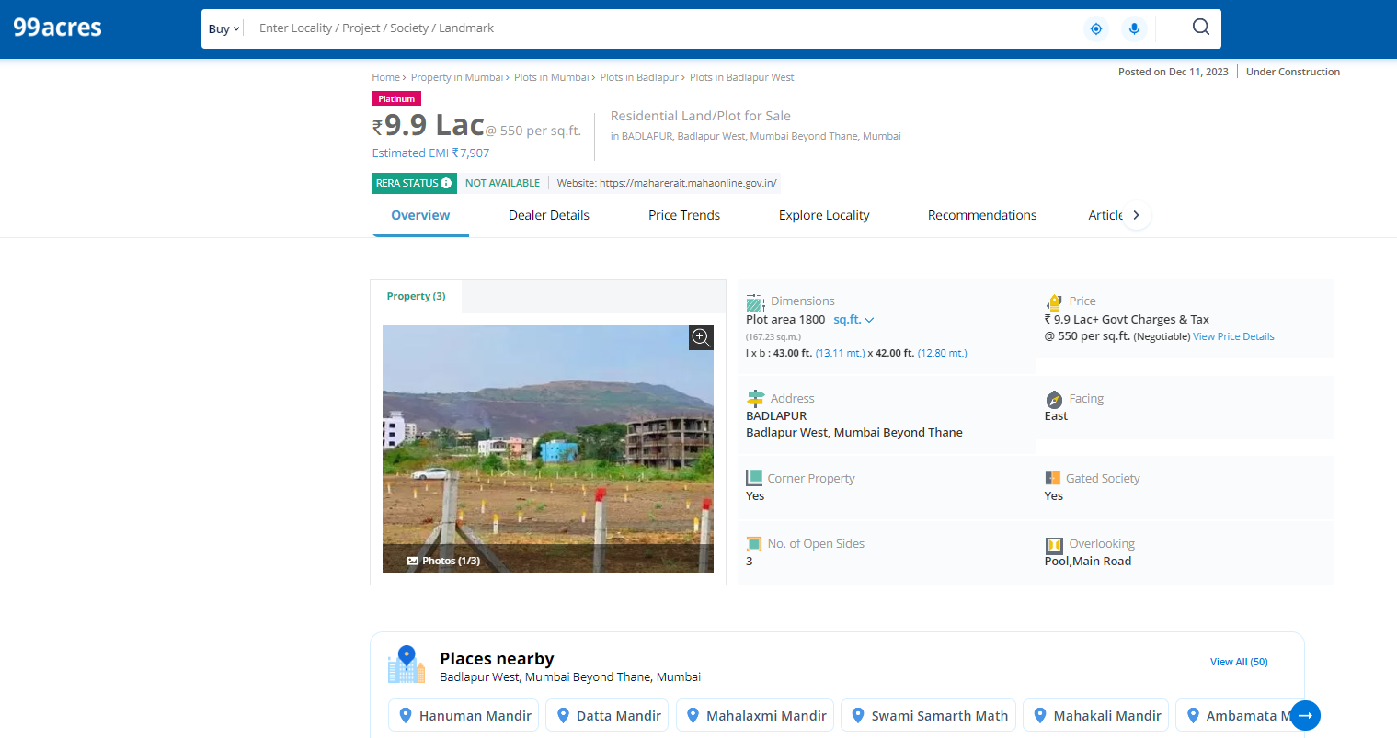

**Price Indicators**

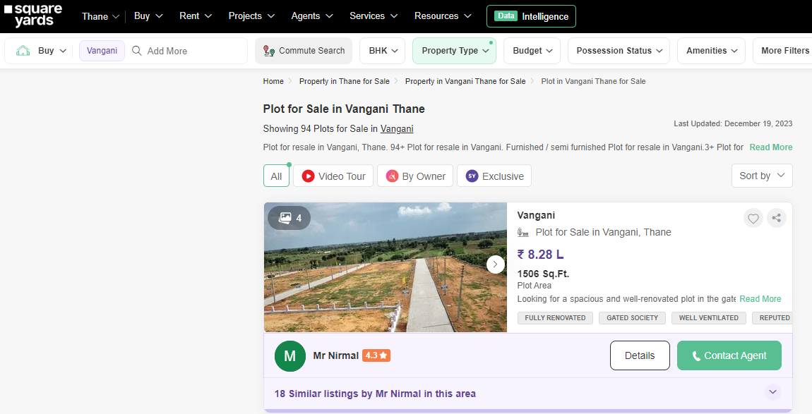

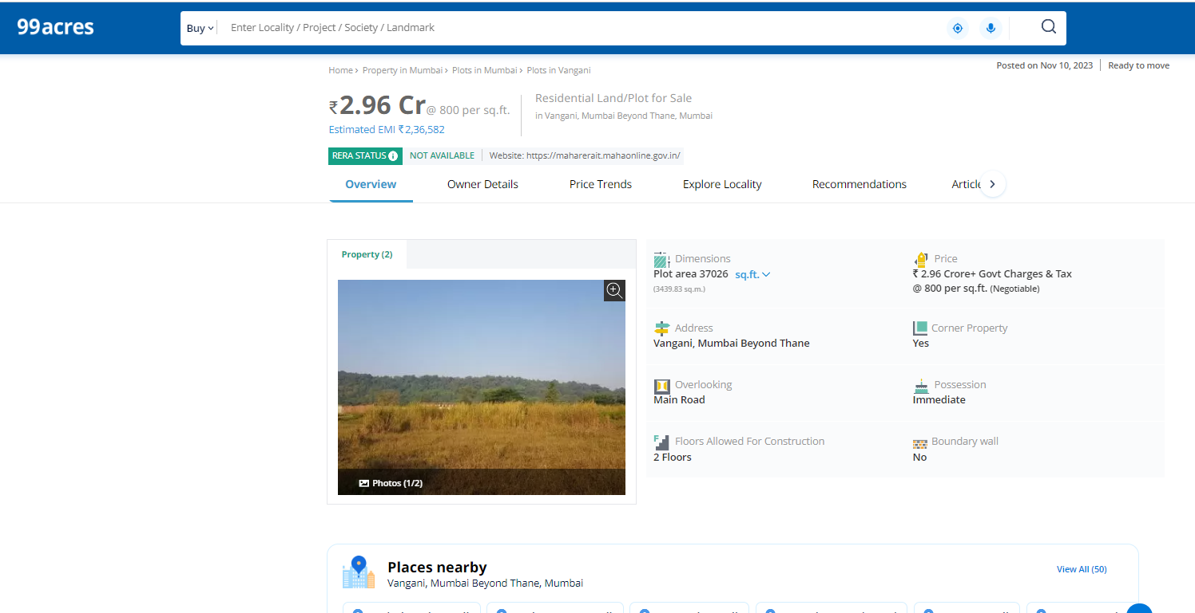

**DEFINITION OF VALUE FOR THIS SPECIFIC PURPOSE**

This exercise is to assess **Fair Market Value** of the property under reference as on **20th December 2023.**

The term **Fair Market Value** is defined as

*“The most probable price, as of a specified date, in cash, terms equivalent to cash, or in other precisely revealed terms for which the specified property rights would sell after reasonable exposure in a competitive market under all conditions requisite to a fair sale, with the buyer and seller each acting prudently knowledgeably and for self-interest assuming that neither is under undue duress”.*

Fundamental assumptions and conditions presumed in this definition are:

1. Buyer and seller are motivated by self-interest.

2. Buyer and seller are well informed and are acting prudently.

3. The property is exposed for a reasonable time on the open market.

4. Payment is made in cash or equivalent or in specified financing terms.

#### UNDER LYING ASSUMPTIONS

1. We assume no responsibility for matters of legal nature affecting the property appraised or the title thereto, nor do we render our opinion as to the title, which is assumed to be good and marketable.

2. The property is valued as though under responsible ownership.

3. It is assumed that the property is free of liens and encumbrances.

4. It is assumed that there are no hidden or unapparent conditions of the subsoil or structure that would render it more or less valuable. No responsibility is assumed for such conditions or for engineering that might be required to discover such factors.

5. There is no direct/ indirect interest in the property valued

6. The rates for valuation of the property are in accordance with the Govt. approved rates and prevailing market rates.

## Sharadkumar B. Chalikwar

Govt. Reg. Valuer

Chartered Engineer (India)

Reg. No. (N) CCIT/1-14/52/2008-09