Valuation Report of the Immovable Property

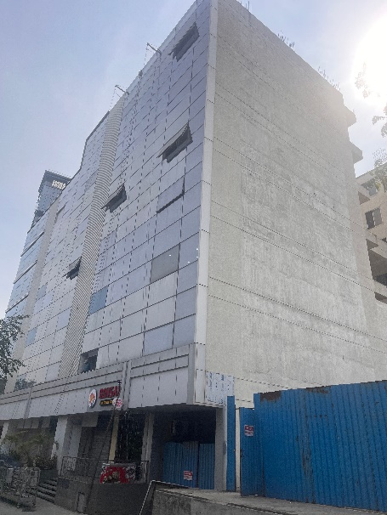

Details of the property under consideration:

Name of the Owner: Imperative Business Ventures Private Limited

I.T. Unit No. 403, 4th Floor, “Bhairaav Milestone”, Plot No. C – 15, Road No. 16, Wagle Industrial Estate,
Village – Panchpakhadi (Wagle Industrial Estate), Taluka & District – Thane, Thane (West),
PIN Code – 400 604, State - Maharashtra, Country - India

Latitude Longitude: 19°11'44.3"N 72°57'16.5"E

Valuation Done for:

Cosmos Bank
Mulund East
Ground + 1st Floor Of Shop No. 2, 1st Floor Of Shop No. 1, "Romell Vasanti", Vasanti Vihar Co-Op. Hsg. Soc. Ltd., Navghar Road, Mulund (East), Mumbai – 400 081, State – Maharashtra, Country – India

Vastu/Mumbai/10/2021/21332/36829
23/02-193-PASH
Date: 19.12.2023

VALUATION OPINION REPORT

The property bearing I.T. Unit No. 403, 4th Floor, “Bhairaav Milestone”, Plot No. C – 15, Road No. 16, Wagle Industrial Estate, Village – Panchpakhadi (Wagle Industrial Estate), Taluka & District – Thane, Thane (West), PIN Code – 400 604, State - Maharashtra, Country – India belongs to Imperative Business Ventures Private Limited.
Boundaries of the property.
North | Internal Road & Ashar 16 Residential Building
South | Caprihans India Limited
East | Road No. 16
West | Open Plot

Considering various parameters recorded, existing economic scenario, and the information that is available with reference to the development of neighbourhood and method selected for valuation, we are of the opinion that, the property premises can be assessed and valued for banking purpose at ` 6,08,64,000.00 (Rupees Six Crore Eight Lakh Sixty Four Thousand Only).

The valuation of the property is based on the documents produced by the concern. Legal aspects have not been taken into considerations while preparing this report.

Hence certified

Sharadkumar B. Chalikwar
Govt. Reg. Valuer
Chartered Engineer (India)
Reg. No. (N) CCIT/1-14/52/2008-09
Encl.: Valuation report

Valuation Opinion Report of I.T. Unit No. 403, 4th Floor, “Bhairaav Milestone”, Plot No. C – 15, Road No. 16, Wagle Industrial Estate, Village – Panchpakhadi (Wagle Industrial Estate), Taluka & District – Thane,
Thane (West), PIN Code – 400 604, State - Maharashtra, Country - India

Form 0-1
(See Rule 8 D)
REPORT OF VALUATION OF IMMOVABLE PROPERTY (OTHER THAN AGRICULTURAL LANDS, PLANTATIONS, FORESTS, MINES AND QUARRIES)
GENERAL:
1 | Purpose for which the valuation is made |  | To assess the Fair Market Value as on 19.12.2023 for Bank Loan Purpose
2 | Date of inspection |  | 18.12.2023
3 | Name of the owner/ owners |  | Imperative Business Ventures Private Limited
4 | If the property is under joint Ownership / co-ownership, share of each such owner. Are the shares undivided? |  | Company Ownership
5 | Brief description of the property |  | I.T. Unit No. 403, 4th Floor, “Bhairaav Milestone”, Plot No. C – 15, Road No. 16, Wagle Industrial Estate, Village – Panchpakhadi (Wagle Industrial Estate), Taluka & District – Thane, Thane (West), PIN Code – 400 604, State - Maharashtra, Country - India
6 | Location, street, ward no |  | Road No. 16, Wagle Industrial Estate, Village – Panchpakhadi (Wagle Industrial Estate), Thane (West)
7 | Survey/ Plot no. of land |  | Plot No. C-15 of Village - Panchpakhadi
8 | Is the property situated in residential/ commercial/ mixed area/ industrial area? |  | Commercial
9 | Classification of locality-high class/ middle class/poor class |  | Middle Class
10 | Proximity to civic amenities like schools, Hospitals, Offices, market, cinemas etc. |  | All available at near by
11 | Means and proximity to surface communication by which the locality is served |  | Served by Buses, Auto, Taxies and Private cars
 | LAND
12 | Area of land supported by documentary proof. Shape, dimension and physical features |  | As per table mentioned below
Particulars | Carpet Area  in Sq. M. | Flowerbed Area  in Sq. M. | Total Carpet Area  in Sq. M
Total Carpet Area in Sq. M. | 1078.00 | 67.00 | 1145.00
Add: Common Passage area will  be converted into usable  Carpet Area |  |  | 73.00
Carpet Area in Sq. M. |  |  | 1218.00
Carpet Area in Sq. Ft. |  |  | 13110.00
Less: Deduction for Duct Area in  Sq. Ft. |  |  | 248.00
Total Carpet Area in Sq. Ft. |  |  | 12862.00
Total Carpet Area as per Actual Site Measurement of I.T. Unit No. 401 to 403:

Area as per Deed of Assignment of I. T. Unit No. 403:

Particulars | Area in Sq. M. | Area in Sq. Ft.
RERA Carpet Area | 320.43 | 3449.00
Balcony / Open Terrace Area | 32.98 | 355.00
Total Carpet Area | 353.41 | 3804.00

Built up Area in Sq. Ft. = 4171.20
(Carpet Area as per Deed of Assignment + 10%)

Particulars | Carpet Area As per Approved Plan | Amalgamated area | As per Deed of Assignment | Balcony / Open Terrace Area | Total Carpet Area | Carpet Area as per Actual Site Measurement | FB Area as per Measurement | Total
IT Office 1 | 62.28 | 318.547 | 319.32 | 32.98 | 352.3
IT Office 2 | 97.713
IT Office 3 | 77.883
IT Office 4 | 80.671
IT Office 5 | 146.482 | 557.622 | 551.29 | 73.86 | 625.15
IT Office 6 | 137.044
IT Office 7 | 137.044
IT Office 8 | 137.052
IT Office 9 | 80.671 | 317.287 | 320.43 | 32.98 | 353.41
IT Office 10 | 77.883
IT Office 11 | 97.713
IT Office 12 | 61.02
Total in  Sq. M. | 1193.456 | 1193.456 | 1191.04 | 139.82 | 1330.86 | 1078.31 | 66.57 | 1144.9

Hence carpet area as per measurement is less than the approved plan & agreement area.

13 | Roads, Streets or lanes on which the land is abutting |  | Road No. 16, Wagle Industrial Estate, Village – Panchpakhadi (Wagle Industrial Estate)
14 | If freehold or leasehold land |  | Leasehold
15 | If leasehold, the name of Lessor/lessee, nature of lease, date of commencement and termination of lease and terms of renewal of lease.  (i) Initial premium  (ii) Ground rent payable per annum  (iii) Unearned increase payable to the Lessor in the event of sale or transfer |  | M.I.D.C.
16 | Is there any restriction covenant in regard to use of land? If so attach a copy of the covenant. |  | As per documents
17 | Are there any agreements of easements? If so attach a copy of the covenant |  | Information not available
18 | Does the land fall in an area included in any Town Planning Scheme or any Development Plan of Government or any statutory body? If so give Particulars. |  | Yes
19 | Has any contribution been made towards development or is any demand for such contribution still outstanding. |  | Information not available
20 | Has the whole or part of the land been notified for acquisition by government or any statutory body? Give date of the notification. |  | N.A.
21 | Attach a dimensioned site plan |  | Attached
 | IMPROVEMENTS
22 | Attach plans and elevations of all structures standing on the land and a lay-out plan. |  | Information not available
23 | Furnish technical details of the building on a separate sheet (The Annexure to this form may be used) |  | Attached
24 | Is the building owner occupied/tenanted/both? |  | Owner Occupied
25 | If the property owner occupied, specify portion and extent of area under owner-occupation |  | Fully Occupied
26 | What is the Floor Space Index permissible and Percentage actually utilized? |  | Floor Space Index permissible - As per M.I.D.C. norms  Percentage actually utilized – Details not available
 | RENTS
 | (i) | Names of tenants/ lessees/ licensees, etc | N.A.
 | (ii) | Portions in their occupation | N.A.
 | (iii) | Monthly or annual rent /compensation/license fee, etc. paid by each | N.A.
 | (iv) | Gross amount received for the whole property | N.A.
27 | Are any of the occupants related to, or close to business associates of the owner? |  | N.A.
28 | Is separate amount being recovered for the use of fixtures, like fans, geysers, refrigerators, cooking ranges, built-in wardrobes, etc. or for services charges? If so, give details |  | N.A.
29 | Give details of the water and electricity charges, If any, to be borne by the owner |  | N.A.
30 | Has the tenant to bear the whole or part of the cost repairs and maintenance? Give particulars |  | N.A.
31 | If a lift is installed, who is to bear the cost of maintenance and operation- owner or tenant? |  | N.A.
32 | If a pump is installed, who is to bear the cost of maintenance and operation- owner or tenant? |  | N.A.
33 | Who has to bear the cost of electricity charges for lighting of common space like entrance hall, stairs, passage, compound, etc. owner or tenant? |  | N.A.
34 | What is the amount of property tax? Who is to bear it? Give details with documentary proof |  | Information not available
35 | Is the building insured? If so, give the policy no., amount for which it is insured and the annual premium |  | Information not available
36 | Is any dispute between landlord and tenant regarding rent pending in a court of rent? |  | N.A.
37 | Has any standard rent been fixed for the premises under any law relating to the control of rent? |  | N.A.
 | SALES
38 | Give instances of sales of immovable property in the locality on a separate sheet, indicating the Name and address of the property, registration No., sale price and area of land sold. |  | N.A.
39 | Land rate adopted in this valuation |  | N. A. as the property under consideration is a I.T. Unit in an I.T. Park Building. The rate is considered as composite rate.
40 | If sale instances are not available or not relied up on, the basis of arriving at the land rate |  | N.A.
 | COST OF CONSTRUCTION
41 | Year of commencement of construction and year of completion |  | Year of Completion – 2021  (As per Part Occupancy Certificate)
42 | What was the method of construction, by contract/By employing Labour directly/ both? |  | N.A.
43 | For items of work done on contract, produce copies of agreements |  | N.A.
44 | For items of work done by engaging Labour directly, give basic rates of materials and Labour supported by documentary proof. |  | N.A.
45 | Remarks
- As per Approved Plan, 4th floor is having I.T. Office 401 to I.T. office 412. But as per Site Information, I.T. Office 401 to 404 will be converted into I.T. Office No. 401, I.T. Office 405 & 408 will be converted into I.T. Office No. 402 and I.T. Office 409 to 412 will be converted into I.T. Office No. 403. Also, the common passage area will be converted into usable carpet area. Hence, it is recommended to obtain revised approved plan. For the purpose of valuation, we have considered area as per Deed of Assignment of I.T. Office No. 403 only.
- As per Site Inspection, I.T. Office No. 401, 402 & 403 are internally amalgamated to form a single office with Two entrances.

PART II- VALUATION
GENERAL:

Under the instruction of Cosmos Bank, Mulund East Branch, we have valued I.T. Unit No. 403, 4th Floor, “Bhairaav Milestone”, Plot No. C – 15, Road No. 16, Wagle Industrial Estate, Village – Panchpakhadi (Wagle Industrial Estate), Taluka & District – Thane, Thane (West), PIN Code – 400 604, State - Maharashtra, Country – India belongs to Imperative Business Ventures Private Limited.

We are in receipt of the following documents:
Copy of Deed of Assignment of I.T. Unit No. 403 dated 13.12.2021
Copy of Commencement Certificate Document No. MIDC / DE & PA – III / SPA / THN / C-15 / IFMS – A - 69288 / of 2018 dated 27.02.2018 issued by Maharashtra Industrial Development Corporation (MIDC)
Copy of Part Occupancy Certificate Document No. MIDC / DE & PA – III / SPA / C-1 / IFMS – D52323 / 2019 dated 25.10.2019 issued by Maharashtra Industrial Development Corporation (MIDC) [for Basement + Ground Floor + 1st Floor + 2nd Floor only.]
Copy of Part Occupancy Certificate Document No. MIDC / IFMS / THANE I / E & MD / Subdn Thane / PAIII / 2021 / E26777 dated 29.10.2021 issued by Maharashtra Industrial Development Corporation (MIDC) [for Ground Floor + 5th upper Floor only.]
Copy of RERA Certificate Document No. P51700020951 dated 18.05.2020
Copy of Approved Plan Document No. MIDC / SPA / THN / IFMS – C92945 / of 2019 dated 03.09.2021 issued by Maharashtra Industrial Development Corporation (MIDC)
LOCATION:
The said building is located at Plot No. C – 15, Road No. 16, Wagle Industrial Estate, Village – Panchpakhadi (Wagle Industrial Estate), Taluka & District – Thane, Thane (West), PIN Code – 400 604, State - Maharashtra, Country – India. It is at a travelling distance of 3.8 Km. from Thane Railway station. The surrounding locality is Commercial.
BUILDING:
The building under reference is having Basement + Ground + 1st to 5th Floor + 6th floor (Part) floor. It is a R.C.C. Framed Structure framed with 9" thick external walls and 6" thick internal POP finished brick walls. The walls are having sand faced plaster from outside. The Staircase is of R.C.C. with R.C.C. trades and risers with chequered tile floor finish. The whole building is I.T. Park Building. As per Approved Plan, 4th floor is having I.T. Office 401 to I.T. office 412. But as per Site Information, I.T. Office 401 to I.T. office 412 will be converted into I.T. Office No. 401 to I.T. Office No. 403. 6 Lifts were provided in the building.

I.T. Unit:
The I.T. Unit under reference is situated on the 4th Floor. As per Approved Plan, 4th floor is having I.T. Office 401 to I.T. office 412. But as per Site Information, I.T. Office 401 to 405 will be converted into I.T. Office No. 401, I.T. Office 406 & 407 will be converted into I.T. Office No. 402 and I.T. Office 408 to 412 will be converted into I.T. Office No. 403. Also, the common passage area will be converted into usable carpet area. As per Site Inspection, I.T. Office No. 401, 402 & 403 are internally amalgamated to form a single office with Two entrances. The Composition of Amalgamated office is 12 Cabins + 2 Employee Areas + Meeting Room + Conference Room + Cafeteria + 2 Toilets + Hub + Passage. Along with 6 Car Parking Space No. 68, 69, 70, 71, 72, 73. The I.T. Unit is finished with Vitrified Tiles flooring, Teak Wood door frame with Glass doors, Cement plastering with acoustic false ceiling, concealed electrification.

Valuation as on 19th December 2023  The Total Carpet Area of the I.T. Unit | : 3804.00 Sq. Ft.
Deduct Depreciation:
Year of Construction of the building | : | 2021
Expected total life of building | : | 60 Years
Age of the building as on 2021 | : | 2 Years
Cost of Construction | : | 4184.40 Sq. Ft. X ` 2,800.00 = ` 1,17,16,320.00
Depreciation | : | N.A., as the age of the building is below 5 years
Amount of depreciation  Guideline rate obtain from the stamp Duty  Ready Reckoner | :  : | Nil  ` 1,17,500.00 Sq. M. i.e.  ` 10,916.00 Sq. Ft.
Value of property as on 19.12.2023 | : | (3804.00 Sq. Ft. X ` 16,000.00 =` 6,08,64,000.00)
(Area of property x market rate of developed land & Residential premises as on 2023-24 published in The Indian Valuer’s Directory and Reference Book for purpose of valuation. – Depreciation)
Fair Market value of the property  as on 19.12.2023 | : | ` 6,08,64,000.00
Value of the property | : | ` 6,08,64,000.00
The realizable value of the property | : | ` 5,47,77,600.00
Distress value of the property | : | ` 4,86,91,200.00
Insurable value of the property | : | ` 1,17,16,320.00
Guideline Value of the property | : | ` 4,56,76,910.00
Taking into consideration above said facts, we can evaluate the value of I.T. Unit No. 403, 4th Floor, “Bhairaav Milestone”, Plot No. C – 15, Road No. 16, Wagle Industrial Estate, Village – Panchpakhadi (Wagle Industrial Estate), Taluka & District – Thane, Thane (West), PIN Code – 400 604, State - Maharashtra, Country – India for this particular purpose at ` 6,08,64,000.00 (Rupees Six Crore Eight Lakh Sixty Four Thousand Only). as on 19th December 2023.

NOTES
- I, Sharadkumar B. Chalikwar with my experience and ability to judgment I am of the considered opinion that the fair market value of the property as on 19th December 2023 is at ` 6,08,64,000.00 (Rupees Six Crore Eight Lakh Sixty Four Thousand Only). Value varies with time and purpose and hence this value should not be referred for any purpose other than mentioned in this report.
- This valuation is done on the basis of information, which the Valuer has obtained by information provided by the client about the premises and location of the surrounding area and also prevailing rates in the surrounding area, and further subject to document as mentioned in valuation report.
- This Valuer should not be held responsible for authentication of documents, clear title and other such related matters. For that purpose, Latest Legal Opinion should be sought.
PART III- DECLARATION
I hereby declare that
- The information furnished in part I is true and correct to the best of my knowledge and belief;
- I have no direct or indirect interest in the property valued:

ANNEXURE TO FORM 0-1

1 | No. of floors and height of each floor |  | Basement + Ground + 1st to 5th Floor + 6th floor (Part) floor
2 | Plinth area floor wise as per IS 3361-1966 |  | N.A. as the said property is a I.T. Unit on 4th floor
3 | Year of construction |  | Year of Completion – 2021
4 | Estimated future life |  | 58 years Subject to proper, preventive periodic maintenance and structural repairs.
5 | Type of construction- load bearing walls/RCC frame/ steel frame |  | R.C.C. Framed Structure
6 | Type of foundations |  | R.C.C. Foundation
7 | Walls |  | All external walls are 9" thick and partition walls are 6" thick.
8 | Partitions |  | 6" thick brick wall
9 | Doors and Windows |  | Teak Wood door frame with Glass doors
10 | Flooring |  | Vitrified Tiles flooring
11 | Finishing |  | Cement Plastering with acoustic false ceiling
12 | Roofing and Terracing |  | R.C.C. Slab
13 | Special architectural or decorative features, if any |  | No.
15 | (i) | Internal wiring :surface/conduit | concealed electrification
 | (ii) | Class of fittings: Superior/Ordinary/Poor. | Ordinary
15 | Sanitary installations
 | (i) | No. of water closets | As per requirement
 | (ii) | No. of lavatory basins
 | (iii) | No. of urinals
 | (iv) | No. of sinks
16 | Class of fittings: Superior colored / superior white/ordinary. |  | Ordinary
17 | Compound wall  Height and length  Type of construction |  | 5'.6" High, R.C.C. columns with B. B. Masonry wall.
18 | No. of lifts and capacity |  | 6 Lifts
19 | Underground sump – capacity and type of construction |  | R.C.C tank

20 | Over-head tank  Location, capacity  Type of construction | R.C.C tank on Terrace
21 | Pumps- no. and their horse power | May be provide as per requirement
22 | Roads and paving within the compound approximate area and type of paving | Cemented road in open spaces, etc.
23 | Sewage disposal – whereas connected to public sewers, if septic tanks provided, no. and capacity | Connected to Municipal Sewerage System

Actual site photographs
Of I.T. office 401, 402 & 403

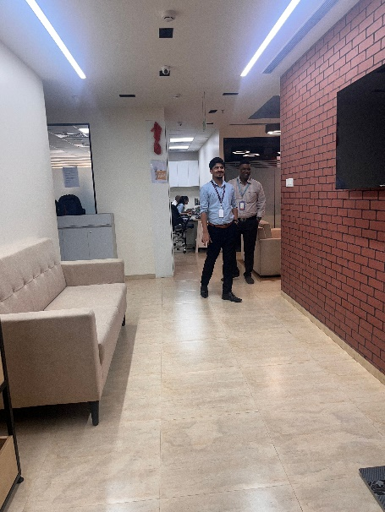
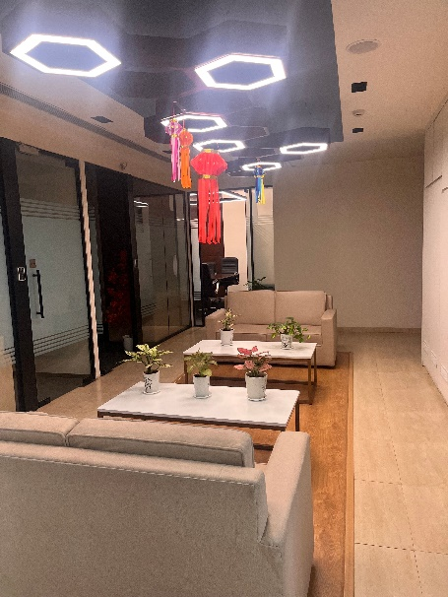
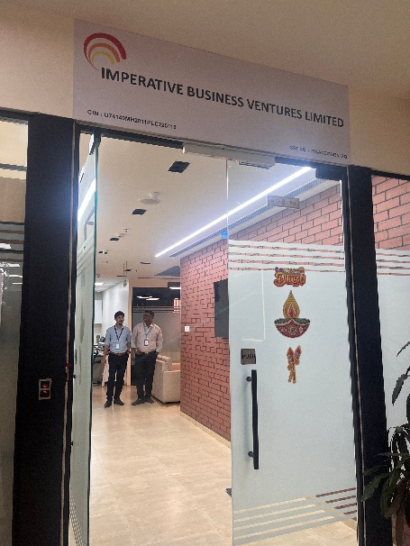

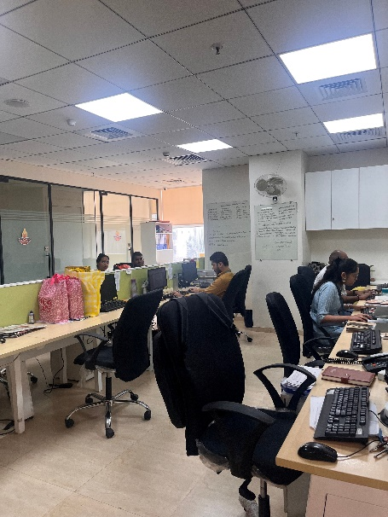
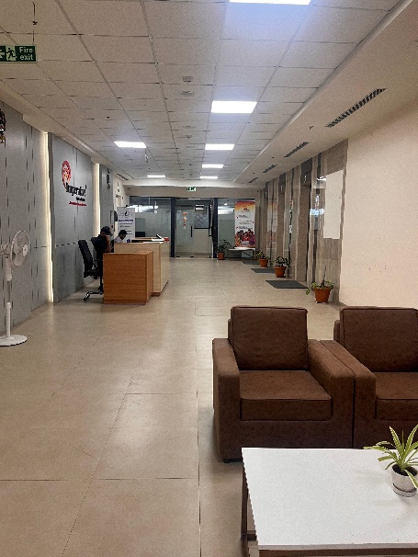
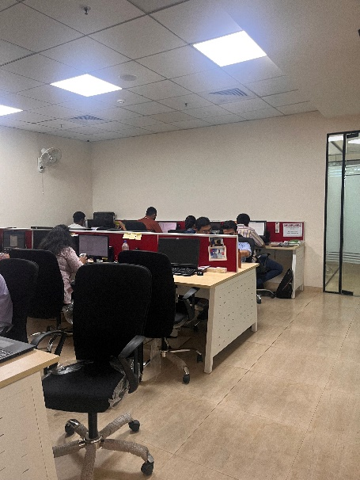

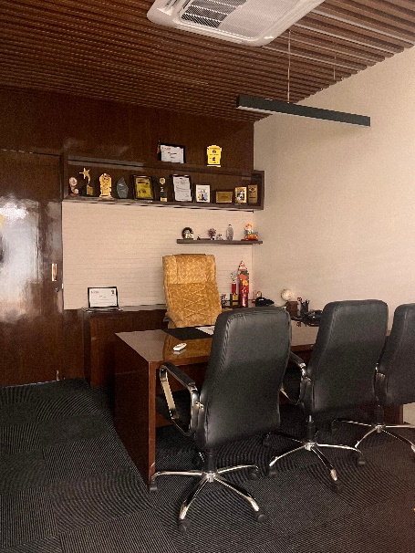
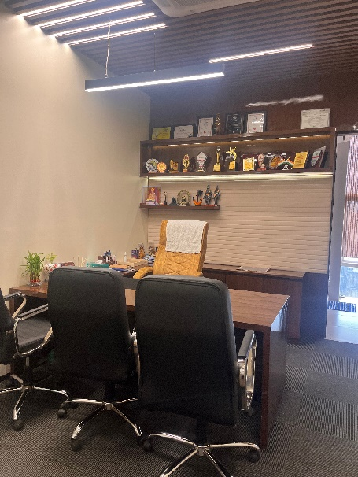
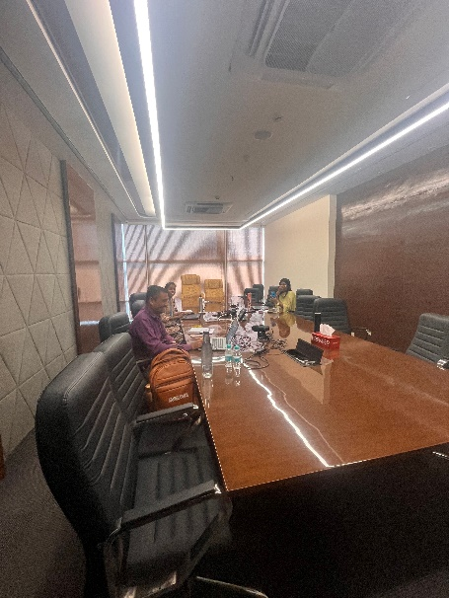
,

Actual site photographs
Of I.T. office 401, 402 & 403
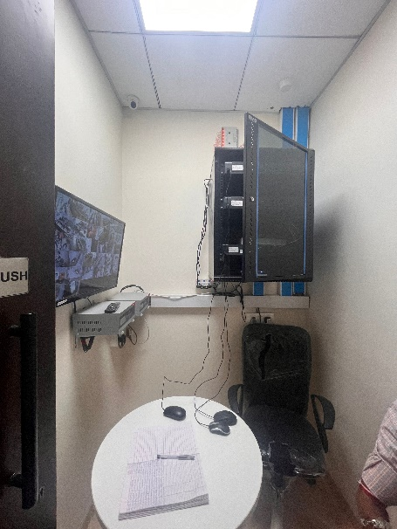
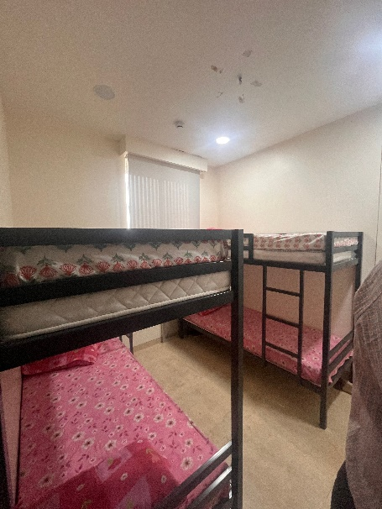
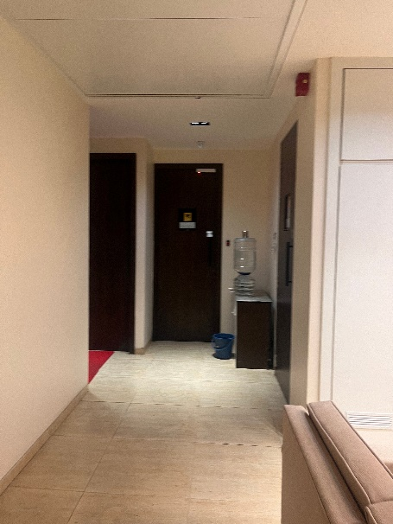

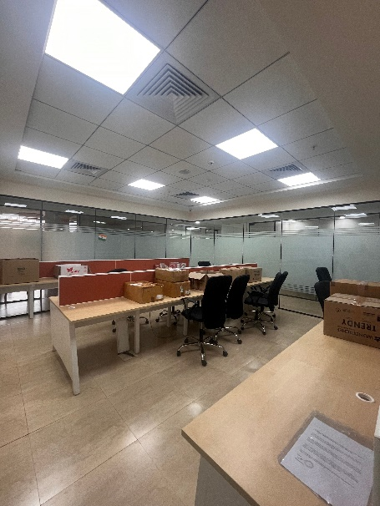
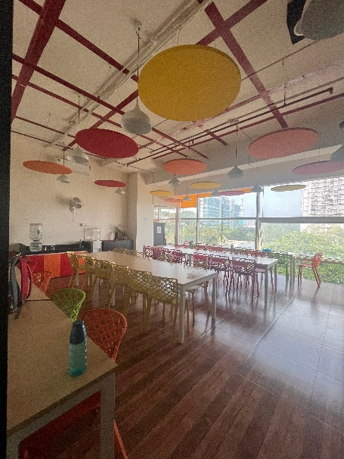
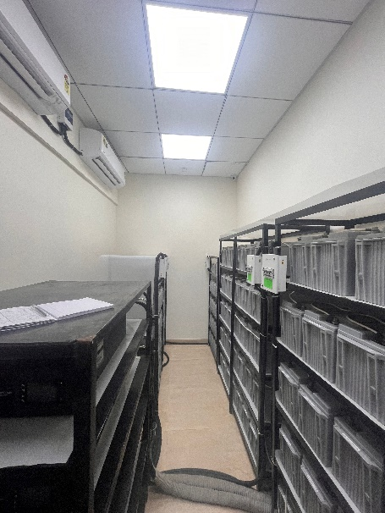

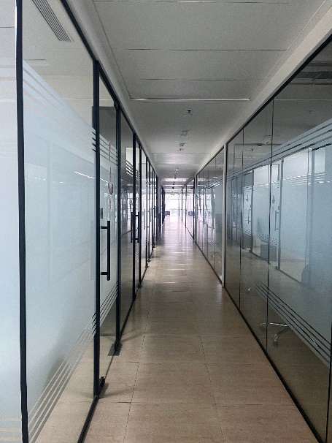
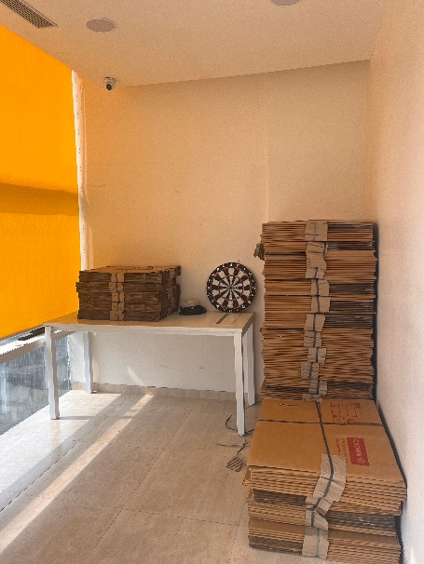
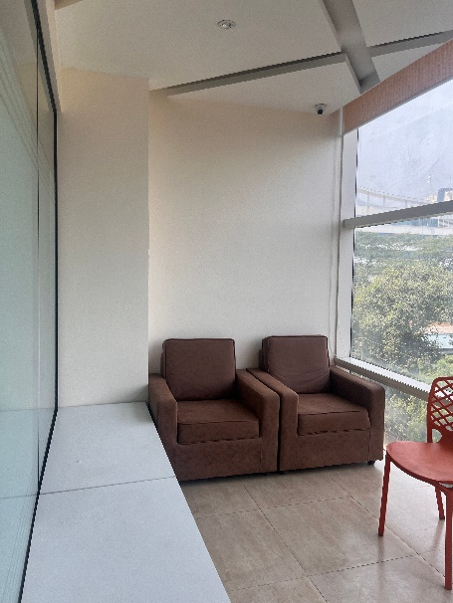

Actual site photographs
Of I.T. office 401, 402 & 403
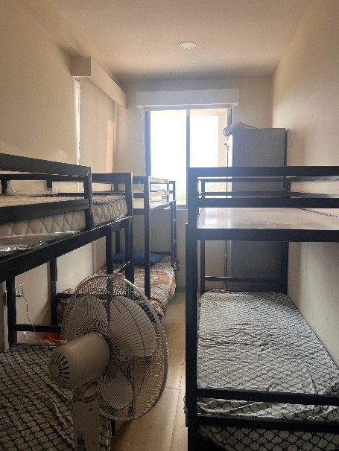
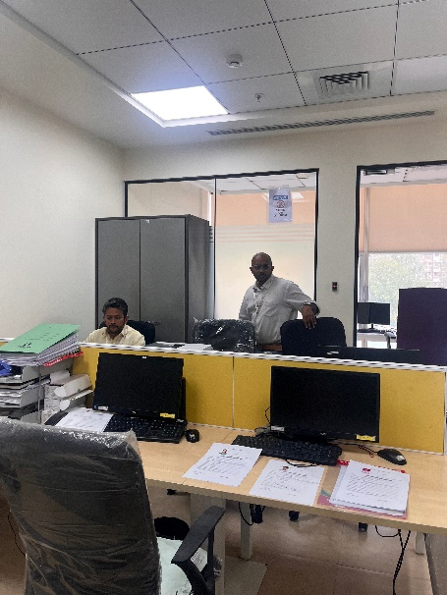
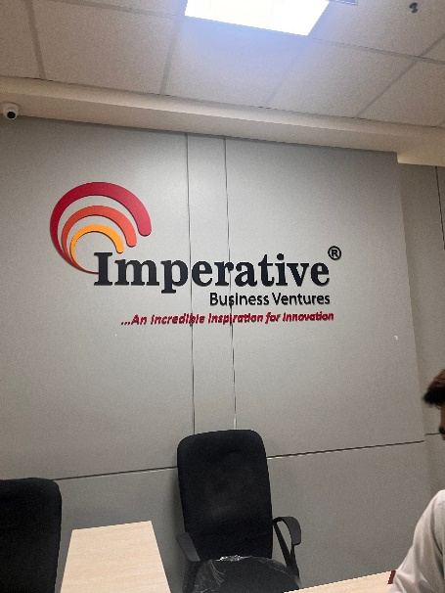
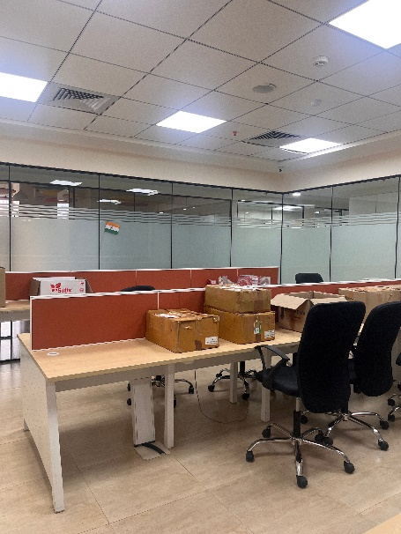
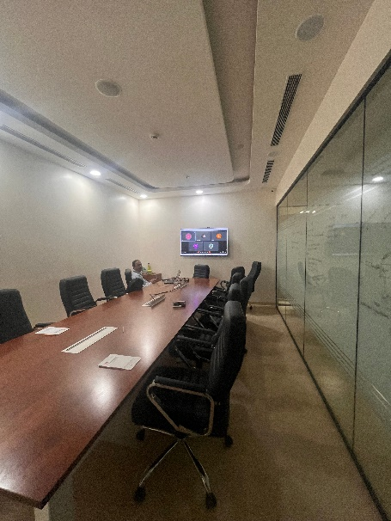
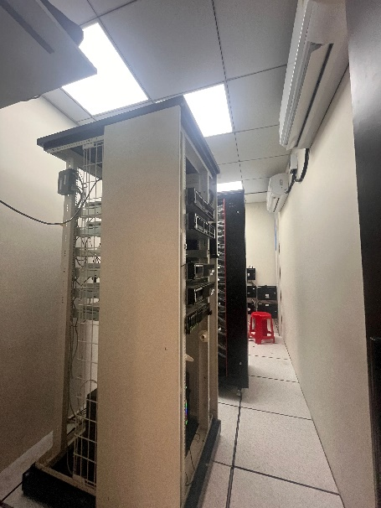
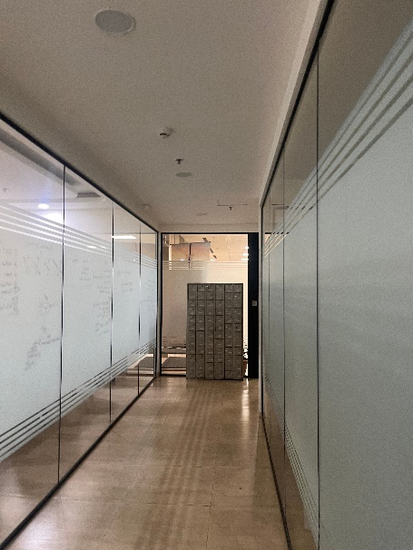
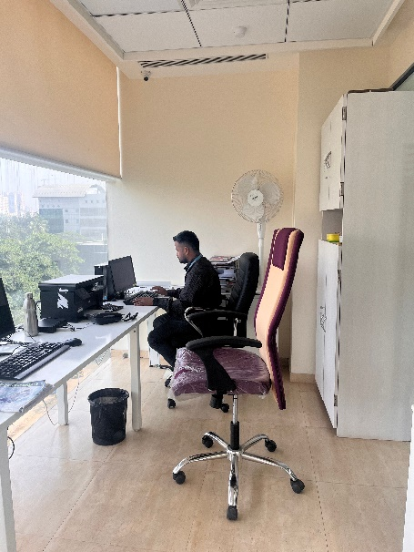
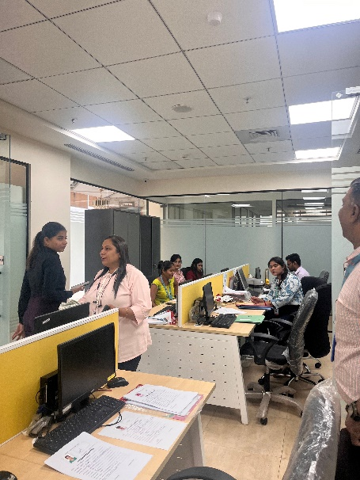

Actual site photographs
Of I.T. office 401, 402 & 403
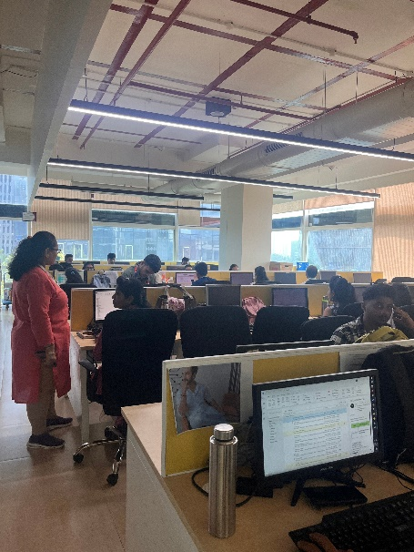
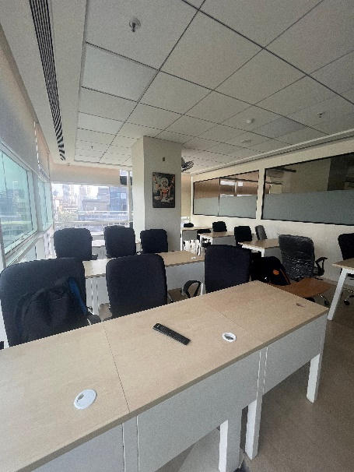
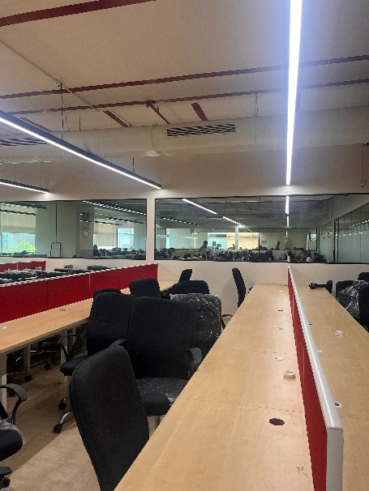
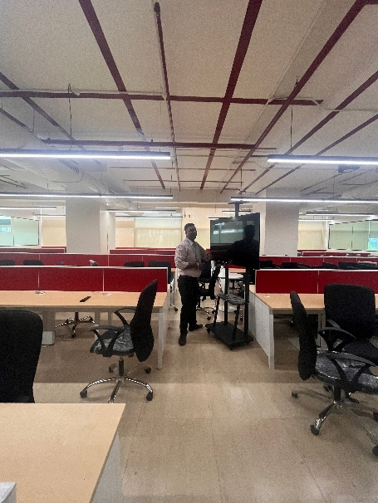
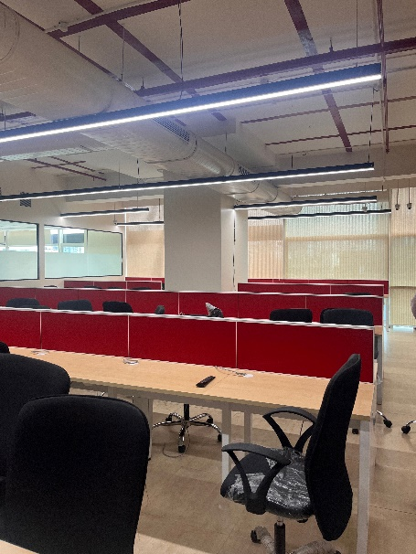
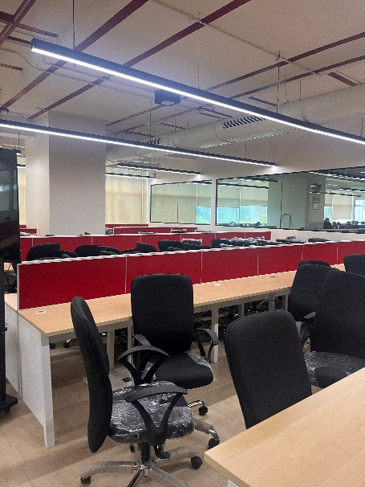
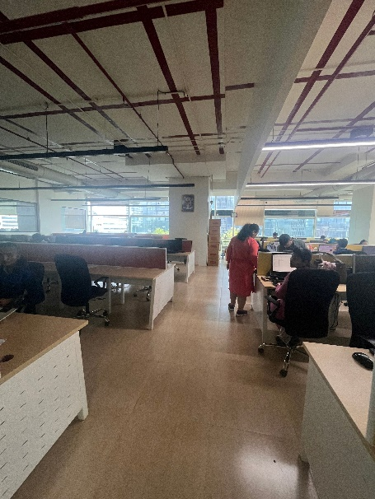
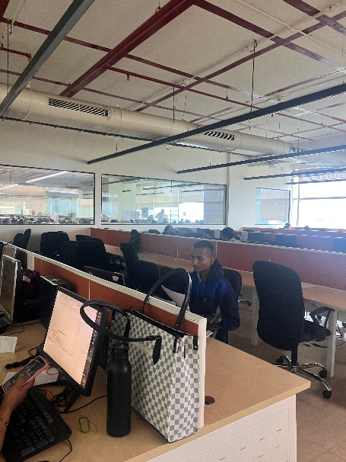
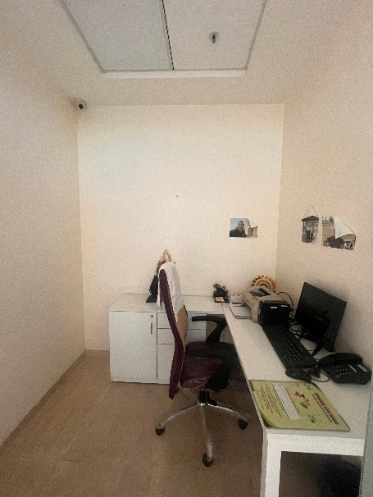

Actual site photographs

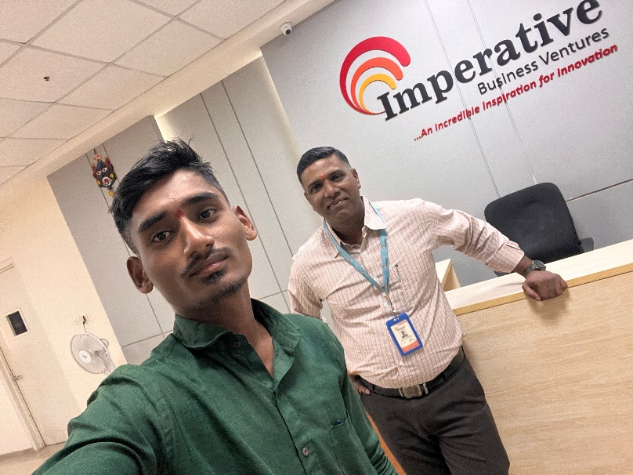

Route Map of the property
Site u/r
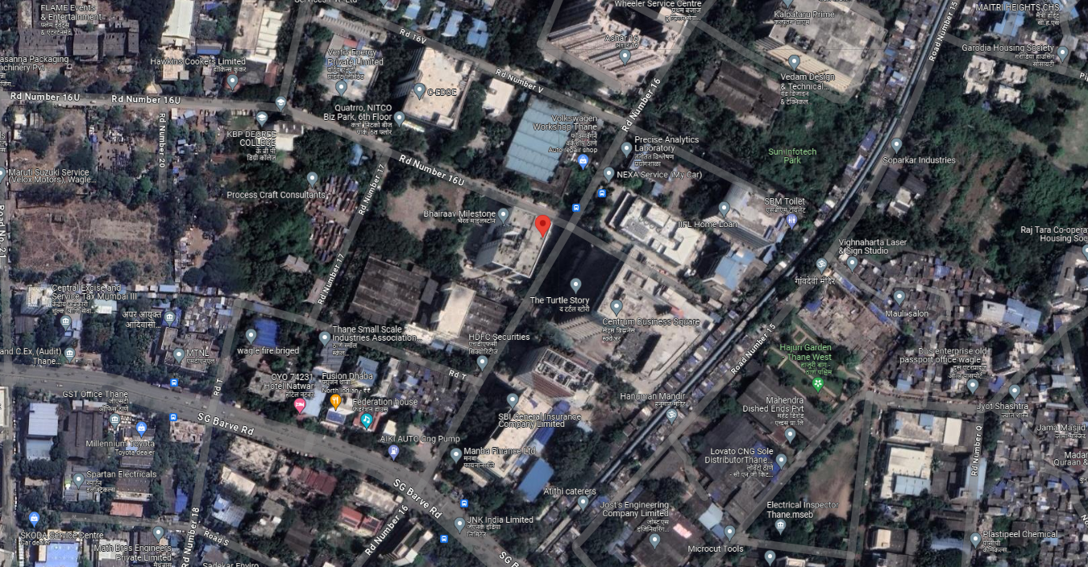

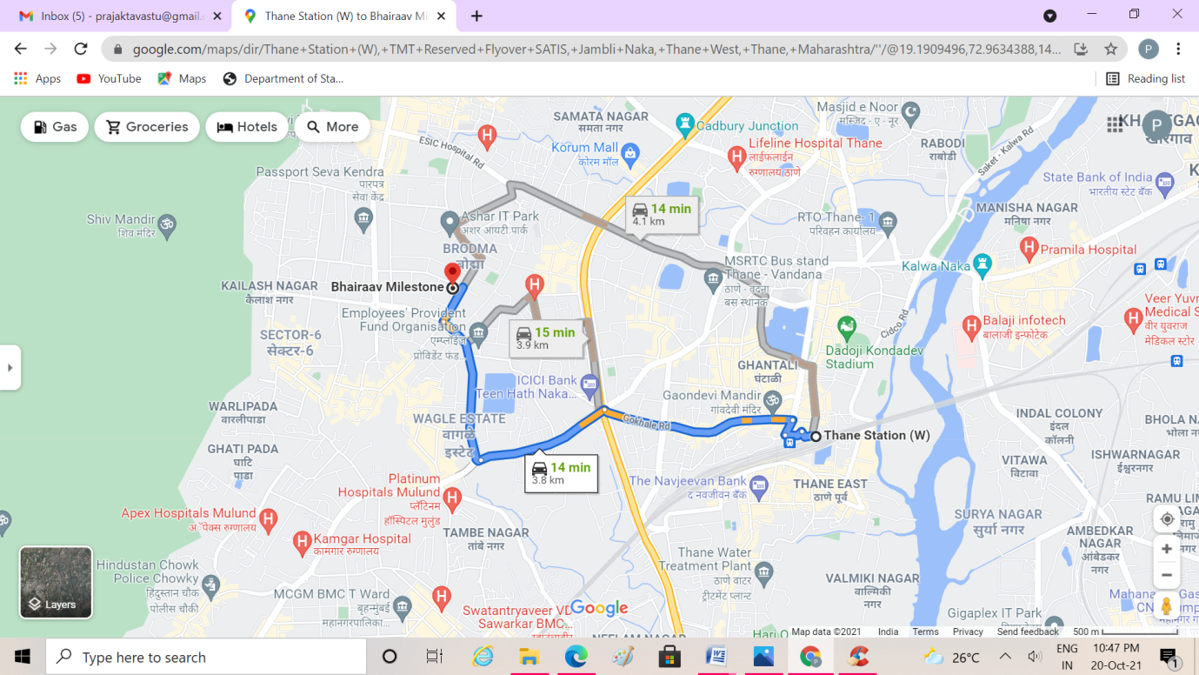

Latitude Longitude: 19°11'44.3"N 72°57'16.5"E
Note: The Blue line shows the route to site from nearest railway station (Thane – 3.8 Km.)

Ready Reckoner Rate
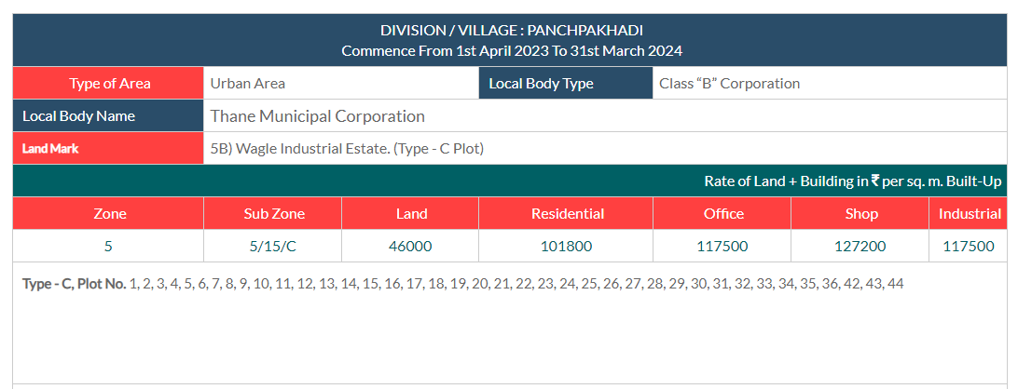

Price Indicators
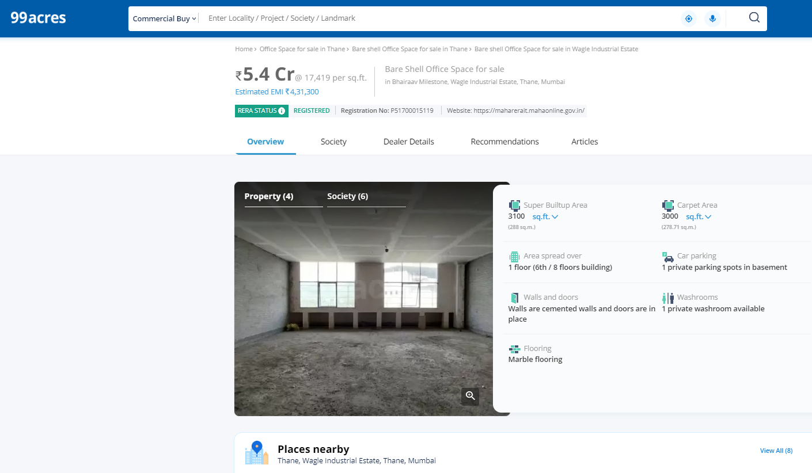

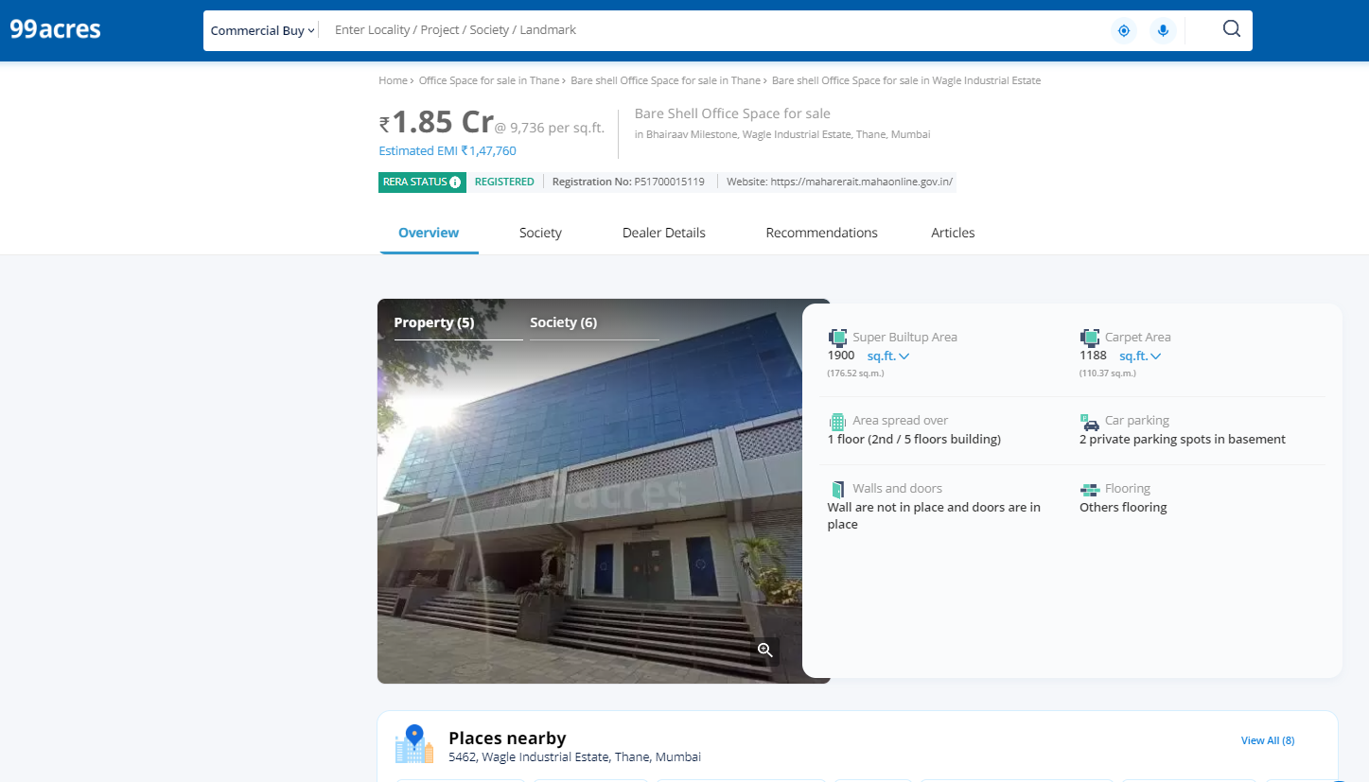
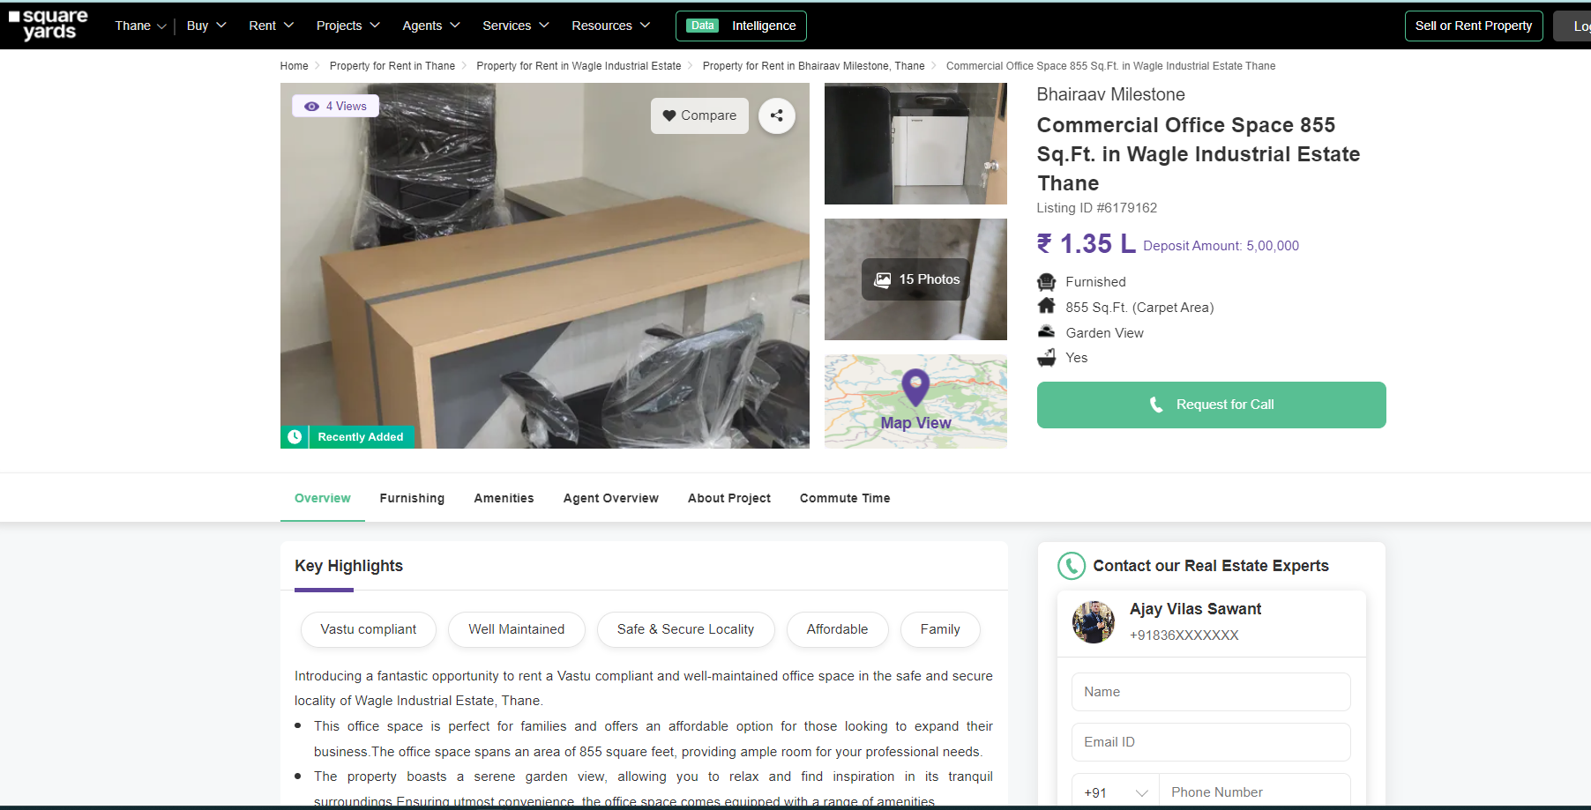
Price Indicators
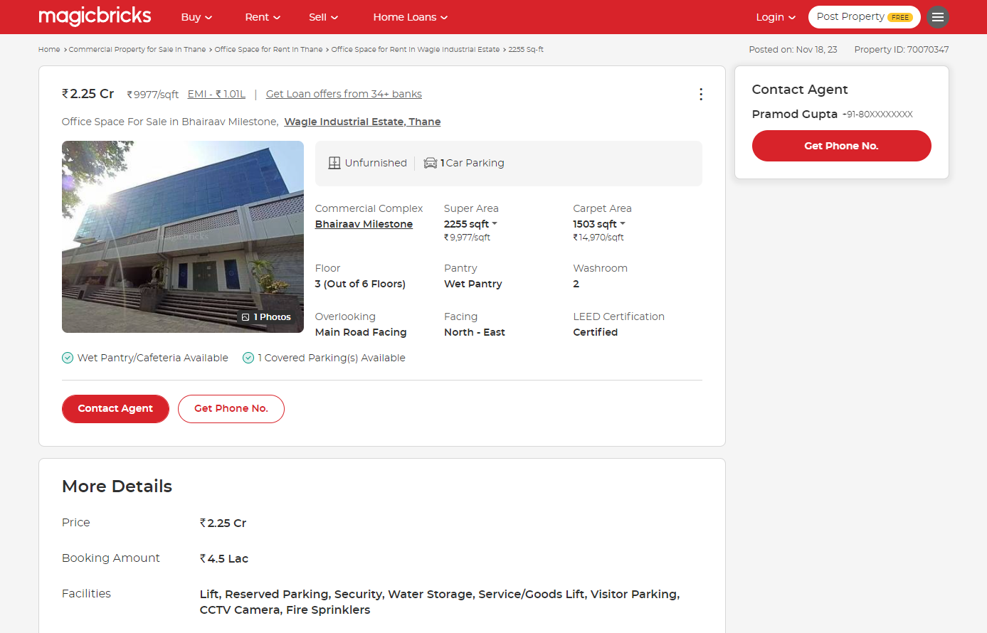

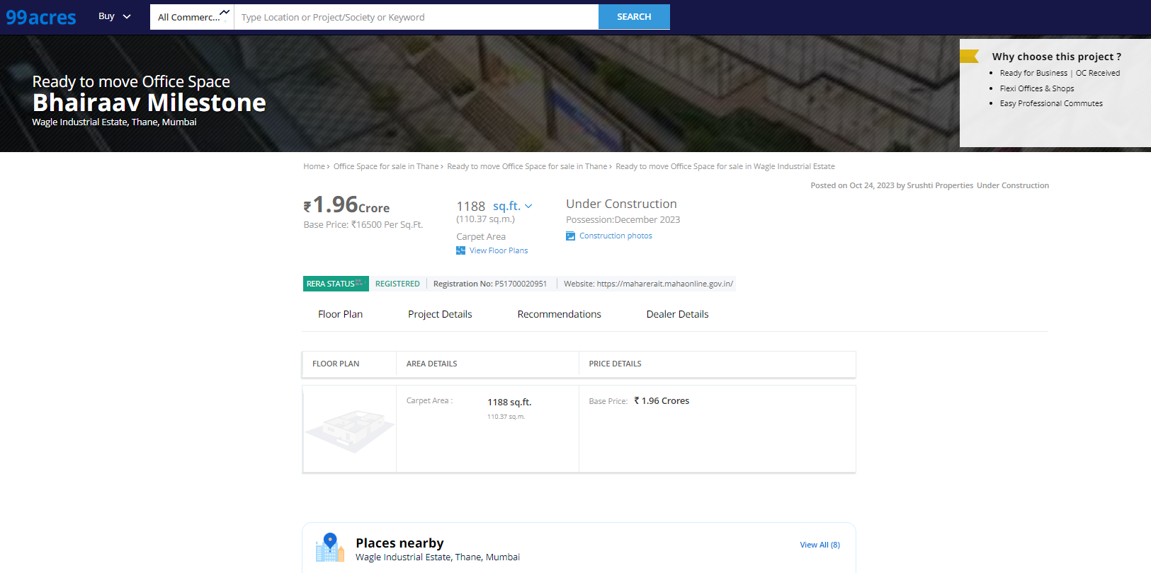
Price Indicators

DEFINITION OF VALUE FOR THIS SPECIFIC PURPOSE

This exercise is to assess Fair Market Value of the property under reference for Bank Loan purpose as on date 19th December 2023

The term Fair Market Value is defined as

"The most probable price, as of a specified date, in cash, terms equivalent to cash, or in other precisely revealed terms for which the specified property rights would sell after reasonable exposure in a competitive market under all conditions requisite to a fair sale, with the buyer and seller each acting prudently knowledgeably and for self-interest assuming that neither is under undue duress"

Fundamental assumptions and conditions presumed in this definition are:

- Buyer and seller are motivated by self-interest.

- Buyer and seller are well informed and are acting prudently.

- The property is exposed for a reasonable time on the open market.

- Payment is made in cash or equivalent or in specified financing terms.

UNDER LYING ASSUMPTIONS

- We assume no responsibility for matters of legal nature affecting the property appraised or the title thereto, nor do we render our opinion as to the title, which is assumed to be good and marketable

- The property is valued as though under responsible ownership.

- It is assumed that the property is free of liens and encumbrances.

- It is assumed that there are no hidden or unapparent conditions of the subsoil or structure that would render it more or less valuable. No responsibility is assumed for such conditions or for engineering that might be required to discover such factors.

DECLARATION OF PROFESSIONAL FEES CHARGED
We hereby declare that, our professional fees are not contingent upon the valuation findings. However, if the statute AND/OR clients demands that, the fees should be charged on the percentage of assessed value then, with the full knowledge of the AND/OR end user, it is being charged accordingly.

VALUATION OF THE PROPERTY PREMISES
Considering various parameters recorded herein above, existing economic scenario, and the information that is available with reference to the development of neighbourhood and method selected for valuation, we are of the opinion that, the property premises can be assessed and valued for Banking Purpose as on day for is at ` 6,08,64,000.00 (Rupees Six Crore Eight Lakh Sixty Four Thousand Only).

Sharadkumar B. Chalikwar
Govt. Reg. Valuer
Chartered Engineer (India)
Reg. No. (N) CCIT/1-14/52/2008-09

