Vastu/Thane/10/2023/4300/2302957  
11/16-154-SBSKM  
 Date: 15.12.2023

**Structural Stability Report**

Structural Observation Report of Residential Flat No. C - 104, 1st Floor, C - Wing **"Kailash Bhavan Co-Op. Hsg. Soc. Ltd."** Off. Chulna Road, Diwanman, Vasai (West), 401202, State – Maharashtra, Country – India.

Name of Owner: **Shri. Ram Devsi Kambaria & Smt. Vanita Ram Kambaria**

This is to certify that on visual inspection, it appears that the structure of the at **"Kailash Bhavan Co-Op. Hsg. Soc. Ltd."**, is in normal condition and the future life can be reasonably taken under good condition and with proper periodic repairs & maintenance is about 29 years.

**General Information**:

|  |  |  |
| --- | --- | --- |
| **A.** | **Introduction** | |
| 1 | Name of Building | **"Kailash Bhavan Co-Op. Hsg. Soc. Ltd."** |
| 2 | Property Address | Residential Flat No. C - 104, 1st Floor, C - Wing **"Kailash Bhavan Co-Op. Hsg. Soc. Ltd."** Off. Chulna Road, Diwanman, Vasai (West), 401202, State – Maharashtra, Country – India |
| 3 | Type of Building | Residential used |
| 4 | No. of Floors | Ground + 3 Upper Floors |
| 5 | Whether stilt / podium / open parking provided | Open Provided |
| 6 | Type of Construction | R.C.C. Framed Structure |
| 7 | Type of Foundation | R.C.C. Footing |
| 8 | Thickness of the External Walls | 9” thick brick walls both sides plastered |
| 9 | Type of Compound | Brick Masonry Walls |
| 10 | Year of Construction | 1992 (As per Navghar Manickpur Council Letter) |
| 11 | Present age of building | 31 years |
| 12 | Residual age of the building | 29 years Subject to proper, preventive periodic maintenance & structural repairs. |
| 13 | No. of flats (Per Floor) | 4 Flats on 1st Floor |
| 14 | Methodology adopted | As per visual site inspection |

|  |  |  |
| --- | --- | --- |
| **B.** | **External Observation of the Building** | |
| 1 | Plaster | Not found |
| 2 | Chajjas | Not found |
| 3 | Plumbing | Not found |
| 4 | Cracks on the external walls | Not found |
| 5 | Filling cracks on the external walls | Not found |
| 6 | Cracks on columns & beams | Not found |
| 7 | Vegetation | Not found |
| 8 | Leakages of water in the drainage pipes or water pipes | Not found |
| 9 | Dampness external in the wall due to leakages | Not found |
| 10 | Any other observation about the condition of external side of the building | 1. **At the time of site inspection, external condition of the building is normal.** 2. **Structural Stability Report from licensed structural engineers not provided for our verification.** |
| **C** | **Internal Observation of the common areas of the building and captioned premises** | |
| 1 | Beams (Cracks & Leakages) | Not found |
| 2 | Columns (Cracks & Leakages) | Not found |
| 3 | Ceiling (Cracks & Leakages) | Not found |
| 4 | Leakages inside the property | Not found |
| 5 | Painting inside the property | Good |
| 6 | Maintenance of staircase & cracks | Normal |

|  |  |  |
| --- | --- | --- |
| **D** | **Common Observation** | |
| 1 | Structural Audit of the Building Under Bye – Laws No. 77 of the Model Bye Laws (Co-Operative Societies Act / Rules) | As per bye Laws No. 77 of Co-Op. Societies bye Laws under the Act the society shall conduct a Structural Audit of the building of the society as follows |
| 2 | Remark | No Structural Audit Report is furnished for the perusal. Cracks found in beam and column at some locations. |

|  |  |
| --- | --- |
| **E** | **Conclusion** |
| The captioned building is having Ground + 3 Upper Floors which are constructed in year 1992 as per Navghar Manickpur Council Letter Estimated future life under present circumstances is about 29 years subject to proper, preventive periodic maintenance & structural repairs.  The inspection dated 13.12.2023 reveals no structural damage or deterioration to the building. The building is well as the property is maintained in normal condition & will stand future life subject to proper, preventive periodic maintenance & Good structural repairs.  Our Observations about the structure are given above.  The above assessment is based on visual inspection only. Separate structural audit from licensed structural engineers is advised to assess exact balance life of structure. | |

## Sharadkumar B. Chalikwar

Govt. Reg. Valuer

Chartered Engineer (India)

Reg. No. (N) CCIT/1-14/52/2008-09

BOB Empanelment No.: ZO:MZ:ADV:46:941

**Actual Site Photographs**

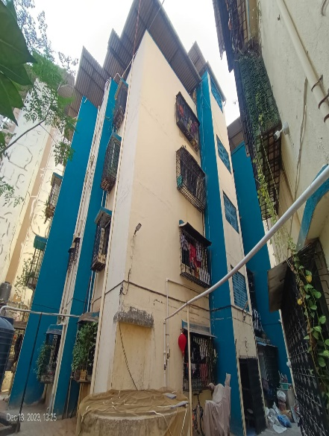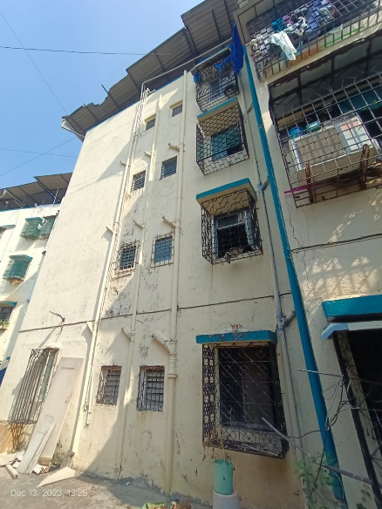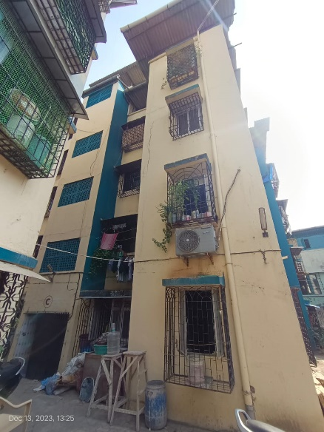

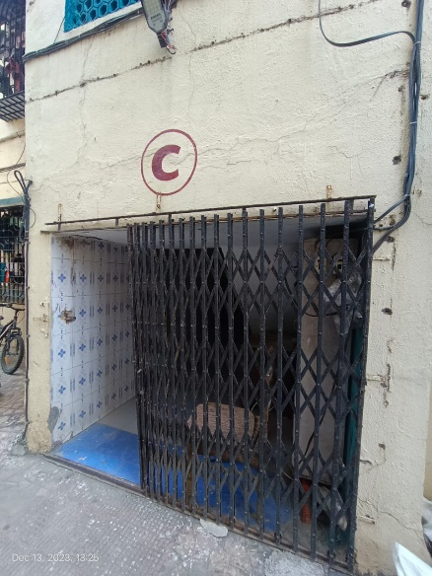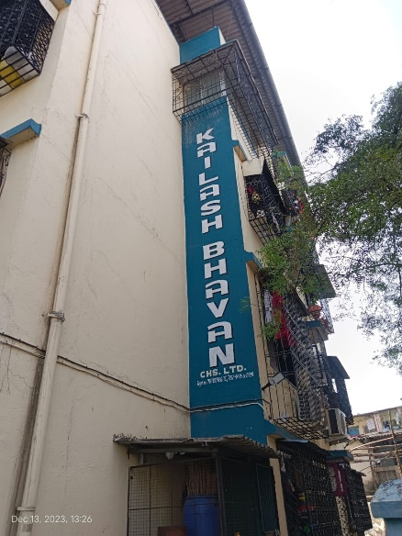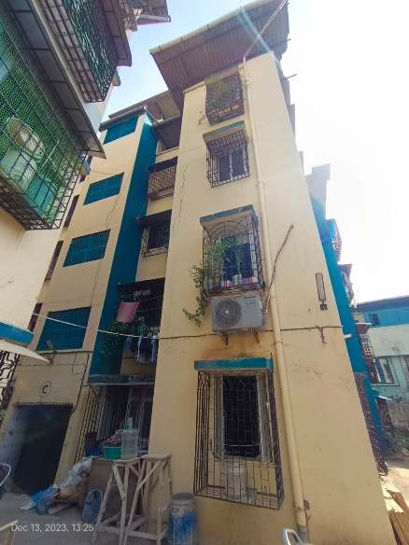

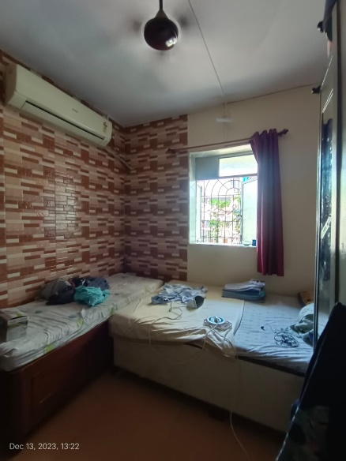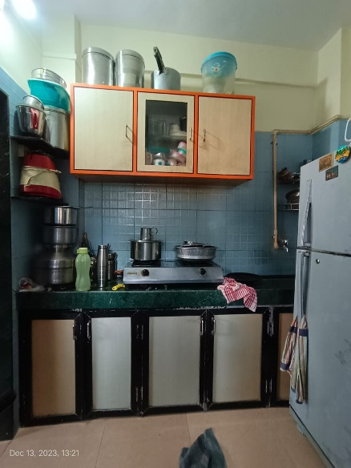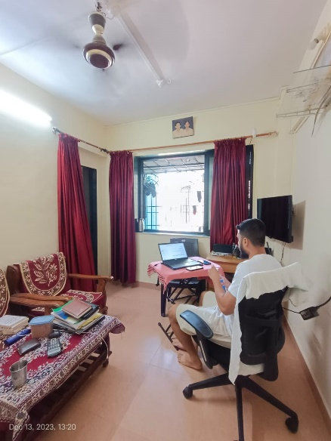

**Actual Site Photographs**

