Vastu/Nashik/12/2023/005601/2303957
14/2-186-RPBS
Date: 14.12.2023

To,
The Branch Manager,
Union Bank of India
Nashik Highway Branch
Shop No. 2, 3, 4, Sagar Plaza, Amrut Dham, Panchavati,
Nashik – 422 003, State – Maharashtra, Country – India.

Sub: Vetting of Extra Work

Sir,

With reference to above subject, we have evaluated the Extra Work for Residential Flat No. 303, Third Floor, " Sai Icchha Apartment", Gat No. 308, Plot No. 58, Near Sanklecha Apartment, Swami Samarth Nagar, Vrindavan Nagar, Jatra - Nandur Road Village – Adgaon, Taluka & District - Nashik, PIN Code – 422203, State – Maharashtra, Country – India belongs Name of Proposed Purchaser: Mr. Kunal Nitin Bhavsar & Mr. Nitin Raghunath Bhavsar, Mrs. Aswhini Nitin Bhavsar. Name of Owner: M/s. Akash Developers.

We have verified the rates quoted as per current market rates. Details of Extra Amenities considered as per copy of Extra Amenities Agreement between Mr. Kunal Nitin Bhavsar & Mr. Nitin Raghunath Bhavsar, Ms. Aswhini Nitin Bhavsar. (First Party). Mr. Kiran Vishwas Dangle (Second Party) received on dated 12.12.2023. The Extra Work amount is Rs. 2,94,000/- (Rupees Two Lakh Ninety-Four Thousand Only)

The said Cost Vetting Certificate is valid upto next 6 months Only.

Thanking you

Sincerely yours

Sharadkumar B. Chalikwar
Govt. Reg. Valuer
Chartered Engineer (India)
Reg. No. (N) CCIT/1-14/52/2008-09

Agreement for Extra Work

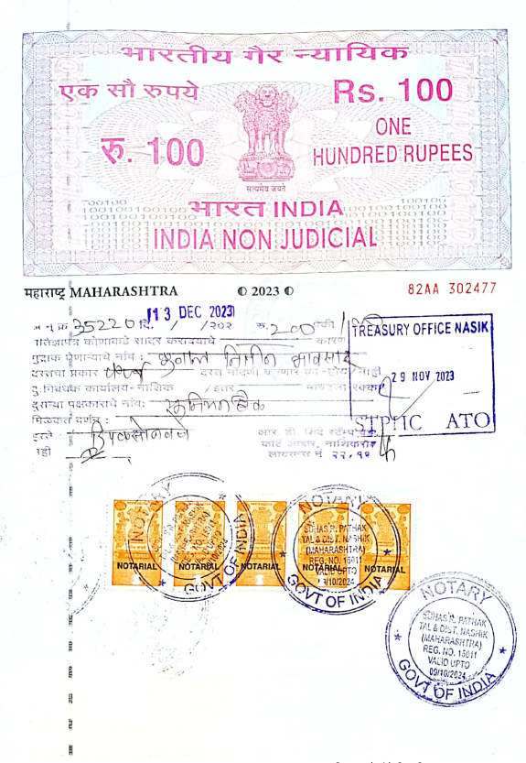
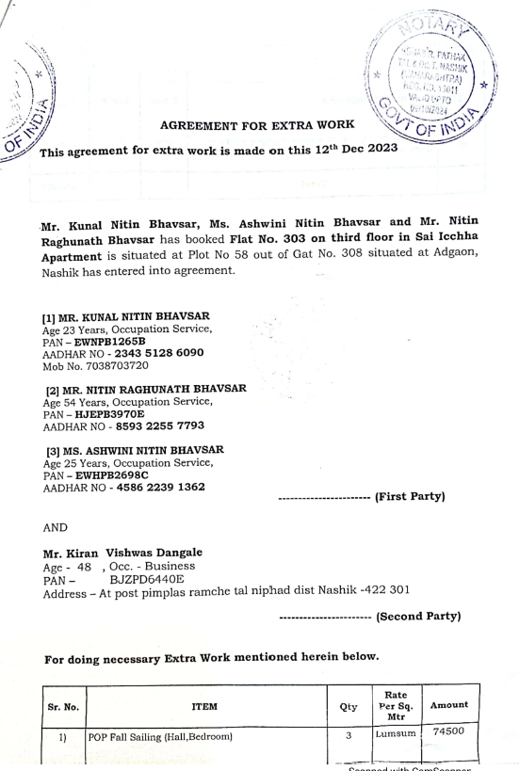

Agreement for Extra Work
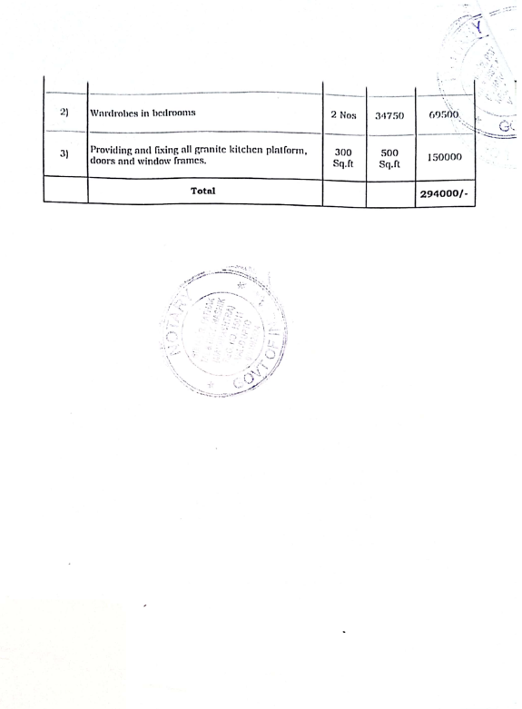
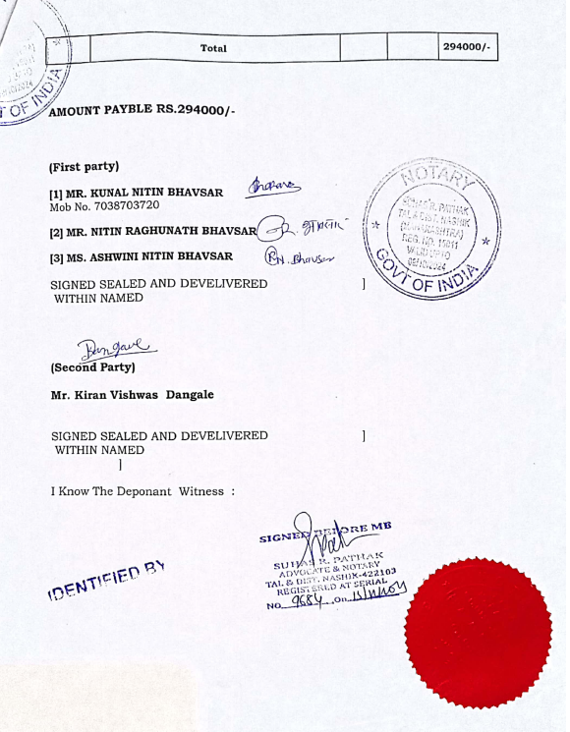

The Extra Work amount is Rs. 2,94,000/- (Rupees Two Lakh Ninety-Four Thousand Only)

