Vastu/Nashik/12/2023/005559/2303925
12/18-154-RYBS
Date: 12.12.2023

To,
The Branch Manager,
Bank of Baroda
Regional Office
BSNL Building, Datta Mandir Road, Nashik Road,
Nashik, PIN – 422 101, State - Maharashtra, Country - India.

Sub: Vetting of Extra Work

Sir,

With reference to above subject, we have evaluated the Extra Work Cost Sheet for Residential Flat No. F - 503, Fifth Floor, " Sagar Sparsh Apartment E & F Wing ", Survey No. 246/ 10, Plot No. 35 & 36, Near Manjuprabha Hospital, Audumbar Nagar, Dr. Nanasaheb Dharmadhikari Marg, Amrutdham, Village - Nashik, Taluka & District - Nashik, PIN Code – 422003, State – Maharashtra, Country – India. belongs to Name of Proposed Purchaser: Mr. Tushar Madhukar Khairnar & Mrs. Ashwini Tushar Khairnar. Name of Owner: Mr. Sagar Mahadeorao Bonde & Mrs. Sarita Sagar Bonde.

We have verified the rates quoted as per current market rates. Details of Extra Work Cost Sheet considered as per copy of Extra Work Cost Sheet by Sagar Constructions received on dated 08.12.2023. The Extra Work Cost Sheet amount is Rs.5,94,000/- (Rupees Five Lakh Ninety-Four Thousand Only)

Note:1) The said Cost Vetting Certificate is valid up to next 6 months Only.

Thanking you

Sincerely yours

Manoj B. Chalikwar
Registered Valuer
Chartered Engineer (India)
Reg. No. CAT-I-F-1763
Reg. No. IBBI/RV/07/2018/10366
BOB Empanelment No.: ZO:MZ:ADV:46:941
Encl: Vetting Report
.
Extra Work Cost Sheet
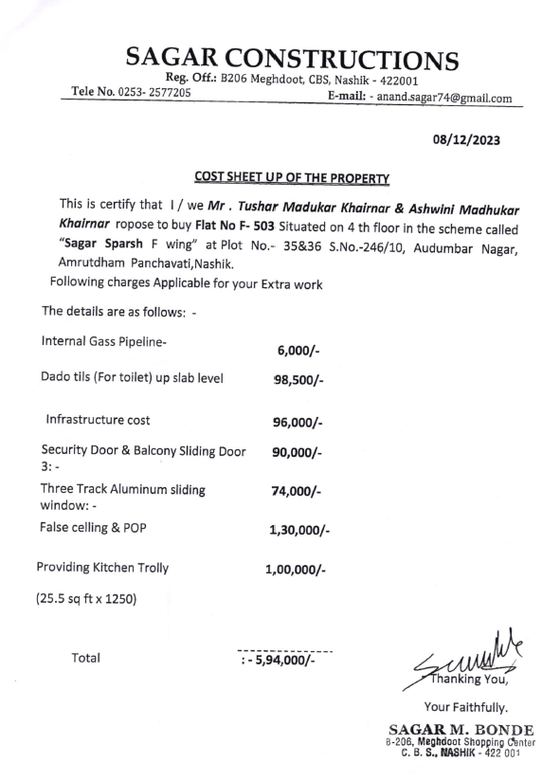

The Extra Work Cost Sheet amount is Rs.5,94,000/- (Rupees Five Lakh Ninety-Four Thousand Only.)

